Sample ID | Unfiltered | Sequence artifact removed | non-silent exonic | rare
HL1 | 41543 | 19062 | 9229 | 586
HL10 | 41861 | 19424 | 9482 | 614
HL11 | 41826 | 19423 | 9506 | 575
HL12 | 41834 | 19589 | 9588 | 584
HL13 | 41792 | 19536 | 9502 | 579
HL14 | 41454 | 19699 | 9628 | 661
HL15 | 41891 | 20067 | 9797 | 648
HL17 | 43266 | 20590 | 10063 | 622
HL18 | 42585 | 19763 | 9591 | 624
HL19 | 42183 | 19849 | 9619 | 593
HL2 | 41896 | 19725 | 9614 | 625
HL20 | 42498 | 20334 | 9897 | 624
HL21 | 41674 | 19554 | 9544 | 636
HL22 | 41514 | 19495 | 9526 | 587
HL23 | 42301 | 19918 | 9773 | 607
HL24 | 42328 | 20135 | 9869 | 651
HL25 | 41310 | 19268 | 9388 | 626
HL26 | 41681 | 19356 | 9457 | 630
HL27 | 41727 | 19413 | 9506 | 615
HL28 | 41675 | 19613 | 9536 | 580
HL29 | 42488 | 19947 | 9703 | 628
HL3 | 41887 | 19917 | 9723 | 660
HL30 | 42167 | 19417 | 9410 | 548
HL31 | 40945 | 19146 | 9322 | 571
HL32 | 41673 | 19568 | 9467 | 588
HL33 | 42102 | 19966 | 9765 | 620
HL34 | 42357 | 20012 | 9636 | 611
HL35 | 42325 | 19652 | 9620 | 609
HL36 | 43103 | 21165 | 10354 | 633
HL37 | 44564 | 21894 | 10726 | 689
HL38 | 43980 | 21497 | 10502 | 684
HL39 | 43226 | 21005 | 10217 | 719
HL4 | 41974 | 19669 | 9577 | 631
HL40 | 43970 | 21511 | 10394 | 628
HL41 | 44173 | 21700 | 10520 | 670
HL42 | 44252 | 21799 | 10633 | 722
HL43 | 44556 | 21712 | 10650 | 706
HL5 | 41167 | 19230 | 9312 | 670
HL6 | 42189 | 19811 | 9643 | 614
HL7 | 42046 | 19752 | 9700 | 618
HL8 | 42093 | 19434 | 9450 | 610
HL9 | 41788 | 19577 | 9532 | 640
HL16 | 43221 | 20823 | 10151 | 697

Table S1: Quality control (QC) report of whole exome analysis

 | # of germline mutations (43 patients)
 | Unfiltered | Sequence artifact removed | Non-silent exonic | Rare germline
min | 40945 | 19062 | 9229 | 548
median | 42093 | 19752 | 9620 | 624
max | 44564 | 21894 | 10726 | 722

Table S2: Summary data for QC

NSHL patient selection criteria
Inclusion criteria:
• Hearing loss present at birth confirmed by auditory brain stem response testing/ Evoked
otoacoustic emissions testing
• Symptomatic and asymptomatic family members of babies with congenital hearing
loss.
Exclusion criteria:
• perinatal infections
• premature birth
• low birth weight
• birth injuries
• drug and alcohol use while pregnant
• jaundice and Rh incompatability
• maternal diabetes
• maternal preeclampsia/ eclampsia
• perinatal asphyxia
• syndromic etiologies
Table S3: Inclusion and exclusion criteria for subject selection.

Sl no | Name | Sequence (5’ - 3’) | Tm (°C) | Product size
1 | PCDH15-HS-FP | ACAGGACACAGTAGCCTCAGT | 60.48 | 453
2 | PCDH15-HS-RP | AAGAATACTTGCCGCGCTTC | 59.27 | 453
3 | MYO7A-HS-FP | GTAGGGAAGCCACAGAAAGCA | 60.27 | 398
4 | MYO7A-HS-RP | TCCAGAACTTGAGGGTAGGTG | 58.74 | 398
5 | TECTA-HS-FP | ATGAAGAAAGGCGGCAGACC | 60.68 | 354
6 | TECTA-HS-RP | CTGGCCTCCCATACCTCGTAA | 61.03 | 354
7 | MYH9-HS-FP | AGTCGGCAGTCATCCCATC | 59.17 | 544
8 | MYH9-HS-RP | GAGCCCAAGTCAGGAGCAAAG | 61.22 | 544
9 | GPSM2(224)-HS-FP | AATTCTTCCTCTCTCCCCCAAT | 58.52 | 352
10 | GPSM2(224)-HS-RP | CCCAAATGTCGGTACTCAAAAC | 57.84 | 352
11 | GPSM2(614)-HS-FP | TGCCCTGAACAAGAGTAGCC | 59.68 | 451
12 | GPSM2(614)-HS-RP | GCGATGTTACTGAAGTAGAACTCA | 58.60 | 451
13 | DNAH5-HS-FP | GCTCATGACTTAGCCTGTCCA | 59.82 | 376
14 | DNAH5-HS-RP | AGACCTCCAGGATGACACAC | 59.35 | 376
15 | COL4A6-HS-FP | CTCTGCCTGTTAGCAGTTTGC | 59.82 | 439
16 | COL4A6-HS-RP | GTCCAAGTCCCTCCCCATTTC | 61.78 | 439
17 | SLC26A4-HS-FP | GGAGCAATGCGGGTTCTTTG | 59.35 | 414
18 | SLC26A4-HS-RP | GCATTATAGCTAATGCCCACT | 55.92
19 | OTOF-HS-FP | GGACAAAAGCCAGAGACCAG | 59.35 | 322
20 | OTOF-HS-RP | GGACAAAAGCCAGAGACCAG | 60.25

Table S4: List of primers used for Sanger sequencing

Temperature | Time | Cycle
95 °C | 5 min | 1 Cycle
95 °C | 30 sec
Specific T_{a} for a primer set | 30 sec | 35 cycles
72 °C | 30 sec
72 °C | 7 min | 1 Cycle
4 °C | infinity

Table S5: Standard 3-step PCR Cycling

Figure S1: Pedigree of 43 NSHL probands and their families

Figure S2: Distribution of various types of mutations in the genes reported to be mutated in NSHL patients. The backbone of each encoded protein is taken from UniProt database.

Figure S3: Segregation analysis of families without trios

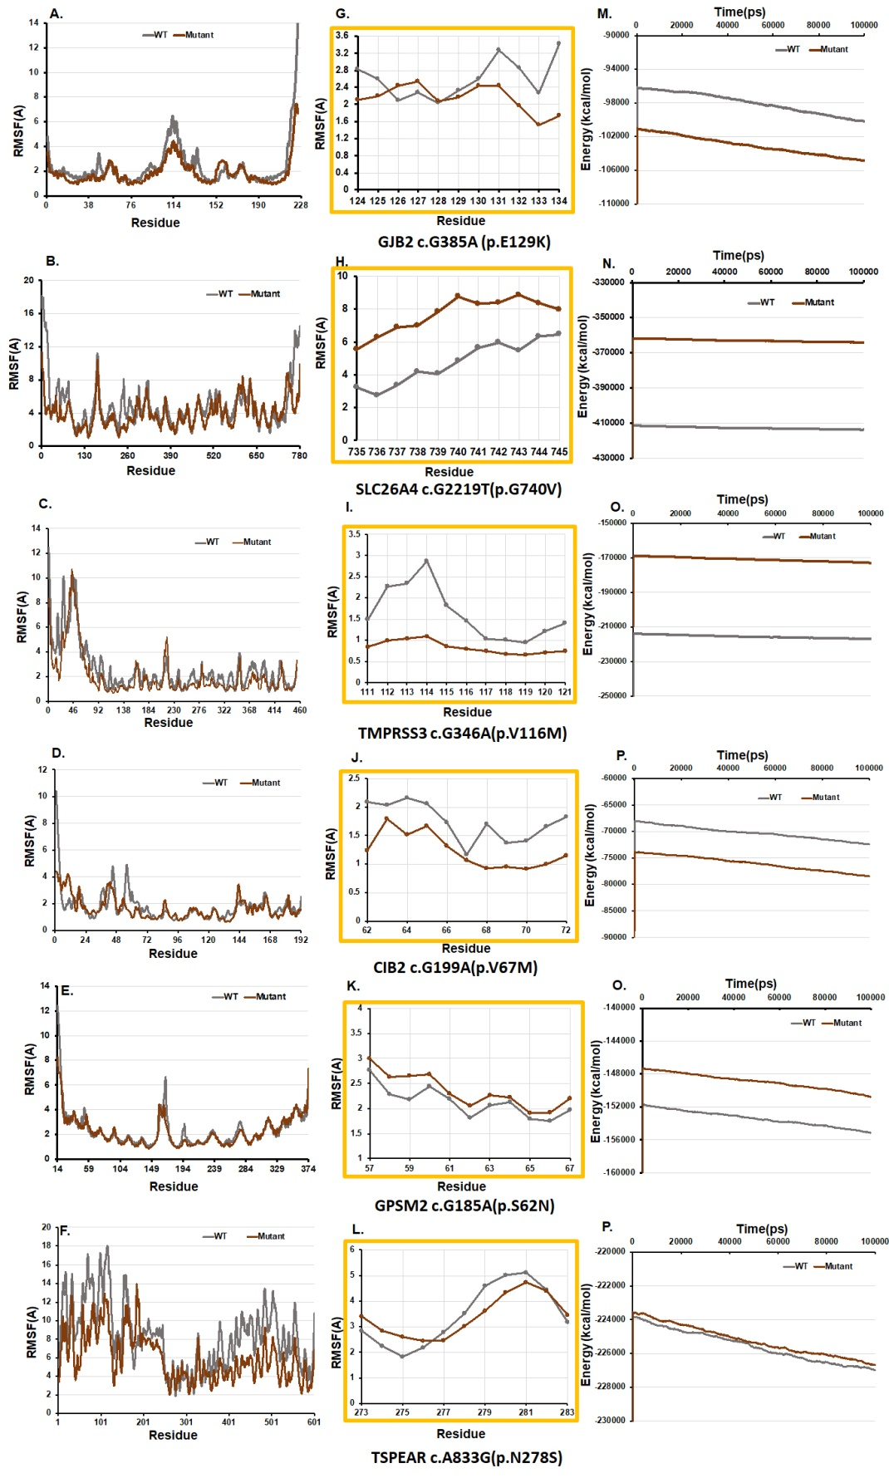
Figure S4: Overview of the fluctuation and energetic stability of the WT and mutant proteins. Root mean square fluctuations (RMSF) values for each amino acid residues are plotted for mutant and WT GJB2, SLC26A4, TMPRSS3, CIB2, GPSM2, and TSPEAR, respectively in panels A-F, respectively whereas the insets (panels G-L) shows the RMSF patterns within close vicinity of the mutation site. Energy profiles of WT and mutant structures with respect to the simulation time are plotted in panel M-R, respectively.
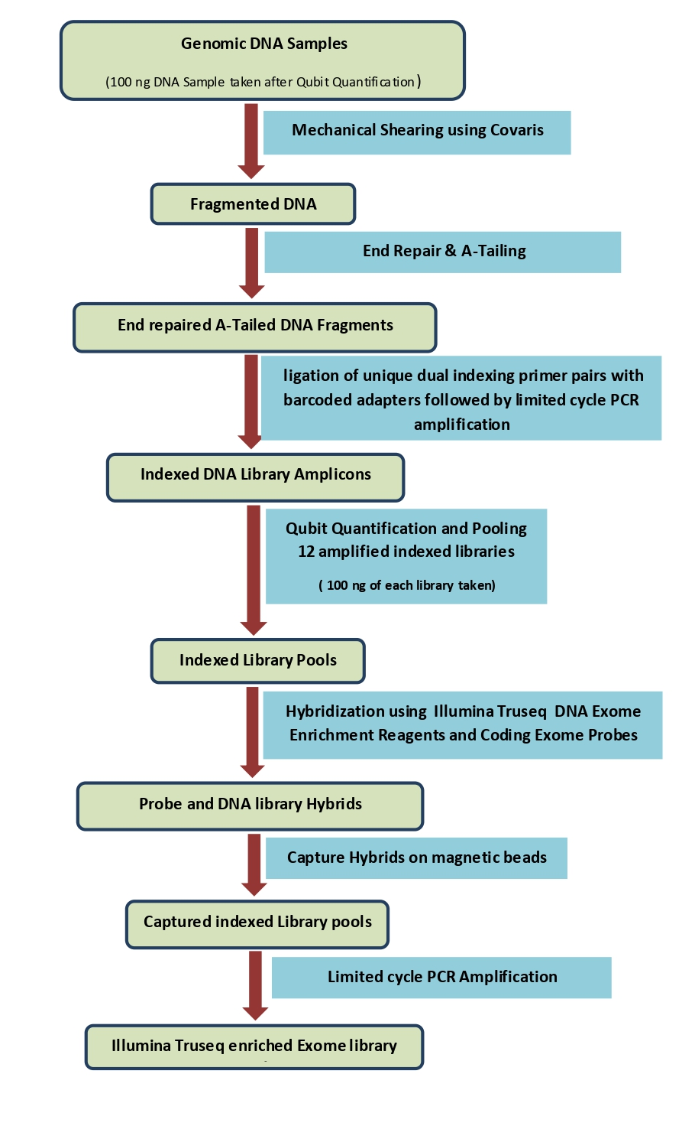
Figure S5: The workflow for Exome Sequencing Library Preparation Using Illumina Truseq Exome with pre- capture pooling.

