Lignin Containing Cellulose Nanofiber (LCNF) Based Nanopapers with Ultrahigh Optical Transmittance and Haze

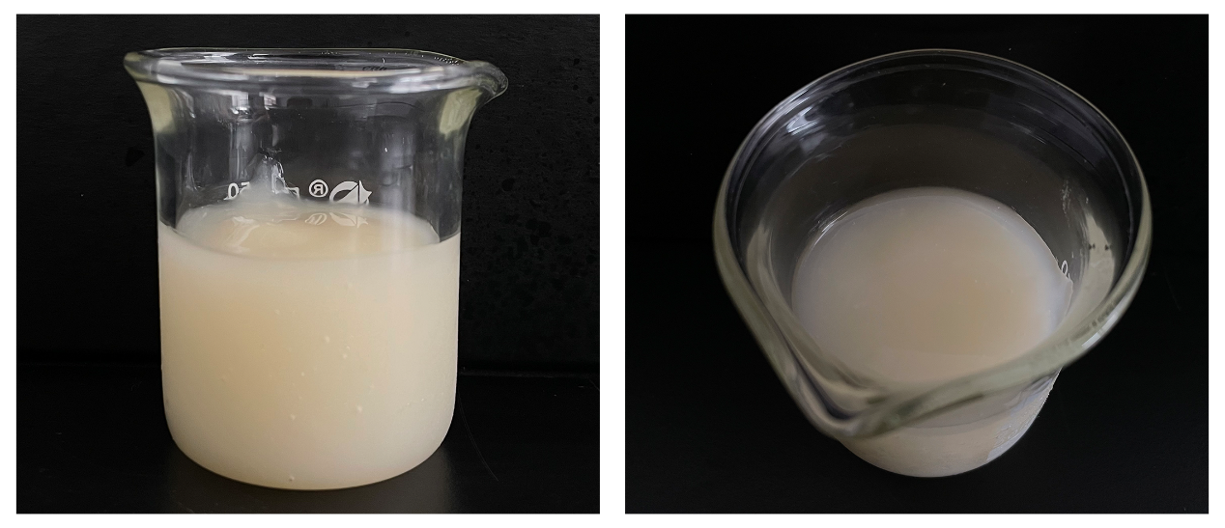
Fig. S1 Photograph of the light yellow translucent LCNF gel (1.38%)

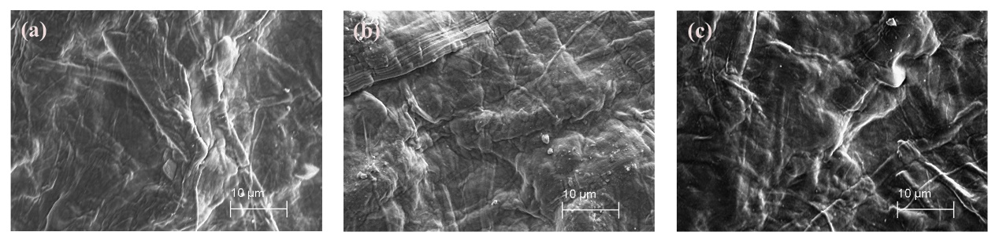
Fig. S2 The microscopic surface morphology of the LCNF/Gly composite films (a) LCNF/Gly-0%; (b) LCNF/Gly-17%; (c) LCNF/Gly-33%

