Harnessing the SARS-CoV-2 Spike Protein binding affinity to ACE2 receptor through Narcotinic Compounds Combined with Adjuvants: an in silico Insight

Saeedeh Mohammadi ^{1,2, *}, Esmail Doustkhah³, Nader Sakhaee⁴, Mohammad Esmailpour², Ayoub Esmailpour^{1, *}

¹ Department of Physics, Shahid Rajaee Teacher Training University, Lavizan, Tehran 16788-15811, Iran
² Department of Physics, Azarbaijan Shahid Madani University, Tabriz 53714-161, Iran
³ International Center for Materials Nanoarchitechtonics (WPI-MANA), National Institute for Materials Science (NIMS), 1-1 Namiki, Tsukuba, Ibaraki 305-0044, Japan
⁴ Roger Adams Lab, school of chemical sciences, University of Illinois Urbana Champaign, IL, 61801 USA
*corresponding. s.mohammadi@sru.ac.ir

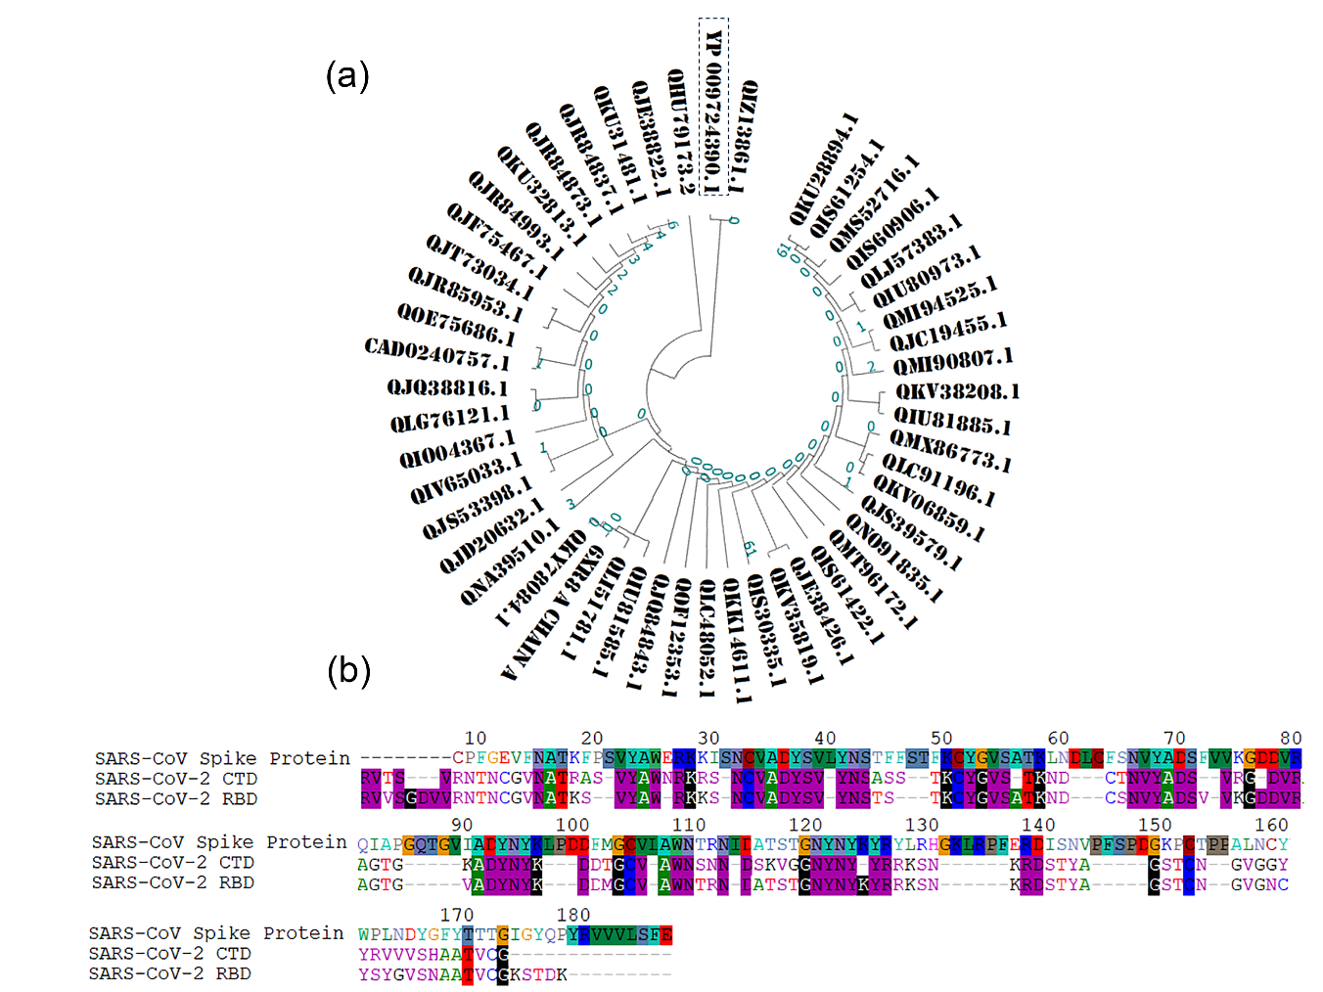
Figure S1: Phylogenetic analysis and sequence alignment of SARS-CoV-2 S protein. (A) Homology tree of 50 nucleotide sequences alignment and (b) sequence alignment of the S proteins RBD/CTD from SARS-CoV-2 with SARS-CoV.
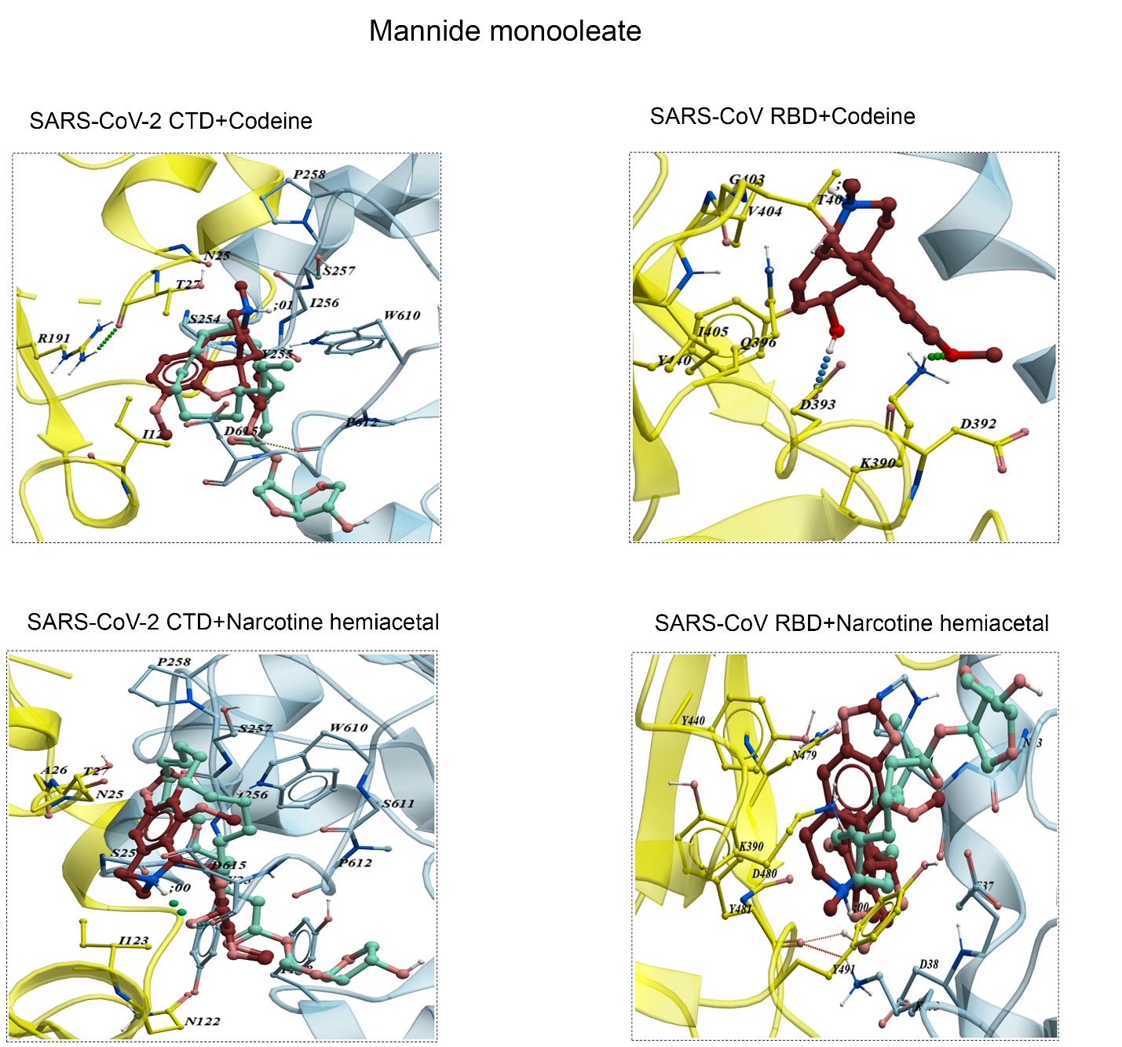
Figure S2: Binding interface of SARS-CoV-2 CTD and human ACE2 with narcotine hemiacetal and codeine + mannide monooleate (in pocket of narcotine hemiacetal and codeine) compared to SARS-CoV RBD. ACE2 is in blue, the core of CTD is in yellow.

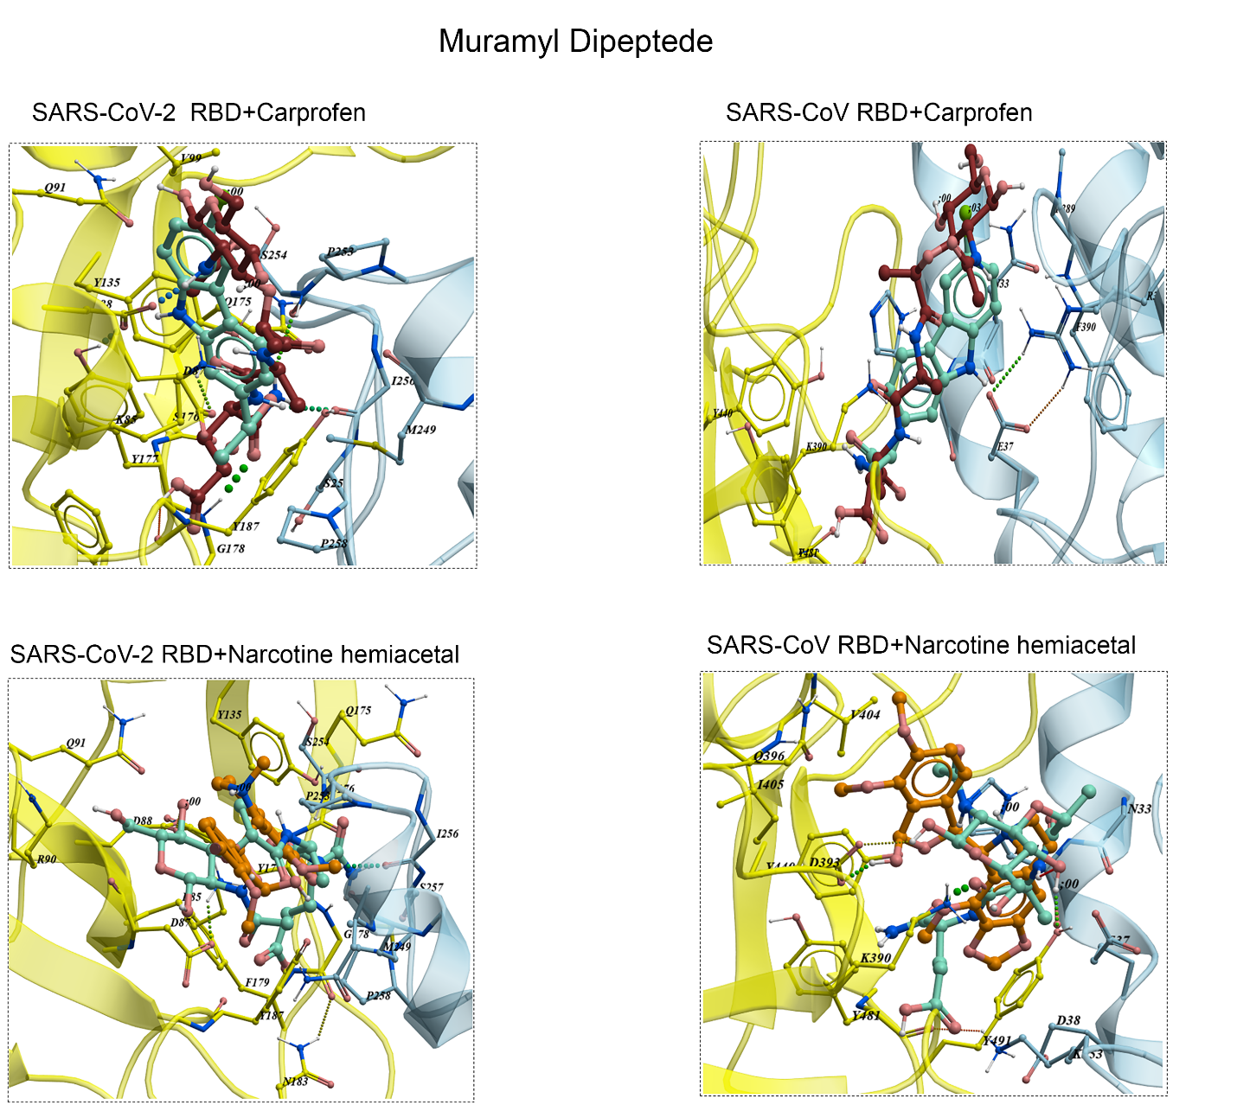
Figure S3: Binding interface of RBD (yellow) external subdomain of spike glycoprotein with receptor ACE2 (blue) in complex of muramyl dipeptide + carprofen and narcotine hemiacetal compare to SARS-CoV RBD in pocket of carprofen and narcotine hemiacetal.
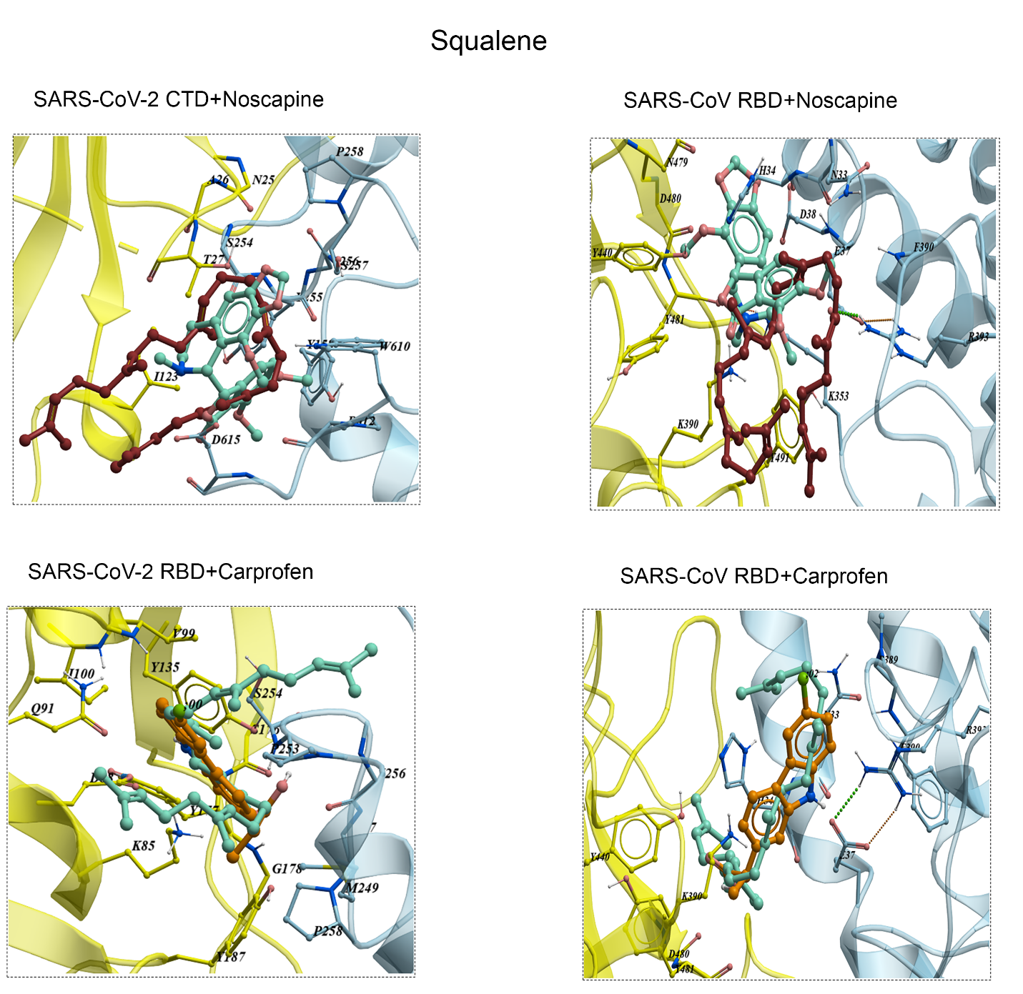
Figure S4: The binding of RBD/CTD (yellow) of spike glycoprotein with receptor ACE2 (blue) in complex of squalene + carprofen and nocapine compare to SARS-CoV RBD in pocket of carprofen and nocapine.

