Annex I

Fig. A1 | Map of evidence distribution by country (1985 – 2022)
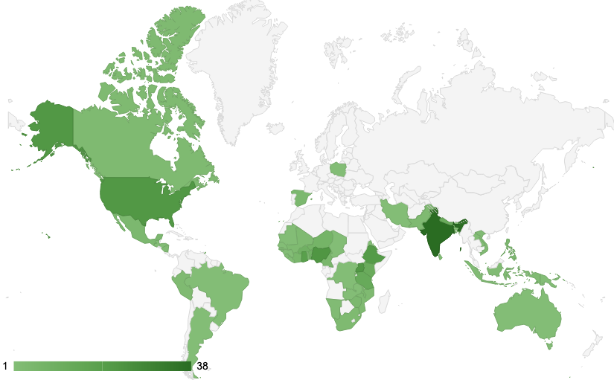

Table A1 | Frequencies of tools in the studies sampled, sorted in descending order

Broad Tool Type | Narrow Tool Type | Frequency
Questions | Individual surveys | 31.9
Questions | FGDs | 15.9
Experience | PVS | 15.1
Experience | Demonstration plots | 6.9
Questions | Group surveys | 2.9
Experience | Field visit | 4.6
Choices | WTP | 3.6
Experience | On farm trials | 1.8
Questions | PRA | 0.9
Choices | Gamification | 0.7
Experience | Other | 0.7
Other | Models and maps | 3.3
Other | Sensory test | 1.5
Questions | Preference voting | 0.5
Choices | Choice experiment | 2.2
Choices | Conjoint analysis | 1.3
Other | Observation of farmers behavior | 1.3
Choices | Auction, Hedonic pricing | 1.1
Experience | On station trial | 1.1
Other | Secondary sources | 1.1
Questions | Tricot | 0.2
Questions | Expert surveys | 1.1
Questions | G+ Tools | 0.2
Total |  | 100

Table A2 | Frequencies of methods in the studies sampled, sorted in descending order

Broad Tool Type | Narrow Tool Type | Frequency
Descriptive and frequency | Frequency count | 24.6
Economic model | GLM | 10.7
Ranking | Pair wise Ranking | 5.8
Statistical Hyp. Testing | T-test between rankings | 3.9
Statistical Hyp. Testing | ANOVA | 7.4
Statistical Hyp. Testing | Chi-squared test | 7.4
Ranking | Ranking | 6.4
Descriptive and frequency | Figures | 0.8
Descriptive and frequency | Descriptive Analysis | 3.5
Economic model | Marginal utility | 0.8
Qualitative | Other | 0.8
Multivariate analysis | PCA | 2.5
Qualitative | Word counting | 1.6
Economic model | Latent class approach | 0.6
Descriptive and frequency | Tabular analysis | 1.4
Multivariate analysis | Other | 5.0
Qualitative | Content analysis | 1.4
Qualitative | Quote statement | 2.3
Statistical Hyp. Testing | Other | 5.0
Descriptive and frequency | Direct prioritization | 0.4
Economic model | Part-worths | 0.4
Ranking | Priority ranking | 0.4
Statistical Hyp. Testing | LSD | 3.1
Multivariate analysis | Cluster, factor analysis | 1.2
Multivariate analysis | Matrix scoring | 1.2
Economic model | Cost-Benefit Analysis | 0.2
Economic model | Growth Rate Analysis | 0.2
Economic model | Heckman Model | 0.2
Economic model | Production function | 0.2
Index | Index | 1.0
Total |  | 100

Fig. A2 | Farmers’ engagement in the studies sampled, by crop and over time

Table A3 | Raw characteristics listed in a sub-sample of studies, according to tools and methods used

Data collection year | PP | Sex | Tools | Method | Authors (lead and last) | Open- or close-ended questions | Raw list of characteristics
2007 | Y | N | Experience; Other (sensory) | Descriptive; Multivariate Analysis | Singh Y.P; Ismail A.M. | Open | Number of productive tillers,  dwarf plant stature,  early maturity,  attractive long slender grains,  better threshability.
2006 | Y | N | Experience; Questions | Descriptive; Ranking | R.K. Singh; N. T. Lang (Singh Y.P; Ismail A.M. are co-authors in the study) | Open | Yield,  ability to withstand salt stress,  flowering duration,  plant height,  quality of straw for fodder,  for use as building material,  taste,  cooking quality,  bold grain shape,  good volume-expansion ratio of cooked rice.
2008 | N | N | Questions | Descriptive; Economic model | Malabayabas M.; Pandey S. | Closed | High yield,  resistance to lodge, resistance to pests, resistance to drought, good for submergence, good taste,  good quality of grains,  high price,  high demand.
The sub-sample of studies is selected among the highest number of studies on cereals in the period 2005 – 2010. Within this time span, we extract the crop appearing in most studies and within the selected target crop, we choose the country with more studies implemented. All the three studies are focused on rice in India. They do not collect sex-disaggregated data (column Sex in the table) and authors do not mention the methodology as being participatory (column PP in the table).

Fig. A3 | Ranking position for five of the most common traits (high yield, pest and disease resistance, drought tolerance, market demand, color and taste) across time and by crop

Fig. A4 | Network of donors

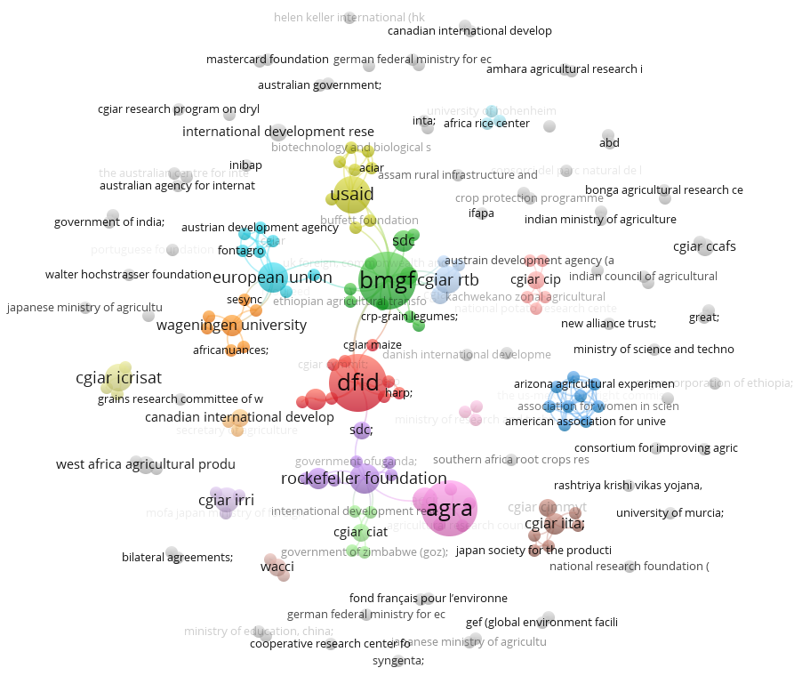

Fig. A5 | Network of co-authors, across time
1990 - 2000
2001 - 2010

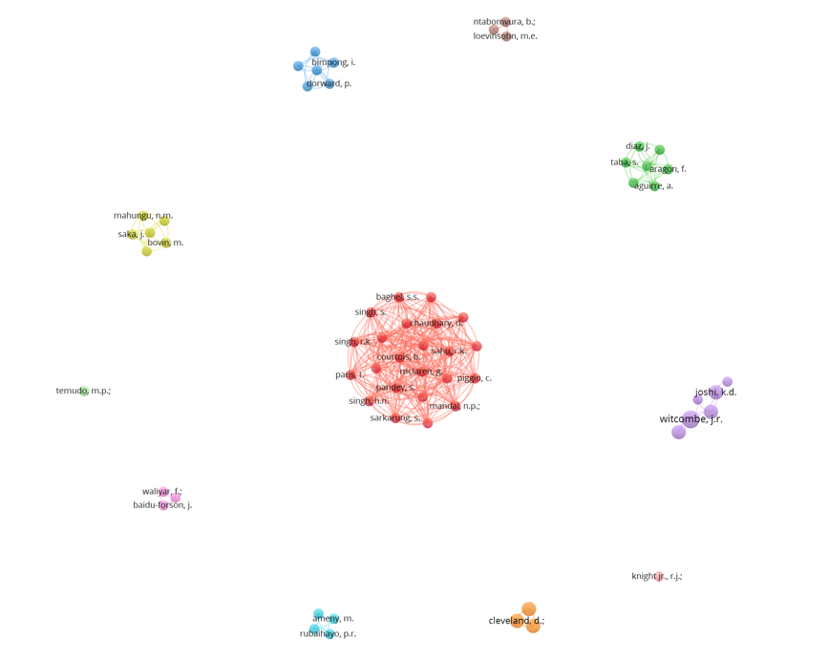
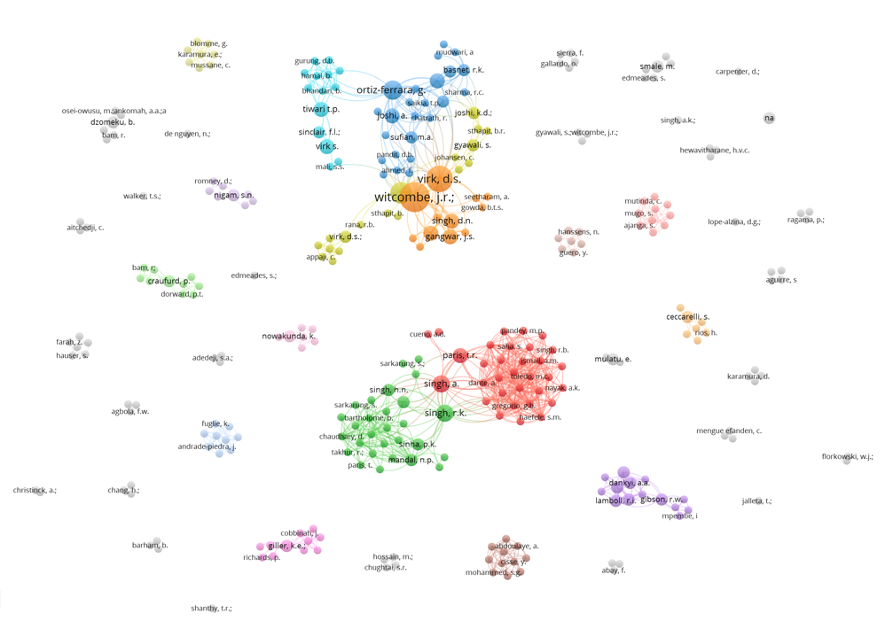

2011 - 2020

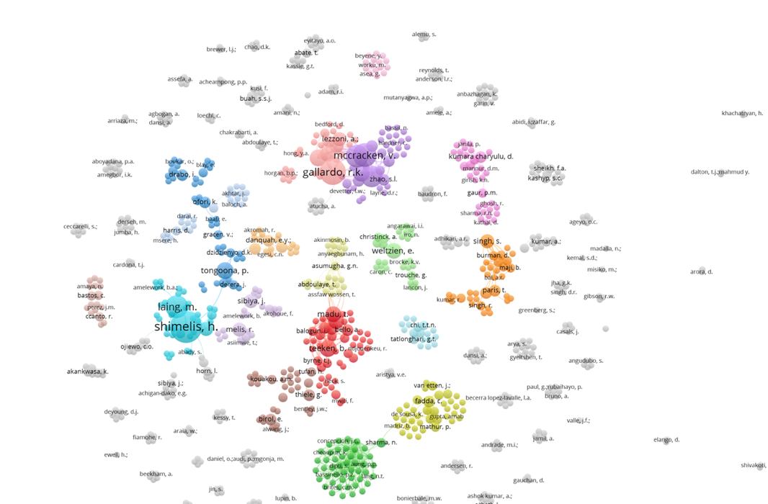

Fig. A6 | Network of co-authors, by crop
Panels: (a) RTB, (b) Cereals, (c) Legumes and (d) Vegetables and Fruits.

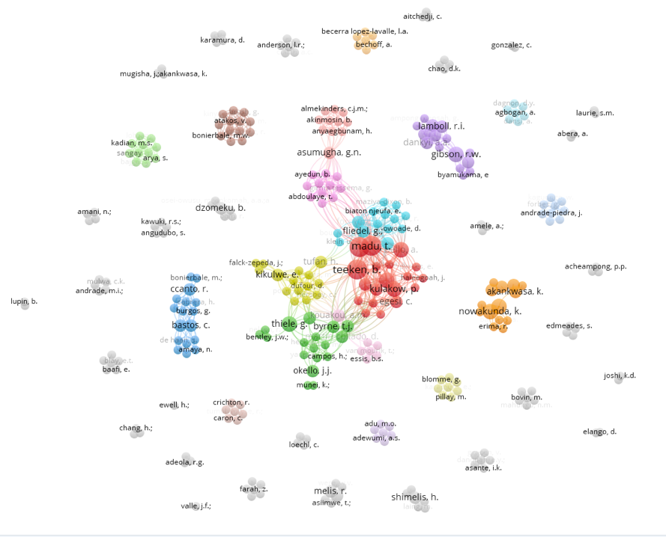
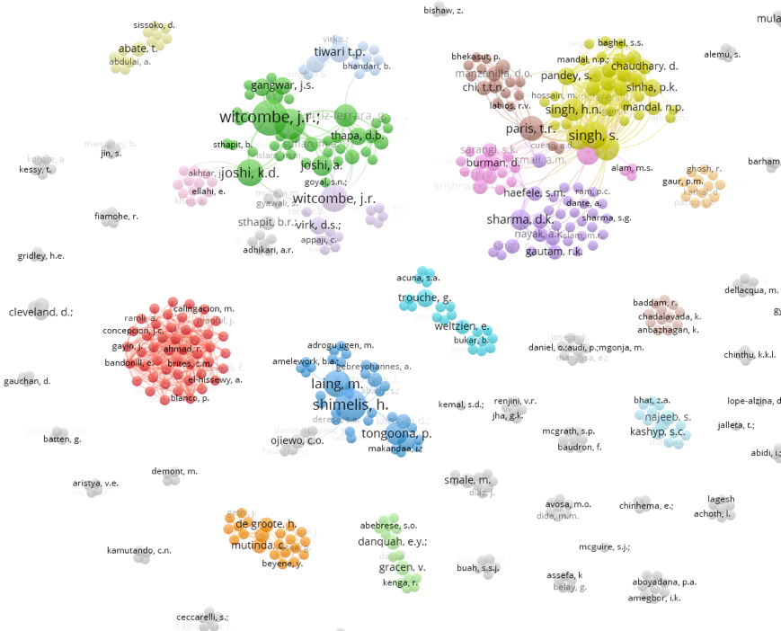
(b) 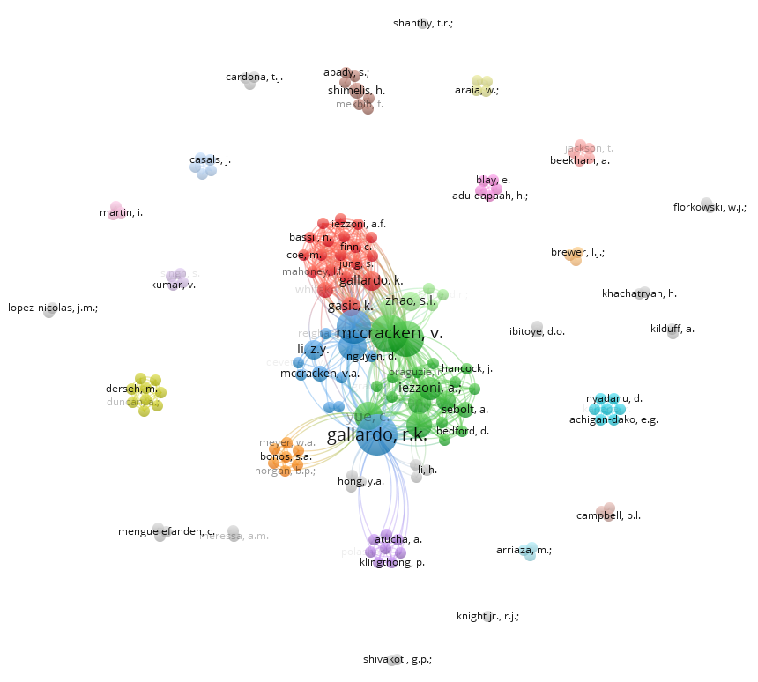
(a)

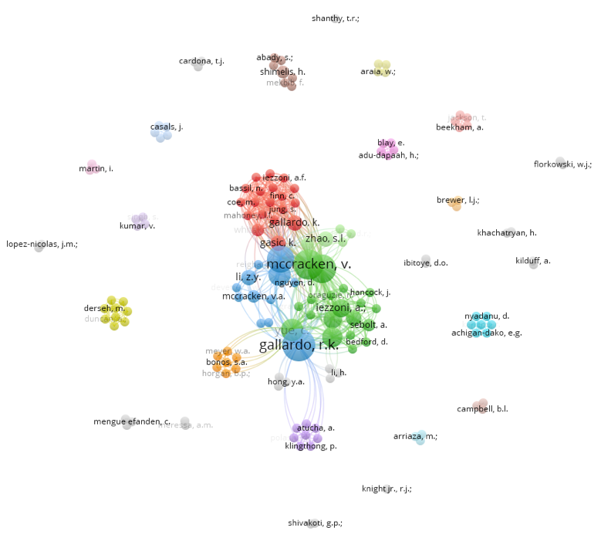
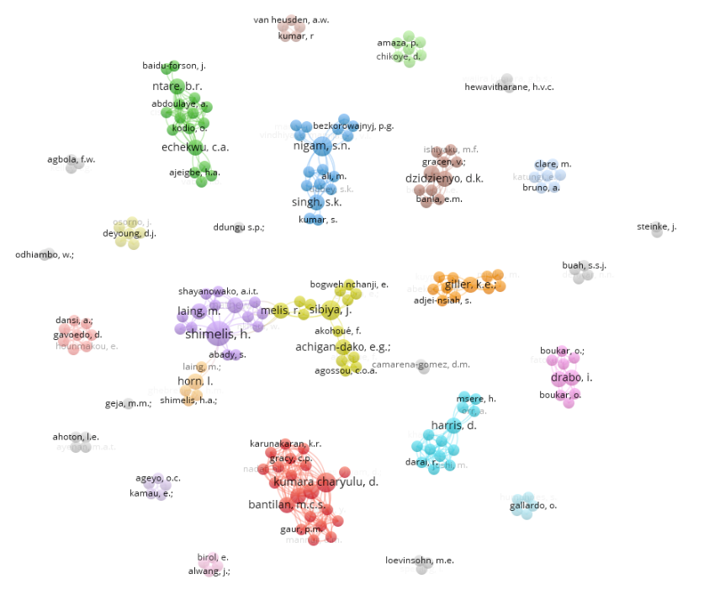
(d)
(c)
Annex II: the study protocol

Trait prioritization in plant breeding programs: a review on tools and methods

Based on the PRIMSA statement for scoping reviews
Open Science Framework registration

Administrative Information

- Identification: Scoping review
- Registration: https://osf.io/ayw8q/
- Authors:

Martina Occelli (MO), Cornell University – mo386@cornell.edu
Rishabh Mukerjee (RM), Cornell University – rm824@cornell.edu
Christian J. Miller (CM), Cornell University – cjm267@cornell.edu
Elisabeth Garner (EG), Cornell University – eg65@cornell.edu
Sergio Puerto (SP), Cornell University – sap257@cornell.edu
Miguel Gomez (MG), Cornell University – mig7@cornell.edu
Jaron Porciello (JP), Cornell University – jat264@cornell.edu
Hale Ann Tufan (HT), Cornell University – hat36@cornell.edu

Roles and responsibilities of authors

Content expertise: EG, MG, RM, MO, JP, SP, HT
Systematic review methods and information retrieval: CM, RM, MO, JP
Protocol elaboration: MO, CM, JP
Title and abstract review: RM, MO
Full text review: RM, MO
Data extraction: EG, MG, RM, MO, SP, HT
Data synthesis and data charting: MO, JP

Introduction and Background

The goal of this article is to review tools and methods currently used to set and rank trait priorities for plant breeding programs. We focus on trait prioritization as it enhances the effectiveness of plant breeding programs by prioritizing variety traits for a targeted selection of parental lines. Often, trait prioritization is led by plant breeders (Ragot et al. 2018); however global challenges of food insecurity and poverty have compelled breeding programs to consider more participatory processes to redefine objectives for social inclusion and impact.

To review how trait prioritization is currently addressed in plant breeding, we perform a scoping review among existing sources. We will look for qualitative and quantitative research that implements tools and methods to operationalize trait prioritization in plant breeding programs. We will scope the results obtained by primary research and reviews, isolating patterns of methods and tools adoption across time, space, crop, institutions and gender.

Methods

A systematic scoping review is designed to thematically characterize the extent, range and nature of existing evidence across a five-step process: identifying the research question; identifying relevant studies; selecting studies; extracting and charting the data; and collating, summarizing, and reporting the results (Arksey & O’Malley, 2005; Tricco et al., 2016).

The following elements were used to conceptualize the research question and the objectives of the study.

Setting/Geographic scope: All geographic regions will be considered for this scoping review. We include any relevant literature that relate to trait priority setting from village - level to regional - level studies or from low and middle – income countries to high – income economies.

Population: Our target population are all stakeholders in the crop value chain (e.g., producers, consumers, processors, dealers, traders), as we are interested in extrapolating tools and methods in which trait prioritization is performed involving end-users.

Interventions/Exposures: We are interested in interventions experiments which led to the elicitation of preferences and priorities by crop producers regarding a new or existing breeding product proposed by researchers. Meta analysis reviews of interventions are also considered as subject of the scoping review.

Defintions

Definitions of the parameters, interventions and exposures of interest in our analysis:

- Trait prioritization: we define trait prioritization as how crop breeding programs establish priorities for ranking traits of a given crop. Establishing priorities in traits, also defined as trait priority setting, is the process of making decisions about how best to allocate limited resources to prioritize a given trait with respect to another trait of the same crop. It is a complex process, as the purposes for choosing a trait are directly linked to the local usage of that crop, to the local agroclimatic zone, to the targeted end-users and to the agronomic characteristics of the local inputs, donors or policy objectives and resources available (e.g., financial capital, human capital). For this reason, trait prioritization often involves a diverse array of stakeholders, decision-makers, and scientists whose motivations and actions are often imperfectly aligned. Effective trait priority setting addresses these differing interests and motivations through a clear process focused on the use of evidence, transparency, and participation to identify the most appropriate set of variety traits to address population needs (Braunschweig 2000). Trait prioritization can entail a participatory nature: we define as participatory trait prioritization (or trait priority setting) the process through which trait priorities are co-established with farmers. Participatory trait priority setting can take the form of participatory rural appraisal, ranking and rating of traits and stated-choice experiments using multi-criteria decision making.
- Variety trait: characteristic of a given variety which expresses a specific quality of the variety. Traits can have different nature: among others, there are agronomic traits, which are of direct interest for agronomists and help the control of pests, diseases and weeds, nutritional traits, which contribute to the food security of consumers and climatic traits, which support the climate change adaptation of end-users.
- Trait preference: preference stated for a given or multiple variety traits.
- Plant breeding: Plant breeding uses principles from a variety of sciences to improve the genetic potential of plants. The process involves combining parental plants to obtain the next generation with the best characteristics. Breeders improve plants by selecting those with the greatest potential based on performance data, pedigree, and more sophisticated genetic information. Plants are improved for food, feed, fiber, fuel, shelter, landscaping, ecosystems services and a variety of other human activities (Definition by the National Association of Plant Breeders, US. Available at: https://www.plantbreeding.org/content/what-is-plant-breeding/). Within plant breeding, we can distinguish participatory plant breeding. Participatory plant breeding was proposed in early 1980s as a socio-technological solution to variety development, complementary to conventional plant breeding. The main participatory research in the plant breeding domain is called client-oriented plant breeding (COPB), and participatory varietal selection (PVS). In participatory research, clients (mainly farmers, but not solely) are included in all major decisions at all stages of a plant breeding program. The difference between this methodology and PVS is the demarcation when client participation starts; specifically, clients are engaged from the first stage of breeding pipeline in COPB, while in PVS farmers are involved in the testing of lines developed by plant breeders.
- Seed systems: science which studies formal and farmers’ seed exchange systems. Formal and farmers’ seed systems differ in how they use and maintain plant genetic resources for food and agriculture. Formal systems tend to produce uniform varieties through scientific breeding. Informal systems tend to generate and maintain fewer uniform materials adapted to local requirements (landraces) but also may provide a conduit for exchange of materials derived from modern varieties.
- Agronomy: agronomy is the science and technology of producing and using plants by agriculture for food, fuel, fiber, chemicals, recreation, or land conservation. Agronomy has come to include research of plant genetics, plant physiology, meteorology, and soil science.
- Crop: a crop is a plant that can be grown and harvested extensively for profit or subsistence.
- Seed: The term seed is used here to include any type of planting material that is intended for use in producing a crop, i.e., either generative or vegetative, such as roots, tubers, bulbs, cuttings, rhizomes, and apomictic seed. We consider only cases when human intervention in handling seed is explicit (Louwaars 2011).
- Planting material: Plant materials include a wide and varied group of plant parts from many species. General categories of plant materials include grasses, rushes, barks, woods, gourds, stems, roots, seeds, and leaves. These materials can be used to construct baskets, netting, cordage, and even fabrics.
- Germplasm: germplasm are living genetic resources such as seeds or tissues that are maintained for the purpose of animal and plant breeding,

Research question

- What tools and methods have been used for trait prioritization in plant breeding programs across time, study location, crop, institutions and gender?

Eligibility criteria

Inclusion

For an article to be included in this study, it must meet all of the following inclusion criteria:

- Original research (qualitative and quantitative reports) and/or review of existing research including gray literature.
- Explicit focus or clear relevance on trait prioritization (see definition).
- Explicit focus on crops, varieties, seed, planting materials or germplasm (see definitions).
- The study is written in English.
- The study presents primary data.
- The study presents meta analysis reviews of interventions.
- The study include field, on-farm, trials, laboratory experiments, where stakeholders’ preferences on traits are elicited.

Exclusion

An article which is excluded will have at least one of the following characteristics:

- The study does not focus or demonstrate a clear relevance on the topics of trait prioritization.
- Study in which the concept of trait prioritization is not matched, or it is matched only in cited references or keywords.
- Study in which trait prioritization or similar definitions appear only in sections related to future works and are not the main subject of the study.
- The study is not specifically carried out in the domain of plant breeding, seed systems or agronomy.
- The study has the main text in a language different from English.
- The study include field experiments, but do not elicit stakeholders’ preferences on traits.

Date: We are not considering a specific time frame for our scoping review. Studies meeting the inclusion criteria were published as early as 1970. We concluded the screening of the sources in March 2022, so studies published after that month are not included.

Information sources

We searched commonly used databases in the life sciences and socioeconomic domains for articles related to trait priority setting in plant breeding.

We screened 5 databases for peer-reviewed articles, books, chapters, and conference papers:
- Scopus
- Web of Science
- CAB Direct
- AgEcon Search
- BIOSIS Citation Index

We do not use Google Scholar, as previous methodological studies have found it inappropriate as a principal search system (Gusenbauer and Haddaway 2020).

We further surveyed the following 12 gray literature sources:
- Commonwealth Scientific and Industrial Research Organization (CSIRO)
- Gardian (searches 15 CGIAR websites - https://gardian.bigdata.cgiar.org)
- International Fund for Agricultural Development (IFAD)
- JPAL/ATAI impact evaluations (IPA)
- Overseas Development Institute (ODI)
- UK Department for International Development (DFID)
- World Bank
- World Health Organization (WHO)
- United Nations Environment Programme (UNEP)
- World Food Programme (WFP)
- Food and Agriculture Organization (FAO)
- AgriLinks (USAID Feed the Future platform)

This list stems partially from the sources used by Acevedo et al. 2020.

Search strategy

A comprehensive strategy was developed to identify all available research on the main topic, trait prioritization in plant breeding programs. Search terms will include variations of the key concepts in the research question. Table 1 presents the search strategy in its entirety, to allow replicability of the results.

Table 1 Search strategy for abstract, as implemented in the Web of Science platform

Row number | Search string
1 | TS = (“trait priority” OR “trait prioritization” OR “trait preference” OR “preferred trait” OR “preferred variety” OR “preference” OR “varietal selection” OR “trait choice” OR “trait characteristic”)
2 | TS = (“plant breeding” OR “variety breeding” OR “crop breeding” OR “crop improvement” OR “seed system” OR “agronomy” OR “agriculture” OR “rural” OR “farming” OR “cropping system” OR “cropping”)
3 | 1 AND 2
TS = topic; DE = keywords; AND = find records containing all terms separated by the operator; OR = find records containing any of the terms separated by the operator.

Study records

Searches will be performed across all sources listed in the section on information sources, and search results will be de-duplicated to remove redundant citations identified from multiple sources.

Extraction of records from peer-reviewed sources: the structure of online databases for peer-reviewed articles, books, chapters, and conference papers makes the search strategy (Table 1) objective and transparent.

Extraction of records from gray literature: as structured databases are missing for documents in the gray literature, the search strategy (Table 1) might result in subjective outcomes, according to the author in charge of conducting the search. To mitigate this element of subjectivity, we internally conduct a peer-review process. Following the search strategy in table 1, MO and RM screen the 10 information sources listed at page 4. The two authors will independently report in an excel file the titles, keywords and abstracts of the studies which result from the search strategy. The two excel files are then compared for differences: studies identified by both authors are included into the first repository without any further review process. On the contrary, studies which appeared in one excel file but not in the other are flagged as potential inconsistencies and they are subjected to the review of a third author (alternatively EG, MG, SP or HT). If considered on scope by the third reviewer, the flagged studies are included into the first repository; otherwise, they are discarded.

A peer-review process will be used for title and abstract and full-text screening. Article screening will take place in two phases:
- Phase 1: Title and abstract screening of all de-duplicated citations. Citations will be screened for relevance against the exclusion criteria of this protocol.
- Phase 2: Full-text screening of all articles deemed relevant in the title and abstract screening phase. Reasons for exclusion at this stage will be documented.

In both phases, all citations will be reviewed for relevance by two independent reviewers among authors (MO and RM). Each citation that meets all of the inclusion criteria at the title and abstract and full-text screening phases will be included. Each citation that meets one of the exclusion criteria at the title and abstract and full- text screening phases will be excluded. All conflicts will be resolved by a third, independent reviewer among authors (alternatively EG, MG, SP or HT). This step of the analysis is performed using the Covidence Library Software.

Once the final library for the review is assembled, a data extraction template will be used to collect all the relevant information. The template is presented in Appendix A. The data extraction template is tested by MO and RM before use, and data are extracted by the review team as a whole. Conflicts will be resolved by consensus.

Critical appraisal of individual sources of evidence

Scoping reviews do not aim to produce a critically appraised and synthesised result/answer to a particular question and therefore no formal critical appraisal is conducted for a scoping review.

Data synthesis

Data extraction (Appendix A) drives the data synthesis of the information from studies in the final repository. Both steps are based on categories, which provide evidence to answer the research questions at the center of this scoping review (listed at page 2). The categories are summarized in Table 2.

Table 2 | Summary of categories to operationalize the concept of trait prioritization

Category type | Categories
Trait prioritization taxa | Mention of trait prioritization vs mention of trait preferences
Journal/Publishing organization | Journal/Organization publishing the study
Institution | Institution / CG center in which the trait prioritization exercise was implemented
Donor | Donor providing funding for the trait prioritization exercise
Crop | Specific crop at the center of the study
Variety | Variety of the crop considered
Gender mention | Mention of gender disaggregation possible for the study
Ranking | Trait ranked
Data disaggregation | Trait ranking data disaggregated by any variable (sex, region, age or any other variable specified)
Timeframe | Year in which the trait prioritization experiment has been conducted
Declared breeding purpose | For yield vs for climate vs for nutrition vs food security
Geographic area of the study | Individual country vs regional vs global
Method | Specific method utilized to conduct the trait prioritization
Tool | Specific tool utilized to conduct the trait prioritization
Specific mention of | Local knowledge vs traditional knowledge vs indigenous knowledge
Specific mention of | Priority setting
Degree of end-users’ engagement | Participatory vs non – participatory experiment

Data Charting

To summarize findings and provide a clear answer to our question of interest, we will list, explain and chart data by a number of criteria:

- Summary of tools to rank trait preferences
- Summary of methods used to analyze data on trait preferences
- Evolution of tools used to rank trait preferences
- Evolution of the methods used to analyse data on trait preferences
- Share of papers mentioning two key dimensions: participation and priority setting
- Share of papers segmented for social dimensions
- Ranking of trait preferences, disaggregated by time, crop group and segment
- Map of evidence distribution by country and crop groups
- Network of (i) authors, (ii) affiliations and (iii) funding agencies
- Stated objectives of the papers focused on trait prioritization

References

Acevedo, M., Pixley, K., Zinyengere, N., Meng, S., Tufan, H., Cichy, K., Bizikova, L., Isaacs, K., Ghezzi-Kopel, K. and Porciello, J. 2020. A scoping review of adoption of climate-resilient crops by small-scale producers in low-and middle-income countries. Nature plants, 6(10): 1231-1241.

Braunschweig, T. 2000. Priority setting in agricultural biotechnology research: Supporting public decisions in developing countries with the Analytic Hierarchy Process. Research Report N. 16. The Hague: International Service for National Agricultural Research.

Louwaars, N.P., Le Coent, P. and Osborn, T., 2011. Seed systems and plant genetic resources for food and agriculture. FAO.

Ragot, M., Bonierbale, M. and Weltzien, E. 2018. From Market Demand to Breeding Decisions: A Framework. Lima (Peru). CGIAR Gender and Breeding Initiative. GBI Working Paper. No. 2. Available online at: www.rtb.cgiar.org/gender-breeding-initiative.

Tricco, AC, Lillie, E, Zarin, W, O'Brien, KK, Colquhoun, H, Levac, D, Moher, D, Peters, MD, Horsley, T, Weeks, L, Hempel, S et al. PRISMA extension for scoping reviews (PRISMA-ScR): checklist and explanation. Ann Intern Med. 2018,169(7):467-473. doi:10.7326/M18-0850.

Data extraction template

Author extracting the information
doi / handle – website
Title of the paper
Year of publication
Type of publication | Peer – reviewed / grey literature
Journal / Publishing organization
Objective of the study | Quote from the paper
Novelty of the study | Quote from the paper
Country (ies) of the study
Admin2 level is included in the study
Data collection end year
Crop / germplasm at the center of the study
Varieties of the crop considered in the study
Number of households included in the study | By admin2 / by sex
Multiple residents from the same household | Yes / No
Tools used for the data collection
Authors consider the study participatory | Word search for participatory
Methods used for analyzing data
Trait ranked | Yes / No
Trait ranking disaggregated by any variable
Explanation for differences in the rankings by disaggregating variable | Quote from the paper if any
Funding agency / Donors
Priority setting mentioned explicitly | Yes / No
Knowledge mentioned explicitly | Yes / No

