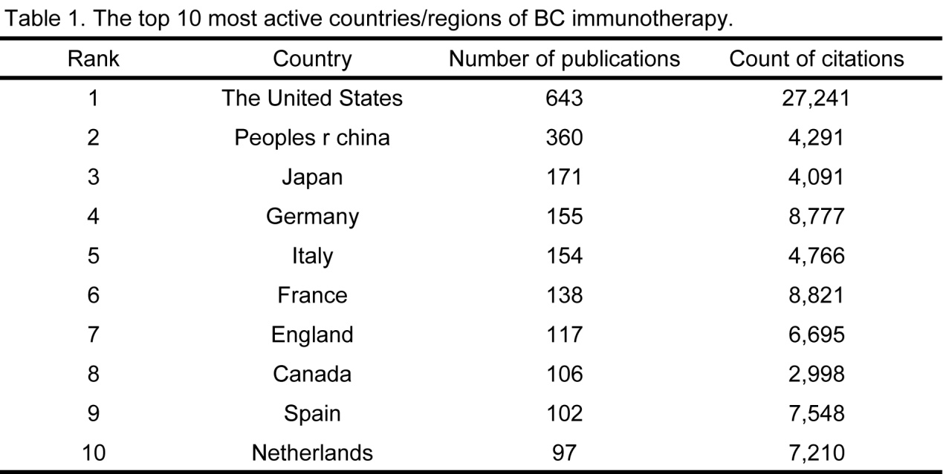
Table 1. The top 10 most active countries/regions related to BC immunotherapy.

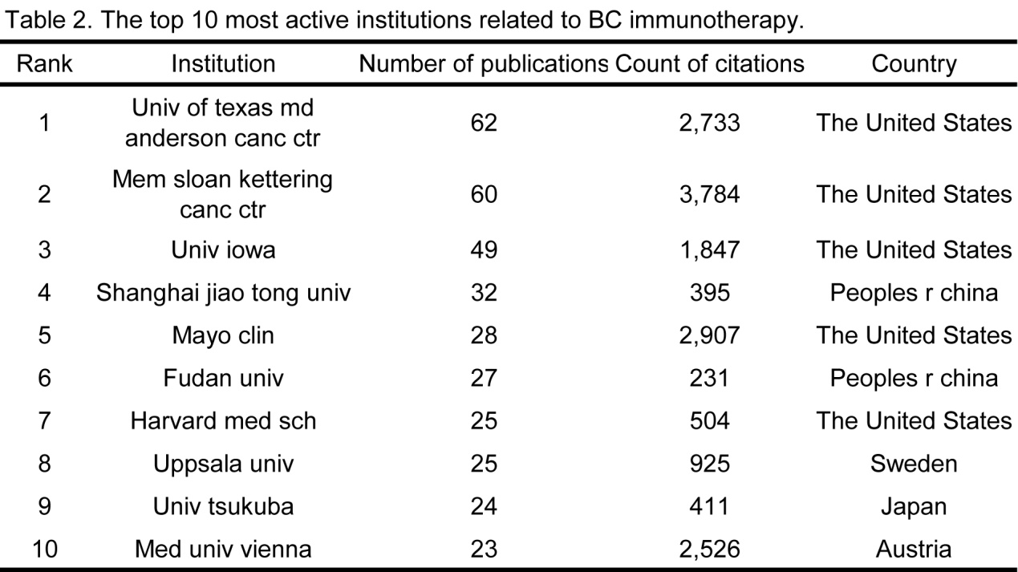
Table 2. The top 10 most active institutions related to BC immunotherapy.

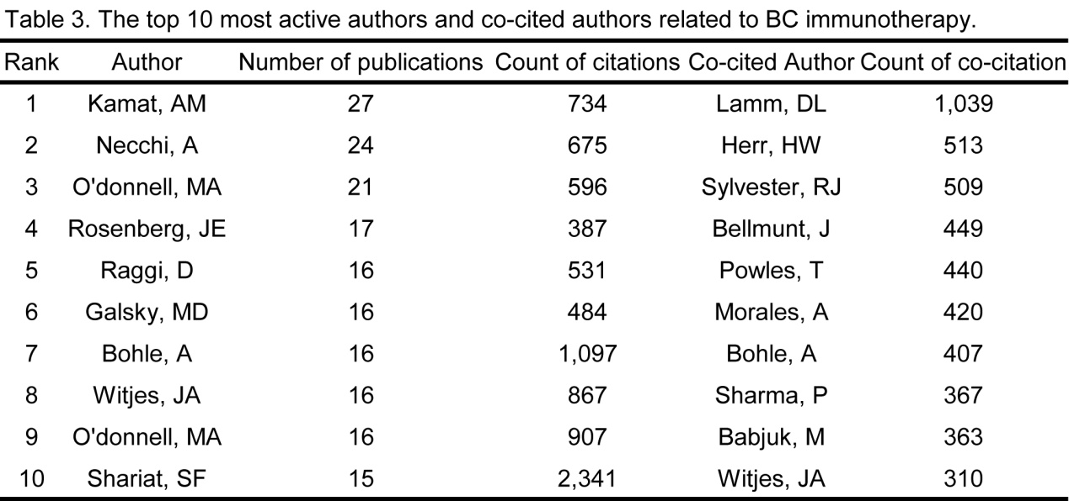
Table 3. The top 10 most active authors and co-cited authors related to BC immunotherapy.

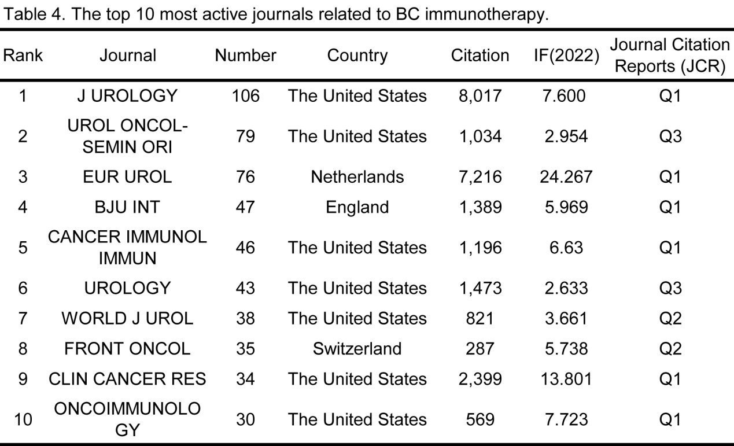
Table 4. The top 10 most active journals related to BC immunotherapy.

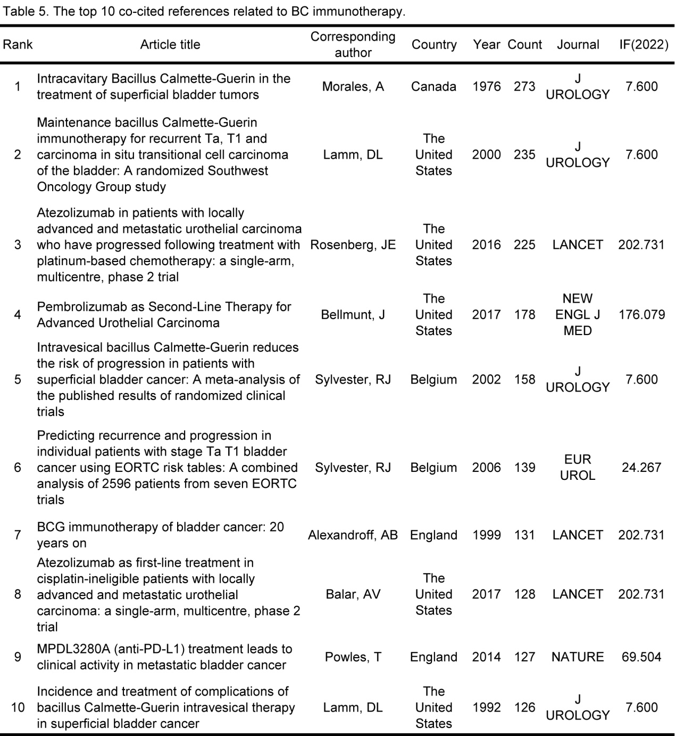
Table 5. The top 10 co-cited references related to BC immunotherapy.

