Supplementary figures and tables

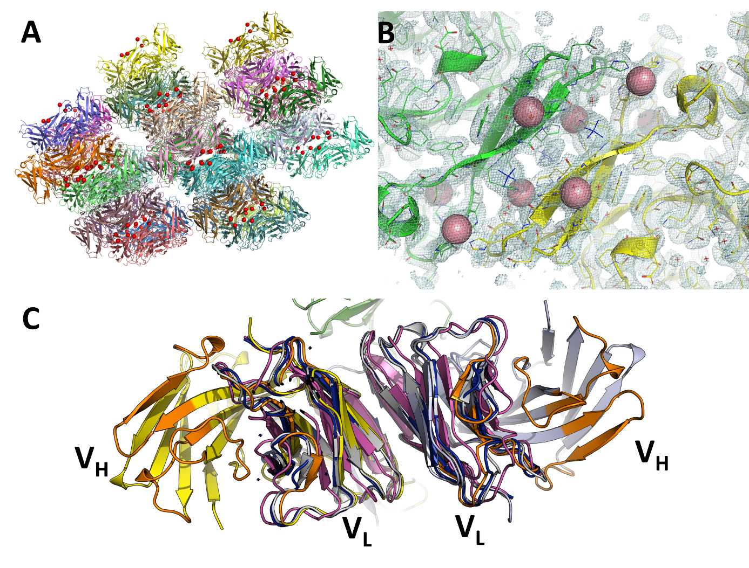

Supplementary figure 1: Crystal structure of scFv 2A2. A. Crystal packing of the scFv 2A2 structure. The protein chains are shown as cartoon representation and the cobalt items are shown as spheres and colored in red. B. 2Fo-Fc electron density map of the TetrHis motif contoured at 1σ. C. Comparison of the V_{L}- V_{L} interface in scFv 2A2 with similar interfaces observed in other scFv (5lwy, magenta and 6j5f, gray) and isolated V_{L} domain structures (1f6l, dark blue).

PDB code | Number of visible Histag residues | bound metal | Number of metal ions | Number of protein chains with coordinating side chains | linear motif
2fg9 | 3 x 5 | NI | 1 | 3 | yes
4bf5 | 1 x 6 | NI | 1 | 2 | no
4ehc | 1 x 6 | ZN | 1 | 1 | no
5fib | 1 x 6 | ZN | 1 | 2 | no
5k1s | 1 x 5 | ZN | 1 | 2 | no
6omk | 1 x 4 | ZN | 1 | 2 | no
6vfu | 1 x4 | NI | 1 | 1 | no
6wxa | 3 x 4 | NI | 1 | 3 | yes
7c3a | 3 x 5 | NI | 1 | 3 | yes
2z36 | 1 x 5 | FE | 1 | 2 | no
1sf8 | 1 x 5 | NI | 2 | 2 | no
4r4x | 1 x 8 | ZN | 2 | 2 | no
2a5v | 1 x 6 | ZN | 2 | 2 | no
3cgm | 2 x 5 | NI | 2 | 2 | yes
4odp | 2 x 6 | NI | 2 | 2 | yes
4zn3 | 1 x 4 | FE | 2 | 2 | no
7cpl | 1 x 6 | NI | 2 | 2 | no
2w5e | 1 x 6 | CD | 3 | 3 | no
3dtu | 1 x 6, 1 x 4 | CD | 3 | 2 | no
3nac | 1 x 6 | ZN | 4 | 2 | no
6h1x | 2 x 6 | CO | 4 | 2 | no
6imz | 2 x 6 | ZN | 4 | 2 | no
6jf1 | 1 x 6 | ZN | 4 | 2 | no
6r3u | 2 x 6 | ZN | 4 | 2 | no
1vk9 | 2 x 6 | ZN | 5 | 2 | no
6fj4 | 2 x 6 | CD | 2 x 3 | 2 | no
SCFV 2A2 | 4 x 6 | CO | 8 | 4 | yes
1hz5 | 2 x 6 | ZN | 9 | 4 | no
3ef7 | 1 x 5, 2 x 5 | ZN | 5 + 7 | 2 + 4 | no

Supplementary table 1: PDB IDs and characteristics of the 27 unique entries identified in the PDB containing at least 4 consecutive visible histidines and any bound zinc, copper, nickel, cobalt, cadmium or iron in interaction with the polyhistidine sequence.

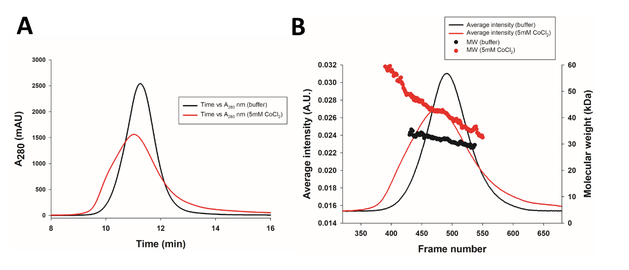

Supplementary figure 2: Additional SEC-SAXS profiles of scFv 2A2 the presence or absence of 5mM CoCl₂ showing the measured absorbance traces at 280 nm (A), and the estimated molecular weight from each data frame (B).

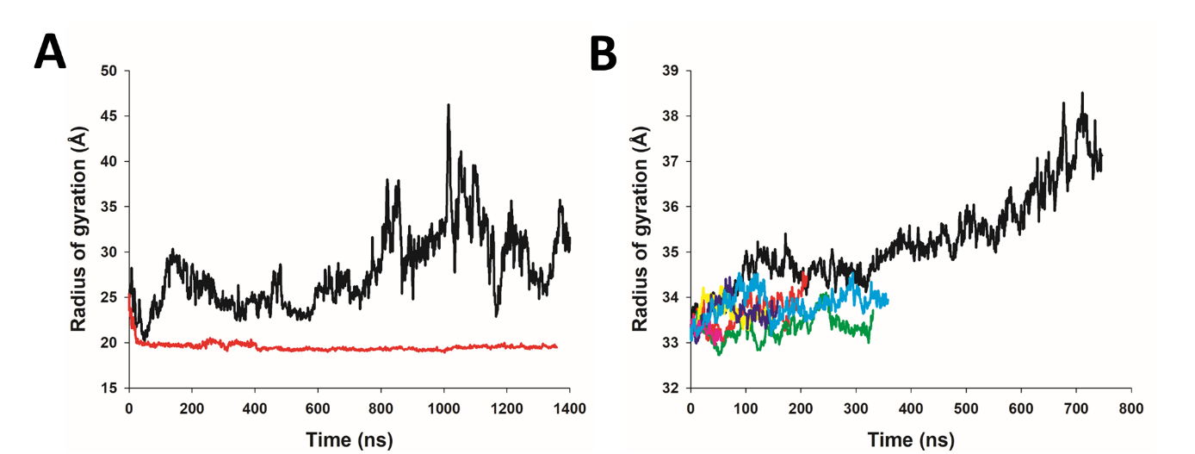

Supplementary figure 3: radius of gyration versus simulation time for molecular dynamics trajectories of the monomer (A) and the tetramer (B).

