Supplementary Materials
Fig.S1. Infrared spectra of Hydrogel of CMC with citric acid
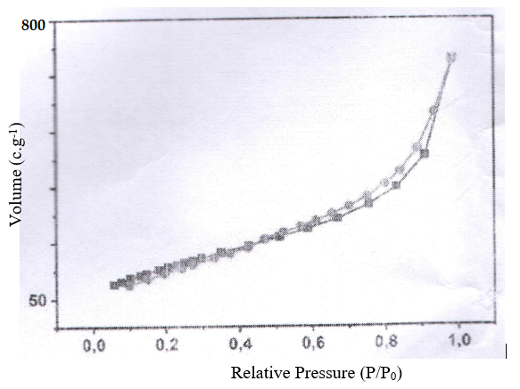
Fig.S2. BET isotherm of nGO

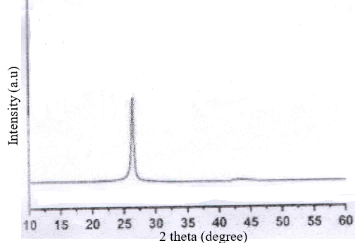
Fig.S3. XRD of nGO

