 | By county ª  Percent |  | By census tract  Median percent (interquartile range)
 |  |  | Overall |  |  | Santa Clara County |  |  | Solano County
 | Santa Clara | Solano | Resp ^{b} | Non-Resp ^{b} | P ^{c} | Resp | Non-Resp | p | Resp | Non-Resp | p
Male | 51 | 52 | 50  (48-52) | 50  (48-52) | 0.18 | 50  (48-52) | 50  (48-52) | 0.58 | 49  (47-51) | 49  (47-51) | 0.76
College or more ^{d} | 54 | 28 | 50  (34-72) | 35  (22 -54) | <0.0001 | 67  (55-78) | 56  (40-72) | <0.0001 | 30  (21-38) | 25  (17-35) | <0.0001
Age 65+ years | 15 | 17 | 15  (11-20) | 14  (11-18) | <0.0001 | 14  (11-19) | 14  (10-17) | <0.0001 | 16  (12-22) | 15  (11-19) | 0.0002
Hispanic | 25 | 29 | 18  (10-29) | 24  (16-34) | <0.0001 | 12  (7-23) | 21  (10-31) | <0.0001 | 26  (17-30) | .27  (18-35) | 0.0004
White only | 51 | 59 | 41  (26-53) | 31  (19-44) | <0.0001 | 39  (26-50) | 31  (16-43) | <0.0001 | 43  (27-56) | 31  (20-46) | <0.001
Black only | 3 | 15 | 2  (1-7) | 4  (2-15) | <0.0001 | 2  (1-2) | 2  (1-3) | <0.0001 | 0.8  (6-17) | 14  (7-18) | <0.001
Asian only | 41 | 17 | 24  (11-38) | 21  (11-36) | <0.02 | 34  (24-49) | 35  (23-51) | 0.91 | 18  (6-25) | 12  (8-21) | 0.0002
Supplemental Table S1: Census-based characteristics of each county (percent), and of census tracts (median percent, interquartile range) among respondents and non-respondents, overall and by county
a: Overall population estimate as reported by census.gov (accessed 30Jan2023)
b: Res: respondents; Non-Resp: non-respondents. A total of 99 (17.2%) respondents and 1283 (15.2%) non-respondents were missing census tract information (p=0.29), 13.8% of the total households initially sent an invitation.
c: Wilcoxon rank sum test
d: Education level assessed in people over age 25 years.
Supplemental Table S2: Comparison of invitation response rates for first and second mailings and their combinations by mailing type (postcard and letter)
 |  | Santa Clara |  |  |  |  | Solano
 |  | Sent | Resp | No resp | Resp rate | OR [95%CI] | Sent | Resp | No resp | Resp rate | OR [95%CI]
 |  | N | N | N | % |  | N | N | N | %
Mailing #1 | P | 2500 | 176 | 2324 | 7.04 | 1 | 2499 | 115 | 2384 | 4.60
Mailing #1 | L | 2501 | 232 | 2269 | 9.28 | 1.35 (1.1-1.7) | 2499 | 153 | 2346 | 6.12 | 1.35 (1.1-1.7)
Mailing #1 | Total | 5001 | 408 | 4593 | 8.16 |  | 4998 | 268 | 4730 | 5.36
Mailing #2  (reminder) | P | 2379 | 55 | 2324 | 2.31 | 1 | 2413 | 30 | 2383 | 1.24 | 1
Mailing #2  (reminder) | L | 2380 | 111 | 2269 | 4.66 | 2.07 (1.5-2.9) | 2412 | 65 | 2347 | 2.69 | 2.20 (1.4-3.4)
Mailing #2  (reminder) | Total | 4759 | 155 | 4593 | 3.49 |  | 4825 | 95 | 4730 | 1.97
Combinations of mailing type ª | P0 or P/P | 1294 | 119 | 1175 | 9.20 | 1 | 1281 | 78 | 1203 | 6.09 | 1
Combinations of mailing type ª | P0 or P/L | 1294 | 88 | 1206 | 6.80 | 0.72 (0.5-1.0) | 1280 | 99 | 1181 | 7.73 | 1.3 (1.0-1.8)
Combinations of mailing type ª | L0 or L/P | 1327 | 178 | 1149 | 13.41 | 1.53 (1.2-2.0) | 1305 | 125 | 1180 | 9.58 | 1.63 (1.2-2.2)
Combinations of mailing type ª | L0 or L/L | 1328 | 208 | 1120 | 15.66 | 1.83 (1.4-2.3) | 1305 | 139 | 1166 | 10.65 | 1.84 (1.4-2.5)
OR: odds ratio; CI: confidence interval; Resp: response; No Resp: No response
Mailing type: P0: postcard only; P/P: postcard/postcard; P/L: postcard/letter; L0: letter only; L/P: letter/postcard; L/L: letter/letter
ª Households who responded to their first mailing are included in each category, as they would have received a second mailing had they not already responded (Santa Clara: P0: N=88, L0: N=154; Solano: P0: N=62, L0: N=111).

Supplemental information: Recruitment invitation.
- Letter
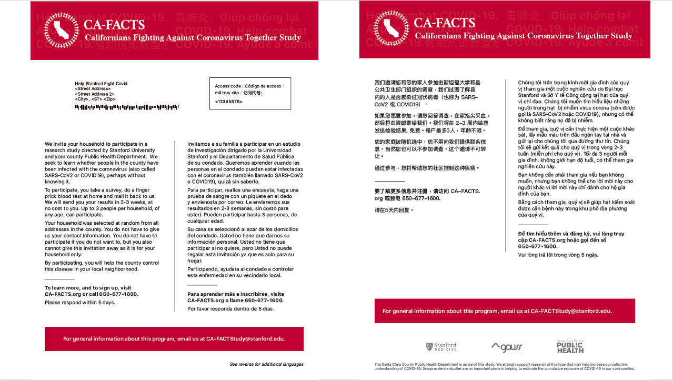
(B) Postcard
