Table 1: Dock score, MM-GBSA dg bind, interacting amino acid residues and 2D interacting diagram of top 10 molecules selected from XP docking.
Ligand Zinc database ID | Dock score | MMGBSA dg bind  (Kcal/mol) | Interacting amino acid residues | 2D interaction diagram
ZINC000000899161 | -10.377 | -32.25 | H-Bond: - HIS146, HIS183, GLY143  Pi-Pi stacking: - HIS 183, PHE210  Metal Coordination: - Zn401 | 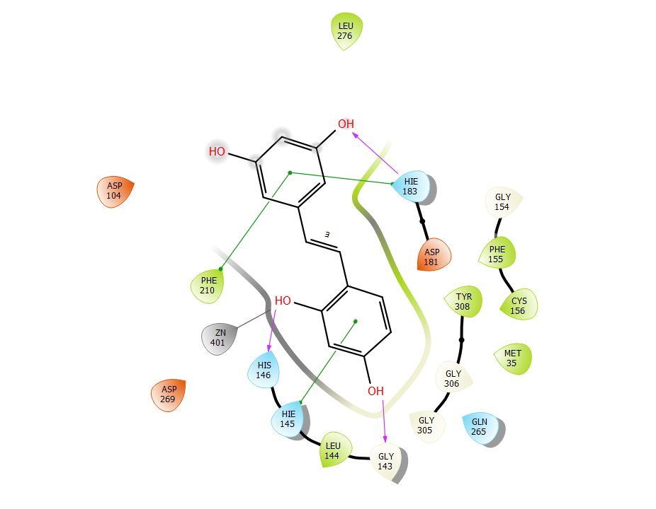
ZINC000040441974 | -10.24 | -48.65 | H-Bond: TYR308, GLU208  Pi-Pi Cation: Phe155  Metal Coordination: Zn401 | 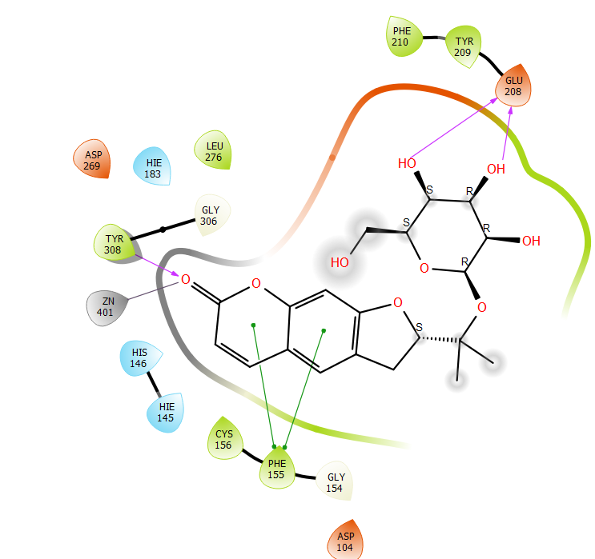
ZINC000040441976 | -9.51 | -35.27 | H-Bond: - GLU103,  Metal Coordination: - Zn401 | 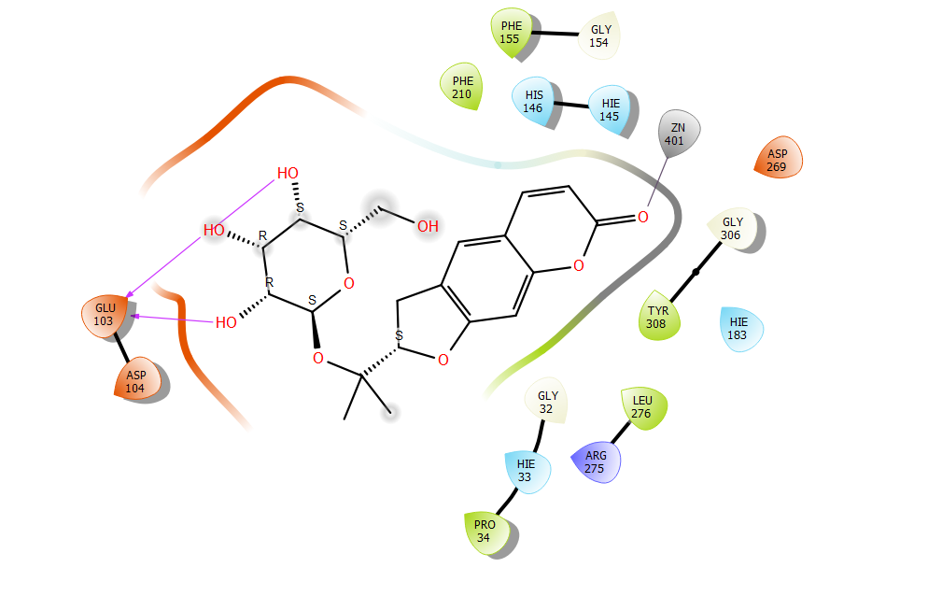
ZINC000006484604 | -9.490 | -18.65 | H-Bond: - HIS146, LEU276  Pi-Pi Stacking: - HIS183, PHE155, HIS146, TYR209  Metal Coordination: - Zn401 | 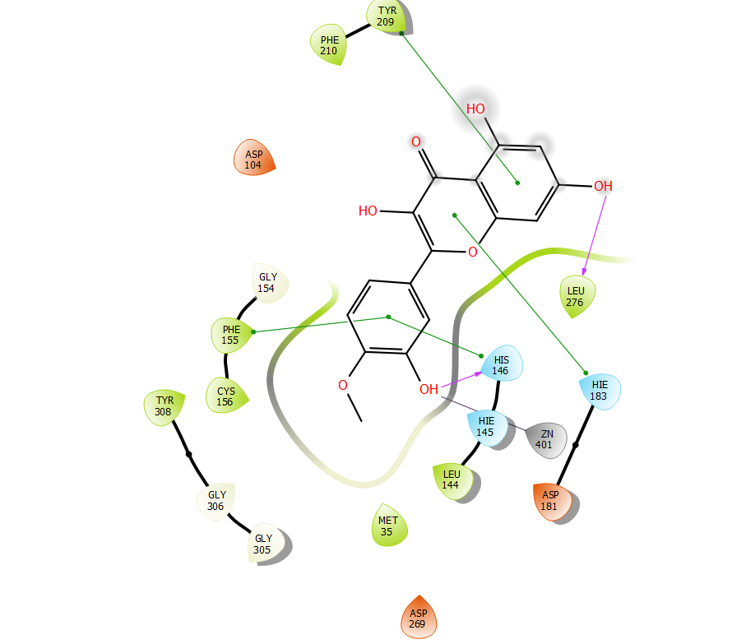
ZINC000002020259 | -9.49 | -35.88 | H Bond: - HIS146, TYR308,  Pi cation: -PHE155, PHE210, HIS183  Metal Coordination: - ZN401 | 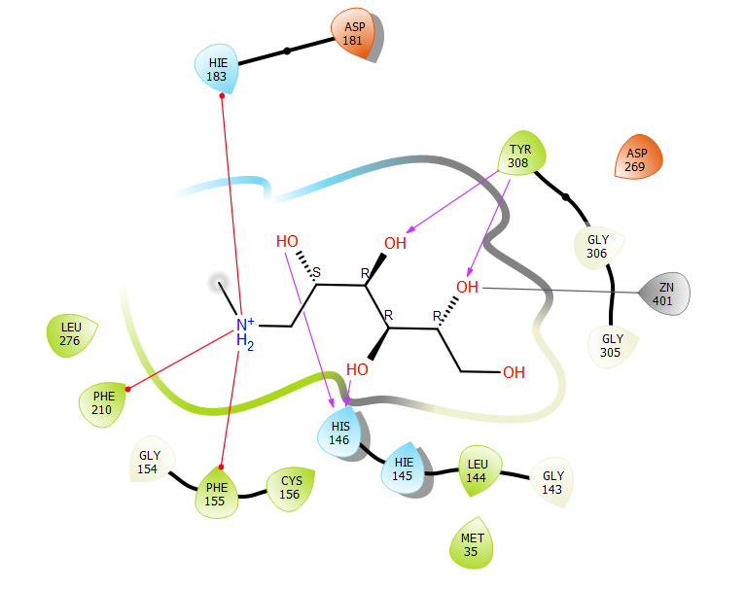
ZINC000000056474 | -9.38 | -29.84 | H-Bond: - GLU103, TYR308, HIS146  Metal coordination: - ZN401  Pi-Pi stacking: - PHE210 | 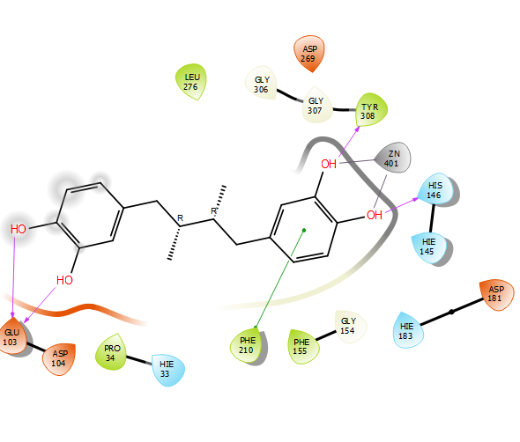
ZINC000000113415 | -9.178 | -47.12 | H-Bond- ASP104  Pi-Pi Stacking: - HIS146, HIS183, PHE155  Metal Coordination: - Zn401 | 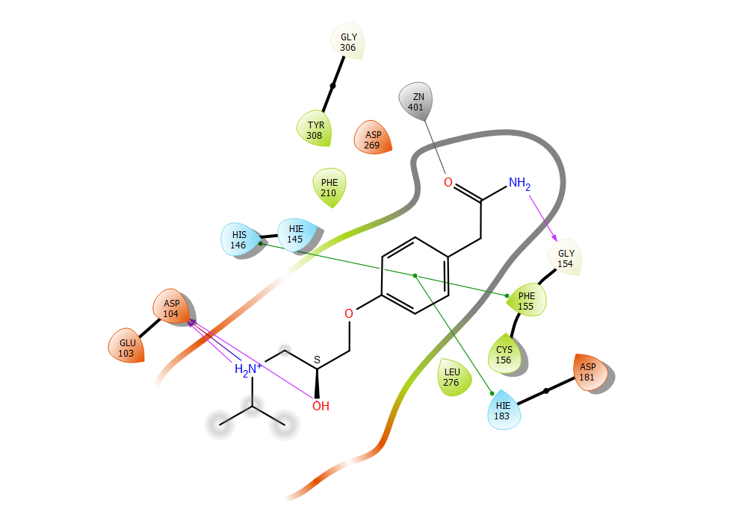
ZINC000086028690 | -9.062 | -40.82 | H-Bond: - GLU103, TYR308  Metal Coordination: -Zn401 | 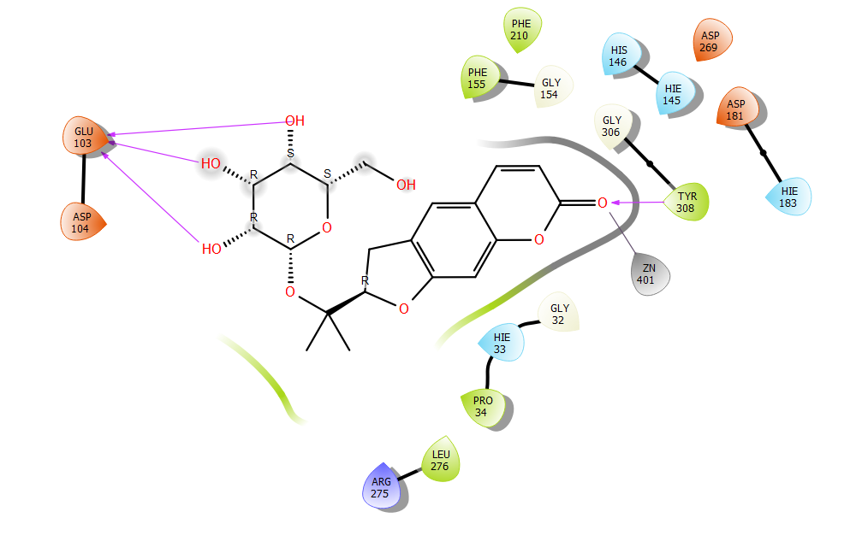
ZINC000000004164 | -9.072 | -37.71 | H-Bond: - GLY154, HIS 146  PI-PI Stacking: - TY209, PHE210, HIS183  Metal Coordination: - Zn401 | 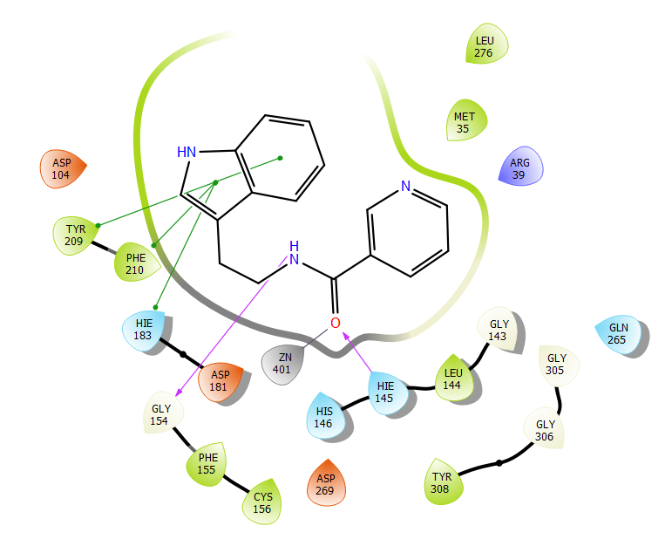
ZINC000019632628 | -8.901 | -42.85 | H bond: - HIS146  Metal Coordination: - ZN401 | 