Supplementary Information
A High-Sensitivity Ionization Humidity Sensor Based on Carbon Nanotubes
Yong Zhang^{1, 2, *}, Zhenzhen Cheng³, Yuangang Deng^{1, 2}, Ruizhe Wang^{1, 2}, Saif aldeen Saad Obayes ALKADHIM^{1, 2, *}, Waqas Muhammad^{1, 2}, Xiaoyu Li^{1, 2}, Chunqi Wang^{1, 2}, Shudong Wang^{1, 4}, Yunjia Li¹.
¹School of Electrical Engineering, Xi’an Jiaotong University, Xi’an,710049, P. R. China.
² State Key Laboratory of Electrical Insulation and Power Equipment, Xi’an Jiaotong University,710049, P. R. China.
³School of Electrical and Control Engineering, Henan University of Urban Construction, Pingdingshan, Henan, 467041, China.
⁴State Key Laboratory for Manufacturing Systems Engineering, Xi'an Jiaotong University, Xi'an, 710049 China.
* Corresponding author; Y.Z. (zhyong@mail.xjtu.edu.cn ) or S.S.A.(saifaldeen.saad@ieee.org; alkadhim@stu.xjtu.edu.cn )

- Experiment on high relative humidity single-value sensitive characteristics (silicon strip CNT, gold film CNT).
Table 1. Experimental conditions for single-value sensitive characteristics of high relative humidity (silicon strip CNT, gold film CNT).
No. | Experiment time | electrode spacing (μm). | Electrode structure |  |  | Electrode voltage (V). |  |  | Temperature, pressure, gas
No. | Experiment time | electrode spacing (μm). | cathode | extracting electrode | collecting electrode | cathode | extracting electrode | collecting electrode | Temperature, pressure, gas
1 | 2022.10.18. | 200ª  100^{b} | 2×Φ 4 mm, round holes silicon strip | Φ 6 mm | 6×8 mm, 200 μm deep groove | 0 | 90 | 10 | 23.7 ℃  93.7 Kpa  air
2 | 2022.10.22. | 200ª  100^{b} | 2×Φ 4 mm, round holes gold film | Φ 6 mm | 6×8 mm, 200 μm deep groove | 0 | 90 | 10 | 23.7 ℃  93.7 Kpa  Pure N₂
a, electrode separation between cathode and the extracting electrode.
b, electrode separation between collecting electrode and the extracting electrode.
Table 2. Single-value sensitive experimental data of high relative humidity in air (silicon strip CNT).
No. | Relative humidity (%) | Collects current (nA). | No. | Relative humidity (%) | Collects current (nA).
1 | 30.0 | 0.61847 | 23 | 70.0 | 1.72837
2 | 32.0 | 0.63609 | 24 | 72.0 | 1.93903
3 | 33.3 | 0.65301 | 25 | 74.0 | 2.35880
4 | 34.0 | 0.66662 | 26 | 76.0 | 2.67520
5 | 34.8 | 0.67441 | 27 | 78.0 | 3.19650
6 | 35.6 | 0.69496 | 28 | 80.0 | 3.76730
7 | 36.4 | 0.70590 | 29 | 82.0 | 4.69800
8 | 40.0 | 0.71602 | 30 | 84.0 | 5.42960
9 | 41.0 | 0.73671 | 31 | 86.0 | 7.14640
10 | 42.0 | 0.75745 | 32 | 88.0 | 7.51510
11 | 43.0 | 0.76180 | 33 | 90.3 | 8.82470
12 | 44.0 | 0.76531 | 34 | 92.0 | 9.54830
13 | 48.0 | 0.77804 | 35 | 94.0 | 11.0635
14 | 50.0 | 0.78852 | 36 | 95.0 | 14.2929
15 | 52.0 | 0.79603 | 37 | 96.0 | 17.5499
16 | 55.0 | 0.83548 | 38 | 97.0 | 80.022
17 | 56.2 | 0.86478 | 39 | 97.5 | 86.146
18 | 58.0 | 0.90884 | 40 | 98.7 | 97.018
19 | 60.0 | 0.95448 | 41 | 99.0 | 100.290
20 | 62.0 | 1.03616 | 42 | 99.5 | 438.91
21 | 64.0 | 1.16702 | 43 | 100 | 512.68
22 | 66.0 | 1.28794

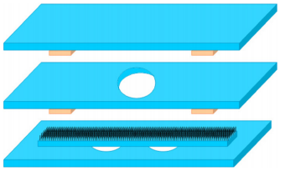
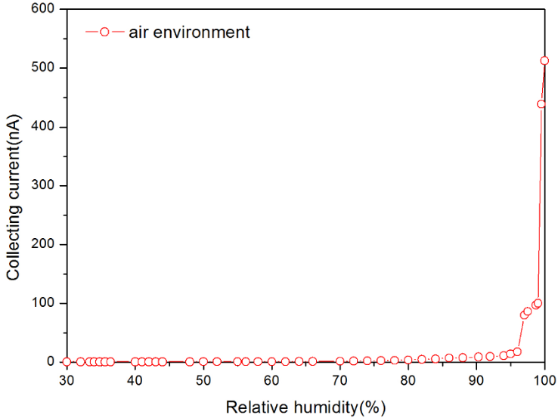
Figure 1. Single-value sensitive characteristic curve of high relative humidity in air (silicon strip CNT).
Cathode

Extracting Electrode
Collecting Electrode

Cathode

Extracting Electrode
Collecting Electrode

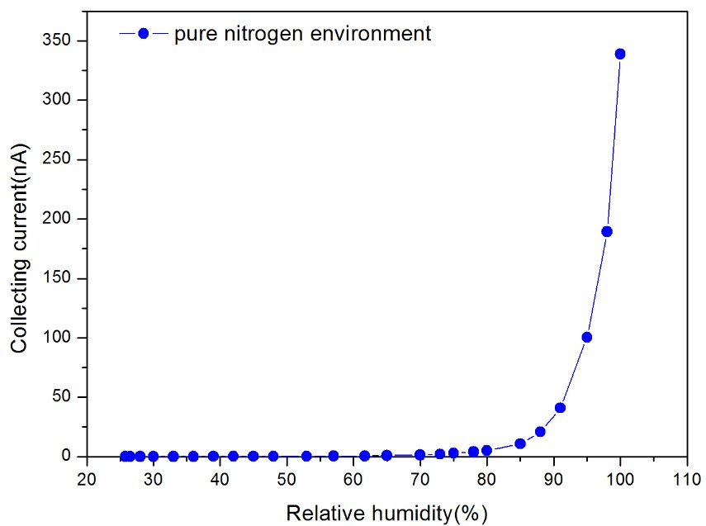
Cathode

Extracting Electrode
Collecting Electrode

Deep Groove

Figure 2. Single-value sensitive characteristic curve of pure N₂ high relative humidity (gold film CNT).

Table 3. Single-valued sensitive experimental data of pure N₂ high relative humidity (gold film CNT).
No. | Relative humidity (%) | Collects current (nA). | No. | Relative humidity (%) | Collects current (nA).
1 | 25.8 | 0.01196 | 14 | 65.0 | 0.87838
2 | 26.5 | 0.02978 | 15 | 70.0 | 1.42468
3 | 28.0 | 0.04875 | 16 | 73.0 | 1.99251
4 | 30.0 | 0.06742 | 17 | 75.0 | 2.87925
5 | 33.0 | 0.09025 | 18 | 78.0 | 3.92135
6 | 36.0 | 0.13451 | 19 | 80.0 | 4.97251
7 | 39.0 | 0.17252 | 20 | 85.0 | 10.9285
8 | 42.0 | 0.21216 | 21 | 88.0 | 20.8275
9 | 45.0 | 0.26327 | 22 | 91.0 | 40.9235
10 | 48.0 | 0.29987 | 23 | 95.0 | 100.290
11 | 53.0 | 0.33789 | 24 | 98.0 | 189.385
12 | 57.0 | 0.38325 | 25 | 100.0 | 338.720
13 | 61.7 | 0.45412 | 26

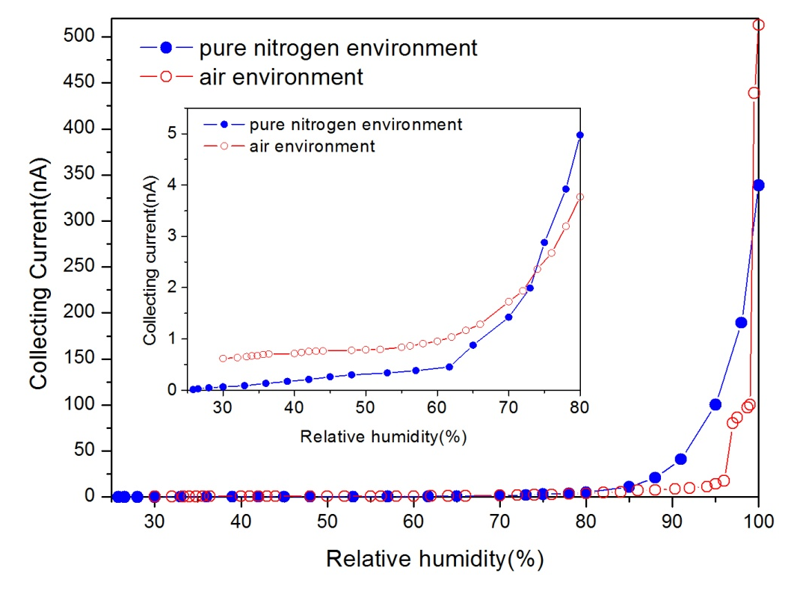

Figure 3. Comparison of pure N₂ and air high relative humidity collection current (silicon strip CNT, gold film CNT).

- Experiment on single-value sensitivity characteristics of low relative humidity in air (gold film CNT).

Table 4. Experimental conditions for single-value sensitivity characteristics of low relative humidity in air (gold film CNT).
Experiment time | Pole spacing (μm). | Electrode structure |  |  | Electrode voltage (V).
Experiment time | Pole spacing (μm). | cathode | extracting electrode | collecting electrode | cathode | extracting electrode | collecting electrode | Experimental conditions
2022.10.13. | 200ª  100^{b} | 2×Φ 4 mm | Φ 6 mm | 6×8 mm, 200 μm deep groove | 0 | 90 | 10 | 22.8℃  93.8Kpa  air
a, electrode separation between cathode and the extracting electrode.
b, electrode separation between collecting electrode and the extracting electrode.

Table 5. Single value sensitive experimental data of low relative humidity in air (gold film CNT).
No. | Relative humidity (%) | Collects current (nA). | No. | Relative humidity (%) | Collects current (nA).
1 | 24.8 | 0.20475 | 16 | 15.4 | 7.85920
2 | 24.6 | 0.21471 | 17 | 15.1 | 9.30570
3 | 24.2 | 0.22125 | 18 | 14.7 | 11.2583
4 | 23.4 | 0.22162 | 19 | 14.3 | 14.0398
5 | 22.9 | 0.22410 | 20 | 14.0 | 17.9020
6 | 22.3 | 0.22848 | 21 | 13.6 | 22.6250
7 | 21.5 | 0.23440 | 22 | 13.2 | 26.7860
8 | 20.9 | 0.24626 | 23 | 12.9 | 30.4700
9 | 20.2 | 0.26783 | 24 | 12.5 | 33.1260
10 | 19.5 | 0.31656 | 25 | 12.3 | 34.0430
11 | 18.8 | 0.42056 | 26 | 12.2 | 34.5190
12 | 18.1 | 0.68096 | 27 | 12.1 | 34.7040
13 | 17.3 | 1.39148 | 28 | 12.0 | 34.8660
14 | 16.1 | 5.23813 | 29 | 11.9 | 35.9570
15 | 15.7 | 6.81530
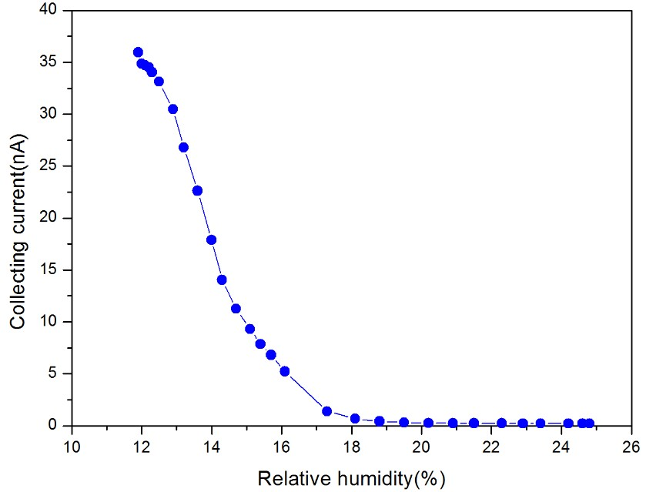
Cathode

Extracting Electrode
Collecting Electrode

Deep Groove

Figure 4. Single-value sensitive characteristic curve of low relative humidity in air (gold film CNT).

