Supplementary Information

Incorporating heterogeneity in farmer disease control behaviour into a livestock disease transmission model
Edward M. Hill^^{1,2}, Naomi S. Prosser^³, Paul E Brown¹, Eamonn Ferguson^{4,5}, Martin J. Green³, Jasmeet Kaler³, Matt J. Keeling^{1,2}, Michael J. Tildesley^{1,2}.
- The Zeeman Institute for Systems Biology and Infectious Disease Epidemiology Research, School of Life Sciences and Mathematics Institute, University of Warwick, Coventry, United Kingdom.
- Joint UNIversities Pandemic and Epidemiological Research, https://maths.org/juniper/.
- School of Veterinary Medicine and Science, University of Nottingham, Sutton Bonington Campus, Leicestershire, United Kingdom.
- School of Psychology, University Park, University of Nottingham, Nottingham, United Kingdom.
- National Institute for Health and Care Research Blood and Transplant Research Unit in Donor Health and Behaviour, University of Cambridge, Cambridge, UK
^ These authors contributed equally: Edward M. Hill, Naomi S. Prosser.
* Corresponding authors: Edward M. Hill (Edward.Hill@warwick.ac.uk); Naomi S. Prosser (Naomi.Prosser@nottingham.ac.uk).

Supplementary Tables
Supplementary Table 1: The mean and 95% confidence intervals of the normalised scores for each covariate in each cluster, from clustering using both the two and five most stable covariates respectively.

Covariate | Cluster | Mean | 95% confidence intervals
Clustering of two stable covariates:
Trust in Governmental  judgements for disease control | 1 | 0.69 | 0.43 - 0.94
Trust in Governmental  judgements for disease control | 2 | -1.03 | -1.25 - -0.80
Trust in Governmental  judgements for disease control | 3 | 0.69 | 0.28 - 1.10
Trust in Governmental  judgements for disease control | 4 | -1.03 | -1.36 - -0.71
Physical opportunity | 1 | 0.62 | 0.39 - 0.85
Physical opportunity | 2 | 0.48 | 0.19 - 0.77
Physical opportunity | 3 | -1.40 | -1.79 - -1.01
Physical opportunity | 4 | -1.03 | -1.40 - -0.65
Clustering of five stable covariates:
Trust in Governmental judgements for disease control | 1 | 0.69 | 0.43 - 0.94
Trust in Governmental judgements for disease control | 2 | -0.92 | -1.12 - -0.72
Trust in Governmental judgements for disease control | 3 | 0.57 | -0.17 - 1.31
Physical opportunity | 1 | 0.54 | 0.27 - 0.81
Physical opportunity | 2 | -0.03 | -0.37 - 0.32
Physical opportunity | 3 | -1.48 | -2.02 - -0.93
Trust in quality of advice from veterinarians | 1 | 0.36 | 0.03 - 0.70
Trust in quality of advice from veterinarians | 2 | -0.22 | -0.62 - 0.18
Trust in quality of advice from veterinarians | 3 | -0.44 | -1.41 - 0.53
Trust in other farmers to control disease | 1 | 0.39 | 0.00 - 0.78
Trust in other farmers to control disease | 2 | -0.55 | -0.85 - -0.24
Trust in other farmers to control disease | 3 | 0.39 | -0.46 - 1.23
Herd size at time of outbreak | 1 | -0.43 | -0.64 - -0.22
Herd size at time of outbreak | 2 | 0.00 | -0.43 - 0.42
Herd size at time of outbreak | 3 | 1.26 | 0.49 - 2.02

Supplementary Table 2: The number and proportion of farmers in each cluster who vaccinate at each stage of the epidemic, from clustering using both the two and five most stable covariates respectively.

Cluster | Epidemic stage | Number of farmers vaccinating | Proportion of farmers vaccinating
Clustering of two stable covariates:
1 | 1 - 2 | 12 | 0.46
1 | 3 - 5 | 10 | 0.38
1 | 6 - Never | 4 | 0.15
2 | 1 - 2 | 6 | 0.40
2 | 3 - 5 | 6 | 0.40
2 | 6 - Never | 3 | 0.20
3 | 1 - 2 | 4 | 0.40
3 | 3 - 5 | 1 | 0.10
3 | 6 - Never | 5 | 0.50
4 | 1 - 2 | 2 | 0.22
4 | 3 - 5 | 3 | 0.33
4 | 6 - Never | 4 | 0.44
Clustering of five stable covariates:
1 | 1 - 2 | 12 | 0.46
1 | 3 - 5 | 10 | 0.38
1 | 6 - Never | 4 | 0.15
2 | 1 - 2 | 10 | 0.40
2 | 3 - 5 | 8 | 0.32
2 | 6 - Never | 7 | 0.28
3 | 1 - 2 | 2 | 0.22
3 | 3 - 5 | 2 | 0.22
3 | 6 - Never | 5 | 0.56

Supplementary Table 3: Epidemiological summary statistics for Great Britain when aggregating outbreaks over all 89 infection seed regions. We computed the summary statistics for each behavioural configuration using 44,500 replicates (500 replicates for each of the 89 seed region locations). We report medians and in parentheses the 95% prediction intervals to the following precision: 1 d.p. for the percentage of holdings infected, integers for outbreak duration (in days) and 2 d.p. for threshold vaccine dose cost. We also report the percentage of simulations that satisfy the stated threshold criteria to a precision of 1 d.p.

 |  | Uncoop-  erative | Strong parasitism | Weak parasitism | Mutual  cooperation | Coop-  Parasitism-FR | Coop-  Parasitism | Trust-  Expectancy | Herd size  dependent
Holdings infected (%) |  | 99.5 (99.3,99.6) | 75.5  (0.0,78.5) | 1.6  (0.0,6.8) | 0.0  (0.0,0.0) | 40.0  (0.1,41.7) | 16.9  (0.0,20.1) | 13.6  (0.0,16.3) | 13.7  (0.0,16.1)
Outbreak duration (days) |  | 251  (163,344) | 153  (29,209) | 29  (29,29) | 0  (0,0) | 192  (59,271) | 150  (29,203) | 172  (31,232) | 170  (31,228)
Threshold vaccine dose cost |  | 0.00  (0.00,0.00) | 0.12  (0.09,0.92) | 1.32  (0.97,4.67) | 1.00  (1.00,1.00) | 0.74  (0.70,0.77) | 0.77  (0.73,2.42) | 0.85  (0.81,2.09) | 0.79  (0.76,2.27)
Percentage holdings infected | > 1% | 98.4% | 96.3% | 65.9% | 0.0% | 96.2% | 94.1% | 93.9% | 93.9%
Percentage holdings infected | > 10% | 98.4% | 96.3% | 0.0% | 0.0% | 96.2% | 94.1% | 93.9% | 93.9%
Percentage holdings infected | > 20% | 98.4% | 96.3% | 0.0% | 0.0% | 96.2% | 2.7% | 0.0% | 0.0%
Outbreak duration | > 30 days | 99.9% | 97.3% | 0.0% | 0.0% | 99.4% | 96.4% | 97.6% | 97.6%
Outbreak duration | > 100 days | 98.9% | 96.3% | 0.0% | 0.0% | 96.4% | 94.1% | 93.9% | 93.9%
Outbreak duration | > 180 days | 93.1% | 20.0% | 0.0% | 0.0% | 60.6% | 13.9% | 37.0% | 34.1%
Threshold intervention cost | > 0.5 | 0.0% | 3.3% | 98.4% | 98.4% | 98.4% | 98.4% | 98.4% | 98.4%
Threshold intervention cost | > 1 | 0.0% | 2.4% | 92.6% | 0.0% | 2.4% | 4.3% | 4.6% | 4.6%
Threshold intervention cost | > 2 | 0.0% | 2.2% | 10.1% | 0.0% | 2.4% | 3.9% | 3.5% | 3.9%

Supplementary Figures

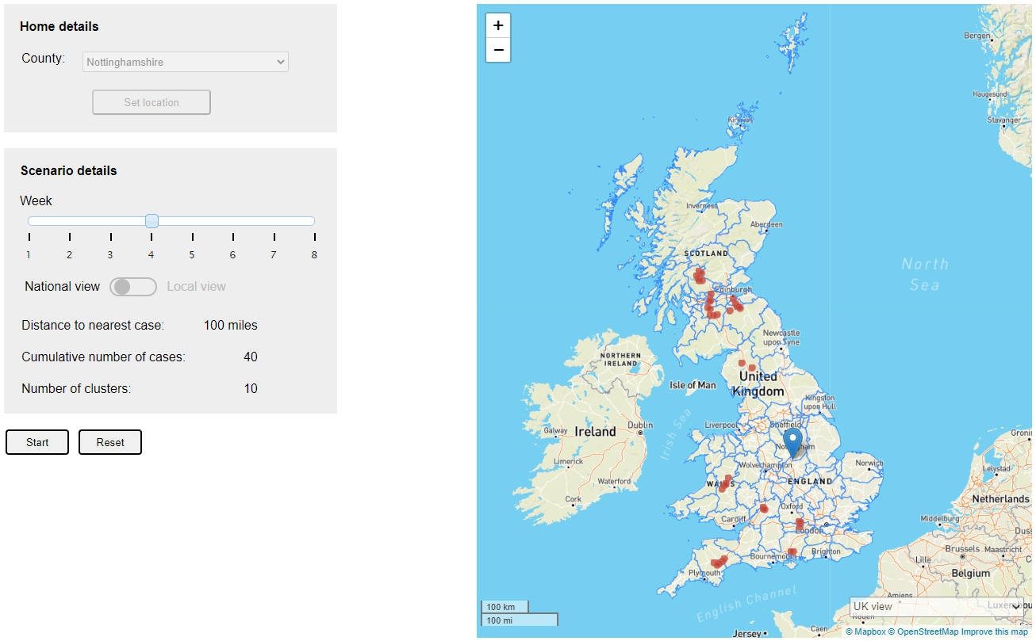Supplementary Fig. 1: A screenshot of the graphical user interface (GUI), which shows the number and locations of infected herds in relation to the location of the farmer’s herd.

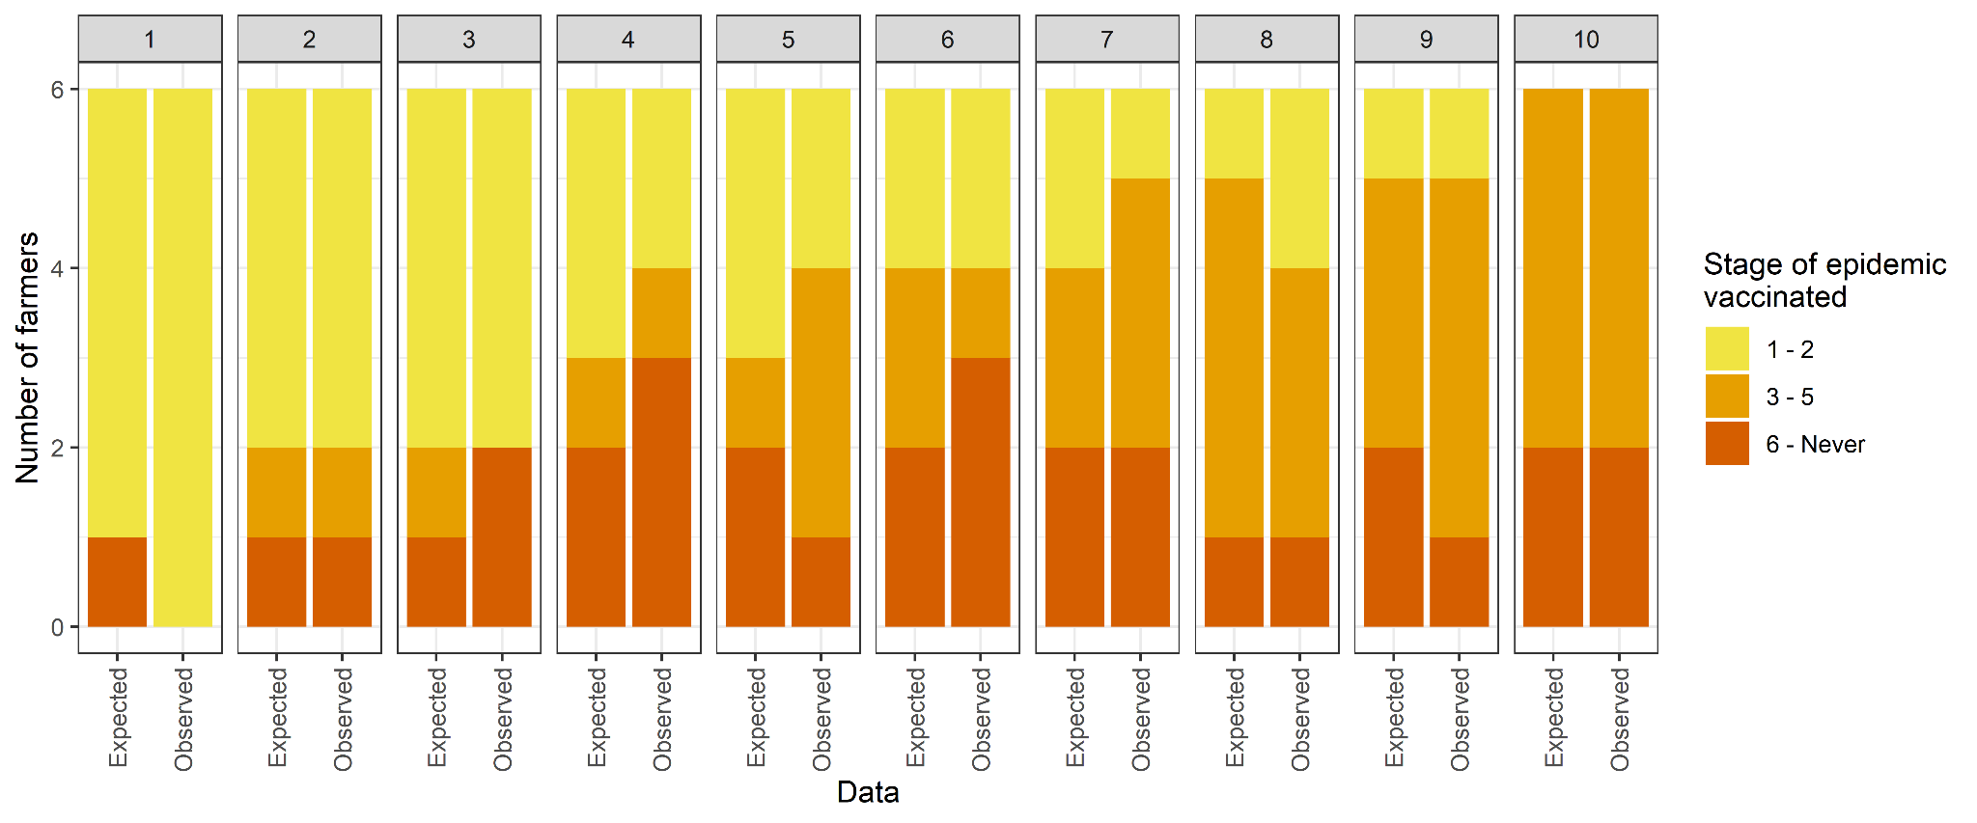
Supplementary Fig. 2: Decile plot of the observed versus predicted vaccination classes of 60 cattle farmers from Great Britain in a multinomial regression model of vaccination class explained by psychosocial, behaviour change and demographic factors. The shading intensity corresponds to the stages of the epidemic when vaccination was deployed: lightest shading for stages 1 - 2, moderate shading for stages 3 - 5 and darkest shading for stage 6 onwards or those who never use vaccination in their herds.

(a) | (b)

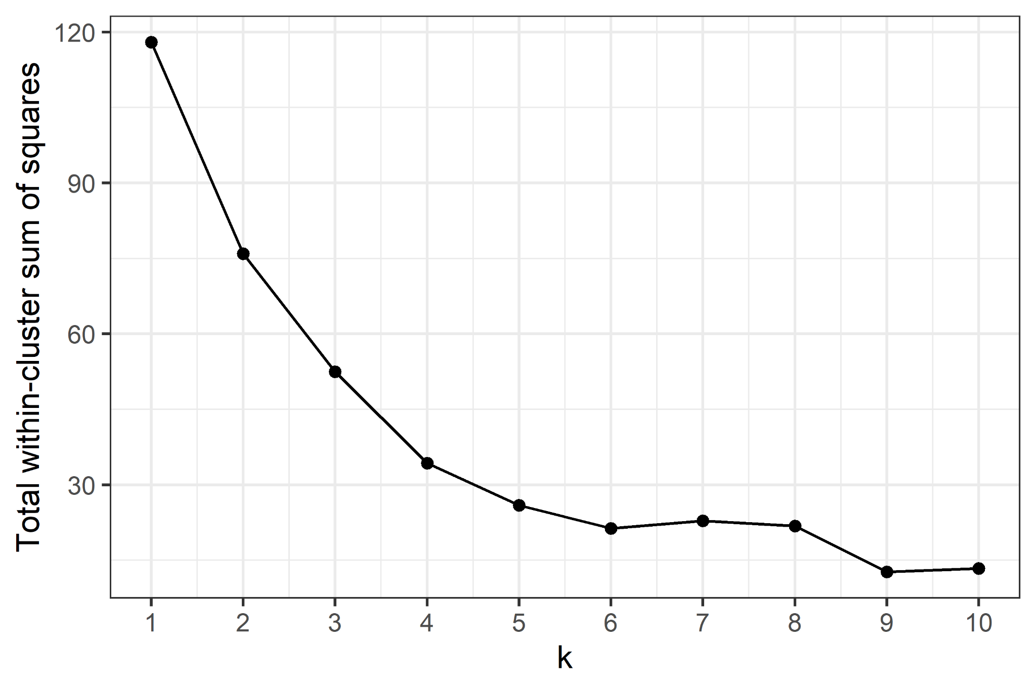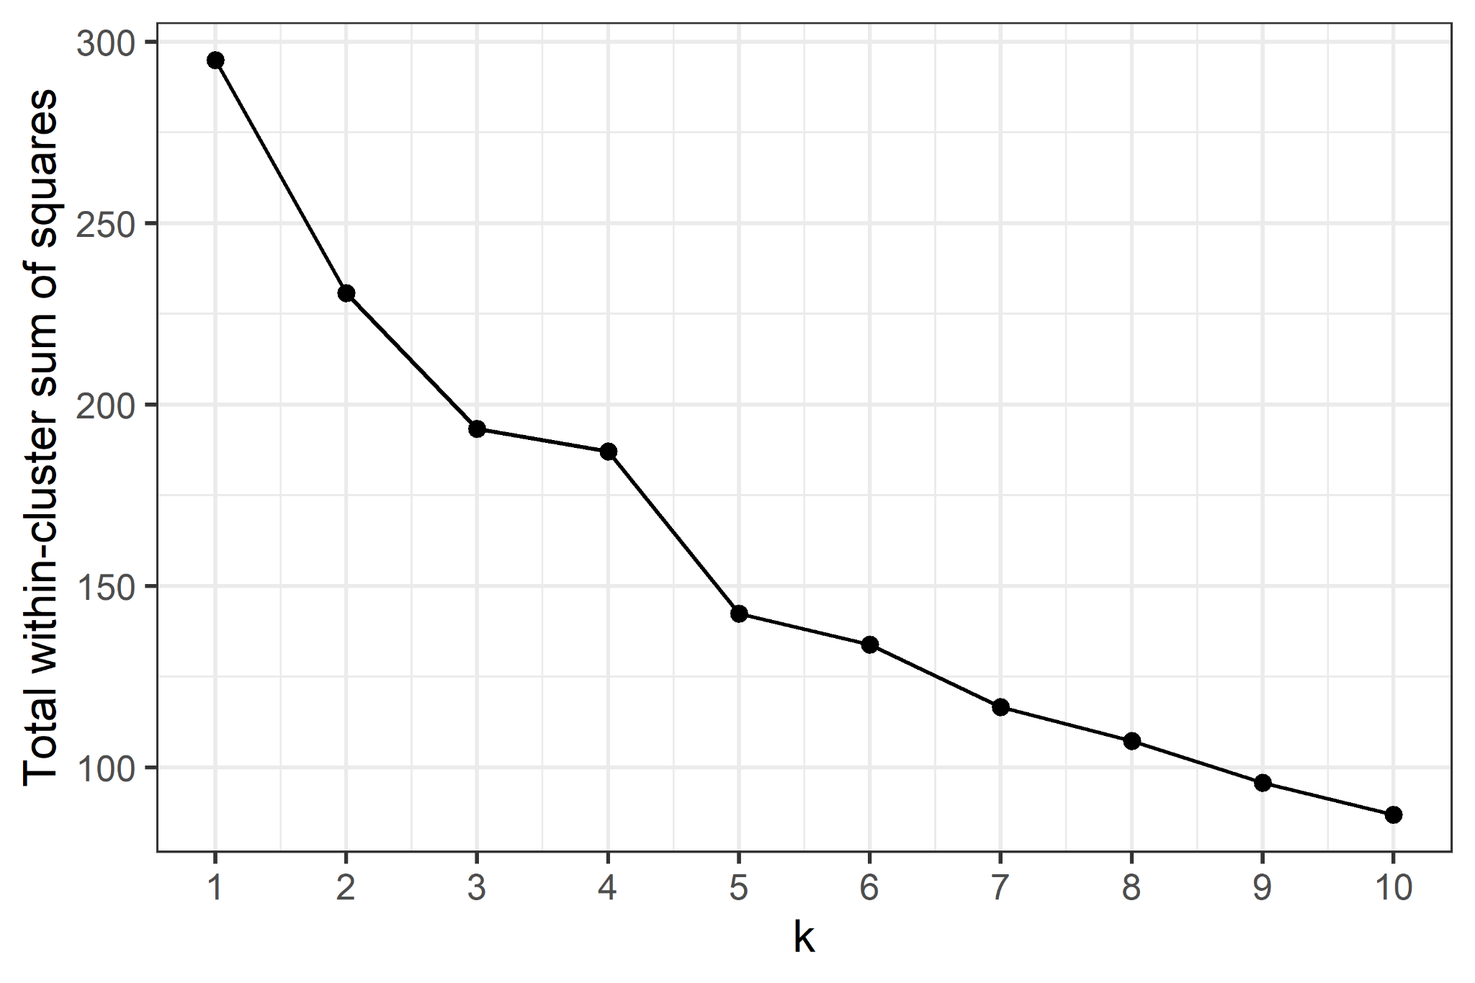
Supplementary Fig. 3: Plots of total within-cluster sum of squares resulting from k-means clustering for k clusters for (a) the two most stable covariates (Trust in Governmental judgements about disease control and Physical opportunity), and (b) the five most stable covariates (Trust in Governmental judgements about disease control, Physical opportunity, Trust in quality of advice from the veterinary profession, Trust in other farmers nationally to control infectious diseases and Herd size at time of disease outbreak).

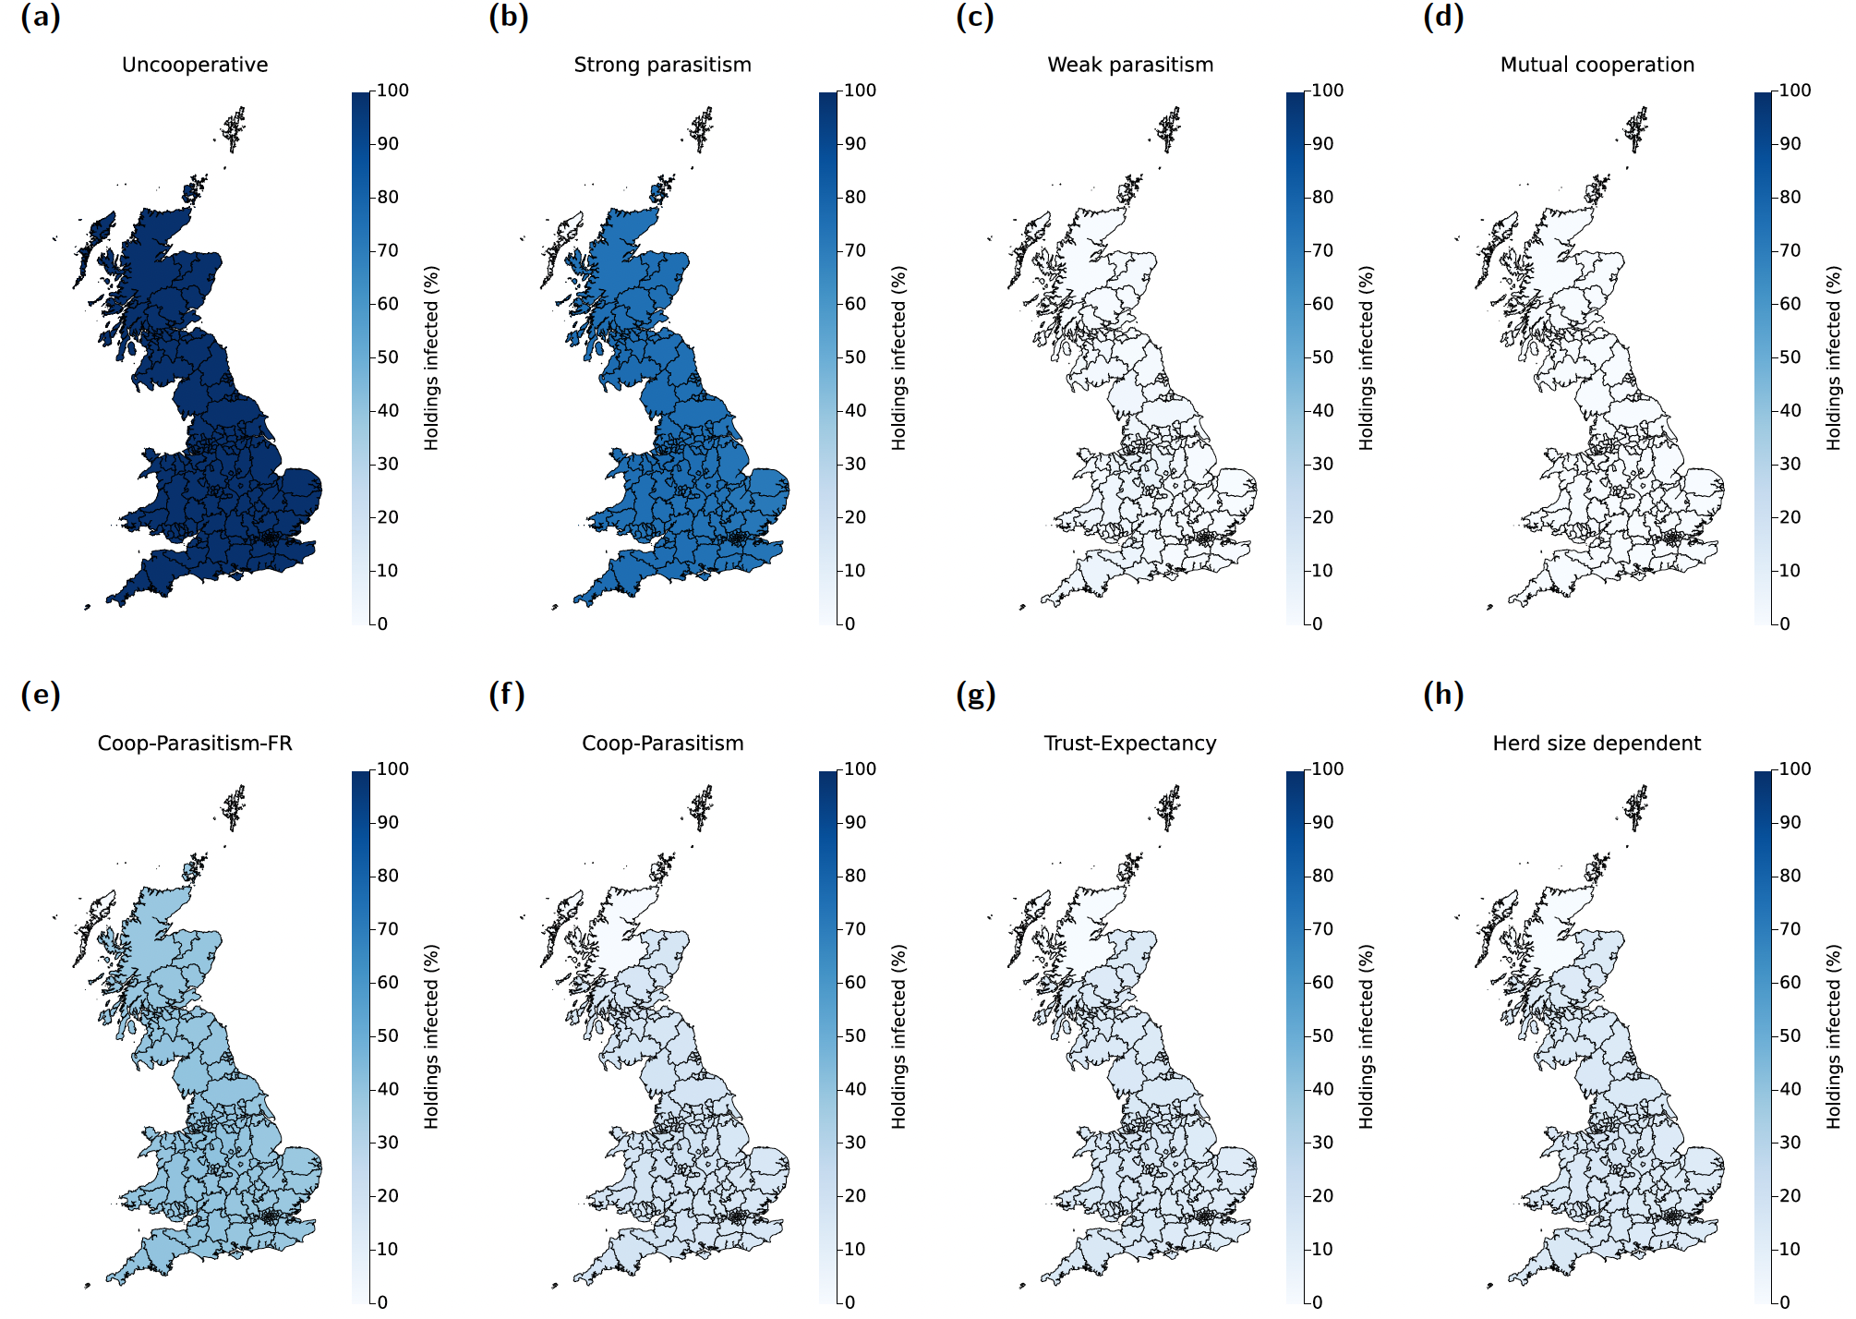
Supplementary Fig. 4: Median percentage of holdings infected, dependent on region of outbreak emergence and behavioural configuration. Statistics computed from 500 replicates per scenario. Intensity of shading corresponds to the percentage of holdings infected during the entire outbreak when the initial infecteds were located within that region; darker shading corresponds to higher values. Behavioural configurations presented are: (a) Uncooperative; (b) Strong parasitism; (c) Weak parasitism; (d) Mutual cooperation; (e) Cooperation-Parasitism-Free riders (Coop-Parasitism-FR); (f) Cooperation-Parasitism (Coop-Parasitism); (g) Trust-Expectancy; (h) Herd size dependent.

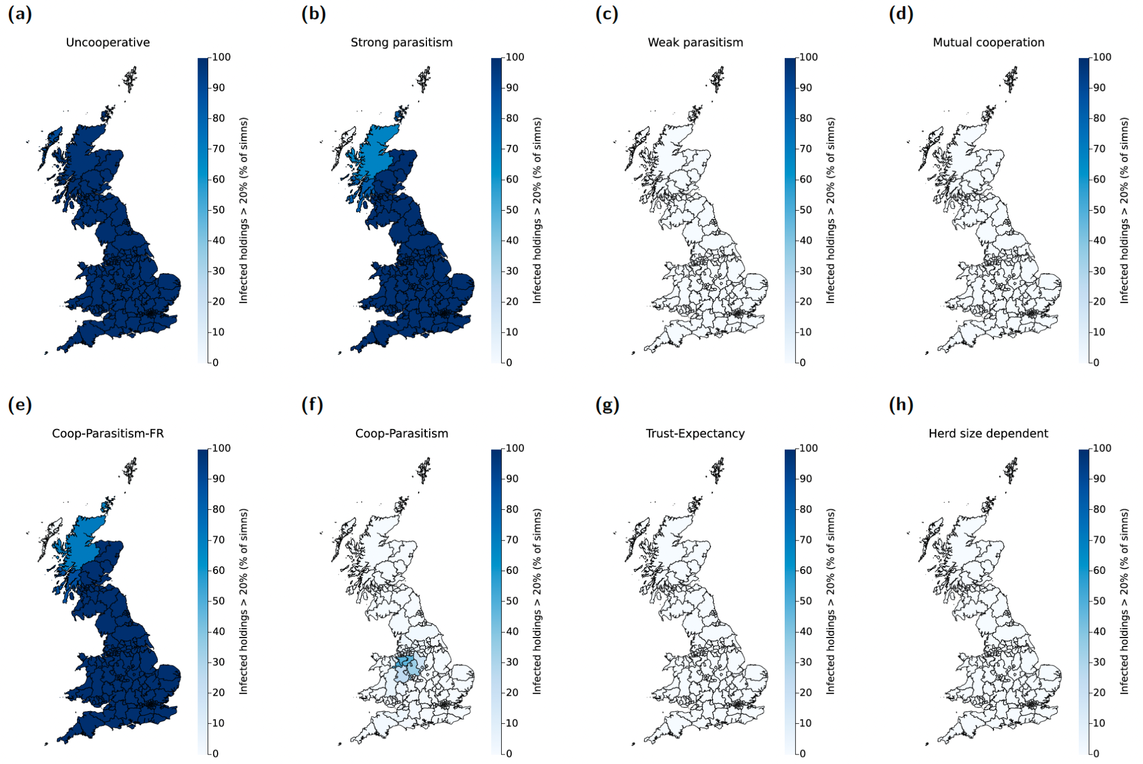
Supplementary Fig. 5: Proportion of simulations that resulted in more than 20% of holdings being infected, dependent on region of outbreak emergence and behavioural configuration. Statistics computed from 500 replicates per scenario. Intensity of shading corresponds to the proportion of simulations where the percentage of holdings infected during the entire outbreak was greater than 20%, when the initial infecteds were located within that region; darker shading corresponds to higher values. Behavioural configurations presented are: (a) Uncooperative; (b) Strong parasitism; (c) Weak parasitism; (d) Mutual cooperation; (e) Cooperation-Parasitism-Free riders (Coop-Parasitism-FR); (f) Cooperation-Parasitism (Coop-Parasitism); (g) Trust-Expectancy; (h) Herd size dependent.

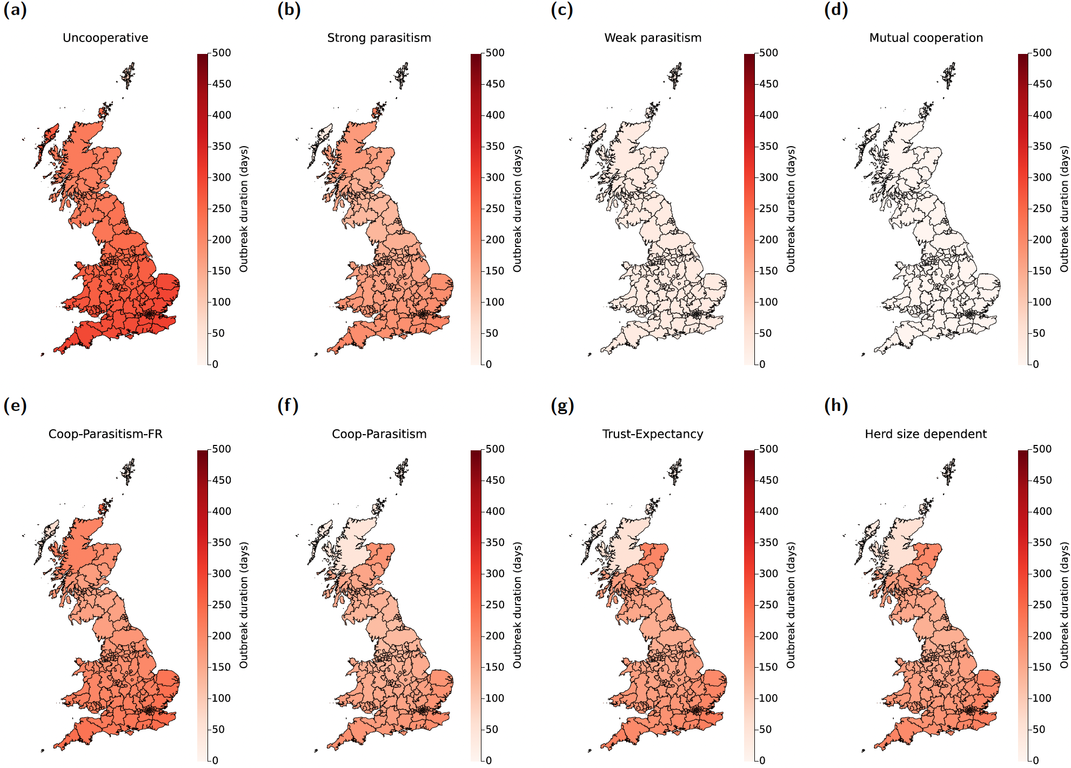
Supplementary Fig. 6: Median outbreak duration, dependent on region of outbreak emergence and behavioural configuration. Statistics computed from 500 replicates per scenario. Intensity of shading corresponds to the outbreak duration (in days) when the initial infecteds were located within that region; darker shading corresponds to higher values. Behavioural configurations presented are: (a) Uncooperative; (b) Strong parasitism; (c) Weak parasitism; (d) Mutual cooperation; (e) Cooperation-Parasitism-Free riders (Coop-Parasitism-FR); (f) Cooperation-Parasitism (Coop-Parasitism); (g) Trust-Expectancy; (h) Herd size dependent.

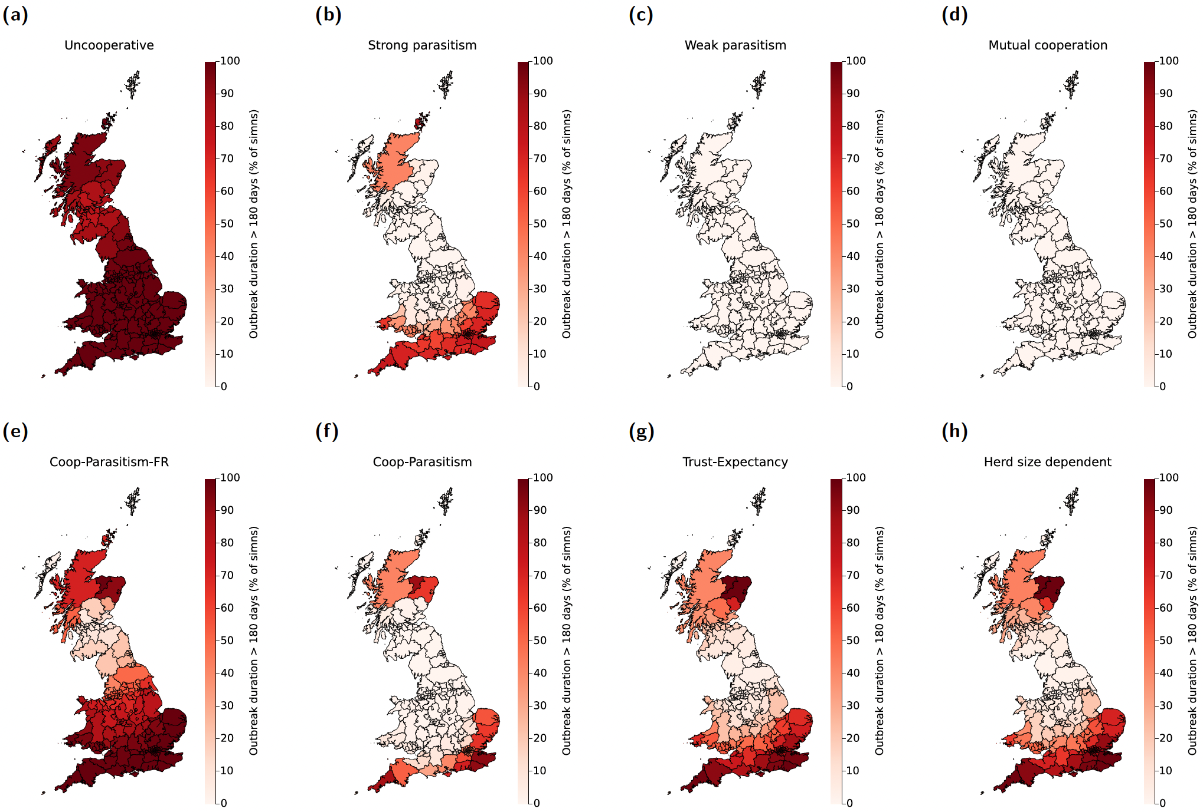
Supplementary Fig. 7: Proportion of simulations that resulted in an outbreak duration greater than 180 days, dependent on region of outbreak emergence and behavioural configuration. Statistics computed from 500 replicates per scenario. Intensity of shading corresponds to the proportion of simulations where the outbreak duration was above 180 days, when the initial infecteds were located within that region; darker shading corresponds to higher values. Behavioural configurations presented are: (a) Uncooperative; (b) Strong parasitism; (c) Weak parasitism; (d) Mutual cooperation; (e) Cooperation-Parasitism-Free riders (Coop-Parasitism-FR); (f) Cooperation-Parasitism (Coop-Parasitism); (g) Trust-Expectancy; (h) Herd size dependent.

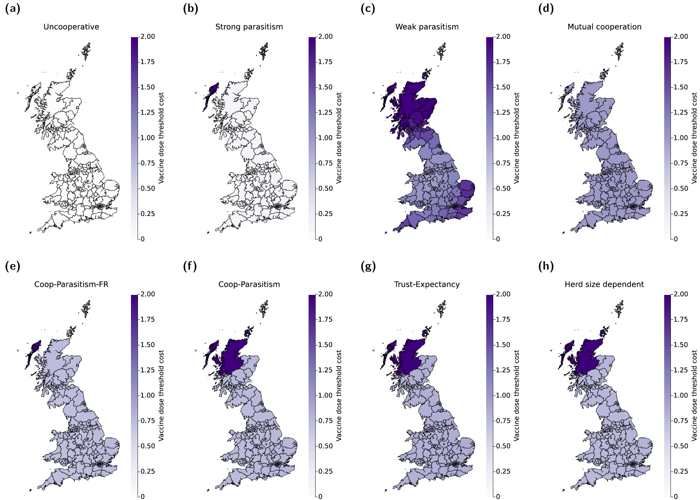
Supplementary Fig. 8: Median threshold cost per intervention unit applied, dependent on region of outbreak emergence and behavioural configuration. Statistics computed from 500 replicates per scenario. Intensity of shading corresponds to the threshold cost per intervention unit applied when the initial infecteds were located within that region; darker shading corresponds to higher values. Behavioural configurations presented are: (a) Uncooperative; (b) Strong parasitism; (c) Weak parasitism; (d) Mutual cooperation; (e) Cooperation-Parasitism-Free riders (Coop-Parasitism-FR); (f) Cooperation-Parasitism (Coop-Parasitism); (g) Trust-Expectancy; (h) Herd size dependent.

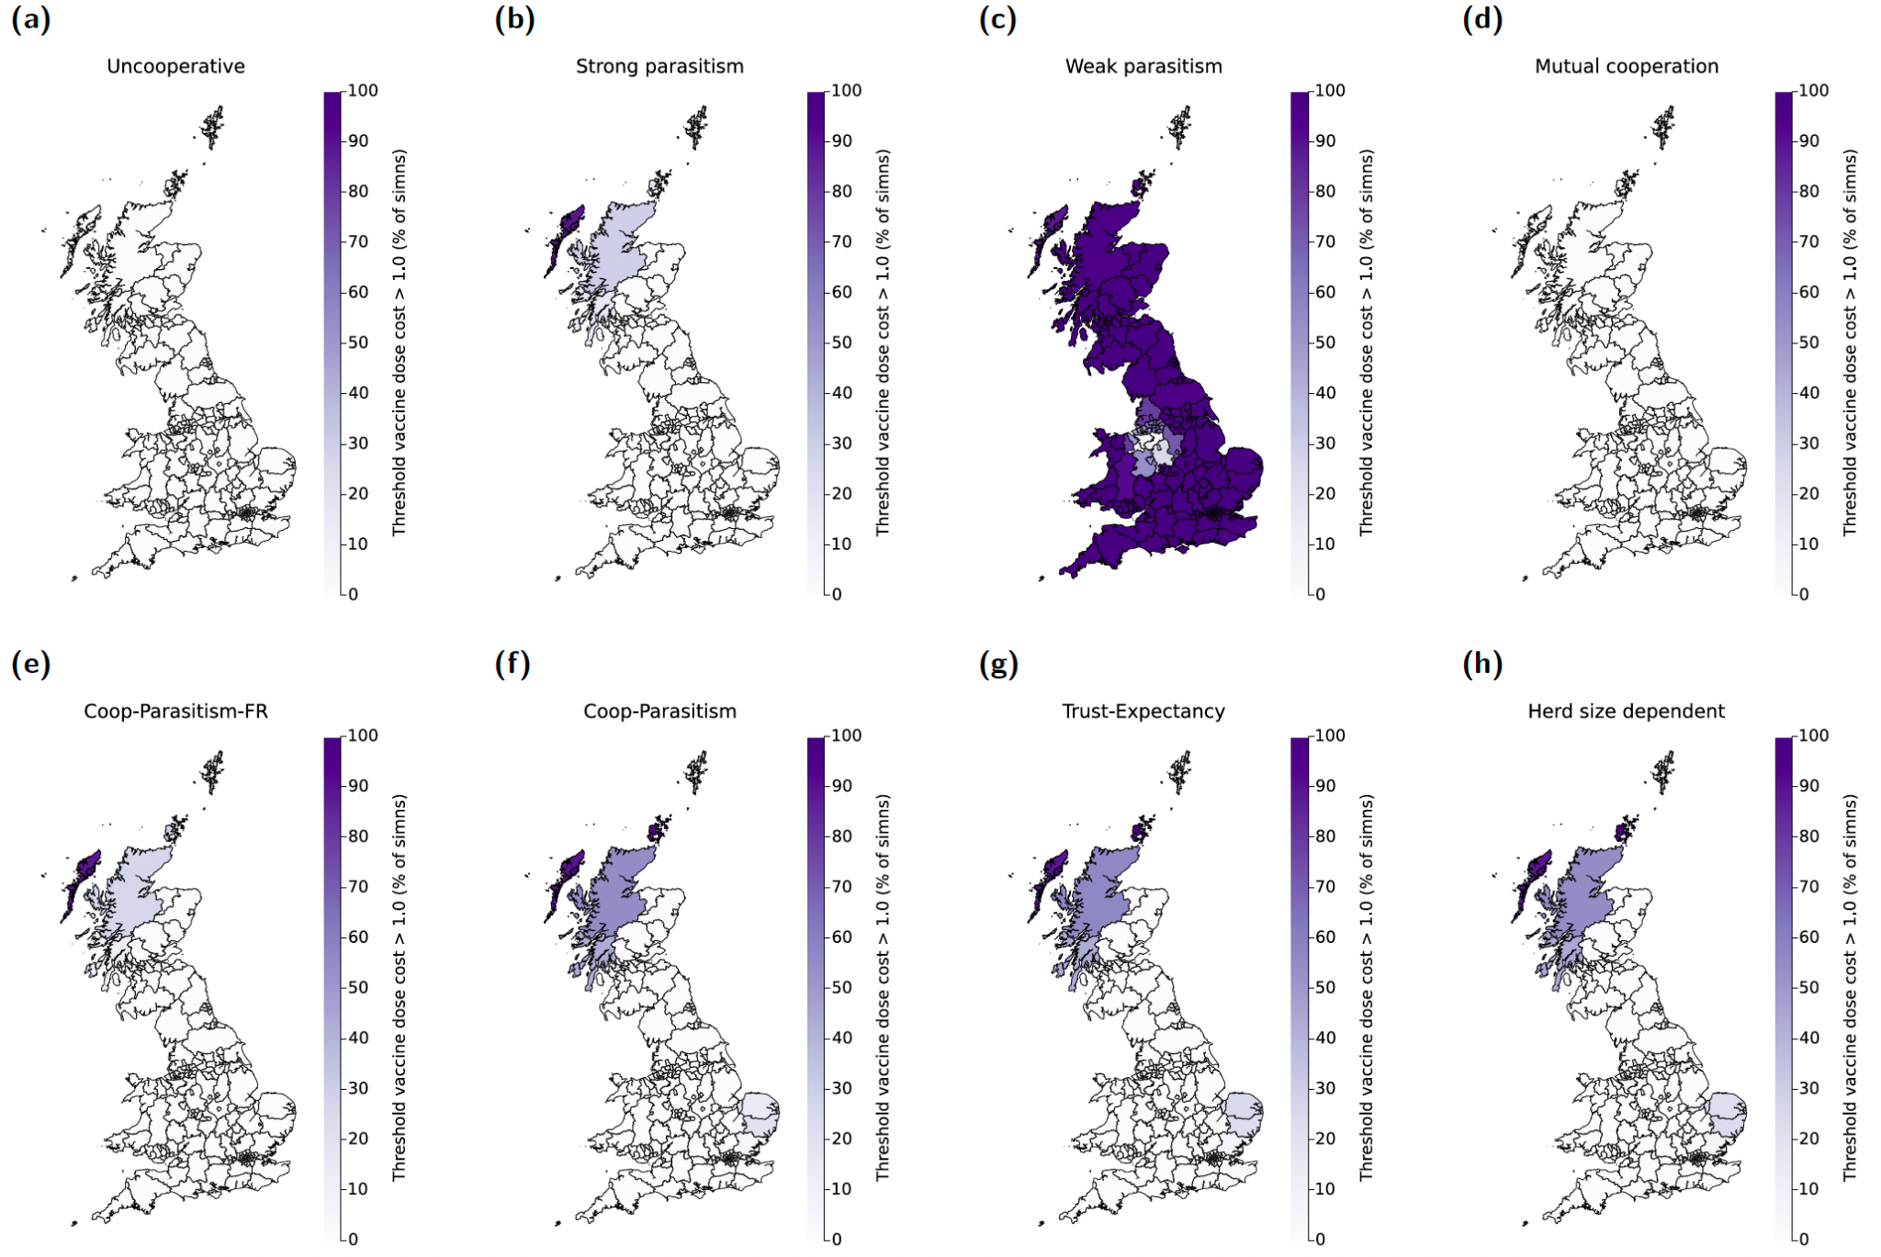
Supplementary Fig. 9: Proportion of simulations that resulted in a threshold intervention unit cost greater than 1, dependent on region of outbreak emergence and behavioural configuration. Statistics computed from 500 replicates per scenario. Intensity of shading corresponds to the proportion of simulations where the threshold intervention unit cost was more than 1, when the initial infecteds were located within that region; darker shading corresponds to higher values. Behavioural configurations presented are: (a) Uncooperative; (b) Strong parasitism; (c) Weak parasitism; (d) Mutual cooperation; (e) Cooperation-Parasitism-Free riders (Coop-Parasitism-FR); (f) Cooperation-Parasitism (Coop-Parasitism); (g) Trust-Expectancy; (h) Herd size dependent.

Supplementary Text 1
We overview here how the outbreak size, outbreak duration and threshold cost per intervention unit summary statistics depended upon the behavioural configuration and the region where the first infecteds were located (Supplementary Figs. 4 - 9).
Uncooperative
By design, in the uncooperative scenario the majority of holdings became infected irrespective of the outbreak location (Supplementary Fig. 4), with a median outbreak duration of roughly 250 days (Supplementary Fig. 6).
Strong parasitism
With everyone exhibiting strong parasitism, the majority of simulations still resulted in at least 20% of holdings becoming infected (Supplementary Fig. 5). However, compared with the Uncooperative setting there were reductions in the median outbreak size (majority of seed infection regions led to outbreaks in the range of 70% - 80% holdings infected, see Supplementary Fig. 4) and median outbreak duration (29 days to 215 days across seed infection regions, see Supplementary Fig. 6). The amount willing to be spent per intervention unit was also generally low, with median values predominately below 0.15 (Supplementary Fig. 8). An exception was for outbreaks beginning in north Scotland, with a reduced anticipated size and duration of outbreak, in tandem with a higher amount being able to be spent per intervention unit whilst remaining cost effective (Supplementary Fig. 6).
Weak parasitism
Were all farmers to practise weak parasitism, such behaviour strongly curtailed the size and the duration of the outbreak; the median outbreak size did not exceed 8% of holdings irrespective of the region of initial infection (Supplementary Figs. 4 and 5), whilst there was very little variability in the median outbreak duration (either 28 or 29 days, see Supplementary Figs. 6 and 7). Per seed infection region, the median threshold cost per intervention unit (Supplementary Fig. 8) was usually greater if everyone had weak parasitism behaviour (median of all regional values of approximately 1.31) rather than strong parasitism behaviour (median of all regional values of approximately 0.12). Additionally, were initial infections to occur in all but a select few regions (located in north-west England), the threshold cost per intervention unit to tackle the outbreak would likely be greater than 1 (Supplementary Fig. 6).
Mutual cooperation
Also by design, under these assumptions there were no outbreaks (Supplementary Figs. 4 and 6). Additionally, as in the baseline scenario (uncooperative, with controls only applied at holdings with confirmed infection) outbreaks usually resulted in almost all holdings becoming infected, the threshold intervention cost was marginally less than 1 (Supplementary Fig. 8).
Coop-Parasitism-FR
Moving onto the behavioural configurations that included a uniform split of behavioural groups across the population, the Coop-Parasitism-FR configuration (that included having a quarter of the population in the non-vaccination group) resulted in a consistent average outbreak size independent of seed outbreak location (Supplementary Fig. 4). Northern regions of Scotland were the only locations where this behavioural configuration made an appreciable difference on the likelihood of an outbreak causing more than 20% of holdings to become infected, resembling the patterns seen for the Strong parasitism configuration (Supplementary Fig. 5). Outbreak duration assessments exhibited regional banding in the likelihood of outbreaks exceeding 180 days. Longer duration outbreaks were a likely prospect if the initial infections were located in east Scotland, Wales, the Midlands, East of England and South England. This markedly contrasts with regions at the England-Scotland border, where the risk of an elongated outbreak was estimated to be below 50% (Supplementary Fig. 7). The median threshold cost per intervention was also similar across regions. Simulations indicated that only for outbreaks beginning in northern Scotland and its surrounding islands would an intervention unit cost above 1 be likely to be cost effective (Supplementary Fig. 9).
Coop-Parasitism
Having a behavioural configuration with even splits between cooperative, strong parasitism and weak parasitism groups suppressed both average outbreak size and risk of large outbreaks, irrespective of the origin of infection. We observed a disparity in the likelihood of outbreaks resulting in more than 20% of holdings becoming infected, with this more likely to occur for outbreaks whose initial cases resided in north-west England (Supplementary Fig. 5). There was also heterogeneity in outbreak duration and threshold intervention cost. In particular, outbreaks that began in north Scotland, Norfolk, Suffolk and the southern coast of England would be more likely to have a duration exceeding 180 days.
Trust-Expectancy and Herd size dependent
Lastly, we inspect outcomes for the two behavioural configurations informed by the interview data, Trust-Expectancy and Herd size dependent. Comparing results for these two configurations with each other, for any given region where initial infections were seeded, all three of the epidemiological outputs under scrutiny were similar, for both median (Supplementary Figs. 4, 6 and 8) and upper tail metrics (Supplementary Figs. 5, 7 and 9).
On the other hand, when comparing the Trust-Expectancy and Herd size dependent configurations to the other configurations, there was clear heterogeneity in outcomes for the large threshold measures. Outbreaks longer than 180 days were not expected if the first cases arose in North England, although there was an increase in the percentage of simulations meeting the criteria as one moved further south in England and Wales or north into Scotland (Supplementary Fig. 7). The median threshold cost per intervention unit applied bore spatial similarity to the Coop-Parasitism scenario (Supplementary Fig. 8). Finally, there was a non-negligible prospect of the threshold intervention unit cost being above 1 for outbreaks with initial cases in north Scotland, Norfolk and Suffolk (Supplementary Fig. 9).

Supplementary Text 2

The script used during the interviews to collect demographic data, explain the hypothetical disease and proceed through the disease outbreak scenario.
County:
Type of cattle: Beef Dairy Both
Thank you for your willingness to take part in this interview.
We are interested in capturing the decisions farmers make in an evolving scenario of a disease epidemic. There are no right or wrong answers to the questions, we value your opinion as a farmer responsible for the decisions made about the care of your cattle. We would also like to capture some information about you as a farmer and the type of farm you have.
This research will help us understand how farmers react in an epidemic scenario. This interview is confidential, your details will be kept anonymous, and the results will only be used for research purposes. You will not be identifiable in any research outputs. The interview will take no longer than an hour.
Before we start can you confirm that you have read and are happy with the consent form.
We will now start the interview. I will start off by asking you some questions about you and your cows.
Demographic questions
Dairy farmers
1. How many adult cows do you have in your dairy herd?
2. What is your annual milk yield per cow?
Less than 6,000 litres | 6,000 - 8,000 litres | 8,000 - 10,000 litres | More than 10,000 litres
Beef farmers
3. How many breeding female cattle do you usually have in your beef herd?
4. How many rearing and/or fattening cattle do you usually have in your beef herd?
All farmers
5. Which of the following best describes your calving system?
Block calving | Partially block calving | All year calving
6. If block or partially block calving, when do you calve?
7. Approximately how many cattle would you have on your farm in total in June?
8. Do you have regular (pre-planned) herd health visits from your vet? Yes No
9. If yes, how often?
10. How long do you usually house your herd for each year?
Year round | More than 5 months | 1 - 5 months | Less than 1 month
11. Does your farm adjoin neighbours with cattle? Yes No
12. What age range are you in?
Under 30 | 30 - 39 | 40 - 49 | 50 - 59 | 60 - 69 | Over 70
Elicitation scenario
For the next stage of the interview, I will take you through a scenario of a hypothetical disease epidemic, using a graphical user interface to help illustrate the geographical coverage of the epidemic. Imagine this is reality in every respect. Try to put yourself in the exact position. However, the scenario is totally fictitious. You may wish to take some notes of the scenario that I am about to give you.
For this scenario, please assume that it is the end of June, your cows are out at grass and you have already got a cut of silage or hay in. Consider what it is like on your own farm in June, and the tasks and responsibilities that you have for the day-to-day management of your cattle and running of other tasks on the farm.
A new viral disease of cattle has been detected in southern France. The disease only infects cattle and spreads rapidly both within and between herds.
Cattle are infected by inhaling or ingesting droplets of virus. Transmission can happen via:
· Direct contact with other cattle – the virus is shed in exhaled air, milk, urine and faeces, spreading very rapidly to infect all animals within a herd, even animals that are managed in separate groups.
· Indirect contact – the virus survives in faeces, urine and milk for up to 14 days and on fencing, equipment, vehicles or peoples clothing and boots for up to 3 days. The virus is killed by general farm disinfectants.
· Air – the virus can transmit up to 30 miles in the air.
Do you understand so far? Do you have any questions?
Clarify if necessary.
There is no immunity in any cattle to this new virus. Once one animal in a herd becomes infected, the disease spreads rapidly to infect all cattle. It takes 5 days before infected cattle become infectious and show clinical signs. All affected cattle develop clinical signs which include a cough, nasal discharge, fever, panting and loss of appetite, often leading to death.
A suspected outbreak in your herd must be reported to DEFRA, who will send a veterinarian to test every cow (both adults and youngstock) for the virus. If the virus is detected in any of your cattle your entire herd will be culled. It takes 4 days from reporting a suspected case to culling of all cattle in an infected herd.
There are two effective prevention measures that can be used to protect your herd.
The first is vaccination. The vaccine is given in a single dose, is 100% effective within 5 days of administration at preventing your cattle from becoming infected and costs £50 per animal. The vaccine is purchased from your vet and must be stored in the fridge. All cattle of all ages must be gathered and vaccinated on the same day, and cattle become immune 5 days after vaccination. Only one dose is required, by intramuscular injection, and this vaccine can be administered alongside other vaccines. To reiterate, vaccination completely protects your herd with only a single dose, but it takes 5 days before cattle are fully protected and costs £50 per dose for both adults and youngstock. Vaccinating all your cattle will cost you £________.
Another method of prevention is housing. Housing offers immediate but limited protection from airborne transmission. In France, farmers who housed their cattle seemed to reduce their risk of infection by 50%. Housing will only offer protection while cattle are housed, and this change in management will require the associated work and resources for feeding, bedding and caring for housed cattle.
Other farmers taking action to limit their chance of infection (such as by vaccinating and or housing their cattle) will reduce the spread of the epidemic.
Do you have any questions?
If yes proceed, if no clarify.
We will now proceed with the disease scenario. I’m going to describe to you how this viral disease is moving, and I’d like you to answer specific questions around preventive measures you would take at different times if you were experiencing this epidemic.
Set farmer location and press “Start”
Scenario 1:
The disease was first detected in a cattle herd in southern-central France two weeks ago. This map shows the current distribution of the disease in herds in France. No cases have been reported in the UK and there are no movement bans. Each point on the map shows a cluster of infected farms, with the number detailing the number of infected farms.
In this situation and with a vaccine price of £50 per cow, which will cost £X for your entire herd, will you vaccinate your cattle?
In this same situation will you house your cattle?
Could you describe your reasoning?
Are there any other things you would do?
Scenario 2:
Two weeks have passed, and the virus has now been detected in the UK. Currently there are two known infected herds, located 200 miles and 250 miles away from your herd as shown on this map. There is no movement ban.
In this situation and with a vaccine price of £50 per cow, which will cost £X for your entire herd, will you vaccinate your cattle?
In this same situation will you house your cattle?
Could you describe your reasoning?
Are there any other things you would do?
I will now show you a map of how the epidemic develops at weekly intervals since its first detection in the UK, with each point showing a herd that has been infected. Included in the map is a summary of how many herds have been infected so far and how close the nearest infected herd is to your farm.
Scenario 3:
One week has passed and a total of 10 herds have been infected, and the nearest is still 200 miles away. There is no movement ban.
In this situation and with a vaccine price of £50 per cow which will cost £X for your entire herd, will you vaccinate your cattle?
In this same situation will you house your cattle?
Could you describe your reasoning?
Are there any other things you would do?
Scenario 4:
One week has passed and a total of 40 herds have been infected, and the nearest is 100 miles away. There is no movement ban.
In this situation and with a vaccine price of £50 per cow which will cost £X for your entire herd, will you vaccinate your cattle?
In this same situation will you house your cattle?
Could you describe your reasoning?
Are there any other things you would do?
Scenario 5:
One week has passed and a total of 100 herds have been infected, and the nearest is still 100 miles away. There is no movement ban.
You are now in this situation and the vaccine still costs £50 per cow, or £X for your entire herd, will you vaccinate your cattle?
In this same situation and with a vaccine price of £50 per cow, will you house your cattle?
Could you describe your reasoning?
Are there any other things you would do?
Scenario 6:
One week has passed and a total of 150 herds have been infected, and the nearest is 30 miles away. There is no movement ban.
In this situation and with a vaccine price of £50 per cow which will cost £X for your entire herd, will you vaccinate your cattle?
In this same situation will you house your cattle?
Could you describe your reasoning?
Are there any other things you would do?
Scenario 7:
One week has passed and a total of 450 herds have been infected, and the nearest is 10 miles away. There is no movement ban.
This ring shows a 10-mile radius around your farm.
In this situation and with a vaccine price of £50 per cow which will cost £X for your entire herd, will you vaccinate your cattle?
In this same situation will you house your cattle?
Could you describe your reasoning?
Are there any other things you would do?
Scenario 8:
One week has passed and a total of 600 herds have been infected, and the nearest is 3 miles away. There is no movement ban.
In this situation and with a vaccine price of £50 per cow which will cost £X for your entire herd, will you vaccinate your cattle?
In this same situation will you house your cattle?
Could you describe your reasoning?
Are there any other things you would do now?
Post elicitation questions
1. How would you have changed your answers if the price of the vaccine was doubled to £100, so would be £X for your entire herd?
2. How would you have changed your answers if the price of the vaccine was halved to £25, so would be £X for your entire herd?
3. Is there anything about the specific location where your farm is that affected your answers?
4. On a scale of 1 - 5, where 1 is few and 5 is many, how many financial pressures are there on your farm at the moment?
5. Are there any routine disease control measures that you use?
We will now move on to some other questions, I will send you a link to a survey that will ask you some questions about how you feel about other people. The answers you give in the online survey will be paired with your interview responses using a code, after which they will be anonymous.
Once you have submitted your responses, please return to the call, where the interview will conclude, and you may choose a voucher.

Supplementary Text 3

The online survey of multiple validated measures to investigate psychosocial and behaviour change factors in the 60 interview farmers.

