TABLES

Table 1. Data and data references for the parameter maps.
Factor map | Data | Data source
Gradient | DEM-ALOS | EOSDIS-NASA
Aspect | DEM-ALOS | EOSDIS-NASA
Geology | Shapefile | Provincial Planning and Development Office (PPDO), Bohol, www.ppdobohol.lgu.ph; field data
Soil type | Shapefile | Provincial Planning and Development Office (PPDO), Bohol (www.ppdobohol.lgu.ph)
Drainage | Shapefile | EOSDIS-NASA
Fault | Shapefile | Philippine Institute of Volcanology and Seismology (PHIVOLCS)
Road | Shapefile | Provincial Planning and Development Office (PPDO), Bohol, www.ppdobohol.lgu.ph;
NDVI | Satellite Image | LandSat 8

Table 2. Rating scale adapted from Saaty (1980).
Intensity of Importance | Definition | Explanation
1 | Equal importance | Two factors contribute equally to the objective.
3 | Moderate importance | Experience and judgment slightly one over the other.
5 | Strong importance | Experience and judgment strongly favor one over the other.
7 | Very strong or demonstrated importance | Experience and judgment very-strongly over one to the other; its importance is demonstrated in practice.
9 | Extreme importance | The evidence favoring one over the other is of the highest possible validity.
2,4,6,8 | Intermediate values | When compromise is needed.

Correspondents | Slope gradient | Geology | Distance from the road | Distance from River | Slope aspect | NDVI | Soil Cover | Distance from fault
1 | 0.03041 | 0.043812 | 0.040359 | 0.149294 | 0.169092 | 0.079071 | 0.094131 | 0.393832
2 | 0.20103 | 0.052285 | 0.032613 | 0.151378 | 0.104641 | 0.044348 | 0.394817 | 0.018888
3 | 0.228748 | 0.10191 | 0.068176 | 0.069816 | 0.144197 | 0.082467 | 0.18636 | 0.118326
4 | 0.037855 | 0.057487 | 0.078725 | 0.131419 | 0.197064 | 0.128952 | 0.133775 | 0.234722
5 | 0.213963 | 0.249454 | 0.108927 | 0.093742 | 0.083181 | 0.065783 | 0.073064 | 0.111885
6 | 0.108215 | 0.13519 | 0.077638 | 0.092221 | 0.194274 | 0.152913 | 0.155336 | 0.084212
7 | 0.068238 | 0.020397 | 0.024337 | 0.121078 | 0.108286 | 0.017737 | 0.180152 | 0.459775
8 | 0.058348 | 0.030251 | 0.043279 | 0.047011 | 0.158314 | 0.165926 | 0.24205 | 0.254821
9 | 0.025844 | 0.465642 | 0.026299 | 0.032718 | 0.049958 | 0.131957 | 0.131957 | 0.135624
10 | 0.350878 | 0.255719 | 0.165303 | 0.090335 | 0.059763 | 0.037593 | 0.018588 | 0.02182
11 | 0.035959 | 0.027837 | 0.447436 | 0.081952 | 0.141784 | 0.135993 | 0.090214 | 0.038824
12 | 0.219309 | 0.148156 | 0.05397 | 0.120751 | 0.043097 | 0.041234 | 0.063143 | 0.310341
13 | 0.121203 | 0.34142 | 0.028707 | 0.150744 | 0.042464 | 0.023826 | 0.034056 | 0.257579
14 | 0.342978 | 0.087377 | 0.073979 | 0.050875 | 0.054489 | 0.045237 | 0.108428 | 0.236636
15 | 0.037791 | 0.277571 | 0.071653 | 0.047263 | 0.160556 | 0.0344 | 0.107202 | 0.263564
16 | 0.124992 | 0.103064 | 0.174771 | 0.272485 | 0.031498 | 0.152812 | 0.104326 | 0.036046
17 | 0.13242 | 0.106894 | 0.119773 | 0.14385 | 0.047067 | 0.142322 | 0.142322 | 0.16535
18 | 0.068094 | 0.301713 | 0.030992 | 0.077914 | 0.049722 | 0.026068 | 0.089387 | 0.35611
19 | 0.170721 | 0.25896 | 0.051728 | 0.078739 | 0.042514 | 0.029675 | 0.043561 | 0.324102
20 | 0.212049 | 0.098148 | 0.069128 | 0.122865 | 0.07832 | 0.087603 | 0.125196 | 0.20669
21 | 0.260234 | 0.177231 | 0.091001 | 0.019598 | 0.104424 | 0.073911 | 0.156503 | 0.117098
22 | 0.031108 | 0.028085 | 0.082907 | 0.290412 | 0.19989 | 0.10585 | 0.159389 | 0.102359
23 | 0.342295 | 0.238439 | 0.048875 | 0.082701 | 0.02671 | 0.033374 | 0.138859 | 0.088748
Total | 3.422682 | 3.607042 | 2.010576 | 2.519161 | 2.291305 | 1.839058 | 2.972816 | 4.337352
 | 0.148812261 | 0.15682791 | 0.08741635 | 0.109528739 | 0.099621957 | 0.079959 | 0.12925287 | 0.188580522
Weigh | 14.88122609 | 15.6827913 | 8.74163478 | 10.95287391 | 9.962195652 | 7.9959043 | 12.925287 | 18.85805217
Table 3. Coalition of data with respect to parameters in Pairwise comparison using Analytical Hierarchy Process (AHP) method.

Table 4. Pairwise comparison of one parameter with its normalized eigen value.
Slope gradient | Geology | Distance from the road | Distance from River | Slope aspect | NDVI | Soil cover | Distance from fault
1 | 2 | 1 | 0.25 | 5 | 0.05 | 1 | 4
0.5 | 1 | 0.5 | 0.333333 | 4 | 1 | 1 | 4
1 | 2 | 1 | 0.5 | 6 | 1 | 3 | 5
4 | 3 | 2 | 1 | 5 | 1 | 4 | 4
0.2 | 0.25 | 0.166667 | 0.2 | 1 | 0.25 | 0.25 | 1
2 | 1 | 1 | 1 | 4 | 1 | 1 | 3
1 | 1 | 0.333333 | 0.25 | 4 | 1 | 1 | 4
0.25 | 0.25 | 0.2 | 0.25 | 1 | 0.333333 | 0.25 | 1
0.124992 | 0.103064 | 0.174771 | 0.272485 | 0.031498 | 0.152818 | 0.104326 | 0.036046

Table 5. Overall weight % of data with respect to parameters in Pairwise comparison using AHP.
 | Parameters | Weigh
1 | Distance from fault | 18.85%
2 | Geology | 15.68%
3 | Slope gradient | 14.88%
4 | Soil cover | 12.92%
5 | Distance from the river | 10.95%
6 | Slope aspect | 9.96%
7 | Distance from road network | 8.74%
8 | NDVI | 8.00%

Table 6. Random consistency index (RI) for n parameters established by Saaty (1980).
n | 1 | 2 | 3 | 4 | 5 | 6 | 7 | 8 | 9 | 10 | 11 | 12 | 13 | 14 | 15
RI | 0.00 | 0.00 | 0.58 | 0.90 | 1.12 | 1.24 | 1.32 | 1.41 | 1.45 | 1.49 | 1.51 | 1.48 | 1.56 | 1.57 | 1.59

Table 7. Location and status of notable landslides in the study area.
Latitude | Longitude | Location | Landslide Status | Area
9,730111 | 124,439333 | Guindulman | Active | Roadside
9,770139 | 124,411972 | Guindulman | Active | Roadside
9,764889 | 124,311111 | Sierra Bullones | Inactive | Roadside
9,760139 | 124,306278 | Sierra Bullones | Inactive | Roadside
9,867027778 | 124,3990833 | Alicia | Inactive | Roadside
9,865222222 | 124,3996944 | Alicia | Active | Agricultural
9,856138889 | 124,3943889 | Alicia | Active | Roadside
9,872138889 | 124,3863889 | Alicia | Inactive | Roadside
9,872305556 | 124,3869722 | Alicia | Inactive | Residential
9,871444444 | 124,389 | Alicia | Active | Roadside
9,864361111 | 124,3794722 | Alicia | Inactive | Residential
9,875 | 124,4284722 | Alicia | Inactive | Residential
9,878333333 | 124,3947222 | Alicia | Inactive | Riverside
9,876694444 | 124,3941667 | Alicia | Active | Riverside
9,880805556 | 124,4048056 | Alicia | Inactive | Riverside
9,881 | 124,4054167 | Alicia | Inactive | Riverside
9,874583333 | 124,3941667 | Alicia | Active | Residential
9,871083333 | 124,4362222 | Alicia | Active | Residential
9,882083333 | 124,4516944 | Alicia | Active | Residential
9,874083333 | 124,4585556 | Alicia | Inactive | Residential
9,875027778 | 124,4607222 | Alicia | Active | Roadside
9,867527778 | 124,4081389 | Alicia | Active | Agricultural
9,868194444 | 124,4100556 | Alicia | Active | Roadside
9,8835 | 124,4120556 | Alicia | Inactive | Residential
9,863666667 | 124,4126944 | Alicia | Sinkhole | Residential
9,883722222 | 124,412 | Alicia | Active | Residential
9,918277778 | 124,4202778 | Alicia | Active | Grassland
9,884027778 | 124,4120833 | Alicia | Active | Residential
9,924222222 | 124,4336944 | Alicia | Sinkhole | Grassland
9,921305556 | 124,4508333 | Alicia | Active | Roadside
9,862027778 | 124,3956389 | Alicia | Active | Roadside
9,862166667 | 124,3960278 | Alicia | Inactive | Roadside
9,920111111 | 124,45 | Alicia | Active | Grassland
9,922388889 | 124,4508056 | Alicia | Active | Roadside
9,878555556 | 124,4228611 | Alicia | Active | Residential
9,875972222 | 124,4159722 | Alicia | Inactive | Residential
9,726694444 | 124,3871667 | Duero | Active | Riverside
9,719944444 | 124,38325 | Duero | Inactive | Residential
9,745319444 | 124,3656944 | Duero | Active | Residential
9,758277778 | 124,3840556 | Duero | Inactive | Residential
9,746472222 | 124,4531389 | Duero | Inactive | Agricultural
9,712277778 | 124,3925833 | Duero | Inactive | School
9,747277778 | 124,5011667 | Guindulman | Inactive | Roadside
9,753527778 | 124,4998611 | Guindulman | Inactive | Roadside
9,764361111 | 124,4619722 | Guindulman | Inactive | Residential
9,779722222 | 124,3163056 | Sierra Bullones | Active | Residential
9,785166667 | 124,3263056 | Sierra Bullones | Active | Residential
9,753777778 | 124,2916667 | Sierra Bullones | Active | Roadside
9,753388889 | 124,2920833 | Sierra Bullones | Active | Roadside
9,788527778 | 124,28325 | Sierra Bullones | Active | Roadside
9,787055556 | 124,2962222 | Sierra Bullones | Active | Residential
9,76525 | 124,3166944 | Sierra Bullones | Active | Residential
9,757361111 | 124,3205833 | Sierra Bullones | Active | Roadside
9,757111111 | 124,3041111 | Sierra Bullones | Active | Roadside
9,752805556 | 124,3038889 | Sierra Bullones | Active | Residential
9,772777778 | 124,3138889 | Sierra Bullones | Active | Residential
9,77225 | 124,3161111 | Sierra Bullones | Active | Roadside
9,765944444 | 124,3091667 | Sierra Bullones | Active | Residential
9,738333333 | 124,3251667 | Sierra Bullones | Active | Roadside
9,743888889 | 124,3177778 | Sierra Bullones | Active | Roadside
9,776916667 | 124,3094722 | Sierra Bullones | Active | Roadside
9,778972222 | 124,3075833 | Sierra Bullones | Active | Roadside
9,778777778 | 124,2981389 | Sierra Bullones | Active | Agricultural/Residential
9,769333333 | 124,2893056 | Sierra Bullones | Active | Forest
9,677 | 124,3972806 | Jagna | Active | Residential
9,714388889 | 124,3573889 | Jagna | Active | Residential
9,723638889 | 124,3544722 | Jagna | Active | Residential
9,724222222 | 124,3551389 | Jagna | Active | Residential
9,721722222 | 124,3568611 | Jagna | Active | Residential
9,725111111 | 124,3555 | Jagna | Active | Roadside
9,726944444 | 124,3545278 | Jagna | Active | Roadside
9,724361111 | 124,3540556 | Jagna | Active | Residential
9,719388889 | 124,3585278 | Jagna | Active | Roadside
9,645138889 | 124,3552222 | Jagna | Active | Residential
9,725361111 | 124,2981111 | Jagna | Active | Residential
9,686638889 | 124,3632222 | Jagna | Active | Roadside
9,660027778 | 124,3433611 | Jagna | Active | Roadside
9,660861111 | 124,336 | Jagna | Active | Roadside
9,661833333 | 124,3414722 | Jagna | Active | Roadside
9,642833333 | 124,3476111 | Jagna | Active | Roadside
9,646361111 | 124,3431667 | Jagna | Active | Roadside
9,665611111 | 124,3508333 | Jagna | Active | Residential
9,66575 | 124,3506111 | Jagna | Active | Roadside
9,666666667 | 124,3498333 | Jagna | Inactive | Residential
9,738166667 | 124,3274444 | Jagna | Active | Roadside
9,72975 | 124,3499722 | Jagna | Active | Roadside
9,7435 | 124,3406667 | Jagna | Active | Residential
9,739527778 | 124,3373889 | Jagna | Active | Roadside
9,670611111 | 124,3969444 | Jagna | Inactive | Residential
9,667694444 | 124,3628611 | Jagna | Active | Roadside
9,678444444 | 124,3610833 | Jagna | Active | Roadside
9,735027778 | 124,5353611 | Anda | Inactive | Barangay Hall
9,736777778 | 124,5469167 | Anda | Sinkhole | Residential
9,738916667 | 124,5572778 | Anda | Sinkhole | Residential
9,772 | 124,5913611 | Anda | Inactive | Barangay Hall
9,758583333 | 124,5609444 | Anda | Sinkhole | Residential
9,735611111 | 124,5479167 | Anda | Sinkhole | School
9,760416667 | 124,5188889 | Anda | Inactive | Residential
9,824666667 | 124,4205 | Candijay | Sinkhole | Residential
9,8185 | 124,4485833 | Candijay | Active | Roadside
9,838666667 | 124,4291944 | Candijay | Inactive | Residential
9,848722222 | 124,4313056 | Candijay | Inactive | Residential
9,848944444 | 124,4316389 | Candijay | Inactive | Residential
9,839527778 | 124,4090833 | Candijay | Inactive | Residential
9,854777778 | 124,4595 | Candijay | Inactive | Residential
9,854777778 | 124,4254167 | Candijay | Inactive | Residential
9,797 | 124,47725 | Candijay | Active | Residential
9,8215 | 124,4930556 | Candijay | Sinkhole | Residential
9,816916667 | 124,4930556 | Candijay | Sinkhole | Residential
9,817666667 | 124,4923889 | Candijay | Sinkhole | Hospital
9,81825 | 124,4969722 | Candijay | Sinkhole | Residential
9,822694444 | 124,4926389 | Candijay | Sinkhole | Residential
9,816527778 | 124,4957222 | Candijay | Sinkhole | Residential
9,829611111 | 124,4486389 | Candijay | Active | Residential
9,797916667 | 124,4906944 | Candijay | Sinkhole | Residential
9,799083333 | 124,3575833 | Pilar | Active | Roadside
9,79225 | 124,3530278 | Pilar | Active | Roadside
9,793388889 | 124,3577222 | Pilar | Active | Forest
9,812666667 | 124,3543889 | Pilar | Active | Residential
9,839361111 | 124,3767222 | Pilar | Inactive | Roadside
9,670305556 | 124,3341111 | Pilar | Active | Residential
9,799194444 | 124,3606944 | Pilar | Active | Forest
9,83125 | 124,3625278 | Pilar | Active | Agricultural
9,822027778 | 124,3741667 | Pilar | Inactive | Residential
9,793888889 | 124,3177778 | Sierra Bullones | Active | Roadside
9,738083333 | 124,2783333 | Sierra Bullones | None | Roadside
9,682972222 | 124,3370556 | Jagna | None | Residential
9,672277778 | 124,3304722 | Jagna | None | Residential
9,733194444 | 124,3014444 | Jagna | None | Residential
9,735166667 | 124,3023056 | Jagna | None | Forest
9,695833333 | 124,3625 | Jagna | None | Forest
9,642833333 | 124,3476111 | Jagna | None | Residential
9,639222222 | 124,3403611 | Jagna | None | Roadside
9,703333333 | 124,3708056 | Jagna | None | Residential
9,664916667 | 124,3505556 | Jagna | None | Roadside
9,665 | 124,3476389 | Jagna | None | Residential
9,664916667 | 124,3505556 | Jagna | None | Roadside
9,654138889 | 124,3859167 | Jagna | None | Roadside
9,690916667 | 124,357 | Jagna | None | Residential
9,672777778 | 124,3606944 | Jagna | None | Roadside
9,674305556 | 124,3608333 | Jagna | None | Roadside
9,668388889 | 124,3645 | Jagna | None | Roadside
9,728611111 | 124,3899167 | Duero | None | Residential
9,706166667 | 124,3686944 | Duero | None | Residential
9,729888889 | 124,4035278 | Duero | None | Barangay Hall
9,746583333 | 124,3915833 | Duero | None | Residential
9,733805556 | 124,4018889 | Duero | None | Barangay Hall
9,825694444 | 124,3448056 | Pilar | None | Barangay Hall
9,825388889 | 124,3398611 | Pilar | None | Residential
9,822055556 | 124,3446389 | Pilar | None | Forest
9,819194444 | 124,3488889 | Pilar | None | Quarry site
9,815 | 124,3505833 | Pilar | None | Residential
9,825333333 | 124,3501111 | Pilar | None | Grassland
9,860833333 | 124,3719444 | Pilar | None | Roadside
9,855 | 124,3755556 | Pilar | None | Roadside
9,799694444 | 124,3318056 | Pilar | None | Residential
9,788472222 | 124,3426667 | Pilar | None | School
9,800944444 | 124,3322222 | Pilar | None | Residential
9,800472222 | 124,3346667 | Pilar | None | Residential
9,801444444 | 124,3333333 | Pilar | None | Barangay Hall
9,801527778 | 124,3395833 | Pilar | None | Residential
9,799916667 | 124,3411389 | Pilar | None | Residential
9,799194444 | 124,3606944 | Pilar | Active | Grassland
9,789694444 | 124,3509167 | Pilar | None | Forest
9,659111111 | 123,9944444 | Pilar | None | Barangay Hall
9,931083333 | 123,9844722 | Pilar | Active | Road
9,659111111 | 123,9944444 | Pilar | None | Barangay Hall
9,822861111 | 24,32663889 | Pilar | None | Residential
9,818472222 | 124,329 | Pilar | None | Barangay Hall
9,821638889 | 124,3330833 | Pilar | None | Residential
9,819416667 | 124,3349444 | Pilar | None | Forest
9,797722222 | 124,3670278 | Pilar | Active | Forest
9,7985 | 124,3685278 | Pilar | None | School
9,798166667 | 124,3718056 | Pilar | None | Forest
9,798694444 | 124,3721389 | Pilar | None | Barangay Hall
9,795305556 | 124,3712222 | Pilar | None | Forest
9,795527778 | 124,3705278 | Pilar | None | Residential
9,774833333 | 24,548 | Anda | None | Barangay Hall
9,761805556 | 124,55225 | Anda | None | Residential
9,739361111 | 124,55875 | Anda | Inactive | Roadside
9,791666667 | 124,5766944 | Anda | None | Residential
9,791361111 | 124,5755833 | Anda | None | Forest
9,791333333 | 124,5397778 | Anda | None | Barangay Hall
9,787388889 | 124,5345556 | Anda | None | Roadside
9,788194444 | 124,5458333 | Anda | None | Forest
9,795 | 124,535 | Anda | None | Residential
9,735027778 | 124,5353611 | Anda | None | Forest
9,732166667 | 124,524 | Anda | None | Forest
9,730027778 | 124,5205278 | Anda | None | Residential
9,921 | 24,425 | Alicia | None | Residential
9,919638889 | 124,4203611 | Alicia | None | Residential
9,914611111 | 124,41575 | Alicia | None | Residential
9,863388889 | 124,3964167 | Alicia | None | Residential
9,865611111 | 124,3994167 | Alicia | None | Residential
9,870472222 | 124,3951389 | Alicia | None | Forest
9,904361111 | 124,4495278 | Alicia | None | Residential
9,906444444 | 124,4515278 | Alicia | None | Residential
9,906583333 | 124,4515556 | Alicia | None | Barangay Hall

Validation
One -way Analysis of Variance (AOV)
Independent Variables are the Status of Landslides
Dependent Variables are the landslide points represented in their raster values (using the 143-point training dataset)
Table 8. AHP Map Values Summary
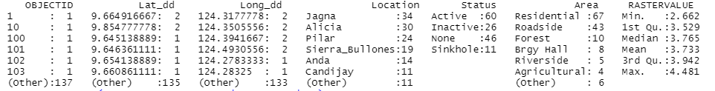
Table 8.1 AOV of AHP Map
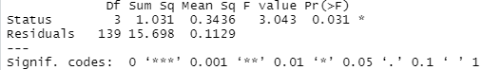
Table 9. Fuzzy Logic Map Values Summary
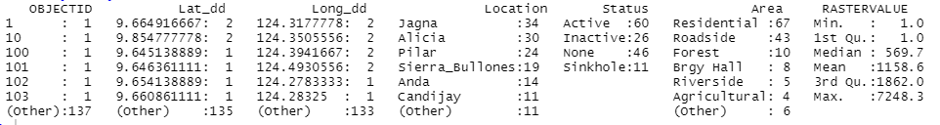
Table 9.1 AOV of Fuzzy Logic Map Values
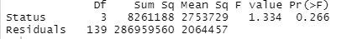

Forest-based Classification and Regression
Table 10. AHP FBCR Susceptibility Prediction Values Summary
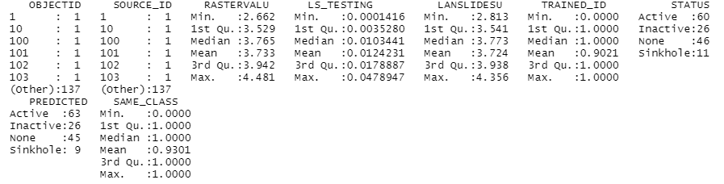
Table 10.1 AHP FBCR Validation of Susceptibility Prediction Values - Ordinary Linear Regression
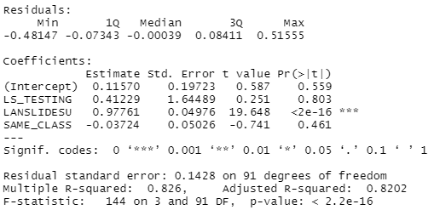

Table 11. Fuzzy Logic FBCR Susceptibility Prediction Values Summary
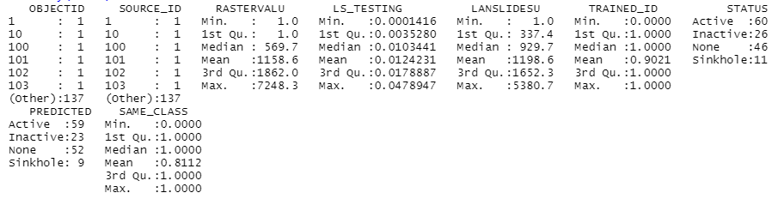
Table 11.1 Fuzzy Logic FBCR Validation of Susceptibility Prediction Values - Ordinary Linear Regression
