The Reading Everyday Emotion Database (REED):
A set of audio-visual recordings of emotions in music and language
Jia Hoong Ong^{1,2}, Florence Yik Nam Leung^{1,3}, Fang Liu^{1,a}

¹ School of Psychology and Clinical Language Sciences, University of Reading, Reading, United Kingdom
² Department of Psychology, School of Social Sciences, Nottingham Trent University, Nottingham, United Kingdom
³ Department of Psychology, University of Bath, Bath, United Kingdom

ª Corresponding author. Email: f.liu@reading.ac.uk; Telephone: +44 (0)118 378 8122; Mailing address: Harry Pitt Building, School of Psychology & Clinical Language Sciences, University of Reading, Earley Gate, Reading RG6 6AL

SUPPLEMENTARY SECTIONS
Section S1: Encoder demographic details
Section S2: Scenarios
Section S3: Screenshots of recording clips
Section S4: Pairwise comparisons of Emotion
Section S5: Pairwise comparisons of Condition by Emotion
Section S6: Acoustic analysis

Section S1: Encoder demographic details
Table S1.1
Details of each encoder (Code) and their demographic details including Age; Gender; their musical training experience (MT); the cumulative years of musical training across multiple instruments (MT Years); whether they were still practising music (MT Still); their drama experience (Drama Exp); and their recording devices (Device).
Code | Age | Gender | MT | MT Years | MT Still | Drama Exp | Device
FW01 | 21 | F | Self-taught, piano, 4 years; self-taught, guitar, 4 years | 8 | No | NA | Macbook Air (2013)
FW02 | 23 | F | Private lessons, piano, 8 years; Private lessons, violin, 5 years | 13 | Yes | NA | Lenovo V110
FW03 | 25 | F | Private lessons, Piano, 5 years | 5 | No | NA | HP Pavillion 14
FW04 | 25 | F | Private lessons, Piano, 6 years; Group lessons, Voice, 12 years | 18 | Yes | Professional actress in film and on stage. Member of the National Youth Theatre of Great Britain. | iPad Pro (2018)
FW05 | 26 | F | Private lessons, Piano, 5 years | 5 | No | NA | Macbook Pro (2012)
FW06 | 22 | F | NA | NA | NA | NA | Macbook Pro (2019)
FW07 | 75 | F | Private lessons, French horn, 6 years | 6 | Yes | NA | Toshiba Satellite C855
FW08 | 45 | F | Group lessons, keyboard, 2 years; Private lessons, violin, 5 years | 7 | No | NA | HP Pavilion G6
FW10 | 81 | F | NA | NA | NA | Acting/directing at a local theatre. Exams - LAMDA Bronze and Silver | Mac laptop (2017/2018)
FW11 | 39 | F | NA | NA | NA | Drama with dance degree 2003, PGCE Drama Teacher 2003. Taught drama ever since and been part of 2 amateur dramatics theatres within that time. | Microsoft Surface Pro
FW12 | 31 | F | Private lessons, Piano, 22 years; Private lessons, Electric Organ, 12 years; Group lessons, Singing, 18 years | 52 | Yes | Performed in musical theatre | iPhone 8
FW13 | 38 | F | NA | NA | NA | NA | Dell 7400
MW01 | 22 | M | Self-taught, Guitar, 9 years | 9 | Yes | GCSE Drama | Lenovo Thinkpad T440s
MW02 | 33 | M | Private lessons, Piano, 7 years | 7 | Yes | NA | HP 3168NGW
MW03 | 75 | M | NA | NA | NA | Appeared in several amateur plays in their youth | Toshiba Satellite C855
MW04 | 60 | M | NA | NA | NA | Did a little professional work when younger now frequently do amateur productions | iPad Air (2020)
MW05 | 24 | M | Private lessons, Clarinet, 9 years | 9 | No | Performed in multiple amateur/university society productions and festivals | MacBook Pro (2017)
MW06 | 33 | M | Private lessons, Piano, 26 years | 26 | Yes | Practised from school until one year after university | MacBook Air (mid 2013)
MW09 | 20 | M | NA | NA | NA | NA | iPhone XS Max
MW10 | 19 | M | NA | NA | NA | NA | Samsung Galaxy S20
MW11 | 50 | M | NA | NA | NA | NA | Dell Ultrabook Latitude E7270
MW12 | 53 | M | NA | NA | NA | NA | MacBook Air 13” (2017)

Section S2: Scenarios
Table S2.1
List of emotions, definitions, and the scenarios given to the encoders to be used for eliciting expressions.
Emotion | Definition | Scenario
Neutral | Dispassionate, detached | You just finished meditating.
Stressed | Pressured, worried | You have been told that you have to completely rewrite your essay but it is due in less than an hour.
Proud | Fulfilling, satisfied | You worked tirelessly to complete a project and it is done and it is well received.
Disgusted | Revulsion, sicken | You’re just about to eat a bite of your food but then you noticed maggots on it.
Happy | Joyous, blissful | You’re on a holiday to a place that you have always wanted to visit.
Hopeful | Optimistic, positive | You think your favourite football team has a chance of winning the championship title this year based on their past few games.
Jealous | Envious, resentful | Your younger brother got the latest gaming console that you wanted for Christmas whereas you got a pair of socks.
Fearful | Terrified, worried | You’re alone at home at night and you hear some noise coming from the kitchen.
Sad | Heavy-hearted, sorrowful | Your pet of 10 years has to be put down because of illness.
Surprised | Unexpected, astonished | The movie you’re watching has a plot twist that you did not see coming
Sarcastic | Cynical, mocking | When someone asks how your terrible day is going, so you respond "Today cannot get any better".
Embarrassed | Ashamed, humiliated | You just did a presentation in front of your boss and colleagues, and then you realised you had on a shirt with a massive food stain.
Angry | Furious, cross | You’re losing your temper because you were crossing a zebra crossing when a car doesn’t give way and narrowly misses you.

Section S3: Screenshots of recording clips
Figure S3.1
A portion of screenshots of all the encoders in the REED. The first two columns represent screenshots of female encoders whereas the last two columns represent screenshots of male encoders.

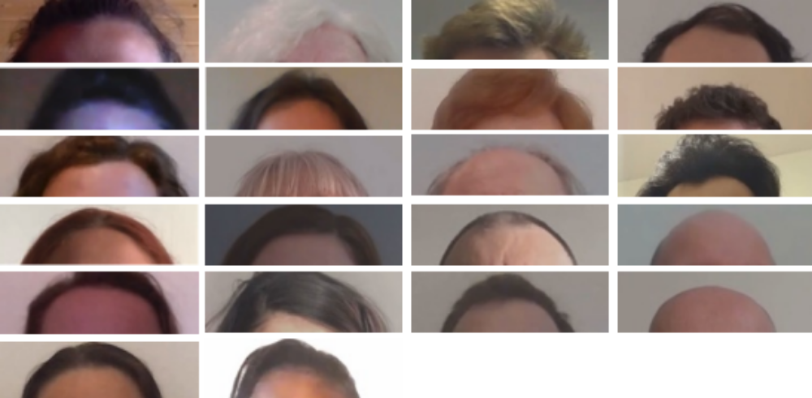

Section S4: Pairwise comparisons of Emotion
Table S4.1
Pairwise comparisons of Emotion.
Contrast 1 | Contrast 2 | z | p
Angry | Disgusted | 0.17 | 1.000
Angry | Embarrassed | 10.93 | < .001
Angry | Fearful | 2.95 | .140
Angry | Happy | -1.31 | .985
Angry | Hopeful | 12.23 | < .001
Angry | Jealous | 13.08 | < .001
Angry | Neutral | -7.05 | < .001
Angry | Proud | 13.20 | < .001
Angry | Sad | -4.23 | .002
Angry | Sarcastic | 2.95 | .140
Angry | Stressed | 9.38 | < .001
Angry | Surprised | -1.06 | .998
Disgusted | Embarrassed | 11.05 | < .001
Disgusted | Fearful | 2.78 | .213
Disgusted | Happy | -1.37 | .979
Disgusted | Hopeful | 12.74 | < .001
Disgusted | Jealous | 13.18 | < .001
Disgusted | Neutral | -7.08 | < .001
Disgusted | Proud | 13.63 | < .001
Disgusted | Sad | -4.22 | .002
Disgusted | Sarcastic | 2.69 | .260
Disgusted | Stressed | 9.53 | < .001
Disgusted | Surprised | -1.20 | .993
Embarrassed | Fearful | -8.91 | < .001
Embarrassed | Happy | -11.29 | < .001
Embarrassed | Hopeful | 1.28 | .988
Embarrassed | Jealous | 2.43 | .421
Embarrassed | Neutral | -16.56 | < .001
Embarrassed | Proud | 2.54 | .350
Embarrassed | Sad | -14.28 | < .001
Embarrassed | Sarcastic | -9.00 | < .001
Embarrassed | Stressed | -2.26 | .547
Embarrassed | Surprised | -12.19 | < .001
Fearful | Happy | -3.89 | .007
Fearful | Hopeful | 10.45 | < .001
Fearful | Jealous | 11.48 | < .001
Fearful | Neutral | -9.62 | < .001
Fearful | Proud | 11.24 | < .001
Fearful | Sad | -6.79 | < .001
Fearful | Sarcastic | -0.07 | 1.000
Fearful | Stressed | 7.03 | < .001
Fearful | Surprised | -3.86 | .007
Happy | Hopeful | 12.25 | < .001
Happy | Jealous | 12.96 | < .001
Happy | Neutral | -5.55 | < .001
Happy | Proud | 12.37 | < .001
Happy | Sad | -2.53 | .356
Happy | Sarcastic | 3.87 | .007
Happy | Stressed | 9.80 | < .001
Happy | Surprised | 0.30 | 1.000
Hopeful | Jealous | 1.29 | .987
Hopeful | Neutral | -17.46 | < .001
Hopeful | Proud | 1.12 | .996
Hopeful | Sad | -15.89 | < .001
Hopeful | Sarcastic | -10.72 | < .001
Hopeful | Stressed | -3.60 | .019
Hopeful | Surprised | -13.53 | < .001
Jealous | Neutral | -17.80 | < .001
Jealous | Proud | -0.05 | 1.000
Jealous | Sad | -16.76 | < .001
Jealous | Sarcastic | -11.56 | < .001
Jealous | Stressed | -4.76 | < .001
Jealous | Surprised | -14.23 | < .001
Neutral | Proud | 17.68 | < .001
Neutral | Sad | 3.07 | .101
Neutral | Sarcastic | 9.80 | < .001
Neutral | Stressed | 16.16 | < .001
Neutral | Surprised | 5.93 | < .001
Proud | Sad | -16.10 | < .001
Proud | Sarcastic | -11.20 | < .001
Proud | Stressed | -4.59 | < .001
Proud | Surprised | -13.97 | < .001
Sad | Sarcastic | 6.86 | < .001
Sad | Stressed | 13.17 | < .001
Sad | Surprised | 2.97 | .132
Sarcastic | Stressed | 7.51 | < .001
Sarcastic | Surprised | -4.00 | .004
Stressed | Surprised | -10.18 | < .001

Section S5: Pairwise comparisons of Condition by Emotion
Table S5.1
Pairwise comparisons of Condition for each Emotion.
Emotion | Contrast 1 | Contrast 2 | z | p
Angry | sung "Birthday" | spoken "Ah" | -1.47 | .457
Angry | sung "Birthday" | spoken "Birthday" | -1.20 | .625
Angry | sung "Birthday" | spoken “Talked” | -1.24 | .600
Angry | spoken "Ah" | spoken "Birthday" | 0.26 | .994
Angry | spoken "Ah" | spoken “Talked” | 0.20 | .997
Angry | spoken "Birthday" | spoken “Talked” | -0.05 | 1.000
Disgusted | sung "Birthday" | spoken "Ah" | -3.68 | .001
Disgusted | sung "Birthday" | spoken "Birthday" | -1.01 | .746
Disgusted | sung "Birthday" | spoken “Talked” | -1.71 | .317
Disgusted | spoken "Ah" | spoken "Birthday" | 2.82 | .025
Disgusted | spoken "Ah" | spoken “Talked” | 2.07 | .165
Disgusted | spoken "Birthday" | spoken “Talked” | -0.76 | .874
Embarrassed | sung "Birthday" | spoken "Ah" | -1.40 | .501
Embarrassed | sung "Birthday" | spoken "Birthday" | 1.25 | .595
Embarrassed | sung "Birthday" | spoken “Talked” | 0.35 | .985
Embarrassed | spoken "Ah" | spoken "Birthday" | 2.76 | .030
Embarrassed | spoken "Ah" | spoken “Talked” | 1.81 | .269
Embarrassed | spoken "Birthday" | spoken “Talked” | -0.93 | .789
Fearful | sung "Birthday" | spoken "Ah" | 2.11 | .152
Fearful | sung "Birthday" | spoken "Birthday" | 1.69 | .331
Fearful | sung "Birthday" | spoken “Talked” | 1.56 | .400
Fearful | spoken "Ah" | spoken "Birthday" | -0.48 | .964
Fearful | spoken "Ah" | spoken “Talked” | -0.60 | .934
Fearful | spoken "Birthday" | spoken “Talked” | -0.12 | .999
Happy | sung "Birthday" | spoken "Ah" | 7.95 | < .001
Happy | sung "Birthday" | spoken "Birthday" | 2.13 | .143
Happy | sung "Birthday" | spoken “Talked” | 5.02 | < .001
Happy | spoken "Ah" | spoken "Birthday" | -6.10 | < .001
Happy | spoken "Ah" | spoken “Talked” | -3.23 | .007
Happy | spoken "Birthday" | spoken “Talked” | 3.01 | .014
Hopeful | sung "Birthday" | spoken "Ah" | -0.95 | .777
Hopeful | sung "Birthday" | spoken "Birthday" | -1.65 | .350
Hopeful | sung "Birthday" | spoken “Talked” | -2.06 | .166
Hopeful | spoken "Ah" | spoken "Birthday" | -0.71 | .892
Hopeful | spoken "Ah" | spoken “Talked” | -1.13 | .671
Hopeful | spoken "Birthday" | spoken “Talked” | -0.42 | .975
Jealous | sung "Birthday" | spoken "Ah" | 3.64 | .002
Jealous | sung "Birthday" | spoken "Birthday" | -0.94 | .783
Jealous | sung "Birthday" | spoken “Talked” | 2.42 | .073
Jealous | spoken "Ah" | spoken "Birthday" | -4.54 | < .001
Jealous | spoken "Ah" | spoken “Talked” | -1.45 | .471
Jealous | spoken "Birthday" | spoken “Talked” | 3.46 | .003
Neutral | sung "Birthday" | spoken "Ah" | 0.85 | .832
Neutral | sung "Birthday" | spoken "Birthday" | -0.77 | .868
Neutral | sung "Birthday" | spoken “Talked” | -2.72 | .033
Neutral | spoken "Ah" | spoken "Birthday" | -1.66 | .345
Neutral | spoken "Ah" | spoken “Talked” | -3.60 | .002
Neutral | spoken "Birthday" | spoken “Talked” | -2.03 | .177
Proud | sung "Birthday" | spoken "Ah" | -0.30 | .991
Proud | sung "Birthday" | spoken "Birthday" | -1.48 | .450
Proud | sung "Birthday" | spoken “Talked” | -2.74 | .031
Proud | spoken "Ah" | spoken "Birthday" | -1.18 | .640
Proud | spoken "Ah" | spoken “Talked” | -2.47 | .066
Proud | spoken "Birthday" | spoken “Talked” | -1.37 | .519
Sad | sung "Birthday" | spoken "Ah" | 1.08 | .701
Sad | sung "Birthday" | spoken "Birthday" | 0.42 | .975
Sad | sung "Birthday" | spoken “Talked” | 0.09 | 1.000
Sad | spoken "Ah" | spoken "Birthday" | -0.67 | .907
Sad | spoken "Ah" | spoken “Talked” | -1.01 | .741
Sad | spoken "Birthday" | spoken “Talked” | -0.35 | .986
Sarcastic | sung "Birthday" | spoken "Ah" | 0.40 | .979
Sarcastic | sung "Birthday" | spoken "Birthday" | -0.96 | .771
Sarcastic | sung "Birthday" | spoken “Talked” | 3.39 | .004
Sarcastic | spoken "Ah" | spoken "Birthday" | -1.38 | .510
Sarcastic | spoken "Ah" | spoken “Talked” | 3.04 | .013
Sarcastic | spoken "Birthday" | spoken “Talked” | 4.44 | < .001
Stressed | sung "Birthday" | spoken "Ah" | -3.73 | .001
Stressed | sung "Birthday" | spoken "Birthday" | -1.06 | .715
Stressed | sung "Birthday" | spoken “Talked” | -3.05 | .012
Stressed | spoken "Ah" | spoken "Birthday" | 2.89 | .020
Stressed | spoken "Ah" | spoken “Talked” | 0.76 | .871
Stressed | spoken "Birthday" | spoken “Talked” | -2.15 | .139
Surprised | sung "Birthday" | spoken "Ah" | -11.89 | < .001
Surprised | sung "Birthday" | spoken "Birthday" | -4.55 | < .001
Surprised | sung "Birthday" | spoken “Talked” | -7.06 | < .001
Surprised | spoken "Ah" | spoken "Birthday" | 8.20 | < .001
Surprised | spoken "Ah" | spoken “Talked” | 5.38 | < .001
Surprised | spoken "Birthday" | spoken “Talked” | -2.82 | .025

Section S6: Acoustic analysis
One concern for using the utterance “Happy Birthday to you” is the possibility that the semantic content and the context in which the utterance is typically expressed (e.g., happy and/or surprised) may have affected the speaker’s emotional expression of that utterance. Happy and Surprised speech are typically characterised by having higher frequency (i.e., higher pitch), higher intensity (i.e., louder) and are faster (i.e., shorter in duration) (Juslin & Laukka, 2003; Livingstone et al., 2013; Sobin & Alpert, 1999). If there is an influence of the semantic content and/or the context, then we would expect that that the spoken “Happy Birthday to you” utterance will exhibit those characteristics, regardless of the emotion it is supposed to express. The goal for this acoustic analysis, thus, is to determine whether there is such an influence by directly comparing the acoustic parameters of the two spoken sentences in the REED: “Happy Birthday to you” (hereafter “birthday”) and “The music played on while they talked” (hereafter “talked”).
For each clip of the two utterances, we obtained three acoustic parameters using the Praat script ProsodyPro (Xu, 2013): mean pitch, mean intensity, and duration. Mean pitch and mean intensity were mean-centred by speaker to account for speaker-specific idiosyncrasies in their speech. For example, the mean pitches for Speaker 1 may be 0 for Emotion A (i.e., the average pitch for Speaker 1) but -10 for Emotion B (i.e., lower than Speaker 1’s average pitch by 10 Hz). Duration was mean-centred by speaker and also by utterance, to account for both speaker-specific idiosyncrasies and differences in the number of syllables between the two utterances.
Data analysis was conducted using R (R Core Team, 2021). We fitted a linear regression model using the lm function for each acoustic parameter, with the acoustic parameter as the dependent variable, and Utterance, Emotion and the interaction between the two as predictors. Statistical significance of the predictors was determined using the Anova function from the car package (Fox & Weisberg, 2019). Posthoc comparisons were conducted using the emmeans package (Lenth, 2019). Results of each of the models are reported in the subsections below.

Mean Pitch
Unsurprisingly, the mean pitch differed by Emotion (F(12, 1637) = 23.89, p < .001) – see Figure S6.1. The mean pitch for Surprised were significantly higher than the other emotions, and the mean pitch for Fearful, Hopeful, Happy, and Angry, were significantly higher than Neutral, Embarrassed, Jealous, Sad, and Sarcastic (see Table S6.1 for all the pairwise comparisons, which is placed at the end of this section for ease of readability). There was also a main effect of Utterance (F(1, 1637) = 5.95, p = .015), such that the mean pitch for the “talked” utterance (M = 11.50, SE = 1.90) was significantly higher than that for the “birthday” utterance (M = 4.91, SE = 1.89). Thus, the semantic content of the utterance does seem to influence mean pitch, but not in the direction that is expected (i.e., if there is a carry-over positive-valenced effect of the semantic content or context of “happy birthday”, the “birthday” utterance should have higher pitch generally). There was no Emotion × Utterance interaction (F(12, 1637) = 1.43, p = .145).

Figure S6.1
Mean pitch (in Hz, normalised by speaker) for each Emotion.
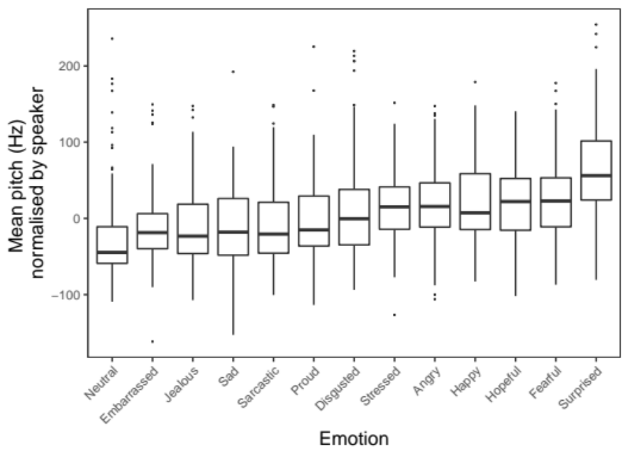

Mean Intensity
The mean intensity also differed by Emotion (F(12, 1637) = 19.33, p < .001), as depicted in Figure S6.2. Generally, the mean intensity for Angry, Surprised, Happy, Stressed, and Hopeful were not significantly different from each other, but were higher than most of the other emotions (see Table S6.2 at the end of this section for all the pairwise comparisons). We also found a main effect of Utterance (F(1, 1637) = 74.12, p < .001), with the mean intensity for the “talked” utterance (M = 0.41, SE = 0.11) being higher than that for the “birthday” utterance (M = -0.86, SE = 0.10). Again, this seems counterintuitive if there is an influence of semantic content or context for the “birthday” utterance on emotional expression (i.e., if true, the “birthday” utterance should have higher intensity generally). There was no Emotion × Utterance interaction (F(12, 1637) = 0.27, p = .994).

Figure S6.2
Mean intensity (in dB, normalised by speaker) for each Emotion.
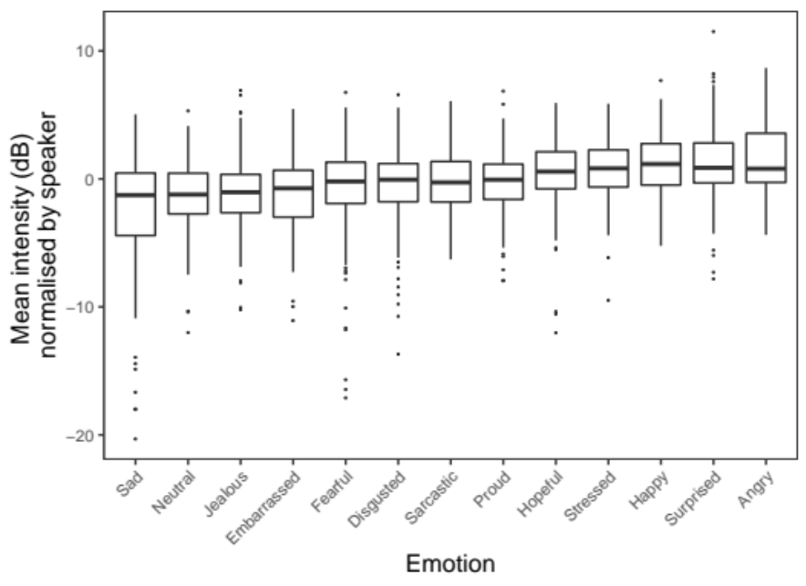

Duration
Though there was no main effect of Utterance on the duration of the clips (F(1, 1637) = 0.01, p = .928), there was a main effect of Emotion (F(12, 1637) = 17.59, p < .001), which was qualified by a significant Emotion × Utterance interaction (F(12, 1637) = 2.90, p < .001), as depicted in Figure S6.3. Comparisons between utterances for each emotion revealed that the duration for the “talked” utterance was significantly longer than the “birthday” utterance for Fearful (t(1637) = 2.36, p = .019) and Sad (t(1637) = 4.34, p < .001), but the duration for the “birthday” utterance was significantly longer than the “talked” utterance for Surprised (t(1637) = 1.97, p = .049). See Table S6.3 at the end of this section for all the comparisons. Thus, as with the findings for mean pitch and mean intensity, this is mostly incompatible with the expectations that if there was an influence of semantic content or context of the emotional expression of the “birthday” utterance (i.e., if true, the “birthday” utterance should be shorter, which was found to be true in only two emotions, and not true for the emotion that we expect it to be).

Figure S6.3
Duration (in ms, normalised by speaker and utterance) for each Emotion by Utterance.
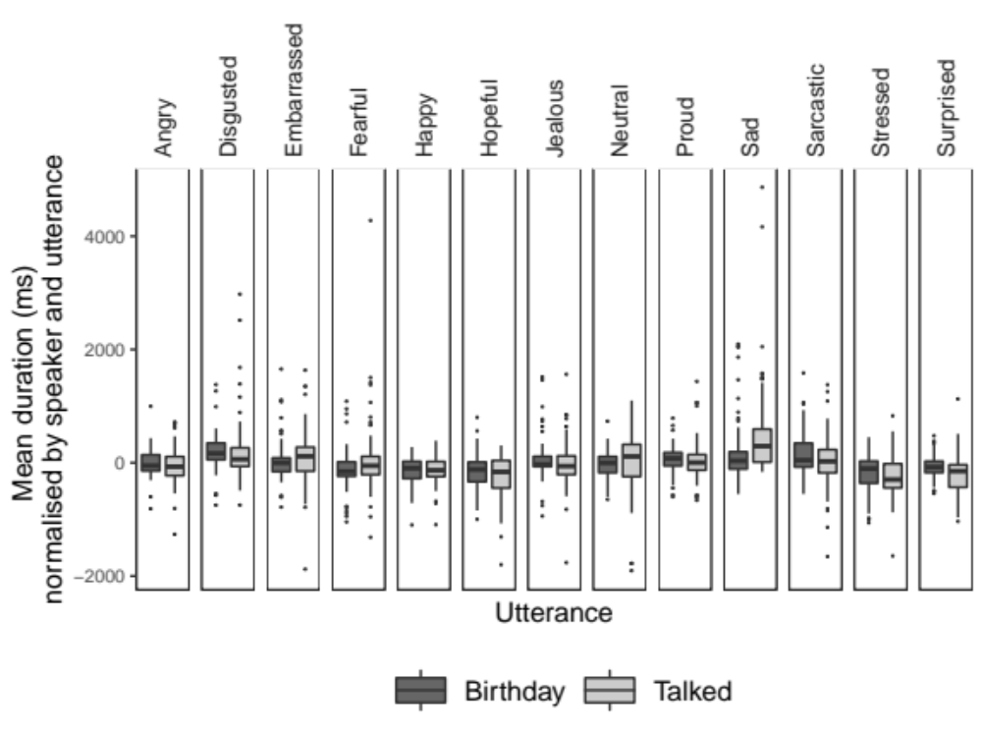

Table S6.1
Pairwise comparisons of Emotion for mean pitch.
Contrast 1 | Contrast 2 | t | p
Angry | Disgusted | 1.11 | .997
Angry | Embarrassed | 4.59 | < .001
Angry | Fearful | -0.75 | 1.000
Angry | Happy | -0.09 | 1.000
Angry | Hopeful | -0.34 | 1.000
Angry | Jealous | 4.38 | .001
Angry | Neutral | 6.37 | < .001
Angry | Proud | 2.97 | .133
Angry | Sad | 4.17 | .002
Angry | Sarcastic | 3.87 | .007
Angry | Stressed | 0.66 | 1.000
Angry | Surprised | -6.99 | < .001
Disgusted | Embarrassed | 3.49 | .028
Disgusted | Fearful | -1.87 | .811
Disgusted | Happy | -1.20 | .993
Disgusted | Hopeful | -1.47 | .962
Disgusted | Jealous | 3.28 | .056
Disgusted | Neutral | 5.29 | < .001
Disgusted | Proud | 1.86 | .816
Disgusted | Sad | 3.08 | .099
Disgusted | Sarcastic | 2.78 | .214
Disgusted | Stressed | -0.46 | 1.000
Disgusted | Surprised | -8.15 | < .001
Embarrassed | Fearful | -5.36 | < .001
Embarrassed | Happy | -4.69 | < .001
Embarrassed | Hopeful | -5.00 | < .001
Embarrassed | Jealous | -0.23 | 1.000
Embarrassed | Neutral | 1.82 | .841
Embarrassed | Proud | -1.65 | .915
Embarrassed | Sad | -0.37 | 1.000
Embarrassed | Sarcastic | -0.71 | 1.000
Embarrassed | Stressed | -3.94 | .006
Embarrassed | Surprised | -11.66 | < .001
Fearful | Happy | 0.67 | 1.000
Fearful | Hopeful | 0.42 | 1.000
Fearful | Jealous | 5.16 | < .001
Fearful | Neutral | 7.15 | < .001
Fearful | Proud | 3.74 | .012
Fearful | Sad | 4.93 | < .001
Fearful | Sarcastic | 4.64 | < .001
Fearful | Stressed | 1.42 | .972
Fearful | Surprised | -6.26 | < .001
Happy | Hopeful | -0.26 | 1.000
Happy | Jealous | 4.48 | .001
Happy | Neutral | 6.48 | < .001
Happy | Proud | 3.07 | .103
Happy | Sad | 4.27 | .002
Happy | Sarcastic | 3.97 | .005
Happy | Stressed | 0.75 | 1.000
Happy | Surprised | -6.93 | < .001
Hopeful | Jealous | 4.79 | < .001
Hopeful | Neutral | 6.81 | < .001
Hopeful | Proud | 3.36 | .044
Hopeful | Sad | 4.57 | < .001
Hopeful | Sarcastic | 4.27 | .001
Hopeful | Stressed | 1.01 | .999
Hopeful | Surprised | -6.74 | < .001
Jealous | Neutral | 2.05 | .699
Jealous | Proud | -1.42 | .971
Jealous | Sad | -0.15 | 1.000
Jealous | Sarcastic | -0.49 | 1.000
Jealous | Stressed | -3.73 | .012
Jealous | Surprised | -11.48 | < .001
Neutral | Proud | -3.46 | .031
Neutral | Sad | -2.16 | .618
Neutral | Sarcastic | -2.52 | .361
Neutral | Stressed | -5.74 | < .001
Neutral | Surprised | -13.43 | < .001
Proud | Sad | 1.26 | .990
Proud | Sarcastic | 0.93 | .999
Proud | Stressed | -2.32 | .504
Proud | Surprised | -10.06 | < .001
Sad | Sarcastic | -0.33 | 1.000
Sad | Stressed | -3.53 | .025
Sad | Surprised | -11.15 | < .001
Sarcastic | Stressed | -3.23 | .066
Sarcastic | Surprised | -10.92 | < .001
Stressed | Surprised | -7.68 | < .001

Table S6.2
Pairwise comparisons of Emotion for mean intensity.
Contrast 1 | Contrast 2 | t | p
Angry | Disgusted | 5.16 | < .001
Angry | Embarrassed | 7.11 | < .001
Angry | Fearful | 6.14 | < .001
Angry | Happy | 1.04 | .998
Angry | Hopeful | 2.76 | .221
Angry | Jealous | 7.22 | < .001
Angry | Neutral | 7.20 | < .001
Angry | Proud | 4.38 | .001
Angry | Sad | 9.89 | < .001
Angry | Sarcastic | 4.47 | .001
Angry | Stressed | 1.33 | .984
Angry | Surprised | 0.48 | 1.000
Disgusted | Embarrassed | 1.95 | .766
Disgusted | Fearful | 0.99 | .999
Disgusted | Happy | -4.13 | .003
Disgusted | Hopeful | -2.45 | .408
Disgusted | Jealous | 2.04 | .707
Disgusted | Neutral | 2.06 | .693
Disgusted | Proud | -0.81 | 1.000
Disgusted | Sad | 4.81 | < .001
Disgusted | Sarcastic | -0.70 | 1.000
Disgusted | Stressed | -3.85 | .008
Disgusted | Surprised | -4.70 | < .001
Embarrassed | Fearful | -0.95 | .999
Embarrassed | Happy | -6.09 | < .001
Embarrassed | Hopeful | -4.42 | .001
Embarrassed | Jealous | 0.08 | 1.000
Embarrassed | Neutral | 0.12 | 1.000
Embarrassed | Proud | -2.77 | .216
Embarrassed | Sad | 2.89 | .165
Embarrassed | Sarcastic | -2.65 | .284
Embarrassed | Stressed | -5.80 | < .001
Embarrassed | Surprised | -6.66 | < .001
Fearful | Happy | -5.12 | < .001
Fearful | Hopeful | -3.45 | .033
Fearful | Jealous | 1.04 | .998
Fearful | Neutral | 1.07 | .998
Fearful | Proud | -1.81 | .845
Fearful | Sad | 3.82 | .009
Fearful | Sarcastic | -1.69 | .900
Fearful | Stressed | -4.83 | < .001
Fearful | Surprised | -5.69 | < .001
Happy | Hopeful | 1.72 | .887
Happy | Jealous | 6.19 | < .001
Happy | Neutral | 6.18 | < .001
Happy | Proud | 3.35 | .046
Happy | Sad | 8.89 | < .001
Happy | Sarcastic | 3.44 | .034
Happy | Stressed | 0.29 | 1.000
Happy | Surprised | -0.56 | 1.000
Hopeful | Jealous | 4.52 | .001
Hopeful | Neutral | 4.52 | .001
Hopeful | Proud | 1.65 | .915
Hopeful | Sad | 7.27 | < .001
Hopeful | Sarcastic | 1.75 | .874
Hopeful | Stressed | -1.43 | .970
Hopeful | Surprised | -2.29 | .525
Jealous | Neutral | 0.04 | 1.000
Jealous | Proud | -2.87 | .173
Jealous | Sad | 2.82 | .195
Jealous | Sarcastic | -2.74 | .233
Jealous | Stressed | -5.90 | < .001
Jealous | Surprised | -6.77 | < .001
Neutral | Proud | -2.88 | .167
Neutral | Sad | 2.76 | .223
Neutral | Sarcastic | -2.75 | .225
Neutral | Stressed | -5.89 | < .001
Neutral | Surprised | -6.75 | < .001
Proud | Sad | 5.64 | < .001
Proud | Sarcastic | 0.11 | 1.000
Proud | Stressed | -3.06 | .106
Proud | Surprised | -3.92 | .006
Sad | Sarcastic | -5.50 | < .001
Sad | Stressed | -8.61 | < .001
Sad | Surprised | -9.46 | < .001
Sarcastic | Stressed | -3.15 | .082
Sarcastic | Surprised | -4.01 | .004
Stressed | Surprised | -0.85 | 1.000

Table S6.3
Pairwise comparisons on duration between utterances for each Emotion.
Utterance | Emotion | t | p
Birthday vs. Talked | Angry | 0.64 | .521
Birthday vs. Talked | Disgusted | -0.26 | .798
Birthday vs. Talked | Embarrassed | -0.72 | .475
Birthday vs. Talked | Fearful | -2.36 | .019
Birthday vs. Talked | Happy | -0.15 | .882
Birthday vs. Talked | Hopeful | 1.09 | .278
Birthday vs. Talked | Jealous | 0.99 | .325
Birthday vs. Talked | Neutral | 0.00 | .998
Birthday vs. Talked | Proud | 0.27 | .788
Birthday vs. Talked | Sad | -4.34 | < .001
Birthday vs. Talked | Sarcastic | 1.67 | .096
Birthday vs. Talked | Stressed | 0.76 | .448
Birthday vs. Talked | Surprised | 1.97 | .049

References
Fox, J., & Weisberg, S. (2019). An R Companion to Applied Regression (3rd ed.). Sage. https://socialsciences.mcmaster.ca/jfox/Books/Companion/
Juslin, P. N., & Laukka, P. (2003). Communication of emotions in vocal expression and music performance: Different channels, same code? Psychological Bulletin, 129(5), 770–814. https://doi.org/10.1037/0033-2909.129.5.770
Lenth, R. V. (2019). emmeans: Estimated Marginal Means, aka Least-Squares Means. https://cran.r-project.org/package=emmeans
Livingstone, S. R., Peck, K., & Russo, F. A. (2013). Acoustic differences in the speaking and singing voice. 035080–035080. https://doi.org/10.1121/1.4799460
R Core Team. (2021). R: A language and environment for statistical computing (4.1.2). R Foundation for Statistical Computing.
Sobin, C., & Alpert, M. (1999). Emotion in speech: The acoustic attributes of fear, anger, sadness, and joy. Journal of Psycholinguistic Research, 28(4), 347–365.
Xu, Y. (2013). ProsodyPro—A tool for large-scale systematic prosody analysis. Proceedings of Tools Resource Analysis Speech Prosody, 7–10.

