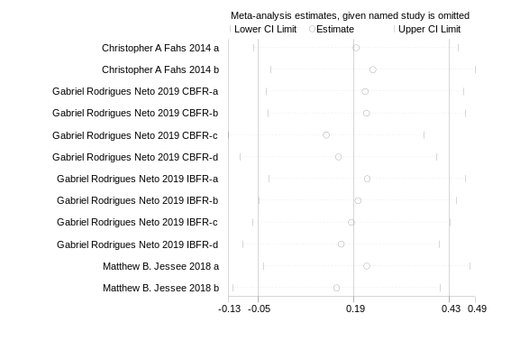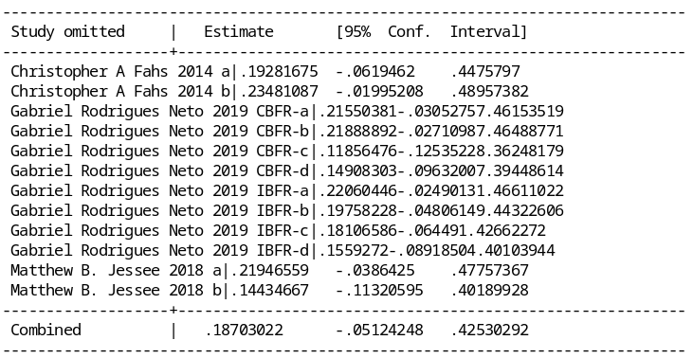
(A)
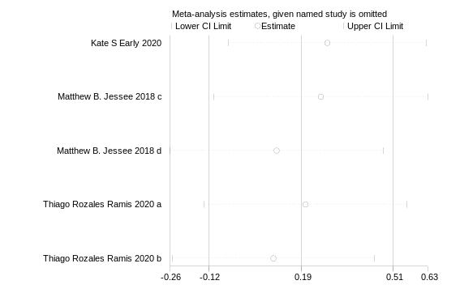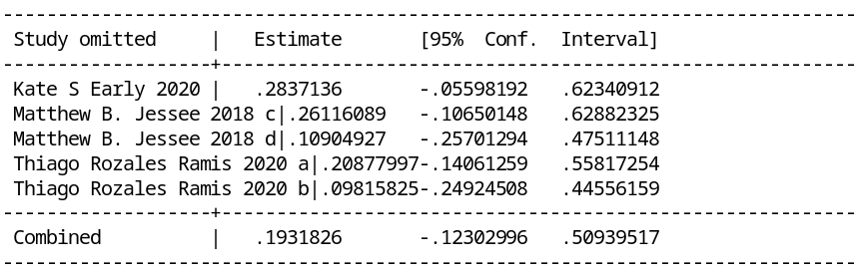
(B)
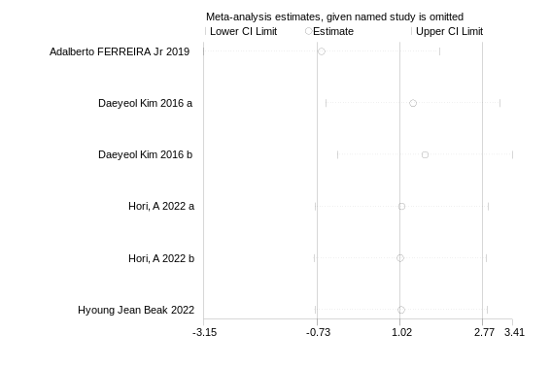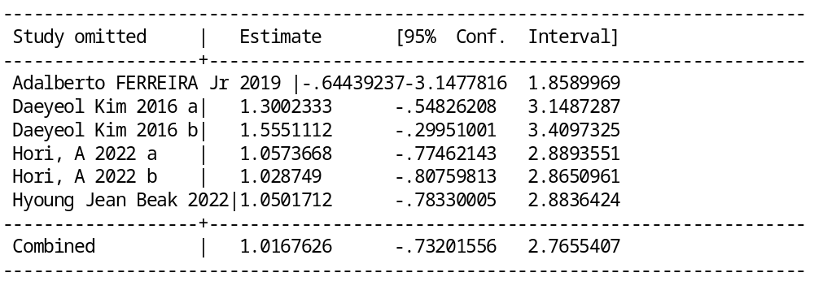
(C)
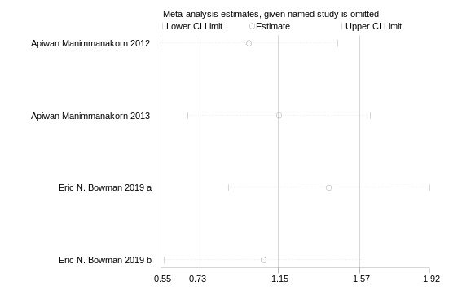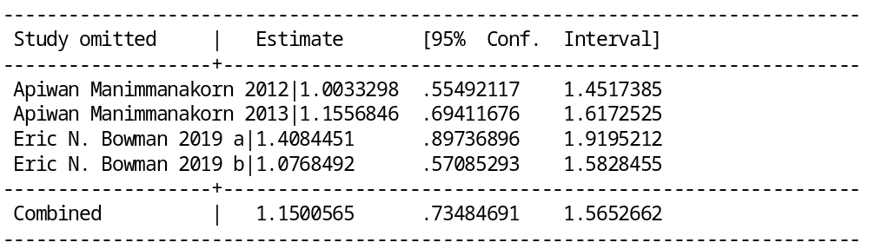
(D)
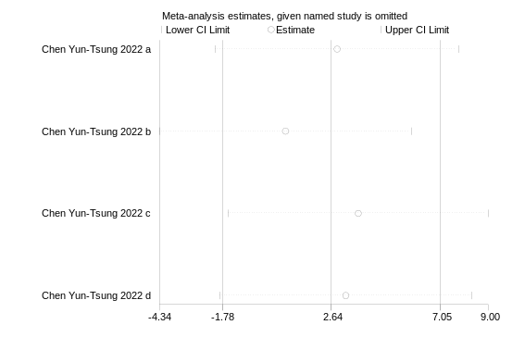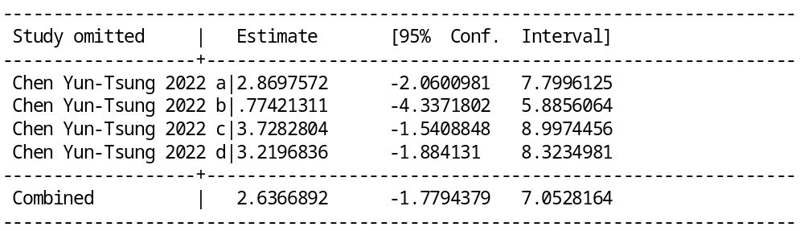
(E)
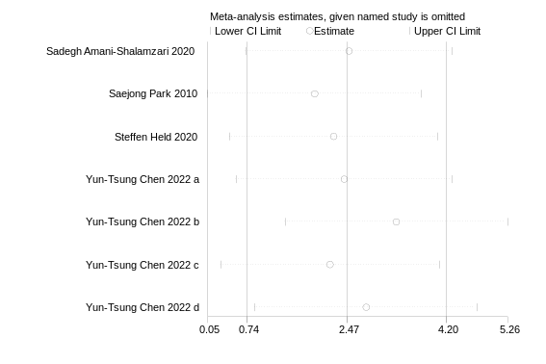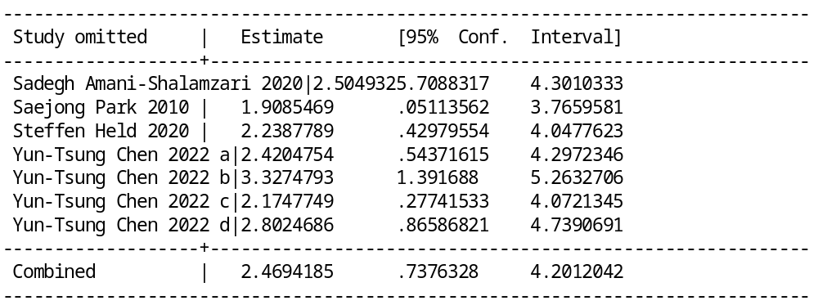
(F)
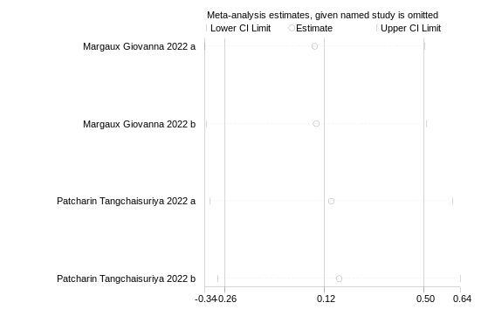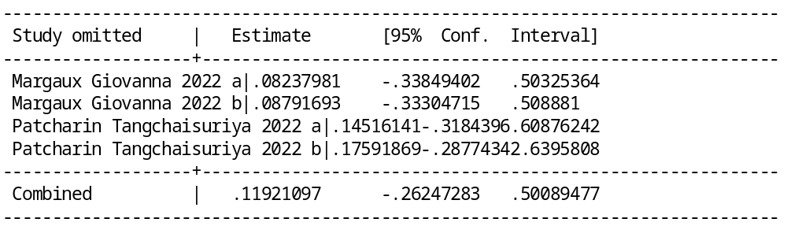
(G)

Supplementary Figure 1. Sensitivity analysis: (A) LBFR-RT VS LL-RT on muscle endurance for healthy people; (B) LBFR-RT VS HL-RT on muscle endurance for healthy people; (C) AE-BFR VS AE on aerobic capacity for healthy people; (D) LBFR-RT VS LL-RT on muscle endurance for athletes; (E) AE-BFR VS AE on muscle endurance for athletes; (F) AE-BFR VS AE on aerobic capacity for athletes; (G) HIIT-BFR VS HIIT on aerobic capacity for athletes.

