Supplementary Materials:

EP300 Promotes Cancer Stem Cell Phenotype, Tumor Growth and Metastasis in Triple Negative Breast Cancer

Alexander Ring ^{1,2,}*, Pushpinder Kaur ¹ and Julie E. Lang ¹
¹ Division of Surgical Oncology, Department of Surgery and University of Southern California Norris Cancer Center, University of Southern California, Los Angeles, CA, USA
² Current Address: Department of Hematology and Oncology, University Hospital Zurich, Zurich, Switzerland
* Correspondence: Alexander Ring, University Hospital Zurich, Rämistrasse 100, 8091 Zurich alexander.ring@usz.ch; Tel.: +41 78 644 0035 (Switzerland)

Supplementary table S1: Genes positively correlated with EP300 (q<0.05) in TNBC and basal-like breast cancer in the TCGA BC cohort (pdf file attachment)

Supplementary table S2: Genes and primer sequences for qPCR
NCBI Gene symbol | Forward primer (5’ -> 3’) | Reverse primer (3’ -> 5’)
ABCG2 | ACGAACGGATTAACAGGGTCA | CTCCAGACACACCACGGAT
GAPDH | GGTGCTGAGTATGTCTGTGA | ACAGTCTTCTGGGTGGCAGT
EP300 | AGCCAACGCGGCCTAAACT | TCACCACCATTGGTTAGTCCC

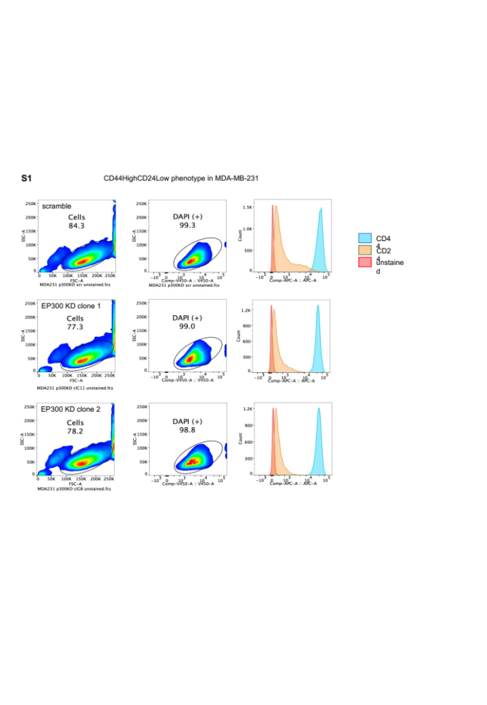

Supplementary figure S1: FACS analysis of CD44 and cD24 expression in MDA-MB-231 scramble transfected as well as 2 EP300 KD clones.

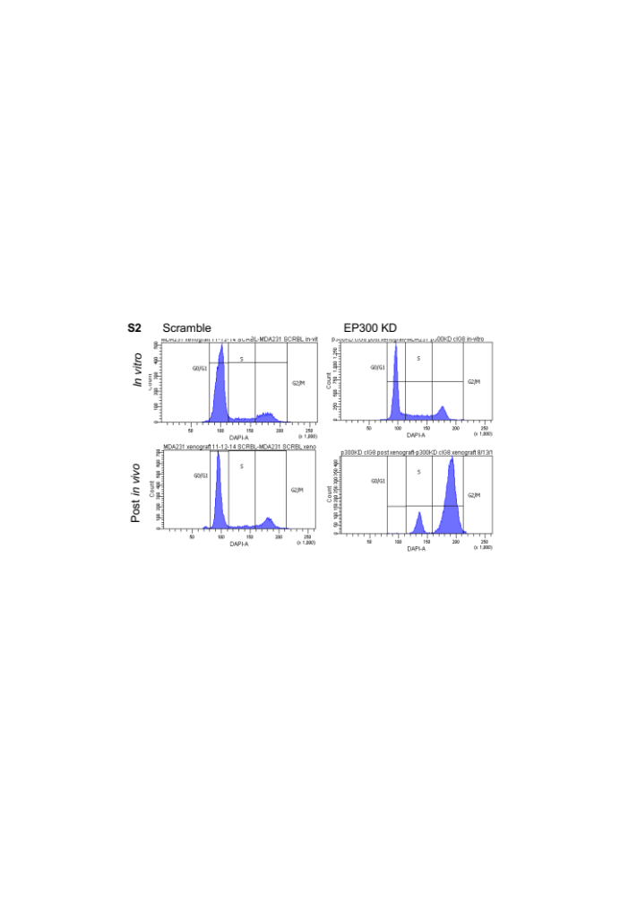

Supplementary fig. S2: Cell cycle analysis of MDA-MB-231^{Scramble} and EP300 KD after regular in vitro 2D monolayer culture (top panel) and after xenograft in mice (bottom panel) (n=1 per condition per cell type).

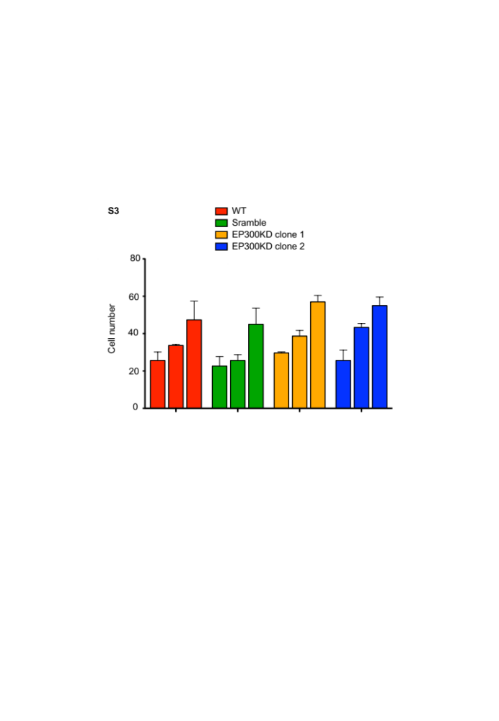

Supplementary fig. S3: Cell count of MDA-MB-231^{WT}, scramble and EP300 KD cells (clone 1 and 2) for 24, 48 and 72h culture under low glucose and low (2%) oxygen conditions (n=3 per cell type per time point).

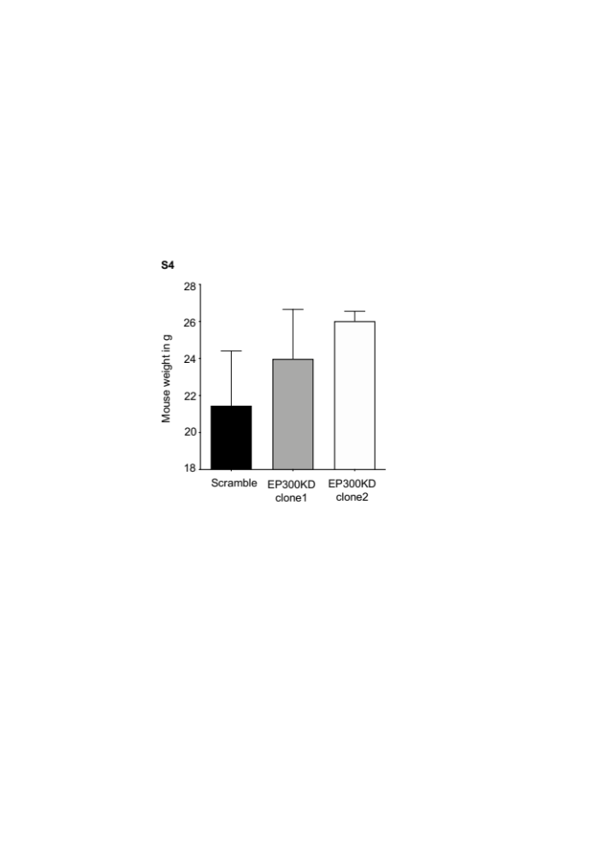

Supplementary fig. S4: Mouse weight at the end of tail vein injection xenograft experiment.

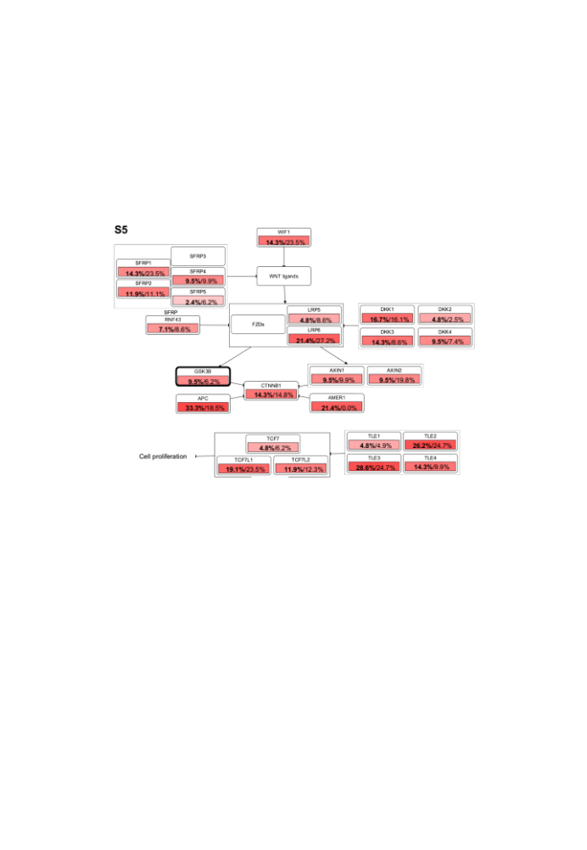

Supplementary fig. S5: Affected biological pathway (WNT signaling) associated with EP300 correlated genes that overlap in TNBC and basal BC (n=298) (cBioPortal). Affected genes are outlined in bold black. Percentages represent the proportion of samples which show alterations in pathway genes (bold – TNBC cases, regular font – basal-like BC).

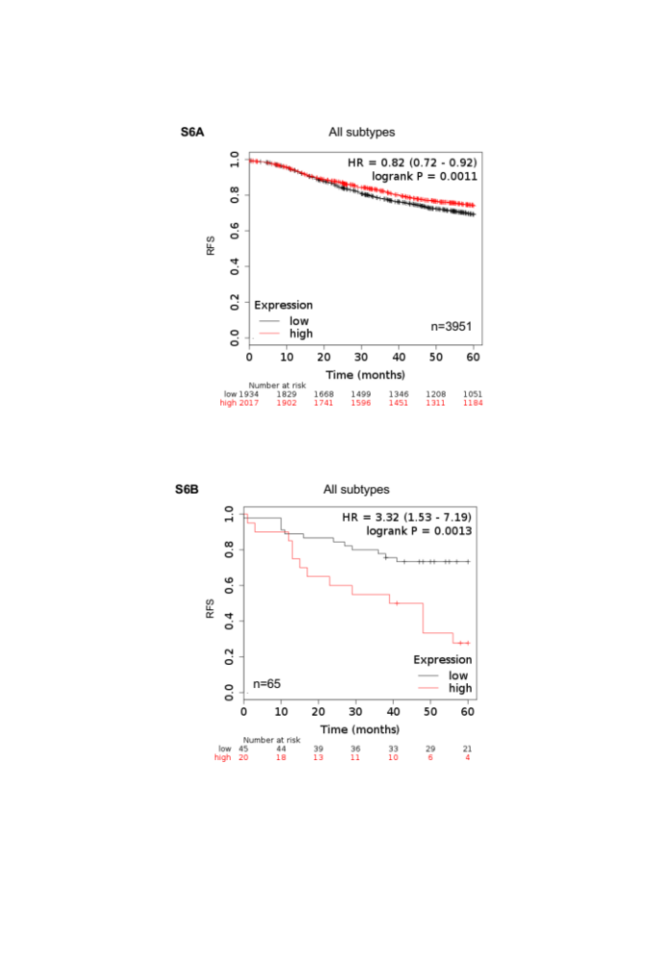

Supplementary fig. S6: Prognostic value (PFS and HR) of EP300 gene and protein expression in BC. A, EP300 gene expression in BC patients irrespective of subtype, receptor expression, grade and LN status. B, EP300 protein expression in BC patients irrespective of subtype, receptor expression, grade and LN status.

