Effect of arbuscular mycorrhizal fungi (AMF) and plant growth-promoting rhizobacteria (PGPR) on microbial community composition of phenanthrene and pyrene contaminated soils using Illumina HiSeq sequencing
Wei Li^{1,*}, Wenbin Li¹, Lijun Xing¹, Shaoxia Guo^{1,2,*}
¹College of Landscape Architecture and Forestry, Qingdao Agricultural University, Qingdao 266109, Shandong. P. R. China.
²Institute of Mycorrhizal Biotechnology, Qingdao Agricultural University, Qingdao, 266109, Shandong. P. R. China.
* Corresponding author

E-mail: lwcsu_caf@163.com (WL)
E-mail: gsx2309@126.com (SG)

a b
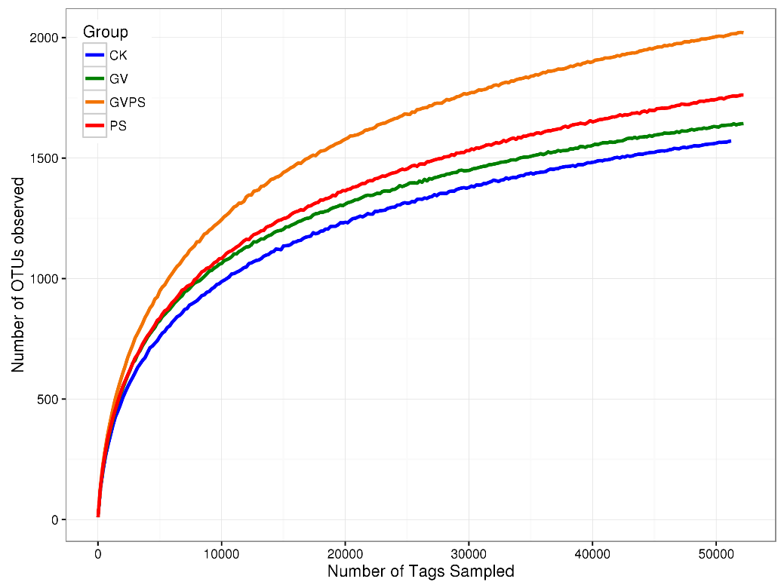
Fig. S1. Rarefaction curves of bacterial (A) and fungal (B) OTUs in four treatments.

a b
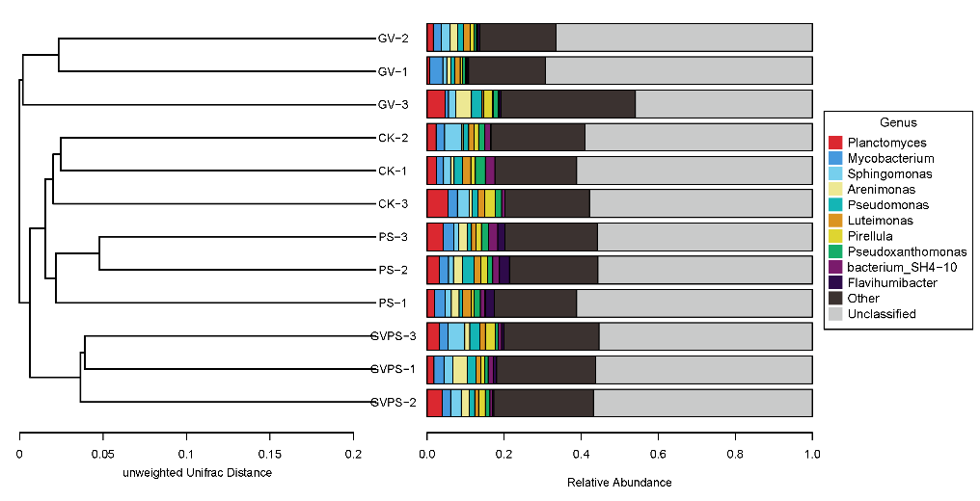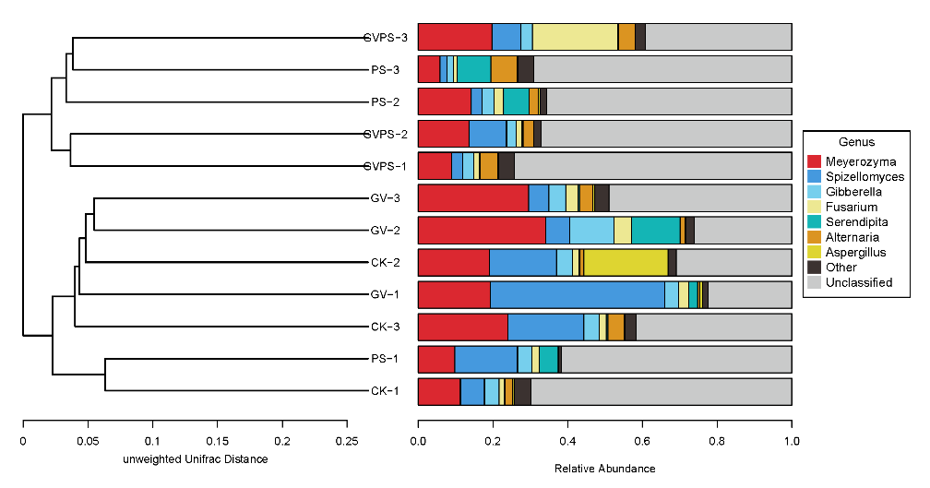

Fig. S2. Cluster analysis of the bacterial (A) and fungal (B) dominant genera in different soil samples based on unweighted UniFrac distances.

