Supplementary materials for

Multi-decadal variation of ENSO forecast skill since the late 1800s

Jiale Lou^{1,2}, Matthew Newman², and Andrew Hoell²
¹ Cooperative Institute for Research in the Environmental Sciences, University of Colorado Boulder, Boulder, CO, USA
² NOAA Physical Sciences Laboratory, Boulder, CO, USA

Submitted to npj Climate and Atmospheric Sciences

Corresponding author: Jiale Lou (jiale.lou@noaa.gov)

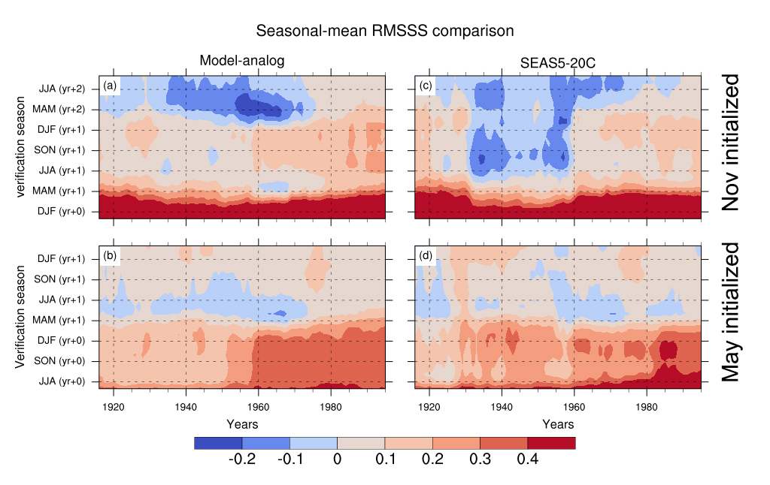
Fig. S1. Comparison of seasonal mean root mean square skill score (RMSSS) skill of NINO3.4 predictions. Seasonal mean RMSSS skill of NINO3.4 predictions as a function of hindcast period on the horizontal axis and forecast lead time on the vertical axis. (a) and (b) Model-analog hindcasts initialized in October and April. (c) and (d) SEAS5-20C hindcasts initialized on November 1st and May 1st, respectively. RMSSS values for each 30-year moving hindcast window are shown at the central year (for example, the value for 1940 represents skill for the 1926-1955 period). The model-analogs are determined based on SSTA+SSHA.

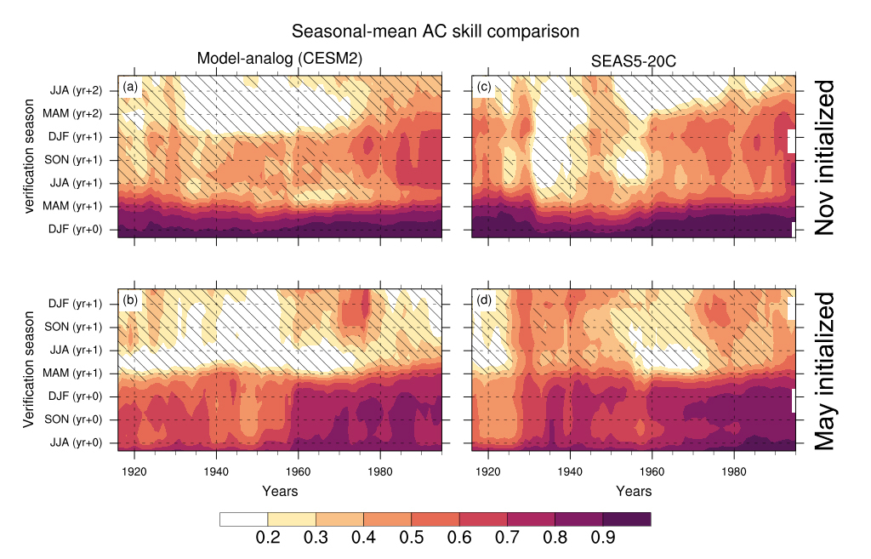
Fig. S2. Comparison of seasonal-mean anomaly correlation (AC) skill of NINO3.4 predictions. Seasonal mean AC skill of NINO3.4 predictions as a function of hindcast period on the horizontal axis and forecast lead time on the vertical axis. (a) and (b) Model-analog hindcasts initialized in October and April using CESM2 pre-industrial control simulation as the library to search for the model-analogs. (c) and (d) SEAS5-20C hindcasts initialized on November 1st and May 1st, respectively. Correlation coefficients for each 30-year sliding hindcast window are shown at the central year (for example, the value for 1940 represents skill for the 1926-1955 period). Hatching indicates the correlation coefficients that are not statistically significant at the 95% significance level. Note that panels (c) and (d) are identical to Figs. 1c and d.

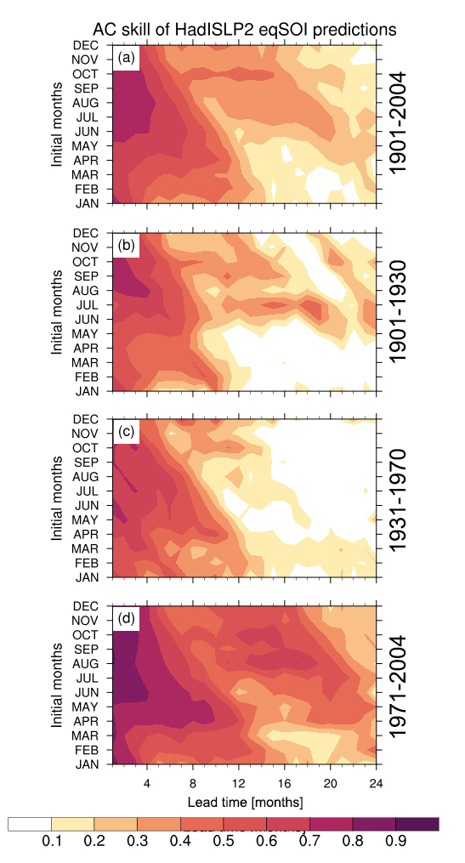
Fig. S3. Anomaly correlation (AC) skill of the equatorial SOI (eqSOI) predictions. AC skill of (a-d) eqSOI as a function of the initial months on the vertical axis and the forecast lead times up to 24 months on the horizonal axis. The AC skill is computed based on the entire period of (a) 1901-2004, and three sub-periods of (b) 1901-1930, (c) 1931-1970, and (d) 1971-2004, respectively. The verification dataset is taken from HadSLP2.

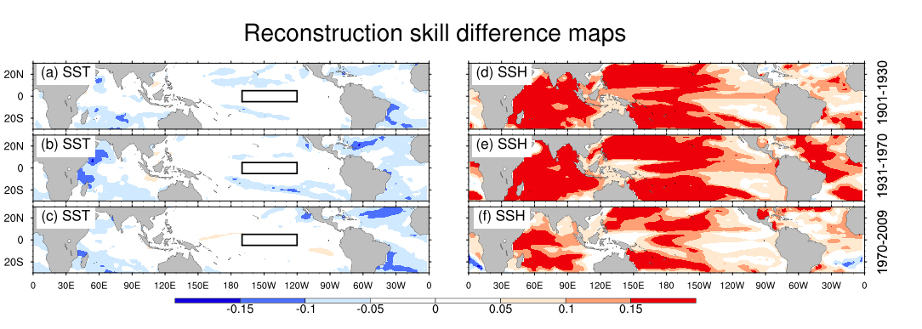
Fig. S4. Skill difference maps of the reconstruction skill for (a-c) SSTA and (d-h) SSHA. The reconstruction skill is computed based on three sub-periods of (a and d) 1901-1930, (b and e) 1931-1970, and (c and f) 1971-2009, respectively. The verification dataset is taken from CERA-20C. Model-analogs are determined from SSTA+SSHA and SSTA-only. The difference maps are computed using SSTA+SSHA experiment minus SST-only experiment. The black boxed indicate NINO3.4 region.
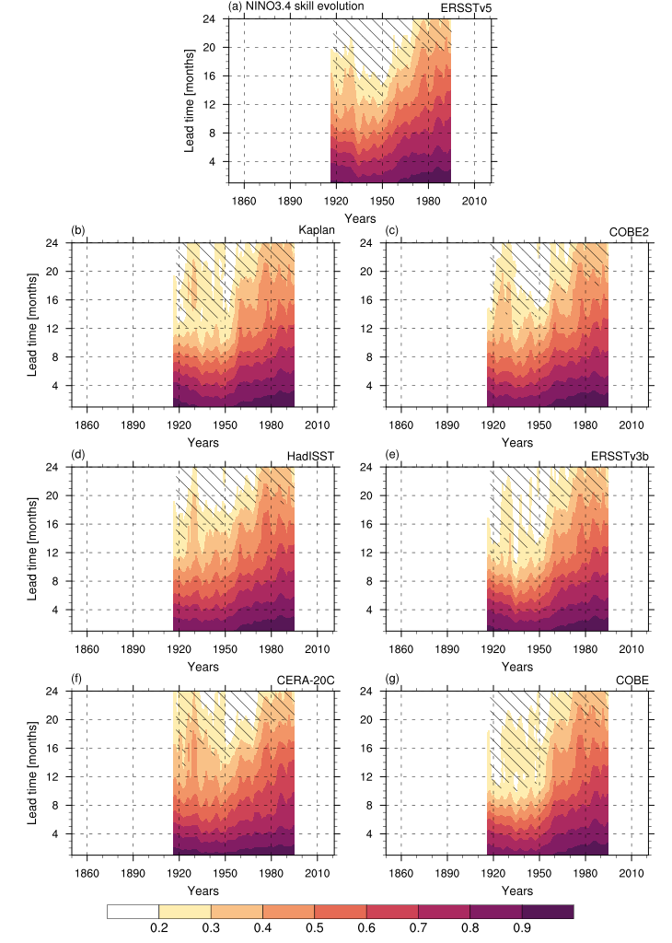
Fig. S5: Anomaly correlation (AC) skill variation of NINO3.4 predictions. Predictive AC skill evolution of NINO3.4 time series over the sliding 30-year hindcast windows for the lead times up to 24 months. The AC skill is verified over seven SST datasets, (a) ERSSTv5, (b) Kaplan, (c) COBE2, (d) HadISST, (e) ERSSTv3b, (f) CERA-20C, and (g) COBE, respectively. Correlation coefficients for each 30-year hindcast window are shown at the central year. Those correlation coefficients that are not statistically significant at the 95% significance level are slashed. The model-analogs are determined based on the corresponding SST anomalies and the CERA-20C SSH anomalies for the period of 1901-2009. Note that panel (f) is identical to Fig. 3a.
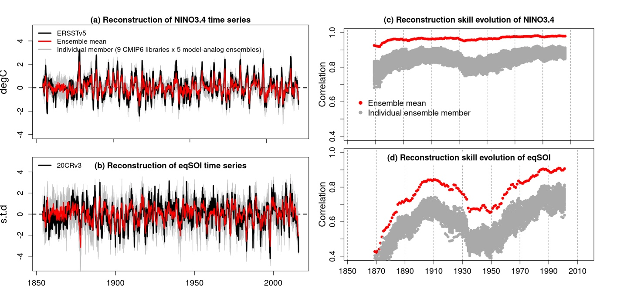
Fig. S6: Same as in Fig. 7 but using ERSSTv5 and 20CRv3 as verification datasets.
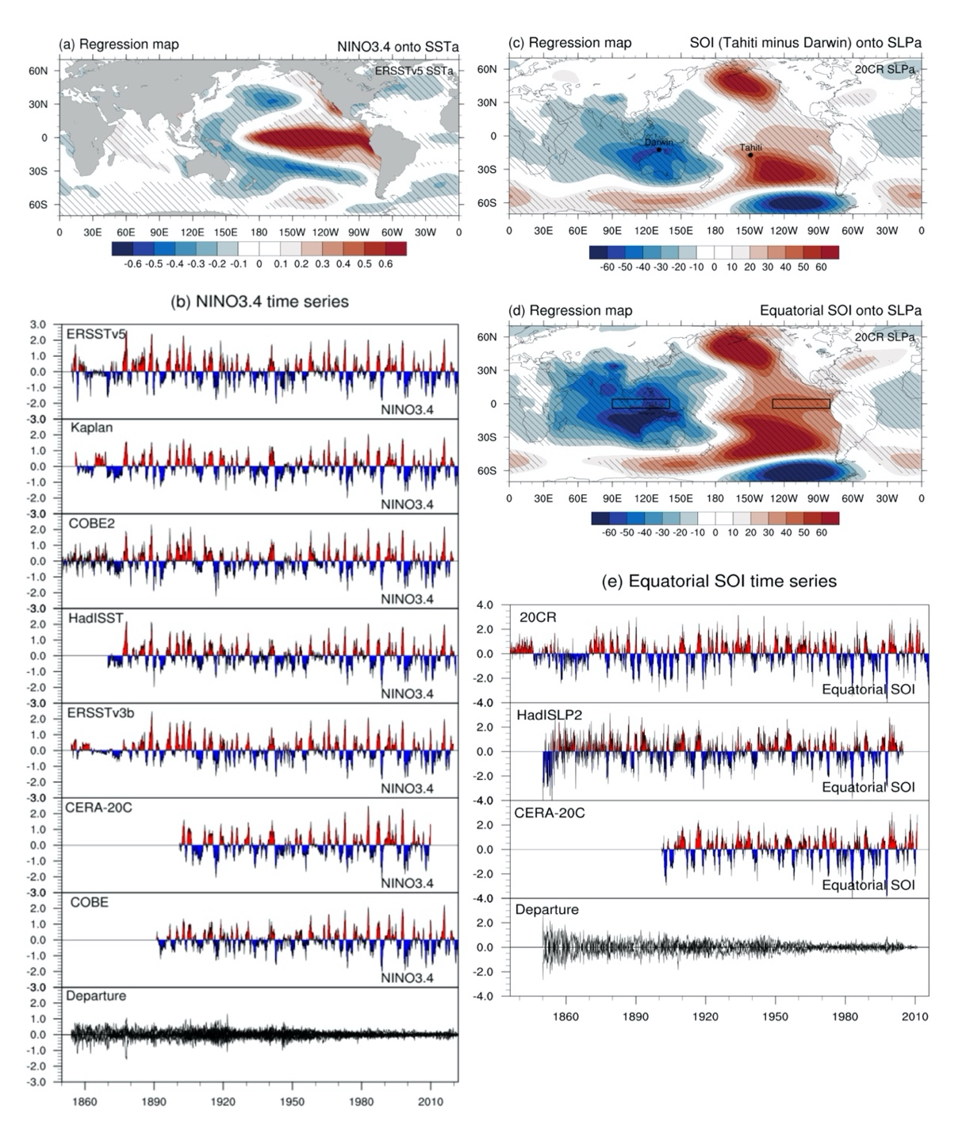
Fig. S7. El Niño-Southern Oscillation over the historical record. (a) Regression map of near-global (70ºS-70ºN) monthly SST anomalies onto the NINO3.4 time series from the ERSSTv5 dataset (1854-2020). (b) NINO3.4 time series determined from the SST datasets, ERSSTv5, Kaplan, COBE2, HadISST, ERSSTv3b, CERA-20C, and COBE. (c, and d) Regression maps of near-global monthly SLP anomalies from 20CRv3 onto the Southern Oscillation Index [SOI: Standardized SLP difference between Tahiti and Darwin (the locations are indicated in c.)] time series for the period of 1855-2020 and the equatorial SOI timeseries [standardized SLP difference between the eastern equatorial Pacific and Indonesia region (the regions are indicated in the boxes in d.)] for the period of 1836-2015. (e) The standardized equatorial SOI time series determined from the SLP datasets, 20CRv3, HadISLP2, and CERA-20C. The hatching in a, c, and d indicates the regression coefficients that are statistically significant (p value < 0.05). The last series in b and e shows the departure of each time series from the mean of all seven SST and three SLP time series.

