Table S1. Number of differentially expressed genes (DEGs) identified from all pairwise comparisons.
NIL pair | Comparison | Number of DEGs
NIL pair | Comparison | Up-regulated | Down-regulated
6HL_NIL 1 | R^{M}_vs_R^{I} | 692 | 160
 | S^{M}_vs_S^{I} | 746 | 67
6HL_NIL 2 | R^{M}_vs_R^{I} | 296 | 129
 | S^{M}_vs_S^{I} | 420 | 117
6HL_NIL 3 | R^{M}_vs_R^{I} | 640 | 359
 | S^{M}_vs_S^{I} | 280 | 44
6HL_NIL 1 | R^{I}_vs_S^{I} | 400 | 305
 | R^{M}_vs_S^{M} | 582 | 254
6HL_NIL 2 | R^{I}_vs_S^{I} | 418 | 353
 | R^{M}_vs_S^{M} | 633 | 279
6HL_NIL 3 | R^{I}_vs_S^{I} | 308 | 170
 | R^{M}_vs_S^{M} | 258 | 118

Table S2. High- and low-confident genes in the genomic region harbouring Qcrs.caf-6H.
Predicted gene IDª | Physical location on  6H pseudomolecule (bp) | Confidence class^{b} | Annotation
HORVU.MOREX.r2.6HG0503660 | 472,315,109-472,316,773 | HC | Pimeloyl-[acyl-carrier protein] methyl ester esterase
HORVU.MOREX.r2.6HG0503680 | 472,581,748-472,584,057 | HC | Tubby-like F-box protein
HORVU.MOREX.r2.6HG0503690 | 472,585,926-472,589,193 | HC | Adenine nucleotide alpha hydrolases-like superfamily protein
HORVU.MOREX.r2.6HG0503700 | 472,589,578-472,591,434 | HC | Basic helix-loop-helix transcription factor
HORVU.MOREX.r2.6HG0503710 | 472,609,074-472,609,350 | LC | Retrovirus-related Pol polyprotein from transposon TNT 1-94
HORVU.MOREX.r2.6HG0503720 | 472,863,603-472,864,529 | LC | WRKY DNA-binding protein 57
HORVU.MOREX.r2.6HG0503730 | 472,864,835-472,867,986 | HC | U-box domain-containing family protein
HORVU.MOREX.r2.6HG0503740 | 472,868,519-472,868,908 | HC | Nodulin MtN21 /EamA-like transporter family protein
HORVU.MOREX.r2.6HG0503750 | 472,869,544-472,869,939 | HC | Receptor like protein 39
HORVU.MOREX.r2.6HG0503760 | 472,960,476-472,960,781 | LC | DNA gyrase subunit B
HORVU.MOREX.r2.6HG0503770 | 472,962,662-472,966,016 | LC | Retrotransposon protein, putative, Ty3-gypsy subclass
HORVU.MOREX.r2.6HG0503780 | 472,969,893-472,970,702 | LC | Transcription regulator NOT2/NOT3/NOT5 family protein
HORVU.MOREX.r2.6HG0503790 | 472,973,258-472,974,388 | LC | LINE-1 retrotransposable element ORF2 protein
HORVU.MOREX.r2.6HG0503800 | 472,974,445-472,975,671 | LC | RNA-directed DNA polymerase (reverse transcriptase)-related family protein
HORVU.MOREX.r2.6HG0503810 | 472,977,409-472,979,100 | HC | Transcription factor RADIALIS
HORVU.MOREX.r2.6HG0503820 | 473,074,179-473,077,165 | HC | Chromatin modification-related protein MEAF6
HORVU.MOREX.r2.6HG0503830 | 473,084,019-473,086,919 | LC | UvrABC system protein B
HORVU.MOREX.r2.6HG0503840 | 473,127,996-473,132,106 | HC | ATPase family AAA domain-containing protein 3
ª The predicted genes and their annotations were retrieved from IPK-Gatersleben blast-website (https://webblast.ipk-gatersleben.de/barley_ibsc/downloads/). Genes in red contain SNP variations between resistant and susceptible alleles.
^{b} The confidence classes include HC, high-confidence gene and LC, low-confidence gene.
Table S3. SNPs detected between R and S isolines for the genes located in the interval harbouring the Qcrs.caf-6H locus and their expression levels.

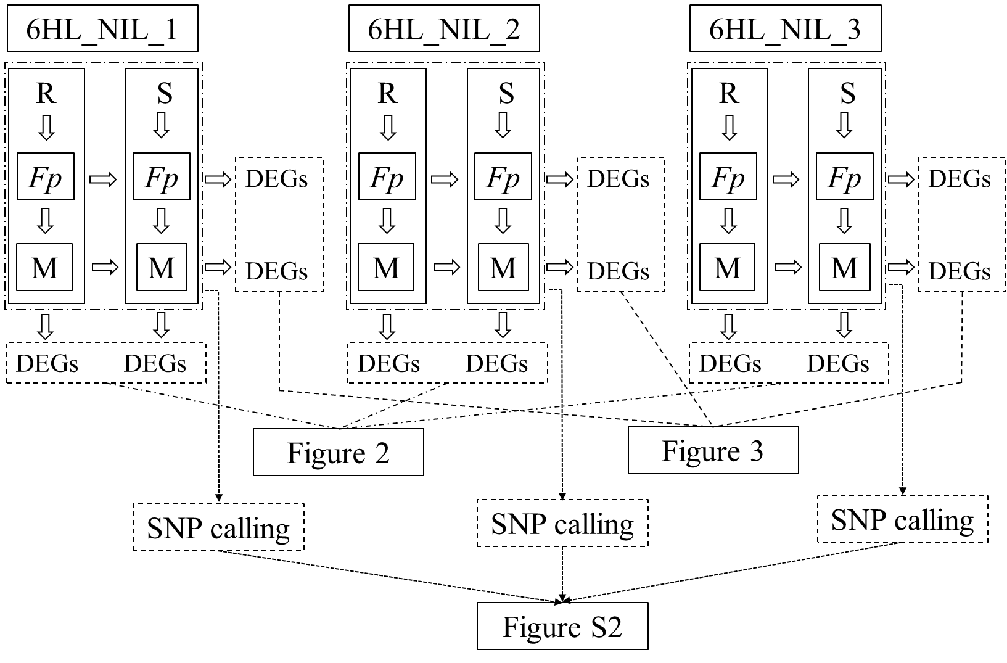
Figure S1. Schematic showing the experimental design for differential gene expression analysis and SNP calling.
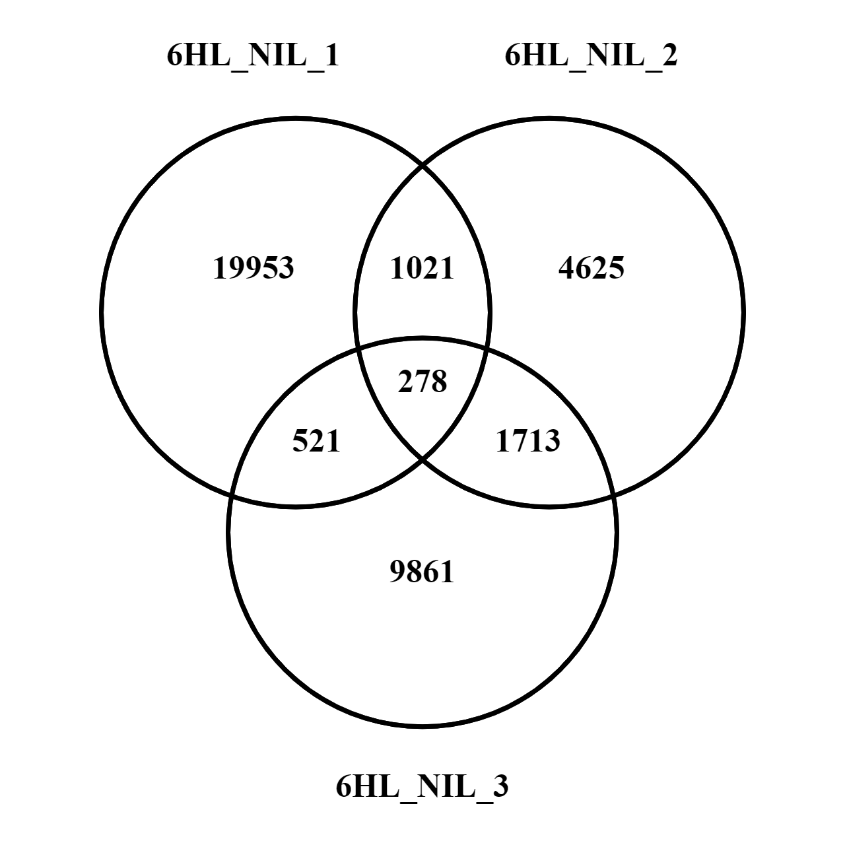
Figure S2. Numbers of SNPs detected between R and S isolines. A Venn diagram showing the numbers of unique and common SNPs between resistant and susceptible isolines among three NIL pairs.
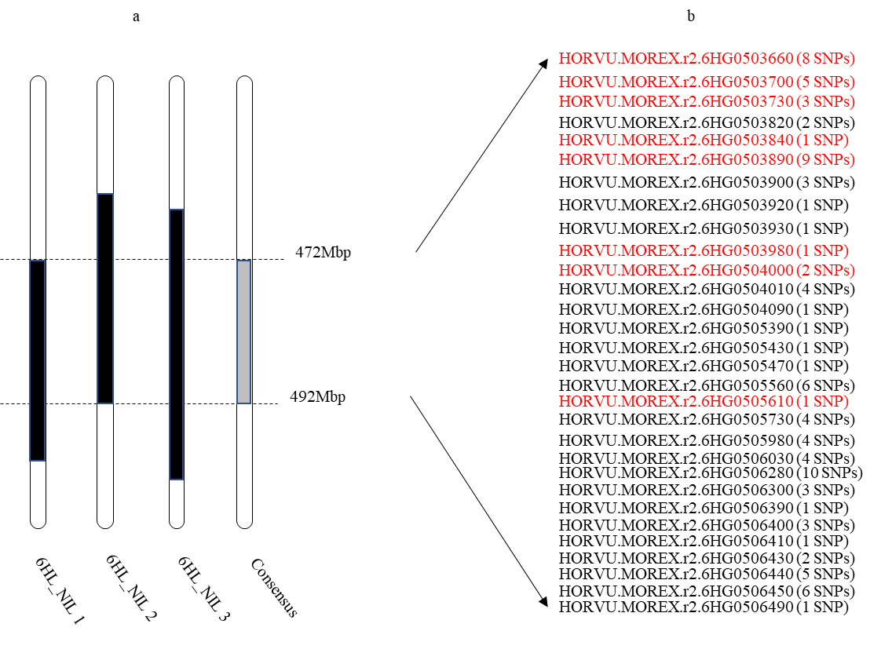
Figure S3. High confident genes identified within the consensus SNP-enriched region. a The physical range of SNP-enriched region. Black boxes indicate the regions defined by SNPs within each 6HL-NIL pair; the grey box represents the consensus region. b High confident genes containing the SNPs among the three comparisons within the consensus region. The numbers of SNPs identified within genes were in brackets and DEGs detected between isolines for at least one of the NIL pairs in the region were marked in red.
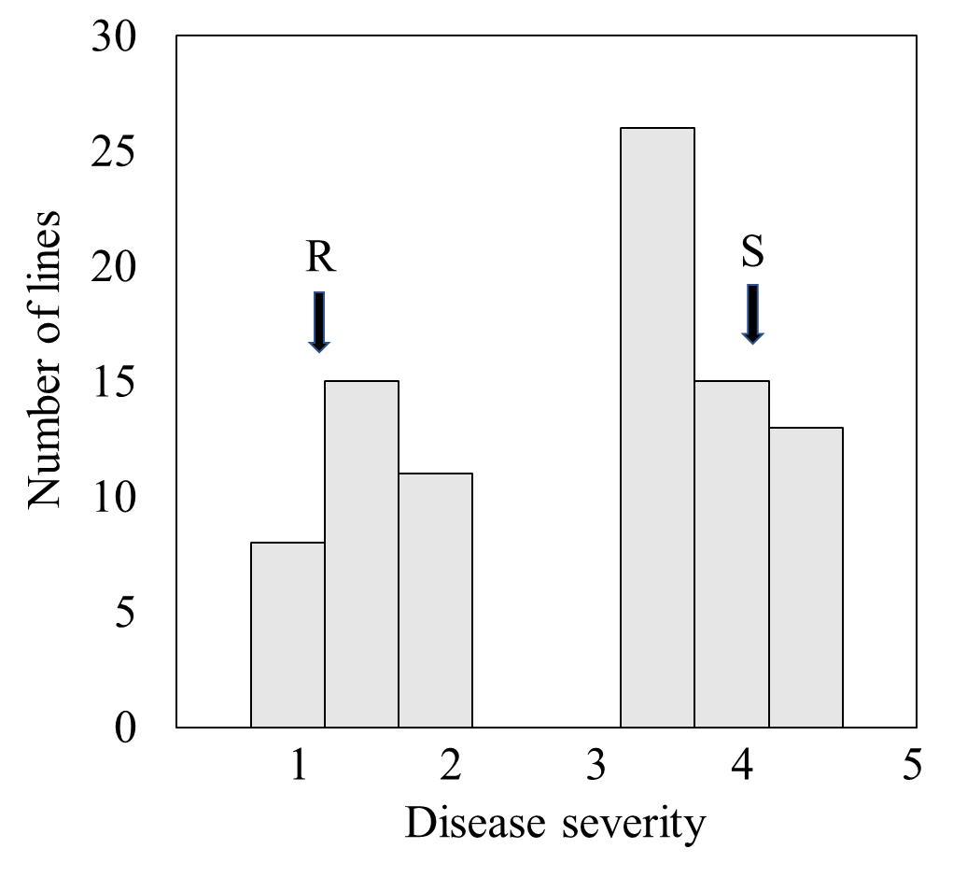
Figure S4. Distribution of FCR severity in the subpopulation of 88 lines. Disease severities of the two controls (NIL_CR6HL_1R and NIL_CR6HL_1S) were indicated with black arrows.

