Authors biography

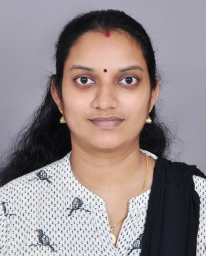
Mrs. Juliet A Murali recived her M Tceh in Computer Science and Engineering from Karunya Institute of Technology and Sciences , India. She has completed her B. Tech in Information Technology from Mahatma Gandhi University , India. Currently, she is doing part–time Ph. D in the Department of Computer Science at Noorul Islam Centre for Higher Education,India. Her area of interest includes cloud computing, parallel processing and distributed computing.

T Brindha received her Ph.D degree in Cloud Computing from Noorul Islam Centre for Higher Education, India. She has completed her M.E degree in Software Engineering from Periyar Manniammai College of Engineering, Anna University, India and her B.Tech degree from Jayamatha Engineering College, Anna University, India. Currently, she is working as an Associate Professor in the Department of Information Technology at Noorul Islam Centre for Higher Education. Her area of interest includes cloud computing, service oriented computing, parallel processing and distributed computing. She has published more than 15 papers in reputed journals.

