Supplementary Information

Foldable Metal-Organic Framework as Origamic Mechanical Metamaterial

Eunji Jin¹, In Seong Lee¹, D. ChangMo Yang¹, Dohyun Moon², Joohan Nam¹, Eunyoung Kang¹, Junghye Lee¹, Hyuk-Jun Noh¹, Seung Kyu Min^{*,1,3}, and Wonyoung Choe^{*,1}

¹Department of Chemistry, Ulsan National Institute of Science and Technology, 50 UNIST, Ulsan 44919, Republic of Korea
²Beamline Department, Pohang Accelerator Laboratory, Pohang, Republic of Korea
³Center for Multidimensional Carbon Materials (CMCM), Institute for Basic Science (IBS), Ulsan 44919, Republic of Korea

*Corresponding author: skmin@unist.ac.kr and choe@unist.ac.kr

1. Materials and Methods
Ligand Synthesis
The 5, 10, 15, 20-tetrakis [4-carboxymethyleneoxyphenyl] porphyrin (TCMOPP) was synthesized by the literature.^{1,2} The synthesis for the porphyrin linker consists of three steps.
Synthesis of 4-carboethoxymethyleneoxybenzaldehyde: 4-hydroxybenzaldehyde (12.2 g, 100 mmol) and ethyl bromoacetate (10.6 mL, 100 mmol) were dissolved in 100 mL of acetone. The solution added to anhydrous potassium carbonate (13.8 g, 100 mmol) was reacted for 8 hours at 70 °C using reflux. After the reaction, all solution was removed by using a rotary evaporator and extracted with H₂O/CHCl₃. The solvent of the separated organic phase was removed, and the crude product was obtained from a mixture of 0.5 % MeOH in CHCl₃. A solid white product was obtained. ¹H NMR (400 MHz, CDCl₃) δ 9.87 (s, 1H), 7.82 (d, 2H), 6.97 (d, 2H), 4.68 (s, 2H), 4.26 (q, 2H), 1.27 (t, 3H).
Synthesis of TEMOPP (5, 10, 15, 20-tetrakis [4-carboethoxymethyleneoxyphenyl] porphyrin): 4-carboethoxymethyleneoxybenzaldehyde (4.2 g, 20.19 mmol) and pyrrole (1.4 mL, 20.27 mmol) were dissolved in 20 mL of nitrobenzene and 40 mL of propionic acid. The solution was heated at 170 °C for 1 hour and then stored for 24 hours at room temperature. After then, the solvent of the mixture was removed except for a small volume and the silica gel was added to the mixture. The powder was loaded on the silica of the chromatography column. The crude product was obtained with 2 % acetone in CHCl₃. The violet crude product was recrystallized with MeOH and CHCl₃ at low temperatures. The purple powder was filtered and dried in an oven. ¹H NMR (400 MHz, CDCl₃) δ 8.84 (s, 8H), 8.12 (d, 8H), 7.29 (d, 8H), 4.92 (s, 8H), 4.41 (q, 8H), 1.41 (t, 12H), -2.78 (s, 2H).
Synthesis of TCMOPP (5, 10, 15, 20-tetrakis [4-carboxymethyleneoxyphenyl] porphyrin): TEMOPP (0.2 g, 0.195 mmol) was refluxed with sodium hydroxide (67 mg, 1.675 mmol) and H₂O of 2 mL in MeOH of 20 mL for 4 hours. After then, the solvent was removed by using a rotary evaporator. 4 mL of 0.5 N HCl solution was added to a crude product. After protonation, the color of the precipitate is green. The product was filtered, washed with water, and dried. The green product was dissolved in 600 μL of pyridine for neutralization of porphyrin and pyridine was removed by a rotary evaporator. Then, the final product was washed with water, filtered, and dried under a vacuum (94 %). ¹H NMR (400 MHz, DMSO-D6) δ 8.82 (s, 8H), 8.10 (d, 8H), 7.33 (d, 8H), 4.94 (s, 8H), -2.92 (s, 2H).

Supplementary Scheme 1. The synthetic procedure of TCMOPP.

Computational Details
Potential energy surface. Potential energy surface (PES) calculations were done with density functional theory using the hybrid functional B3LYP^{3–6}, as implemented in the Gaussian 16 package⁷. Empirical dispersion corrections D3 by Grimme and coworkers were added, with Becke-Johnson damping.⁸ For the basis set, cc-pVDZ was used.⁹ The structure of the isolated aryloxy group was specified with internal coordinates including α and φ. The scan was made adiabatically in increments of ∆α = ∆φ = 1° within the ranges.
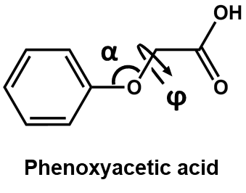
Elastic constants. Quantum mechanical calculations were performed based on density-functional theory (DFT) using the VASP program.¹⁰ For DFT calculation, Perdew-Burke-Ernzerhof exchange-correlation functional¹¹ was used with the plane wave cutoff of 500 eV. Further, DFT-D3 dispersion correction with Becke-Johnson damping function was used.¹² The initial molecular configuration was constructed from the experimental X-ray crystal structure which contains 1,208 atoms in a unit cell with a volume of 1.3 × 10⁴ Å³. First, geometries as well as lattice parameters were optimized at Γ-point since the unit cell is reasonably large. The optimized lattice parameters with DFT are a = 21.158 Å, b = 23.866 Å, c = 27.677 Å, α = 98.622˚, β = 104.977˚, and γ = 103.696˚, implying similar crystal structure with the experimental X-ray crystal structure (Supplementary Table 1). In the cartesian coordinate, the optimized cell parameters are represented as a = (21.16, 0.0, 0.0), b = (−5.65, 23.19, 0.0), and c = (−7.15, −6.01, 26.05) in Å.
In addition, elastic constants were obtained by calculating total electronic energies to external distortions from the ElaStic program¹³. Using Voigt notation, the relation between Lagrangian strains η_{i} and stresses τ_{i} can be written as
$$τ_{i}=\sum_{j=1}^{6}{C_{ij}η_{i}}$$
where C_{ij} is the stiffness tensor of material properties. Triclinic materials have 21 independent elements: C₁₁, C₁₂, C₁₃, ⋯, C₆₆ and 21 independent distortions, D_{i} (i = 1, ⋯, 21) to lattice vectors were applied to determine these elements. Detailed information about the distortion and the energies of a strained crystal can be found in the literature.¹³ For the DFT method, 17 points for each distortion were used and the maximum Lagrangian strain is 0.04. Further, second order of elastic constants and energy choose as a method of calculation for the evaluation of elastic constants. From the above distortions D_{i}, C_{ij}'s were obtained based on polynomial fittings to the energies of a strained crystal. Polynomial functions are well fitted to the data points. There are the calculated stiffness components (C_{ij}'s) in the GPa unit,
$$\left(\begin{matrix}C_{11} & C_{12} & C_{13} & C_{14} & C_{15} & C_{16} \\ C_{21} & C_{22} & C_{23} & C_{24} & C_{25} & C_{26} \\ C_{31} & C_{32} & C_{33} & C_{34} & C_{35} & C_{36} \\ C_{41} & C_{42} & C_{43} & C_{44} & C_{45} & C_{46} \\ C_{51} & C_{52} & C_{53} & C_{54} & C_{55} & C_{56} \\ C_{61} & C_{62} & C_{63} & C_{64} & C_{65} & C_{66}\end{matrix}\right)=\left(\begin{matrix}15.4 & 7.0 & 4.9 & 2.0 & 1.2 & 3.7 \\ 0 & 10.8 & 6.8 & -0.2 & 0.3 & 3.2 \\ 0 & 0 & 13.0 & 0.2 & 1.3 & 1.9 \\ 0 & 0 & 0 & 5.7 & 0.4 & -0.0 \\ 0 & 0 & 0 & 0 & 4.6 & 1.9 \\ 0 & 0 & 0 & 0 & 0 & 4.3\end{matrix}\right)$$
and compliance components (S_{ij}'s) in 1/GPa unit
$$\left(\begin{matrix}S_{11} & S_{12} & S_{13} & S_{14} & S_{15} & S_{16} \\ S_{21} & S_{22} & S_{23} & S_{24} & S_{25} & S_{26} \\ S_{31} & S_{32} & S_{33} & S_{34} & S_{35} & S_{36} \\ S_{41} & S_{42} & S_{43} & S_{44} & S_{45} & S_{46} \\ S_{51} & S_{52} & S_{53} & S_{54} & S_{55} & S_{56} \\ S_{61} & S_{62} & S_{63} & S_{64} & S_{65} & S_{66}\end{matrix}\right)=\left(\begin{matrix}0.109 & -0.052 & -0.005 & -0.040 & 0.003 & -0.055 \\ 0 & 0.201 & -0.078 & 0.024 & 0.060 & -0.096 \\ 0 & 0 & 0.120 & -0.003 & -0.037 & 0.025 \\ 0 & 0 & 0 & 0.191 & -0.017 & 0.027 \\ 0 & 0 & 0 & 0 & 0.289 & -0.161 \\ 0 & 0 & 0 & 0 & 0 & 0.413\end{matrix}\right)$$
Furthermore, the stability of the crystal was checked by using the fact that the strain energy (C_{ij}η_{i}η_{j}) must be positive-definite, calculating the determinants of the elastic stiffness constants matrices. PPF-301 satisfies this condition showing the values from 15.4 to 5.71 $×$ 10⁴ with DFT calculation.
In addition, Young's modulus (E), Poisson's ratio (ν), shear modulus (G), and bulk modulus (B) can be obtained in terms of C_{ij}'s or S_{ij}'s. For the calculation of bulk and shear moduli; Voigt and Reuss representations as
$$B_{V}=\frac{1}{9}\left[\left(C_{11}+C_{22}+C_{33}\right)+2\left(C_{12}+C_{13}+C_{23}\right)\right]$$
$$G_{V}=\frac{1}{15}\left[\left(C_{11}+C_{22}+C_{33}\right)-\left(C_{12}+C_{13}+C_{23}\right)+3\left(C_{44}+C_{55}+C_{66}\right)\right]$$
and
$$B_{R}={\left[\left(S_{11}+S_{22}+S_{33}\right)+2\left(S_{12}+S_{13}+S_{23}\right)\right]}^{-1}$$
$$G_{R}=15{\left[4\left(S_{11}+S_{22}+S_{33}\right)-4\left(S_{12}+S_{13}+S_{23}\right)+3\left(S_{44}+S_{55}+S_{66}\right)\right]}^{-1}$$
Young's modulus and Poisson's ratio can be simply calculated from bulk (B = 1/2(B_{V} + B_{R})) and shear (G = 1/2(G_{V} + G_{R})) moduli using the assumption that the material is isotropic. There are two representations according to the values of bulk and shear moduli, and these are expressed by
$$E=\frac{9BG}{3B+G}$$
$$ν=\frac{3B-2G}{2\left(3B+G\right)}$$
With the calculated elastic stiffness constants, the spatial dependence of elastic moduli and Poisson’s ratio were analyzed from the ELATE software.¹⁴ Maximum and minimum values, as well as anisotropy (A) for Young's modulus, linear compressibility (β), shear modulus, and Poisson’s ratio, were obtained. Linear compressibility is defined as a reciprocal number of the Bulk modulus; thus, it has a unit of 1/TPa. Anisotropy is defined as a maximal value of the elastic moduli divided by a minimal value. When the value becomes negative, the anisotropy is expressed to infinity.

2. Structural analysis and characterization of PPF-301
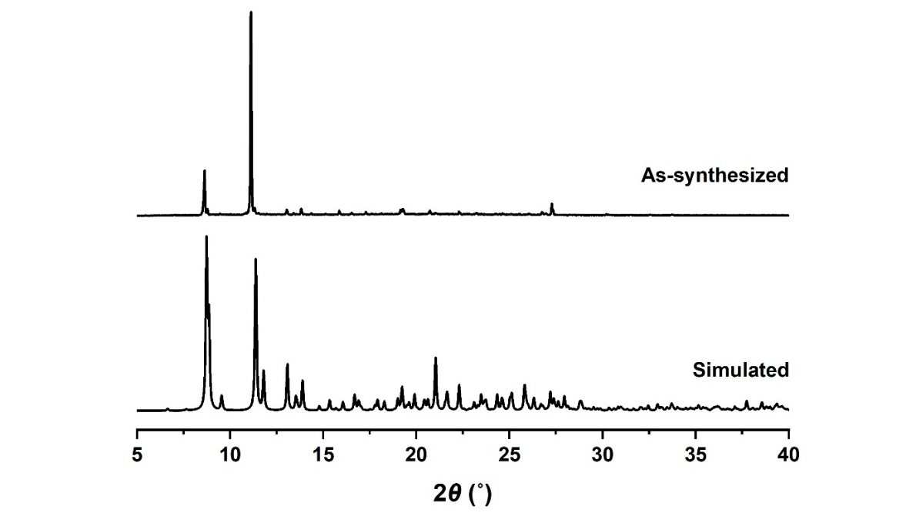
Supplementary Figure 1. Simulated and experimental PXRD patterns of PPF-301.

Supplementary Figure 2. The stacking of the sheets in a unitcell, embedded to $(\overline{1}11)$ plane.

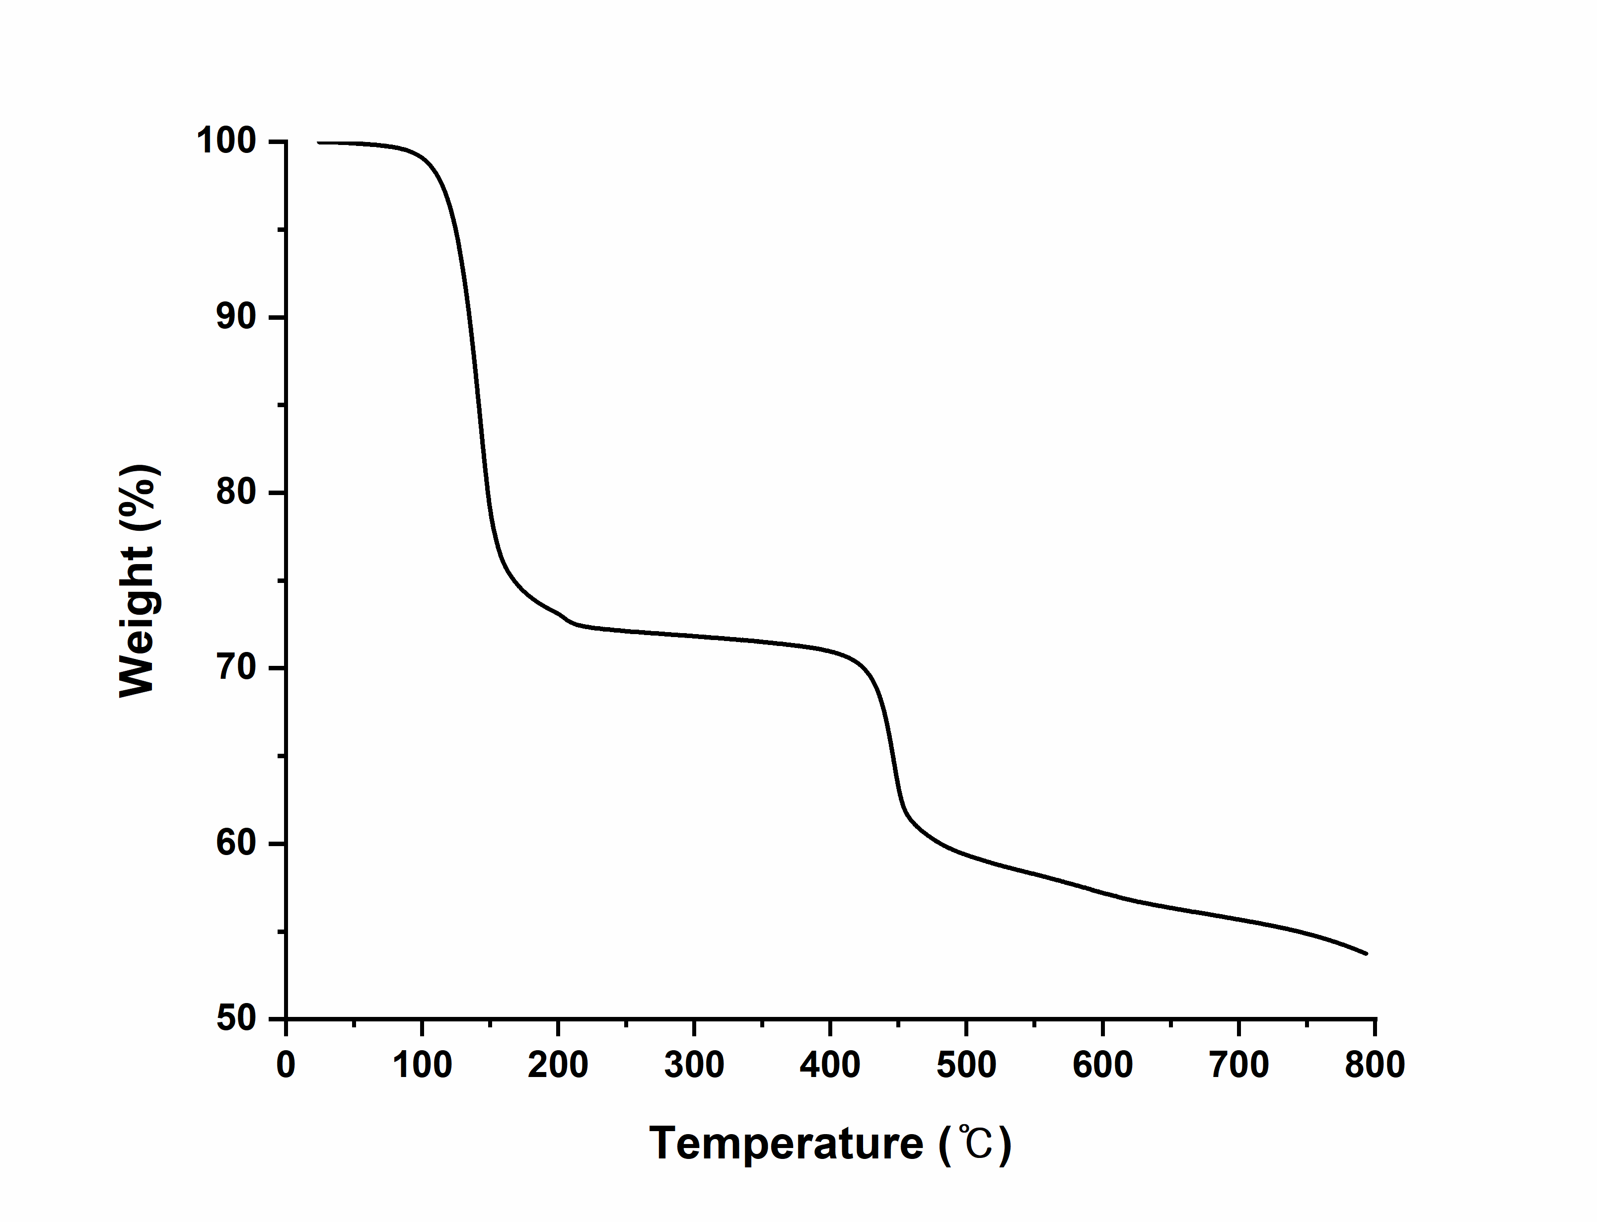
Supplementary Figure 3. Thermogravimetric analysis data for PPF-301. The initial weight loss (~27 %, 30–150 °C) represents the removal of solvents. The next weight loss represents the decomposition of the structure at around 430 °C (~40 %).

Supplementary Figure 4. N₂ isotherm of PPF-301 at 77 K.

Supplementary Figure 5. CO₂ uptake of PPF-301 at 195, 273, and 298 K. The small amounts of CO₂ adsorbed 4.26, 1.96, and 1.77 mmol/g, respectively.

3. Temperature-dependent experiments
Supplementary Table 1. Temperature-dependent crystallographic data of PPF-301.
Complex | PPF-301_100 | PPF-301_120 | PPF-301_140 | PPF-301_160
Formula | C₇₀H₇₄N₁₀O₁₈Zn₃ | C₇₀H₇₄N₁₀O₁₈Zn₃ | C₇₀H₇₄N₁₀O₁₈Zn₃ | C₇₀H₇₄N₁₀O₁₈Zn₃
T (K) | 100(2) | 120(2) | 140(2) | 160(2)
Crystal system | Triclinic | Triclinic | Triclinic | Triclinic
Space group | P-1 | P-1 | P-1 | P-1
a (Å) | 10.855(2) | 10.868(2) | 10.885(2) | 10.902(2)
b (Å) | 12.536(3) | 12.558(3) | 12.583(3) | 12.611(3)
c (Å) | 14.026(3) | 14.033(3) | 14.038(3) | 14.040(3)
V (Å³) | 1723.0(7) | 1728.0(7) | 1733.4(7) | 1738.6(7)
α (°) | 100.69(3) | 100.68(3) | 100.70(3) | 100.72(3)
β (°) | 101.29(3) | 101.29(3) | 101.26(3) | 101.21(3)
γ (°) | 107.50(3) | 107.59(3) | 107.72(3) | 107.86(3)
Z | 1 | 1 | 1 | 1
R1 [I > 2σ(I)] | 0.0525 | 0.0526 | 0.0529 | 0.0534
wR2 [I > 2σ(I)] | 0.1537 | 0.1586 | 0.1565 | 0.1577
R1 [all data] | 0.0696 | 0.0701 | 0.0709 | 0.0727
wR2 [all data] | 0.1609 | 0.1667 | 0.1646 | 0.1659
CCDC number | 2122043 | 2122044 | 2122045 | 2122046

Complex | PPF-301_180 | PPF-301_200 | PPF-301_220 | PPF-301_240
Formula | C₇₀H₇₄N₁₀O₁₈Zn₃ | C₇₀H₇₄N₁₀O₁₈Zn₃ | C₇₀H₇₄N₁₀O₁₈Zn₃ | C₇₀H₇₄N₁₀O₁₈Zn₃
T (K) | 180(2) | 200(2) | 220(2) | 240(2)
Crystal system | Triclinic | Triclinic | Triclinic | Triclinic
Space group | P-1 | P-1 | P-1 | P-1
a (Å) | 10.921(2) | 10.941(2) | 10.964(2) | 10.986(2)
b (Å) | 12.640(3) | 12.674(3) | 12.707(3) | 12.739(3)
c (Å) | 14.041(3) | 14.043(3) | 14.047(3) | 14.050(3)
V (Å³) | 1744.1(7) | 1750.3(7) | 1757.0(7) | 1763.4(7)
α (°) | 100.74(3) | 100.78(3) | 100.80(3) | 100.81(3)
β (°) | 101.16(3) | 101.10(3) | 101.05(3) | 101.00(3)
γ (°) | 108.02(3) | 108.21(3) | 108.39(3) | 108.57(3)
Z | 1 | 1 | 1 | 1
R1 [I > 2σ(I)] | 0.0539 | 0.0533 | 0.0543 | 0.0547
wR2 [I > 2σ(I)] | 0.1591 | 0.1563 | 0.1587 | 0.1586
R1 [all data] | 0.0741 | 0.0746 | 0.0782 | 0.0796
wR2 [all data] | 0.1670 | 0.1648 | 0.1679 | 0.1681
CCDC number | 2122047 | 2122048 | 2122049 | 2122050

Complex | PPF-301_260 | PPF-301_280 | PPF-301_300 | PPF-301_320
Formula | C₇₀H₇₄N₁₀O₁₈Zn₃ | C₇₀H₇₄N₁₀O₁₈Zn₃ | C₇₀H₇₄N₁₀O₁₈Zn₃ | C₇₀H₇₄N₁₀O₁₈Zn₃
T (K) | 260(2) | 280(2) | 300(2) | 320(2)
Crystal system | Triclinic | Triclinic | Triclinic | Triclinic
Space group | P-1 | P-1 | P-1 | P-1
a (Å) | 11.010(2) | 11.035(2) | 11.061(2) | 11.089(2)
b (Å) | 12.773(3) | 12.807(3) | 12.842(3) | 12.877(3)
c (Å) | 14.055(3) | 14.060(3) | 14.065(3) | 14.071(3)
V (Å³) | 1770.5(7) | 1777.9(7) | 1785.6(7) | 1793.5(7)
α (°) | 100.81(3) | 100.80(3) | 100.77(3) | 100.74(3)
β (°) | 100.97(3) | 101.95(3) | 100.93(3) | 100.94(3)
γ (°) | 108.75(3) | 108.93(3) | 109.11(3) | 109.29(3)
Z | 1 | 1 | 1 | 1
R1 [I > 2σ(I)] | 0.0546 | 0.0552 | 0.0554 | 0.0565
wR2 [I > 2σ(I)] | 0.1581 | 0.1592 | 0.1599 | 0.1628
R1 [all data] | 0.0829 | 0.0867 | 0.0913 | 0.0960
wR2 [all data] | 0.1693 | 0.1706 | 0.1728 | 0.1771
CCDC number | 2122051 | 2122052 | 2122053 | 2122054

Complex | PPF-301_340 | PPF-301_360 | PPF-301_380
Formula | C₇₀H₇₄N₁₀O₁₈Zn₃ | C₇₀H₇₄N₁₀O₁₈Zn₃ | C₇₀H₇₄N₁₀O₁₈Zn₃
T (K) | 340(2) | 360(2) | 380(2)
Crystal system | Triclinic | Triclinic | Triclinic
Space group | P-1 | P-1 | P-1
a (Å) | 11.115(2) | 11.142(2) | 11.168(2)
b (Å) | 12.904(3) | 12.925(3) | 12.952(3)
c (Å) | 14.076(3) | 14.083(3) | 14.088(3)
V (Å³) | 1800.1(7) | 1806.3(7) | 1812.8(7)
α (°) | 100.70(3) | 100.65(3) | 100.60(3)
β (°) | 100.96(3) | 101.01(3) | 101.05(3)
γ (°) | 109.45(3) | 109.59(3) | 109.74(3)
Z | 1 | 1 | 1
R1 [I > 2σ(I)] | 0.0569 | 0.0585 | 0.0619
wR2 [I > 2σ(I)] | 0.1633 | 0.1692 | 0.1859
R1 [all data] | 0.1004 | 0.1089 | 0.1069
wR2 [all data] | 0.1779 | 0.1868 | 0.2042
CCDC number | 2122055 | 2122056 | 2122057

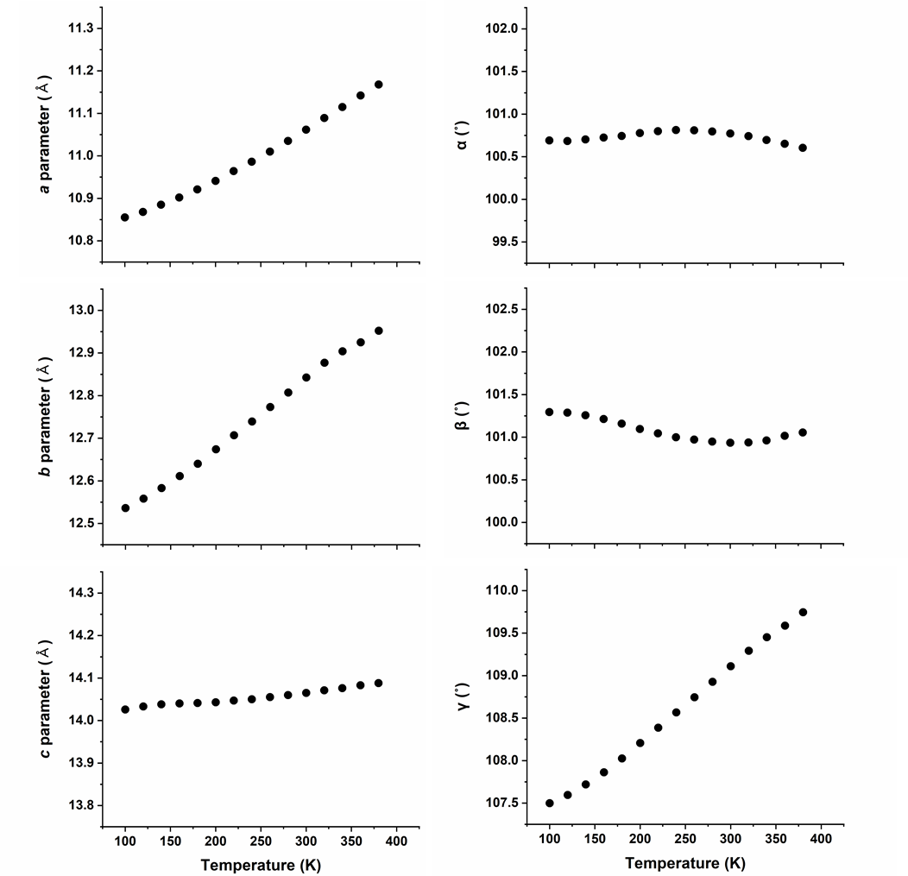
Supplementary Figure 6. Lattice parameters at variable temperatures of PPF-301 (The small error bar is represented in the graph).

Supplementary Figure 7. Cell volume at variable temperature (The small error bar is represented in the graph).

Supplementary Table 2. The lengths, area and cell volume at variable temperatures.
T (K) | d₁ (Å) | d₂ (Å) | σ (°) | Area (S) (Å²) | Interlayer (Å) | V (Å³)
100 | 15.97 | 13.90 | 86.26 | 221.43 | 7.78 | 1723.0
120 | 15.98 | 13.90 | 86.30 | 221.71 | 7.79 | 1728.0
140 | 16.00 | 13.91 | 86.35 | 222.03 | 7.81 | 1733.4
160 | 16.01 | 13.91 | 86.40 | 222.36 | 7.82 | 1738.6
180 | 16.03 | 13.92 | 86.45 | 222.68 | 7.83 | 1744.1
200 | 16.05 | 13.92 | 86.54 | 223.02 | 7.85 | 1750.3
220 | 16.08 | 13.92 | 86.59 | 223.43 | 7.86 | 1757.0
240 | 16.10 | 13.92 | 86.65 | 223.76 | 7.88 | 1763.4
260 | 16.12 | 13.93 | 86.70 | 224.16 | 7.90 | 1770.5
280 | 16.14 | 13.93 | 86.76 | 224.51 | 7.92 | 1777.9
300 | 16.16 | 13.94 | 86.80 | 224.89 | 7.94 | 1785.6
320 | 16.18 | 13.94 | 86.85 | 225.25 | 7.96 | 1793.5
340 | 16.19 | 13.95 | 86.87 | 225.51 | 7.98 | 1800.1
360 | 16.20 | 13.95 | 86.89 | 225.72 | 8.00 | 1806.3
380 | 16.21 | 13.96 | 86.92 | 225.95 | 8.02 | 1812.8
% Change | 1.55 | 0.42 | 0.77 | 2.04 | 3.11 | 5.21

Thermal expansion coefficient (α) of PPF-301
Supplementary Table 3. Principal coefficients of thermal expansion and corresponding principal axes, determined for PPF-301 (MK⁻¹, 10⁻⁶ K⁻¹) in the range of 100–380 K.
Principal axis, i | α_{i} (MK⁻¹) | Component of X_{i} along the crystallographic axes |  |  |  | Approximate axis
Principal axis, i | α_{i} (MK⁻¹) | a |  | b | c | Approximate axis
X₁ | 2.1(4) |  | 0.6703 | 0.5718 | 0.4731 | $$\left[122\right]$$
X₂ | 17(1) |  | -0.5970 | -0.3233 | 0.7342 | $$\left[\overline{2}\overline{1}1\right]$$
X₃ | 170(3) |  | 0.6842 | -0.7220 | 0.1024 | $$\left[1\overline{1}0\right]$$
V | 192(3) |  | - | - | - | -

a
b
c
Supplementary Figure 8. Thermal expansion coefficients (α) of PPF-301. a, The thermal expansion indicatrix (red positive) of PPF-301 along the principle orthogonal axis X₃. The fitting graph is the change of b, lengths and c, volume from 100 K to 380 K.

Supplementary Table 4. Thermal expansion coefficients (α) of 2D solid-state materials.
Compound | T (K) | max α (10⁻⁶ K⁻¹) |  |  |  | Ref
Compound | T (K) | a (or X₁) | b (or X₂) | c (or X₃) | V | Ref
PPF-301 | 100–380 | 2.1(4) | 17(1) | 170(3) | 192(3) | This work
Zn2-1 | 80–293 | 12.09 | 14.08 | 49.32 | 78.78 | 15
Compound 1 | 100–350 | -36(2) | 2.5(9) | 152(3) | 119(2) | 16
[Ni(pba)₂]·2DMA | 112–300 | 153(2) | 41(4) | -35(4) | 159(3) | 17
[Co(pba)₂] ·2DMA | 112–300 | 193(3) | 64(4) | -76(3) | 180(4) | 17
[Zn(pba)₂] ·2DMA | 112–300 | 187(2) | 89(3) | -84(3) | 191(2) | 17
[Zn_{0.77}Cd_{0.23}(pba)₂] ·2DMA | 112–300 | 188(4) | 142(4) | -134(5) | 195(5) | 17
[Cd(pba)₂] ·2DMA | 112–300 | 226(2) | 165(2) | -155(3) | 233(3) | 17
Ni(CN₂) | 28–300 | 6.5(1) | - | 61.8(3) | 48.5(4) | 18
LiBeBO₃ | 73–193 | -3.31(13) | -176(08) | 7.58(76) | - | 19

4. Geometrical analysis of 2D sheets based on origami tessellation
a
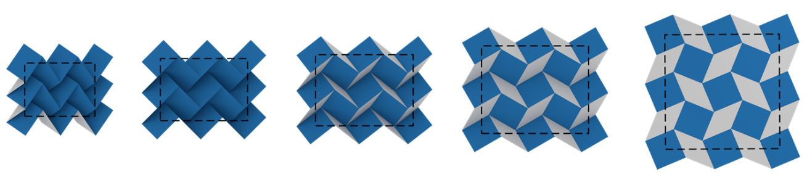
b
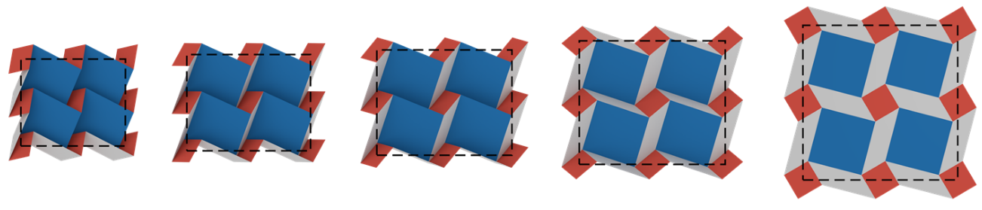
Supplementary Figure 9. Two types of DCS tessellations. a, Same-sized squares and b, Different-sized squares.

a
b
Supplementary Figure 10. Area changes of four types of tiles, filled in the 2D sheet at variable temperatures. a, Four types of different-sized tiles. A; Zn SBU (yellow), B; porphyrinic ligand (blue), C and D; hollow tiles (gray and dark gray, respectively). b, Variation of area depending on temperatures. The A, B, and D are rarely changed, and the C was gradually reduced.

Supplementary Figure 11. Schematic representation in a folding model with four types of tiles. θ₁, θ₂: Folding angles, l₁, l₂, l₃, l₄: Edges of tiles, α, β: Actual angles of tiles.
(Constants: l₁ = l₂ = 6.751 Å, l₃ = l₄ = 12.901 Å, α = 33.759°, β = 34.814°, δ = 90°)

Correlation between θ₁ and θ₂
$$A (x+l_{4}\cos{β},y-l_{4}\sin{β}\cos{θ_{2}},l_{4}\sin{β}\sin{θ_{2}})$$
$$B(x-l_{3}\sin{α}\cos{θ_{1}},y-l_{3}\cos{α},-l_{3}\sin{α}\sin{θ_{1}})$$

$$\overline{AB}=\sqrt{{l_{3}}^{2}+{l_{4}}^{2}-2l_{3}l_{4}\cos{δ}}$$
$$\vec{BA}=\left(l_{4}\cos{β}+l_{3}\sin{α}\cos{θ_{1}}, l_{3}\cos{α}-l_{4}\sin{β}\cos{θ_{2}}, l_{4}\sin{β}\sin{θ_{2}}+l_{3}\sin{α}\sin{θ_{1}}\right)$$

$${\overline{AB}}^{2}$$
$$={\left(l_{4}\cos{β}+l_{3}\sin{α}\cos{θ_{1}}\right)}^{2}+{\left(l_{3}\cos{α}-l_{4}\sin{β}\cos{θ_{2}}\right)}^{2}+{\left(l_{4}\sin{β}\sin{θ_{2}}+l_{3}\sin{α}\sin{θ_{1}}\right)}^{2}= {l_{3}}^{2}+{l_{4}}^{2}-2l_{3}l_{4}\cos{δ}$$
$$={\left(l^{'}\sin{α}\cos{θ_{1}}+l^{'}\cos{β}\right)}^{2}+{\left(-l^{'}\cos{α}+l^{'}\sin{β}\cos{θ_{2}}\right)}^{2}+{\left(l^{'}\sin{α}\sin{θ_{1}}+l^{'}\sin{β}\sin{θ_{2}}\right)}^{2}$$
$$-\sin{α}\cos{β}\cos{θ_{1}}+\cos{α}\sin{β}\cos{θ_{2}}-\sin{α}\sin{β}\sin{θ_{1}}\sin{θ_{2}}=\cos{δ}$$
Arrange in terms of $\sin{θ_{2}}$
$$\cos{θ_{2}}=\frac{\sin{α}\cos{β}\cos{θ_{1}}}{\cos{α}\sin{β}}+\frac{\sin{α}\sin{β}\sin{θ_{1}}\sin{θ_{2}}}{\cos{α}\sin{β}}$$
$$\cos{θ_{2}}=\frac{\tan{α}\cos{θ_{1}}}{\tan{β}}+\tan{α}\sin{θ_{1}}\sin{θ_{2}}$$
$$1-\sin^{2}{θ_{2}}={\left(\frac{\tan{α}\cos{θ_{1}}}{\tan{β}}\right)}^{2}+ {\left(\tan{α}\sin{θ_{1}}\sin{θ_{2}}\right)}^{2}+2\left(\frac{\tan{α}\cos{θ_{1}}}{\tan{β}}\right)\left(\tan{α}\sin{θ_{1}}\sin{θ_{2}}\right)$$
$$\left(\sin^{2}{θ_{1}\tan^{2}{α}}+1\right)\sin^{2}{θ_{2}}+\left(\frac{\tan^{2}{α}sin{2θ_{1}}}{\tan{β}}\right)\sin{θ_{2}}+\left[{\left(\frac{\tan{α}\cos{θ_{1}}}{\tan{β}}\right)}^{2}-1\right]=0$$
Using Quadratic formula $(\sin{θ_{2}}>0)$
$$\sin{θ_{2}}=\frac{-\left(\frac{\tan^{2}{α}sin{2θ_{1}}}{\tan{β}}\right)+\sqrt{{\left(\frac{\tan^{2}{α}sin{2θ_{1}}}{\tan{β}}\right)}^{2}-4\left(\sin^{2}{θ_{1}\tan^{2}{α}}+1\right)\left[{\left(\frac{\tan{α}\cos{θ_{1}}}{\tan{β}}\right)}^{2}-1\right]}}{2\left(\sin^{2}{θ_{1}\tan^{2}{α}}+1\right)}$$

Equation S1.
$$∴θ_{2}=\sin^{-1}\left(\frac{-\left(\frac{\tan^{2}{α}sin{2θ_{1}}}{\tan{β}}\right)+\sqrt{{\left(\frac{\tan^{2}{α}sin{2θ_{1}}}{\tan{β}}\right)}^{2}-4\left(\sin^{2}{θ_{1}\tan^{2}{α}}+1\right)\left[{\left(\frac{\tan{α}\cos{θ_{1}}}{\tan{β}}\right)}^{2}-1\right]}}{2\left(\sin^{2}{θ_{1}\tan^{2}{α}}+1\right)}\right)$$

Correlation between d₁, d₂ and θ₁
$$C (x+l_{4}\cos{β},y-l_{4}\sin{β}\cos{θ_{2}},l_{4}\sin{β}\sin{θ_{2}})$$
$$D (x-l_{3}\sin{α}\cos{θ_{1}},y-l_{3}\cos{α},-l_{3}\sin{α}\sin{θ_{1}})$$
$$O (0, 0, 0)$$

$$\vec{CO}=\left(-l_{4}\sin{α}\cos{θ_{1}}-l_{4}\cos{β}, l^{'}\sin{β}\cos{θ_{2}}-l_{4}\cos{α}, -l_{4}\sin{α}\sin{θ_{1}}-l_{4}\sin{β}\sin{θ_{2}}\right)$$
$$\vec{DO}=\left(-l_{3}\sin{α}\cos{θ_{1}}-l_{3}\cos{β}, l_{3}\sin{β}\cos{θ_{2}}-l_{3}\cos{α}, -l_{3}\sin{α}\sin{θ_{1}}-l_{3}\sin{β}\sin{θ_{2}}\right)$$

$$∴\overline{CO}=d_{1}=\sqrt{{\left(l_{1}-l_{4}\sin{α}\cos{θ_{1}}\right)}^{2}+{l_{4}}^{2}\cos^{2}{α}+{l_{4}}^{2}\sin^{2}{α}\sin^{2}{θ_{1}}}$$
$$∴\overline{DO}=d_{2}=\sqrt{{\left(l_{2}-l_{3}\sin{β}\cos{θ_{2}}\right)}^{2}+{l_{3}}^{2}\cos^{2}{β}+{l_{3}}^{2}\sin^{2}{β}\sin^{2}{θ_{2}}}$$
a
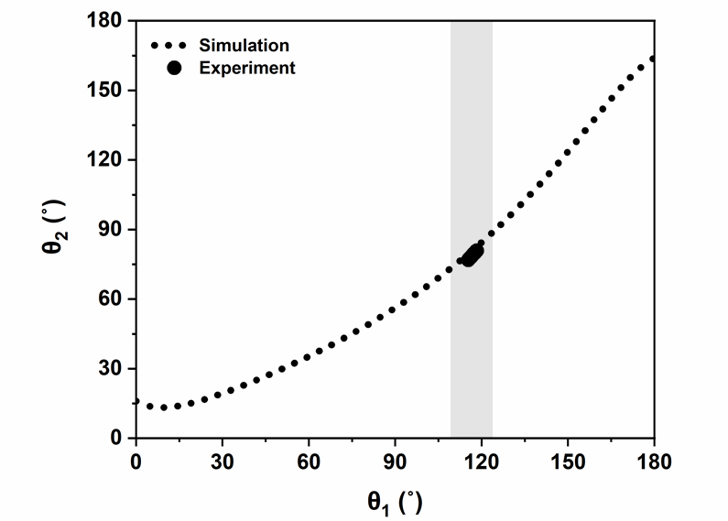
b
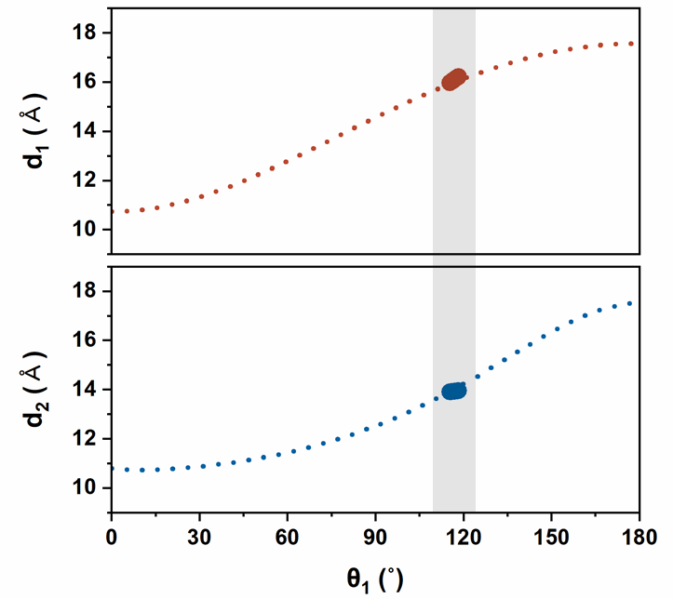
Supplementary Figure 12. A comparison between experiment and mathematical model. a, Relationships between folding angles; θ₁ and θ₂. b, Relationships between lengths (d₁ and d₂) and θ₁.

5. Origin of origami movement
Supplementary Table 5. Variation of dihedral angle (φ) and bond angle (α) of aryloxy group at 100 K and 380 K.
T (K) | φ_{A} (°) | α_{A} (°) | φ_{B} (°) | α_{B} (°)
100 | ±63.4 | 116.8 | ±71.2 | 116.5
380 | ±65.8 | 117.9 | ±72.1 | 117.2

6. Mechanical behavior of PPF-301
Supplementary Figure 13. Fitting curves for electronic energies for 21 independent distortions. A red solid line represents a polynomial fitting curve, while a black circle represents the electronic energy at a given distortion.
Supplementary Table 6. Calculated elastic moduli (GPa) and Poisson's ratio using the ElaStic program. (Voigt; V, Reuss; R)
Bulk modulus |  | Young's modulus |  | Shear modulus |  | Poisson's ratio
B_{V} | B_{R} | E_{V} | E_{R} | G_{V} | G_{R} | v_{V} | v_{R}
8.52 | 6.25 | 11.04 | 7.84 | 4.30 | 3.04 | 0.28 | 0.29

a
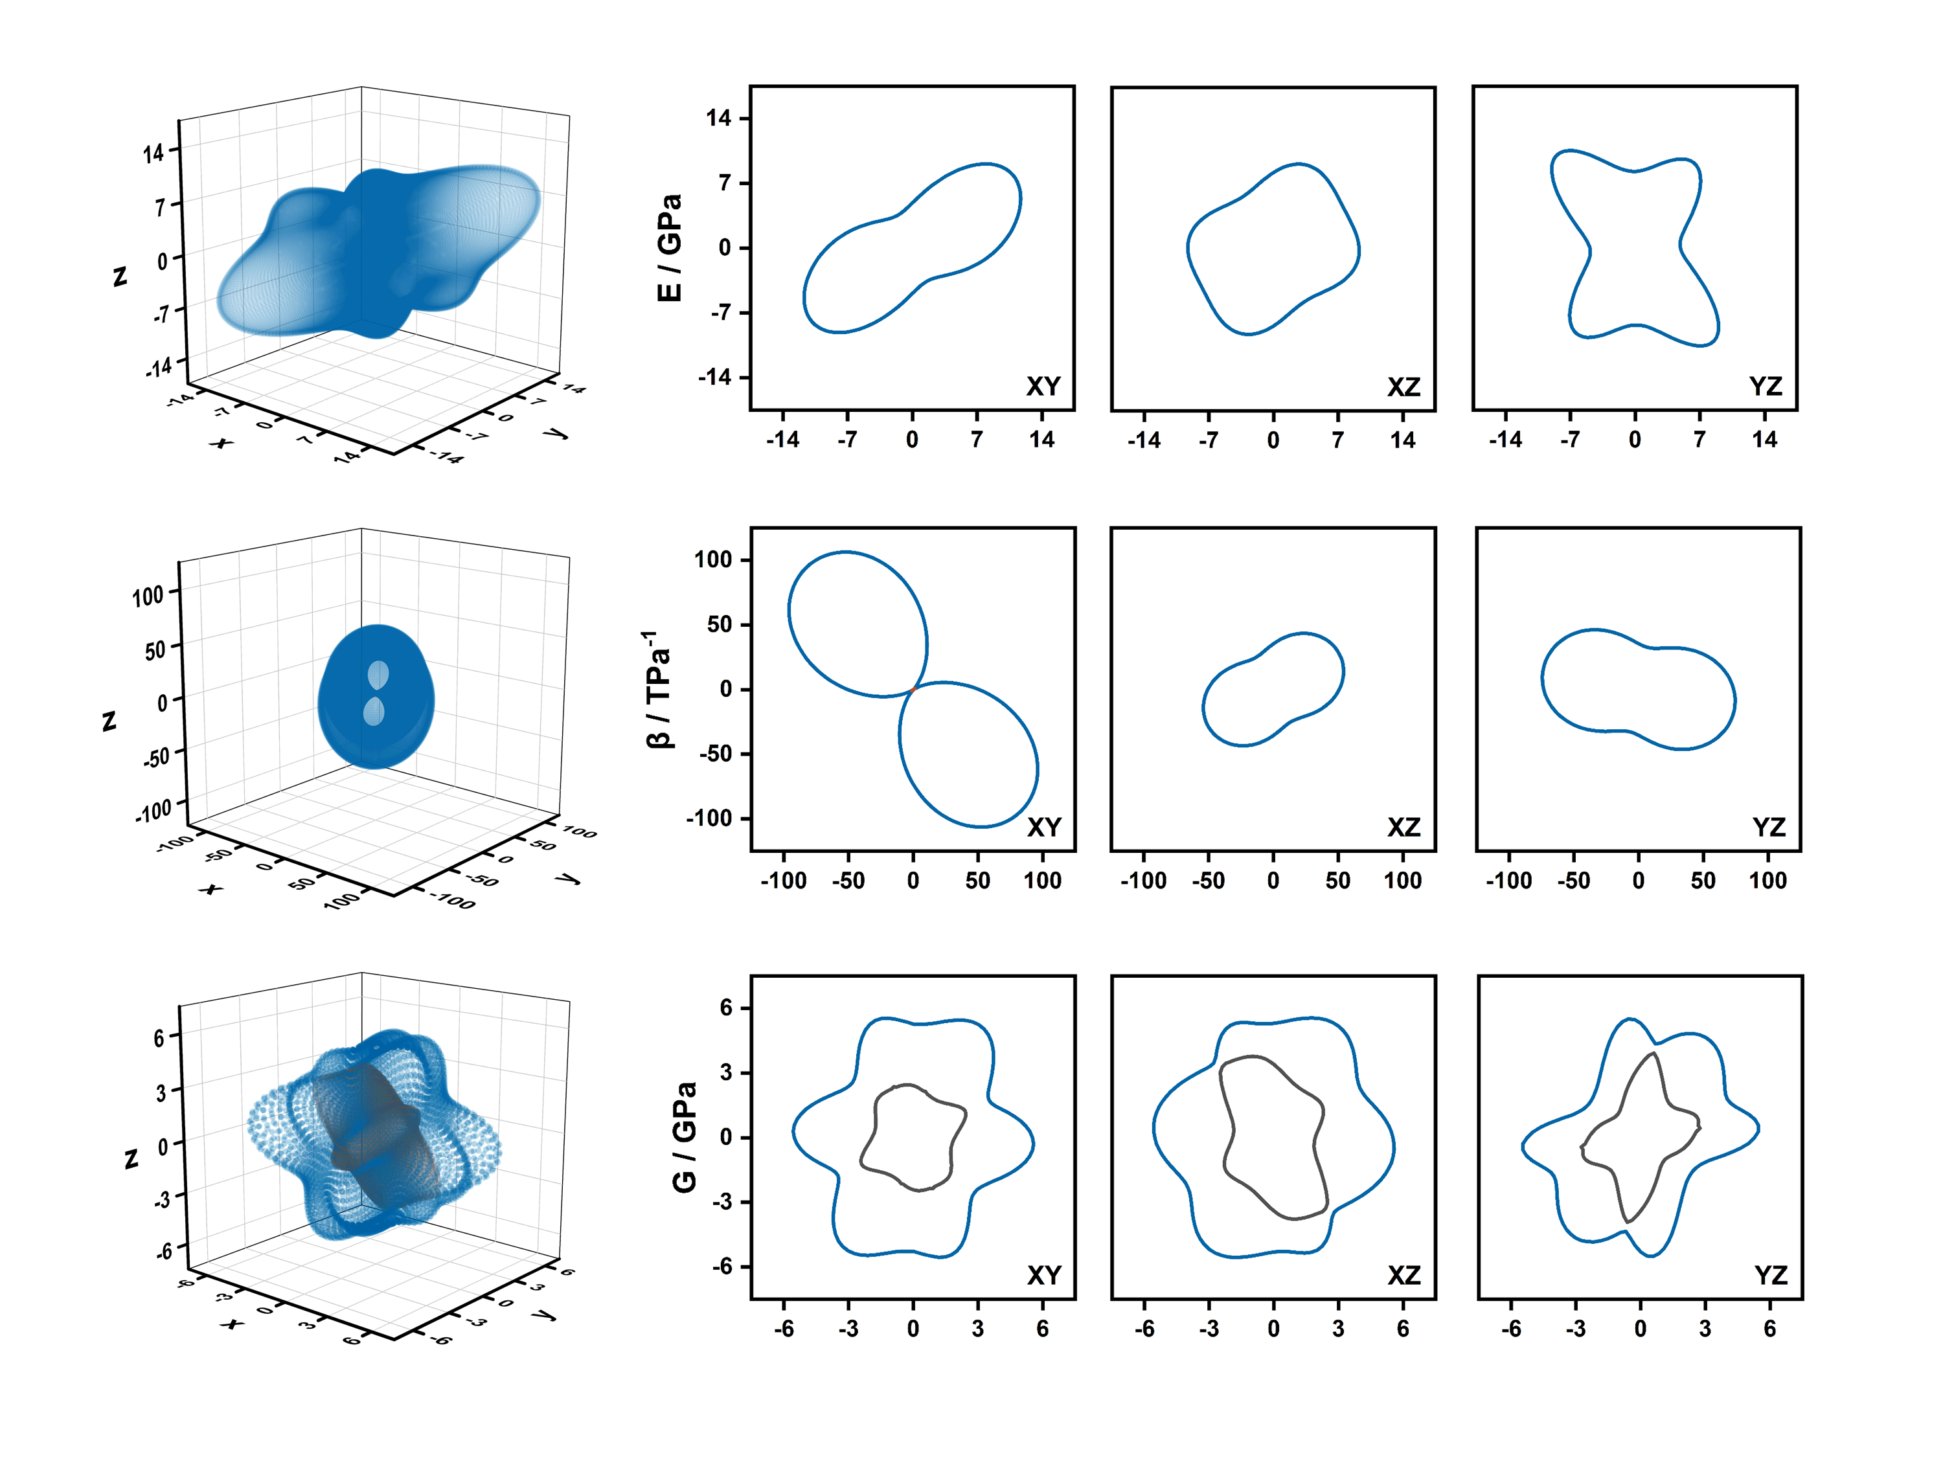
b
c
Supplementary Figure 14. 3D surfaces and 2D polar plots of elastic moduli for the xy, xz, and yz planes. a, Young's modulus (E), b, Linear compressibility (β), c, Shear modulus (G). Blue and black lines represent the maximal and minimal positive values, respectively, while the red line represents the minimal negative values over all possible values.

7. References
- Karmakar, A. & Goldberg, I. Flexible porphyrin tetracarboxylic acids for crystal engineering. CrystEngComm 12, 4095–4100 (2010).
- Das, T., Chakraborty, S., Sarma, H. D., Banerjee, S. & Venakatesh, M. A novel ¹⁷⁷Lu-labeled porphyrin for possible use in targeted tumor therapy. Nucl Med Biol. 37, 655–663 (2010).
- Stephens, P. J., Devlin, F. J., Chabalowski, C. F. & Frisch, M. J. Ab Initio calculation of vibrational absorption and circular dichroism spectra using density functional force fields. J. Phys. Chem. 98, 11623–11627 (1994).
- Lee, C., Yang, W. & Parr, R. G. Development of the colle-salvetti correlation-energy formula into a functional of the electron density. Phys. Rev. B 37 (2), 785–789 (1988).
- Becke, A. D. Density-functional exchange-energy approximation with correct asymptotic behavior. Phys. Rev. A 38 (6), 3098–3100 (1988).
- Becke, A. D. Density-functional thermochemistry. III. The role of exact exchange. J. Chem. Phys. 98 (7), 5648–5652 (1993).
- Frisch, M. J. et al. Gaussian 16 Revision C.01; Gaussian Inc.: Wallingford, CT, 2016.
- Grimme, S., Ehrlich, S. & Goerigk, L. Effect of the damping function in dispersion corrected density functional theory. J. Chem. Phys. 32 (7), 1456–1465 (2011).
- Dunning Jr., T. H. Gaussian basis sets for use in correlated molecular calculations. I. The atoms boron through neon and hydrogen. J. Chem. Phys. 90 (2), 1007–1023 (1989).
- Kressen, G.; Furthmüller, J. Efficient iterative schemes for ab initio total-energy calculations using a plane-wave basis set. Phys. Rev. B. 54, 11169–11186 (1996)
- Perdew, J. P.; Burke, K.; Ernzerhof, M. Generalized Gradient Approximation Made Simple. Phys. Rev. Lett. 77, 3865–3868 (1997).
- Grimme, S.; Ehrlich, S.; Goerigk, L. Effect of the Damping Function in Dispersion Corrected Density Functional Theory. J. Comput. Chem. 32, 1456–1465 (2011).
- Golesorkhtabar, R., Pavone, P., Spitaler, J., Puschnig, P. & Draxl, C. ElaStic: A tool for calculating second-order elastic constants from first principles. Comput. Phys. Commun. 184, 1861–1873 (2013).
- Gaillac, R., Pullumbi, P. & Coudert, F.-X. ELATE: an open-source online application for analysis and visualization of elastic tensors. J. Phys.: Condens. Matter 28, 275201 (2016).
- Shi, Y.-X., Chen, H.-H., Zhang, W.-H., Day, G. S., Lang, J.-P. & Zhou, H.-C. Photoinduced nonlinear contraction behavior in metal-organic frameworks. Chem. Eur. J. 25, 8543–8549 (2019).
- Shrivastava, A. & Das, D. Axial positive, negative, and zero thermal expansion in a mixed-metal mixed-linker coordination compound: role of 2D layer in the thermal expansion property. Cryst. Growth Des. 19, 4908–4913 (2019).
- Zhou, H.-L., Zhang, J.-P. & Chen, X.-M. Controlling thermal expansion behaviors of fence-like metal-organic frameworks by varying/mixing metal ions. Front. Chem. 6, 306 (2018).
- Hibble, S. J., Chippindale, A. M., Pohl, A. H. & Hannon, A. C. Surprise from a simple material-The structure and properties of nickel cyanide. Angew. Chem. 119, 7246–7248 (2007).
- Yao, W. et al. Area negative thermal expansion in a beryllium borate LiBeBO₃ with edge sharing tetrahedral. Chem. Commun. 50, 13499 (2014).

