Appendix:
Table I: Size estimation of measurable fish (n=15) by five individual observers in Centimeters. Size was estimated by each observer independently, the mean was used for further analyses. Mean lengths with a standard deviation >3.5 cm were not used for Figure 3.

Fig. I: Catch per unit effort (CPUE) data as a function of fish length from 2011 (red squares) and 2018 (blue circles). Blue line: Minimum landing size of cod for commercial fishing (35 cm). Data shown is for cod in ICES subdivision 22 (1st quarter of the year). Note that there is only one mode in the size distribution in 2018 that is at 34 cm, which is just under the minimum landing size. Figure generated from ICES BITS (Baltic International Trawl Survey) dataset (data download file: CPUE per length per subarea_2021-01-26 15_21_38).

Fig. II – VI: Example screenshots with dead fish from video transects. GPS coordinates are expressed in WGS 84 Datum and Decimal Degrees (DD).
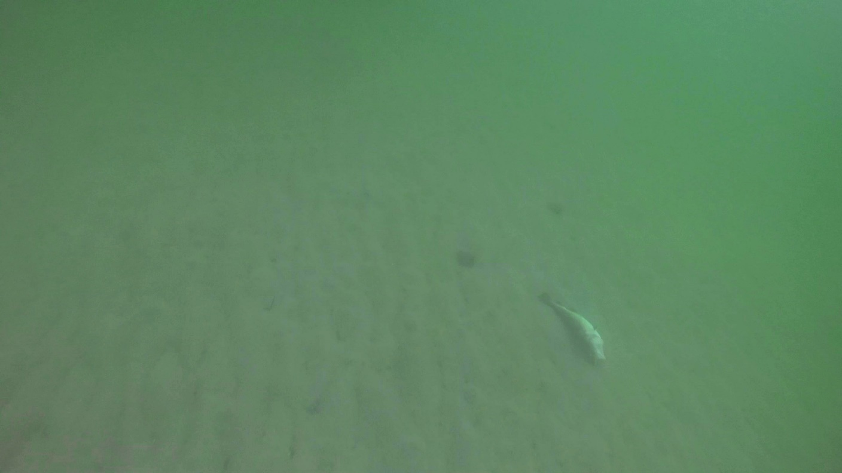Fig. II: Screenshot 35: Dead cod from video “20180910_BALTZOS_GOPR1108” at depth of 3.9 m. GPS coordinates: E11.085502°, N54.245503°.

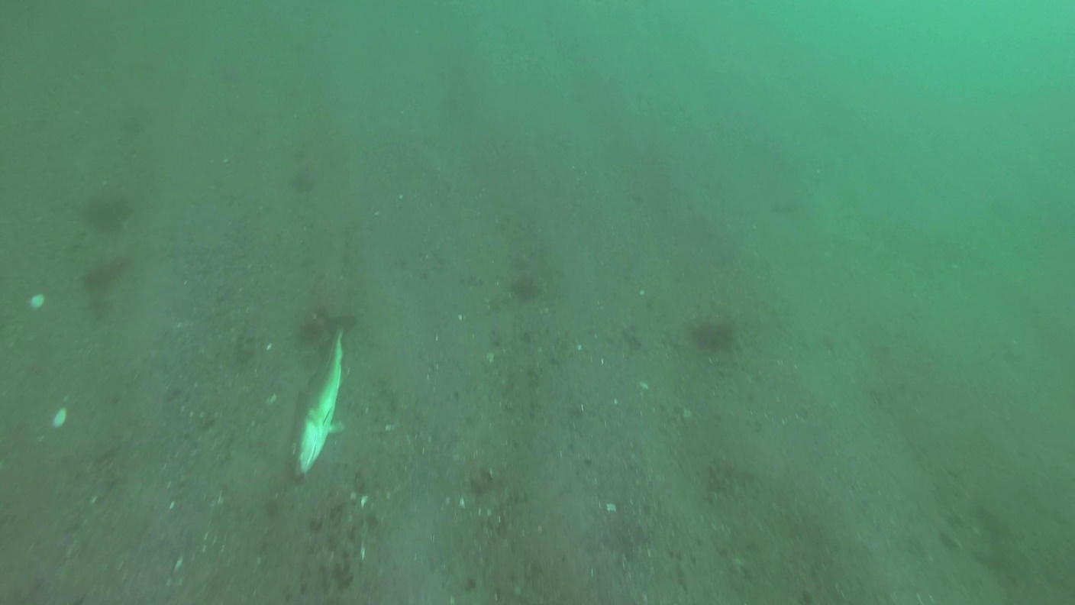Fig. III: Screenshot 37: Dead cod from video “20180910_BALTZOS_GOPR1108” at depth of 4.8 m. GPS coordinates: E11.09108°, N54.229118°.
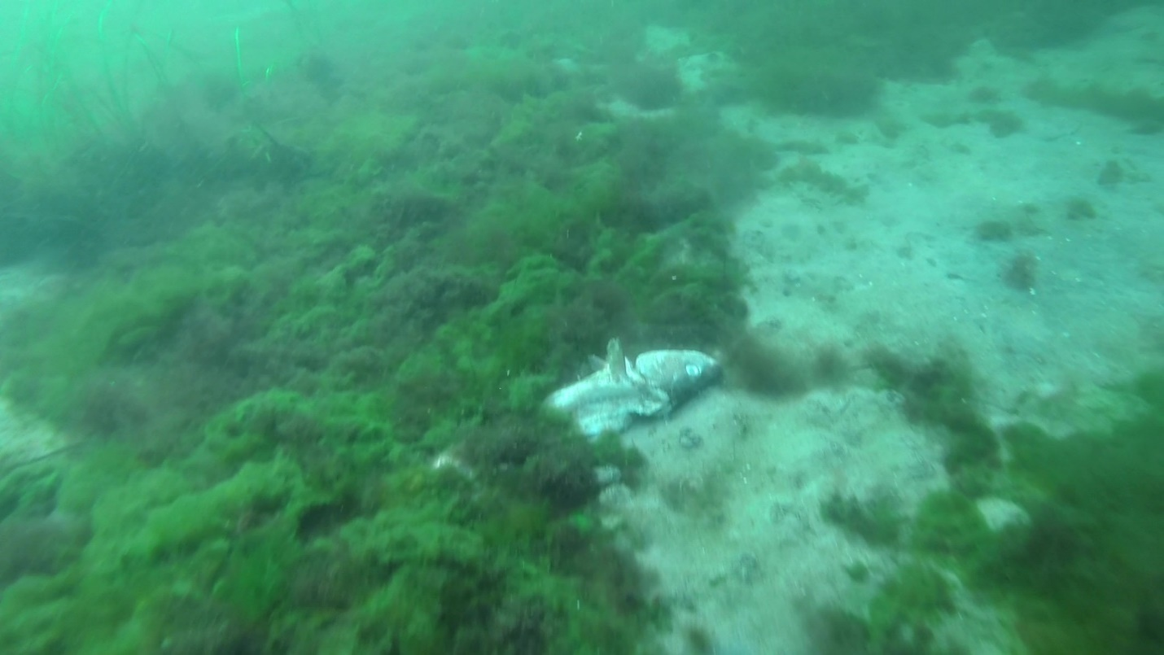Fig. IV: Screenshot 44: Dead cod from video “20181004_BALTZOS_GOPR1127” at depth of 3.6 m. GPS coordinates: E10.807538°, N54.09136°.

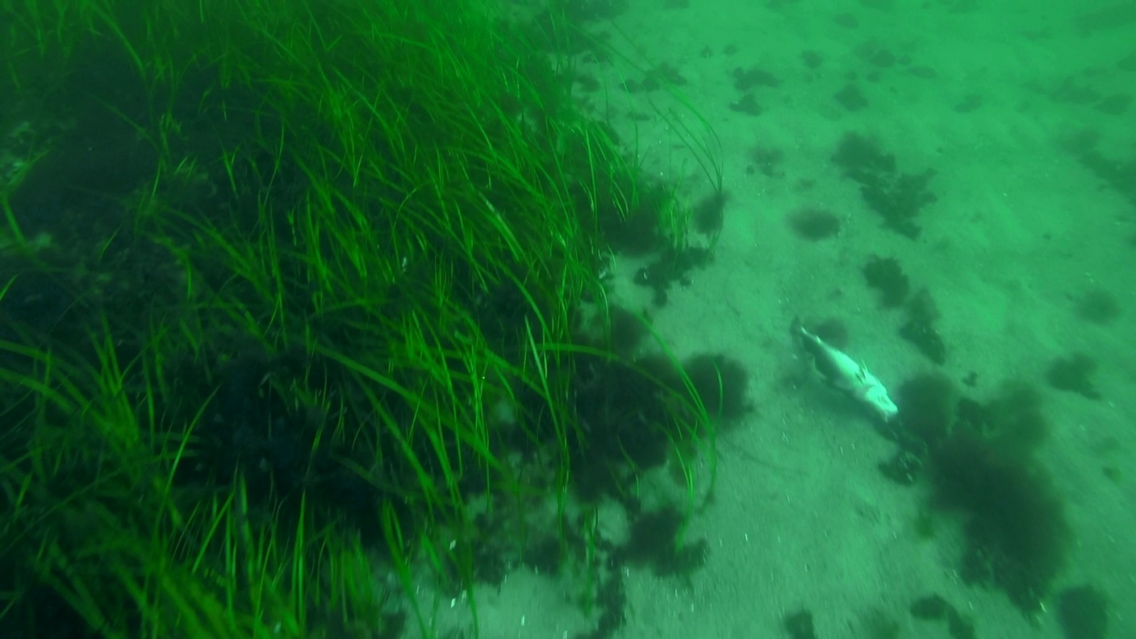Fig. V: Screenshot 92: Dead cod from video “20180913_BALTZOS_GOPR1116” at depth of 4.5. GPS coordinates: E11.089993°, N54.193888°.

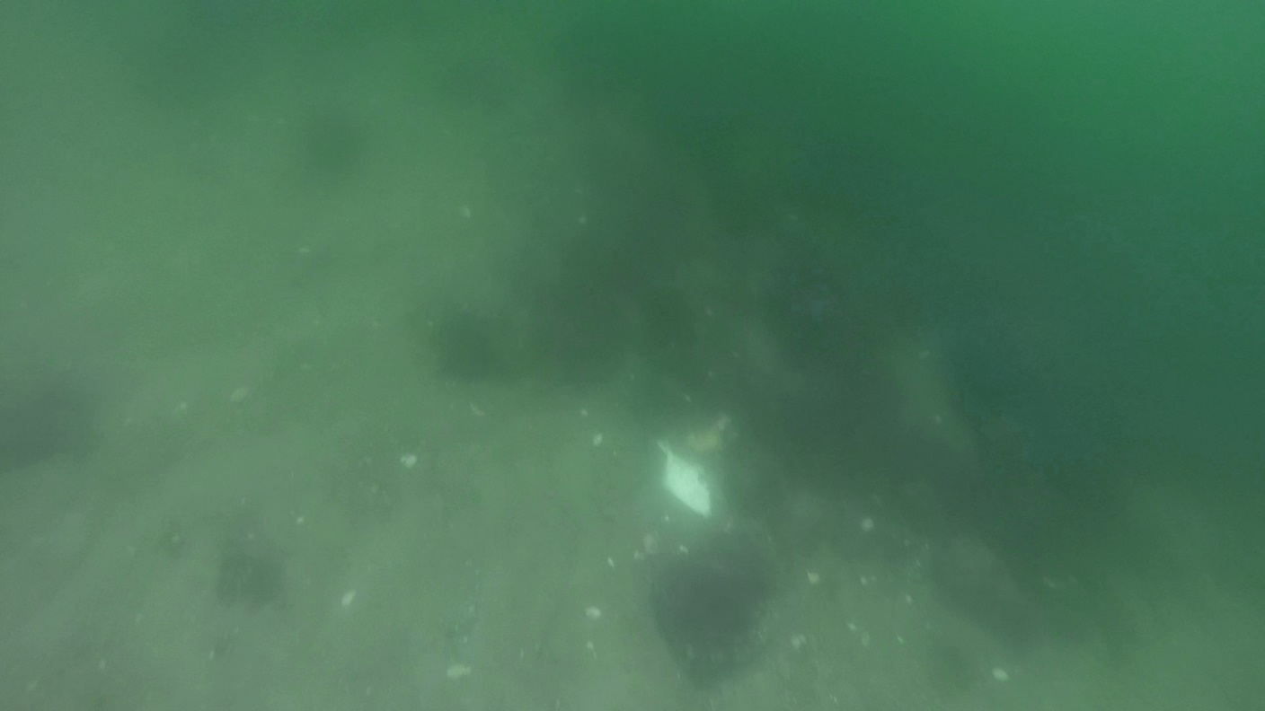Fig. VI: Screenshot 95: Dead flatfish from video “20180619_BALTZOS_GOPR1047” at depth of 4.2 m. GPS coordinates: E10.423738°, N54.413628°.

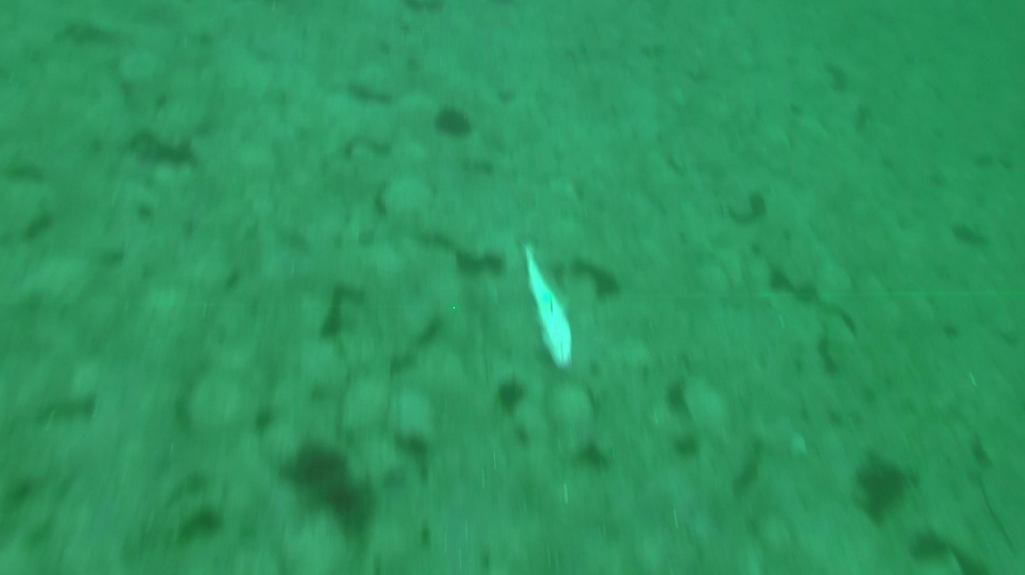Fig. VII: Screenshot 135: Dead cod from video “20181004_BALTZOS_GOPR1130” at depth of 5.4 m. GPS coordinates: E10.766792°, N54.021013°.

