Authors Information
List of members of The Danish COVID-19 Genome Consortium
The ordering of affiliation and authors does not reflect any difference in contribution
Anders Fomsgaard¹, Morten Rasmussen¹, Søren M. Karst¹, Jannik Fonager1, Vithiagaran Gunalan¹, Marc Bennedbæk¹, Aleksander Ring1, Marc Stegger¹, Raphael Sieber¹, Kirsten Ellegaard¹, Anna C. Ingham¹, Thor B. Johannesen¹, Gitte Nygaard Aasbjerg¹, Berit Lilje¹,
Kim L. Ng¹, Sofie M. Edslev¹, Sharmin Baig¹, Povilas Matusevicius¹, Lars Bustamante Christoffersen¹, Man-Hung Eric Tang¹, Leandro Andrés Escobar-Herrera¹, Casper Westergaard¹, Christina Wiid Svarrer¹, Nour Saad Al-Tamimi¹, Marie Bækvad-Hansen¹, Jonas Byberg-Grauholm¹, Mette Theilgaard Christiansen¹, Karen Marie Jørgensen², Tobias Nikolaj Gress Hansen², Esben Mørk Hartmann², Nicolai Balle Larsen², Arieh Cohen², Kasper Holtz Uhre³, Christian Nielsen³, Anders Jensen³, Jakob Matias Melbye³, Bartlomiej Wilkowski³, Karina Meden Sørensen³, Mads Albertsen⁴, Thomas Y. Michaelsen⁴, Vang Le-Quy⁴, Mantas Sereika⁴, Rasmus H. Kirkegaard⁴, Kasper S. Andersen⁴, Martin H. Andersen⁴, Karsten K. Hansen⁴, Mads Boye⁴, Mads P. Bach⁴, Peter Dissing⁴, Anton Drastrup-Fjordbak⁴, Michael Collin⁴, Finn Büttner⁴, Jakob Brandt⁴, Simon Knuttson⁴, Emil A. Sørensen⁴, Thomas B. N. Jensen⁴, Trine Sørensen⁴, Celine Petersen⁴, Clarisse Chiche-Lapierre⁴, Frederik T. Hansen⁴, Emilio F. Collados⁴, Amalie Berg⁴, Susanne R. Bielidt⁴, Sebastian M. Dall⁴, Erika Dvarionaite⁴, Susan H. Hansen⁴, Vibeke R. Jørgensen⁴, Trine B. Nicolajsen⁴, Wagma Saei⁴, Stine K. Østergaard⁴, Martin Bøgsted⁴, Rasmus Brøndu⁴, Katja Hose⁴, Tomer Sagi⁴, Miroslav Pakanec⁴, Henrik Krarup⁵, David Fuglsang-Damgaard⁵, Mette Mølvadgaard⁵, Marc T. K. Nielsen⁵, Kristian Schønning⁶, Martin S. Pedersen⁶, Rasmus L. Marvig⁶, Nikolai Kirkby⁶, Uffe V. Schneider⁷, Jose A. S. Castruita⁷, Nana G. Jacobsen⁷, Christian Ø. Andersen⁷, Mette Christiansen⁸, Ole H. Larsen⁸, Kristian A. Skipper⁸, Søren Vang⁸, Kurt J. Handberg⁸, Carl M. Kobel⁸, Camilla Andersen⁸, Irene H. Tarpgaard⁸, Svend Ellermann-Eriksen⁸, Marianne Skov⁹, Thomas V. Sydenham⁹, Lene Nielsen¹⁰, Line L. Nilsson¹⁰, Martin B. Friis¹⁰ ,Thomas Sundelin¹⁰, Thomas A. Hansen¹⁰, Dorte T. Andersen¹¹, John E. Coia¹¹, Anders Jensen¹², Ea S. Marmolin¹², Xiaohui C. Nielsen¹³, Christian H. Schouw¹³
1 Statens Serum Institut, Copenhagen, Denmark
2 TestCenter Denmark, Copenhagen, Denmark
3 Danish National Biobank, Copenhagen, Denmark
4 Aalborg University, Aalborg, Denmark
5 Aalborg University Hospital, Aalborg, Denmark

6 Rigshospitalet, Copenhagen University Hospital, Copenhagen, Denmark

7 Hvidovre Hospital, Hvidovre, Denmark

8 Aarhus University Hospital, Aarhus, Denmark

9 Odense University Hospital, Odense, Denmark

10 Herlev Hospital, Herlev, Denmark

11 Sydvestjysk Sygehus, Denmark

12 Sygehus Lillebaelt, Denmark

13 Zealand University Hospital, Denmark

Additional figures

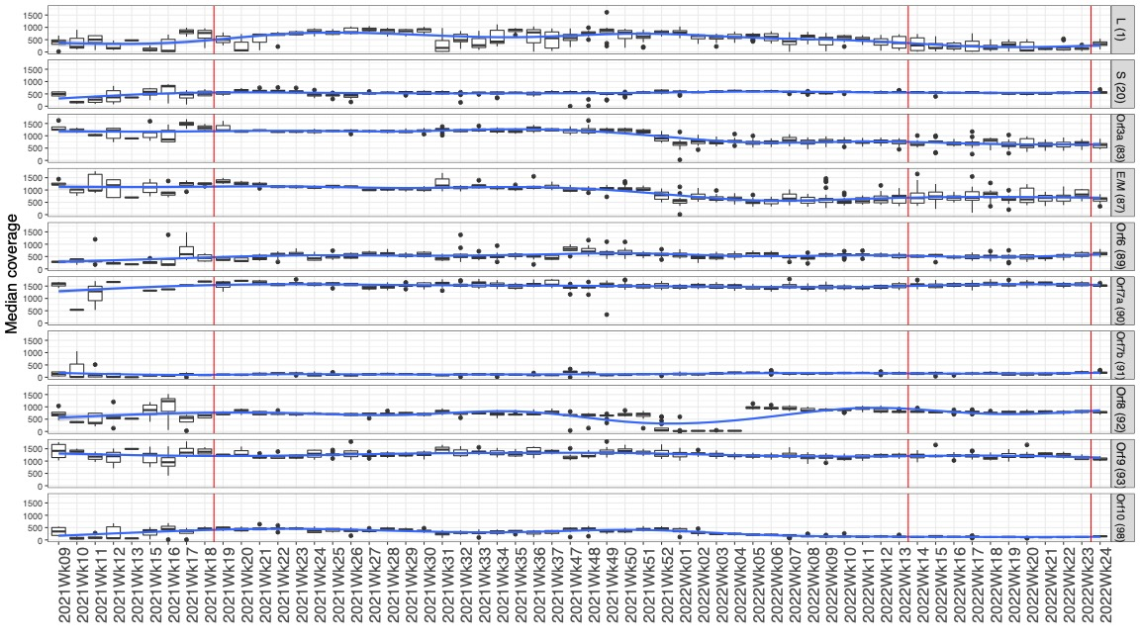
Supplementary figure 1: Overall median amplicon coverage distribution observed across all sequencing runs performed by the Danish COVID-19 genomic surveillance across the sample collection timeline.
Smoothed curved median coverage of selected amplicons covering the 5’-end of the subgenomic mRNAs is shown (amplicon=Leader, 20=S, 83=Orf3a, 87=E/M, 89=Orf6, 9 =Orf7a, 91=Orf7b, 92=Orf8, 93=Orf9, 98=Orf10). The red lines delineate the run periods during which amplicon 1 and 20 showed lower median coverage values (March-April, 2021 and April-May, 2022). Loss of amplicon 92 in January 2022 was caused by the emergence of BA.2 lineage, restauration of amplicon efficiency was achieved using a new primer spike-in.

Supplementary figure 2: Histogram of missing value frequencies.
The missingness reports the fraction of samples with no observations at each subgenomic RNA site and for each lineage. The lineage-subgenomic RNA sample groups further analysed in Figure 5 A-D are marked.

Supplementary figure 3: Principal component analysis biplot of the previous medical conditions of the included cases of the study (n=3,995).
A principal component analysis was performed on the occurrence in the past five years of a list of diseases and the first two leading components shown in a biplot. Cases were colored according to the lineage of SARS-CoV-2 genome isolated in the subjects.

Supplementary figure 4: Subgenomic mRNA abundance across Alpha, Delta and Omicron SARS-CoV-2 lineages across the entire sample collection period.
This boxplot shows sample groups collected during the non-included time window Mars-April 2021 and April-May 2022 time points. Non-included samples consist of 64 Alpha, 1 Delta, 12 BA.1, 348 BA.2, 1,329 BA2.12.1, 729 BA.4 and 2,144 BA.5 lineages. Late BA.5 corresponds to the BA5 sample group in Figure 2 while BA.5 designates the samples collected in April-May 2022.

Supplementary figure 5: Median coverage of amplicon covering the Leader and each ORF of interest, stratified by lineage. Top: median coverage values normalized to 2-million total reads. Bottom: non-normalized median coverage values.

Supplementary figure 6: Variable importance plot of the most significant factors associated with subgenomic mRNA count per 2 million excluding sparse variables from the STPS (Danish Patient Safety Authority) and RUKS (Chronic Diseases and Severe Mental) and data sources.
Variables selected by 10-fold cross-validated elastic-net for association with subgenomic mRNA levels are shown in their order of importance, repeated 50 times. The analysis on the largest available population after excluding sparse variables from STPS and RUKS was performed on 11365 samples.

