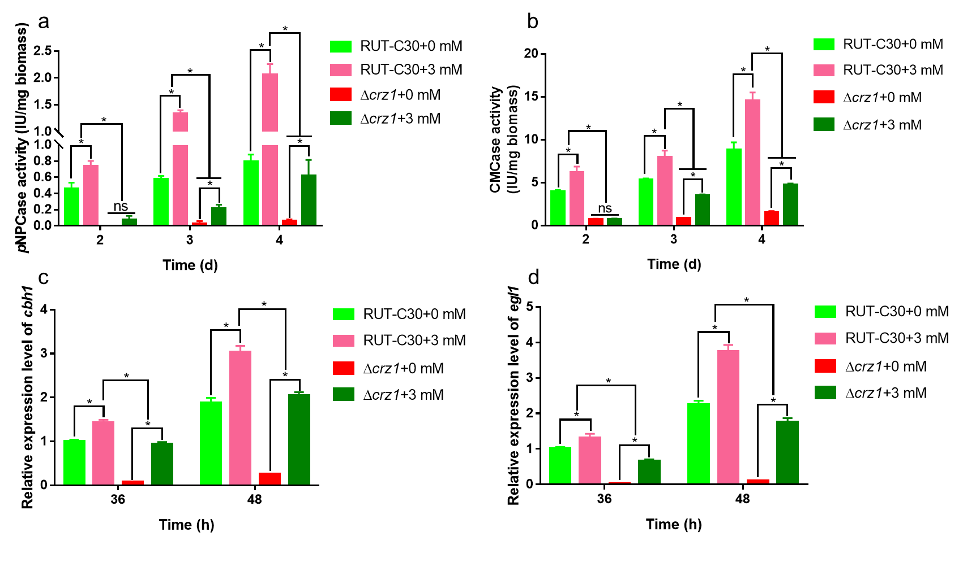
Fig. S4 Effect of crz1 on cellulase production after Zn²⁺ addition. pNPCase activity (a), CMCase activity (b) of RUT-C30 and Δcrz1 cultured in liquid MM for 2, 3, or 4 days with or without 3 mM Zn²⁺ and 1% (w/v) Avicel as the sole carbon source, respectively. The expression levels of cbh1 (c) and egl1 (d) were also determined. The final values are presented as the mean±standard deviation (SD) of three independent experimental results. Asterisks indicate significant differences compared to the control (*P <0.05, according to Student’s t-test).

