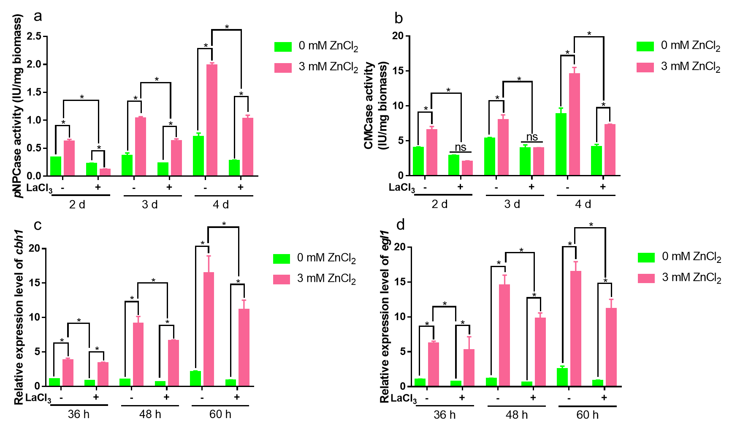
Fig. S3 Effect of LaCl₃ on cellulase production after Zn²⁺ treatment. pNPCase (a) and CMCase (b) activity were measured in the RUT-C30 strain after exposed to Zn²⁺ or LaCl₃. The transcriptional levels of cbh1 (c) and egl1 (d) were detected after culturing the RUT-C30 strain in medium supplemented with 0 or 3 mM Zn²⁺ and with (+) or without (−) 5 mM LaCl₃. The final values are presented as the mean±standard deviation (SD) of three independent experimental results. Asterisks indicate significant differences compared to the control (*P <0.05, according to Student’s t-test).

