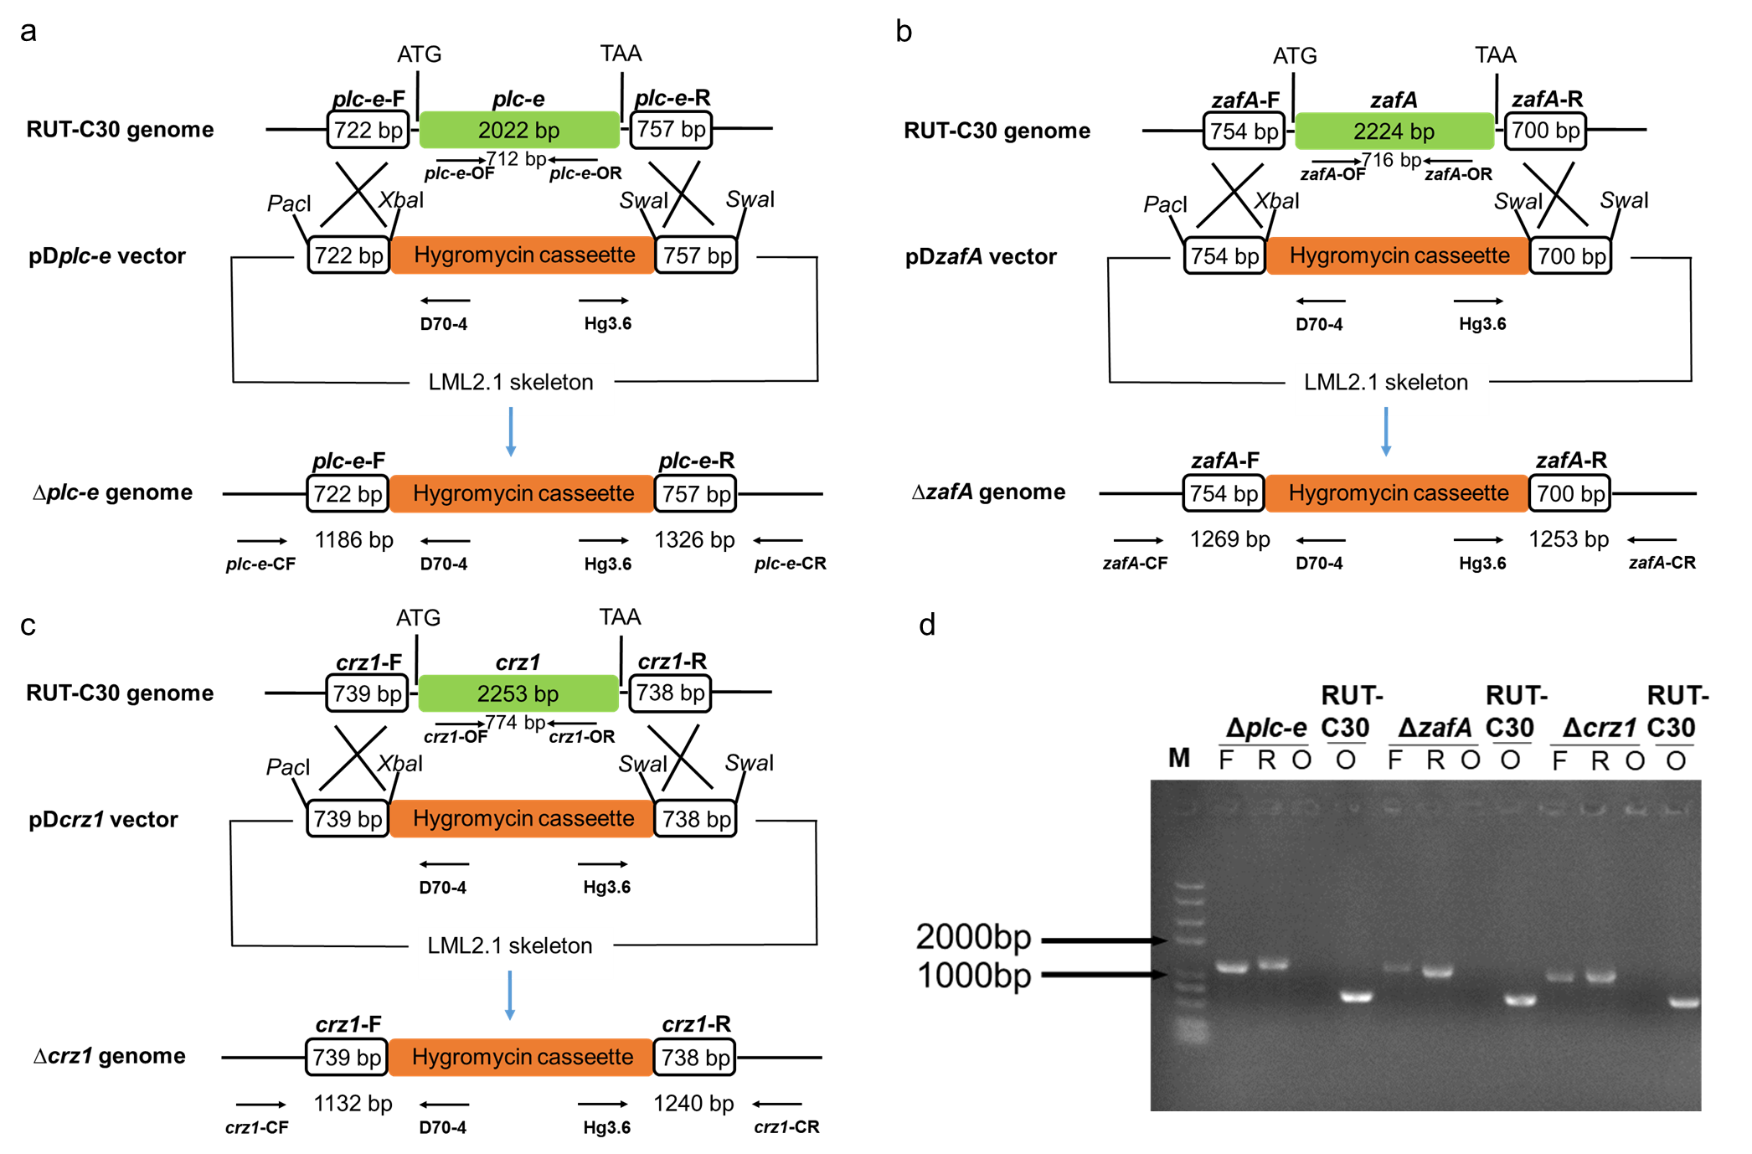
Fig. S7 Construction and verification of T. reesei deletion mutant, which were performed as described in our previous study [1]. a: The skeleton schematic diagram to delete plc-e in the parent strain RUT-C30. b: The skeleton schematic diagram to delete zafA in the parent strain RUT-C30. c: The skeleton schematic diagram to delete crz1 in the parent strain RUT-C30. d: Validated electrophoretic diagram to verify the knockout of plc-e, zafA, and crz1 in the parent strain RUT-C30, respectively; M: marker.

References
1. Li N, Zeng Y, Chen YM, Shen YL, Wang W. Induction of cellulase production by Sr²⁺ in Trichoderma reesei via calcium signaling transduction. Bioresour Bioprocess. 2022;9:96.

