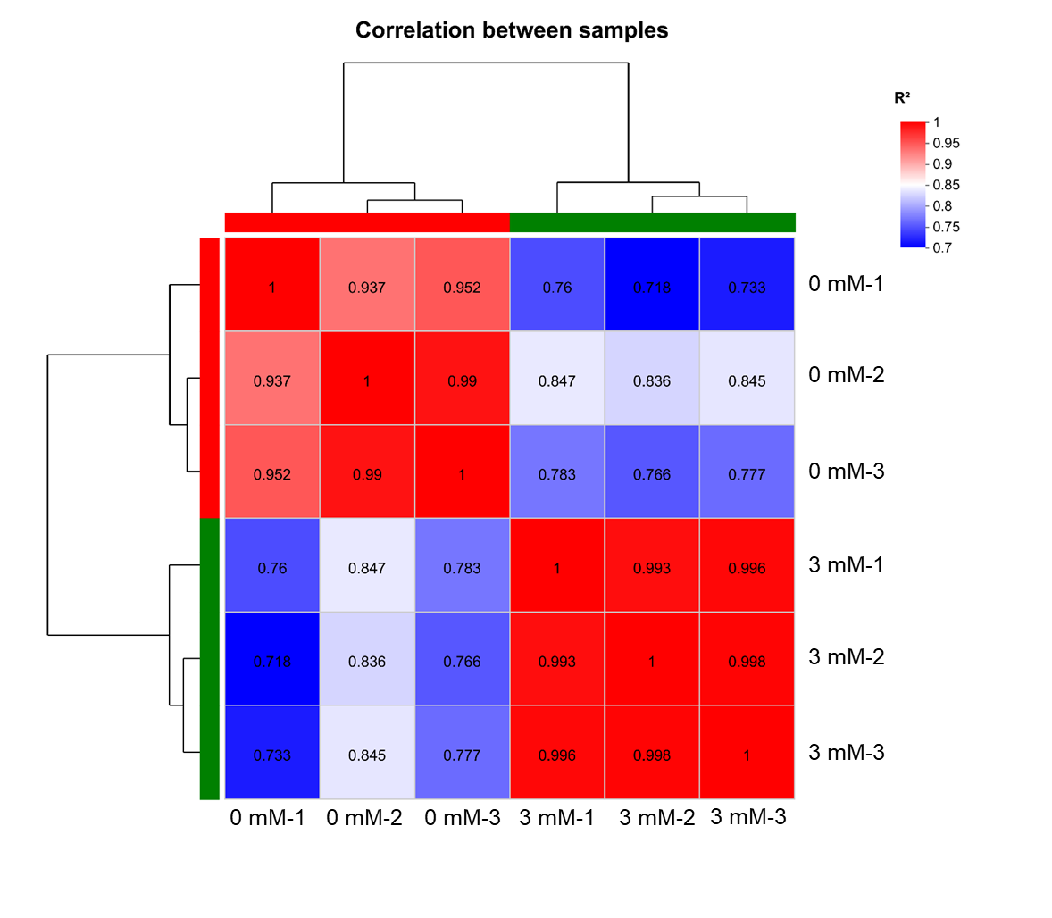
Fig. S1 The heat map showed the correlation between the biological replicates of each sample in RNA‑seq analysis. The value in the square is the correlation coefficient between the two samples. The larger the value, the greater the correlation between the two samples and the closer they are. These results mean that the RNA‑seq data is very reliable.

