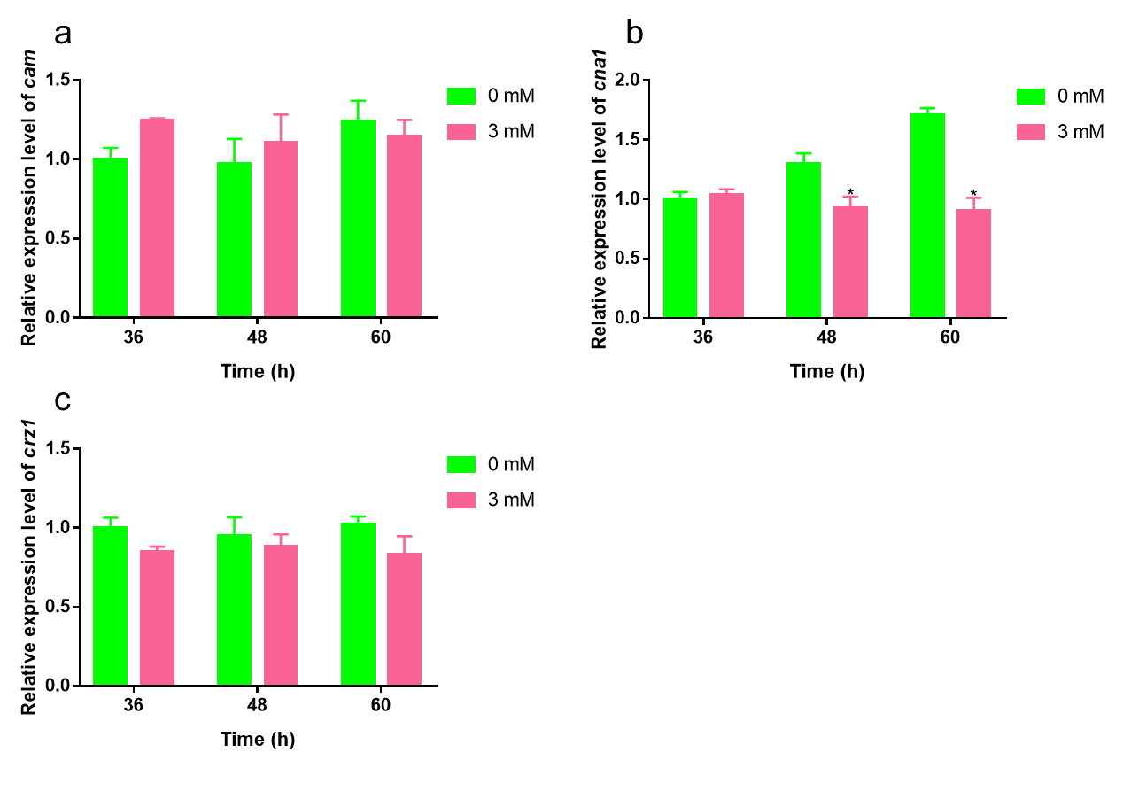
Fig. S2 Effect of 3 mM Zn²⁺ on calcium signal transduction related gene transcription levels in RUT-C30 strain. Transcriptional levels of cam (a), cna1 (b), and crz1 (c) of the RUT-C30 strain were detected after culturing in liquid MM for 36, 48 or 60 h containing 3 mM Zn²⁺ and 1% (w/v) Avicel as the sole carbon source. The final values are presented as the mean±standard deviation (SD) of three independent experimental results. Asterisks indicate significant differences compared to the control (*P <0.05, according to Student’s t-test).

