Supplement 2 Principal component analysis (PCA) results of pronotum and elytron

Table 1 List of top 10 eigenvalues by pronotum test (variance value account for more than 1.000 % are shown in bold)

Component | Eigenvalue | Variance (%) | Cum. Variance (%)
1 | 0.008 | 41.065 | 41.065
2 | 0.008 | 36.853 | 77.918
3 | 0.002 | 9.976 | 87.894
4 | 0.001 | 4.639 | 92.533
5 | 0.000 | 1.848 | 94.381
6 | 0.000 | 1.153 | 95.534
7 | 0.000 | 0.728 | 96.262
8 | 0.000 | 0.698 | 96.960
9 | 0.000 | 0.574 | 97.534
10 | 0.000 | 0.357 | 97.891

Table 2 List of top 10 eigenvalues by elytron test (variance value account for more than 1.000 % are shown in bold)

Component | Eigenvalue | Variance (%) | Cum. Variance (%)
1 | 0.008 | 73.266 | 73.266
2 | 0.002 | 16.465 | 89.731
3 | 0.000 | 3.631 | 93.362
4 | 0.000 | 1.766 | 95.128
5 | 0.000 | 1.233 | 96.361
6 | 0.000 | 1.055 | 97.416
7 | 0.000 | 0.560 | 97.975
8 | 0.000 | 0.376 | 98.351
9 | 0.000 | 0.297 | 98.649
10 | 0.000 | 0.188 | 98.837

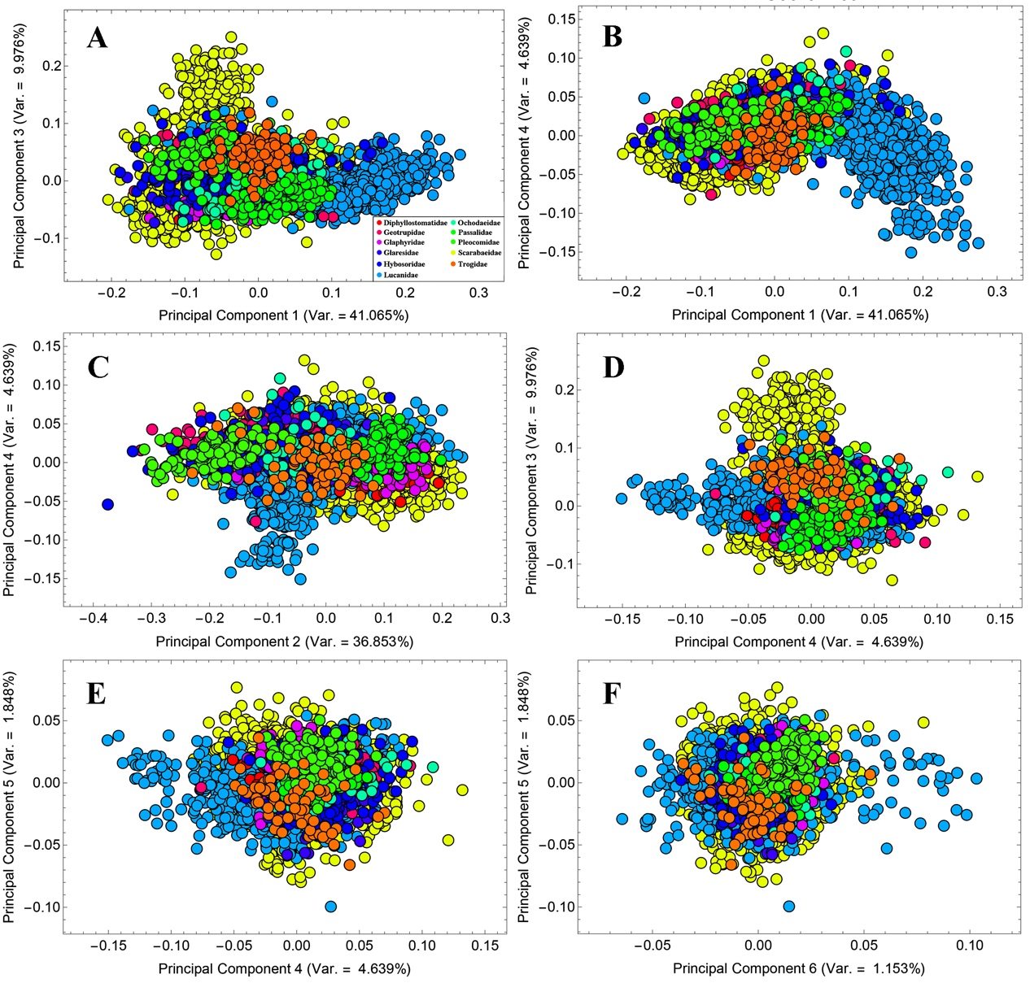
Fig. 1 Principal component plot of pronotum by phylogenetic factor (11 family categories)
Variations of pronotum varies in different subspaces composed of PCs which account for more than 1.000 %. A: Variations of PC1 and PC3; B: Variations of PC1 and PC4; C: Variations of PC2 and PC4; D: Variations of PC4 and PC3; E: Variations of PC4 and PC5; F: Variations of PC6 and PC5.

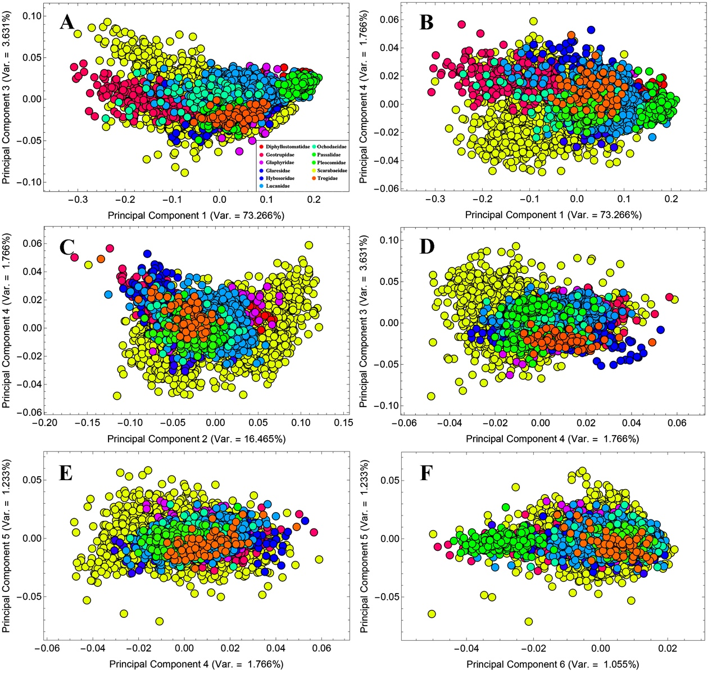
Fig. 2 Principal component plot of elytron by phylogenetic factor (11 family categories)
Variations of elytron varies in different subspaces composed of PCs which account for more than 1.000 %. A: Variations of PC1 and PC3; B: Variations of PC1 and PC4; C: Variations of PC2 and PC4; D: Variations of PC4 and PC3; E: Variations of PC4 and PC5; F: Variations of PC6 and PC5.

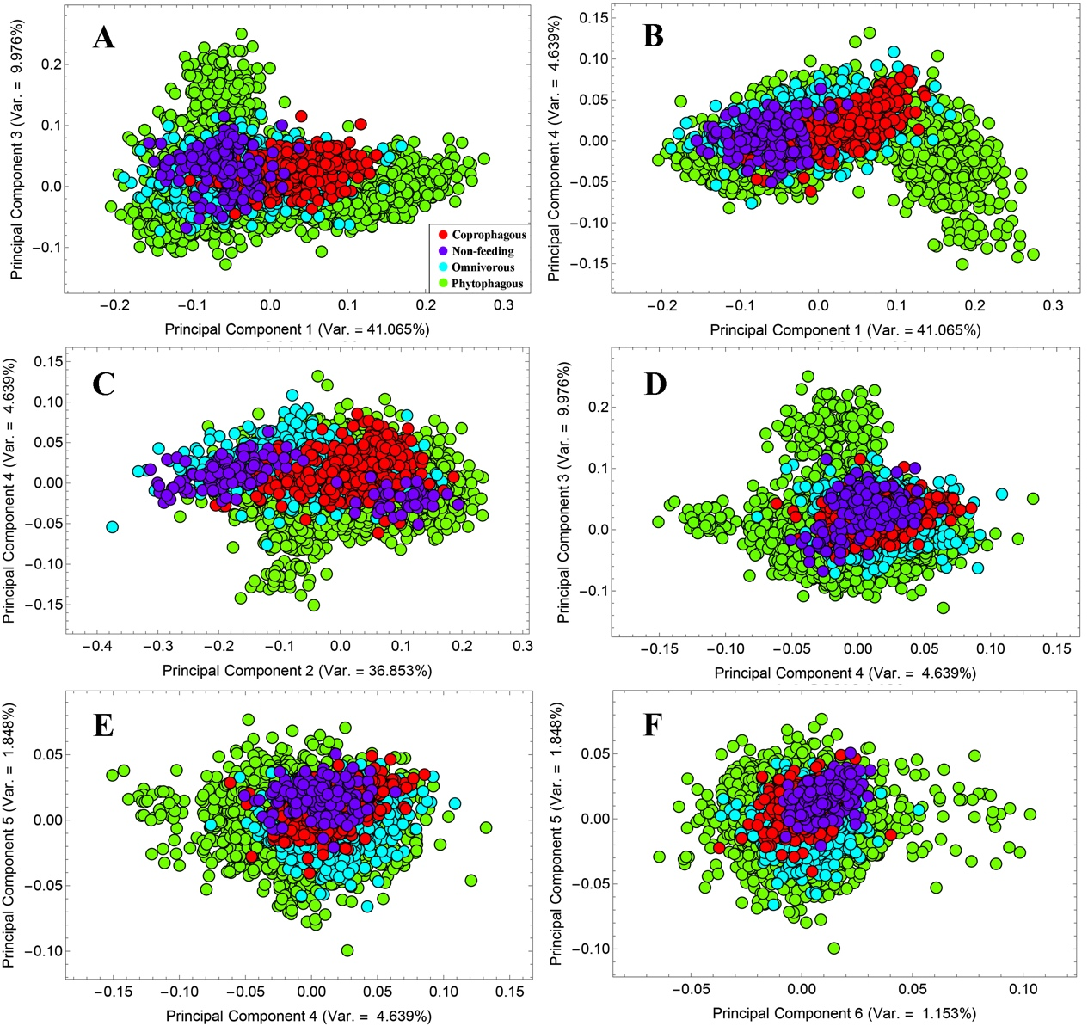
Fig. 3 Principal component plot of pronotum by ecological factor (4 feeding types)
Variations of pronotum varies in different subspaces composed of PCs which account for more than 1.000 %. A: Variations of PC1 and PC3; B: Variations of PC1 and PC4; C: Variations of PC2 and PC4; D: Variations of PC4 and PC3; E: Variations of PC4 and PC5; F: Variations of PC6 and PC5.

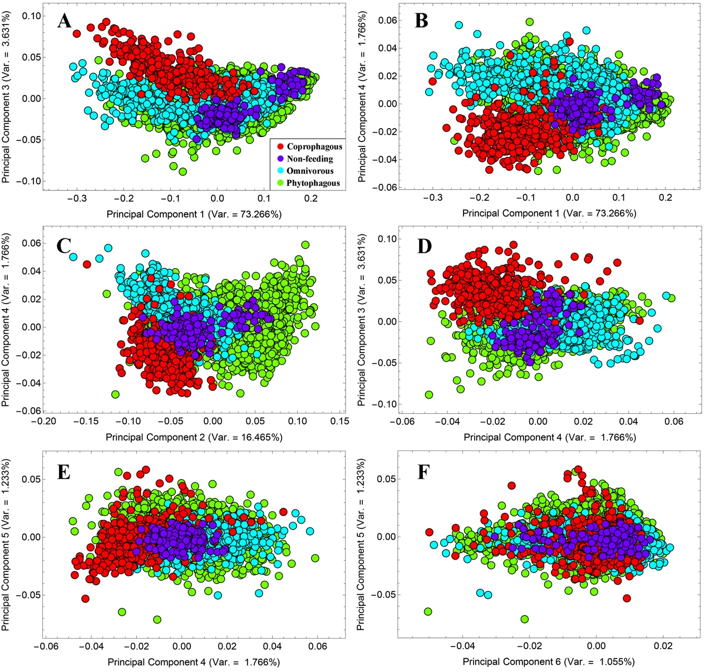
Fig. 4 Principal component plot of elytron by ecological factor (4 feeding types)
Variations of elytron varies in different subspaces composed of PCs which account for more than 1.000 %. A: Variations of PC1 and PC3; B: Variations of PC1 and PC4; C: Variations of PC2 and PC4; D: Variations of PC4 and PC3; E: Variations of PC4 and PC5; F: Variations of PC6 and PC5.

