Supplementary information.

Solvent-Free Recyclable Heterogeneous Copper(I) oxide/Zinc oxide (Cu₂O/ZnO) nanoflake: C-O Coupling of Phenols With Aryl halides
Mona Hosseini-Sarvari ^{1*}, Hossein Sheikh ^{1†} and
Fatemeh Moeini ^{1†}
^{1*} Department of Chemistry, Shiraz University, Shiraz 71454, I. R. Iran.
*Corresponding author. E-mail: hossaini@shirazu.ac.ir; Contributing authors: hosseinsheiikh@gmail.com; fmoeini@yahoo.com; †

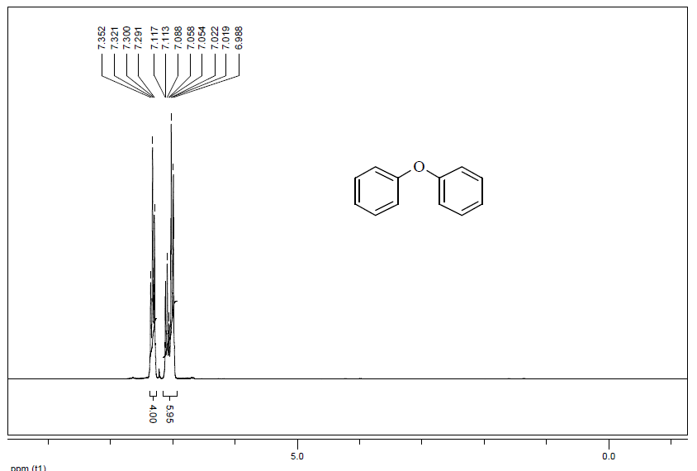
The ¹H-NMR spectrum of 3a
The ¹³C-NMR spectrum of 3a
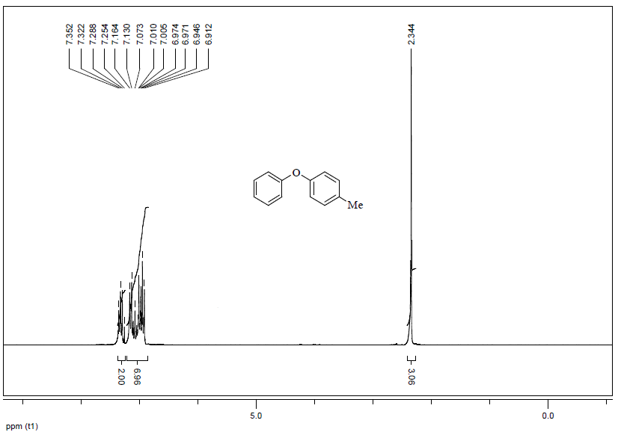
The ¹H-NMR spectrum of 3b
The ¹³C-NMR spectrum of 3b
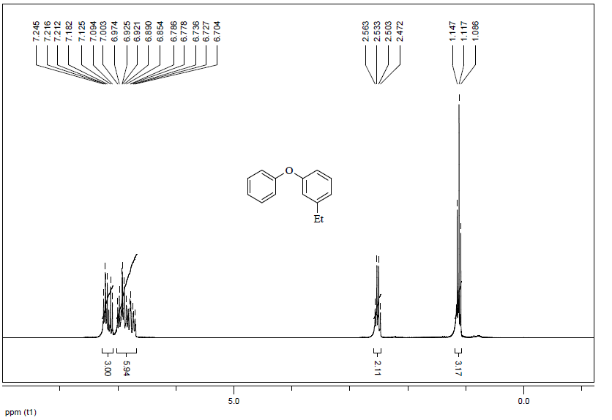
The ¹H-NMR spectrum of 3c
The ¹³C-NMR spectrum of 3c
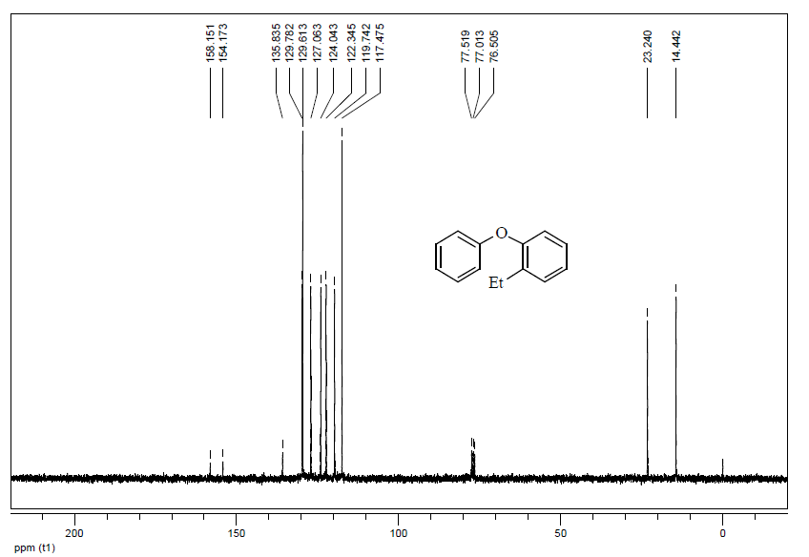
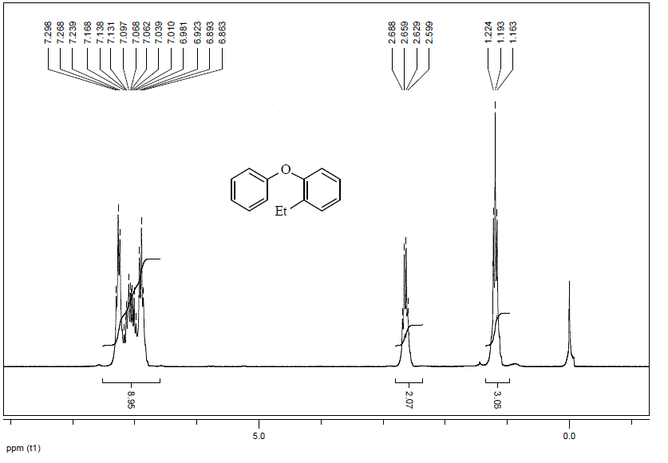
The ¹H-NMR spectrum of 3d
The ¹³C-NMR spectrum of 3d
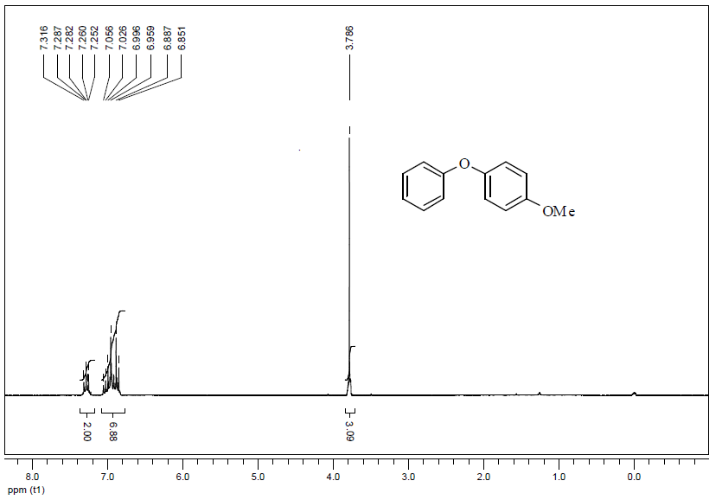
The ¹H-NMR spectrum of 3e
The ¹³C-NMR spectrum of 3e
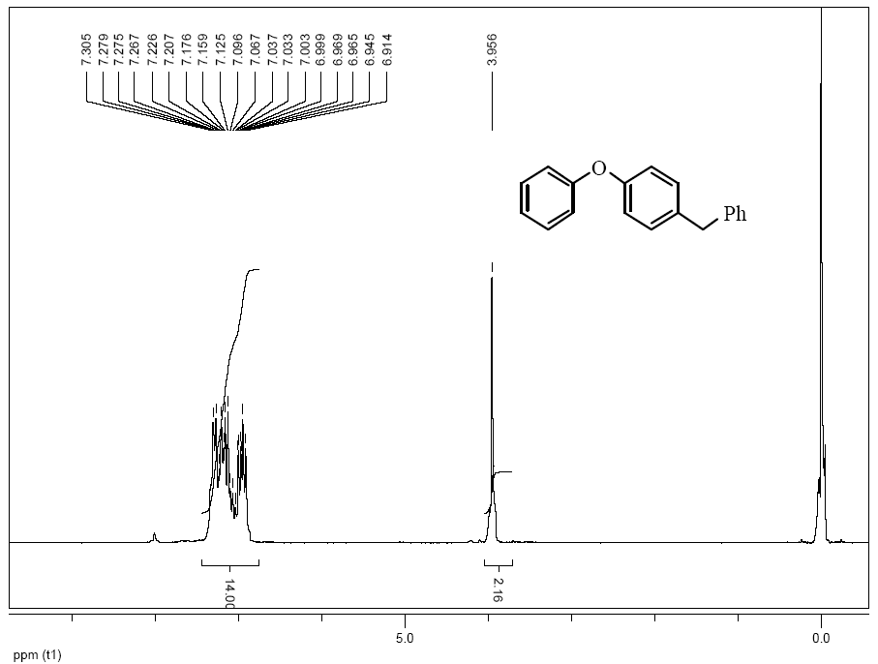
The ¹H-NMR spectrum of 3f
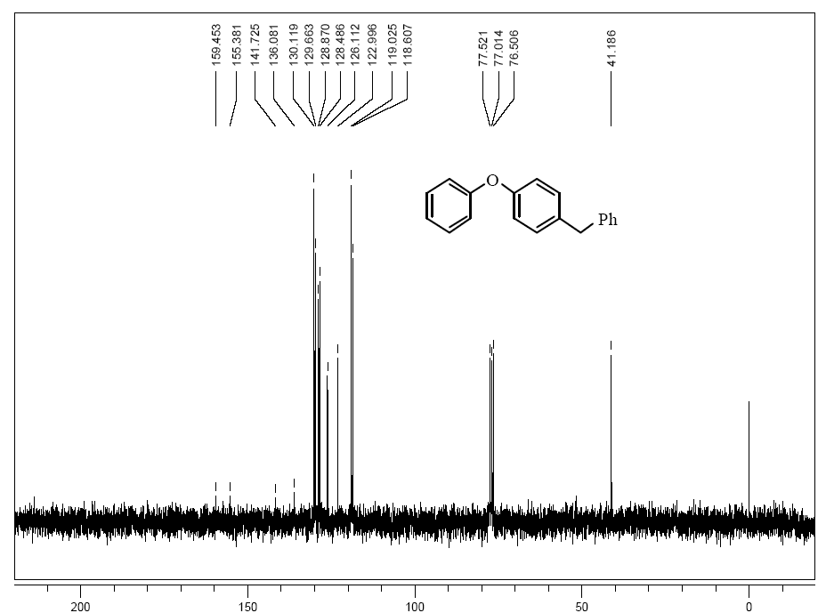
The ¹³C-NMR spectrum of 3f
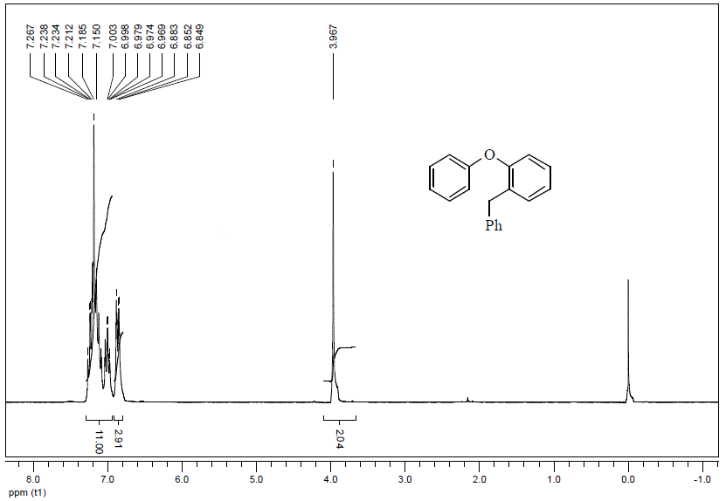
The ¹H-NMR spectrum of 3g
The ¹³C-NMR spectrum of 3g
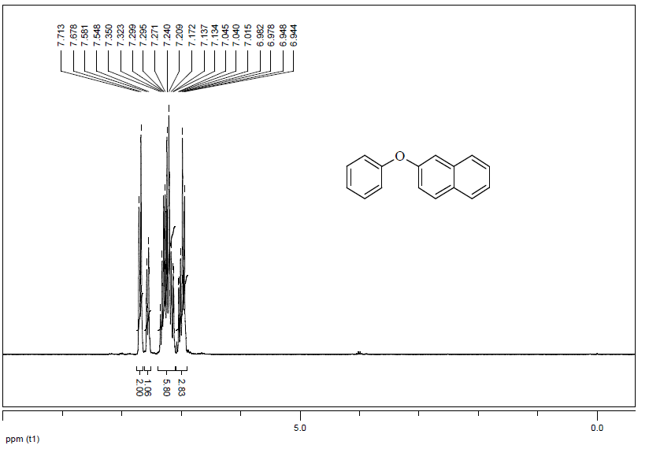
The ¹H-NMR spectrum of 3h
The ¹³C-NMR spectrum of 3h
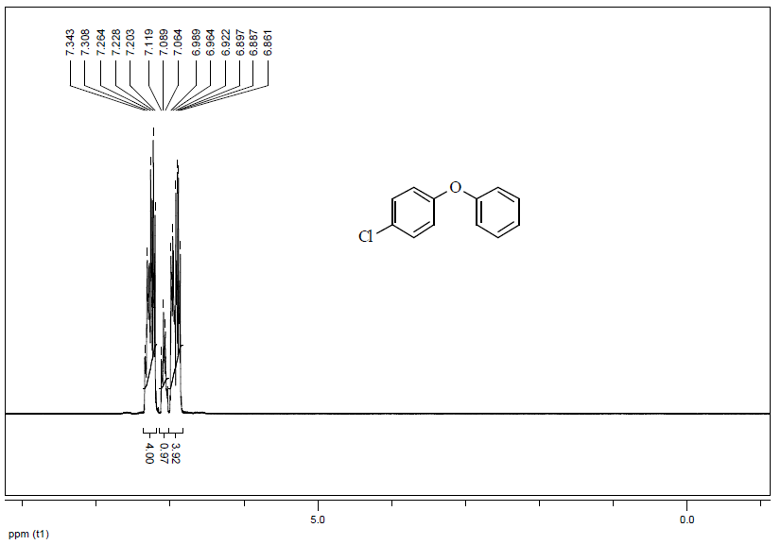
The ¹H-NMR spectrum of 3i
The ¹³C-NMR spectrum of 3i
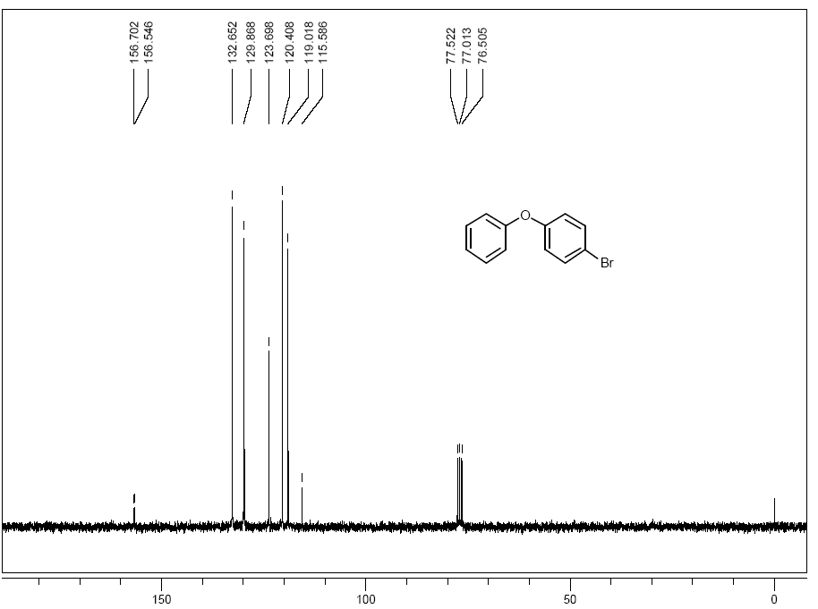
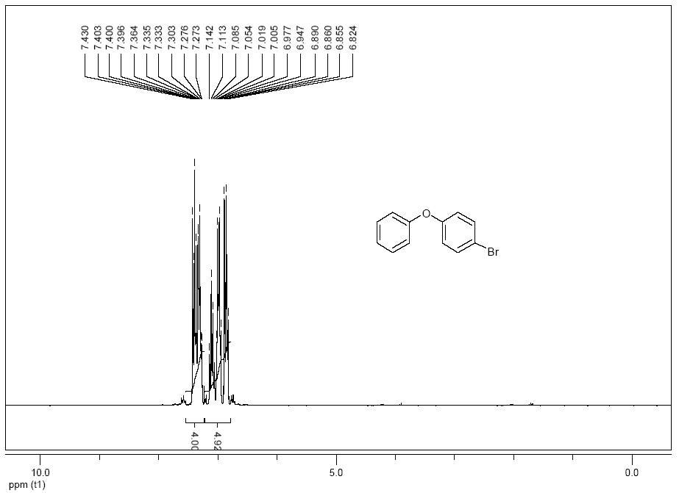
The ¹H-NMR spectrum of 3j
The ¹³C-NMR spectrum of 3j
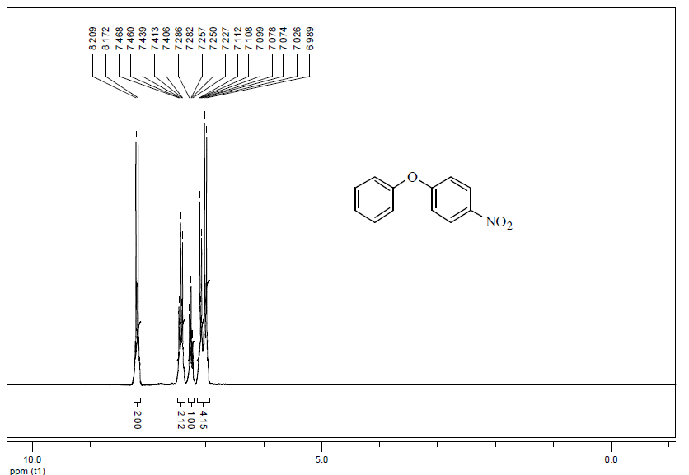
The ¹H-NMR spectrum of 3k
The ¹³C-NMR spectrum of 3k

