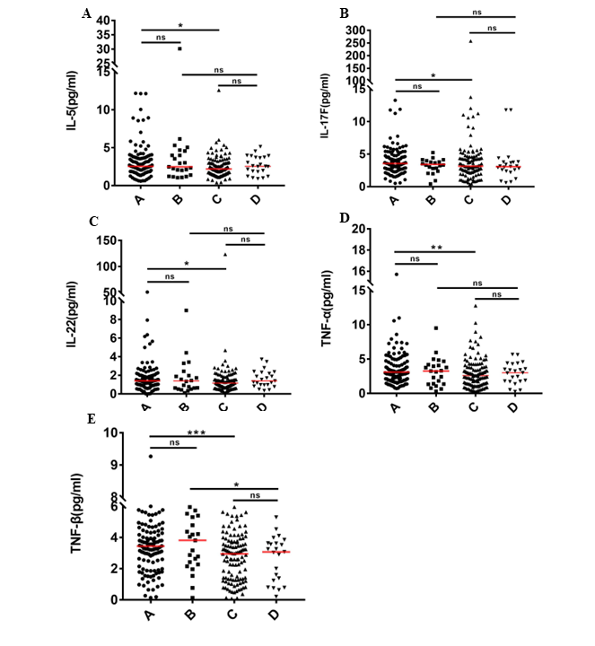
Supplementary Figures 1A–E：(A) Newly diagnosed patients（Remission following 2 chemotherapy sessions）； (B) Newly diagnosed patients（No remission following 2 chemotherapy sessions）；(C) Patients in remission following 2 chemotherapy sessions；(D) Patients not in remission following 2 chemotherapy sessions. The median is shown by the horizontal lines. *P < 0.05; **P < 0.01; ***P < 0.001; (ns) Not significant.

