Chromatographia
Supporting Information

Preparation of C-terminal epitope imprinted particles for recognition of cytochrome c assisted with γ-cyclodextrin by host-guest interaction
Wenquan Ji¹, Yongjian Wang¹, Hongfeng Zhang¹, Jin Zhao¹, Qinran Li*^{1,2},
Qiliang Deng^{1,2}, Donglan Sun², Tianjun Liu³

¹ College of Chemical Engineering and Materials Science, Tianjin University of Science and Technology, Tianjin 300457 , People’s Republic of China
² College of Science, Tianjin University of Science and Technology, Tianjin 300457, People’s Republic of China
³ Tianjin Key Laboratory of Biomedical Materials, Institute of Biomedical Engineering, Chinese Academy of Medical Sciences & Peking Union Medical College, Tianjin 300192, People’s Republic of China

*Qinran Li
E-mail: qrlee@tust.edu.cn

Table S1 Adsorption capacity and imprinting factor of imprinted polymers on AE-9（a）and Cyt c(b) at different amounts of functional monomer ZDMA

ZDMA （mg） | EGDMA  （μL） | AE-9 |  |  | Cyt c
ZDMA （mg） | EGDMA  （μL） | Q_{MIPs}  （mg·g⁻¹） | Q_{NIPs}  （mg·g⁻¹） | IF | Q_{MIPs}  （mg·g⁻¹） | Q_{NIPs}  （mg·g⁻¹） | IF
45.00 | 150.00 | 2.05±0.18 | 0.56±0.16 | 3.47 | 25.25±1.58 | 8.58±1.46 | 2.91
55.00 | 150.00 | 2.89±0.21 | 0.71±0.17 | 4.07 | 37.58±1.76 | 11.12±1.27 | 3.38
65.00 | 150.00 | 3.76±0.21 | 1.05±0.18 | 3.58 | 38.65±1.74 | 15.25±1.34 | 2.53
75.00 | 150.00 | 4.30±0.22 | 1.45±0.21 | 2.96 | 39.25±1.51 | 20.29±1.54 | 1.91
85.00 | 150.00 | 5.13±0.19 | 2.01±0.21 | 2.55 | 39.76±1.71 | 30.24±1.30 | 1.31

Figure. S1 Adsorption isotherms of CD-MIPs/ NIPs fitted by Langmuir (a) and Freundlich (b) models

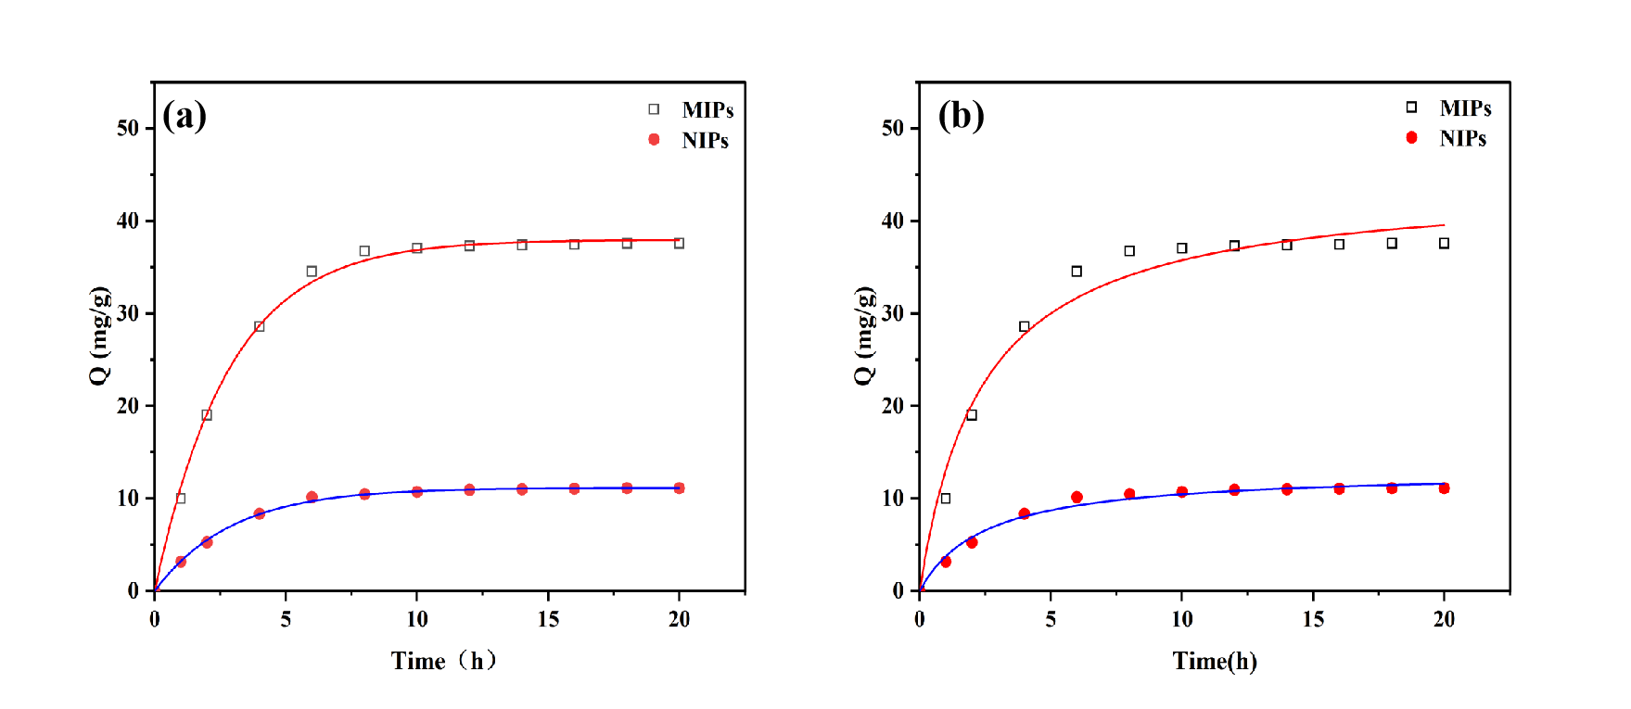

Fig. S2 Fitting of pseudo-first-order kinetic model (a) and pseudo-second-order kinetic model (b) by kinetic adsorption curves

