Supplementary Information
Spatial variations in PΜ_{2.5} physico-chemical characteristics and associated health risk in an urban coastal city
Shruti Tripathi¹, Abhishek Chakraborty^{1*} and Debayan Mandal¹
1. Environmental Science and Engineering Department, Indian Institute of Technology Bombay, Mumbai, Maharashtra, 400076
* Corresponding Author

Table SI 1 Parameters used in exposure risk assessment analysis
S. No. |  | Values
1 | Exposure Frequency | 180 days
2 | Body weight (Kg) | 70 for adults and 40 for children
3 | Averaging Time | 365 to ED for non-carcinogen risk and carcinogen risk, its value is 25550
4 | Conversion Fraction | 10⁻⁶ kg mg⁻¹
5 | Absorption factor dermal | 0.03 for As and 0.001 for Cd; for the other metals 0.01 value was taken

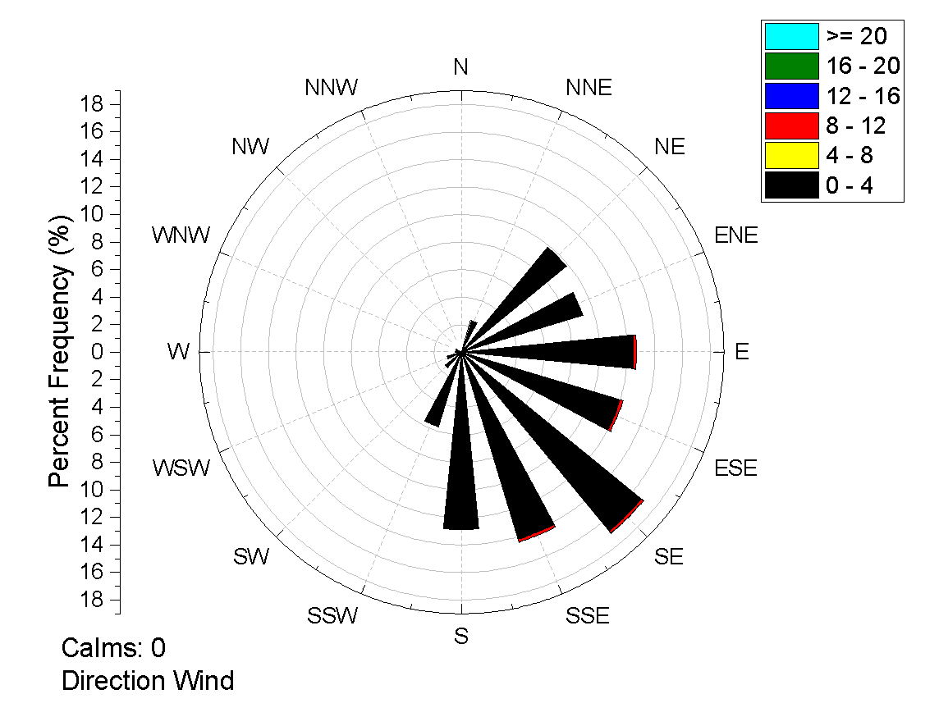
YP-gate
HP
Fig. SI 1 Wind rose diagram to show the wind pattern for HP and YP-gate sampling sites

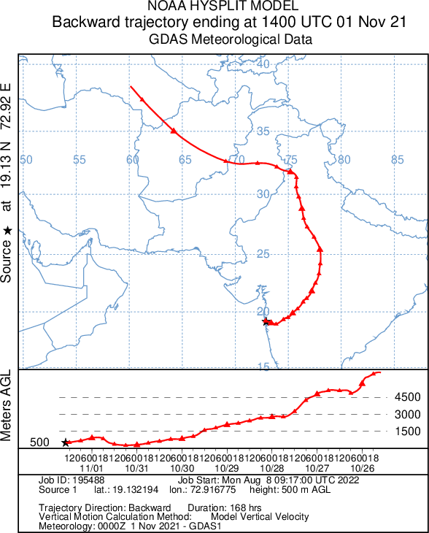
a
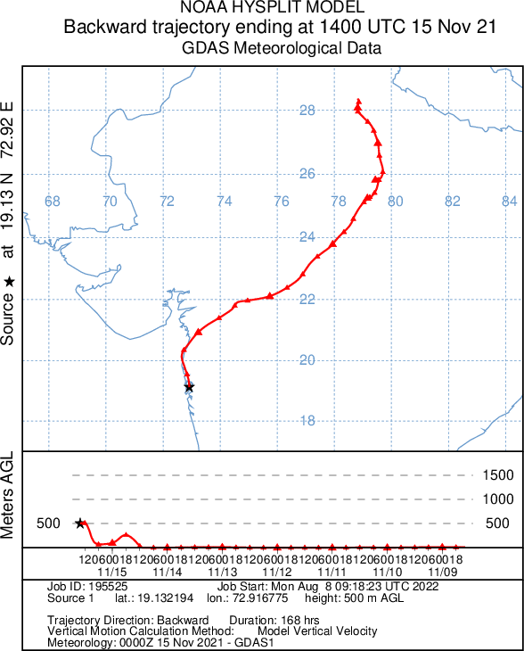
b
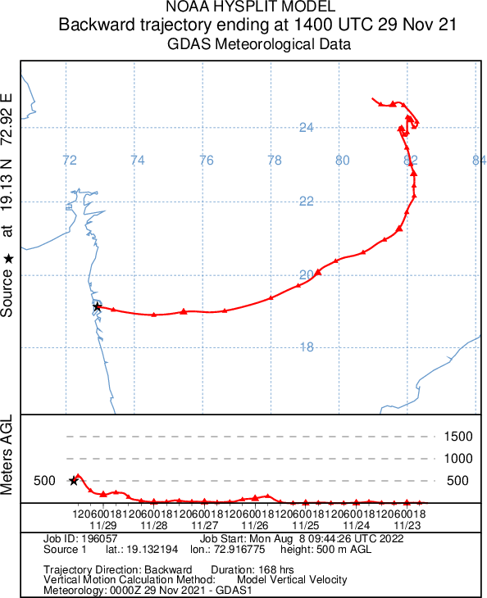
c

Fig. SI 2 NOAA HYSPLIT MODEL seven days Backward trajectory GDAS Meteorological Data for Mumbai a). 5-11-2021, b). 15.11.2021 and c). 29.11.2021
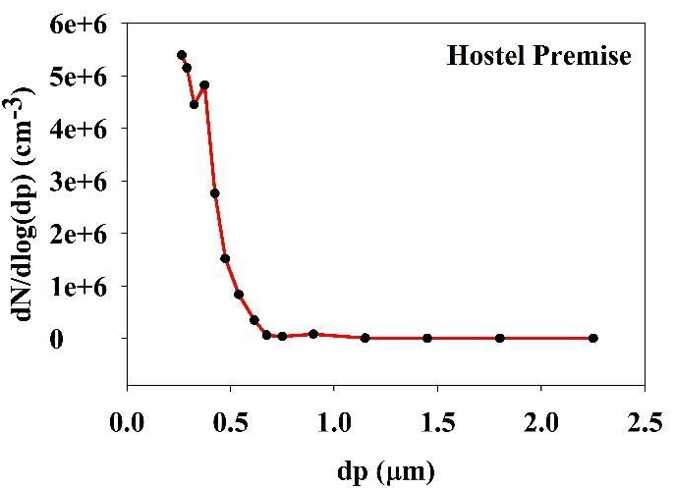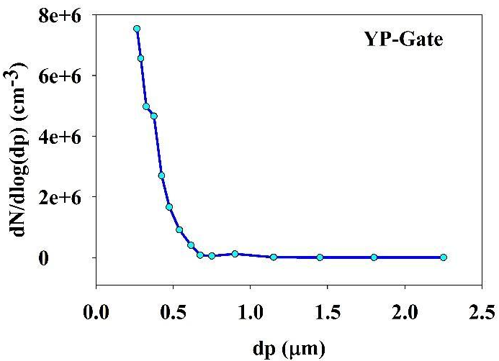
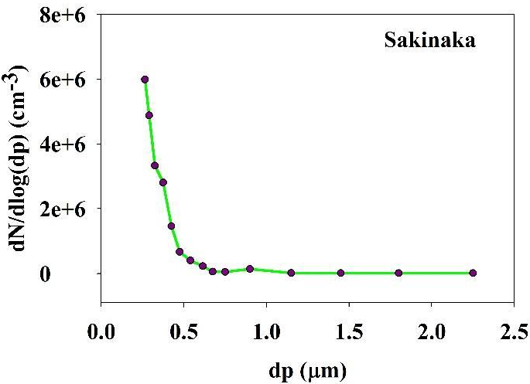
Fig. SI 3 The log-normal distribution of particle number concentration at different sampling locations
Table SI 2 PM₁₀, PM_{2.5,} and PM₁ concentrations at different locations
Location | Location Type | PM₁₀  (μg/m³) | PM_{2.5}  (μg/m³) | PM₁  (μg/m³) | References
Hostel Premise (Mumbai, India) | Residential | 161 | 126 | 90 | This study
YP-Gate (Mumbai, India) | Traffic | 230 | 180 | 112 | This study
Sakinaka (Mumbai, India) | Traffic | 424 | 240 | 120 | This study
Delhi, India | Traffic | 568 | 289 | 204 | Garg & Arvind, 2022
Agra, India | Residential near Traffic Location | 301 | 212 | 143 | Massey et al., 2012
Chennai, India | Traffic | 162 | 87 | 74 | Srimuruganandam & Shiva Nagendra, 2011
Xinxiang, China | Residential | 155 | 120 | 85.6 | Liu et al., 2022
Lahore, Pakistan | Traffic | 103 | 50 | 38 | Colbeck et al., 2011
Bandar Mahshahr, Iran | Residential | 204 | 97 | 69 | Jahedi et al., 2021
Qom, Iran | Residential | 90 | 50 | 6.5 | Nadali et al., 2020
Tuoji Island, China | Residential | 94 | 62 | 45 | Zhang et al., 2016
Algiers, Algeria | Traffic | 77 | 46 | 26 | Talbi et al., 2018
Nablus, Palestine | Residential | 142 | 107 | 74 | Jodeh et al., 2018
Zagreb, Croatia | Residential | 47 | 37 | 27 | Bes, 2012
Seoul | Residential | 102 | 34 | 21 | Han et al., 2022

Table SI 3 The summary of concentrations (µg/m³) of cations and anions in PM_{2.5} from across the world
Location | PM_{2.5} | NO₃⁻ | Cl⁻ | SO₄²⁻ | Mg²⁺ | K⁺ | Na⁺ | NH₄⁺ | Reference
Tianjin China | 141.47 | 18.8 | 8.1 | 24.9 | 0.23 | 2.1 | 0.6 | 7.64 | Zhao et al., 2013
Gulou China | 243 | 32.6 | 7.38 | 52.3 | 0.12 | 0.93 | 2.07 | 7.24 | Li et al., 2016
Croatia | 13.6 | 1.23 | 0.031 | 2.3 | 0.11 | 0.18 | 0.08 | 1.2 | Gluščić et al., 2020
Salvador, Brazil | 27 | 2.79 | 0.267 | 3.34 | 0.03 | 0.5 | 0.1 | 1.5 | Souza et al., 2014
Northeastern Italy | 28 | 5 | 0.19 | 2.4 | - | 0.31 | 0.15 | 2.3 | Masiol et al., 2015
Vellore, India (Residential) | 28 | 0.7 | 1.5 | 12.8 | 1 | - | 0.6 | 1.1 | Jithin et al., 2022
Vellore, India (Traffic) | 38 | 0.5 | 0.5 | 11.1 | 0.7 | - | 0.6 | 0.9 | Jithin et al., 2022
Bhubaneswar | 129 | 5.9 | 1.3 | 18.2 | 0.03 | 2.8 | 2.5 | 8.4 | Mahapatra et al., 2021
Kolkata | 93.2 | 0.08 | 0.03 | 0.67 | 0.05 | 1.18 | 1.26 | 8.61 | Devi et al., 2020
Visakhapatnam | 65.4 (PM₁₀) | - | 1.80 | 2.85 | 0.35 | 3.15 | 1.22 | 0.84 | Police et al., 2016
Chennai | 170 (SPM) | 5.35 | 3.47 | 10.88 | 0.25 | 1.54 | 4.35 | 5.61 | Chithra & Nagendra, 2013
Mumbai (Sakinaka, Traffic) | 240 | 15 | 31 | 32 | 0 | 0 | 20 | 1.23 | This Study
Mumbai (YP-Gate, IITB Traffic) | 185 | 16 | 17 | 21 | 1 | 2.75 | 19 | 1.9 | This Study
Mumbai (Hostel-14, IITB, Residential) | 130 | 10.7 | 19.42 | 28.4 | 1.2 | 0 | 11.18 | 1.5 | This Study

Table SI 4 The organic carbon and elemental carbon fraction in PM_{2.5} samples at different study locations (concentration is in µg/m³)
Locations | OC1 | OC2 | OC3 | OC4 | EC1 | EC2 | EC3 | OP
HP | 0 | 5.17 | 5.34 | 3.5 | 3.92 | 1.07 | 0.0 | 1.49
YP-Gate | 0 | 5.93 | 5.98 | 3.42 | 5.9 | 2.78 | 0.06 | 0.17
Sakinaka | 0 | 12.75 | 14.9 | 6.9 | 8.1 | 4.9 | 0.0 | 0.0

Table SI 5 Comparison of OC/EC and Char-EC/Soot-EC ratios of this study and reported values from other Asian cities
Study area | OC/EC | Char-EC/Soot-EC | References
Kangra, Himachal Pradesh (India) | 2.29 | 40 | (A. Kumar & Attri, 2016)
Kanpur Uttar Pradesh (India) | 2.27 | 47.25 | (Kumar, Kumar, and Yadav 2018)
Prayagraj, Uttar Pradesh (India) | 1.4 | 3.1 | (Mishra & Kulshrestha, 2021)
Raipur (Chhattisgarh) | 3.52 | 3.56 | (Sahu et al., 2018)
Sakinaka, Mumbai (India) | 2.8 | 1.6 | This Study
YP-Gate, IITB, Mumbai (India) | 2.5 | 2 | This Study
Hostel Premises, IITB, Mumbai (India) | 4.5 | 2.4 | This Study
Gosan (South Korea) | 2.3 | 4 | (Lim et al., 2012)
Pathum Thani (Thailand) | 3.52 | 6.94 | (Choochuay et al., 2020)
Hanoi (Vietnam) | 4.28 | 2.69 | (Thi et al., 2018)
Nanjing (China) | 2.74 | 84 | (B. Li et al., 2015)
Saitama (Japan) | 1.98 | 12.8 | (Kim et al. 2011)
Singapore | 0.2 | 1.6 | (Tham et al., 2019)
Selangor (Malaysia) | 2.6 | 14.8 | (Fujii et al., 2016)

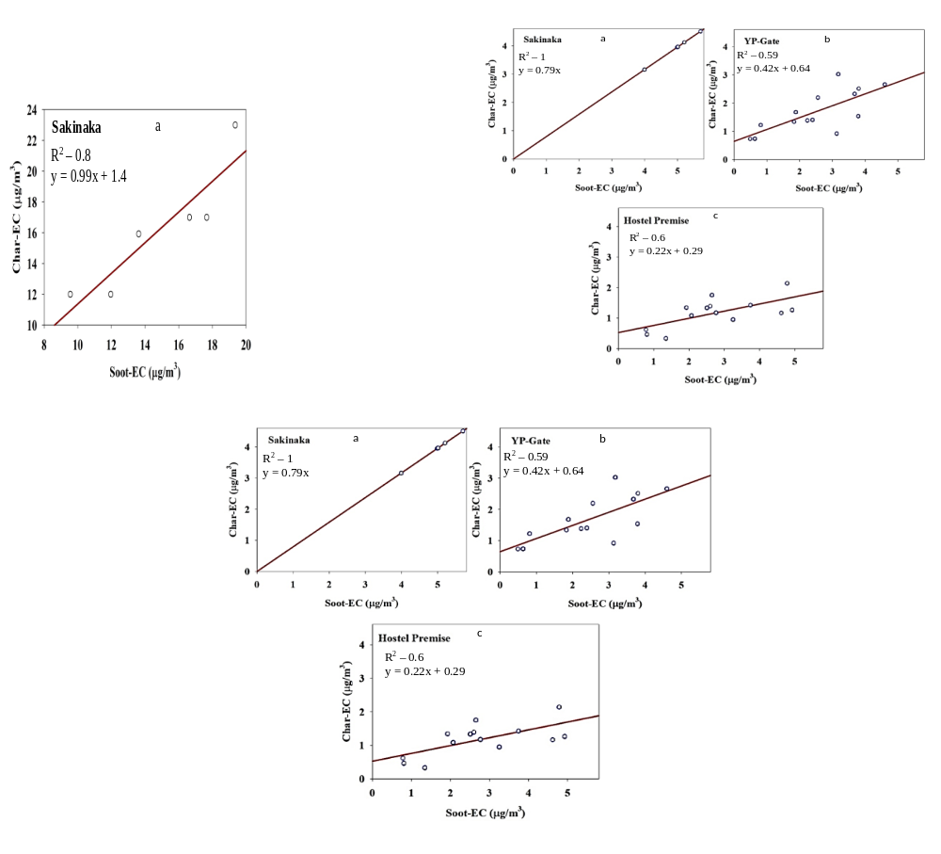
Fig. SI 4 The correlation between Char-EC and Soot-EC at Sakinaka (a), YP-Gate (b), and HP (c); the red line is for regression.

Table SI 6 Metal concentration in PM2.5 at all three locations
Metals | Hostel Premise (Residential) (ng/m³) | YP-Gate (Low traffic density) (ng/m³) | Sakinaka (High traffic density) (ng/m³)
Al | 429.45 | 763 | 1712.16
Ca | 451.12 | 1263.94 | 4257.85
Fe | 463.8 | 1127.87 | 2669.05
Ba | 4.2 | 44.16 | 63.48
Cu | 4.55 | 3.45 | 54.51
Pb | 84.45 | 57.13 | 652.60
Mn | 129.03 | 61.82 | 53.68
Zn | 513.36 | 622.93 | 679.37
As | 40 | 56.30 | 381.84
Table SI 7 Hazard and cancer risk index for DAD at all three locations for adults and Children
Hazard Index for DAD
Metals | Sakinaka Junction |  | YP-Gate |  | HP
 | HQ (Adult) | HQ (Children) | HQ (Adult) | HQ (Children) | HQ (Adult) | HQ (Children)
Cr | 3.0E-04 | 3.0E-04 | 4.3E-06 | 4.2E-06 | 4.0E-06 | 4.0E-06
Mn | 5.6E-09 | 5.6E-09 | 7.1E-09 | 7.0E-08 | 6.9E-08 | 7.01E-09
Pb | 1.9E-05 | 1.9E-05 | 7.0E-06 | 6.9E-06 | 3.2E-06 | 3.2E-06
Cd | 6.3E-05 | 6.3E-05 | 2.1E-06 | 2.1E-06 | 5.4E-07 | 5.5E-07
As | 1.6E-06 | 1.6E-06 | 2.7E-06 | 2.6E-06 | 2.1E-06 | 2.1E-06
Zn | 3.2E-08 | 3.2E-08 | 4.2E-08 | 4.3E-08 | 2.68E-08 | 2.71E-08
HI | 3.4E-04 | 3.4E-04 | 1.6E-05 | 1.6E-05 | 9.9E-06 | 9.9E-06
Cancer Risk for DAD
Metals | Sakinaka Junction |  | YP-Gate |  | HP
 | CR (Adult) | CR (Children) | CR (Adult) | CR (Children) | CR (Adult) | CR (Children)
Cr | 4.5E-07 | 4.4E-07 | 6.4E-09 | 6.3E-09 | 6.0E-09 | 6.0E-09
Pb | 1.9E-07 | 1.9E-07 | 7.0E-08 | 6.9E-08 | 3.2E-08 | 3.2E-08
As | 7.2E-09 | 7.1E-09 | 1.2E-09 | 1.2E-09 | 9.6E-10 | 9.5E-10
Total CR | 6.4E-07 | 6.4E-07 | 7.8E-08 | 7.7E-08 | 3.9E-08 | 3.9E-08
Table SI 8 Hazard and cancer risk index for CDI at all three locations for adults and Children
Hazard Index for CDI
Metals | Sakinaka Junction |  | YP-Gate |  | HP
 | HQ (Adult) | HQ (Children) | HQ (Adult) | HQ (Children) | HQ (Adult) | HQ (Children)
Cr | 0.000959 | 0.007671 | 1.37E-05 | 1.1E-04 | 1.4E-04 | 1.3E-05
Mn | 8.15E-07 | 6.52E-06 | 9.1E-07 | 7.2E-06 | 7.23E-06 | 9.03E-07
Pb | 6.16E-05 | 0.000493 | 2.2E-05 | 1.8E-04 | 8.22E-05 | 1.03E-05
Zn | 0.00411 | 0.032877 | 5.4E-03 | 4.3E-02 | 0.028231 | 0.003529
Cd | 6.16E-05 | 0.000493 | 5.4E-03 | 1.6E-04 | 4.27E-05 | 5.34E-06
As | 0.002028 | 0.016222 | 2.7E-03 | 3.3E-04 | 0.002163 | 0.00027
Fe | 1.37E-06 | 1.09E-05 | 2.6E-05 | 3.32E-06 | 1.09E-05 | 1.37E-06
HI | 0.007 | 0.06 | 0.005 | 0.05 | 0.003 | 0.04
Cancer Risk for CDI
Metals | Sakinaka Junction |  | YP-Gate |  | HP
 | CR (Adult) | CR (Children) | CR (Adult) | CR (Children) | CR (Adult) | CR (Children)
Cr | 1.7E-07 | 4.0E-07 | 1.7E-07 | 3.9E-07 | 2.3E-09 | 5.4E-09
Pb | 3.0E-08 | 7.1E-08 | 1.1E-08 | 2.6E-08 | 5.1E-09 | 1.2E-08
As | 1.1E-07 | 2.5E-07 | 1.8E-08 | 4.2E-08 | 1.4E-08 | 3.4E-08
Total CR | 2.8E-07 | 6.5E-07 | 1.9E-07 | 4.4E-07 | 1.6E-08 | 3.9E-08

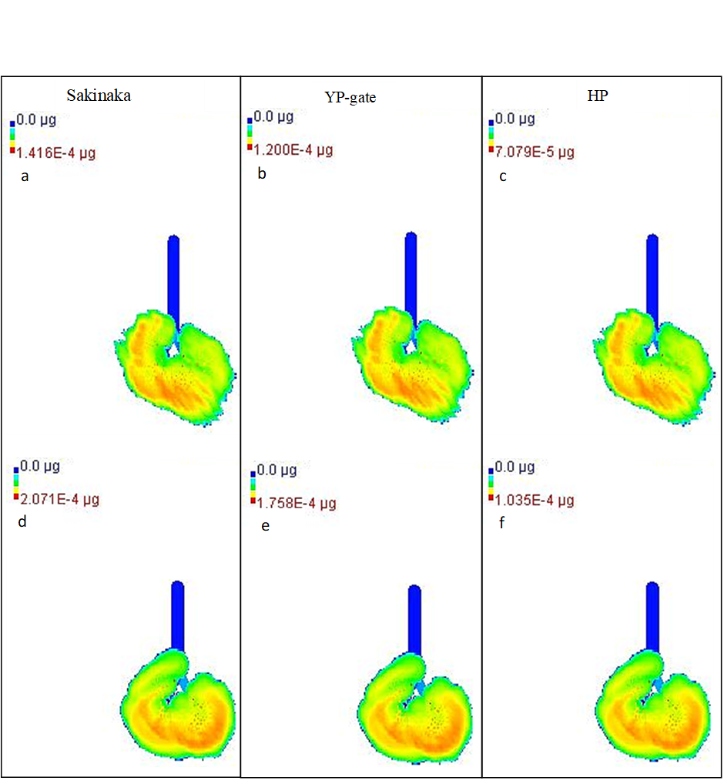
Fig. SI 5 The PM mass deposition in lungs of children (a to c) and adults (d to f) obtained from the MPPD model at different study sites
References
Bes, I. (2012). Winter Mass Concentrations of Carbon Species in PM 10 , PM 2 . 5 and PM 1 in Zagreb Air , Croatia. 1087–1090. https://doi.org/10.1007/s00128-012-0787-4
Chithra, V. S., & Nagendra, S. M. S. (2013). Chemical and morphological characteristics of indoor and outdoor particulate matter in an urban environment. Atmospheric Environment, 77, 579–587. https://doi.org/10.1016/j.atmosenv.2013.05.044
Choochuay, C., Pongpiachan, S., Tipmanee, D., Deelaman, W., Suttinun, O., Wang, Q., Xing, L., Li, G., Han, Y., Palakun, J., Poshyachinda, S., Aukkaravittayapun, S., Surapipith, V., & Cao, J. (2020). Long-range transboundary atmospheric transport of polycyclic aromatic hydrocarbons, carbonaceous compositions, and water-soluble ionic species in southern thailand. Aerosol and Air Quality Research, 20(7), 1591–1606. https://doi.org/10.4209/aaqr.2020.03.0120
Colbeck, I., Nasir, Z. A., Ahmad, S., & Ali, Z. (2011). Lahore , Pakistan. 11, 689–695.
Devi, N. L., Kumar, A., & Yadav, I. C. (2020). PM10 and PM2.5 in Indo-Gangetic Plain (IGP) of India: Chemical characterization, source analysis, and transport pathways. Urban Climate, 33, 100663. https://doi.org/10.1016/J.UCLIM.2020.100663
Fujii, Y., Mahmud, M., Tohno, S., Okuda, T., & Mizohata, A. (2016). A Case Study of PM 2 . 5 Characterization in Bangi , Selangor , Malaysia during the Southwest Monsoon Season. Mahmud 2009, 2685–2691. https://doi.org/10.4209/aaqr.2015.04.0277
Garg, A., & Arvind, N. C. G. (2022). Spatio ‑ Temporal Variability and Health Risk Assessment of Benzo [ a ] pyrene in Different Population Through Ambient Air Exposure in Delhi ,. Exposure and Health, 14(1), 111–127. https://doi.org/10.1007/s12403-021-00422-8
Gluščić, V., Čačković, M., Pehnec, G., & Bešlić, I. (2020). Ionic composition of PM 2 . 5 particle fraction at a coastal urban background site in Croatia. Atmospheric Pollution Research, 11(12), 2202–2214. https://doi.org/10.1016/j.apr.2020.07.004
Jahedi, F., Rad, H. D., Goudarzi, G., Babaei, A. A., & Angali, K. A. (2021). Polycyclic aromatic hydrocarbons in PM 1 , PM 2 . 5 and PM 10 atmospheric particles : identification , sources , temporal and spatial variations. 851–866.
Jithin, N. M., Gowtham, J., & Srimuruganandam, A. B. B. (2022). Mass , composition , and sources of particulate matter in residential and traffic sites of an urban environment. Environmental Geochemistry and Health, 0123456789. https://doi.org/10.1007/s10653-022-01327-4
Jodeh, S., Hasan, A. R., Amarah, J., Judeh, F., Salghi, R., Lgaz, H., & Jodeh, W. (2018). Indoor and outdoor air quality analysis for the city of Nablus of residential homes. 229–237.
Kim, K. H., Sekiguchi, K., Kudo, S., & Sakamoto, K. (2011). Characteristics of Atmospheric Elemental Carbon (Char and Soot) in Ultrafine and Fine Particles in a Roadside Environment, Japan. Aerosol and Air Quality Research, 11(1), 1–12. https://doi.org/10.4209/aaqr.2010.07.0061
Kumar, A., & Attri, A. K. (2016). Biomass combustion a dominant source of carbonaceous aerosols in the ambient environment of Western Himalayas. Aerosol and Air Quality Research, 16(3), 519–529. https://doi.org/10.4209/aaqr.2015.05.0284
Kumar, P., Kumar, S., & Yadav, S. (2018). Seasonal variations in size distribution, water-soluble ions, and carbon content of size-segregated aerosols over New Delhi. Environmental Science and Pollution Research, 25(6), 6061–6078. https://doi.org/10.1007/s11356-017-0954-6
Li, B., Zhang, J., Zhao, Y., Yuan, S., Zhao, Q., Shen, G., & Wu, H. (2015). Seasonal variation of urban carbonaceous aerosols in a typical city Nanjing in Yangtze River Delta, China. Atmospheric Environment, 106, 223–231. https://doi.org/10.1016/j.atmosenv.2015.01.064
Li, H., Wang, Q., Yang, M., Li, F., Wang, J., Sun, Y., Wang, C., Wu, H., & Qian, X. (2016). Chemical characterization and source apportionment of PM2.5 aerosols in a megacity of Southeast China. Atmospheric Research, 181, 288–299. https://doi.org/10.1016/J.ATMOSRES.2016.07.005
Lim, S., Lee, M., Lee, G., Kim, S., Yoon, S., & Kang, K. (2012). Ionic and carbonaceous compositions of PM10, PM2.5 and PM1.0 at Gosan ABC Superstation and their ratios as source signature. Atmospheric Chemistry and Physics, 12(4), 2007–2024. https://doi.org/10.5194/acp-12-2007-2012
Liu, H., Jia, M., You, K., Wang, J., Tao, J., Liu, H., Zhang, R., Li, L., Xu, M., Ren, Y., Zhao, Y., Liu, Y., Cheng, K., Fan, Y., & Li, J. (2022). Elucidating the Chemical Compositions and Source Apportionment of Multi-Size Atmospheric Particulate (PM10, PM2.5 and PM1) in 2019–2020 Winter in Xinxiang, North China. Atmosphere, 13(9). https://doi.org/10.3390/atmos13091400
Mahapatra, P. S., Panda, U., Mallik, C., Boopathy, R., Jain, S., Sharma, S. K., Mandal, T. K., Senapati, S., Satpathy, P., Panda, S., & Das, T. (2021). Chemical, microstructural, and biological characterization of wintertime PM2.5 during a land campaign study in a coastal city of eastern India. Atmospheric Pollution Research, 12(9), 101164. https://doi.org/10.1016/j.apr.2021.101164
Masiol, M., Benetello, F., Harrison, R. M., Formenton, G., De Gaspari, F., & Pavoni, B. (2015). Spatial, seasonal trends and transboundary transport of PM2.5 inorganic ions in the Veneto region (Northeastern Italy). Atmospheric Environment, 117, 19–31. https://doi.org/10.1016/J.ATMOSENV.2015.06.044
Massey, D., Kulshrestha, A., Masih, J., & Taneja, A. (2012). of residential homes located in North-Central India. Building and Environment, 47, 223–231. https://doi.org/10.1016/j.buildenv.2011.07.018
Mishra, M., & Kulshrestha, U. C. (2021). Source impact analysis using char-ec/soot-ec ratios in the central indo-gangetic plain (Igp) of India. Aerosol and Air Quality Research, 21(9), 1–17. https://doi.org/10.4209/aaqr.200628
Nadali, A., Arfaeinia, H., Asadgol, Z., & Fahiminia, M. (2020). Indoor and outdoor concentration of PM 10 , PM 2 . 5 and PM 1 in residential building and evaluation of negative air ions ( NAIs ) in indoor PM removal. Environmental Pollutants and Bioavailability, 32(1), 47–55. https://doi.org/10.1080/26395940.2020.1728198
Police, S., Sahu, S. K., & Pandit, G. G. (2016). Chemical characterization of atmospheric particulate matter and their source apportionment at an emerging industrial coastal city ,. Atmospheric Pollution Research, 7(4), 725–733. https://doi.org/10.1016/j.apr.2016.03.007
Sahu, R. K., Pervez, S., Chow, J. C., Watson, J. G., Tiwari, S., Panicker, A. S., Chakrabarty, R. K., & Pervez, Y. F. (2018). Temporal and spatial variations of PM2.5 organic and elemental carbon in Central India. Environmental Geochemistry and Health, 40(5), 2205–2222. https://doi.org/10.1007/s10653-018-0093-0
Souza, D. Z., Vasconcellos, P. C., Lee, H., Aurela, M., Saarnio, K., Teinilä, K., & Hillamo, R. (2014). Composition of PM 2 . 5 and PM 10 Collected at Urban Sites in Brazil. 168–176. https://doi.org/10.4209/aaqr.2013.03.0071
Srimuruganandam, B., & Shiva Nagendra, S. M. (2011). Chemical characterization of PM10 and PM2.5 mass concentrations emitted by heterogeneous traffic. Science of The Total Environment, 409(17), 3144–3157. https://doi.org/10.1016/J.SCITOTENV.2011.04.042
Talbi, A., Kerchich, Y., & Kerbachi, R. (2018). Assessment of annual air pollution levels with PM1 , PM2 . 5 , PM10 and associated heavy metals in Algiers , Algeria * nou e. 232, 252–263. https://doi.org/10.1016/j.envpol.2017.09.041
Tham, J., Sarkar, S., Jia, S., Reid, J. S., Mishra, S., Sudiana, I. M., Swarup, S., Ong, C. N., & Yu, L. E. (2019). Impacts of peat-forest smoke on urban PM2.5 in the Maritime Continent during 2012–2015: Carbonaceous profiles and indicators. Environmental Pollution, 248, 496–505. https://doi.org/10.1016/j.envpol.2019.02.049
Thi, N., Thuy, T., Dung, N. T., Sekiguchi, K., Thuy, L. B., Thi, N., Hien, T., & Yamaguchi, R. (2018). at Urban Locations in Hanoi , Vietnam. 1591–1605. https://doi.org/10.4209/aaqr.2017.11.0502
Zhang, J., Yang, L., Mellouki, A., Wen, L., Yang, Y., & Gao, Y. (2016). Science of the Total Environment Chemical characteristics and in fl uence of continental out fl ow on PM 1 . 0 , PM 2 . 5 and PM 10 measured at Tuoji island in the Bohai Sea. 573, 699–706. https://doi.org/10.1016/j.scitotenv.2016.08.146
Zhao, P. S., Dong, F., He, D., Zhao, X. J., Zhang, X. L., Zhang, W. Z., Yao, Q., & Liu, H. Y. (2013). Characteristics of concentrations and chemical compositions for PM&amp;lt;sub&amp;gt;2.5&amp;lt;/sub&amp;gt; in the region of Beijing, Tianjin, and Hebei, China. Atmospheric Chemistry and Physics, 13(9), 4631–4644. https://doi.org/10.5194/acp-13-4631-2013
Bes, I. (2012). Winter Mass Concentrations of Carbon Species in PM 10 , PM 2 . 5 and PM 1 in Zagreb Air , Croatia. 1087–1090. https://doi.org/10.1007/s00128-012-0787-4
Chithra, V. S., & Nagendra, S. M. S. (2013). Chemical and morphological characteristics of indoor and outdoor particulate matter in an urban environment. Atmospheric Environment, 77, 579–587. https://doi.org/10.1016/j.atmosenv.2013.05.044
Choochuay, C., Pongpiachan, S., Tipmanee, D., Deelaman, W., Suttinun, O., Wang, Q., Xing, L., Li, G., Han, Y., Palakun, J., Poshyachinda, S., Aukkaravittayapun, S., Surapipith, V., & Cao, J. (2020). Long-range transboundary atmospheric transport of polycyclic aromatic hydrocarbons, carbonaceous compositions, and water-soluble ionic species in southern thailand. Aerosol and Air Quality Research, 20(7), 1591–1606. https://doi.org/10.4209/aaqr.2020.03.0120
Colbeck, I., Nasir, Z. A., Ahmad, S., & Ali, Z. (2011). Lahore , Pakistan. 11, 689–695.
Devi, N. L., Kumar, A., & Yadav, I. C. (2020). PM10 and PM2.5 in Indo-Gangetic Plain (IGP) of India: Chemical characterization, source analysis, and transport pathways. Urban Climate, 33, 100663. https://doi.org/10.1016/J.UCLIM.2020.100663
Fujii, Y., Mahmud, M., Tohno, S., Okuda, T., & Mizohata, A. (2016). A Case Study of PM 2 . 5 Characterization in Bangi , Selangor , Malaysia during the Southwest Monsoon Season. Mahmud 2009, 2685–2691. https://doi.org/10.4209/aaqr.2015.04.0277
Garg, A., & Arvind, N. C. G. (2022). Spatio ‑ Temporal Variability and Health Risk Assessment of Benzo [ a ] pyrene in Different Population Through Ambient Air Exposure in Delhi ,. Exposure and Health, 14(1), 111–127. https://doi.org/10.1007/s12403-021-00422-8
Gluščić, V., Čačković, M., Pehnec, G., & Bešlić, I. (2020). Ionic composition of PM 2 . 5 particle fraction at a coastal urban background site in Croatia. Atmospheric Pollution Research, 11(12), 2202–2214. https://doi.org/10.1016/j.apr.2020.07.004
Jahedi, F., Rad, H. D., Goudarzi, G., Babaei, A. A., & Angali, K. A. (2021). Polycyclic aromatic hydrocarbons in PM 1 , PM 2 . 5 and PM 10 atmospheric particles : identification , sources , temporal and spatial variations. 851–866.
Jithin, N. M., Gowtham, J., & Srimuruganandam, A. B. B. (2022). Mass , composition , and sources of particulate matter in residential and traffic sites of an urban environment. Environmental Geochemistry and Health, 0123456789. https://doi.org/10.1007/s10653-022-01327-4
Jodeh, S., Hasan, A. R., Amarah, J., Judeh, F., Salghi, R., Lgaz, H., & Jodeh, W. (2018). Indoor and outdoor air quality analysis for the city of Nablus of residential homes. 229–237.
Kim, K. H., Sekiguchi, K., Kudo, S., & Sakamoto, K. (2011). Characteristics of Atmospheric Elemental Carbon (Char and Soot) in Ultrafine and Fine Particles in a Roadside Environment, Japan. Aerosol and Air Quality Research, 11(1), 1–12. https://doi.org/10.4209/aaqr.2010.07.0061
Kumar, A., & Attri, A. K. (2016). Biomass combustion a dominant source of carbonaceous aerosols in the ambient environment of Western Himalayas. Aerosol and Air Quality Research, 16(3), 519–529. https://doi.org/10.4209/aaqr.2015.05.0284
Kumar, P., Kumar, S., & Yadav, S. (2018). Seasonal variations in size distribution, water-soluble ions, and carbon content of size-segregated aerosols over New Delhi. Environmental Science and Pollution Research, 25(6), 6061–6078. https://doi.org/10.1007/s11356-017-0954-6
Li, B., Zhang, J., Zhao, Y., Yuan, S., Zhao, Q., Shen, G., & Wu, H. (2015). Seasonal variation of urban carbonaceous aerosols in a typical city Nanjing in Yangtze River Delta, China. Atmospheric Environment, 106, 223–231. https://doi.org/10.1016/j.atmosenv.2015.01.064
Li, H., Wang, Q., Yang, M., Li, F., Wang, J., Sun, Y., Wang, C., Wu, H., & Qian, X. (2016). Chemical characterization and source apportionment of PM2.5 aerosols in a megacity of Southeast China. Atmospheric Research, 181, 288–299. https://doi.org/10.1016/J.ATMOSRES.2016.07.005
Lim, S., Lee, M., Lee, G., Kim, S., Yoon, S., & Kang, K. (2012). Ionic and carbonaceous compositions of PM10, PM2.5 and PM1.0 at Gosan ABC Superstation and their ratios as source signature. Atmospheric Chemistry and Physics, 12(4), 2007–2024. https://doi.org/10.5194/acp-12-2007-2012
Liu, H., Jia, M., You, K., Wang, J., Tao, J., Liu, H., Zhang, R., Li, L., Xu, M., Ren, Y., Zhao, Y., Liu, Y., Cheng, K., Fan, Y., & Li, J. (2022). Elucidating the Chemical Compositions and Source Apportionment of Multi-Size Atmospheric Particulate (PM10, PM2.5 and PM1) in 2019–2020 Winter in Xinxiang, North China. Atmosphere, 13(9). https://doi.org/10.3390/atmos13091400
Mahapatra, P. S., Panda, U., Mallik, C., Boopathy, R., Jain, S., Sharma, S. K., Mandal, T. K., Senapati, S., Satpathy, P., Panda, S., & Das, T. (2021). Chemical, microstructural, and biological characterization of wintertime PM2.5 during a land campaign study in a coastal city of eastern India. Atmospheric Pollution Research, 12(9), 101164. https://doi.org/10.1016/j.apr.2021.101164
Masiol, M., Benetello, F., Harrison, R. M., Formenton, G., De Gaspari, F., & Pavoni, B. (2015). Spatial, seasonal trends and transboundary transport of PM2.5 inorganic ions in the Veneto region (Northeastern Italy). Atmospheric Environment, 117, 19–31. https://doi.org/10.1016/J.ATMOSENV.2015.06.044
Massey, D., Kulshrestha, A., Masih, J., & Taneja, A. (2012). of residential homes located in North-Central India. Building and Environment, 47, 223–231. https://doi.org/10.1016/j.buildenv.2011.07.018
Mishra, M., & Kulshrestha, U. C. (2021). Source impact analysis using char-ec/soot-ec ratios in the central indo-gangetic plain (Igp) of India. Aerosol and Air Quality Research, 21(9), 1–17. https://doi.org/10.4209/aaqr.200628
Nadali, A., Arfaeinia, H., Asadgol, Z., & Fahiminia, M. (2020). Indoor and outdoor concentration of PM 10 , PM 2 . 5 and PM 1 in residential building and evaluation of negative air ions ( NAIs ) in indoor PM removal. Environmental Pollutants and Bioavailability, 32(1), 47–55. https://doi.org/10.1080/26395940.2020.1728198
Police, S., Sahu, S. K., & Pandit, G. G. (2016). Chemical characterization of atmospheric particulate matter and their source apportionment at an emerging industrial coastal city ,. Atmospheric Pollution Research, 7(4), 725–733. https://doi.org/10.1016/j.apr.2016.03.007
Sahu, R. K., Pervez, S., Chow, J. C., Watson, J. G., Tiwari, S., Panicker, A. S., Chakrabarty, R. K., & Pervez, Y. F. (2018). Temporal and spatial variations of PM2.5 organic and elemental carbon in Central India. Environmental Geochemistry and Health, 40(5), 2205–2222. https://doi.org/10.1007/s10653-018-0093-0
Souza, D. Z., Vasconcellos, P. C., Lee, H., Aurela, M., Saarnio, K., Teinilä, K., & Hillamo, R. (2014). Composition of PM 2 . 5 and PM 10 Collected at Urban Sites in Brazil. 168–176. https://doi.org/10.4209/aaqr.2013.03.0071
Srimuruganandam, B., & Shiva Nagendra, S. M. (2011). Chemical characterization of PM10 and PM2.5 mass concentrations emitted by heterogeneous traffic. Science of The Total Environment, 409(17), 3144–3157. https://doi.org/10.1016/J.SCITOTENV.2011.04.042
Talbi, A., Kerchich, Y., & Kerbachi, R. (2018). Assessment of annual air pollution levels with PM1 , PM2 . 5 , PM10 and associated heavy metals in Algiers , Algeria * nou e. 232, 252–263. https://doi.org/10.1016/j.envpol.2017.09.041
Tham, J., Sarkar, S., Jia, S., Reid, J. S., Mishra, S., Sudiana, I. M., Swarup, S., Ong, C. N., & Yu, L. E. (2019). Impacts of peat-forest smoke on urban PM2.5 in the Maritime Continent during 2012–2015: Carbonaceous profiles and indicators. Environmental Pollution, 248, 496–505. https://doi.org/10.1016/j.envpol.2019.02.049
Thi, N., Thuy, T., Dung, N. T., Sekiguchi, K., Thuy, L. B., Thi, N., Hien, T., & Yamaguchi, R. (2018). at Urban Locations in Hanoi , Vietnam. 1591–1605. https://doi.org/10.4209/aaqr.2017.11.0502
Zhang, J., Yang, L., Mellouki, A., Wen, L., Yang, Y., & Gao, Y. (2016). Science of the Total Environment Chemical characteristics and in fl uence of continental out fl ow on PM 1 . 0 , PM 2 . 5 and PM 10 measured at Tuoji island in the Bohai Sea. 573, 699–706. https://doi.org/10.1016/j.scitotenv.2016.08.146
Zhao, P. S., Dong, F., He, D., Zhao, X. J., Zhang, X. L., Zhang, W. Z., Yao, Q., & Liu, H. Y. (2013). Characteristics of concentrations and chemical compositions for PM&amp;lt;sub&amp;gt;2.5&amp;lt;/sub&amp;gt; in the region of Beijing, Tianjin, and Hebei, China. Atmospheric Chemistry and Physics, 13(9), 4631–4644. https://doi.org/10.5194/acp-13-4631-2013
Bes, I. (2012). Winter Mass Concentrations of Carbon Species in PM 10 , PM 2 . 5 and PM 1 in Zagreb Air , Croatia. 1087–1090. https://doi.org/10.1007/s00128-012-0787-4
Chithra, V. S., & Nagendra, S. M. S. (2013). Chemical and morphological characteristics of indoor and outdoor particulate matter in an urban environment. Atmospheric Environment, 77, 579–587. https://doi.org/10.1016/j.atmosenv.2013.05.044
Choochuay, C., Pongpiachan, S., Tipmanee, D., Deelaman, W., Suttinun, O., Wang, Q., Xing, L., Li, G., Han, Y., Palakun, J., Poshyachinda, S., Aukkaravittayapun, S., Surapipith, V., & Cao, J. (2020). Long-range transboundary atmospheric transport of polycyclic aromatic hydrocarbons, carbonaceous compositions, and water-soluble ionic species in southern thailand. Aerosol and Air Quality Research, 20(7), 1591–1606. https://doi.org/10.4209/aaqr.2020.03.0120
Colbeck, I., Nasir, Z. A., Ahmad, S., & Ali, Z. (2011). Lahore , Pakistan. 11, 689–695.
Devi, N. L., Kumar, A., & Yadav, I. C. (2020). PM10 and PM2.5 in Indo-Gangetic Plain (IGP) of India: Chemical characterization, source analysis, and transport pathways. Urban Climate, 33, 100663. https://doi.org/10.1016/J.UCLIM.2020.100663
Fujii, Y., Mahmud, M., Tohno, S., Okuda, T., & Mizohata, A. (2016). A Case Study of PM 2 . 5 Characterization in Bangi , Selangor , Malaysia during the Southwest Monsoon Season. Mahmud 2009, 2685–2691. https://doi.org/10.4209/aaqr.2015.04.0277
Garg, A., & Arvind, N. C. G. (2022). Spatio ‑ Temporal Variability and Health Risk Assessment of Benzo [ a ] pyrene in Different Population Through Ambient Air Exposure in Delhi ,. Exposure and Health, 14(1), 111–127. https://doi.org/10.1007/s12403-021-00422-8
Gluščić, V., Čačković, M., Pehnec, G., & Bešlić, I. (2020). Ionic composition of PM 2 . 5 particle fraction at a coastal urban background site in Croatia. Atmospheric Pollution Research, 11(12), 2202–2214. https://doi.org/10.1016/j.apr.2020.07.004
Jahedi, F., Rad, H. D., Goudarzi, G., Babaei, A. A., & Angali, K. A. (2021). Polycyclic aromatic hydrocarbons in PM 1 , PM 2 . 5 and PM 10 atmospheric particles : identification , sources , temporal and spatial variations. 851–866.
Jithin, N. M., Gowtham, J., & Srimuruganandam, A. B. B. (2022). Mass , composition , and sources of particulate matter in residential and traffic sites of an urban environment. Environmental Geochemistry and Health, 0123456789. https://doi.org/10.1007/s10653-022-01327-4
Jodeh, S., Hasan, A. R., Amarah, J., Judeh, F., Salghi, R., Lgaz, H., & Jodeh, W. (2018). Indoor and outdoor air quality analysis for the city of Nablus of residential homes. 229–237.
Kim, K. H., Sekiguchi, K., Kudo, S., & Sakamoto, K. (2011). Characteristics of Atmospheric Elemental Carbon (Char and Soot) in Ultrafine and Fine Particles in a Roadside Environment, Japan. Aerosol and Air Quality Research, 11(1), 1–12. https://doi.org/10.4209/aaqr.2010.07.0061
Kumar, A., & Attri, A. K. (2016). Biomass combustion is a dominant source of carbonaceous aerosols in the ambient environment of the Western Himalayas. Aerosol and Air Quality Research, 16(3), 519–529. https://doi.org/10.4209/aaqr.2015.05.0284
Kumar, P., Kumar, S., & Yadav, S. (2018). Seasonal variations in size distribution, water-soluble ions, and carbon content of size-segregated aerosols over New Delhi. Environmental Science and Pollution Research, 25(6), 6061–6078. https://doi.org/10.1007/s11356-017-0954-6
Li, B., Zhang, J., Zhao, Y., Yuan, S., Zhao, Q., Shen, G., & Wu, H. (2015). Seasonal variation of urban carbonaceous aerosols in a typical city Nanjing in the Yangtze River Delta, China. Atmospheric Environment, 106, 223–231. https://doi.org/10.1016/j.atmosenv.2015.01.064
Li, H., Wang, Q., Yang, M., Li, F., Wang, J., Sun, Y., Wang, C., Wu, H., & Qian, X. (2016). Chemical characterization and source apportionment of PM2.5 aerosols in a megacity of Southeast China. Atmospheric Research, 181, 288–299. https://doi.org/10.1016/J.ATMOSRES.2016.07.005
Lim, S., Lee, M., Lee, G., Kim, S., Yoon, S., & Kang, K. (2012). Ionic and carbonaceous compositions of PM10, PM2.5, and PM1.0 at Gosan ABC Superstation and their ratios as source signature. Atmospheric Chemistry and Physics, 12(4), 2007–2024. https://doi.org/10.5194/acp-12-2007-2012
Liu, H., Jia, M., You, K., Wang, J., Tao, J., Liu, H., Zhang, R., Li, L., Xu, M., Ren, Y., Zhao, Y., Liu, Y., Cheng, K., Fan, Y., & Li, J. (2022). Elucidating the Chemical Compositions and Source Apportionment of Multi-Size Atmospheric Particulate (PM10, PM2.5 and PM1) in 2019–2020 Winter in Xinxiang, North China. Atmosphere, 13(9). https://doi.org/10.3390/atmos13091400
Mahapatra, P. S., Panda, U., Mallik, C., Boopathy, R., Jain, S., Sharma, S. K., Mandal, T. K., Senapati, S., Satpathy, P., Panda, S., & Das, T. (2021). Chemical, microstructural, and biological characterization of wintertime PM2.5 during a land campaign study in a coastal city of eastern India. Atmospheric Pollution Research, 12(9), 101164. https://doi.org/10.1016/j.apr.2021.101164
Masiol, M., Benetello, F., Harrison, R. M., Formenton, G., De Gaspari, F., & Pavoni, B. (2015). Spatial, seasonal trends and transboundary transport of PM2.5 inorganic ions in the Veneto region (Northeastern Italy). Atmospheric Environment, 117, 19–31. https://doi.org/10.1016/J.ATMOSENV.2015.06.044
Massey, D., Kulshrestha, A., Masih, J., & Taneja, A. (2012). of residential homes located in North-Central India. Building and Environment, 47, 223–231. https://doi.org/10.1016/j.buildenv.2011.07.018
Mishra, M., & Kulshrestha, U. C. (2021). Source impact analysis using char-ec/soot-ec ratios in the central indo-gangetic plain (Igp) of India. Aerosol and Air Quality Research, 21(9), 1–17. https://doi.org/10.4209/aaqr.200628
Nadali, A., Arfaeinia, H., Asadgol, Z., & Fahiminia, M. (2020). Indoor and outdoor concentration of PM 10 , PM 2 . 5 and PM 1 in residential building and evaluation of negative air ions ( NAIs ) in indoor PM removal. Environmental Pollutants and Bioavailability, 32(1), 47–55. https://doi.org/10.1080/26395940.2020.1728198
Police, S., Sahu, S. K., & Pandit, G. G. (2016). Chemical characterization of atmospheric particulate matter and their source apportionment at an emerging industrial coastal city ,. Atmospheric Pollution Research, 7(4), 725–733. https://doi.org/10.1016/j.apr.2016.03.007
Sahu, R. K., Pervez, S., Chow, J. C., Watson, J. G., Tiwari, S., Panicker, A. S., Chakrabarty, R. K., & Pervez, Y. F. (2018). Temporal and spatial variations of PM2.5 organic and elemental carbon in Central India. Environmental Geochemistry and Health, 40(5), 2205–2222. https://doi.org/10.1007/s10653-018-0093-0
Souza, D. Z., Vasconcellos, P. C., Lee, H., Aurela, M., Saarnio, K., Teinilä, K., & Hillamo, R. (2014). Composition of PM 2 . 5 and PM 10 Collected at Urban Sites in Brazil. 168–176. https://doi.org/10.4209/aaqr.2013.03.0071
Srimuruganandam, B., & Shiva Nagendra, S. M. (2011). Chemical characterization of PM10 and PM2.5 mass concentrations emitted by heterogeneous traffic. Science of The Total Environment, 409(17), 3144–3157. https://doi.org/10.1016/J.SCITOTENV.2011.04.042
Talbi, A., Kerchich, Y., & Kerbachi, R. (2018). Assessment of annual air pollution levels with PM1, PM2 . 5, PM10, and associated heavy metals in Algiers , Algeria * nou e. 232, 252–263. https://doi.org/10.1016/j.envpol.2017.09.041
Tham, J., Sarkar, S., Jia, S., Reid, J. S., Mishra, S., Sudiana, I. M., Swarup, S., Ong, C. N., & Yu, L. E. (2019). Impacts of peat-forest smoke on urban PM2.5 in the Maritime Continent during 2012–2015: Carbonaceous profiles and indicators. Environmental Pollution, 248, 496–505. https://doi.org/10.1016/j.envpol.2019.02.049
Thi, N., Thuy, T., Dung, N. T., Sekiguchi, K., Thuy, L. B., Thi, N., Hien, T., & Yamaguchi, R. (2018). at Urban Locations in Hanoi , Vietnam. 1591–1605. https://doi.org/10.4209/aaqr.2017.11.0502
Zhang, J., Yang, L., Mellouki, A., Wen, L., Yang, Y., & Gao, Y. (2016). Science of the Total Environment Chemical characteristics and influence of continental outflow on PM 1 . 0 , PM 2 . 5 and PM 10 measured at Tuoji island in the Bohai Sea. 573, 699–706. https://doi.org/10.1016/j.scitotenv.2016.08.146
Zhao, P. S., Dong, F., He, D., Zhao, X. J., Zhang, X. L., Zhang, W. Z., Yao, Q., & Liu, H. Y. (2013). Characteristics of concentrations and chemical compositions for PM&amp;lt;sub&amp;gt;2.5&amp;lt;/sub&amp;gt; in the region of Beijing, Tianjin, and Hebei, China. Atmospheric Chemistry and Physics, 13(9), 4631–4644. https://doi.org/10.5194/acp-13-4631-2013

