Supplementary Material
For Research on Chemical Intermediates
Efficient Removal of Methylene Blue by Micro-/Mesoporous Heteroatom-doped Biochar Derived from Waste Bovine Horn
Qifan Peng ^{a, 1}, Zhen Du ^{a, 1}, Chaoqiang Ma ª, Yuepeng Guan ^{b, *}, Zhenxing Feng ^{c, *},Yaqin Huang ^{a, *}
ª Beijing Laboratory of Biomedical Materials, Beijing Key Laboratory of Electrochemical Process and Technology for Materials, Beijing University of Chemical Technology, Beijing 100029, China
^{b} Beijing Key Laboratory of Clothing Materials R&D and Assessment, Beijing Engineering Research Center of Textile Nano Fiber, Beijing Institute of Fashion Technology, Beijing 100029, China
^{c} School of Chemical, Biological, and Environmental Engineering, Oregon State University, Corvallis, Oregon, USA Oregon State University
* Corresponding author.
E-mail address:
Yaqin Huang: huangyq@mail.buct.edu.cn
Yuepeng Guan: 20210007@bift.edu.cn
Zhenxing Feng: zhenxing.feng@oregonstate.edu
¹ Both authors contributed equally to this work.

Fig. S1 Element distribution on surface of (a-d) BHB-Air and (e-h) BHB-N₂
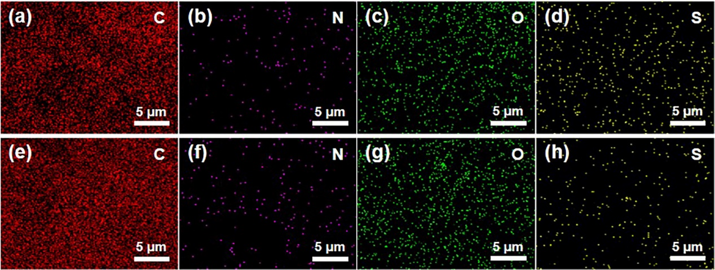

Fig. S2 Raman spectra of (a) BHB-Air and (b) BHB-N₂
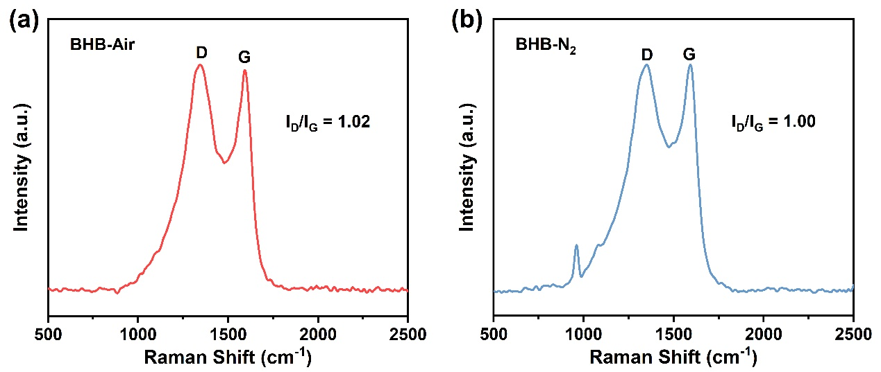

Fig. S3 Fitting curves of pseudo-first-order and pseudo-second-order kinetic models for adsorption of MB on (a, b) BHB-Air and (c, d) BHB-N₂
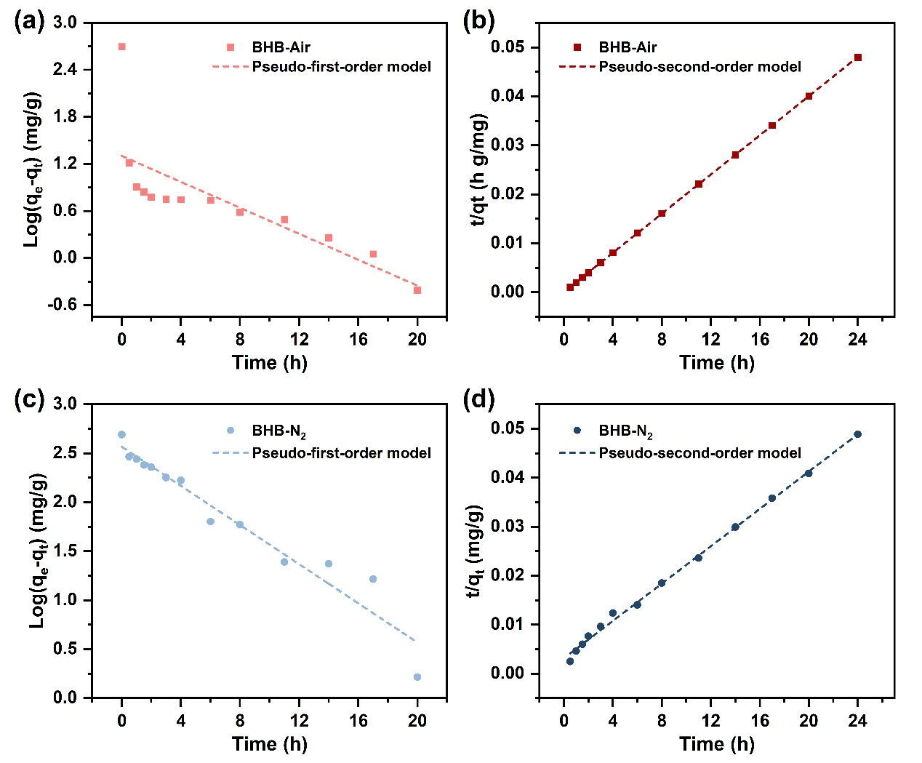
Fig. S4 Fitting curves of Langmuir isotherm model and Freundlich isotherm model for adsorption of MB on BHB-Air at (a, b) 30 ℃, (c, d) 40 ℃ and (e, f) 50 ℃
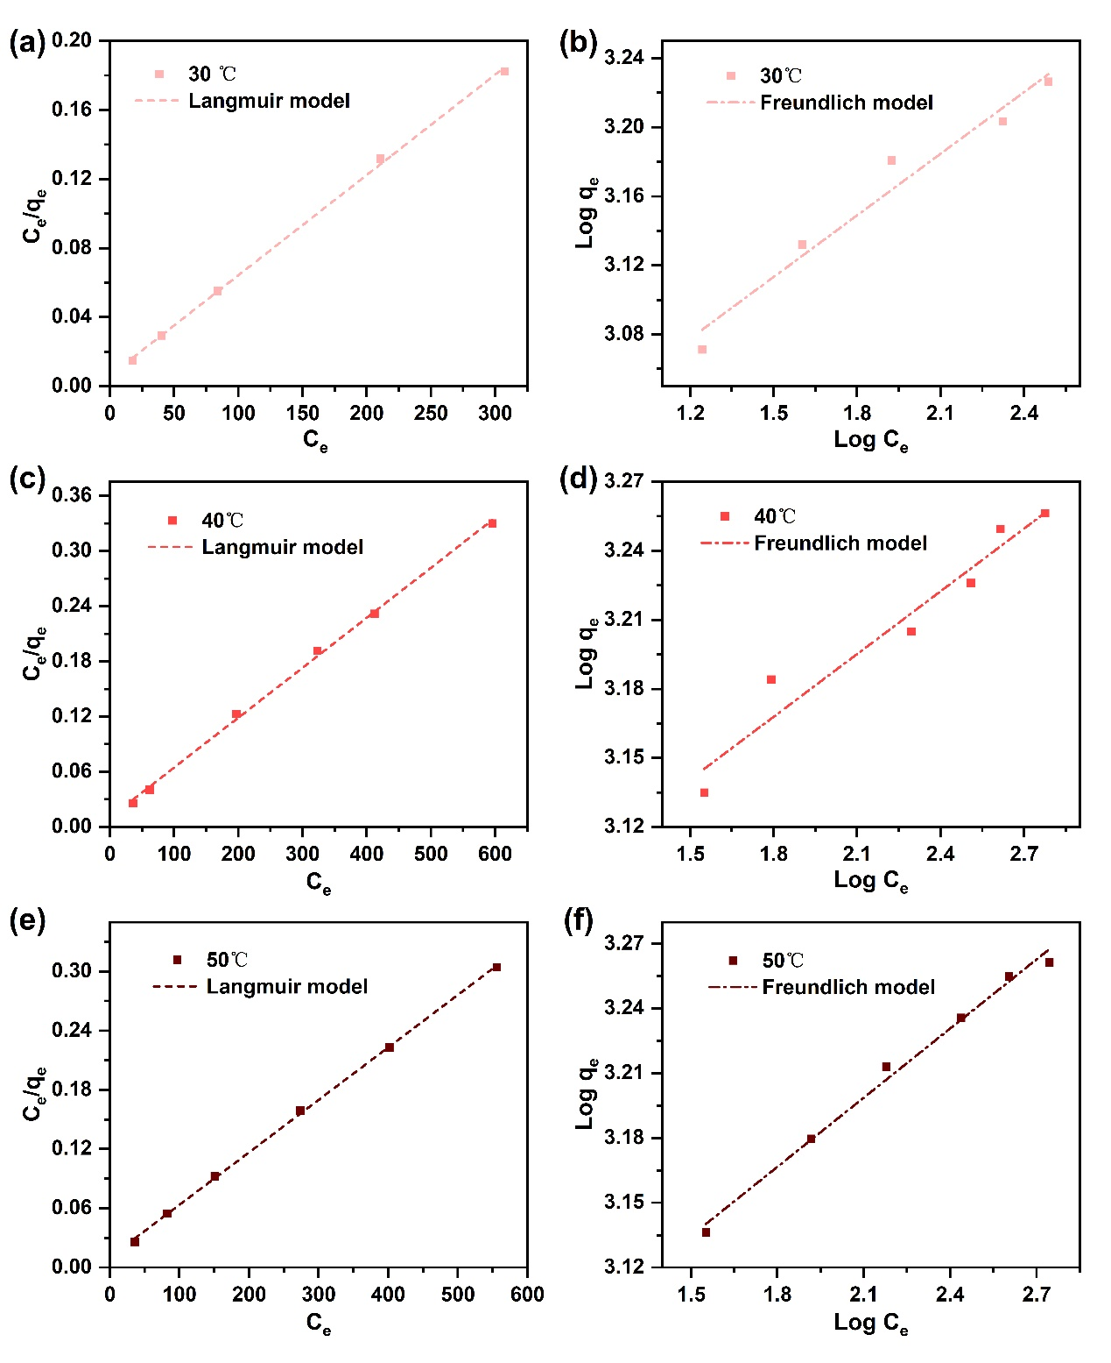

Fig. S5 Fitting curves of Langmuir isotherm model and Freundlich isotherm model for adsorption of MB on BHB-N₂ at (a, b) 30 ℃, (c, d) 40 ℃ and (e, f) 50 ℃
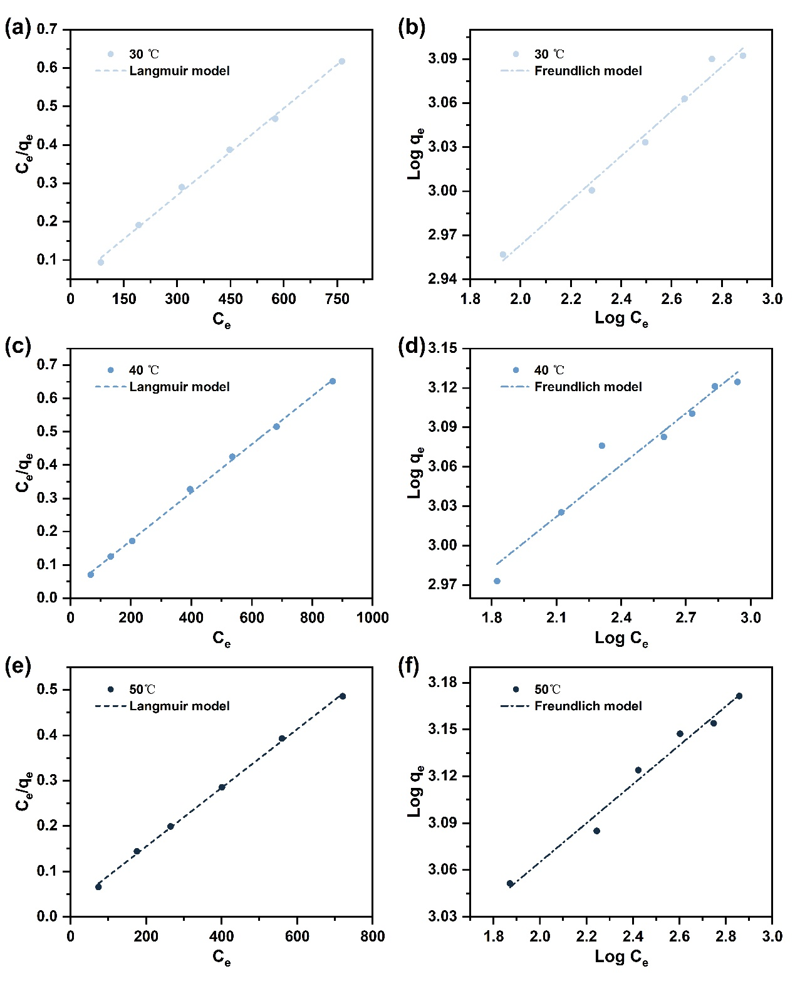

Fig. S6 Structural properties of BHBs after adsorption
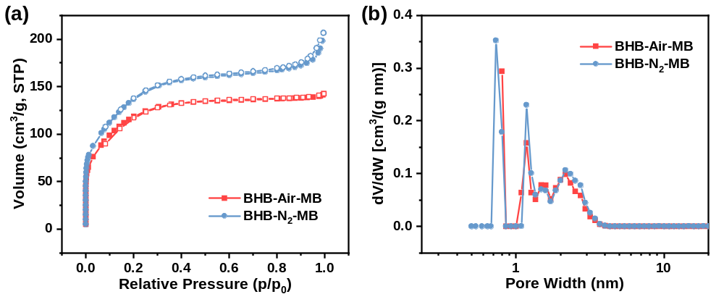

Fig. S7 XPS spectra of N1s and O 1s from (a, b) BHB-N₂ and (c, d) BHB-N₂-MB
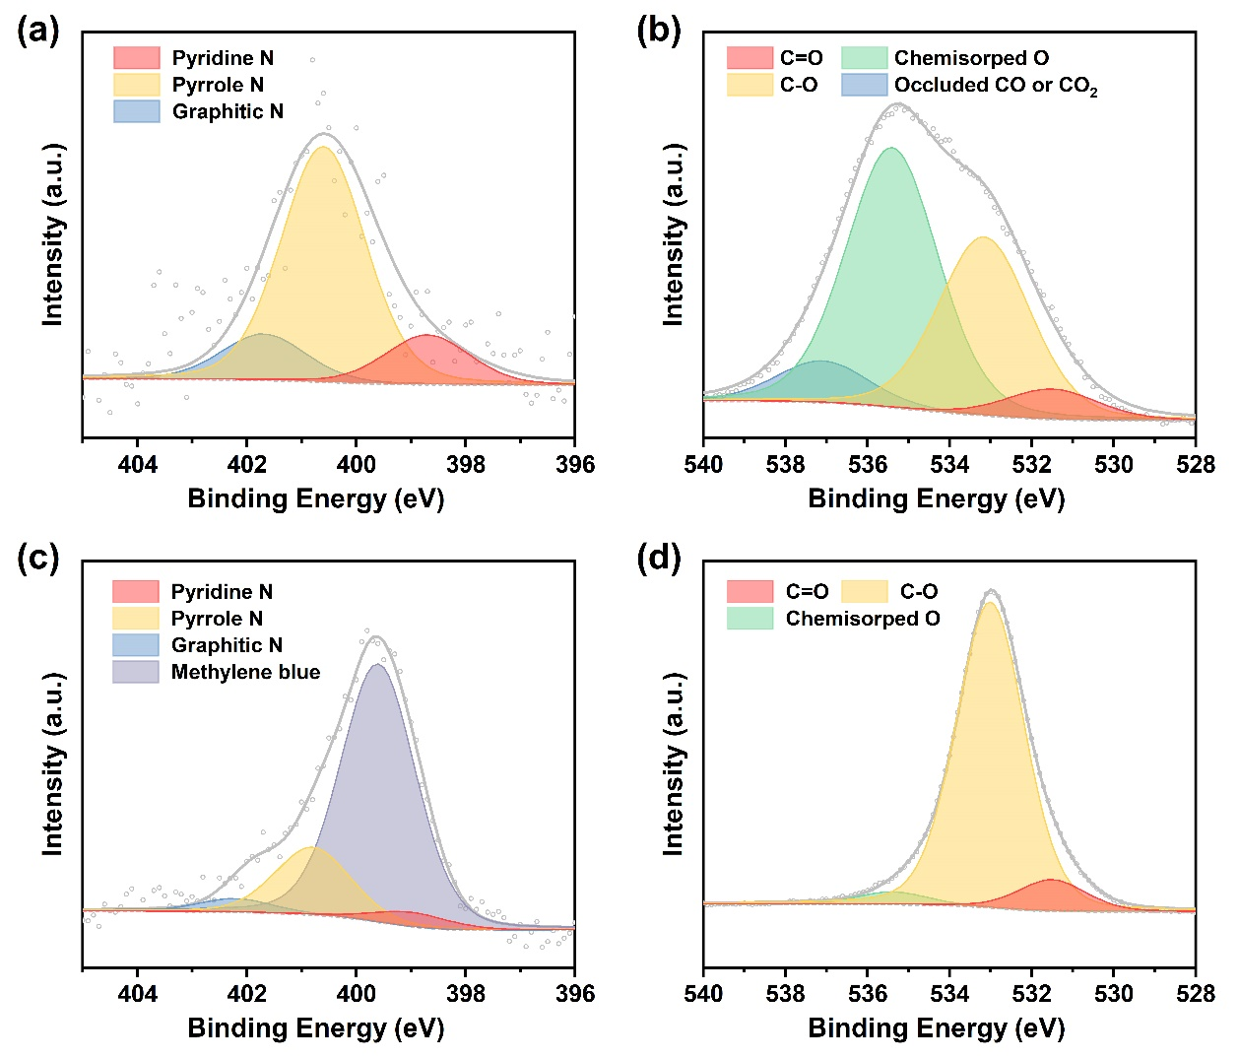

Table S1 Thermodynamic constants for the adsorption of MB on BHBs
Adsorbents | ΔG (kJ/mol) |  |  | ΔH (kJ/mol) | ΔS [J/ (mol K)]
Adsorbents | 303K | 313K | 323K | ΔH (kJ/mol) | ΔS [J/ (mol K)]
BHB-Air | -5.97 | -6.24 | -6.51 | 2.13 | 26.73
BHB-N₂ | -4.88 | -5.34 | -5.80 | 9.05 | 45.96

Table S2 Structural properties of BHBs after MB adsorption
Samples | S_{BET} ª  (m²/g) | V_{total} ^{b}  (cm³/g) | V_{micro} ^{c}  (cm³/g) | D_{p} ⁴  (nm)
BHB-Air-MB | 434.04 | 0.22 | 0.0092 | 2.21
BHB-N₂-MB | 509.31 | 0.32 | -0.011 | 2.74
Note: S_{BET} is the specific surface area calculated from BET method, V_{total} is the total pore volume measured at P/P₀ = 0.99; V_{micro} is the micropore volume calculated by t-Plot method, and D_{p} is the average pore width calculated from the equation of 4V_{total}/S_{BET}.

