Supplementary information

A healthier microbiome helps transgenic maize to defend herbicide toxicity
Authors
Zhongmin Dai, ^{1,2} Zhenjiang Chu,¹ Mingzhu Tao, ³ Zeyu Yu, ³ Yimin Tao, ³ Xuping Feng, ^{2,3}* Yong He, ³ Huaihai Chen, ⁴

Affiliations
¹ Institute of Soil and Water Resources and Environmental Science, College of Environmental and Resource Sciences, Zhejiang University, Hangzhou 310058, China
² The Rural Development Academy at Zhejiang University, Zhejiang University, Hangzhou 310058, China
³ College of Biosystems Engineering and Food Science, Zhejiang University, Hangzhou 310058, China
⁴ State Key Laboratory of Biocontrol, School of Ecology, Sun Yat-sen University, Guangzhou, 510006, China

* Correspondence: fengxp@zju.edu.cn

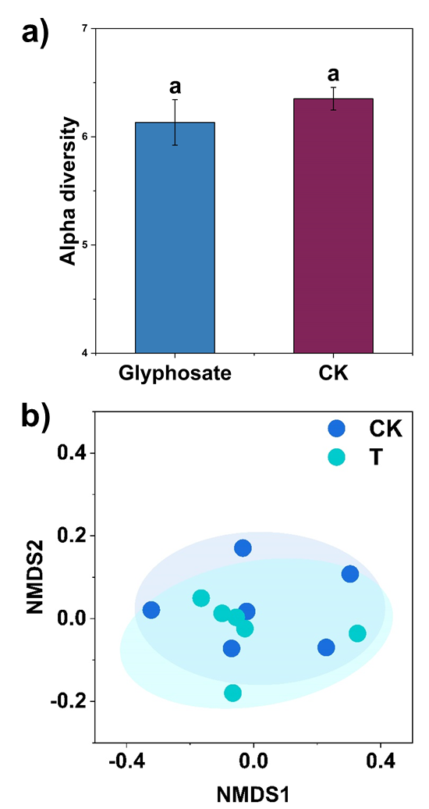

Fig. S1. Bacterial alpha diversity (a) and beta diversity (b) in the bulk soil with and without glyphosate treatment. Different letters in lower case represents significant differences at p < 0.05 probability level by one-way ANOVA between treatments. ANOSIM showed non-significant differences (p > 0.05) in bacterial community between the bulk soils with and without glyphosate treatment.

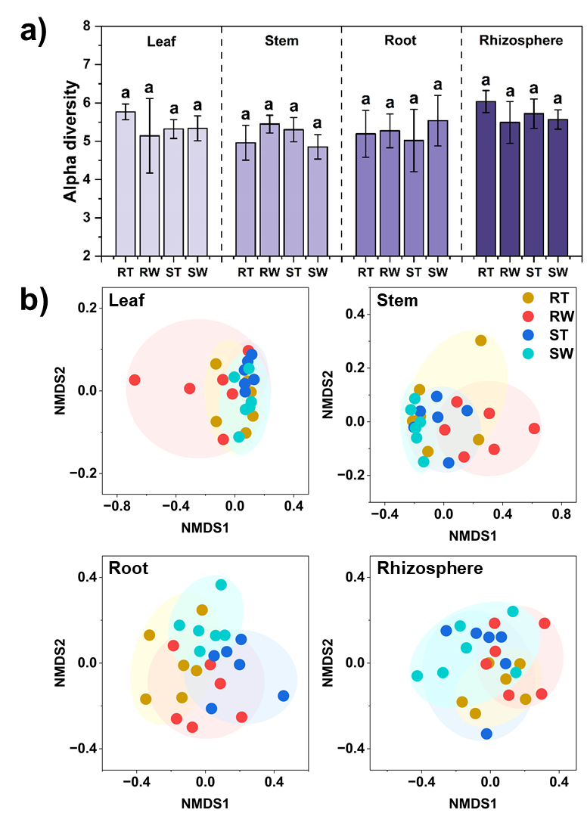
Fig. S2. Bacterial alpha diversity (a) and beta diversity (b) in the leaf, stem, root and rhizosphere soil of the transgenic and non-transgenic maize with and without glyphosate treatment on day 2. RT: transgenic maize + glyphosate; RW: transgenic maize + water; ST, non-transgenic maize + glyphosate; SW, non-transgenic maize + water. Different letters in lower case represents significant differences at p < 0.05 probability level by one-way ANOVA between treatments in each habitat. ANOSIM showed non-significant differences (p > 0.05) in bacterial community between the ST and RT treatments, and RT and RW treatments from leaf to rhizosphere.

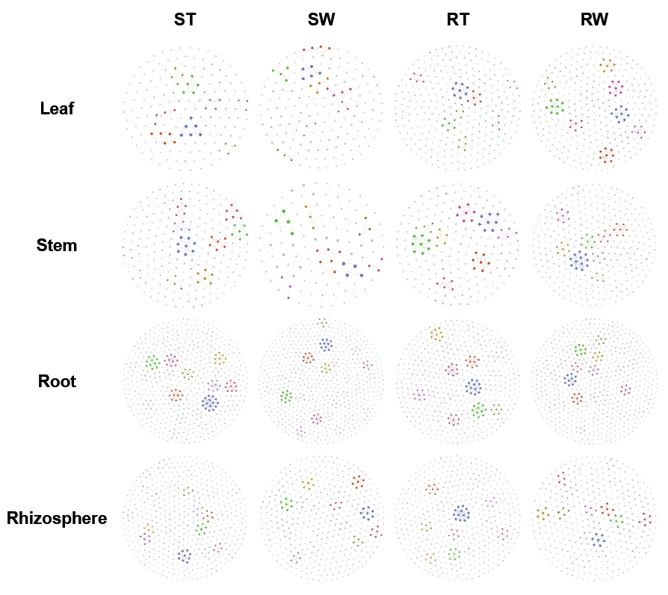

Fig. S3. Bacterial occurrence network in the leaf, stem, root and rhizosphere soil of the transgenic and non-transgenic maize with and without glyphosate treatment on day 2. The topological parameters of bacterial occurrence network are presented in Table S4.

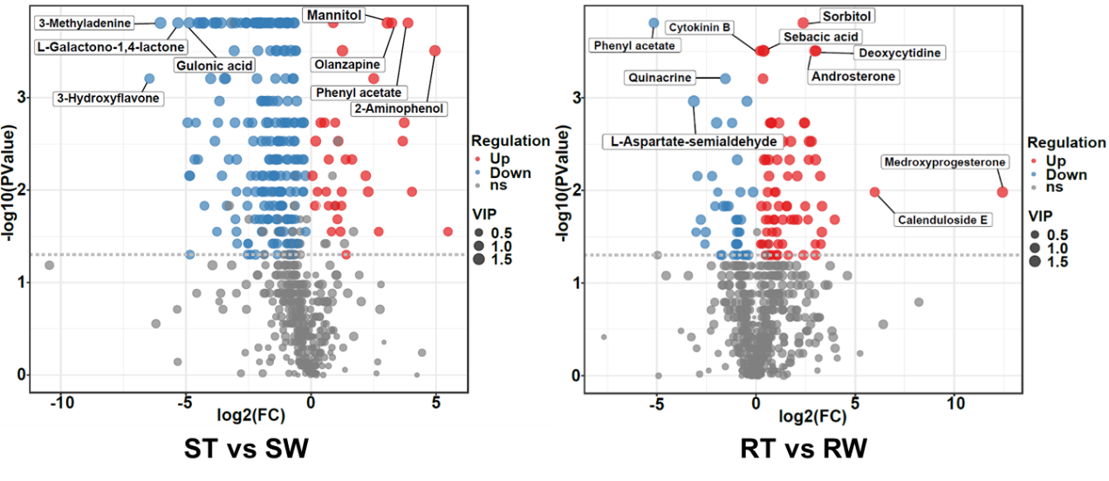
Fig. S4. Abundance of differential metabolites in the root-microbe systems between ST vs SW and RW vs SW. The differential metabolites between are identified based on the criteria: log2-fold change in relative abundance > 1, VIP > 1 and an adjusted P-value of < 0.05 in one treatment as compared to another treatment.

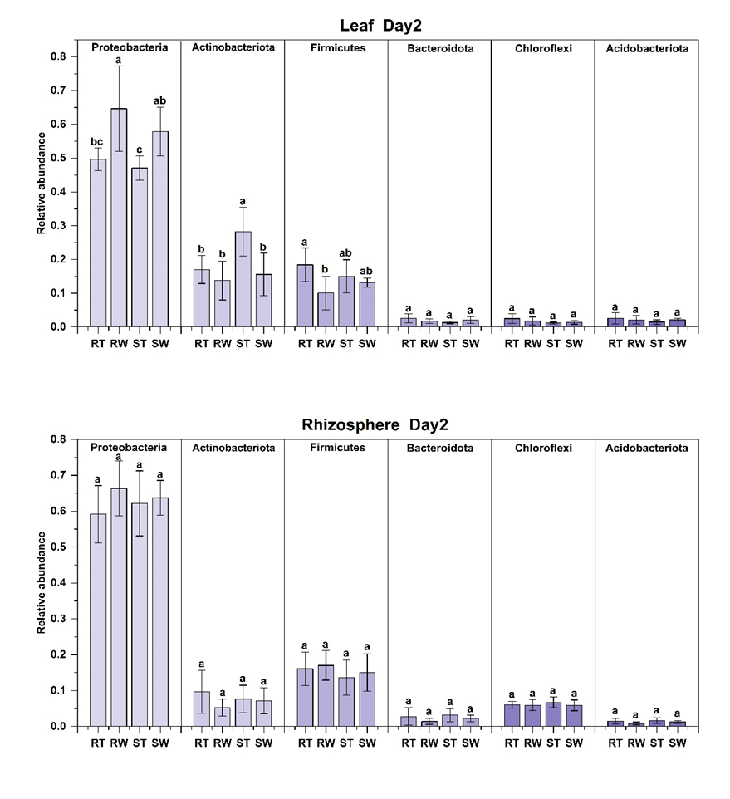
Fig. S5. Abundance changes in the bacterial phyla in the leaf and rhizosphere of the transgenic and non-transgenic maize with and without glyphosate treatment on day 2. Different letters in lower case represents significant differences at p < 0.05 probability level by one-way ANOVA between treatments in each habitat.

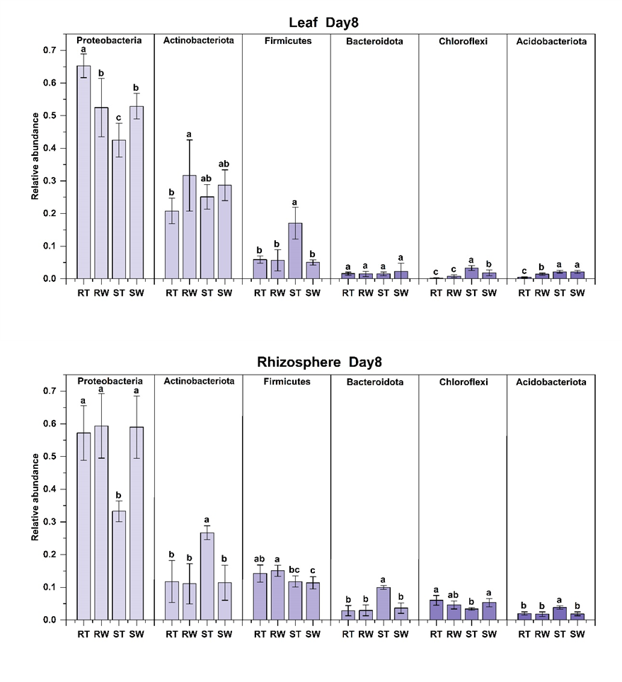
Fig. S6. Abundance changes in the bacterial phylam in the leaf and rhizosphere soil of the transgenic and non-transgenic maize with and without glyphosate treatments on day 8. Different letters in lower case represents significant differences at p < 0.05 probability level by one-way ANOVA between treatments in each habitat.

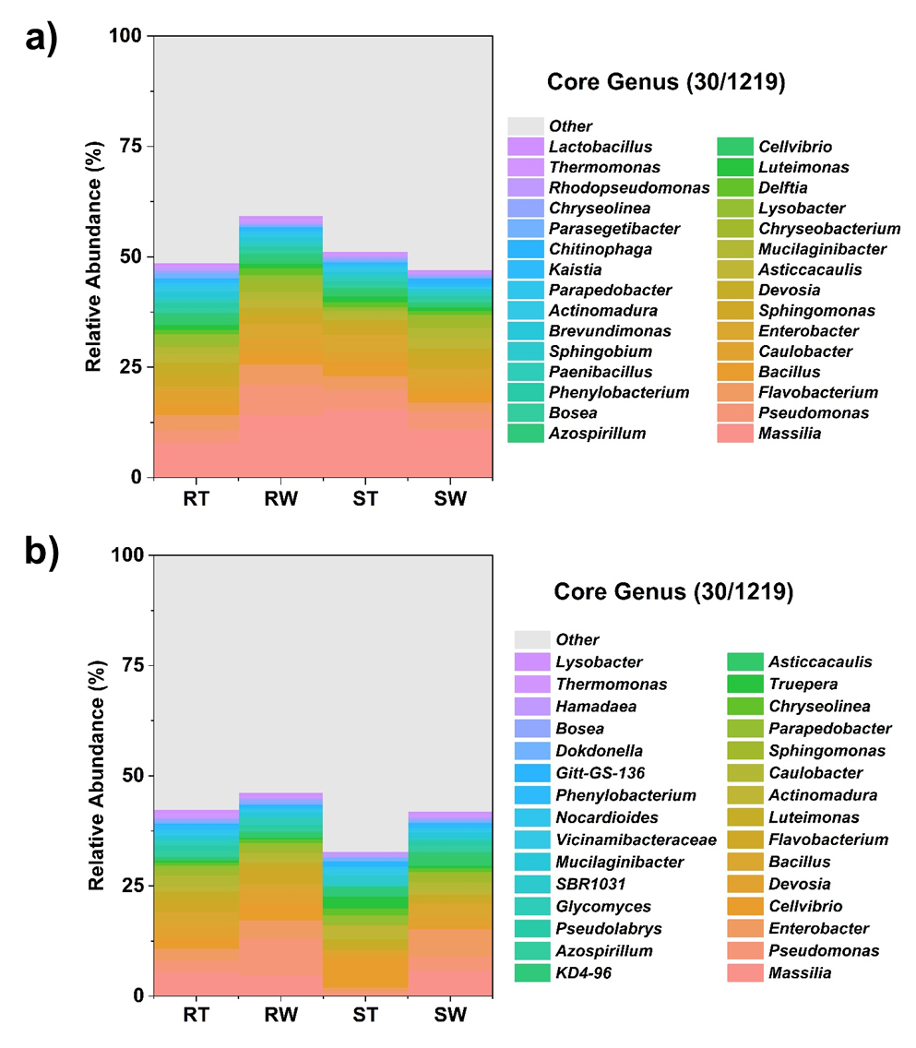
Fig. S7. Abundance of bacterial genera in the rhizosphere in the transgenic and non-transgenic genotype with and without glyphosate at day 2 (a) and day 8 (b).

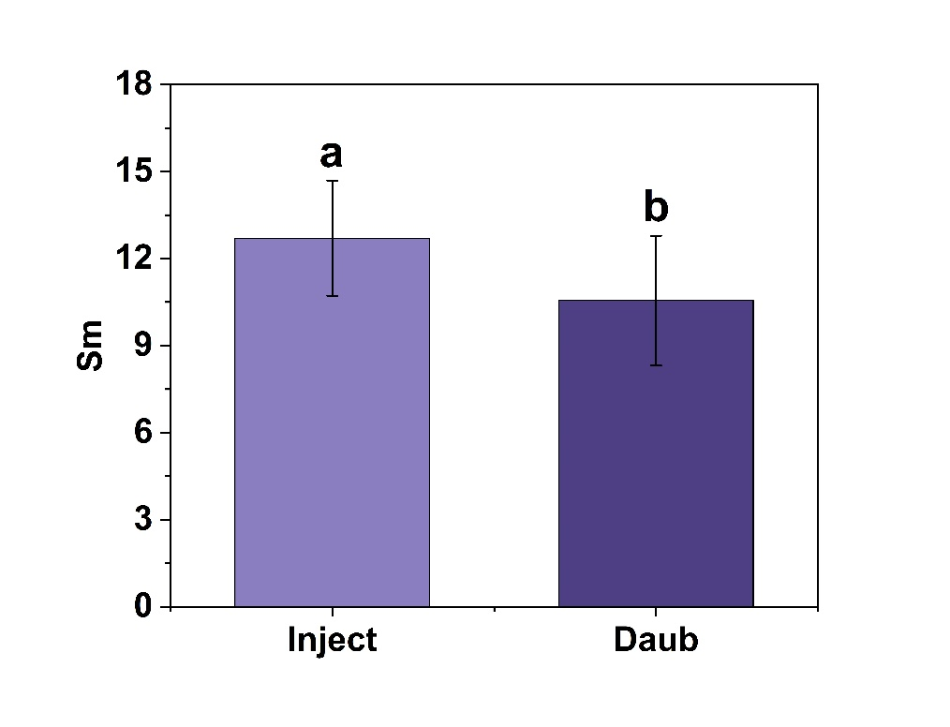
Fig. S8. The effectiveness of injection and smear inoculation methods on the plant phenotype parameters as the example of Sm.

Table S1. Various vegetation indices calculation formulas
Vegetation Index | Formula | Vegetation Index | Formula
Normalized Difference Vegetation Index (NDVI) | $$\frac{R_{800}-R_{670}}{R_{800}+R_{670}}$$ | Structural Independent Pigment Index (SIPI) | $$\frac{R_{800}-R_{445}}{R_{800}+R_{680}}$$
Enhanced Vegetation Index (TVI) | $$\frac{R_{800}-R_{670}}{{1+R}_{800}+{6×R}_{670}-7×R_{479}}×2.5$$ | Renormalized Difference Vegetation Index (RDVI) | $$\frac{R_{800}-R_{670}}{\sqrt{R_{800}+R_{670}}}$$
Optimized Soil-Adjusted Vegetation Index (OSAVI) | $$\frac{R_{800}-R_{670}}{R_{800}+R_{670}+0.16}×1.16$$ | Green Normalized Different Vegetation Index (GNDVI) | $$\frac{R_{800}-R_{550}}{R_{800}+R_{550}}$$
Transformed Chlorophyll Absorption in Reflectance Index (TCARI) | $$3×[{R_{700}-R_{670}-0.2×(R}_{700}-R_{550})×\frac{R_{700}}{R_{670}}]$$ | Simple Ration (SR) | $$\frac{R_{800}}{R_{670}}$$
Modified Simple Ratio (MSR) | $$\frac{\frac{R_{800}}{R_{670}}-1}{\sqrt{\frac{R_{800}}{R_{670}}}-1}$$ | Anthocyanin Reflectance Index (ARI) | $$\frac{1}{R_{550}}-\frac{1}{R_{700}}$$
Triangular Vegetation Index (TVI) | $$0.5×[{{120×(R}_{750}-R_{550})-200×(R}_{670}-R_{550})]$$ | Red-edge Index (ZM) | $$\frac{R_{750}}{R_{710}}$$
Modified Triangular Vegetation Index (MTVI) | $$1.2×[{{1.2×(R}_{800}-R_{550})-2.5×(R}_{670}-R_{550})]$$ | Red-edge Vegetation Stress Index (RVSI) | $$\frac{R_{714}-R_{752}}{2-R_{733}}$$
Photochemical Reflectance Index (PRI) | $$\frac{R_{531}-R_{570}}{R_{531}+R_{570}}$$ | Chlorophyll Index (CI) | $$\frac{R_{750}-R_{705}}{R_{750}+R_{705}}$$
Healthy Index (HI) | $$\frac{R_{534}-R_{698}}{R_{534}+R_{698}}-\frac{1}{2}×R_{704}$$ | Plant Senescence Reflectance Index (PSRI) | $$\frac{R_{678}-R_{500}}{R_{750}}$$
Modified Chlorophyll Absorption in Reflectance Index (MCARI) | $$\frac{{{[(R}_{700}-R_{670})-0.2×(R}_{700}-R_{550})]×R_{700}]}{R_{670}}$$ | Nitrogen Reflectance Index (NRI) | $$\frac{R_{570}-R_{670}}{R_{570}+R_{670}}$$

Table S2. The references for the functional bacterial genera responsible for disease occurrence, N-fixation, disease prevention and phosphorus solubilization.

Type | Phylum | Class | Order | Family | Genus | Referance
Pathegon | Proteobacteria | Gammaproteobacteria | Enterobacterales | Enterobacteriaceae | Enterobacter | (39)
Pathegon | Proteobacteria | Gammaproteobacteria | Pseudomonadales | Pseudomonadaceae | Pseudomonas | (40)
N-fixation bacteria | Proteobacteria | Alphaproteobacteria | Azospirillales | Azospirillaceae | Azospirillum | (41)
N-fixation bacteria | Proteobacteria | Alphaproteobacteria | Rhizobiales | Rhizobiaceae | Mesorhizobium | (42)
N-fixation bacteria | Firmicutes | Bacilli | Paenibacillales | Paenibacillaceae | Paenibacillus | (43)
P solubilizing bacteria | Proteobacteria | Alphaproteobacteria | Sphingomonadales | Sphingomonadaceae | Novosphingobium | (44)
P solubilizing bacteria | Proteobacteria | Alphaproteobacteria | Caulobacterales | Caulobacteraceae | Brevundimonas | (45)
P solubilizing bacteria | Proteobacteria | Gammaproteobacteria | Burkholderiales | Oxalobacteraceae | Massilia | (46)
P solubilizing bacteria | Actinobacteriota | Actinobacteria | Streptomycetales | Streptomycetaceae | Streptomyces | (47)
Biocontrol agents | Proteobacteria | Gammaproteobacteria | Pseudomonadales | Pseudomonadaceae | Pseudomonas | (48)
Biocontrol agents | Firmicutes | Bacilli | Bacillales | Bacillaceae | Bacillus | (48)

Table S3. ANOSIM analyses of bacterial community between the ST, SW, RT and RW treatments in the transgenic and non-transgenic genotype with and without glyphosate at experimental periods of day 2 and day 8.
Experiment Period | Treatment | Leaf | Stem | Endophyte | Rhizosphere
Day2 | RT v RW | ＞0.05 | ＞0.05 | ＞0.05 | ＞0.05
Day2 | RT v ST | ＞0.05 | ＞0.05 | ＞0.05 | ＞0.05
Day2 | RW v SW | ＞0.05 | ＞0.05 | ＞0.05 | ＞0.05
Day2 | ST v SW | ＞0.05 | ＞0.05 | ＞0.05 | ＞0.05
Day8 | RT v RW | ＞0.05 | ＞0.05 | ＞0.05 | < 0.05
Day8 | RT v ST | ＜0.05 | ＜0.05 | ＜0.05 | ＜0.05
Day8 | RW v SW | ＞0.05 | ＞0.05 | ＞0.05 | < 0.05
Day8 | ST v SW | ＜0.05 | ＜0.05 | ＜0.05 | ＜0.05

Table S4. The topological parameters of bacterial occurrence networks in the leaf, stem, root and rhizosphere soil of the transgenic and non-transgenic genotype with and without glyphosate treatment on day 2.

Habitat | Treatment | Degree | Density | Modularity | Node | Edge
Leaf | ST | 1.66 | 0.011 | 0.962 | 159 | 132
Leaf | SW | 1.605 | 0.01 | 0.974 | 162 | 130
Leaf | RT | 2 | 0.007 | 0.976 | 300 | 300
Leaf | RW | 2.687 | 0.008 | 0.968 | 332 | 446
Stem | ST | 2.286 | 0.011 | 0.962 | 217 | 248
Stem | SW | 1.441 | 0.013 | 0.968 | 111 | 80
Stem | RT | 2.562 | 0.013 | 0.948 | 192 | 246
Stem | RW | 2.711 | 0.008 | 0.96 | 332 | 450
Root | ST | 3.58 | 0.006 | 0.971 | 557 | 997
Root | SW | 2.575 | 0.004 | 0.984 | 685 | 882
Root | RT | 3.247 | 0.006 | 0.972 | 507 | 823
Root | RW | 2.6 | 0.004 | 0.985 | 623 | 810
Rhizosphere | ST | 2.056 | 0.004 | 0.984 | 498 | 512
Rhizosphere | SW | 2.089 | 0.005 | 0.982 | 427 | 446
Rhizosphere | RT | 2.408 | 0.005 | 0.97 | 485 | 584
Rhizosphere | RW | 2.021 | 0.005 | 0.982 | 377 | 381

Table S5. The topological parameters of bacterial occurrence networks in the leaf, stem, root and rhizosphere soil of the transgenic and non-transgenic genotype with and without glyphosate treatment on day 8.
Habitat | Treatment | Degree | Density | Modularity | Node | Edge
Leaf | ST | 2.425 | 0.006 | 0.981 | 433 | 525
Leaf | SW | 1.37 | 0.011 | 0.969 | 127 | 87
Leaf | RT | 1.393 | 0.025 | 0.927 | 56 | 39
Leaf | RW | 1.2 | 0.016 | 0.963 | 75 | 45
Stem | ST | 37.14 | 0.22 | 0.263 | 170 | 3157
Stem | SW | 1.84 | 0.011 | 0.967 | 162 | 149
Stem | RT | 2.57 | 0.01 | 0.969 | 263 | 338
Stem | RW | 1.237 | 0.013 | 0.967 | 97 | 60
Root | ST | 6.886 | 0.044 | 0.793 | 158 | 544
Root | SW | 2.702 | 0.003 | 0.981 | 838 | 1132
Root | RT | 2.547 | 0.004 | 0.984 | 709 | 903
Root | RW | 2.593 | 0.003 | 0.986 | 783 | 1015
Rhizosphere | ST | 1.689 | 0.003 | 0.989 | 591 | 499
Rhizosphere | SW | 2.107 | 0.005 | 0.984 | 469 | 494
Rhizosphere | RT | 2.077 | 0.004 | 0.986 | 568 | 590
Rhizosphere | RW | 2.529 | 0.004 | 0.981 | 616 | 779

Table S6. The number of differential bacterial OTUs whose relative abundance increased or decreased significantly from one treatment to another treatment on day 2.
Treatments | Habitats | Increased number | Decreased number
2RT vs 2ST | Leaf | 2 | 2
2RT vs 2ST | Stem | 2 | 0
2RT vs 2ST | Root | 11 | 3
2RT vs 2ST | Rhizosphere | 0 | 0
2RW vs 2SW | Leaf | 9 | 1
2RW vs 2SW | Stem | 32 | 1
2RW vs 2SW | Root | 6 | 2
2RW vs 2SW | Rhizosphere | 0 | 0
2RT vs 2RW | Leaf | 2 | 8
2RT vs 2RW | Stem | 0 | 0
2RT vs 2RW | Root | 1 | 0
2RT vs 2RW | Rhizosphere | 0 | 1
2ST vs 2SW | Leaf | 2 | 2
2ST vs 2SW | Stem | 4 | 1
2ST vs 2SW | Root | 1 | 4
2ST vs 2SW | Rhizosphere | 0 | 6

Table S7. The number of differential bacterial OTUs whose relative abundance increased or decreased significantly from one treatment to another treatment on day 8.
Treatments | Habitats | Increased number | Decreased number
8RT vs 8ST | Leaf | 0 | 87
8RT vs 8ST | Stem | 3 | 44
8RT vs 8ST | Root | 4 | 32
8RT vs 8ST | Rhizosphere | 263 | 45
8RW vs 8SW | Leaf | 2 | 0
8RW vs 8SW | Stem | 0 | 8
8RW vs 8SW | Root | 2 | 10
8RW vs 8SW | Rhizosphere | 26 | 17
8RT vs 8RW | Leaf | 1 | 4
8RT vs 8RW | Stem | 2 | 0
8RT vs 8RW | Root | 0 | 0
8RT vs 8RW | Rhizosphere | 0 | 0
8ST vs 8SW | Leaf | 10 | 0
8ST vs 8SW | Stem | 31 | 0
8ST vs 8SW | Root | 18 | 0
8ST vs 8SW | Rhizosphere | 14 | 206

