Table.1 Light view comparison for quality parameters.
Light View
Sl.no | Input | Output | Gray value | Time taken (sec) | Contrast | SNR | MSE
1 | 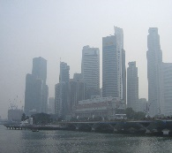 | 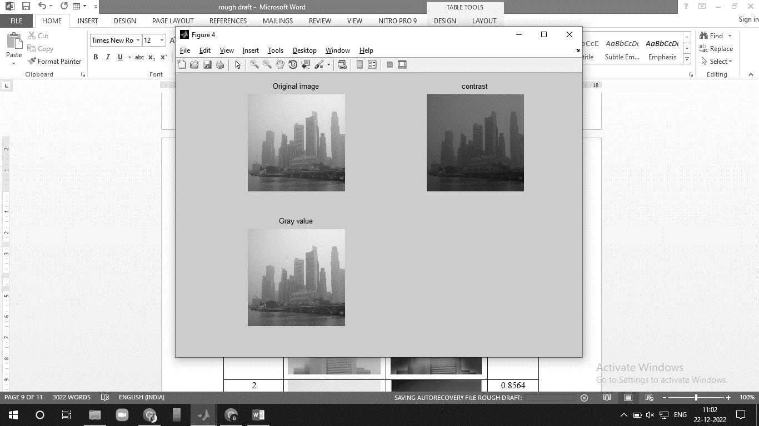 | 0.6535 | 2.3737358 | 50.26 | 22.7561 | 0.2
2 | 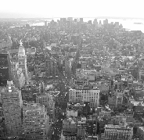 | 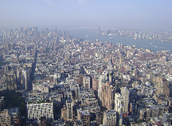 | 0.7012 | 9.850093 | 51.85 | 22.4025 | 0.25
3 | 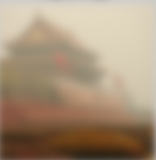 | 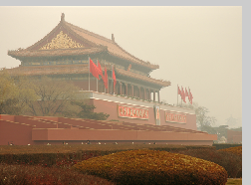 | 0.7221 | 7.123303 | 50.0148 | 21.6309 | 0.26
4 | 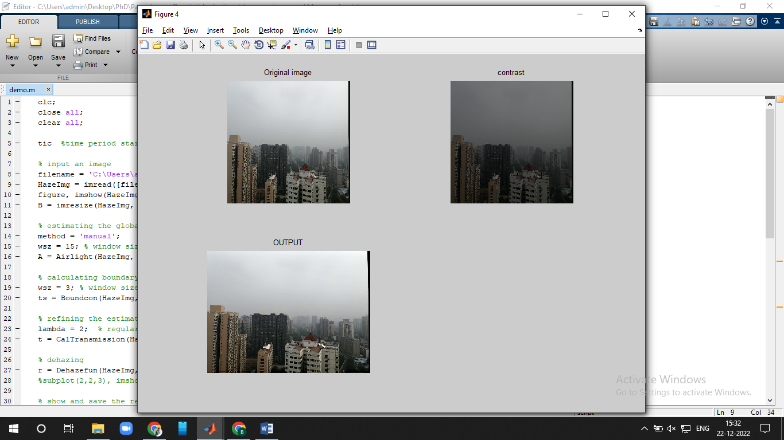 |  | 0.6208 | 2.3708954 | 51.0160 | 22.1532 | 0.291
5 | 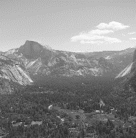 | 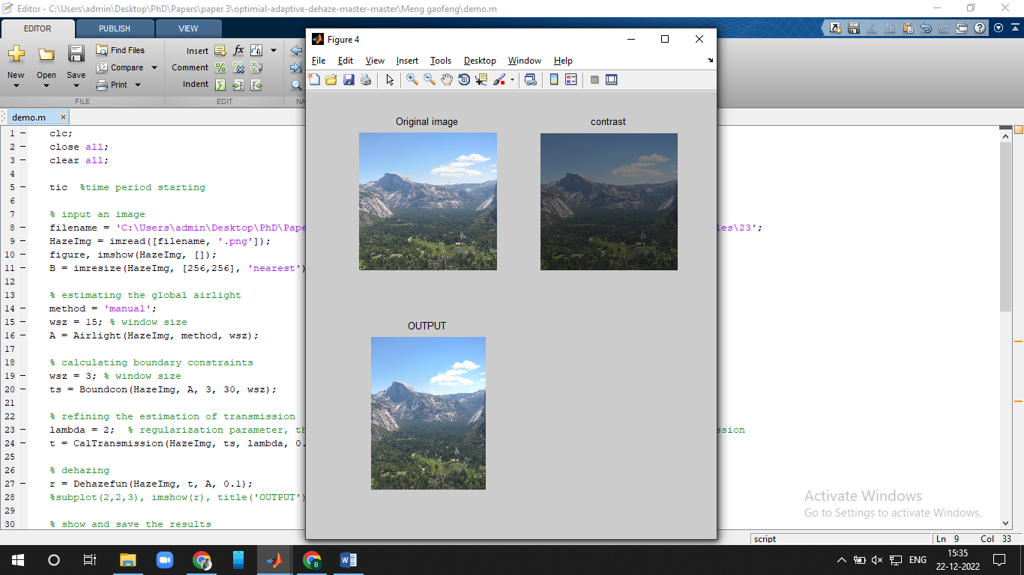 | 0.6681 | 10.472842 | 51.0172 | 22.4431 | 0.35
Average |  |  | 0.6731 | 6.4382 | 50.8316 | 22.2772 | 0.27

