Table.2 Dark view comparison for quality parameters.
Dark View
Sl.no | Input | Output | Gray value | Time taken (sec) | Contrast | SNR | MSE
1 | 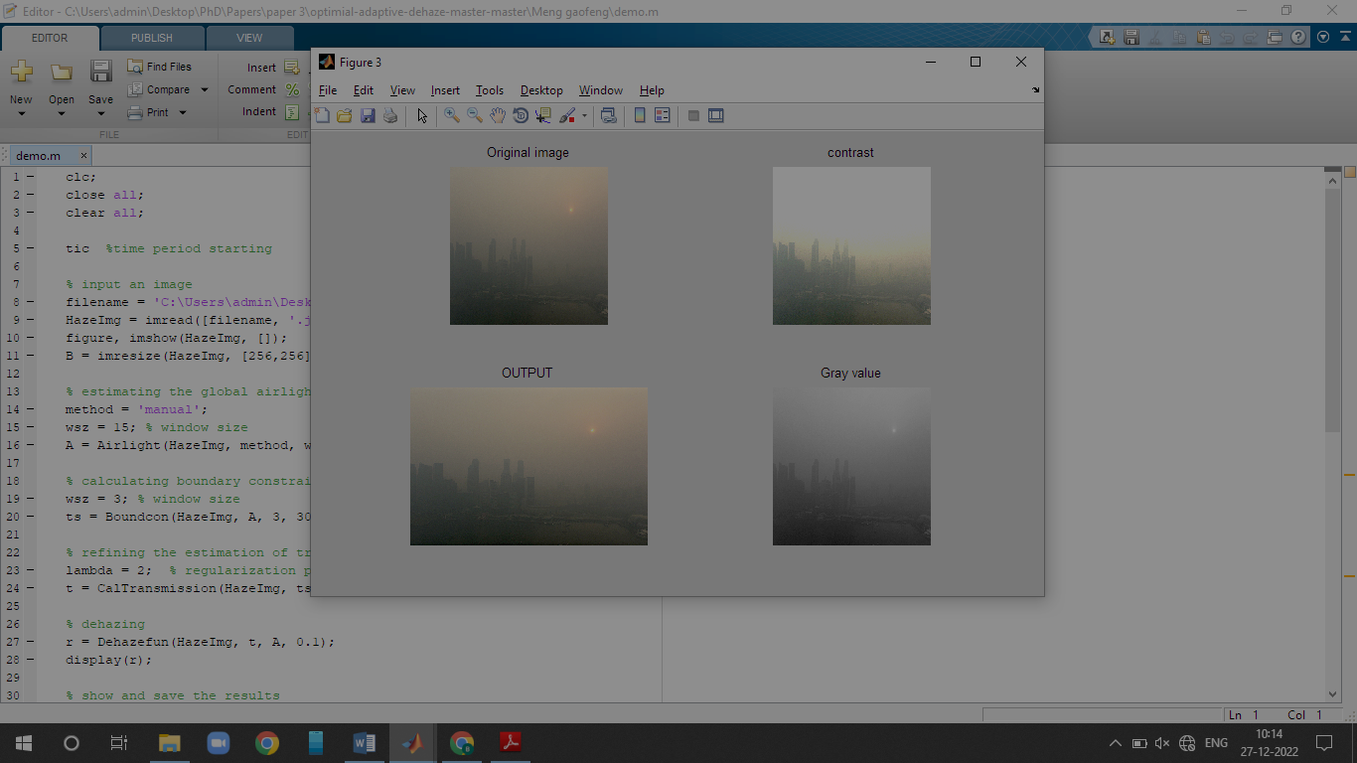 | 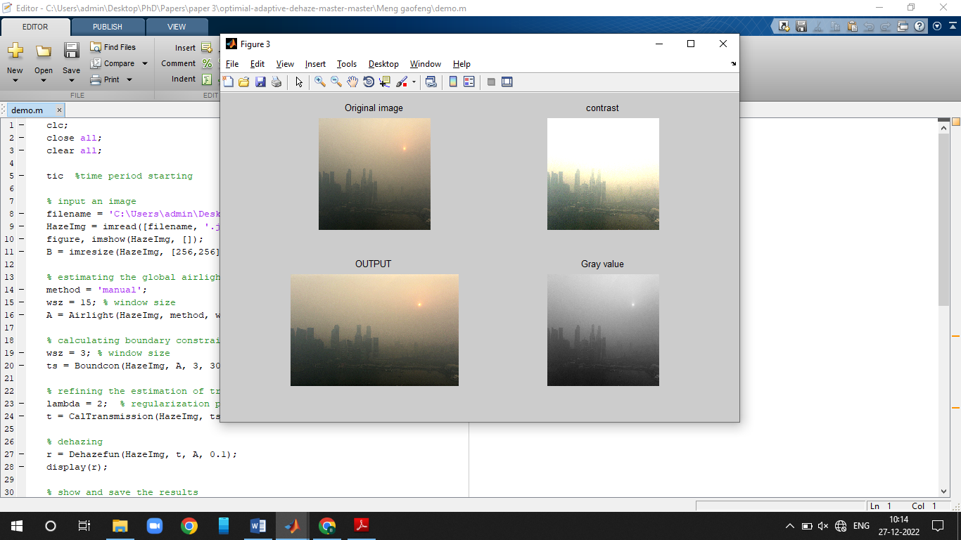 | 0.4985 | 4.7894 | 53.401 | 21.5135 | 0.32
2 | 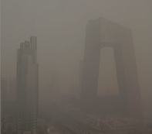 | 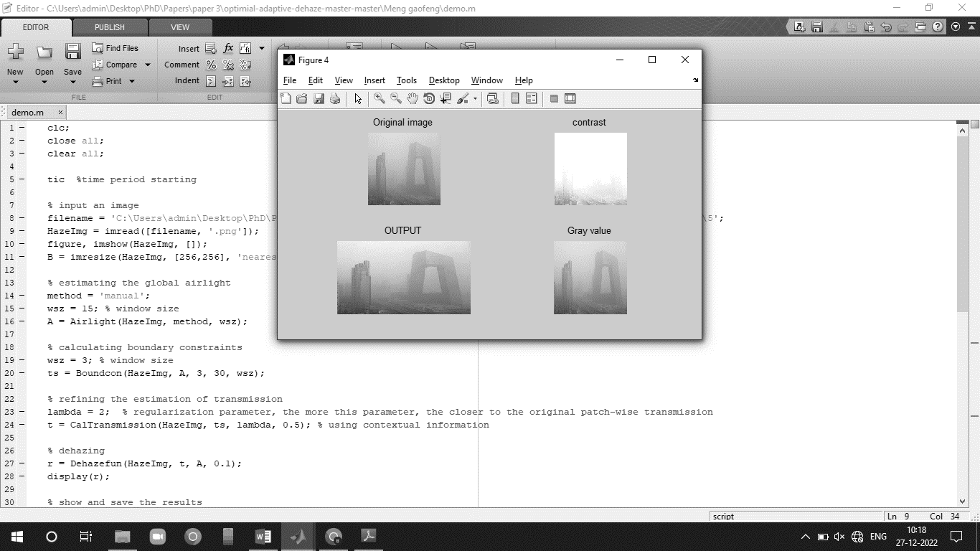 | 0.6270 | 8.545199 | 52.0013 | 21.7310 | 0.28
3 | 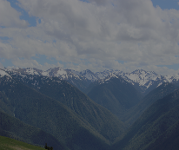 | 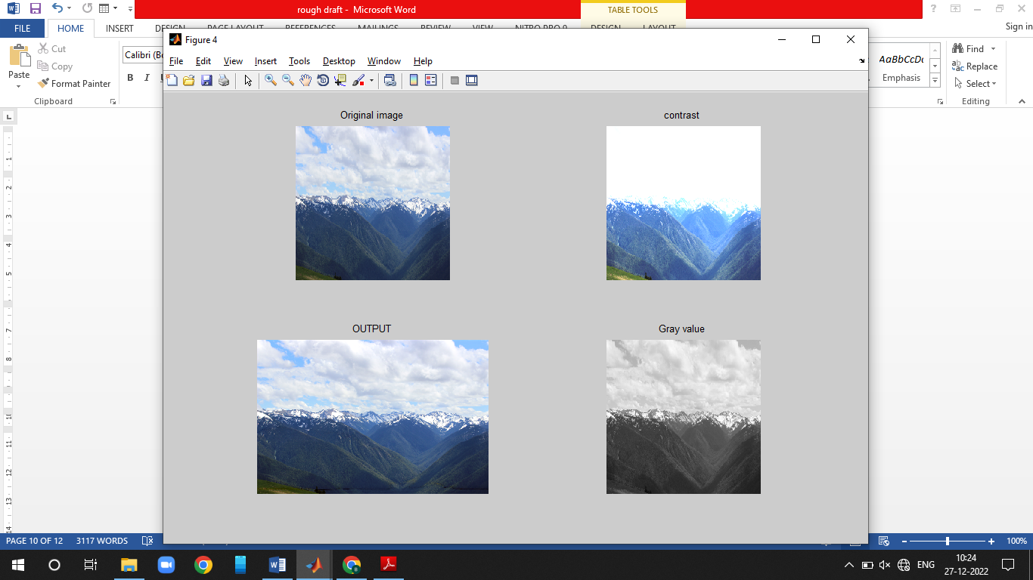 | 0.4658 | 6.467150 | 51.0026 | 22.1855 | 0.42
4 | 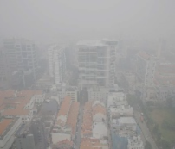 | 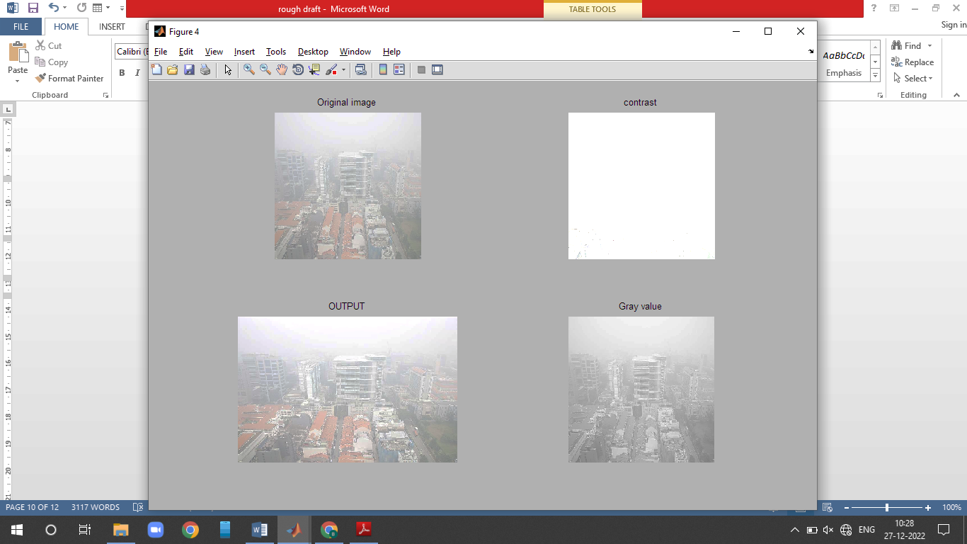 | 0.5616 | 7.901969 | 54.7696 | 22.7561 | 0.39
5 | 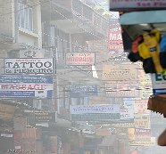 | 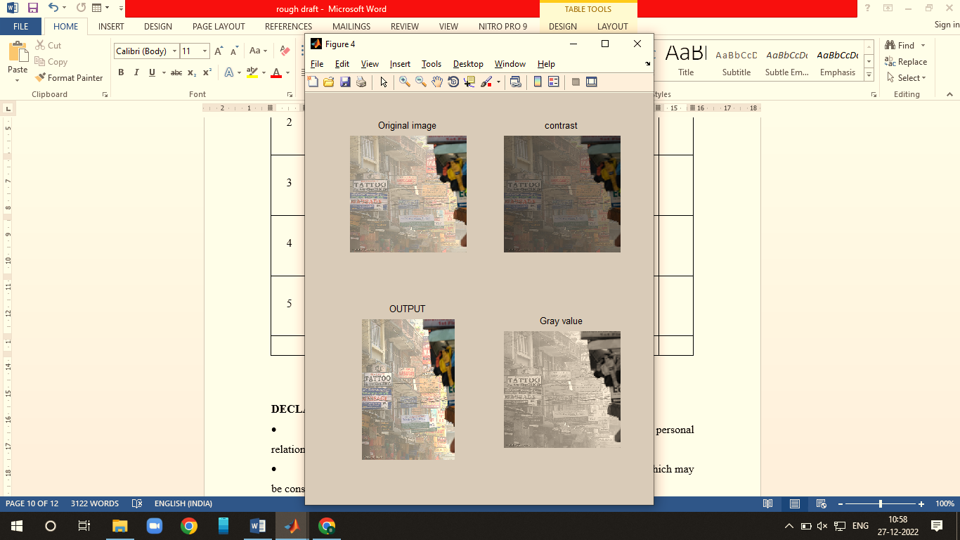 | 0.6038 | 5.942407 | 54.7703 | 21.8750 | 0.34
Average |  |  | 0.5513 | 6.72924 | 53.18896 | 22.0122 | 0.35

