Table.4 Comparison of Dark view with proposed and existing work.
Sl.no | Dark view
Sl.no | Input | Output
Sl.no | Input | A | B [6] | B [8]
1 | 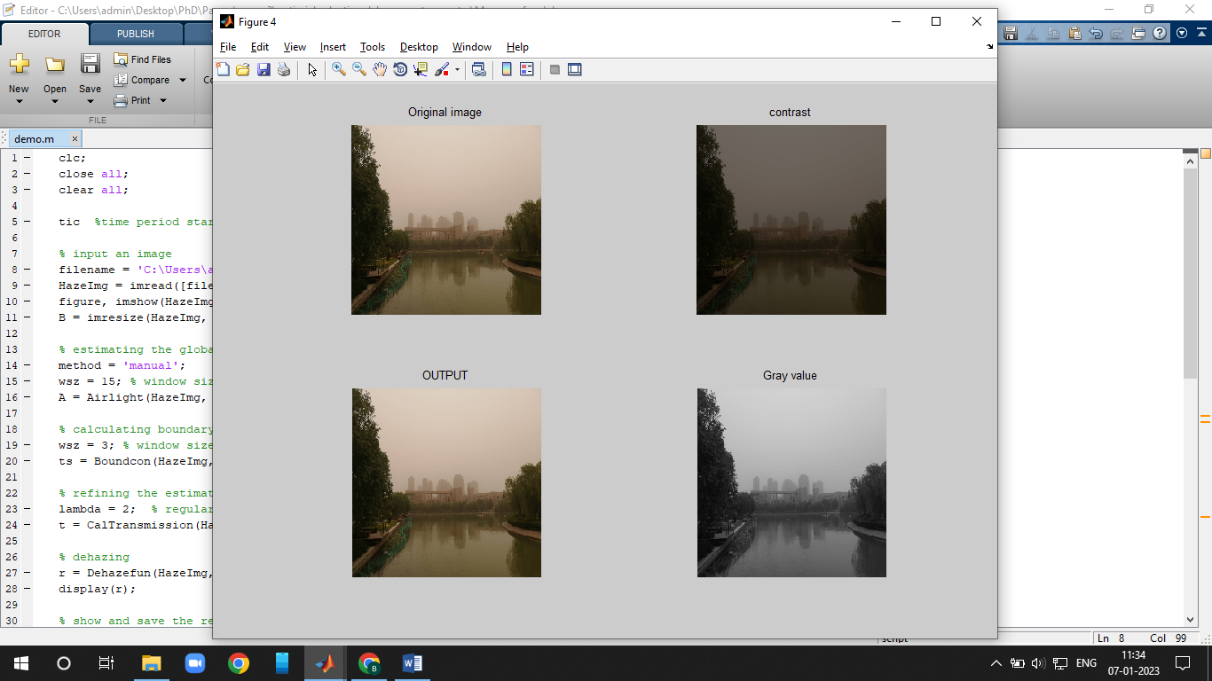
2 | 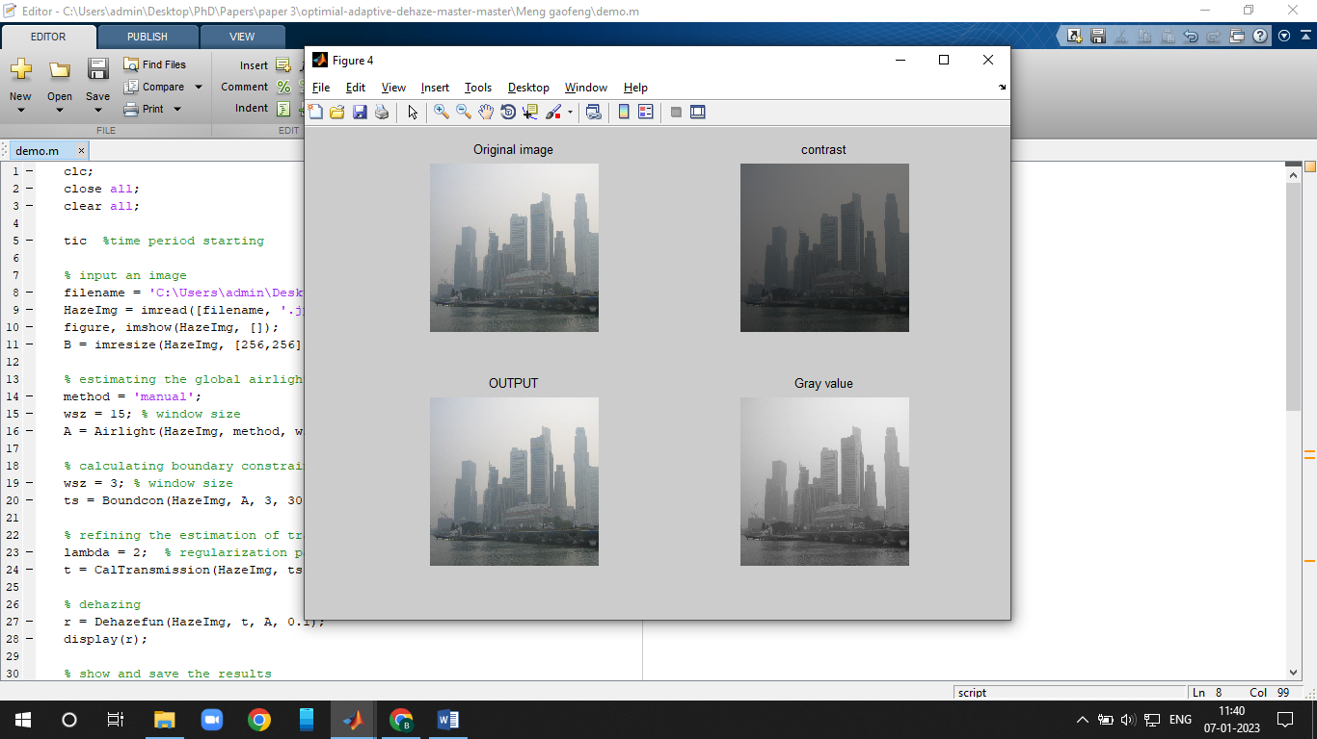
3 | 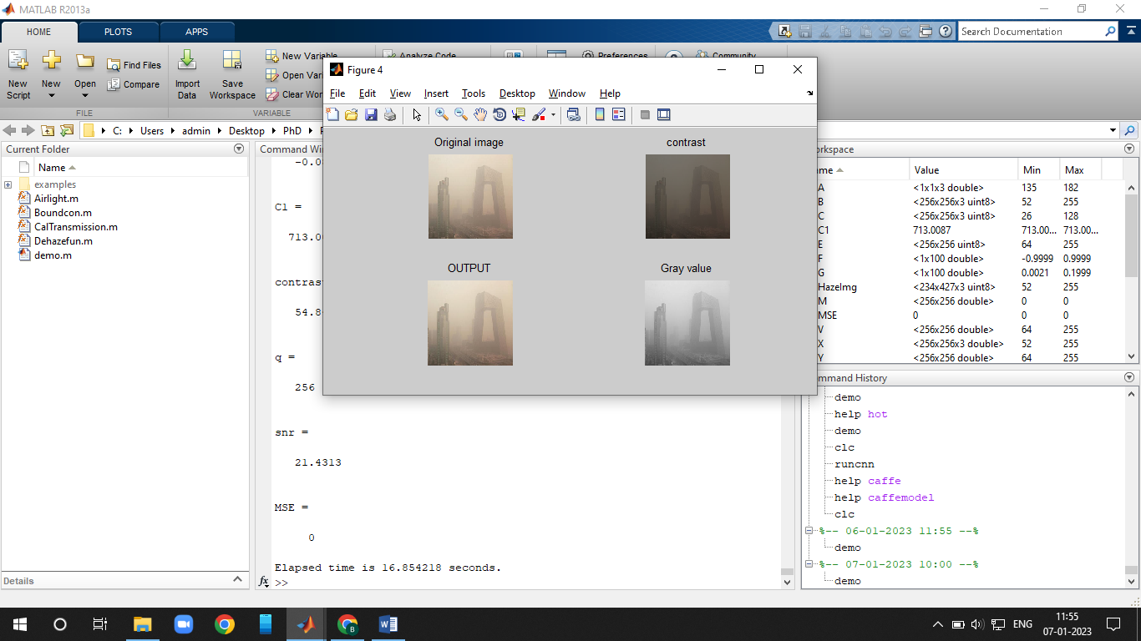
4 | 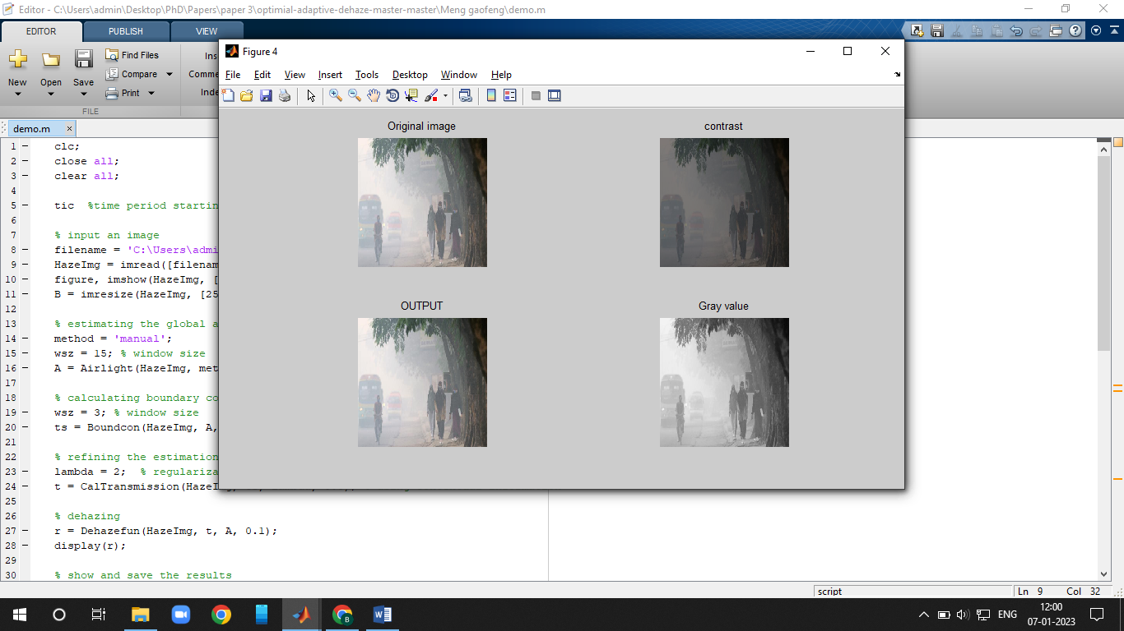
5 | 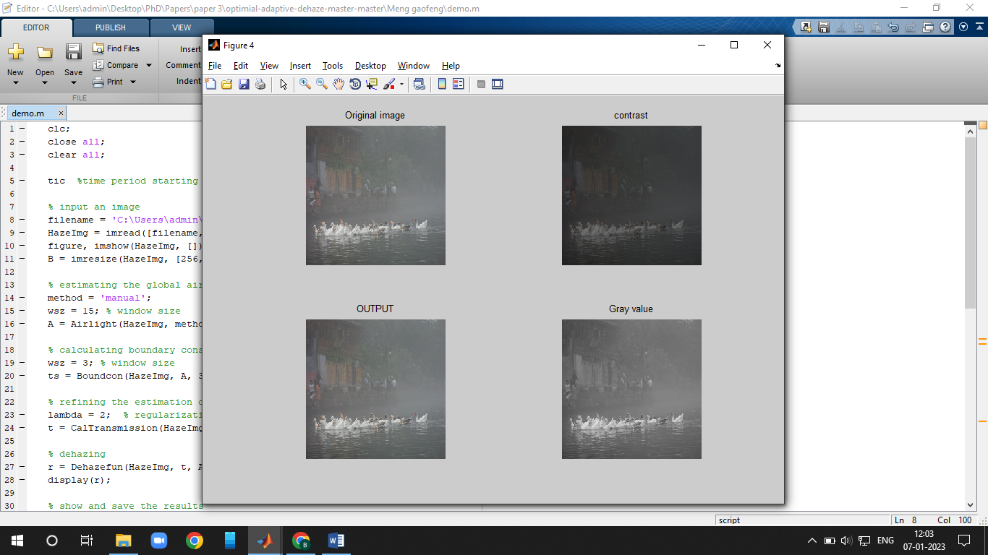 |  |  | 