Inhibition of GSK3β activity alleviates acute liver failure via suppressing multiple programmed cell death
Danmei Zhang, Chunxia Shi, Qingqi Zhang, Yukun Wang, Jin Guo, Zuojiong Gong

Department of Infectious Diseases, Renmin Hospital of Wuhan University, 430060, Wuhan, China

# Corresponding author: Zuojiong Gong; Department of Infectious Diseases, Renmin Hospital of Wuhan University, 238 Jiefang Road, Wuhan, 430060, China. E-mail: zjgong@163.com

The first of the three images of each molecule below is the image of the protein placed in the manuscript.

Liver
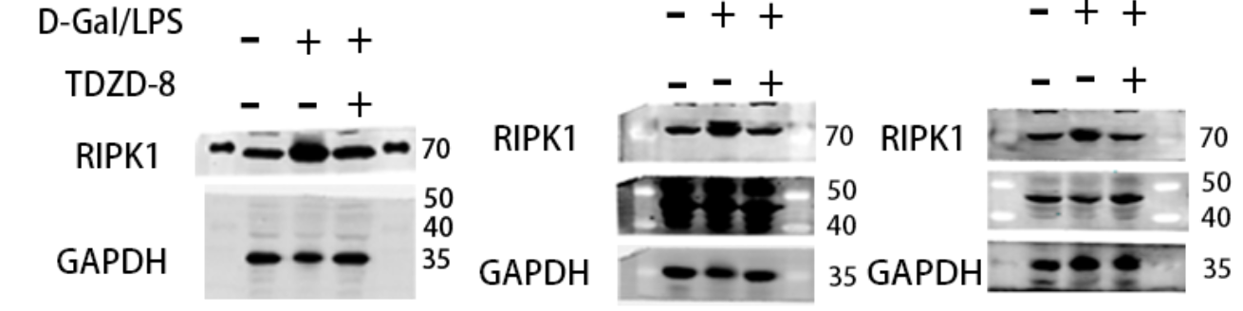

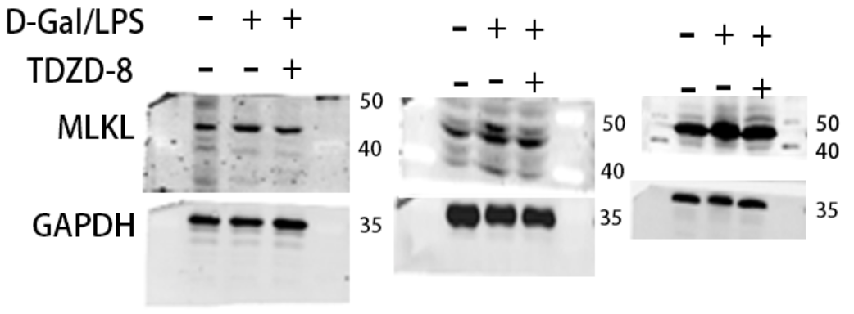

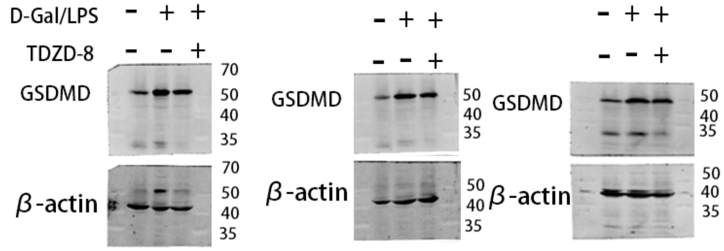

Note: After scanning the GSDMD by the membrane sweeper, the membrane was washed with eluent, closed and incubated with β-actin. The target molecule was located on the same membrane as the β-actin.
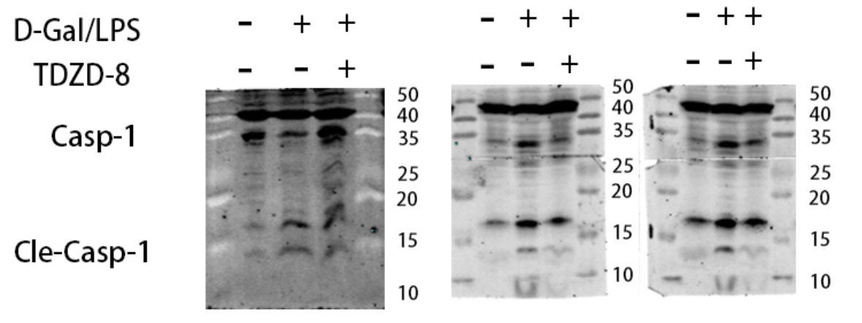

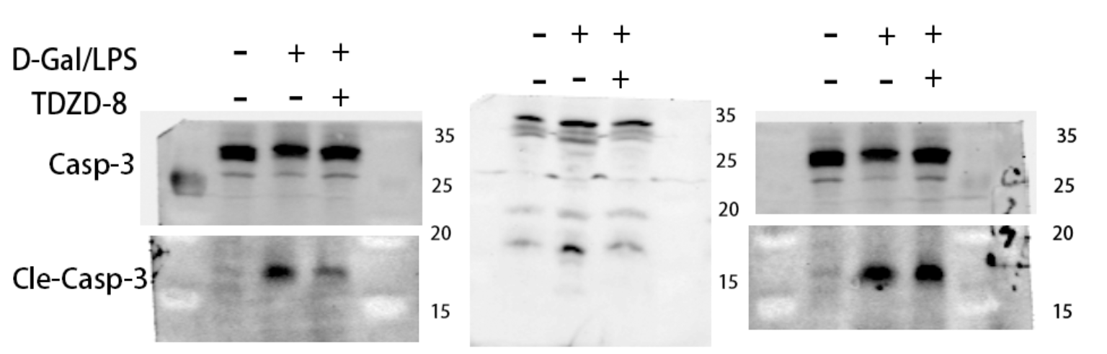

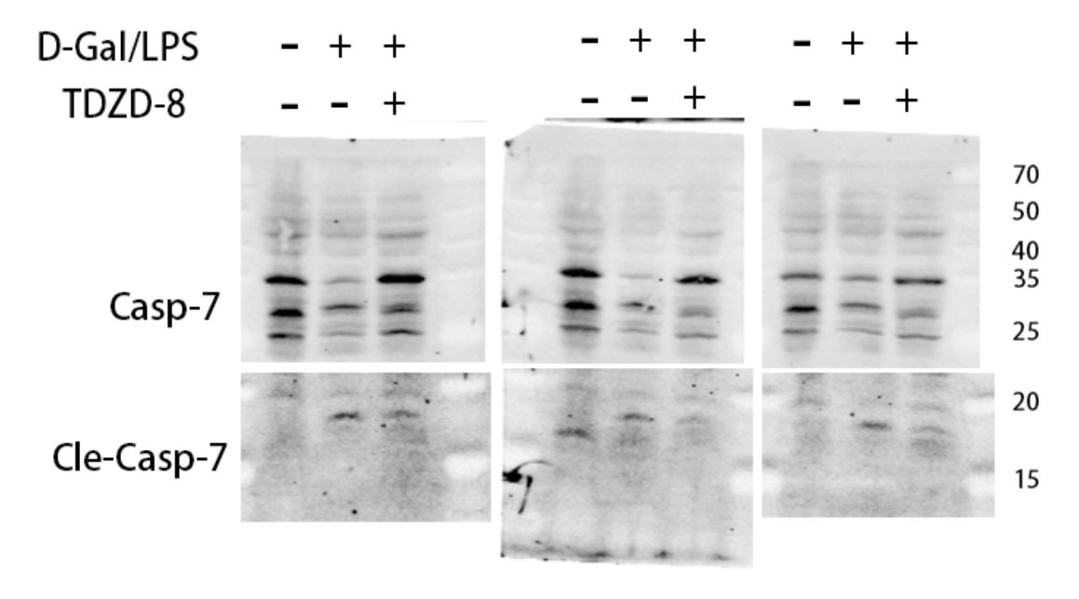
Note: The above molecules are presented in figure 1.
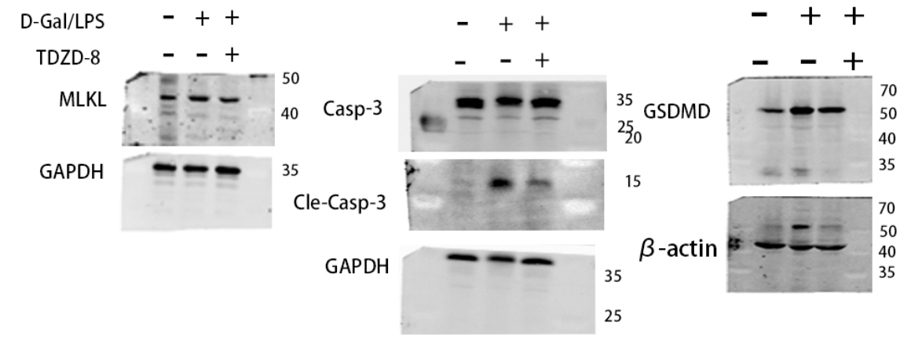
Note: GAPDH and β-actin are presented in figure 1 in the above figure.

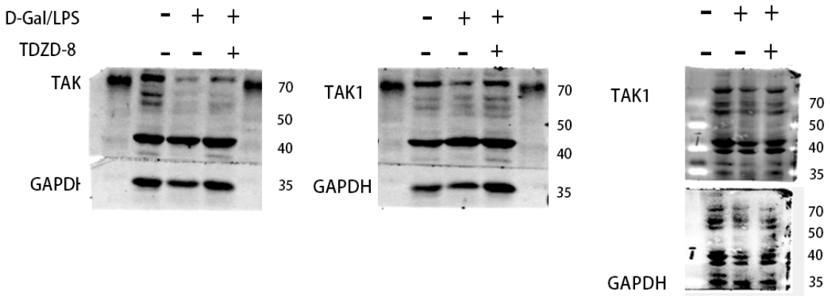
Note: The third image above shows the incubation of GAPDH after TAK1 elution.
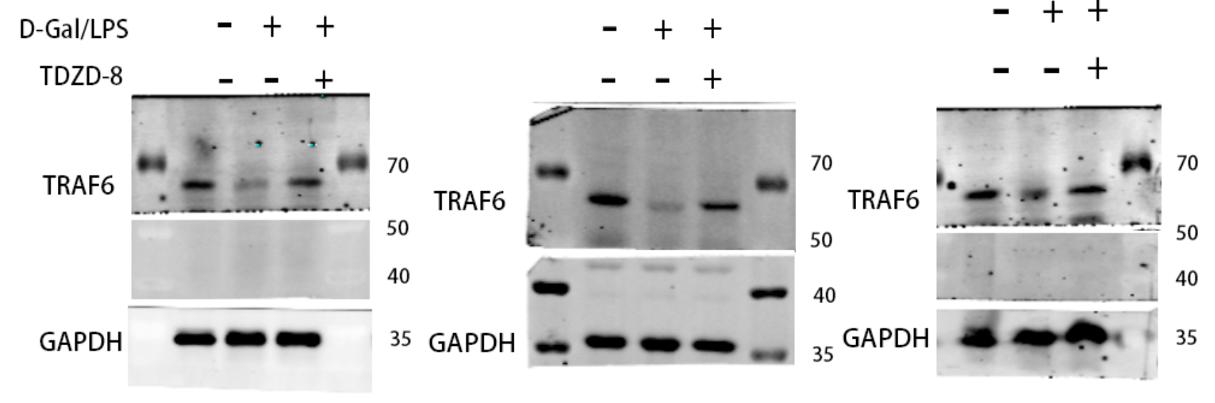

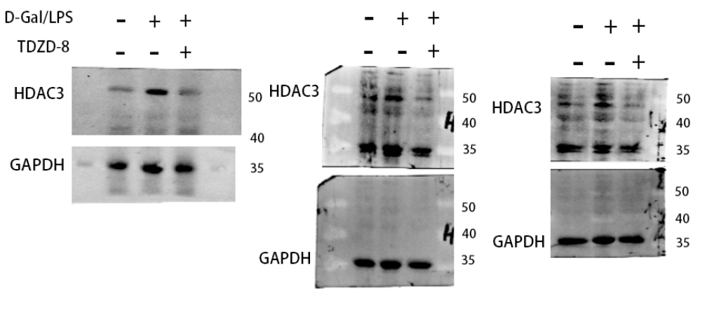
Note: The second and third pictures above show the incubation of GAPDH after HDAC3 elution.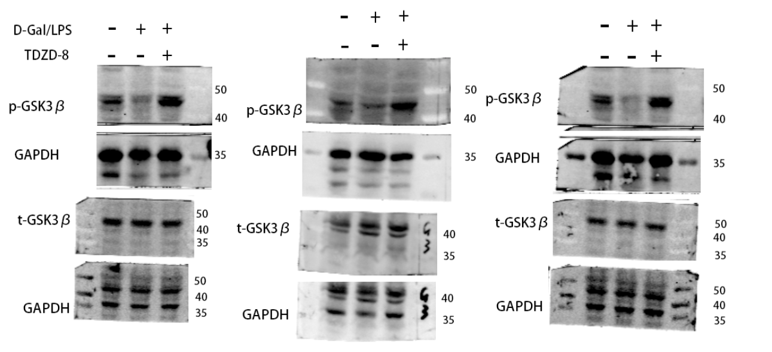
Note: All three graphs for t-GSK3β are from incubation with GAPDH after elution.

Note: TAK1, TRAF6, HDAC3, p-GSK3β and t-GSK3β above are presented in figure 4.
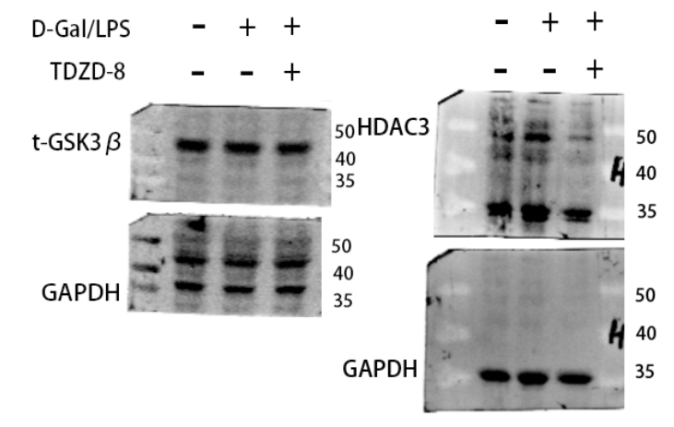
The image above shows GAPDH as it appears in figure4.

L02 cells
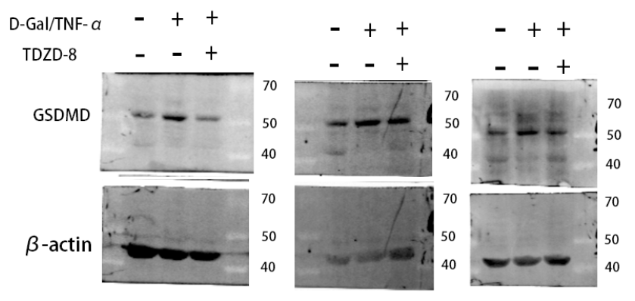
Note: All three images of the GSDMD molecule above show incubation of β-actin after elution.

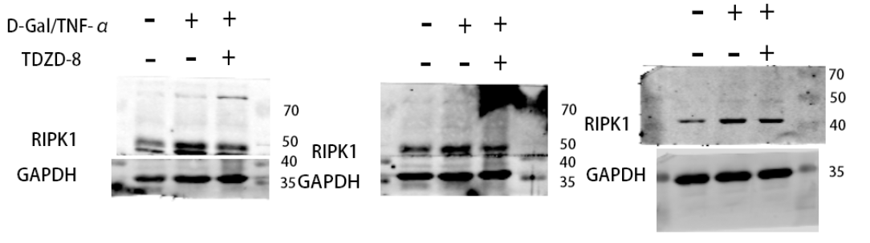

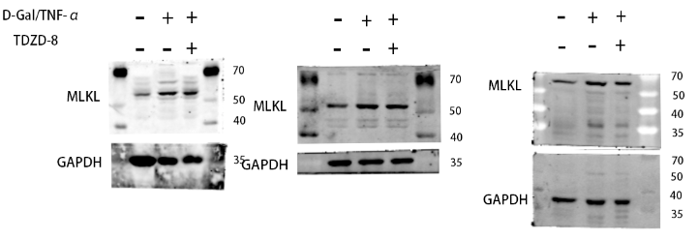
Note: The third image above shows GAPDH incubated after MLKL elution.

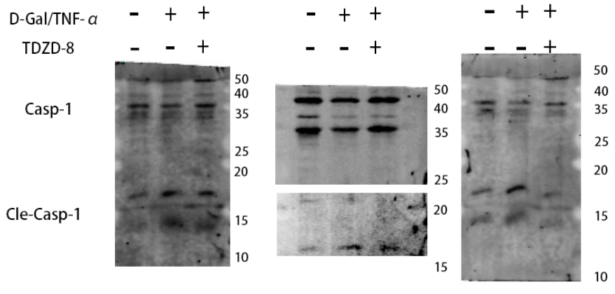
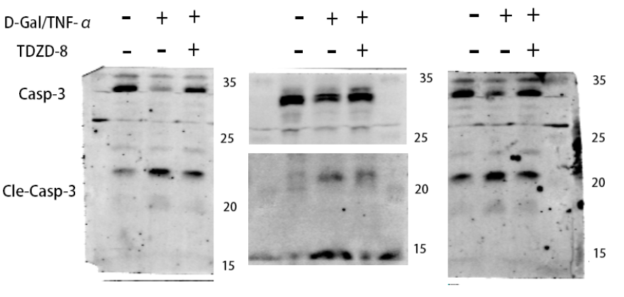

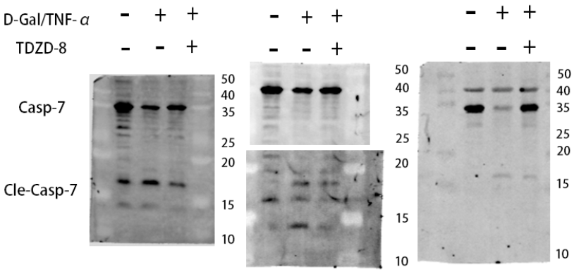
Note: GSDMD, RIPK1, MLKL, caspase-1, caspase-3, casepase-7 above appear in figure3.
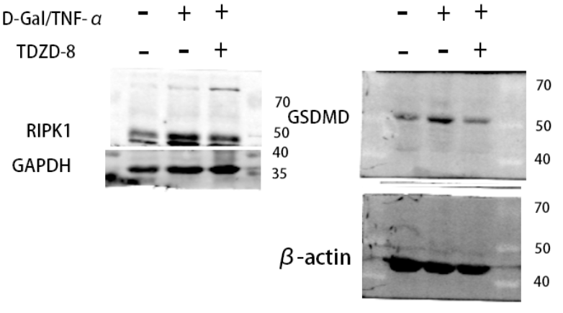
Note: The figure above shows the appearance of GAPDH and β-actin in figure3

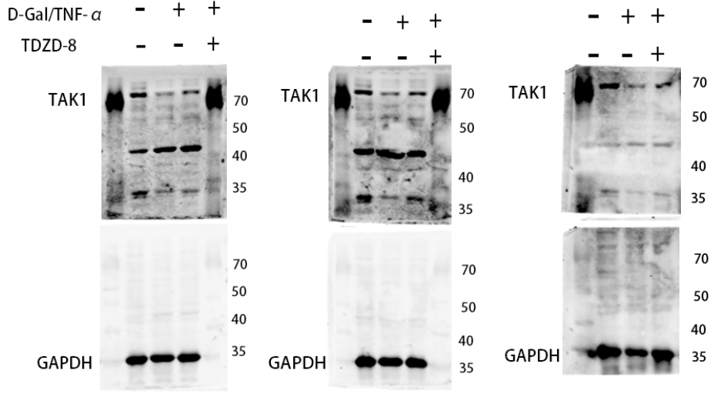
Note: All three plots of the TAK1 molecule above show GAPDH incubated after elution.

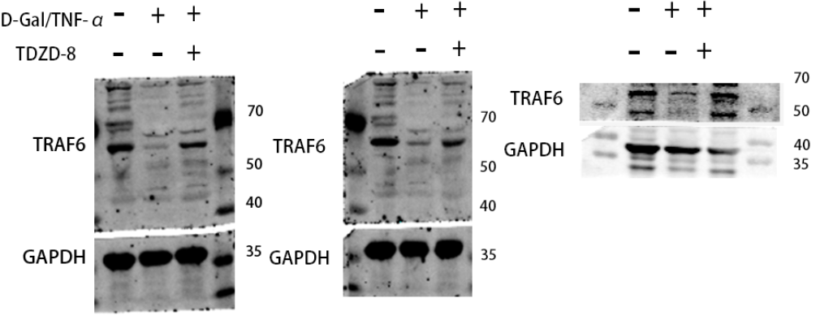

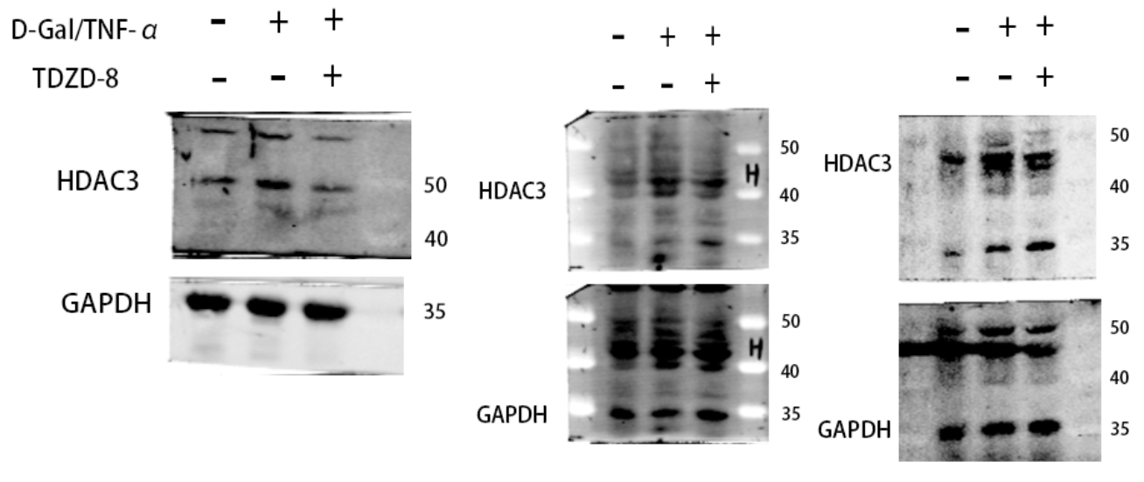
Note: The second and third pictures of the HDAC3 molecule above show GAPDH incubated after elution.

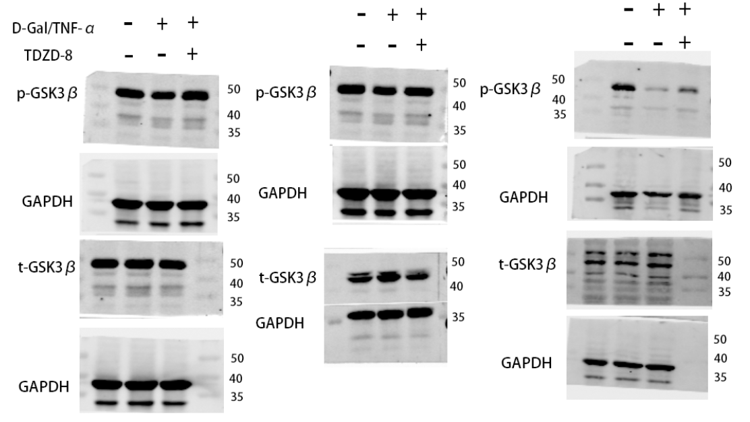
Note: All GAPDHs in the above graphs are incubated after elution.

The above molecules (TAK1, TRAF6, HDAC3, p-GSK3β and t-GSK3β) appear in figure 4.

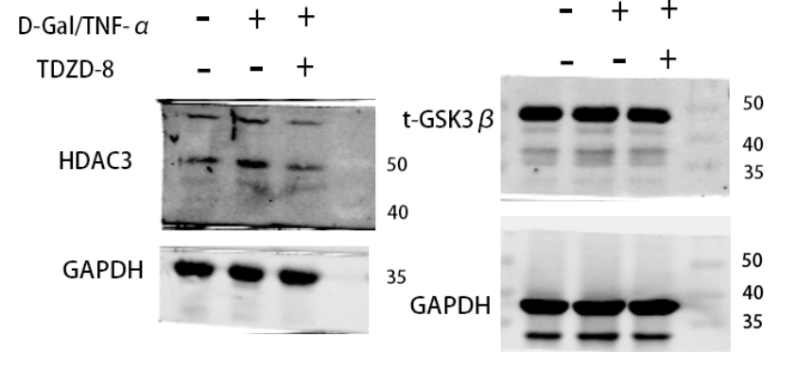 The image on the left shows GAPDH as it appears in figure4.

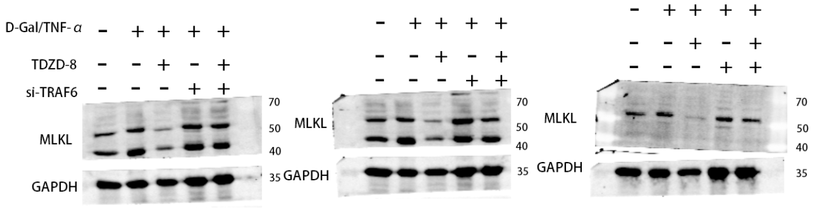

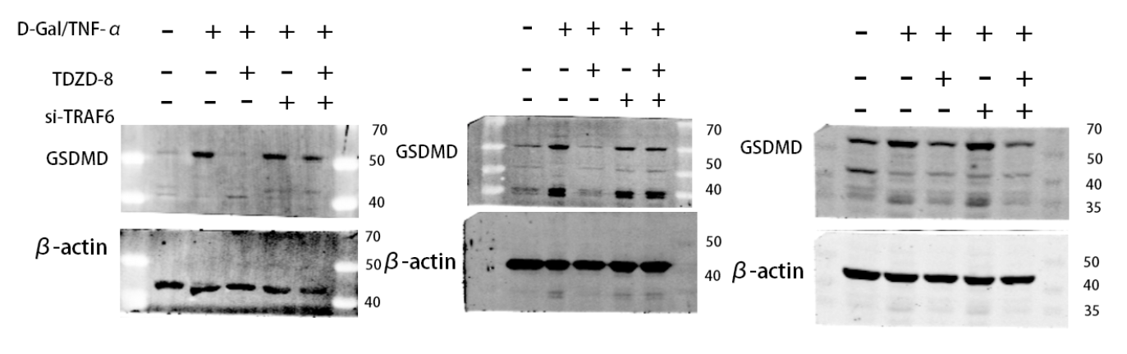
Note: All three images of the GSDMD molecule above show incubation of β-actin after elution.

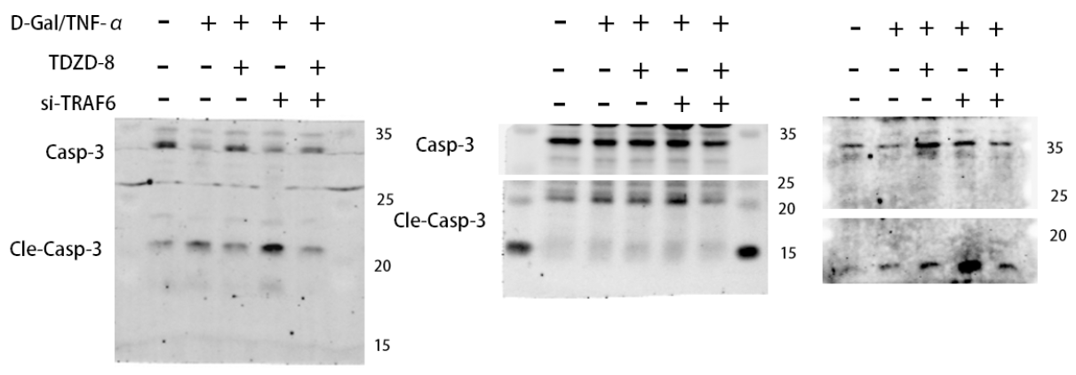
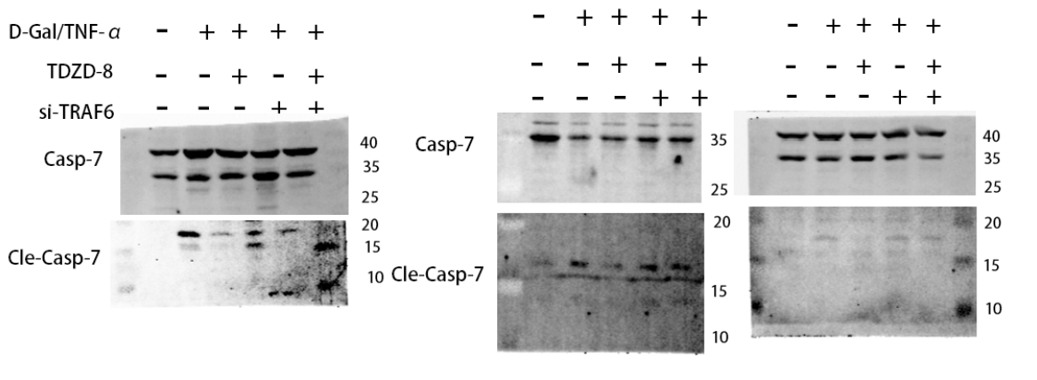
Note: The above molecules MLKL, GSDMD, caspase-3 and caspase-7 appear in figure5.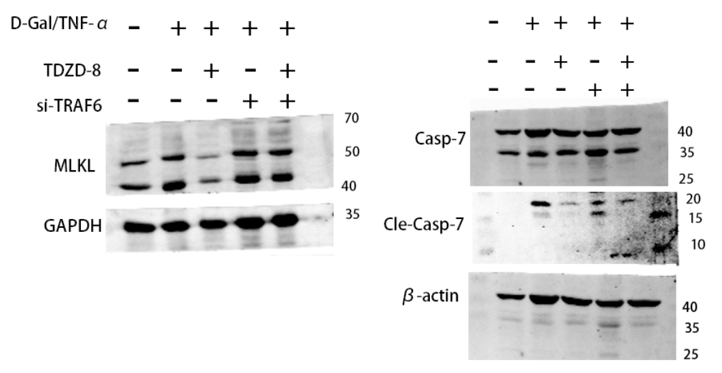 The image on the left shows GAPDH and β-actin as they appear in figure5.

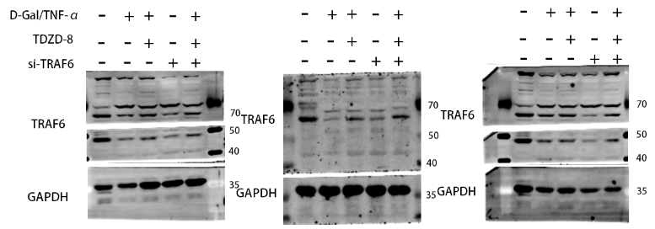

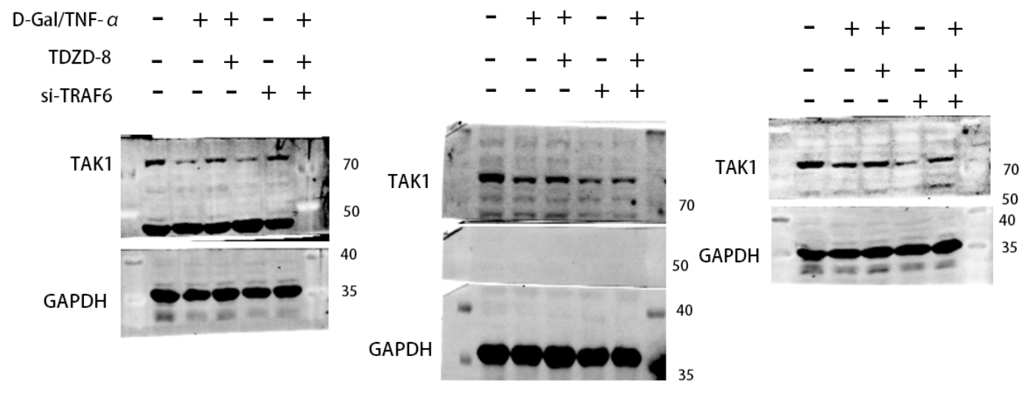

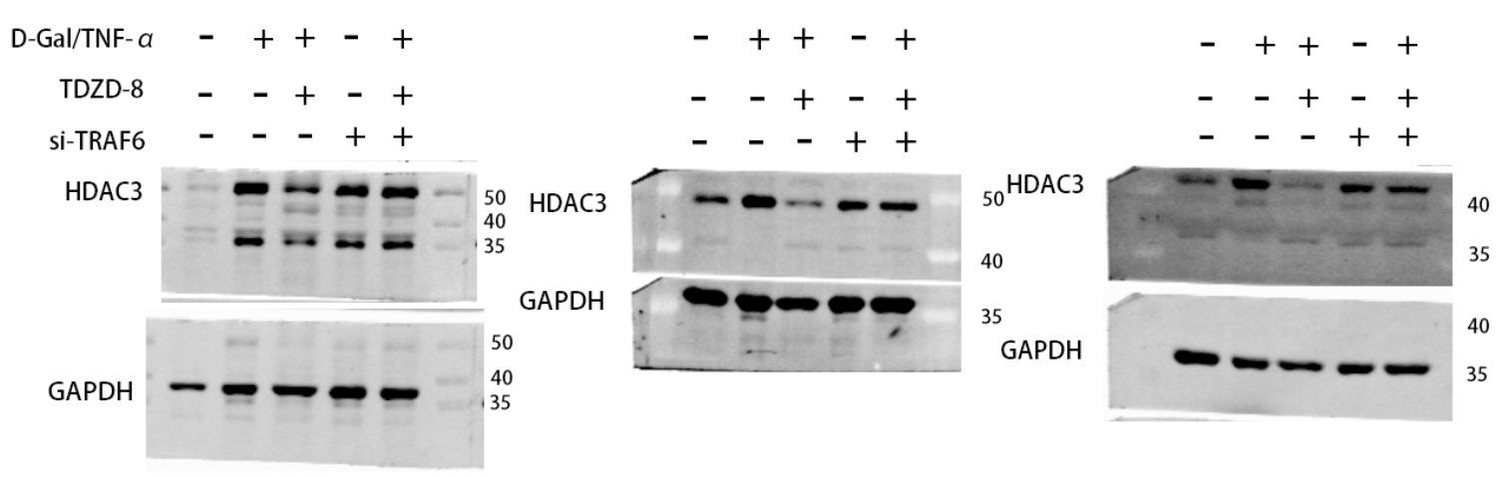
Note: The first and third HDAC3 pictures above show the incubation of GAPDH after elution.

The TRAF6, TAK1 and HDAC3 molecules above appear in figure 6, with GAPDH in the first figure of HDAC3 appearing in figure 6.

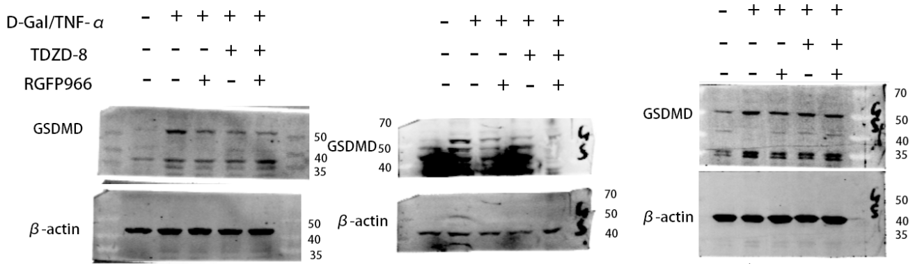
Note: The image above shows incubation of β-actin after elution of GSDMD.

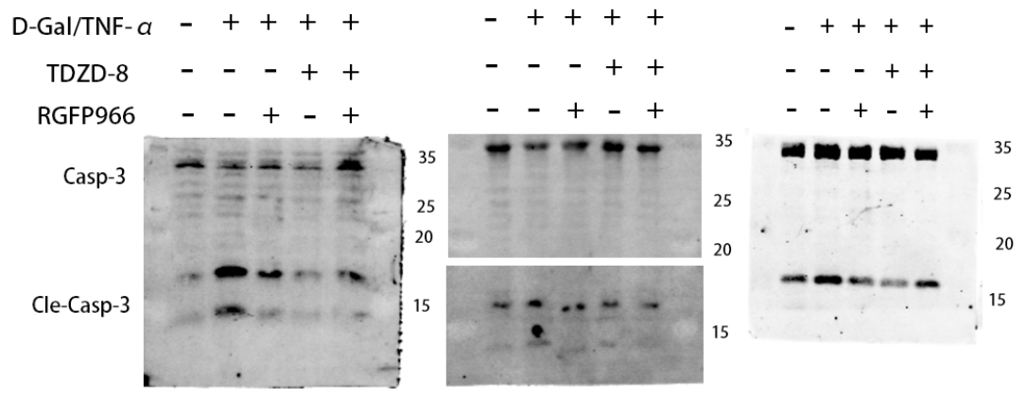

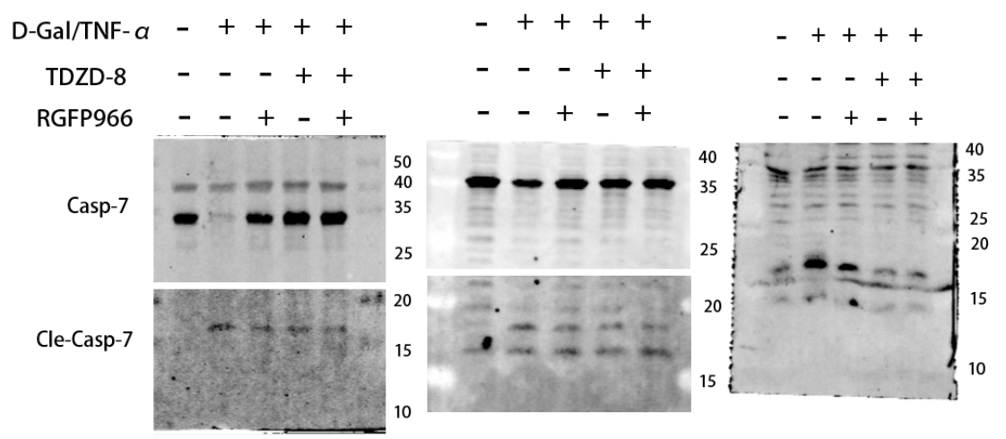

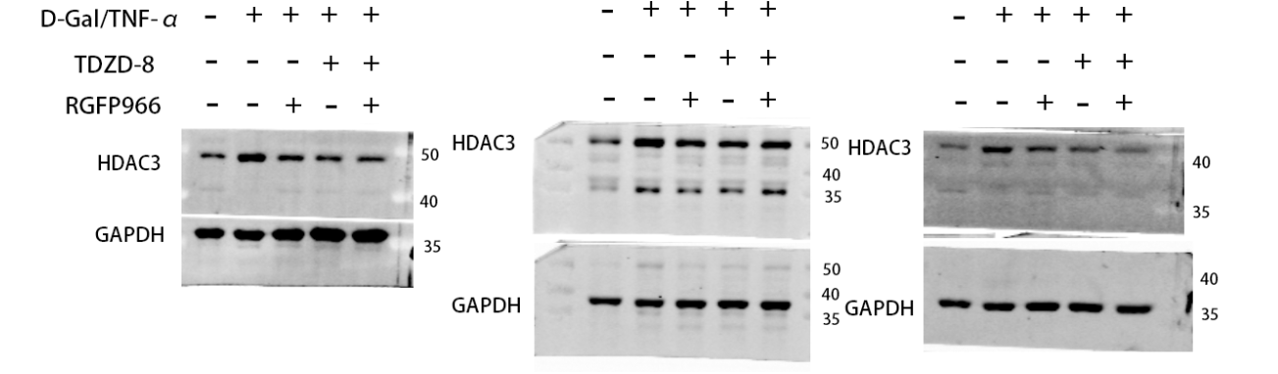
Note: The second and third sheets of HDAC3 in the above picture show the incubation of GAPDH after elution of HDAC3.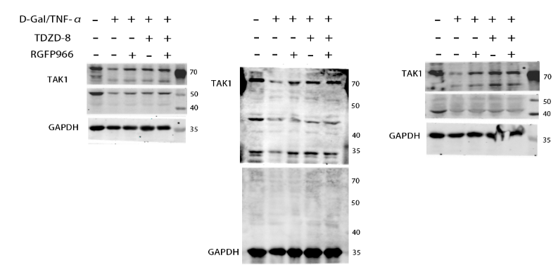
Note: The second picture above shows GAPDH incubation after elution of TAK1.

The above molecules (GSDMD, caspase-3, caspase-7, TAK1 and HDAC3) appear in figure7.

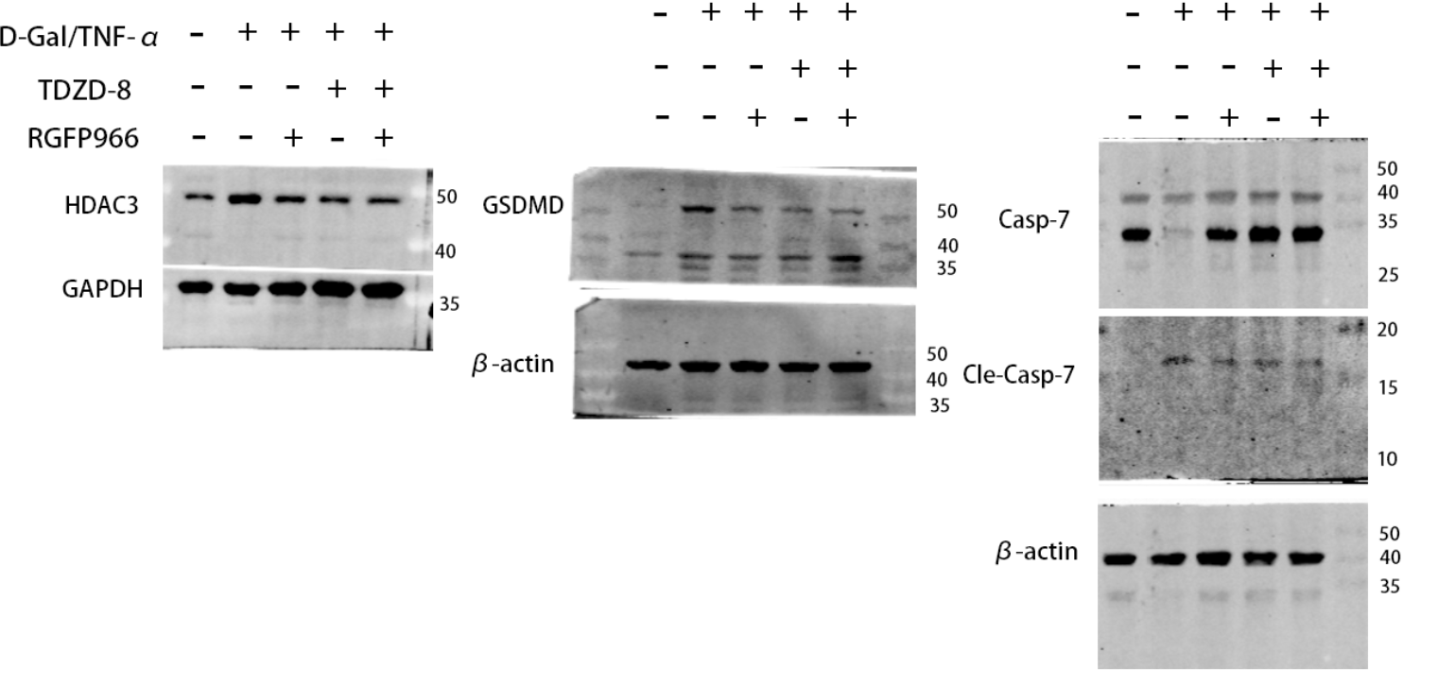
The figure above shows GAPDH and β-actin as they appear in figure 7.
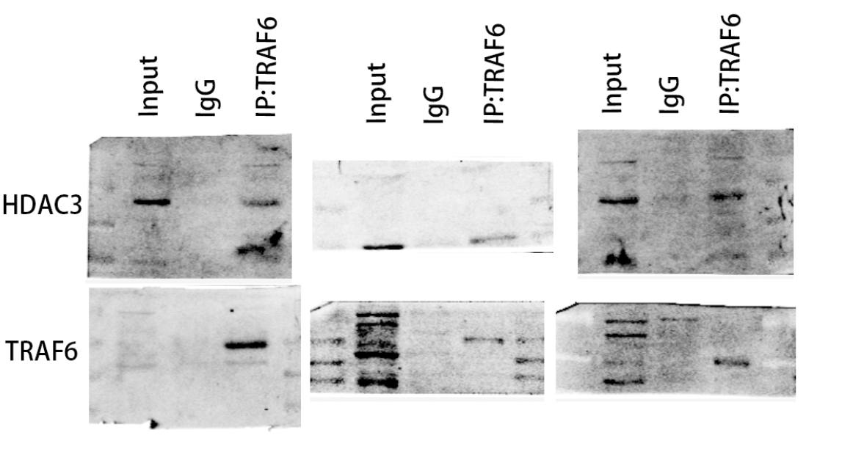
The figure above is presented in figure6.

