Supplementary information

Comprehensive characterization of the chemical constituents in Yiganmingmu oral liquid and the absorbed prototypes in cynomolgus monkey plasma after oral administration by UPLC-Q-TOF-MS based on the self built components database
Wei wei^{1,2,3∗}, Siwei Li^{4∗}, Linyou Cheng³, Erwei Hao, Xiaotao Hou⁴, Hua Zhou³, Jiagang Deng^{2∗} and Xinsheng Yao^{1∗}
1. College of Pharmacy and International Cooperative Laboratory of Traditional Chinese Medicine Modernization and Innovative Drug Development of Chinese Ministry of Education, Jinan University, Guangzhou 510632, China
2. Guangxi Key Laboratory of Efficacy Study on Chinese Materia Medica, Guangxi University of Chinese Medicine, Nanning, Guangxi 530200, China
3. National and Region joint Engineering Center for Anticancer Drug Development, Guangxi Hebabiz Pharmaceutical Co. Ltd., Qinzhou 535000, China
4. Faculty of Pharmacy, Guangxi University of Chinese Medicine, Nanning 530200, China
Table S1. The chemical compounds of YGMM collected from literatures
No. | Name | Formula | Source
1 | Leonuride | C₁₅H₂₄O₉ | RG
2 | 5-Hydroxymethyl-2-furoic acid | C₆H₆O₄ | RG
3 | 5-Hydroxymethylfurfural | C₆H₆O₃ | RG
4 | 6-O-E-Feruloylajugol | C₂₅H₃₂O₁₂ | RG
5 | 8-Epiloganic acid | C₁₆H₂₄O₁₀ | RG
6 | Acteoside | C₂₉H₃₆O₁₅ | RG
7 | Adenosine | C₁₀H₁₃N₅O₄ | RG
8 | Afrormosine | C₁₅H₂₄O₉ | RG
9 | Apigenin | C₁₅H₁₀O₅ | RG
10 | Aucubin | C₁₅H₂₂O₉ | RG
11 | Catalpol | C₁₅H₂₂O₁₀ | RG
12 | Citric acid | C₆H₈O₇ | RG
13 | Decaffeoyl-verbascoside | C₂₀H₃₀O₁₂ | RG
14 | Dihydrocatalpol | C₁₅H₂₄O₁₀ | RG
15 | Diosmetin | C₁₆H₁₂O₆ | RG
16 | Echinacoside | C₃₅H₄₆O₂₀ | RG
17 | Forsythiaside | C₂₉H₃₆O₁₅ | RG
18 | Forsythoside E | C₂₀H₃₀O₁₂ | RG
19 | Geniposide | C₁₇H₂₄O₁₀ | RG
20 | Gentisic acid | C₇H₆O₄ | RG
21 | Guanosine | C₁₀H₁₃N₅O₅ | RG
22 | Isoacteoside | C₂₉H₃₆O₁₅ | RG
23 | Jioglutoside B1 | C₃₇H₅₀O₂₀ | RG
24 | Jionoside A1 | C₃₆H₄₈O₂₀ | RG
25 | Jionoside B1 | C₃₇H₅₀O₂₀ | RG
26 | Jionoside D | C₃₀H₃₈O₁₅ | RG
27 | Leucosceptoside A | C₃₀H₃₈O₁₅ | RG
28 | Luteolin | C₁₅H₁₀O₆ | RG
29 | Martynoside | C₃₁H₄₀O₁₅ | RG
30 | Melittoside | C₂₁H₃₂O₁₅ | RG
31 | Monomelittoside | C₁₅H₂₂O₁₀ | RG
32 | Oleanolic acid | C₃₀H₄₈O₃ | RG
33 | p-hydroxybenzoic acid | C₇H₆O₃ | RG
34 | Protocatechuic acid | C₇H₆O₄ | RG
35 | Purpureaside B | C₃₅H₄₆O₂₀ | RG
36 | Rehmaionoside A | C₁₉H₃₄O₈ | RG
37 | Rehmannioside A | C₂₁H₃₂O₁₅ | RG
38 | Rehmannioside C | C₂₁H₃₄O₁₄ | RG
39 | Rehmannioside D | C₂₇H₄₂O₂₀ | RG
40 | Rehmapicroside | C₁₆H₂₆O₈ | RG
41 | Salidroside | C₁₄H₂₀O₇ | RG
42 | Uridine | C₉H₁₂N₂O₆ | RG
43 | Ursolic acid | C₃₀H₄₈O₃ | RG
44 | Verbascoside | C₂₉H₃₆O₁₅ | RG
45 | β-sitosterol | C₂₉H₅₀O | RG
46 | Z-ligustilide | C₁₂H₁₄O₂ | LC
47 | Senkyunolide A | C₁₂H₁₆O₂ | LC
48 | Senkyunolide B | C₁₂H₁₂O₃ | LC
49 | Senkyunolide D | C₁₂H₁₂O₄ | LC
50 | Senkyunolide E | C₁₂H₁₂O₄ | LC
51 | Senkyunolide F | C₁₂H₁₄O₃ | LC
52 | Senkyunolide G | C₁₂H₁₆O₃ | LC
53 | Senkyunolide H | C₁₂H₁₆O₄ | LC
54 | Senkyunolide J | C₁₂H₁₈O₄ | LC
55 | Senkyunolide K | C₁₂H₁₆O₃ | LC
56 | Senkyunolide L | C₁₆H₂₂O₄ | LC
57 | Senkyunolide N | C₁₆H₂₄O₃ | LC
58 | Senkyunolide O | C₁₂H₁₆O₅ | LC
59 | Butylphthalide | C₁₂H₁₄O₂ | LC
60 | Z-butylidenephthalide | C₁₂H₁₂O₂ | LC
61 | 3-Butylidene-7-hydroxyphthalide | C₁₂H₁₂O₃ | LC
62 | 4-Hydroxy-3-butylphthalide | C₁₂H₁₄O₃ | LC
63 | 4，7-Dihydroxy-3-butylphthalide | C₁₂H₁₄O₄ | LC
64 | Cnidilide | C₁₂H₁₈O₂ | LC
65 | 7-Epoxyligustilide | C₁₂H₁₄O₃ | LC
66 | 3-Carboxyrthyl-phthalide | C₁₀H₈O₄ | LC
67 | Chuanxiongnolide Ｒ2 | C₁₂H₁₈O₄ | LC
68 | 7-Dihydroxy-3-butylphthalide | C₁₂H₁₈O₅ | LC
69 | Levistolide A | C₂₄H₂₈O₄ | LC
70 | Tokinolide B | C₂₄H₂₈O₄ | LC
71 | Ferulic acid | C₁₀H₁₀O₄ | LC
72 | Caffeic acid | C₉H₈O₄ | LC
73 | protocatechuic acid | C₇H₆O₄ | LC
74 | p-Hydroxybenzoicacid | C₇H₆O₃ | LC
75 | Vanillic acid | C₈H₈O₄ | LC
76 | Vanillin | C₈H₈O₃ | LC
77 | Sedanonic acid | C₁₂H₁₈O₃ | LC
78 | Gallic acid | C₇H₆O₅ | LC
79 | Chlorogenic acid | C₁₆H₁₈O₉ | LC
80 | Tetramethylpyrazine | C₈H₁₂N₂ | LC
81 | Adenine | C₅H₅N₅ | LC
82 | Scopoletin | C₁₀H₈O₄ | LC
83 | Daidzein | C₁₅H₁₀O₄ | LC
84 | Palmitic acid | C₁₆H₃₂O₂ | LC
85 | Isoleucine | C₆H₁₃NO₂ | AS
86 | Leucine | C₆H₁₃NO₂ | AS
87 | Chlorogenic acid | C₁₆H₁₈O₉ | AS
88 | Caffeic acid | C₉H₈O₄ | AS
89 | Phthalic acid | C₈H₆O₄ | AS
90 | Vanillic acid | C₈H₈O₄ | AS
91 | p-Coumaric acid | C₉H₈O₃ | AS
92 | Ferulic Acid | C₁₀H₁₀O₄ | AS
93 | Senkyunolide I | C₁₂H₁₆O₄ | AS
94 | Anchoicacid | C₉H₁₆O₄ | AS
95 | Senkyunolide H | C₁₂H₁₆O₄ | AS
96 | n-Butylidenephthalide | C₁₂H₁₂O₂ | AS
97 | Coniferyl ferulate | C₂₀H₂₀O₆ | AS
98 | 2-Valeryl-benzoic acid | C₁₂H₁₄O₃ | AS
99 | (Z)-6,7-epoxyligustilide | C₁₂H₁₄O₃ | AS
100 | Senkyunolide G | C₁₂H₁₆O₃ | AS
101 | Senkyunolide F | C₁₂H₁₄O₃ | AS
102 | (Z)-3-Butylidene-7-hydroxyphthalide | C₁₂H₁₂O₃ | AS
103 | 1-Phenyl-Ethanone | C₈H₈O | AS
104 | Senkyunolide C | C₁₂H₁₂O₃ | AS
105 | Senkyunolide B | C₁₂H₁₂O₃ | AS
106 | Senkyunolide E | C₁₂H₁₂O₃ | AS
107 | Senkyunolide A | C₁₂H₁₆O₂ | AS
108 | Butylphthalide | C₁₂H₁₄O₂ | AS
109 | E-Ligustilide | C₁₂H₁₄O₂ | AS
110 | Ligustrazine | C₁₂H₁₂O₂ | AS
111 | Z-Ligustilide | C₁₂H₁₄O₂ | AS
112 | (E)-Butylidenephthalide | C₁₂H₁₂O₂ | AS
113 | (Z)-Butylidenephthalide | C₁₂H₁₂O₂ | AS
114 | Senkyunolide O | C₂₄H₂₈O₄ | AS
115 | Senkyunolide P | C₂₄H₂₈O₄ | AS
116 | Angelicide | C₂₄H₂₈O₄ | AS
117 | Levistilide A | C₂₄H₂₈O₄ | AS
118 | Riligustilide | C₂₄H₂₈O₄ | AS
119 | (4S)-perillic acid 6-O-α- L-arabinopyranosyl- (1' →6' ' )-β-D-glucopyranosyl | C₂₁H₃₂O₁₁ | RP
120 | 4-Hydroxybenzoic acid | C₇H₆O₃ | RP
121 | AlbiflorinR1 | C₂₃H₂₈O₁₁ | RP
122 | Aplopaeonoside | C₂₀H₂₈O₁₂ | RP
123 | Benzoylalbiflorin | C₃₀H₃₂O₁₂ | RP
124 | Benzoyloxypaeoniflorin | C₃₀H₃₁O₁₃ | RP
125 | Gallic acid | C₇H₆O₅ | RP
126 | Paeonol | C₉H₁₀O₃ | RP
127 | (1-O-β-D-glucopyransoyl-paeonisuf-frone) | C₁₆H₂₄O₉ | RP
128 | (Z)-(1S,5R)-β-pinen-10-yl-β-vicianoside | C₂₁H₃₄O₁₀ | RP
129 | 1,2,3,4,6-penta-O-galloyl-β-D- glucopyranoside | C₄₁H₃₂O₂₆ | RP
130 | 1,2,3,6-Tetragalloylglucose | C₃₄H₂₈O₂₂ | RP
131 | 1,2,3,6-Tetra-O-galloyl-β-D-glucose | C₃₄H₂₇O₂₂ | RP
132 | 1,3,6-Tri-O-galloyl-beta-D-glucose | C₂₇H₂₄O₁₈ | RP
133 | 1-O-β-D-glucopyranosyl-8-O-benzoylpaeonisuffrone | C₂₃H₂₈O₁₀ | RP
134 | 3', 6'-Di-O-gal-loylpaeoniflorin | C₃₇H₃₆O₁₉ | RP
135 | 3,4-Dihydroxybenzoic acid | C₇H₆O₄ | RP
136 | 30- norheder-agenin | C₂₉H₄₄O₄ | RP
137 | 3-Methoxygallic acid | C₈H₈O₅ | RP
138 | 3β-Hydroxy-20(29)-lupaene-28-oic acid | C₃₀H₄₈O₃ | RP
139 | 4"-Hydroxyl-albiflorin | C₂₃H₂₈O₁₂ | RP
140 | 4,9-Dihydroxy-8,10-dehydrothymol-1-O-β-D-glucoside | C₁₆H₂₂O₈ | RP
141 | 6'- O- β- D- glu-copyranosylalbiflorin | C₂₉H₃₈O₁₆ | RP
142 | 6' -O-galloylsucrose | C₁₉H₂₆O₁₅ | RP
143 | 6-Hydroxycoumarin | C₉H₆O₃ | RP
144 | 6-O-copyranosyl-lactinolide | C₁₆H₂₆O₉ | RP
145 | 6-O-galloylsucrose | C₁₃H₁₆O₁₀ | RP
146 | 8-Debenzoylpaeoniflorin | C₁₆H₂₄O₁₀ | RP
147 | Adenosine | C₁₀H₁₃N₅O₄ | RP
148 | Ailexperphenoside A | C₂₁H₃₀O₁₁ | RP
149 | Albiflorin | C₂₃H₂₈O₁₁ | RP
150 | Astragaloside | C₂₁H₂₀O₁₁ | RP
151 | Benzoic acid | C₇H₆O₂ | RP
152 | Benzoylpaeoniflorin | C₃₀H₃₂O₁₃ | RP
153 | Benzoylpaeoniflorin sulfonate | C₃₀H₃₂O₁₄S | RP
154 | Betulonicacid | C₃₀H₄₆O₃ | RP
155 | Catechol | C₁₅H₁₄O₆ | RP
156 | Citric acid | C₆H₈O₇ | RP
157 | Daucosterol | C₃₅H₆₀O₆ | RP
158 | Diglucosyl Gallic Acid | C₁₉H₂₆O₁₅ | RP
159 | Dipropylphthalate | C₁₄H₁₈O₄ | RP
160 | Ellagic acid | C₁₄H₆O₈ | RP
161 | Emodin-8-O-β-D-glucoside | C₁₃H₁₆O₇ | RP
162 | Epigallocatechin gallate | C₂₂H₁₈O₁₁ | RP
163 | Ethyl gallate | C₉H₁₀O₅ | RP
164 | Ethyl palmitate | C₁₈H₃₆O₂ | RP
165 | Galloylpaeoniflorin | C₃₀H₃₂O₁₅ | RP
166 | Galloylpaeoniflorin | C₃₀H₃₂O₁₅ | RP
167 | Galloylpaeoniflorin | C₃₀H₃₂O₁₅ | RP
168 | Gentiopicroside | C₂₃H₂₈O₁₂ | RP
169 | Gentiopicroside | C₃₀H₄₈O₃ | RP
170 | Gentiopicroside | C₃₀H₄₈O₄ | RP
171 | Gentiopicroside | C₃₀H₅₀O₂ | RP
172 | Glucopyranose gallate | C₁₃H₁₆O₁₀ | RP
173 | Hederagenin | C₃₀H₄₈O₄ | RP
174 | Isomaltopaeoniflorin | C₂₉H₃₈O₁₆ | RP
175 | Kaempferitrin | C₂₇H₃₀O₁₄ | RP
176 | Kaempferol | C₁₅H₁₀O₆ | RP
177 | Kaempferol 3,7-O-di-β-D-glucopyranside | C₂₇H₃₀O₁₆ | RP
178 | KaeMpferol 3-O-D-glucopyranoside | C₂₁H₁₈O₁₂ | RP
179 | KaeMpferol-3-O-α-L-rhaMnoside | C₂₁H₂₀O₁₀ | RP
180 | Lactiflorin | C₂₃H₂₆O₁₀ | RP
181 | Leontoside A | C₁₄H₁₈O₉ | RP
182 | Methyl gallate | C₈H₈O₅ | RP
183 | Mudanpinoicacid A | C₃₀H₄₆O₃ | RP
184 | Mudanpioside A | C₃₁H₃₄O₁₃ | RP
185 | Mudanpioside B | C₃₁H₃₄O₁₄ | RP
186 | Mudanpioside D | C₂₄H₃₀O₁₂ | RP
187 | Mudanpioside H | C₃₀H₃₂O₁₄ | RP
188 | Mudanpioside E | C₂₄H₂₉O₁₃ | RP
189 | Mudanpioside F | C₁₆H₂₄O₈ | RP
190 | Mudanpioside G | C₁₆H₂₄O₈ | RP
191 | Mudanpioside H | C₃₀H₃₂O₁₄ | RP
192 | Mudanpioside I | C₂₃H₂₈O₁₁ | RP
193 | Naringenin | C₁₅H₁₂O₅ | RP
194 | Paeonidanin | C₂₄H₃₀O₁₁ | RP
195 | Paeonidanin E | C₄₆H₅₄O₂₁ | RP
196 | Paeoniflorin | C₂₃H₂₈O₁₁ | RP
197 | Paeoniflorin sulfite | C₂₃H₂₈O₁₃S | RP
198 | paeonilactone B | C₁₀H₁₂O₄ | RP
199 | Paeonilactone C | C₁₇H₁₈O₆ | RP
200 | Paeonin D | C₃₇H₃₆O₁₆ | RP
201 | Paeonisuffrone | C₁₀H₁₄O₄ | RP
202 | Paeonoside | C₁₅H₂₀O₈ | RP
203 | Pentagalloylglucose | C₄₁H₃₂O₂₆ | RP
204 | Protocatechualdehyde | C₇H₆O₃ | RP
205 | Pyrogallol | C₆H₆O₃ | RP
206 | Resveratrol | C₁₄H₁₂O₃ | RP
207 | Scabioside C | C₁₈H₂₄O₁₄ | RP
208 | Sucralose | C₁₂H₂₂O₁₁ | RP
209 | β-D-glucopyranosyl benzoate | C₂₁H₂₀O₁₀ | RP
210 | β-gentiobiosyl paeoniflorin | C₂₉H₃₈O₁₆ | RP
211 | Ophiofurospiside K | C₅₁H₈₄O₂₃ | OJ
212 | 5, 7-dihydroxy-6, 8-dimethyl-3-(2'- hydroxy, 3', 4'-methylenedioxybenzyl) chromone | C₁₉H₁₆O₇ | OJ
213 | 5,7, 2',4'-tetradihydroxy-8-methoyl-6-methyl-homoisoflavanone | C₁₈H₁₈O₇ | OJ
214 | 5,7,2’-trihydroxy-6,8-dimethyl-3-(3', 4'-methylenedioxybenzyl) chromone | C₁₉H₁₆O₇ | OJ
215 | 5,7,2'-trihydroxy-8-methyl-3-(3', 4'-methylenedioxybenzyl) chromone | C₁₇H₁₆O₅ | OJ
216 | 5,7,4'-trihydroxy ，3’-methoxyl-6,8-dimethyl-homisoflavanone. | C₁₉H₂₀O₆ | OJ
217 | 5,7-dihydroxy-6,8-dialdehyde-3-(4'- methoxybenzyl) chromone | C₁₈H₁₄O₇ | OJ
218 | 5,7-dihydroxy-6-dimethyl-3-(4'-hydroxybenzyl) chromone | C₁₇H₁₄O₅ | OJ
219 | 5,7-dihydroxy-8-formyl-3-(4'- methoxybenzyl) chromone | C₁₈H₁₄O₆ | OJ
220 | 7-dihydroxy-3-(4'-hydroxybenzyl) chromone-4-one | C₁₆H₁₂O₅ | OJ
221 | Dracaenoside F | C₃₉H₆₂O₁₃ | OJ
222 | Lophiopogonanone B | C₁₉H₂₀O₅ | OJ
223 | Methylophiopogonanone A | C₁₉H₁₈O₆ | OJ
224 | Methylophiopogonanone B | C₁₉H₂₀O₅ | OJ
225 | Methylophiopogonone A | C₁₉H₁₆O₆ | OJ
226 | Ophiofurospiside A | C₅₀H₈₂O₂₃ | OJ
227 | Ophiofurospiside C | C₅₆H₉₂O₂₈ | OJ
228 | Ophiofurospiside F | C₄₅H₇₄O₂₀ | OJ
229 | Ophiofurospiside L | C₅₀H₈₂O₂₃ | OJ
230 | Ophiopogonanoe A | C₁₈H₁₆O₆ | OJ
231 | Ophiopogonanoe B | C₁₈H₁₈O₅ | OJ
232 | Ophiopogonanone C | C₁₉H₁₆O₇ | OJ
233 | Ophiopogonanone E | C₁₉H₂₀O₇ | OJ
234 | Ophiopogonin B | C₃₉H₆₂O₁₂ | OJ
235 | Ophiopogonin C' | C₃₉H₆₂O₁₂ | OJ
236 | Ophiopogonin D | C₄₄H₇₀O₁₆ | OJ
237 | Ophiopogonin D' | C₄₄H₇₀O₁₆ | OJ
238 | Ophiopogonin F | C₅₆H₉₂O₂₇ | OJ
239 | Ophiopogonin G | C₅₆H₉₂O₂₇ | OJ
240 | Ophiopogonin G | C₅₆H₉₂O₂₇ | OJ
241 | Ophiopogonin H | C₅₆H₉₂O₂₉ | OJ
242 | Ophiopogonin I | C₅₀H₈₂O₂₃ | OJ
243 | Ophiopogonin J | C₅₆H₉₂O₂₇ | OJ
244 | Ophiopogonin N | C₅₆H₉₂O₂₈ | OJ
245 | Ophiopogonin O | C₅₀H₈₀O₂₄ | OJ
246 | Ophiopogonin P | C₄₁H₆₄O₁₄ | OJ
247 | Ophiopogonin Q | C₅₆H₉₂O₂₈ | OJ
248 | Ophiopogonin Ｒ | C₃₉H₆₂O₁₅ | OJ
249 | Ophiopogonin Ra | C₃₉H₆₂O₁₄ | OJ
250 | Ophiopojaponin C | C₄₄H₇₀O₁₈ | OJ
251 | Tb | C₃₉H₆₂O₁₃ | OJ
252 | Chlorogenic acid | C₁₆H₁₈O₉ | CM
253 | Apigenin-7-O-glucoside | C₂₁H₂₀O₁₀ | CM
254 | Luteolin-7-O-6''-malonyl-glucoside | C₂₄H₂₂O₁₄ | CM
255 | 4,5-Dicaffeoylquinic acid | C₂₅H₂₄O₁₂ | CM
256 | 3,5-Dicaffeoylquinic acid | C₂₅H₂₄O₁₂ | CM
257 | 3,4-Dicaffeoylquinic acid | C₂₅H₂₄O₁₃ | CM
258 | Acacetin-7-O-6''-malonyl-galactoside | C₂₅H₂₄O₁₃ | CM
259 | Caffeic acid | C₁₃H₁₂O₉ | CM
260 | Bellidifodin | C₁₄H₁₀O₆ | CM
261 | Apigenin | C₁₅H₁₀O₅ | CM
262 | Luteolin | C₁₅H₁₀O₆ | CM
263 | Acacetin | C₁₆H₁₂O₅ | CM
264 | Diosmetin | C₁₆H₁₂O₆ | CM
265 | Neochlorogenicacid | C₁₆H₁₈O₁₀ | CM
266 | Chlorogenic acid | C₁₆H₁₈O₁₁ | CM
267 | Cryptochlorogenic acid | C₁₆H₁₈O₁₂ | CM
268 | 1-Caffeoylquinic acid | C₁₆H₁₈O₉ | CM
269 | Neochlorogenic acid | C₁₆H₁₈O₉ | CM
270 | Chlorogenic acid | C₁₆H₁₈O₉ | CM
271 | Eupatorin | C₁₈H₁₆O₇ | CM
272 | Tuberonic acid glucoside | C₁₈H₂₈O₉ | CM
273 | Norswertianolin | C₁₉H₁₈O₁₁ | CM
274 | Casticin | C₁₉H₁₈O₈ | CM
275 | Chlorogenic acid butyl ester | C₂₀H₂₆O₉ | CM
276 | Apigenin-7-O-glucuronide | C₂₁H₁₈O₁₁ | CM
277 | Luteolin-7-O-glucuronide | C₂₁H₁₈O₁₂ | CM
278 | Apigenin-7-O-β-D-glucopyranoside | C₂₁H₂₀O₁₀ | CM
279 | Apigenin-4'-O-glucopyranoside | C₂₁H₂₀O₁₀ | CM
280 | Luteoloside | C₂₁H₂₀O₁₁ | CM
281 | Luteolin-7-O-glucoside | C₂₁H₂₀O₁₁ | CM
282 | Quercetin-7-O-galactoside | C₂₁H₂₀O₁₂ | CM
283 | Quercetin-3-O-glucoside | C₂₁H₂₀O₁₂ | CM
284 | Isookanin-7-O-β-diglucopyranoside | C₂₁H₂₂O₁₁ | CM
285 | Acacetin-7-O-glucuronide | C₂₂H₂₀O₁₁ | CM
286 | Diosmetin 7-glucuronide | C₂₂H₂₀O₁₂ | CM
287 | Acacetin-7-Glucoside | C₂₂H₂₂O₁₀ | CM
288 | Acacetin-7-O-galactoside | C₂₂H₂₂O₁₀ | CM
289 | Apigenin 7-O-acetylglucoside isomer | C₂₃H₂₂O₁₁ | CM
290 | Apigenin-7-O-6''-acetyl-glucoside | C₂₃H₂₂O₁₁ | CM
291 | Kaempferol-3-O-acetyl-glucoside | C₂₃H₂₂O₁₂ | CM
292 | Apigenin-7-O-6''-malonyl-glucoside | C₂₄H₂₂O₁₃ | CM
293 | Isochlorogenic acid C | C₂₅H₂₄O₁₂ | CM
294 | Isochlorogenic acid A | C₂₅H₂₄O₁₂ | CM
295 | Isochlorogenic acid B | C₂₅H₂₄O₁₂ | CM
296 | 1,3-Dicaffeoylquinic acid | C₂₅H₂₄O₁₂ | CM
297 | Dicaffeoylquinic acid isomer | C₂₅H₂₄O₁₂ | CM
298 | 3,4-Di-caffeoyl-quinic acid | C₂₅H₂₄O₁₂ | CM
299 | Acacetin-7-O-6″-malonylgactoside | C₂₅H₂₄O₁₃ | CM
300 | Diosmetin-7-O-6''-malonyl-glucoside | C₂₅H₂₄O₁₄ | CM
301 | Tasumatrol B | C₂₆H₃₈O₁₁ | CM
302 | Apigenin-7-O-rutinoside | C₂₇H₃₀O₁₄ | CM
303 | Apigenin-7-O-neohesperidoside | C₂₇H₃₀O₁₄ | CM
304 | Luteolin 7-O-rutinoside | C₂₇H₃₀O₁₅ | CM
305 | 6,8-C,C-diglucosylapigenin isomer | C₂₇H₃₀O₁₅ | CM
306 | Luteolin-7-O-rutinoside | C₂₇H₃₀O₁₅ | CM
307 | Naringenin-6,8-di-C-glucoside | C₂₇H₃₂O₁₅ | CM
308 | Buddleoside | C₂₈H₃₂O₁₄ | CM
309 | Diosmetin 7-O-rutinoside | C₂₈H₃₂O₁₅ | CM
310 | Ombuin-3β-rutinoside | C₂₉H₃₄O₁₆ | CM
311 | Malonic acid | C₇H₈O₇ | CM
312 | 6-Gingerol | C₁₇H₂₆O₄ | BC
313 | Baicalin | C₂₁H₁₈O₁₁ | BC
314 | Hydroxy-saikosaponin A | C₄₂H₇₀O₁₄ | BC
315 | Hydroxy-saikosaponin C | C₄₈H₈₀O₁₈ | BC
316 | Hydroxy-saikosaponin D | C₄₂H₇₀O₁₄ | BC
317 | Malonyl-saikosaponin A | C₄₅H₇₀O₁₆ | BC
318 | Malonyl-saikosaponin C | C₅₁H₈₀O₂₀ | BC
319 | Malonyl-saikosaponin D | C₄₅H₇₀O₁₆ | BC
320 | Saikochromoside A | C₁₇H₂₀O₁₀ | BC
321 | (-)-(5S,6S)-5,6-Dihydro-3,8,10-trihydroxy-5-(4-hydroxy-3-methoxyphenyl)-6-hydroxymethyl-2,4-dimethoxy7H-benzo[c]xanthen-7-one | C₂₇H₂₄O₁₀ | BC
322 | 2"-O-acetylsaikosaponin A | C₄₄H₇₁O₁₄ | BC
323 | 23-O-acetylsaikosaponin-A | C₄₄H₇₀O₁₄ | BC
324 | 2''-O-acetylsaikosaponin A | C₄₄H₇₀O₁₄ | BC
325 | 3"-O-acetylsaikosaponin A | C₄₄H₇₀O₁₄ | BC
326 | 3"-O-Acetylsaikosaponin D | C₄₄H₇₀O₁₄ | BC
327 | 3,7-Di-O-methylquercetin | C₁₇H₁₄O₇ | BC
328 | 4"-O-Acetylsaikosaponin A | C₄₄H₇₀O₁₅ | BC
329 | 4"-O-Acetylsaikosaponin D | C₄₄H₇₀O₁₅ | BC
330 | 5-hydroxy-7-acetoxylsaccharidesavone | C₁₇H₁₂O₅ | BC
331 | 6"-O-acetylsaikosaponin A | C₄₄H₇₀O₁₄ | BC
332 | 6''-O-acetylsaikosaponin A | C₄₄H₇₀O₁₄ | BC
333 | 6''-O-acetylsaikosaponin D | C₄₄H₇₀O₁₆ | BC
334 | Acetyl-prosaikogenin D | C₃₆H₅₈O₈ | BC
335 | Ammonium Glycyrrhizinate | C₄₂H₆₂O₁₆.₃H₂O.H₃N | BC
336 | Chikusaikoside I | C₄₇H₇₆O₁₇ | BC
337 | Chlorogenic acid | C₁₆H₁₈O₉ | BC
338 | Eugenin | C₁₀H₁₂O₂ | BC
339 | Gallic acid | C₇H₆O₅ | BC
340 | Ginsenoside Rb1 | C₅₄H₉₂O₂₃ | BC
341 | Ginsenoside Re | C₄₈H₈₂O₁₈ | BC
342 | Isochlorogenic acid A | C₂₅H₂₄O₁₂ | BC
343 | Isochlorogenic acid B | C₂₅H₂₄O₁₃ | BC
344 | Isoquercitrin | C₂₁H₂₀O₁₂ | BC
345 | Liquiritin | C₂₁H₂₂O₉ | BC
346 | Luteolin | C₁₅H₁₀O₆ | BC
347 | Malonyl-saikosaponin B2 | C₅₁H₈₀O₂₁ | BC
348 | Malonyl-saikosaponin E | C₄₅H₇₀O₁₅ | BC
349 | malonyl-saikosaponin F | C₅₁H₈₂O₂₀ | BC
350 | Narcissoside | C₂₈H₃₂O₁₆ | BC
351 | Prosaikogenin A | C₃₆H₅₈O₈ | BC
352 | Prosaikogenin D | C₃₆H₅₈O₈ | BC
353 | Prosaikogenin F | C₃₆H₅₈O₈ | BC
354 | Prosaikogenin G | C₃₆H₅₈O₈ | BC
355 | Puerarin | C₂₁H₂₀O₁₀ | BC
356 | Rotundifolioside I | C₄₇H₇₆O₁₆ | BC
357 | Rutin | C₂₇H₃₀O₁₆ | BC
358 | Saikochrome A | C₄₃H₇₂O₁₄ | BC
359 | Saikosaponin A | C₄₂H₆₈O₁₃ | BC
360 | Saikosaponin B1 | C₄₂H₆₈O₁₃ | BC
361 | Saikosaponin B2 | C₄₂H₆₈O₁₃ | BC
362 | Saikosaponin B3 | C₄₃H₇₂O₁₄ | BC
363 | Saikosaponin B4 | C₄₃H₇₂O₁₄ | BC
364 | Saikosaponin C | C₄₈H₇₈O₁₇ | BC
365 | Saikosaponin D | C₄₂H₆₈O₁₃ | BC
366 | Saikosaponin E | C₄₂H₆₈O₁₂ | BC
367 | Saikosaponin F | C₄₈H₈₀O₁₇ | BC
368 | Saikosaponin F | C₄₈H₈₀O₁₇ | BC
369 | Saikosaponin G | C₄₂H₆₈O₁₃ | BC
370 | Saikosaponin I | C₄₂H₆₈O₁₄ | BC
371 | Saikosaponin N | C₄₈H₇₈O₁₈ | BC
372 | Saikosaponin S | C₄₈H₇₇O₁₈ | BC
373 | Saikosaponin X | C₄₂H₆₆O₁₅ | BC
374 | Salcolin B | C₂₇H₂₆O₁₁ | BC
375 | Tartronoyl-saikosaponin D | C₄₅H₇₀O₁₆ | BC
376 | Tricin 4"-O-(threo-β-guaiacylglyceryl) Ether | C₂₉H₂₈O₁₂ | BC
377 | Tricin 4"-O-(threo-βguaiacylglyceryl) Ether⁃7"⁃O⁃β⁃D⁃glucopyranose | C₃₃H₃₆O₁₆ | BC
378 | Vittariflavone | C₂₄H₂₆O₁₂ | BC
379 | Rhamnetin | C₁₆H₁₂O₇ | BC
380 | 5,7,2',4'-tetrahydroxy-6-methoxy-8-methyl homoisoflavanone | C₁₈H₁₈O₇ | PO
381 | trans-ferulamide | C₁₀H₁₁NO₃ | PO
382 | 3-(4-Hydroxy-3-methoxy-phenyl)-acrylic acid carbox-ymethyl ester | C₁₂H₁₂O₆ | PO
383 | emodin | C₁₅H₁₀O₅ | PO
384 | physcion | C₁₆H₁₂O₅ | PO
385 | 5,7,4'-trihydroxyl homoisoflavanone | C₁₆H₁₄O₅ | PO
386 | (3R)-5,7-dihydroxyl-3-(2',4'-dihydroxylbenzyl)-chroman-4-one | C₁₆H₁₄O₆ | PO
387 | 5,7,2',4'-tetrahydroxyl homoisoflavanone | C₁₆H₁₄O₆ | PO
388 | (3R)-5,7-dihydroxy-6-me-thyl-3-(4′-hydroxybenzyl)-chroman-4-one | C₁₇H₁₆O₅ | PO
389 | (3R)-5,7-dihydroxyl-6-methyl-3-(4'-hydroxylbenzyl)-chroman-4-one | C₁₇H₁₆O₅ | PO
390 | 5,7,4'-trihydroxy-6-methyl homoisoflavanone | C₁₇H₁₆O₅ | PO
391 | 5,7,4'-trihydroxy-8-methyl homoisoflavanone | C₁₇H₁₆O₅ | PO
392 | 5,7,2',4'-tetrahydroxy-6-methyl-homoisoflavanone | C₁₇H₁₆O₆ | PO
393 | 5,7,2',4'-tetrahydroxy-8-methyl homoisoflavanone | C₁₇H₁₆O₆ | PO
394 | 5,7,2'-trihydroxy-4'-methoxyl homoisoflavanone | C₁₇H₁₆O₆ | PO
395 | 5,7,2',4'-tetrahydroxy-8-methoxyl homoisoflavanone | C₁₇H₁₆O₇ | PO
396 | N-trans-p-coumaroyltyramine | C₁₇H₁₇NO₃ | PO
397 | N-cis-p-coumaroyltyramine | C₁₇H₁₇NO₃ | PO
398 | N-trans-p-coumaroyloctopamine | C₁₇H₁₇NO₄ | PO
399 | N-trans-p-coumaroyloctopamine | C₁₇H₁₇NO₄ | PO
400 | N-cis-p-coumaroyloctopamine | C₁₇H₁₇NO₄ | PO
401 | (E)-3-(4-Hydroxy-3-methoxybenzylidene)-4-(4-hydroxyphenyl)pyrrolidin-2-one | C₁₈H₁₇NO₄ | PO
402 | (3R)-5,7-dihydroxy-6,8-dimethyl-3-(4′-hydroxybenzyl)-chroman-4-one | C₁₈H₁₈O₅ | PO
403 | (3R)-5,7-dihydroxyl-6,8-dimethyl-3-(4'-hydroxylbenzyl)-chroman-4-one | C₁₈H₁₈O₅ | PO
404 | 5,7,4'-trihydroxyl-6,8-dimethyl homoisoflavanone | C₁₈H₁₈O₅ | PO
405 | (3R)-5,7-dihydroxyl-6-methyl-8-methoxyl-3-(4'-hydroxylbenzyl)-chroman-4-one | C₁₈H₁₈O₆ | PO
406 | 5,7,2'-trihydroxy-8-methyl-4'-methoxyl homoisoflavanone | C₁₈H₁₈O₆ | PO
407 | 5,7,4'-trihydroxy-6-methyl-8-methoxyl homoisoflavanone | C₁₈H₁₈O₆ | PO
408 | 5,7,2'-trihydroxy-8,4'-dimethoxy homoisoflavanone | C₁₈H₁₈O₇ | PO
409 | N-cis-feruloyltyramine | C₁₈H₁₉NO₄ | PO
410 | N-trans-feruloyltyramine | C₁₈H₁₉NO₄ | PO
411 | N-cis-feruloyloctopamine | C₁₈H₁₉NO₅ | PO
412 | N-trans-feruloyloctopamine | C₁₈H₁₉NO₅ | PO
413 | 5,7-dihydroxyl-6-methyl-8,4'-dimethoxyl homoisoflavanone | C₁₉H₂₀O₆ | PO
414 | 5,7,2'-trihydroxy-6-methyl-8,4'-dimethoxyl homoisoflavanone | C₁₉H₂₀O₇ | PO
415 | polygodoquinone A | C₂₈H₂₀O₈ | PO
416 | polygonatumoside G | C₃₃H₅₄O₁₀ | PO
417 | Polygoside A | C₄₅H₇₂O₁₉ | PO
418 | Polygoside B | C₄₅H₇₂O₁₉ | PO
419 | officinalisnin II | C₄₅H₇₆O₁₉ | PO
420 | Polygodoraside B | C₅₀H₈₀O₂₄ | PO
421 | (25S)-26-O-(β-D-glucopyranosyl)-furost-5-en3β,22α,26-triol 3-O-β-D-glucopyranosyl-(1 → 2)-β-D-glucopyranosyl-(1 → 4)-β-D-gluco-pyranoside | C₅₁H₈₄O₂₄ | PO
422 | typaspidoside L | C₅₆H₉₀O₂₇ | PO
423 | Polygodoraside E | C₅₆H₉₀O₂₈ | PO
424 | typaspidoside H | C₅₆H₉₀O₂₈ | PO
425 | Polygodoraside A | C₅₆H₉₀O₂₉ | PO
426 | Polygodoraside D | C₅₆H₉₀O₂₉ | PO
427 | Polygodoraside F | C₅₆H₉₀O₂₉ | PO
428 | Polygodoraside C | C₅₆H₉₀O₃₀ | PO
429 | timosaponin H1 | C₅₆H₉₂O₂₈ | PO
430 | polygonatumoside F | C₅₆H₉₂O₂₉ | PO
431 | Polygodoraside H | C₅₇H₉₄O₂₉ | PO
432 | Polygodoraside G | C₅₇H₉₄O₃₀ | PO
433 | Trans-p-coumaramide | C₉H₈NO₂ | PO
434 | Emodin-6-glucoside | C₂₁H₁₉O₁₀ | CO
435 | Isorubrofusarin-6-O-β-gentiobioside | C₂₇H₃₂O₁₅ | CO
436 | Rubrofusarin-6-O-β-glucoside | C₂₁H₂₂O₁₀ | CO
437 | 1-Desmethyl- aurantio-obtusin-2- O-β-D- glucopyranoside | C₂₂H₂₂O₁₂ | CO
438 | 1-Desmethylobtusin | C₁₇H₁₄O₇ | CO
439 | 2-Gluco- chrysoobtusin | C₂₄H₂₆O₁₂ | CO
440 | 2-Gluco-chryso-obtusin | C₂₅H₂₈O₁₂ | CO
441 | 6-Hydroxymusizin-8-O-β-D-glucoside | C₁₉H₂₂O₉ | CO
442 | Alaternin | C₁₅H₁₀O₆ | CO
443 | Alaternin-2-O-β-D-glucoside | C₂₁H₂₀O₁₁ | CO
444 | Aloe-emodin | C₁₅H₁₀O₅ | CO
445 | Aloe-emodin-8-O-β-D-glucoside | C₂₁H₂₀O₁₀ | CO
446 | Aurantioobtusin | C₁₇H₁₄O₇ | CO
447 | Aurantio-obtusin-6-O-β-D-glucoside | C₂₃H₂₄O₁₂ | CO
448 | Cassia-lactone gentiobioside | C₂₈H₃₆O₁₆ | CO
449 | Cassiaside | C₂₀H₂₀O₁₀ | CO
450 | Cassiaside B | C₂₆H₃₀O₁₄ | CO
451 | Cassiaside B2 | C₃₉H₅₂O₂₅ | CO
452 | Cassiaside C | C₂₇H₃₂O₁₅ | CO
453 | Cassiaside C2 | C₃₉H₅₂O₂₅ | CO
454 | Cassitoroside | C₂₅H₃₂O₁₄ | CO
455 | Chrysophanol | C₁₅H₁₀O₄ | CO
456 | Chrysophanol 1-glucoside | C₂₁H₂₀O₉ | CO
457 | Chrysophanol-1-glucoside | C₃₃H₄₀O₁₉ | CO
458 | Chrysophanol-1-glucoside | C₃₉H₅₀O₂₄ | CO
459 | Chrysophanol-1-O-β-gentiobioside | C₂₇H₃₀O₁₄ | CO
460 | Citreorosein | C₁₅H₁₀O₆ | CO
461 | Emodin | C₁₅H₁₀O₅ | CO
462 | Emodin-1-O-β-gentiobioside | C₂₇H₃₂O₁₅ | CO
463 | Emodin-3-methyl ether | C₁₆H₁₂O₅ | CO
464 | Emodin-6-O-β-gentiobioside | C₂₇H₃₀O₁₅ | CO
465 | Gluco-aurantio-obtusin | C₂₃H₂₄O₁₂ | CO
466 | Isorubrofusarin 6-O-beta-gentiobioside | C₂₇H₃₂O₁₅ | CO
467 | Nor-rubrofusarin | C₂₆H₃₀O₁₅ | CO
468 | Nor-rubrofusarin-6-O-β-D-(6'-O-acetyl ) glucopyranoside | C₂₂H₂₂O₁₁ | CO
469 | Nor-rubrofusarin-6-O-β-D-glucophyranoside | C₂₀H₂₀O₁₀ | CO
470 | Obtusifolin | C₁₆H₁₂O₅ | CO
471 | Obtusin | C₂₄H₂₆O₁₂ | CO
472 | Physcion 8-glucoside | C₂₈H₃₂O₁₅ | CO
473 | Physcion-8-O-β-glucoside | C₂₂H₂₂O₁₀ | CO
474 | Pureonebio | C₁₉H₁₈O₇ | CO
475 | Rhein | C₁₅H₈O₆ | CO
476 | Rhein-8-glucoside | C₂₁H₁₈O₁₁ | CO
477 | Rubrofusarin-6-O-β-gentiobioside | C₂₆H₃₀O₁₅ | CO
478 | Rubrofusatin triglucoside | C₃₃H₄₂O₂₀ | CO
479 | Torachrysone tetraglucoside | C₃₈H₅₄O₂₄ | CO
480 | Torachrysone-8-O-β-D-gentiobioside | C₂₆H₃₄O₁₄ | CO
481 | Protocatechualdehyde | C₇H₆O₃ | LB
482 | Caffeic acid | C₉H₈O₄ | LB
483 | Catechin | C₁₅H₁₆O₇ | LB
484 | Epicatechin | C₁₅H₁₄O₆ | LB
485 | Ferulic Acid | C₁₀H₁₀O₄ | LB
486 | Rutinum | C₂₇H₃₀O₁₆ | LB
487 | Chlorogenic acid | C₁₆H₁₈O₉ | LB
488 | Lycibarbarspermidine A | C₃₁H₄₃N₃O₁₁ | LB
489 | Lycibarbarspermidine B | C₃₁H₄₃N₃O₁₂ | LB
490 | Lycibarbarspermidine C | C₃₁H₄₃N₃O₁₃ | LB
491 | Lycibarbarspermidine D | C₃₁H₄₃N₃O₁₄ | LB
492 | Lycibarbarspermidine E | C₃₁H₄₃N₃O₁₅ | LB
493 | Withanolide A | C₂₈H₃₈O₆ | LB
494 | Withanolide B | C₂₈H₃₈O₅ | LB
495 | β-Carotene | C₄₀H₅₆ | LB
496 | β-Cryptoxanthin | C₄₀H₅₆O | LB
497 | Zeaxanthin | C₄₀H₅₆O₂ | LB
498 | Zeaxanthin monopalmitate | C₅₆H₈₆O₃ | LB
499 | Zeaxanthin dipalmitate | C₇₂H₁₁₆O₄ | LB
500 | Zeaxanthin monomyristate | C₅₄H₈₂O₃ | LB
501 | Zeaxanthin dimyristate | C₆₈H₁₀₈O₄ | LB
502 | β-Cryptoxanthin palmitate | C₅₆H₈₆O₂ | LB
503 | Lyciumamide A | C₃₆H₃₆N₂O₈ | LB
504 | Lyciumamide B | C₃₆H₃₆N₂O₈ | LB
505 | Lyciumamide C | C₂₈H₂₉NO₇ | LB
506 | Lyciumide A | C₁₈H₁₉NO₄ | LB
507 | Quercitrin | C₂₁H₂₀O₁₁ | LB
508 | Quercetin | C₁₅H₁₀O₇ | LB
509 | Rutin | C₂₇H₃₀O₁₆ | LB
510 | Narcissoside | C₂₈H₃₂O₁₆ | LB
511 | 3-O-Sophoroside-quercetin | C₂₇H₃₀O₁₇ | LB
512 | Isoquercitrin | C₂₁H₂₀O₁₂ | LB
513 | Linolenic acid | C₁₈H₃₀O₂ | LB
514 | Oleic acid | C₁₈H₃₄O₂ | LB
515 | Linoleic acid | C₁₈H₃₂O₂ | LB
516 | Lycibarbarphenylpropanoids A | C₂₁H₂₈O₁₃ | LB
517 | Lycibarbarphenylpropanoids B | C₂₁H₂₈O₁₃ | LB
518 | Lycibarbarphenylpropanoids C | C₂₂H₃₀O₁₄ | LB
519 | Lycibarbarphenylpropanoids D | C₂₂H₃₀O₁₄ | LB
520 | Lycibarbarphenylpropanoids E | C₂₂H₃₂O₁₃ | LB
521 | Lycibarbarphenylpropanoids F | C₂₃H₃₂O₁₃ | LB
522 | Lycibarbarphenylpropanoids G | C₂₃H₃₂O₁₃ | LB
523 | Lycibarbarphenylpropanoids H | C₂₄H₃₄O₁₄ | LB
524 | Lycibarbarphenylpropanoids I | C₂₄H₃₄O₁₄ | LB
525 | E-p-coumaric acid | C₉H₈O₃ | LB
526 | Emodin | C₁₅H₁₀O₅ | LB
527 | p-Hydroxybenzaldehyde | C₇H₆O₂ | LB
528 | (3S,4R)-6-hydroxy-4-(4-hydroxy-3,5-dimethoxyphenyl)-3-(hydroxymethyl)-N-(4-hydroxyphenethyl)-5,7-dimethoxy-3,4-dihydronaphthalene-2-carboxamide | C₃₀H₃₃NO₉ | LB
529 | (2S,3S,E)-3-{-2-(4-hydroxy-3,5-methoxyphenyl)-3-hydroxymethyl-2,3-dihydrobenzo[b][1,4]dioxin-6-yl}-N-(4-hydroxyphenethyl)-acrylamide | C₂₈H₂₉NO₈ | LB
530 | (2R,3R,E)-3-{-2-(4-hydroxy-3,5-methoxyphenyl)-3-hydroxymethyl-2,3-dihydrobenzo[b][1,4]dioxin-6-yl}-N-(4-hydroxyphenethyl)-acrylamide | C₂₈H₂₉NO₈ | LB
531 | N-trans-Feruloyltyramine | C₁₈H₁₉NO₄ | LB
532 | N-Acetyltyramine | C₉H₁₃NO₂ | LB
533 | N-p-trans-Coumaroyltyramine | C₁₇H₁₇NO₃ | LB
534 | Dihydro-N-Caffeoyl Tyramine | C₁₇H₁₉NO₄ | LB
535 | N-Caffeoyltyramine | C₁₇H₁₇NO₄ | LB
536 | Dihydro-feruloyl-5-methoxytyramine | C₁₉H₂₃NO₅ | LB
537 | 3-(4-hydroxy-3-methoxyphenyl)-N-[2-(4-hydroxyphenyl)-2-methoxyethyl]acrylamide | C₁₉H₂₁NO₅ | LB
538 | N-acetyl-N'-trans-feruloylputrescine | C₁₆H₂₂N₂O₄ | LB
539 | erythro-canabisine H | C₂₈H₃₁NO₈ | LB
540 | grossamide K | C₂₈H₂₉NO₇ | LB
541 | (1,2-trans)-N3-(4-acetamidobutyl)-1-(3,4-dihydroxyphey)-7-hydroxy-N2-(4-hydroxyphenethyl)-6,8-dimethoxy-1,2-dihydronaphthalene-2,3-dicarboxamide | C₃₄H₃₉N₃O₉ | LB
542 | 1,2-dihydro-6,8-dimethoxy-7-hydroxy-1-(3,4-dihydroxyphenyl)-N1,N2-bis[2-(4-hydroxyphenyl)ethyl]-2,3-naphthalene dicarboxamide | C₃₆H₃₆N₂O₉ | LB
543 | Cannabisin F | C₃₆H₃₆N₂O₈ | LB
544 | Cannabisin D | C₃₆H₃₆N₂O₈ | LB
545 | (E)-2-(4,5-dihydroxy-2-{3-[(4-hydroxyphenethyl)amino]-3-oxopropyl}phenyl)-3-(4-hydroxy-3,5-dimethoxyphenyl)-N-(4-acetamidobutyl)acrylamide | C₃₄H₄₁N₃O₉ | LB
546 | (E)-2-(4,5-dihydroxy-2-{3-[(4-hydroxyphenethyl)amino]-3-oxopropyl}phenyl)-3-(4-hydroxy-3-methoxyphenyl)-N-(4-acetamidobutyl)acrylamide | C₃₃H₃₉N₃O₈ | LB
547 | (E)-2-(4,5-dihydroxy-2-{3-[(4-hydroxyphenethyl)amino]-3-oxopropyl}phenyl)-3-(4-hydroxy-3,5-dimethoxyphenyl)-N-(4-hydroxyphenethyl)acrylamide | C₃₆H₃₈N₂O₉ | LB
548 | 3-Benzofurancarboxamide | C₃₆H₃₆N₂O₈ | LB
549 | (+)-Lyoniresinol-3α-O-β-D-glucopyranoside | C₂₈H₃₈O₁₃ | LB
550 | Lipoxin | C₁₈H₃₂O₅ | LB
551 | Scopolamine | C₁₀H₈O₄ | LB
552 | 2,4-Dihydroxy-3,5-dimethoxybenzaldehyde | C₉H₁₀O₄ | LB
553 | Lycifuranone A | C₁₆H₂₂O₃ | LB
554 | Nobiletin | C₂₁H₂₂O₈ | LB
555 | 5-Hydroxymethylfurfural | C₆H₆O₃ | LB
556 | Scopoletin glucoside | C₁₆H₁₈O₉ | LB
557 | 2,6,2',6'-Tetramethoxy-4,4'-bis(2,3-epoxy-hydroxypropyl)biphenyl | C₂₂H₂₆O₈ | LB
558 | 4-（9H-β-carbolin-1-yl）-4-oxo-butyric acid | C₁₅H₁₂N₂O₃ | AA
559 | Carboxymethyl isoferulate | C₁₂H₁₂O₆ | AA
560 | Isoferulic Acid | C₁₀H₁₀O₄ | AA
561 | Cirsiumaldehyde | C₁₂H₁₀O₅ | AA
562 | Daucossterol | C₃₅H₆₀O₆ | AA
563 | Succinic Acid | C₄H₆O₄ | AA
564 | Cinnamic acid | C₉H₈O₂ | AA
565 | 3,4-Dihydroxybenzaldehyde | C₇H₆O₃ | AA
566 | CiMigenol 3-beta-D-xylopyranoside | C₃₅H₅₆O₉ | AA
567 | Caffeic acid | C₉H₈O₄ | AA
568 | Adenosine | C₁₀H₁₃N₅O₄ | AA
569 | Uridine | C₉H₁₂N₂O₆ | AA
570 | Vanillic acid 4-β-D-glucoside | C₁₄H₁₈O₉ | AA
571 | Methyl chlorogenate | C₁₇H₂₀O₉ | AA
572 | 3-O-Feruloylquinic | C₁₇H₂₀O₉ | AA
573 | Esculetin | C₉H₆O₄ | AA
574 | 3,4-Dihydroxyhydrocinnamic acid | C₉H₁₀O₄ | AA
575 | Ferulic Acid | C₁₀H₁₀O₄ | AA
576 | Hydroferulic acid | C₁₀H₁₂O₄ | AA
577 | 5-Hydroxymethyl-2-furaldehyde | C₆H₆O₃ | AA
578 | 3,4-Dihydroxybenzyl alcohol | C₇H₈O₃ | AA
579 | isosinensetin | C₂₀H₂₀O₇ | CR
580 | sinensetin | C₂₀H₂₀O₇ | CR
581 | tangerine | C₂₀H₂₀O₇ | CR
582 | Gentiopicroside | C₂₇H₃₂O₁₄ | CR
583 | Hesperidin | C₂₈H₃₄O₁₅ | CR
584 | Nobiletin | C₂₁H₂₂O₈ | CR
585 | 3,5,6,7,8,3’,4’-Heptemthoxyflavone | C₂₂H₂₄O₉ | CR
586 | Tangeretin | C₂₀H₂₀O₇ | CR
587 | 3’,4’-Dihydroxy-7,5’-dimethoxyflavone | C₁₇H₁₄O₆ | CR
588 | 7-Hydroxy-5,6,8,4’-tetramethoxyflavone | C₁₉H₁₈O₇ | CR
589 | Monohydroxytrimethoxyflavone | C₁₈H₁₆O₆ | CR
590 | 3-Hydroxy-5,7,8-trimethoxyflavone | C₁₈H₁₆O₆ | CR
591 | 5-Hydroxy-7,8,3’,4’-tetramethoxyflavone | C₁₉H₁₈O₇ | CR
592 | 8-Hydroxy-5,6,7,3’,4’,5’-hexamethoxyflavone | C₂₁H₂₂O₉ | CR
593 | Monohydroxytrimethoxyflavone | C₁₈H₁₆O₆ | CR
594 | 6-Hydroxy-5,7,8,4’-tetramethoxyflavone | C₂₀H₂₀O₈ | CR
595 | 5-Hydroxy-3,6,7,8-tetramethoxyflavone | C₁₉H₁₈O₇ | CR
596 | 5,6,7,3’,4’-Pentamethoxyflavanone | C₂₀H₂₂O₇ | CR
597 | 7-Hydroxy-5,6,8,3’,4’-pentamethoxyflavone | C₂₀H₂₀O₈ | CR
598 | 3-Hydroxy-5,6,7,4’-tetramethoxyflavanone | C₁₉H₂₀O₇ | CR
599 | 5,7,8,3',4'-Pentamethoxyflavone | C₂₀H₂₀O₇ | CR
600 | Monohydroxytrimethoxyflavone | C₁₈H₁₆O₆ | CR
601 | 3’-Hydroxy-5,6,7,8,4'-pentamethoxyflavone/4’-Hydroxy-5,6,7,8,3'-pentamethoxyflavone | C₂₀H₂₀O₈ | CR
602 | 3- Hydroxy-5,6,7,8,3’,4’-hexamethoxyflavone | C₂₁H₂₂O₉ | CR
603 | Monohydroxypentamethoxyflavanone | C₂₀H₂₂O₈ | CR
604 | 5,7,3’,4’-Tetramethoxyflavone | C₁₇H₁₄O₆ | CR
605 | 5,7,8,3’,4’,5’-Hexamethoxyflavone | C₂₁H₂₂O₈ | CR
606 | 5,6,7,3',4'-Pentamethoxyflavone | C₂₀H₂₀O₇ | CR
607 | 5,6,7,4’-Tetramethoxyflavone | C₁₉H₁₈O₆ | CR
608 | 5,7,8,3’,4’-Pentamethoxyflavanone | C₂₀H₂₂O₇ | CR
609 | 5,6,7,3’,4’,5’-Hexamethoxyflavone | C₂₁H₂₂O₈ | CR
610 | 5,7,4’-Trimethoxyflavone | C₁₈H₁₆O₅ | CR
611 | 5,6,7,8,3',4'-Hexamethoxyflavanone | C₂₁H₂₄O₈ | CR
612 | 5,6,7,8,3',4'-Hexamethoxyflavone | C₂₁H₂₂O₈ | CR
613 | 5,7,8,4’-Tetramethoxyflavone | C₁₉H₁₈O₆ | CR
614 | 3,5,6,7,8,3',4'-Heptamethoxyflavone | C₂₂H₂₄O₉ | CR
615 | 5-Hydroxy-6,7,3’,4’-tetram ethoxyflavone | C₁₉H₁₈O₇ | CR
616 | 5-Hydroxy-6,7,8,3’,4’-pentamethoxyflavanone | C₂₀H₂₂O₈ | CR
617 | 5-Hydroxy-3,6,7,8,3’,4’-hexamethoxyflavone | C₂₁H₂₂O₉ | CR
618 | 5,6,7,8,4'-Pentamethoxyflavone | C₂₀H₂₀O₇ | CR
619 | 5-Hydroxy-6,7,8,3',4'-pentamethoxyflavone | C₂₀H₂₀O₈ | CR
620 | Hexamethoxyflavone | C₂₁H₂₂O₈ | CR
621 | Monohydroxytrimethoxyflavone | C₁₈H₁₆O₆ | CR
622 | 6,7,8,3’,4’-Pentamethoxyflvanone | C₂₀H₂₂O₇ | CR
623 | 5-Hydroxy-7,3’,4’-trimethoxyflavone | C₁₈H₁₆O₆ | CR
624 | 5,6,7,8,3’,4’-Hexamethoxyflvanone | C₂₁H₂₄O₈ | CR
625 | 5-Hydroxy-6,7,8,3’,4’,5’-hexamethoxyflavone(Gardenin A) | C₂₁H₂₂O₉ | CR
626 | 5-Hydroxy-6,7,8,4’-tetramethoxyflavone(Gardenin B) | C₁₉H₁₈O₇ | CR
627 | Pentamethoxyflvanone | C₂₀H₂₂O₇ | CR
628 | vicenin Ⅱ | C₂₇H₃₀O₁₅ | CR
629 | Apigenin 7-O-(2G-rhamnosyl)gentiobioside | C₃₃H₄₀O₁₉ | CR
630 | Orientin | C₂₁H₂₀O₁₁ | CR
631 | Eriocitrin | C₂₇H₃₂O₁₅ | CR
632 | Eriodictyol | C₁₅H₁₂O₆ | CR
633 | Vitexin | C₂₁H₂₀O₁₀ | CR
634 | Vicenin Ⅲ | C₂₆H₂₈O₁₄ | CR
635 | Kaempferol 3-rutinoside | C₂₇H₃₀O₁₅ | CR
636 | Isovitexin | C₂₁H₂₀O₁₀ | CR
637 | Prunin | C₂₁H₂₂O₁₀ | CR
638 | Naringin | C₂₇H₃₂O₁₄ | CR
639 | Naringenin chalcone | C₁₅H₁₂O₅ | CR
640 | Naringenin | C₁₅H₁₂O₅ | CR
641 | Hesperetin | C₁₆H₁₄O₆ | CR
642 | Apigenin | C₁₅H₁₀O₅ | CR
643 | Rhoifolin | C₂₇H₃₀O₁₄ | CR
644 | Hydroxygenkwanin | C₁₆H₁₂O₆ | CR
645 | Diosmin | C₂₈H₃₂O₁₅ | CR
646 | Neohesperidin | C₂₈H₃₄O₁₅ | CR
647 | Methyl hesperidin | C₂₉H₃₆O₁₅ | CR
648 | Isorhamnetin-3-O-neohespeidoside | C₂₈H₃₂O₁₆ | CR
649 | Homoplantaginin | C₂₂H₂₂O₁₁ | CR
650 | Pectolinarigenin | C₁₇H₁₄O₆ | CR
651 | (2S)-poncirenin | C₂₂H₂₄O₁₀ | CR
652 | Poncirin | C₂₈H₃₄O₁₄ | CR
653 | Isosakuranetin | C₁₆H₁₄O₅ | CR
654 | Luteolin | C₁₅H₁₀O₆ | CR
655 | Diosmetin | C₁₆H₁₂O₆ | CR
656 | Isorhamnetol | C₁₆H₁₂O₇ | CR
657 | Pureonebio | C₁₇H₁₄O₇ | CR
658 | Isosinensetin | C₂₀H₂₀O₇ | CR
659 | Sinensetin | C₂₀H₂₀O₇ | CR
660 | Eupatilin | C₁₈H₁₆O₇ | CR
661 | (+)-Pinocembrin | C₁₅H₁₂O₄ | CR
662 | Artemisetin | C₂₀H₂₀O₈ | CR
663 | 6-Demethoxytangeretin | C₁₉H₁₈O₆ | CR
664 | Chrysosplenetin | C₁₉H₁₈O₈ | CR
665 | Tangeretin | C₂₀H₂₀O₇ | CR
666 | Demethylnobiletin | C₂₀H₂₀O₈ | CR
667 | Gardenin B | C₁₉H₁₈O₇ | CR

Table S2. The screened candidate compounds in YGMM.
No. | Retention Time | Adduct/Charge | Precursor Mass | Found At Mass | Mass Error (ppm) | Name | Formula | Source
1 | 0.56 | [M+H]+ | 313.055 | 313.0534 | -6.5 | Caffeic acid | C₁₃H₁₂O₉ | CM, LB, AA, AS, LC
2 | 0.59 | [M+H]+ | 519.171 | 519.172 | 2.2 | Lycibarbarphenylpropanoids D | C₂₂H₃₀O₁₄ | LB
3 | 0.59 | [M+H]+ | 601.192 | 601.1952 | 6.1 | Benzoylpaeoniflorin | C₃₀H₃₂O₁₃ | RP
4 | 0.6 | [M+K]+ | 423.069 | 423.0688 | -0.1 | Saikochromoside A | C₁₇H₂₀O₁₀ | BC
5 | 0.6 | [M+H]+ | 527.155 | 527.1578 | 5.7 | Salcolin B | C₂₇H₂₆O₁₁ | BC
6 | 0.6 | [M+H]+ | 545.132 | 545.135 | 4.9 | Paeoniflorin sulfite | C₂₃H₂₈O₁₃S | RP
7 | 0.6 | [M+FA-H]- | 591.1931 | 591.1937 | 1 | Lycibarbarphenylpropanoids H or Lycibarbarphenylpropanoids I | C₂₄H₃₄O₁₄ | LB
8 | 0.6 | [M+FA-H]- | 629.1876 | 629.1913 | 6 | Benzoylalbiflorin | C₃₀H₃₂O₁₂ | RP
9 | 0.62 | [M+K]+ | 384.121 | 384.12 | -2.1 | Dihydro-feruloyl-5-methoxytyramine | C₁₉H₂₃NO₅ | LB
10 | 0.62 | [M-H]- | 939.1109 | 939.1119 | 1.1 | 1,2,3,4,6-penta-O-galloyl-β-D- glucopyranoside | C₄₁H₃₂O₂₆ | RP
11 | 0.63 | [M-H]- | 343.1187 | 343.1184 | -0.9 | 5,7-Dihydroxyl-6-methyl-8,4'-dimethoxyl homoisoflavanone | C₁₉H₂₀O₆ | PO
12 | 0.64 | [M-H]- | 341.1089 | 341.1084 | -1.5 | Sucralose | C₁₂H₂₂O₁₁ | RP
13 | 0.64 | [M+FA-H]- | 389.1242 | 389.1214 | -7.3 | 5,7,4'-trihydroxy ，3’-methoxyl-6,8-dimethyl-homisoflavanone. | C₁₉H₂₀O₆ | OJ
14 | 0.64 | [M-H]- | 389.1242 | 389.1214 | -7.3 | Monohydroxypentamethoxyflavanone | C₂₀H₂₂O₈ | CR
15 | 0.64 | [M+H]+ | 509.144 | 509.1487 | 8.8 | (-)-(5S,6S)-5,6-Dihydro-3,8,10-trihydroxy-5-(4-hydroxy-3-methoxyphenyl)-6-hydroxymethyl-2,4-dimethoxy7H-benzo[c]xanthen-7-one | C₂₇H₂₄O₁₀ | BC
16 | 0.65 | [M+FA-H]- | 343.0823 | 343.0812 | -3.4 | 5,7-dihydroxy-6-dimethyl-3-(4'-hydroxybenzyl) chromone or 5,7-dihydroxy-8-dimethyl-3-(4'-hydroxybenzyl) chromone | C₁₇H₁₄O₅ | OJ
17 | 0.65 | [M-H]- | 523.1821 | 523.1775 | -8.8 | 6-O-E-Feruloylajugol | C₂₅H₃₂O₁₂ | RG
18 | 0.66 | [M+Cl]- | 377.0434 | 377.0406 | -7.2 | 5,7-dihydroxy-6,8-dialdehyde-3-(4'- methoxybenzyl) chromone | C₁₈H₁₄O₇ | OJ
19 | 0.66 | [M+Cl]- | 437.1009 | 437.1017 | 1.9 | Nobiletin | C₂₁H₂₂O₈ | LB
20 | 0.67 | [M-H]- | 203.0197 | 203.0199 | 1 | Malonic acid | C₇H₈O₇ | CM
21 | 0.68 | [M+H]+ | 315.123 | 315.1229 | 0.6 | (3R)-5,7-Dihydroxyl-6,8-dimethyl-3-(4'-hydroxylbenzyl)-chroman-4-one | C₁₈H₁₈O₅ | PO
22 | 0.69 | [M+Cl]- | 515.1326 | 515.1318 | -1.5 | AlbiflorinR1 | C₂₃H₂₈O₁₁ | RP
23 | 0.7 | [M+H]+ | 163.063 | 163.0612 | -9.9 | Trans-p-coumaramide | C₉H₈NO₂ | PO
24 | 0.7 | [M+Cl]- | 495.1275 | 495.1321 | 9.4 | Aplopaeonoside or Diglucosyl Gallic Acid | C₂₀H₂₈O₁₂ | RP
25 | 0.70 | [M+Na]+ | 709.216 | 709.213 | -4.4 | Rehmannioside D | C₂₇H₄₂O₂₀ | RG
26 | 0.71 | [M-H]- | 331.0671 | 331.0673 | 0.6 | Glucopyranose gallate | C₁₃H₁₆O₁₀ | RP
27 | 0.72 | [M+H]+ | 168.102 | 168.1023 | 2.1 | N-Acetyltyramine | C₉H₁₃NO₂ | LB
28 | 0.72 | [M+FA-H]- | 312.095 | 312.0946 | -1.3 | Adenosine | C₁₀H₁₃N₅O₄ | AA, RP, RG
29 | 0.73 | [M-H]- | 141.0193 | 141.0198 | 3.3 | 5-Hydroxymethyl-2-furoic acid | C₆H₆O₄ | RG
30 | 0.83 | [M+Cl]- | 822.0688 | 822.0762 | 9 | 1,2,3,6-Tetra-O-galloyl-β-D-glucose | C₃₄H₂₇O₂₂ | RP
31 | 0.84 | [M+FA-H]- | 833.1054 | 833.1056 | 0.2 | 1,2,3,6-Tetragalloylglucose | C₃₄H₂₈O₂₂ | RP
32 | 0.85 | [M+K]+ | 415.1 | 415.0995 | -1.4 | 8-Epiloganic acid | C₁₆H₂₄O₁₀ | RG
33 | 0.87 | [M+H]+ | 136.062 | 136.062 | 2 | Adenine | C₅H₅N₅ | LC
34 | 0.88 | [M+H]+ | 165.055 | 165.0551 | 2.8 | E-p-coumaric acid | C₉H₈O₃ | LB
35 | 0.88 | [M+Na]+ | 215.016 | 215.0167 | 2.1 | Citric acid | C₆H₈O₇ | RP, RG
36 | 0.88 | [M+H]+ | 284.099 | 284.0995 | 1.8 | Guanosine | C₁₀H₁₃N₅O₅ | RG
37 | 0.90 | [M-H]- | 243.0623 | 243.0623 | 0.2 | Uridine | C₉H₁₂N₂O₆ | RG, AA
38 | 0.91 | [M+H]+ | 194.081 | 194.0813 | 0.7 | Trans-ferulamide | C₁₀H₁₁NO₃ | PO
39 | 0.91 | [M-H]- | 506.182 | 506.1795 | -5.1 | (2R,3R,E)-3-{-2-(4-hydroxy-3,5-methoxyphenyl)-3-hydroxymethyl-2,3-dihydrobenzo[b][1,4]dioxin-6-yl}-N-(4-hydroxyphenethyl)-acrylamide | C₂₈H₂₉NO₈ | LB
40 | 0.98 | [M-H]- | 117.0193 | 117.0193 | -0.3 | Succinic Acid | C₄H₆O₄ | AA
41 | 1.04 | [M+Cl]- | 466.0672 | 466.0701 | 6.2 | Emodin-6-glucoside | C₂₁H₁₉O₁₀ | CO
42 | 1.06 | [M+H]+ | 171.029 | 171.029 | 1.3 | Gallic acid | C₇H₆O₅ | BC, RP, LC
43 | 1.07 | [M+H]+ | 132.102 | 132.102 | 0.6 | Isoleucine | C₆H₁₃NO₂ | AS
44 | 1.07 | [M+K]+ | 401.084 | 401.084 | -1.2 | Monomelittoside | C₁₅H₂₂O₁₀ | RG
45 | 1.08 | [M-H]- | 130.0874 | 130.0874 | 0.6 | leucine | C₆H₁₃NO₂ | AS
46 | 1.09 | [M+FA-H]- | 171.0299 | 171.0299 | 0.2 | 5-Hydroxymethylfurfural | C₆H₆O₃ | LB, RG
47 | 1.16 | [M-H]- | 195.0663 | 195.0662 | -0.6 | paeonilactone B | C₁₀H₁₂O₄ | RP
48 | 1.25 | [M-H]- | 137.0244 | 137.0245 | 0.6 | 4-Hydroxybenzoic acid | C₇H₆O₃ | RP
49 | 1.26 | [M-H]- | 183.0299 | 183.03 | 0.5 | Methyl gallate | C₈H₈O₅ | RP
50 | 1.28 | [M+FA-H]- | 243.0874 | 243.0874 | -0.2 | Paeonisuffrone | C₁₀H₁₄O₄ | RP
51 | 1.64 | [M-H]- | 147.0452 | 147.0453 | 0.7 | Cinnamic acid | C₉H₈O₂ | AA
52 | 1.66 | [M+H]+ | 127.039 | 127.0391 | 0.8 | 5-Hydroxymethyl-2-furaldehyde | C₆H₆O₃ | AA
53 | 1.66 | [M+H]+ | 127.039 | 127.0391 | 0.8 | Pyrogallol | C₆H₆O₃ | RP
54 | 1.85 | [M-H]- | 167.035 | 167.0351 | 0.6 | Vanillic acid | C₈H₈O₄ | AS, LC
55 | 1.94 | [M+FA-H]- | 185.0455 | 185.0457 | 1 | 3,4-Dihydroxybenzyl alcohol | C₇H₈O₃ | AA
56 | 1.96 | [M+H]+ | 155.034 | 155.034 | 0.8 | 3,4-Dihydroxybenzoic acid | C₇H₆O₄ | RP
57 | 1.96 | [M+H]+ | 155.034 | 155.034 | 0.8 | protocatechuic acid | C₇H₆O₄ | LC
58 | 1.99 | [M-H]- | 153.0193 | 153.0195 | 0.8 | Gentisic acid or Protocatechuic acid | C₇H₆O₄ | RG
59 | 2.01 | [M+FA-H]- | 373.114 | 373.1141 | 0.3 | Paeonoside | C₁₅H₂₀O₈ | RP
60 | 2.12 | [M+FA-H]- | 493.0988 | 493.1019 | 6.5 | Astragaloside | C₂₁H₂₀O₁₁ | RP
61 | 2.39 | [M+H]+ | 163.039 | 163.0389 | -0.4 | 6-Hydroxycoumarin | C₉H₆O₃ | RP
62 | 2.4 | [M+FA-H]- | 399.0933 | 399.0931 | -0.5 | 1-Caffeoylquinic acid | C₁₆H₁₈O₉ | CM
63 | 2.4 | [M+FA-H]- | 399.0933 | 399.0931 | -0.5 | Chlorogenic acid | C₁₆H₁₈O₉ | LB, BC, AS, LC, CM
64 | 2.52 | [M-H]- | 329.0878 | 329.0877 | -0.2 | Leontoside A | C₁₄H₁₈O₉ | RP
65 | 2.63 | [M+FA-H]- | 393.1402 | 393.1403 | 0.1 | Leonuride | C₁₅H₂₄O₉ | RG
66 | 2.64 | [M-H]- | 219.0663 | 219.0678 | 6.8 | Senkyunolide D | C₁₂H₁₂O₄ | LC
67 | 2.73 | [M-H]- | 197.0455 | 197.0456 | 0.2 | Ethyl gallate | C₉H₁₀O₅ | RP
68 | 2.92 | [M-H]- | 347.1348 | 347.1347 | 0 | Afrormosine | C₁₅H₂₄O₉ | RG
69 | 3.06 | [M-H]- | 461.1664 | 461.1663 | -0.4 | Decaffeoyl-verbascoside or Forsythoside E | C₂₀H₃₀O₁₂ | RG
70 | 3.13 | [M-H]- | 137.0244 | 137.0243 | -0.9 | p-Hydroxybenzoicacid | C₇H₆O₃ | LC
71 | 3.31 | [M-H]- | 343.1398 | 343.14 | 0.4 | Mudanpioside G | C₁₆H₂₄O₈ | RP
72 | 3.32 | [M+FA-H]- | 183.0299 | 183.0316 | 9.3 | Protocatechualdehyde | C₇H₆O₃ | LB, RP
73 | 3.38 | [M+FA-H]- | 345.1191 | 345.1192 | 0.3 | Salidroside | C₁₄H₂₀O₇ | RG
74 | 3.47 | [M+FA-H]- | 391.1246 | 391.1231 | -3.8 | Aucubin | C₁₅H₂₂O₉ | RG
75 | 3.77 | [M+FA-H]- | 533.1512 | 533.1517 | 0.9 | Lycibarbarphenylpropanoids A or Lycibarbarphenylpropanoids B | C₂₁H₂₈O₁₃ | LB
76 | 4.02 | [M+H]+ | 497.165 | 497.1657 | 0.8 | 4"-Hydroxyl-albiflorin | C₂₃H₂₈O₁₂ | RP
77 | 4.03 | [M+Na]+ | 519.147 | 519.1453 | -3.9 | Gentiopicroside | C₂₃H₂₈O₁₂ | RP
78 | 4.06 | [M-H]- | 361.114 | 361.112 | -5.6 | Catalpol | C₁₅H₂₂O₁₀ | RG
79 | 4.57 | [M+FA-H]- | 227.0561 | 227.055 | -5 | 2,4-Dihydroxy-3,5-dimethoxybenzaldehyde | C₉H₁₀O₄ | LB
80 | 4.64 | [M-H]- | 181.0506 | 181.0507 | 0.6 | 3,4-Dihydroxyhydrocinnamic acid | C₉H₁₀O₄ | AA
81 | 4.69 | [M+FA-H]- | 197.0455 | 197.046 | 2.2 | Vanillin | C₈H₈O₃ | LC
82 | 4.7 | [M+H]+ | 179.034 | 179.0343 | 2.2 | Esculetin | C₉H₆O₄ | AA
83 | 4.72 | [M+H]+ | 355.102 | 355.1022 | -0.5 | Scopoletin glucoside | C₁₆H₁₈O₉ | LB
84 | 4.74 | [M-H]- | 421.0776 | 421.076 | -3.8 | Norswertianolin | C₁₉H₁₈O₁₁ | CM
85 | 4.88 | [M-H]- | 457.1715 | 457.1717 | 0.3 | Ailexperphenoside A | C₂₁H₃₀O₁₁ | RP
86 | 4.96 | [M-H]- | 135.0928 | 135.0929 | 1.1 | Tetramethylpyrazine | C₈H₁₂N₂ | LC
87 | 5.12 | [M-H]- | 121.0295 | 121.0296 | 1 | p-Hydroxybenzaldehyde | C₇H₆O₂ | LB
88 | 5.31 | [M-H]- | 369.0827 | 369.0829 | 0.4 | Neochlorogenicacid | C₁₆H₁₈O₁₀ | CM
89 | 5.34 | [M+FA-H]- | 167.035 | 167.0348 | -0.8 | Benzoic acid | C₇H₆O₂ | RP
90 | 5.5 | [M-H]- | 163.0401 | 163.0401 | 0.5 | p-Coumaric acid | C₉H₈O₃ | AS
91 | 5.53 | [M-H]- | 367.1035 | 367.1036 | 0.3 | 3-O-Feruloylquinic or Methyl chlorogenate | C₁₇H₂₀O₉ | AA
92 | 5.57 | [M+FA-H]- | 563.1618 | 563.1621 | 0.6 | Lycibarbarphenylpropanoids C | C₂₂H₃₀O₁₄ | LB
93 | 5.72 | [M-H]- | 345.1555 | 345.1554 | -0.3 | Rehmapicroside | C₁₆H₂₆O₈ | RG
94 | 5.98 | [M+H]+ | 235.06 | 235.0603 | 0.9 | Cirsiumaldehyde | C₁₂H₁₀O₅ | AA
95 | 7.85 | [M-H]- | 533.0937 | 533.0942 | 1 | Luteolin-7-O-6''-malonyl-glucoside | C₂₄H₂₂O₁₄ | CM
96 | 8.05 | [M+H]+ | 627.156 | 627.156 | 0.8 | 3-O-Sophoroside-quercetin | C₂₇H₃₀O₁₇ | LB
97 | 8.9 | [M-H]- | 223.0976 | 223.0976 | -0.1 | Senkyunolide H | C₁₂H₁₆O₄ | LC
98 | 8.9 | [M-H]- | 223.0976 | 223.0976 | -0.1 | Senkyunolide H | C₁₂H₁₆O₄ | AS
99 | 9.13 | [M-H]- | 119.0502 | 119.0501 | -1 | 1-Phenyl-Ethanone | C₈H₈O | AS
100 | 10.63 | [M+H]+ | 411.165 | 411.1642 | -1.9 | Chlorogenic acid butyl ester | C₂₀H₂₆O₉ | CM
101 | 10.64 | [M+H]+ | 227.128 | 227.1277 | -0.3 | Senkyunolide J | C₁₂H₁₈O₄ | LC
102 | 10.69 | [M+FA-H]- | 678.2668 | 678.2625 | -6.4 | (1,2-trans)-N3-(4-acetamidobutyl)-1-(3,4-dihydroxyphey)-7-hydroxy-N2-(4-hydroxyphenethyl)-6,8-dimethoxy-1,2-dihydronaphthalene-2,3-dicarboxamide | C₃₄H₃₉N₃O₉ | LB
103 | 10.72 | [M-H]- | 387.1661 | 387.1662 | 0.4 | Tuberonic acid glucoside | C₁₈H₂₈O₉ | CM
104 | 10.8 | [M+H]+ | 197.081 | 197.0809 | 0.5 | Hydroferulic acid | C₁₀H₁₂O₄ | AA
105 | 10.8 | [M+Na]+ | 503.152 | 503.1523 | -0.2 | Albiflorin | C₂₃H₂₈O₁₁ | RP
106 | 11.29 | [M-H]- | 641.2087 | 641.2083 | -0.7 | β-gentiobiosyl paeoniflorin | C₂₉H₃₈O₁₆ | RP
107 | 11.56 | [M+H]+ | 634.297 | 634.2965 | -0.9 | Lycibarbarspermidine A | C₃₁H₄₃N₃O₁₁ | LB
108 | 11.74 | [M-H]- | 225.1132 | 225.1133 | 0.2 | Chuanxiongnolide Ｒ2 | C₁₂H₁₈O₄ | LC
109 | 12.39 | [M+H]+ | 193.05 | 193.0494 | -0.8 | Scopoletin | C₁₀H₈O₄ | LC
110 | 12.4 | [M+Na]+ | 215.031 | 215.0317 | 1 | 3-Carboxyrthyl-phthalide | C₁₀H₈O₄ | LC
111 | 12.4 | [M+Na]+ | 215.031 | 215.0317 | 1 | Scopolamine | C₁₀H₈O₄ | LB
112 | 12.8 | [M-H]- | 635.089 | 635.0886 | -0.6 | 1,3,6-Tri-O-galloyl-beta-D-glucose | C₂₇H₂₄O₁₈ | RP
113 | 12.81 | [M+FA-H]- | 742.2676 | 742.2717 | 5.4 | Lycibarbarspermidine E | C₃₁H₄₃N₃O₁₅ | LB
114 | 13.2 | [M-H]- | 479.1559 | 479.1555 | -0.7 | Mudanpioside I or Paeoniflorin | C₂₃H₂₈O₁₁ | RP
115 | 13.21 | [M+H]+ | 301.107 | 301.1074 | 1.2 | (3R)-5,7-Dihydroxy-6-me-thyl-3-(4′-hydroxybenzyl)-chroman-4-one | C₁₇H₁₆O₅ | PO
116 | 13.21 | [M+H]+ | 463.16 | 463.1604 | 1.2 | Lactiflorin | C₂₃H₂₆O₁₀ | RP
117 | 13.21 | [M+H]+ | 741.224 | 741.228 | 5.9 | Apigenin 7-O-(2G-rhamnosyl)gentiobioside | C₃₃H₄₀O₁₉ | CR
118 | 13.21 | [M+Na]+ | 965.305 | 965.3048 | -0.2 | Paeonidanin E | C₄₆H₅₄O₂₁ | RP
119 | 13.23 | [M-H]- | 569.1876 | 569.1873 | -0.5 | Torachrysone-8-O-β-D-gentiobioside | C₂₆H₃₄O₁₄ | CO
120 | 13.26 | [M-H]- | 193.0506 | 193.0507 | 0.5 | Ferulic Acid | C₁₀H₁₀O₄ | LB, AS, LC
121 | 13.26 | [M-H]- | 193.0506 | 193.0507 | 0.5 | Ferulic Acid or Isoferulic Acid | C₁₀H₁₀O₄ | AA
122 | 13.69 | [M-H]- | 241.1081 | 241.108 | -0.8 | 7-Dihydroxy-3-butylphthalide | C₁₂H₁₈O₅ | LC
123 | 13.81 | [M+Cl]- | 629.1279 | 629.1257 | -3.4 | Kaempferol 3-rutinoside | C₂₇H₃₀O₁₅ | CR
124 | 13.82 | [M+H]+ | 595.166 | 595.1654 | -0.6 | Emodin-6-O-β-gentiobioside | C₂₇H₃₀O₁₅ | CO
125 | 13.83 | [M+K]+ | 633.122 | 633.1166 | -7.9 | 6,8-C,C-diglucosylapigenin isomer or Luteolin 7-O-rutinoside | C₂₇H₃₀O₁₅ | CM
126 | 14.99 | [M+Cl]- | 583.086 | 583.0897 | 6.4 | Diosmetin-7-O-6''-malonyl-glucoside | C₂₅H₂₄O₁₄ | CM
127 | 17.01 | [M+H]+ | 625.176 | 625.1758 | -0.8 | Narcissoside | C₂₈H₃₂O₁₆ | LB, BC
128 | 17.03 | [M+FA-H]- | 623.1618 | 623.1612 | -0.9 | Kaempferitrin | C₂₇H₃₀O₁₄ | RP
129 | 17.25 | [M+FA-H]- | 669.1672 | 669.1687 | 2.2 | Isorhamnetin-3-O-neohespeidoside | C₂₈H₃₂O₁₆ | CR
130 | 19.04 | [M-H]- | 393.1191 | 393.1189 | -0.5 | 6-Hydroxymusizin-8-O-β-D-glucoside | C₁₉H₂₂O₉ | CO
131 | 19.64 | [M-H]- | 563.1406 | 563.1404 | -0.5 | Vicenin Ⅲ | C₂₆H₂₈O₁₄ | CR
132 | 20.02 | [M+H]+ | 209.117 | 209.1174 | 1 | Senkyunolide G | C₁₂H₁₆O₃ | LC
133 | 20.02 | [M+H]+ | 209.117 | 209.1174 | 1 | Senkyunolide G | C₁₂H₁₆O₃ | AS
134 | 20.81 | [M+FA-H]- | 463.1246 | 463.1241 | -1.1 | C14 | C₂₁H₂₂O₉ | CR
135 | 20.96 | [M-H]- | 417.1191 | 417.1189 | -0.6 | Liquiritin | C₂₁H₂₂O₉ | BC
136 | 21.72 | [M-H]- | 239.0925 | 239.0923 | -0.8 | Senkyunolide O | C₁₂H₁₆O₅ | LC
137 | 21.8 | [M+K]+ | 503.059 | 503.0567 | -3.9 | Isoquercitrin | C₂₁H₂₀O₁₂ | BC, LB
138 | 21.8 | [M+K]+ | 503.059 | 503.0567 | -3.9 | Quercetin-7-O-galactoside or Quercetin-3-O-glucoside | C₂₁H₂₀O₁₂ | CM
139 | 22.26 | [M+FA-H]- | 333.0616 | 333.0587 | -8.7 | Eriodictyol | C₁₅H₁₂O₆ | CR
140 | 22.33 | [M-H]- | 449.1089 | 449.1085 | -0.9 | Isookanin-7-O-β-diglucopyranoside | C₂₁H₂₂O₁₁ | CM
141 | 22.61 | [M+FA-H]- | 499.3429 | 499.3405 | -4.9 | Betulonicacid | C₃₀H₄₆O₃ | RP
142 | 23.11 | [M+Na]+ | 367.136 | 367.1345 | -5 | Mudanpioside F | C₁₆H₂₄O₈ | RP
143 | 24.67 | [M-H]- | 310.1085 | 310.1088 | 1 | (E)-3-(4-Hydroxy-3-methoxybenzylidene)-4-(4-hydroxyphenyl)pyrrolidin-2-one | C₁₈H₁₇NO₄ | PO
144 | 24.67 | [M-H]- | 328.119 | 328.1189 | -0.6 | N-cis-feruloyloctopamine or N-trans-feruloyloctopamine | C₁₈H₁₉NO₅ | PO
145 | 24.87 | [M+H]+ | 303.05 | 303.0501 | 0.7 | Quercetin | C₁₅H₁₀O₇ | LB
146 | 24.89 | [M-H]- | 609.1461 | 609.145 | -1.8 | Rutin | C₂₇H₃₀O₁₆ | BC
147 | 24.89 | [M+Cl]- | 645.1228 | 645.1224 | -0.7 | Rutin or Rutinum | C₂₇H₃₀O₁₆ | LB
148 | 24.9 | [M+H]+ | 611.161 | 611.1601 | -1 | Kaempferol 3,7-O-di-β-D-glucopyranside | C₂₇H₃₀O₁₆ | RP
149 | 25.19 | [M+K]+ | 501.043 | 501.0386 | -8.8 | KaeMpferol 3-O-D-glucopyranoside | C₂₁H₁₈O₁₂ | RP
150 | 25.21 | [M-H]- | 461.0725 | 461.0721 | -1 | Luteolin-7-O-glucuronide | C₂₁H₁₈O₁₂ | CM
151 | 26.49 | [M-H]- | 447.0933 | 447.0928 | -1.1 | Luteoloside or Luteolin-7-O-glucoside | C₂₁H₂₀O₁₁ | CM
152 | 26.49 | [M+FA-H]- | 493.0988 | 493.0985 | -0.6 | Alaternin-2-O-β-D-glucoside | C₂₁H₂₀O₁₁ | CO
153 | 26.49 | [M+FA-H]- | 493.0988 | 493.0985 | -0.6 | Orientin | C₂₁H₂₀O₁₁ | CR
154 | 26.52 | [M+H]+ | 287.055 | 287.0552 | 0.8 | Alaternin or Citreorosein | C₁₅H₁₀O₆ | CO
155 | 26.52 | [M+H]+ | 287.055 | 287.0552 | 0.8 | Kaempferol | C₁₅H₁₀O₆ | RP
156 | 26.52 | [M+H]+ | 287.055 | 287.0552 | 0.8 | Luteolin | C₁₅H₁₀O₆ | BC, RG, CM
157 | 26.79 | [M-H]- | 785.251 | 785.2502 | -1 | Echinacoside or Purpureaside B | C₃₅H₄₆O₂₀ | RG
158 | 27.68 | [M-H]- | 165.0557 | 165.0556 | -0.8 | Paeonol | C₉H₁₀O₃ | RP
159 | 27.85 | [M-H]- | 893.2932 | 893.2925 | -0.8 | Torachrysone tetraglucoside | C₃₈H₅₄O₂₄ | CO
160 | 28.53 | [M-H]- | 187.0976 | 187.0974 | -0.9 | Anchoicacid | C₉H₁₆O₄ | AS
161 | 28.71 | [M+Na]+ | 247.094 | 247.0938 | -0.9 | Senkyunolide I | C₁₂H₁₆O₄ | AS
162 | 28.79 | [M+Na]+ | 229.084 | 229.0855 | 8.5 | (Z)-6,7-epoxyligustilide or 2-Valeryl-benzoic acid | C₁₂H₁₄O₃ | AS
163 | 28.79 | [M+Na]+ | 229.084 | 229.0855 | 8.5 | 4-Hydroxy-3-butylphthalide | C₁₂H₁₄O₃ | LC
164 | 28.79 | [M-H]- | 783.1778 | 783.1779 | 0.1 | 3', 6'-Di-O-gal-loylpaeoniflorin | C₃₇H₃₆O₁₉ | RP
165 | 29.52 | [M-H]- | 627.1931 | 627.1924 | -1 | Cassia-lactone gentiobioside | C₂₈H₃₆O₁₆ | CO
166 | 30.42 | [M-H]- | 251.0561 | 251.0559 | -0.8 | 3-(4-Hydroxy-3-methoxy-phenyl)-acrylic acid carbox-ymethyl ester | C₁₂H₁₂O₆ | PO
167 | 30.42 | [M-H]- | 251.0561 | 251.0559 | -0.8 | Carboxymethyl isoferulate | C₁₂H₁₂O₆ | AA
168 | 30.67 | [M-H]- | 799.2666 | 799.2659 | -0.9 | Jionoside A1 | C₃₆H₄₈O₂₀ | RG
169 | 30.75 | [M-H]- | 271.0612 | 271.0611 | -0.2 | Naringenin chalcone | C₁₅H₁₂O₅ | CR
170 | 31.63 | [M-H]- | 163.0765 | 163.0763 | -1 | Eugenin | C₁₀H₁₂O₂ | BC
171 | 32.2 | [M+FA-H]- | 561.125 | 561.1252 | 0.4 | 3,4-Di-caffeoyl-quinic acid or 4,5-Dicaffeoylquinic acid | C₂₅H₂₄O₁₂ | CM
172 | 32.33 | [M-H]- | 515.1195 | 515.1189 | -1.2 | Isochlorogenic acid B | C₂₅H₂₄O₁₂ | CM, BC
173 | 32.54 | [M+Cl]- | 615.1486 | 615.1482 | -0.7 | Naringin | C₂₇H₃₂O₁₄ | CR
174 | 33.01 | [M+H]+ | 447.092 | 447.0924 | 0.5 | Rhein-8-glucoside | C₂₁H₁₈O₁₁ | CO
175 | 33.01 | [M+Na]+ | 469.074 | 469.0749 | 1.7 | Apigenin-7-O-glucuronide or Apigenin-4'-O-glucopyranoside | C₂₁H₁₈O₁₁ | CM
176 | 33.01 | [M+Na]+ | 469.074 | 469.0749 | 1.7 | Baicalin | C₂₁H₁₈O₁₁ | BC
177 | 33.19 | [M+FA-H]- | 477.1038 | 477.1011 | -5.9 | Aloe-emodin-8-O-β-D-glucoside | C₂₁H₂₀O₁₀ | CO
178 | 33.19 | [M+FA-H]- | 477.1038 | 477.1011 | -5.9 | Isovitexin | C₂₁H₂₀O₁₀ | CR
179 | 33.33 | [M+H]+ | 271.06 | 271.0603 | 0.6 | Aloe-emodin | C₁₅H₁₀O₅ | CO
180 | 33.33 | [M+H]+ | 433.113 | 433.1124 | -1.1 | Vitexin | C₂₁H₂₀O₁₀ | CR
181 | 33.34 | [M+K]+ | 471.069 | 471.0686 | -0.5 | β-D-glucopyranosyl benzoate | C₂₁H₂₀O₁₀ | RP
182 | 33.35 | [M-H]- | 431.0984 | 431.0979 | -1.1 | Puerarin | C₂₁H₂₀O₁₀ | BC
183 | 33.52 | [M+H]+ | 221.081 | 221.081 | 0.6 | Senkyunolide E | C₁₂H₁₂O₄ | LC
184 | 34.13 | [M+H]+ | 139.039 | 139.0383 | -5 | 3,4-Dihydroxybenzaldehyde | C₇H₆O₃ | AA
185 | 34.13 | [M+H]+ | 139.039 | 139.0383 | -5 | p-hydroxybenzoic acid | C₇H₆O₃ | RG
186 | 34.53 | [M+K]+ | 617.127 | 617.1246 | -3.5 | Apigenin-7-O-rutinoside | C₂₇H₃₀O₁₄ | CM
187 | 35.89 | [M-H]- | 623.1981 | 623.1975 | -1 | Acteoside or Isoacteoside | C₂₉H₃₆O₁₅ | RG
188 | 35.91 | [M+FA-H]- | 669.2036 | 669.2036 | 0 | Methyl hesperidin | C₂₉H₃₆O₁₅ | CR
189 | 36.04 | [M-H]- | 255.0663 | 255.0661 | -0.8 | (+)-Pinocembrin | C₁₅H₁₂O₄ | CR
190 | 37.17 | [M+H]+ | 479.118 | 479.119 | 1.3 | 1-Desmethyl- aurantio-obtusin-2- O-β-D- glucopyranoside | C₂₂H₂₂O₁₂ | CO
191 | 37.23 | [M-H]- | 301.0718 | 301.0715 | -0.7 | (3R)-5,7-Dihydroxyl-3-(2',4'-dihydroxylbenzyl)-chroman-4-one | C₁₆H₁₄O₆ | PO
192 | 37.23 | [M-H]- | 301.0718 | 301.0715 | -0.7 | Hesperetin | C₁₆H₁₄O₆ | CR
193 | 37.23 | [M+FA-H]- | 577.1199 | 577.1187 | -2.1 | Acacetin-7-O-6''-malonyl-galactoside | C₂₅H₂₄O₁₃ | CM
194 | 37.63 | [M+H]+ | 303.086 | 303.0863 | -0.2 | 5,7,2',4'-Tetrahydroxyl homoisoflavanone | C₁₆H₁₄O₆ | PO
195 | 37.63 | [M+H]+ | 449.144 | 449.1439 | -0.8 | (2S)-poncirenin | C₂₂H₂₄O₁₀ | CR
196 | 37.63 | [M+H]+ | 611.197 | 611.196 | -1.7 | Neohesperidin | C₂₈H₃₄O₁₅ | CR
197 | 37.63 | [M+H]+ | 649.159 | 649.1537 | -7.5 | Benzoylpaeoniflorin sulfonate | C₃₀H₃₂O₁₄S | RP
198 | 37.68 | [M-H]- | 631.1668 | 631.1665 | -0.6 | Galloylpaeoniflorin | C₃₀H₃₂O₁₅ | RP
199 | 37.79 | [M-H]- | 475.0882 | 475.0885 | 0.6 | Diosmetin 7-glucuronide | C₂₂H₂₀O₁₂ | CM
200 | 37.99 | [M+H]+ | 463.123 | 463.1231 | -0.8 | Homoplantaginin | C₂₂H₂₂O₁₁ | CR
201 | 37.99 | [M+H]+ | 463.123 | 463.1231 | -0.8 | Nor-rubrofusarin-6-O-β-D-(6'-O-acetyl ) glucopyranoside | C₂₂H₂₂O₁₁ | CO
202 | 38 | [M+H]+ | 301.071 | 301.0709 | 0.9 | Hydroxygenkwanin | C₁₆H₁₂O₆ | CR
203 | 38.00 | [M+H]+ | 301.071 | 301.0709 | 0.9 | Diosmetin | C₁₆H₁₂O₆ | RG, CM
204 | 38.07 | [M+FA-H]- | 509.1148 | 509.1192 | 8.6 | Scabioside C | C₁₈H₂₄O₁₄ | RP
205 | 38.28 | [M+FA-H]- | 859.2877 | 859.2897 | 2.3 | Jioglutoside B1 | C₃₇H₅₀O₂₀ | RG
206 | 38.41 | [M+H]+ | 609.181 | 609.1809 | -0.8 | Physcion 8-glucoside | C₂₈H₃₂O₁₅ | CO
207 | 38.42 | [M+H]+ | 517.134 | 517.1335 | -1 | 1,3-Dicaffeoylquinic acid or Isochlorogenic acid A or Isochlorogenic acid C | C₂₅H₂₄O₁₂ | CM
208 | 38.43 | [M+K]+ | 555.09 | 555.0891 | -1.5 | Isochlorogenic acid A | C₂₅H₂₄O₁₂ | BC
209 | 38.99 | [M+H]+ | 255.065 | 255.0654 | 0.9 | Chrysophanol | C₁₅H₁₀O₄ | CO
210 | 38.99 | [M+H]+ | 255.065 | 255.0654 | 0.9 | Daidzein | C₁₅H₁₀O₄ | LC
211 | 39.02 | [M+H]+ | 435.129 | 435.1285 | -0.3 | Prunin | C₂₁H₂₂O₁₀ | CR
212 | 39.02 | [M+H]+ | 435.129 | 435.1285 | -0.3 | Rubrofusarin-6-O-β-glucoside | C₂₁H₂₂O₁₀ | CO
213 | 39.43 | [M+Na]+ | 661.174 | 661.1735 | -0.6 | Ombuin-3β-rutinoside | C₂₉H₃₄O₁₆ | CM
214 | 39.73 | [M+H]+ | 557.186 | 557.1859 | -1 | Cassitoroside | C₂₅H₃₂O₁₄ | CO
215 | 39.8 | [M-H]- | 509.1664 | 509.1618 | -9.2 | Mudanpioside D | C₂₄H₃₀O₁₂ | RP
216 | 39.82 | [M+FA-H]- | 477.1038 | 477.104 | 0.2 | KaeMpferol-3-O-α-L-rhaMnoside | C₂₁H₂₀O₁₀ | RP
217 | 39.87 | [M+FA-H]- | 539.177 | 539.1772 | 0.3 | Paeonidanin | C₂₄H₃₀O₁₁ | RP
218 | 39.9 | [M+H]+ | 314.139 | 314.1384 | -0.9 | N-trans-Feruloyltyramine | C₁₈H₁₉NO₄ | LB
219 | 39.91 | [M+FA-H]- | 965.278 | 965.2787 | 0.7 | Cassiaside B2 or Cassiaside C2 | C₃₉H₅₂O₂₅ | CO
220 | 39.97 | [M-H]- | 312.1241 | 312.1242 | 0.1 | Lyciumide A | C₁₈H₁₉NO₄ | LB
221 | 39.97 | [M-H]- | 312.1241 | 312.1242 | 0.1 | N-cis-feruloyltyramine or N-trans-feruloyltyramine | C₁₈H₁₉NO₄ | PO
222 | 41.48 | [M+FA-H]- | 623.1618 | 623.1617 | 0 | Apigenin-7-O-neohesperidoside | C₂₇H₃₀O₁₄ | CM
223 | 41.48 | [M+FA-H]- | 623.1618 | 623.1617 | 0 | Rhoifolin | C₂₇H₃₀O₁₄ | CR
224 | 41.48 | [M+FA-H]- | 623.1618 | 623.1617 | 0 | Chrysophanol-1-O-β-gentiobioside | C₂₇H₃₀O₁₄ | CO
225 | 41.74 | [M+FA-H]- | 803.2251 | 803.2253 | 0.2 | Rubrofusatin triglucoside | C₃₃H₄₂O₂₀ | CO
226 | 41.93 | [M+H]+ | 273.076 | 273.0756 | -0.5 | Naringenin | C₁₅H₁₂O₅ | CR
227 | 41.93 | [M+H]+ | 417.118 | 417.1187 | 1.6 | Chrysophanol 1-glucoside | C₂₁H₂₀O₉ | CO
228 | 41.93 | [M+H]+ | 597.181 | 597.1809 | -0.8 | Eriocitrin | C₂₇H₃₂O₁₅ | CR
229 | 41.93 | [M+H]+ | 597.181 | 597.1809 | -0.8 | Cassiaside C | C₂₇H₃₂O₁₅ | CO
230 | 41.93 | [M+H]+ | 597.181 | 597.1809 | -0.8 | Emodin-1-O-β-gentiobioside or Isorubrofusarin 6-O-beta-gentiobioside | C₂₇H₃₂O₁₅ | CO
231 | 41.96 | [M-H]- | 595.1668 | 595.1663 | -0.9 | Naringenin-6,8-di-C-glucoside | C₂₇H₃₂O₁₅ | CM
232 | 41.96 | [M+FA-H]- | 641.1723 | 641.1727 | 0.6 | Isorubrofusarin-6-O-β-gentiobioside | C₂₇H₃₂O₁₅ | CO
233 | 42.72 | [M-H]- | 637.2138 | 637.2132 | -0.9 | Jionoside D or Leucosceptoside A | C₃₀H₃₈O₁₅ | RG
234 | 43.02 | [M+H]+ | 771.416 | 771.417 | 1.1 | Ophiopogonin Ｒ | C₃₉H₆₂O₁₅ | OJ
235 | 43.08 | [M+K]+ | 663.169 | 663.1672 | -2 | Verbascoside | C₂₉H₃₆O₁₅ | RG
236 | 43.12 | [M-H]- | 687.1931 | 687.1928 | -0.4 | Tricin 4"-O-(threo-βguaiacylglyceryl) Ether⁃7"⁃O⁃β⁃D⁃glucopyranose | C₃₃H₃₆O₁₆ | BC
237 | 43.17 | [M+FA-H]- | 1287.5499 | 1287.5499 | 0 | Polygodoraside C | C₅₆H₉₀O₃₀ | PO
238 | 43.2 | [M+H]+ | 1227.564 | 1227.5656 | 1.3 | Polygodoraside A or Polygodoraside D or Polygodoraside F | C₅₆H₉₀O₂₉ | PO
239 | 43.28 | [M-H]- | 837.4642 | 837.4571 | -8.5 | 4"-O-Acetylsaikosaponin A | C₄₄H₇₀O₁₅ | BC
240 | 43.44 | [M+Na]+ | 513.1 | 513.1009 | 1 | Kaempferol-3-O-acetyl-glucoside | C₂₃H₂₂O₁₂ | CM
241 | 43.58 | [M-H]- | 221.0819 | 221.0819 | -0.4 | 4，7-Dihydroxy-3-butylphthalide | C₁₂H₁₄O₄ | LC
242 | 43.69 | [M+FA-H]- | 680.2825 | 680.2865 | 5.9 | (E)-2-(4,5-dihydroxy-2-{3-[(4-hydroxyphenethyl)amino]-3-oxopropyl}phenyl)-3-(4-hydroxy-3,5-dimethoxyphenyl)-N-(4-acetamidobutyl)acrylamide | C₃₄H₄₁N₃O₉ | LB
243 | 43.75 | [M-H]- | 457.0776 | 457.0773 | -0.7 | Epigallocatechin gallate | C₂₂H₁₈O₁₁ | RP
244 | 43.88 | [M+Na]+ | 1235.567 | 1235.559 | -6.3 | Ophiofurospiside C | C₅₆H₉₂O₂₈ | OJ
245 | 43.88 | [M+Na]+ | 1235.567 | 1235.559 | -6.3 | Timosaponin H1 | C₅₆H₉₂O₂₈ | PO
246 | 43.89 | [M+H]+ | 1211.569 | 1211.5688 | -0.3 | Typaspidoside H | C₅₆H₉₀O₂₈ | PO
247 | 43.89 | [M-H]- | 1227.5652 | 1227.5613 | -3.1 | Ophiopogonin H | C₅₆H₉₂O₂₉ | OJ
248 | 43.89 | [M-H]- | 1227.5652 | 1227.5613 | -3.1 | polygonatumoside F | C₅₆H₉₂O₂₉ | PO
249 | 43.9 | [M+H]+ | 917.474 | 917.4744 | 0.4 | Polygoside A | C₄₅H₇₂O₁₉ | PO
250 | 43.93 | [M-H]- | 1079.528 | 1079.5263 | -1.6 | (25S)-26-O-(β-D-glucopyranosyl)-furost-5-en3β,22α,26-triol 3-O-β-D-glucopyranosyl-(1 → 2)-β-D-glucopyranosyl-(1 → 4)-β-D-gluco-pyranoside | C₅₁H₈₄O₂₄ | PO
251 | 44.05 | [M+H]+ | 567.171 | 567.1716 | 1.3 | Cassiaside B | C₂₆H₃₀O₁₄ | CO
252 | 44.06 | [M-H]- | 933.4701 | 933.4695 | -0.6 | Ophiofurospiside F | C₄₅H₇₄O₂₀ | OJ
253 | 44.15 | [M-H]- | 419.0984 | 419.0979 | -1.1 | Cassiaside or Nor-rubrofusarin-6-O-β-D-glucophyranoside | C₂₀H₂₀O₁₀ | CO
254 | 44.22 | [M-H]- | 809.4329 | 809.432 | -1.1 | Saikosaponin X | C₄₂H₆₆O₁₅ | BC
255 | 44.32 | [M+Na]+ | 665.205 | 665.2102 | 7.5 | 6'- O- β- D- glu-copyranosylalbiflorin or Isomaltopaeoniflorin | C₂₉H₃₈O₁₆ | RP
256 | 44.51 | [M+H]+ | 887.463 | 887.4677 | 4.7 | Ophiopojaponin C | C₄₄H₇₀O₁₈ | OJ
257 | 44.54 | [M+FA-H]- | 331.0823 | 331.0804 | -5.9 | Isosakuranetin | C₁₆H₁₄O₅ | CR
258 | 44.54 | [M+H]+ | 595.202 | 595.2015 | -1 | Poncirin | C₂₈H₃₄O₁₄ | CR
259 | 44.55 | [M+H]+ | 287.091 | 287.0919 | 1.7 | 5,7,4'-Trihydroxyl homoisoflavanone | C₁₆H₁₄O₅ | PO
260 | 44.55 | [M+H]+ | 617.186 | 617.1856 | -1.4 | Mudanpioside H | C₃₀H₃₂O₁₄ | RP
261 | 44.55 | [M+K]+ | 631.142 | 631.1436 | 2 | Buddleoside | C₂₈H₃₂O₁₄ | CM
262 | 44.56 | [M-H]- | 919.4908 | 919.49 | -0.9 | Officinalisnin II | C₄₅H₇₆O₁₉ | PO
263 | 44.75 | [M-H]- | 651.2294 | 651.2284 | -1.6 | Martynoside | C₃₁H₄₀O₁₅ | RG
264 | 44.76 | [M+H]+ | 251.128 | 251.1266 | -4.8 | Dipropylphthalate | C₁₄H₁₈O₄ | RP
265 | 44.82 | [M+FA-H]- | 653.1723 | 653.1722 | -0.1 | Diosmin | C₂₈H₃₂O₁₅ | CR
266 | 44.82 | [M-H]- | 939.1109 | 939.1019 | -9.6 | Pentagalloylglucose | C₄₁H₃₂O₂₆ | RP
267 | 44.86 | [M+H]+ | 475.123 | 475.123 | -1 | Apigenin 7-O-acetylglucoside isomer or Apigenin-7-O-6''-acetyl-glucoside | C₂₃H₂₂O₁₁ | CM
268 | 44.91 | [M+H]+ | 285.039 | 285.038 | -4.7 | Rhein | C₁₅H₈O₆ | CO
269 | 44.92 | [M+H]+ | 285.076 | 285.0757 | -0.1 | Obtusifolin | C₁₆H₁₂O₅ | CO
270 | 44.92 | [M+H]+ | 447.129 | 447.1273 | -2.8 | Acacetin-7-O-galactoside | C₂₂H₂₂O₁₀ | CM
271 | 44.92 | [M-H]- | 491.1195 | 491.1184 | -2.2 | Aurantio-obtusin-6-O-β-D-glucoside or Gluco-aurantio-obtusin | C₂₃H₂₄O₁₂ | CO
272 | 44.92 | [M+FA-H]- | 491.1195 | 491.1184 | -2.2 | Physcion-8-O-β-glucoside | C₂₂H₂₂O₁₀ | CO
273 | 44.93 | [M+FA-H]- | 315.051 | 315.0491 | -6.1 | Emodin | C₁₅H₁₀O₅ | LB, CO, PO
274 | 44.97 | [M-H]- | 1195.5753 | 1195.5749 | -0.3 | Ophiopogonin F or Ophiopogonin G or Ophiopogonin J | C₅₆H₉₂O₂₇ | OJ
275 | 44.97 | [M-H]- | 1241.5808 | 1241.5782 | -2.1 | Polygodoraside H | C₅₇H₉₄O₂₉ | PO
276 | 44.99 | [M-H]- | 269.0455 | 269.0453 | -0.8 | Apigenin | C₁₅H₁₀O₅ | CM
277 | 45.13 | [M+FA-H]- | 1109.5385 | 1109.537 | -1.4 | Ophiofurospiside K | C₅₁H₈₄O₂₃ | OJ
278 | 45.16 | [M+H]+ | 739.426 | 739.4256 | -1 | Dracaenoside F | C₃₉H₆₂O₁₃ | OJ
279 | 45.16 | [M+K]+ | 761.387 | 761.3856 | -2.3 | Ophiopogonin C' | C₃₉H₆₂O₁₂ | OJ
280 | 45.16 | [M-H]- | 1211.5702 | 1211.5674 | -2.4 | Ophiopogonin N or Ophiopogonin Q | C₅₆H₉₂O₂₈ | OJ
281 | 45.16 | [M-H]- | 1257.5757 | 1257.5745 | -1 | Polygodoraside G | C₅₇H₉₄O₃₀ | PO
282 | 45.17 | [M-H]- | 355.1187 | 355.1185 | -0.5 | Coniferyl ferulate | C₂₀H₂₀O₆ | AS
283 | 45.25 | [M+Cl]- | 219.0066 | 219.0066 | 0 | 3-Methoxygallic acid | C₈H₈O₅ | RP
284 | 45.27 | [M+H]+ | 447.222 | 447.2211 | -3 | (Z)-(1S,5R)-β-pinen-10-yl-β-vicianoside | C₂₁H₃₄O₁₀ | RP
285 | 45.43 | [M+Cl]- | 659.2166 | 659.21 | -9.9 | 3-Benzofurancarboxamide or Cannabisin D or Lyciumamide B | C₃₆H₃₆N₂O₈ | LB
286 | 45.45 | [M-H]- | 581.224 | 581.2235 | -0.9 | (+)-Lyoniresinol-3α-O-β-D-glucopyranoside | C₂₈H₃₈O₁₃ | LB
287 | 45.54 | [M+H]+ | 507.15 | 507.149 | -1.4 | 2-Gluco- chrysoobtusin | C₂₄H₂₆O₁₂ | CO
288 | 45.55 | [M+K]+ | 545.106 | 545.1069 | 2.5 | Vittariflavone | C₂₄H₂₆O₁₂ | BC
289 | 45.55 | [M+FA-H]- | 551.1406 | 551.1402 | -0.8 | Obtusin | C₂₄H₂₆O₁₂ | CO
290 | 45.57 | [M-H]- | 581.1512 | 581.1507 | -0.8 | Nor-rubrofusarin or Rubrofusarin-6-O-β-gentiobioside | C₂₆H₃₀O₁₅ | CO
291 | 45.59 | [M+FA-H]- | 675.1931 | 675.1928 | -0.4 | Mudanpioside B | C₃₁H₃₄O₁₄ | RP
292 | 45.7 | [M+H]+ | 625.254 | 625.2604 | 9.5 | Cannabisin F | C₃₆H₃₆N₂O₈ | LB
293 | 45.7 | [M+FA-H]- | 1255.5601 | 1255.5598 | -0.2 | Polygodoraside E | C₅₆H₉₀O₂₈ | PO
294 | 46 | [M-H]- | 490.1871 | 490.1868 | -0.7 | grossamide K or Lyciumamide C | C₂₈H₂₉NO₇ | LB
295 | 46.01 | [M+FA-H]- | 1239.5652 | 1239.5538 | -9.1 | Typaspidoside L | C₅₆H₉₀O₂₇ | PO
296 | 46.06 | [M+Cl]- | 649.1693 | 649.1629 | -9.9 | Mudanpioside A | C₃₁H₃₄O₁₃ | RP
297 | 46.07 | [M-H]- | 797.4693 | 797.4669 | -3 | Hydroxy-saikosaponin A or Hydroxy-saikosaponin D | C₄₂H₇₀O₁₄ | BC
298 | 46.10 | [M+FA-H]- | 435.2236 | 435.2234 | -0.4 | Rehmaionoside A | C₁₉H₃₄O₈ | RG
299 | 46.14 | [M+H]+ | 329.232 | 329.2329 | 2 | Lipoxin | C₁₈H₃₂O₅ | LB
300 | 46.25 | [M+H]+ | 533.129 | 533.1308 | 3.5 | 3,4-Dicaffeoylquinic acid | C₂₅H₂₄O₁₃ | CM
301 | 46.35 | [M+H]+ | 189.091 | 189.0909 | -0.8 | (E)-Butylidenephthalide or (Z)-Butylidenephthalide | C₁₂H₁₂O₂ | AS
302 | 46.35 | [M+H]+ | 189.091 | 189.0909 | -0.8 | Ligustrazine or n-Butylidenephthalide | C₁₂H₁₂O₂ | AS
303 | 46.35 | [M+H]+ | 189.091 | 189.0909 | -0.8 | Z-butylidenephthalide | C₁₂H₁₂O₂ | LC
304 | 46.36 | [M-H]- | 205.087 | 205.0868 | -0.9 | 7-Epoxyligustilide or Senkyunolide F | C₁₂H₁₄O₃ | LC
305 | 46.36 | [M-H]- | 205.087 | 205.0868 | -0.9 | Senkyunolide F | C₁₂H₁₄O₃ | AS
306 | 46.44 | [M+FA-H]- | 655.3699 | 655.3694 | -0.8 | Polygonatumoside G | C₃₃H₅₄O₁₀ | PO
307 | 46.6 | [M+H]+ | 191.107 | 191.1066 | -0.5 | Butylphthalide or E-Ligustilide or Z-Ligustilide | C₁₂H₁₄O₂ | AS
308 | 46.6 | [M+H]+ | 191.107 | 191.1066 | -0.5 | Butylphthalide or Z-ligustilide | C₁₂H₁₄O₂ | LC
309 | 46.61 | [M-H]- | 207.1027 | 207.1026 | -0.5 | Senkyunolide K | C₁₂H₁₆O₃ | LC
310 | 46.8 | [M-H]- | 680.2672 | 680.2626 | -6.8 | Lycibarbarspermidine D | C₃₁H₄₃N₃O₁₄ | LB
311 | 47.29 | [M+Cl]- | 319.059 | 319.0601 | 3.4 | Emodin-8-O-β-D-glucoside | C₁₃H₁₆O₇ | RP
312 | 47.37 | [M+H]+ | 331.081 | 331.081 | -0.7 | 3,7-Di-O-methylquercetin | C₁₇H₁₄O₇ | BC
313 | 47.37 | [M+H]+ | 331.081 | 331.081 | -0.7 | Aurantioobtusin | C₁₇H₁₄O₇ | CO
314 | 47.38 | [M-H]- | 329.0667 | 329.0664 | -0.9 | 1-Desmethylobtusin | C₁₇H₁₄O₇ | CO
315 | 47.49 | [M-H]- | 191.1078 | 191.1075 | -1.1 | Senkyunolide A | C₁₂H₁₆O₂ | LC
316 | 47.49 | [M-H]- | 191.1078 | 191.1075 | -1.1 | Senkyunolide A | C₁₂H₁₆O₂ | AS
317 | 47.67 | [M+Na]+ | 759.19 | 759.1903 | 1 | Paeonin D | C₃₇H₃₆O₁₆ | RP
318 | 47.68 | [M+H]+ | 317.066 | 317.0656 | 0 | Isorhamnetol | C₁₆H₁₂O₇ | CR
319 | 47.7 | [M+FA-H]- | 255.1238 | 255.1237 | -0.2 | Sedanonic acid | C₁₂H₁₈O₃ | LC
320 | 47.8 | [M-H]- | 283.2643 | 283.2657 | 5 | Ethyl palmitate | C₁₈H₃₆O₂ | RP
321 | 47.81 | [M+H]+ | 195.138 | 195.1381 | 1 | cnidilide | C₁₂H₁₈O₂ | LC
322 | 48.08 | [M-H]- | 373.1293 | 373.129 | -0.8 | 5,7,8,3’,4’-Pentamethoxyflavanone | C₂₀H₂₂O₇ | CR
323 | 48.15 | [M+FA-H]- | 373.0929 | 373.0928 | -0.2 | 3-Hydroxy-5,7,8-trimethoxyflavone | C₁₈H₁₆O₆ | CR
324 | 48.16 | [M+Na]+ | 351.084 | 351.0843 | 1.2 | Ophiopogonanoe A | C₁₈H₁₆O₆ | OJ
325 | 48.41 | [M+FA-H]- | 694.2829 | 694.2828 | -0.1 | Lycibarbarspermidine B | C₃₁H₄₃N₃O₁₂ | LB
326 | 48.52 | [M+Cl]- | 411.1063 | 411.1075 | 2.7 | 8-Debenzoylpaeoniflorin | C₁₆H₂₄O₁₀ | RP
327 | 48.57 | [M+H]+ | 315.086 | 315.0867 | 1.2 | 5,7,3’,4’-Tetramethoxyflavone | C₁₇H₁₄O₆ | CR
328 | 48.63 | [M-H]- | 493.1199 | 493.118 | -3.8 | 6' -O-galloylsucrose | C₁₉H₂₆O₁₅ | RP
329 | 48.64 | [M-H]- | 203.0714 | 203.0712 | -0.9 | (Z)-3-Butylidene-7-hydroxyphthalide or Senkyunolide C | C₁₂H₁₂O₃ | AS
330 | 48.64 | [M-H]- | 203.0714 | 203.0712 | -0.9 | 3-Butylidene-7-hydroxyphthalide | C₁₂H₁₂O₃ | LC
331 | 48.66 | [M+Cl]- | 397.1271 | 397.1295 | 6.1 | 6-O-copyranosyl-lactinolide | C₁₆H₂₆O₉ | RP
332 | 48.74 | [M-H]- | 331.0671 | 331.0654 | -5.2 | 6-O-galloylsucrose | C₁₃H₁₆O₁₀ | RP
333 | 48.76 | [M-H]- | 299.0925 | 299.0924 | -0.4 | (3R)-5,7-Dihydroxyl-6-methyl-3-(4'-hydroxylbenzyl)-chroman-4-one | C₁₇H₁₆O₅ | PO
334 | 48.76 | [M-H]- | 299.0925 | 299.0924 | -0.4 | 5,7,2'-trihydroxy-8-methyl-3-(3', 4'-methylenedioxybenzyl) chromone | C₁₇H₁₆O₅ | OJ
335 | 48.83 | [M+FA-H]- | 359.0772 | 359.0752 | -5.7 | Pectolinarigenin | C₁₇H₁₄O₆ | CR
336 | 49.07 | [M-H]- | 373.0929 | 373.0926 | -0.9 | Casticin | C₁₉H₁₈O₈ | CM
337 | 49.09 | [M+H]+ | 331.118 | 331.1176 | 0 | (3R)-5,7-Dihydroxyl-6-methyl-8-methoxyl-3-(4'-hydroxylbenzyl)-chroman-4-one | C₁₈H₁₈O₆ | PO
338 | 49.1 | [M+Na]+ | 427.136 | 427.1369 | 1.2 | 5,6,7,8,3',4'-Hexamethoxyflavanone | C₂₁H₂₄O₈ | CR
339 | 49.25 | [M+H]+ | 359.113 | 359.1129 | 1.1 | 5-Hydroxy-7,8,3’,4’-tetramethoxyflavone | C₁₉H₁₈O₇ | CR
340 | 49.25 | [M+H]+ | 359.113 | 359.1129 | 1.1 | Pureonebio | C₁₉H₁₈O₇ | CO
341 | 49.31 | [M+H]+ | 403.139 | 403.1372 | -3.8 | 5,6,7,3’,4’,5’-Hexamethoxyflavone | C₂₁H₂₂O₈ | CR
342 | 49.41 | [M+Na]+ | 335.089 | 335.0908 | 5.5 | 5,7,4’-Trimethoxyflavone | C₁₈H₁₆O₅ | CR
343 | 49.46 | [M+H]+ | 343.118 | 343.1171 | -1.6 | 5,7,8,4’-Tetramethoxyflavone | C₁₉H₁₈O₆ | CR
344 | 49.46 | [M+K]+ | 381.095 | 381.0975 | 7.7 | 4,9-Dihydroxy-8,10-dehydrothymol-1-O-β-D-glucoside | C₁₆H₂₂O₈ | RP
345 | 49.47 | [M+K]+ | 381.073 | 381.0738 | 0.8 | Methylophiopogonanone A | C₁₉H₁₈O₆ | OJ
346 | 49.59 | [M-H]- | 753.4067 | 753.4067 | 0 | Ophiopogonin Ra | C₃₉H₆₂O₁₄ | OJ
347 | 49.62 | [M+FA-H]- | 710.2778 | 710.2758 | -2.8 | Lycibarbarspermidine C | C₃₁H₄₃N₃O₁₃ | LB
348 | 49.67 | [M-H]- | 313.1081 | 313.1081 | -0.1 | (3R)-5,7-Dihydroxy-6,8-dimethyl-3-(4′-hydroxybenzyl)-chroman-4-one | C₁₈H₁₈O₅ | PO
349 | 49.67 | [M-H]- | 313.1081 | 313.1081 | -0.1 | Ophiopogonanoe B | C₁₈H₁₈O₅ | OJ
350 | 50.01 | [M+K]+ | 317.115 | 317.1123 | -8.5 | Senkyunolide L | C₁₆H₂₂O₄ | LC
351 | 50.01 | [M+K]+ | 471.105 | 471.106 | 1.7 | 3,5,6,7,8,3',4'-Heptamethoxyflavone | C₂₂H₂₄O₉ | CR
352 | 50.04 | [M+Cl]- | 381.0747 | 381.0756 | 2.5 | 5,7, 2',4'-tetradihydroxy-8-methoyl-6-methyl-homoisoflavanone | C₁₈H₁₈O₇ | OJ
353 | 50.04 | [M+Cl]- | 381.0747 | 381.0756 | 2.5 | 5,7,2',4'-Tetrahydroxy-6-methoxy-8-methyl homoisoflavanone | C₁₈H₁₈O₇ | PO
354 | 50.04 | [M+Cl]- | 1049.5093 | 1049.5017 | -7.2 | malonyl-saikosaponin F | C₅₁H₈₂O₂₀ | BC
355 | 50.06 | [M-H]- | 343.0823 | 343.0819 | -1.4 | Eupatorin | C₁₈H₁₆O₇ | CM
356 | 50.06 | [M+Cl]- | 379.059 | 379.0602 | 3 | Eupatilin | C₁₈H₁₆O₇ | CR
357 | 50.24 | [M+H]+ | 455.352 | 455.352 | 0.1 | Mudanpinoicacid A | C₃₀H₄₆O₃ | RP
358 | 50.24 | [M+K]+ | 819.429 | 819.4296 | 0.5 | Saikosaponin B1 or Saikosaponin D | C₄₂H₆₈O₁₃ | BC
359 | 50.29 | [M-H]- | 283.0612 | 283.0611 | -0.3 | 7-dihydroxy-3-(4'-hydroxybenzyl) chromone-4-one | C₁₆H₁₂O₅ | OJ
360 | 50.29 | [M-H]- | 283.0612 | 283.0611 | -0.3 | Acacetin | C₁₆H₁₂O₅ | CM
361 | 50.29 | [M+Cl]- | 395.0903 | 395.0906 | 0.8 | Ophiopogonanone E | C₁₉H₂₀O₇ | OJ
362 | 50.3 | [M-H]- | 359.1136 | 359.1136 | 0 | 3-Hydroxy-5,6,7,4’-tetramethoxyflavanone | C₁₉H₂₀O₇ | CR
363 | 50.32 | [M-H]- | 811.4849 | 811.4869 | 2.5 | Saikochrome A or Saikosaponin B3 | C₄₃H₇₂O₁₄ | BC
364 | 50.33 | [M+H]+ | 419.134 | 419.1337 | 0.1 | 3- Hydroxy  -5,6,7,8,3’,4’-hexamethoxyflavone | C₂₁H₂₂O₉ | CR
365 | 50.36 | [M+Cl]- | 336.9757 | 336.9734 | -6.7 | Ellagic acid | C₁₄H₆O₈ | RP
366 | 50.4 | [M+FA-H]- | 329.0667 | 329.066 | -2.1 | Emodin-3-methyl ether | C₁₆H₁₂O₅ | CO
367 | 50.4 | [M+FA-H]- | 329.0667 | 329.066 | -2.1 | Physcion | C₁₆H₁₂O₅ | PO
368 | 50.46 | [M-H]- | 911.501 | 911.5006 | -0.4 | Chikusaikoside I | C₄₇H₇₆O₁₇ | BC
369 | 50.49 | [M+Na]+ | 967.524 | 967.5159 | -8.1 | Hydroxy-saikosaponin C or Saikosaponin N | C₄₈H₈₀O₁₈ | BC
370 | 50.53 | [M+H]+ | 373.128 | 373.1273 | -2.4 | isosinensetin | C₂₀H₂₀O₇ | CR
371 | 50.53 | [M+K]+ | 411.084 | 411.0839 | -0.4 | 5,7,8,3',4'-Pentamethoxyflavone | C₂₀H₂₀O₇ | CR
372 | 50.59 | [M+H]+ | 552.223 | 552.223 | 0.3 | (3S,4R)-6-hydroxy-4-(4-hydroxy-3,5-dimethoxyphenyl)-3-(hydroxymethyl)-N-(4-hydroxyphenethyl)-5,7-dimethoxy-3,4-dihydronaphthalene-2-carboxamide | C₃₀H₃₃NO₉ | LB
373 | 50.62 | [M-H]- | 1049.5174 | 1049.5083 | -8.7 | Ophiofurospiside A or Ophiofurospiside L | C₅₀H₈₂O₂₃ | OJ
374 | 50.62 | [M+FA-H]- | 1095.5229 | 1095.5137 | -8.4 | Ophiopogonin I | C₅₀H₈₂O₂₃ | OJ
375 | 50.74 | [M+FA-H]- | 1057.5225 | 1057.5126 | -9.4 | Malonyl-saikosaponin C | C₅₁H₈₀O₂₀ | BC
376 | 50.87 | [M+H]+ | 797.468 | 797.4677 | -0.6 | Saikosaponin I | C₄₂H₆₈O₁₄ | BC
377 | 50.99 | [M+H]+ | 839.479 | 839.4797 | 1.1 | 4"-O-Acetylsaikosaponin D | C₄₄H₇₀O₁₅ | BC
378 | 51.09 | [M-H]- | 915.4595 | 915.4588 | -0.8 | Polygoside B | C₄₅H₇₂O₁₉ | PO
379 | 51.19 | [M+K]+ | 427.079 | 427.0796 | 1.4 | C16 or C23 | C₂₀H₂₀O₈ | CR
380 | 51.23 | [M+FA-H]- | 973.5378 | 973.5296 | -8.4 | Saikosaponin F | C₄₈H₈₀O₁₇ | BC
381 | 51.24 | [M-H]- | 925.5166 | 925.5155 | -1.2 | Saikosaponin C | C₄₈H₇₈O₁₇ | BC
382 | 51.33 | [M-H]- | 737.4118 | 737.4121 | 0.4 | Tb | C₃₉H₆₂O₁₃ | OJ
383 | 51.67 | [M+H]+ | 942.518 | 942.516 | -2.4 | Saikosaponin S | C₄₈H₇₇O₁₈ | BC
384 | 51.73 | [M+Na]+ | 317.172 | 317.1735 | 3.6 | 6-Gingerol | C₁₇H₂₆O₄ | BC
385 | 51.94 | [M+K]+ | 861.44 | 861.4401 | 0.4 | 23-O-acetylsaikosaponin-A or 3"-O-acetylsaikosaponin A or 6"-O-acetylsaikosaponin A | C₄₄H₇₀O₁₄ | BC
386 | 51.98 | [M-H]- | 860.4501 | 860.4476 | -2.9 | Ammonium Glycyrrhizinate | C₄₂H₆₂O₁₆.₃H₂O.H₃N | BC
387 | 52.24 | [M-H]- | 763.4638 | 763.4647 | 1.2 | Saikosaponin E | C₄₂H₆₈O₁₂ | BC
388 | 52.26 | [M+FA-H]- | 941.5115 | 941.511 | -0.6 | Rotundifolioside I | C₄₇H₇₆O₁₆ | BC
389 | 52.36 | [M-H]- | 865.4591 | 865.4587 | -0.5 | Malonyl-saikosaponin A or Tartronoyl-saikosaponin D | C₄₅H₇₀O₁₆ | BC
390 | 52.51 | [M+Cl]- | 507.3247 | 507.3281 | 6.8 | Hederagenin | C₃₀H₄₈O₄ | RP
391 | 52.87 | [M+Na]+ | 363.084 | 363.0843 | 1 | Methylophiopogonone A | C₁₉H₁₆O₆ | OJ
392 | 53.1 | [M+H]+ | 381.206 | 381.2065 | 1.3 | Angelicide or Levistilide A or Riligustilide or Senkyunolide O or Senkyunolide P | C₂₄H₂₈O₄ | AS
393 | 53.1 | [M+H]+ | 381.206 | 381.2065 | 1.3 | Levistolide A or Tokinolide B | C₂₄H₂₈O₄ | LC
394 | 53.55 | [M+K]+ | 819.393 | 819.3952 | 3 | Ophiopogonin P | C₄₁H₆₄O₁₄ | OJ
395 | 53.82 | [M-H]- | 327.1238 | 327.1238 | 0 | Lophiopogonanone B or Methylophiopogonanone B | C₁₉H₂₀O₅ | OJ
396 | 53.99 | [M+K]+ | 893.43 | 893.428 | -1.7 | Ophiopogonin D' | C₄₄H₇₀O₁₆ | OJ
397 | 54.02 | [M-H]- | 853.4591 | 853.4596 | 0.6 | Ophiopogonin D | C₄₄H₇₀O₁₆ | OJ
398 | 54.05 | [M-H]- | 263.1653 | 263.1655 | 1 | Senkyunolide N | C₁₆H₂₄O₃ | LC
399 | 55.08 | [M-H]- | 721.4169 | 721.4183 | 2.1 | Ophiopogonin B | C₃₉H₆₂O₁₂ | OJ
400 | 55.09 | [M-H]- | 617.4059 | 617.4044 | -2.4 | Acetyl-prosaikogenin D or Prosaikogenin A or Prosaikogenin D | C₃₆H₅₈O₈ | BC
401 | 55.09 | [M-H]- | 617.4059 | 617.4044 | -2.4 | Prosaikogenin G | C₃₆H₅₈O₈ | BC
402 | 57.15 | [M+H]+ | 205.086 | 205.0859 | -0.1 | Senkyunolide B or Senkyunolide E | C₁₂H₁₂O₃ | AS
403 | 58.86 | [M+H]+ | 621.4 | 621.3994 | -0.5 | CiMigenol 3-beta-D-xylopyranoside | C₃₅H₅₆O₉ | AA
404 | 59.6 | [M-H]- | 305.1507 | 305.1491 | -5.2 | N-acetyl-N'-trans-feruloylputrescine | C₁₆H₂₂N₂O₄ | LB
405 | 60.04 | [M-H]- | 455.3531 | 455.3533 | 0.5 | Oleanolic acid | C₃₀H₄₈O₃ | RG
406 | 60.08 | [M+FA-H]- | 323.2228 | 323.221 | -5.4 | Linolenic acid | C₁₈H₃₀O₂ | LB
407 | 60.78 | [M+Na]+ | 285.146 | 285.1462 | 0.2 | Lycifuranone A | C₁₆H₂₂O₃ | LB
408 | 60.79 | [M+H]+ | 281.248 | 281.2477 | 0.8 | Linoleic acid | C₁₈H₃₂O₂ | LB
409 | 60.88 | [M-H]- | 417.1555 | 417.1533 | -5.2 | 2,6,2',6'-Tetramethoxy-4,4'-bis(2,3-epoxy-hydroxypropyl)biphenyl | C₂₂H₂₆O₈ | LB
410 | 61.53 | [M+FA-H]- | 327.2541 | 327.2549 | 2.5 | Oleic acid | C₁₈H₃₄O₂ | LB
411 | 62.24 | [M+Na]+ | 591.417 | 591.4167 | -0.9 | Zeaxanthin | C₄₀H₅₆O₂ | LB
412 | 62.35 | [M+H]+ | 167.034 | 167.0341 | 1.4 | Phthalic acid | C₈H₆O₄ | AS
413 | 62.43 | [M+H]+ | 577.446 | 577.4463 | 0.1 | Daucossterol | C₃₅H₆₀O₆ | AA
414 | 65.38 | [M+FA-H]- | 1153.6011 | 1153.6083 | 6.2 | Ginsenoside Rb1 | C₅₄H₉₂O₂₃ | BC
415 | 65.4 | [M-H]- | 777.6191 | 777.6249 | 7.4 | Zeaxanthin monomyristate | C₅₄H₈₂O₃ | LB

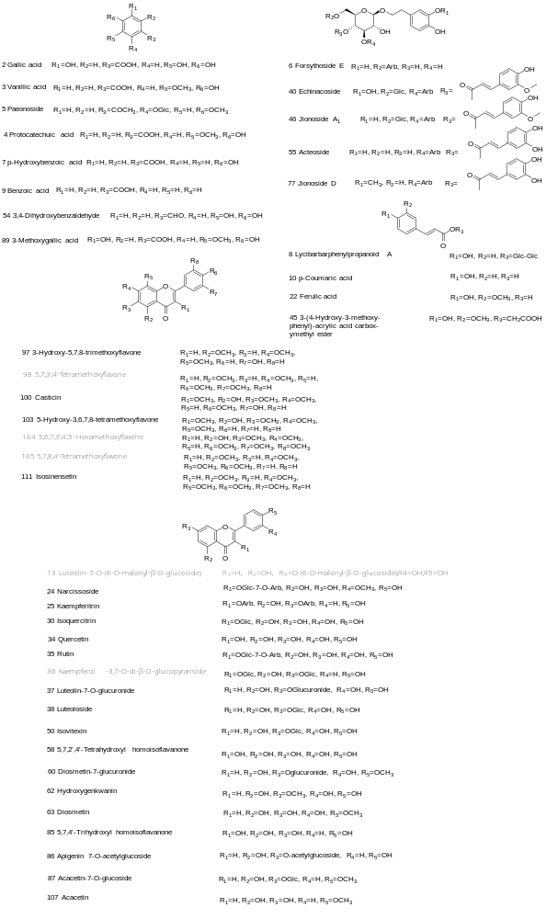
Fig. S1 The chemical structures of identified constituents in YGMM
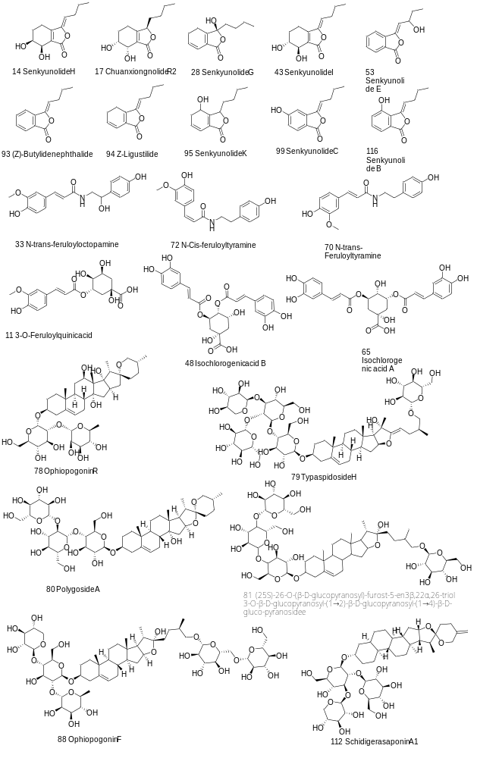 Fig. S1 The chemical structures of identified constituents in YGMM(Continued)

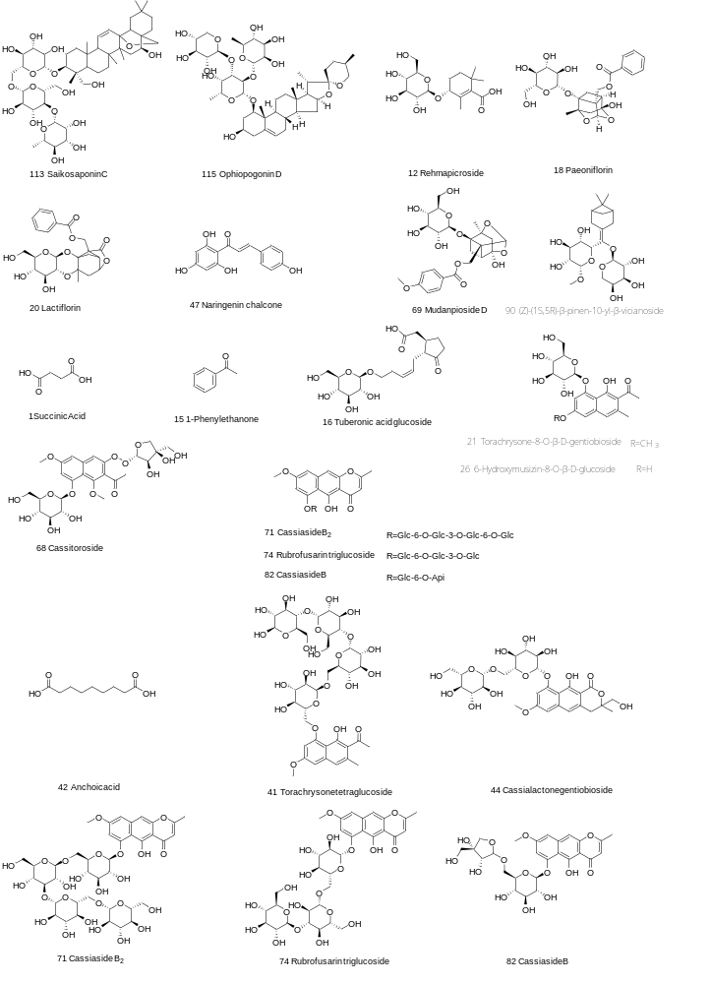 Fig. S1 The chemical structures of identified constituents in YGMM(Continued)

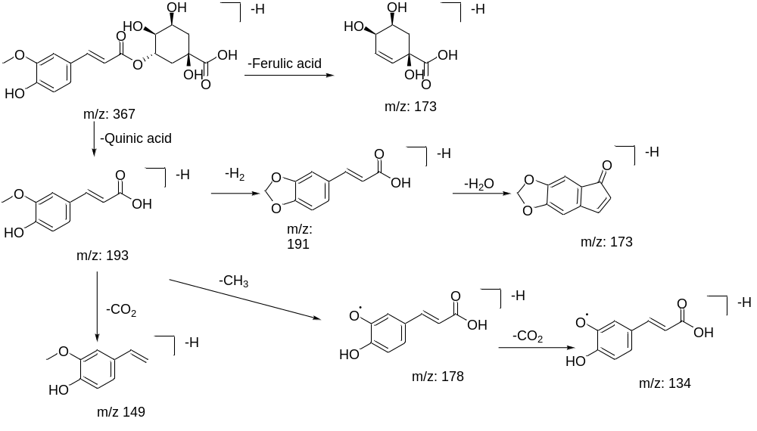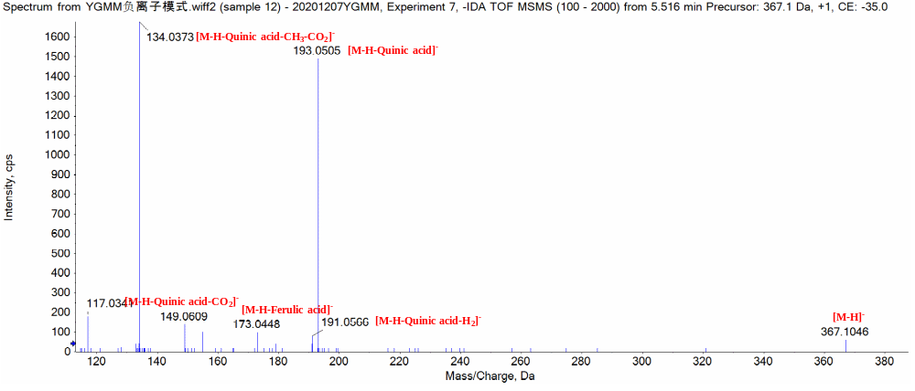Fig. S2 The possible fragament pathway of 3-O-feruloylquinic acid
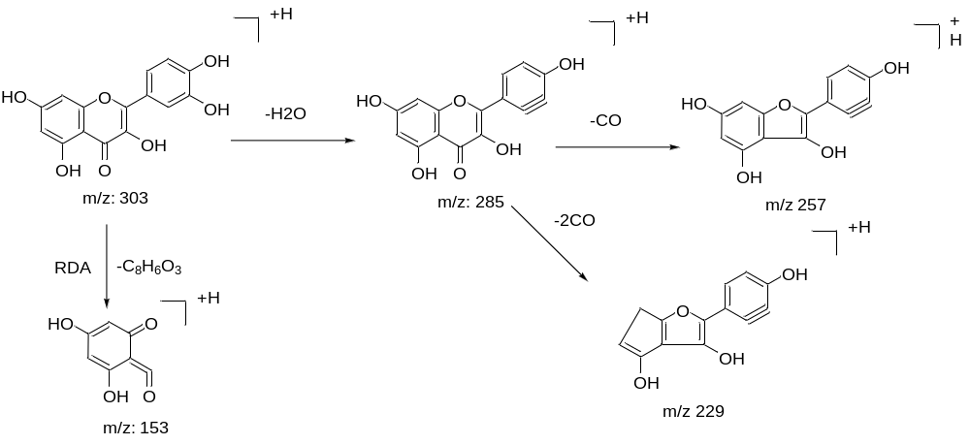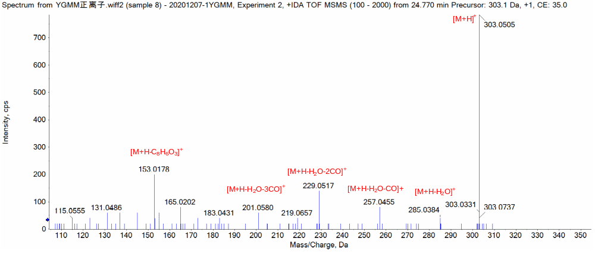Fig.S3 The possible fragament pathway of quercetin
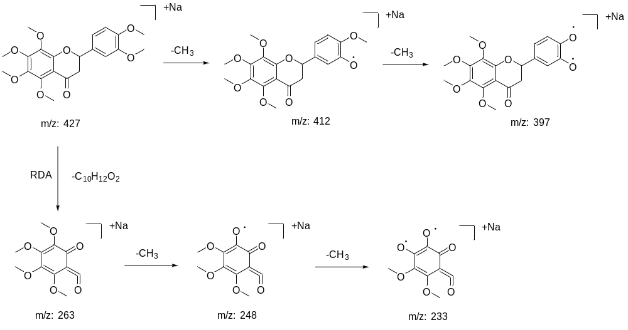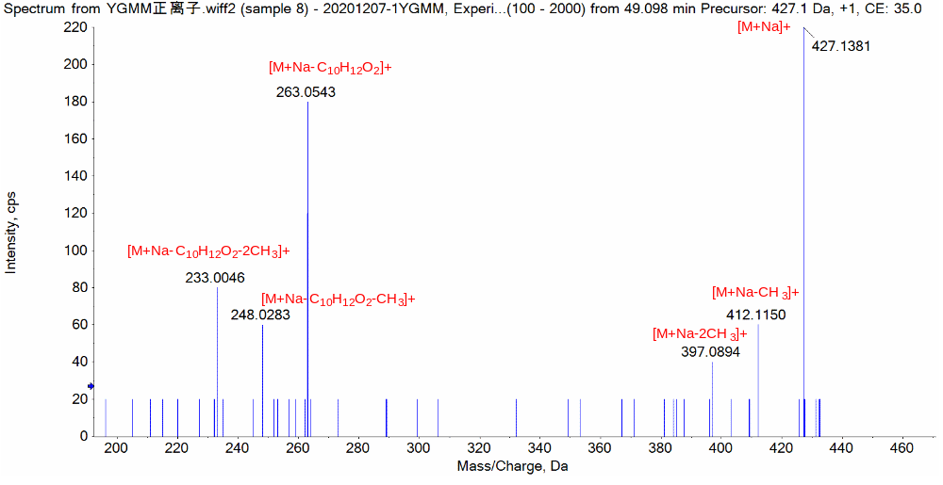
Fig.S4 The possible fragament pathway of 5,6,7,8,3',4'-Hexamethoxyflavanone
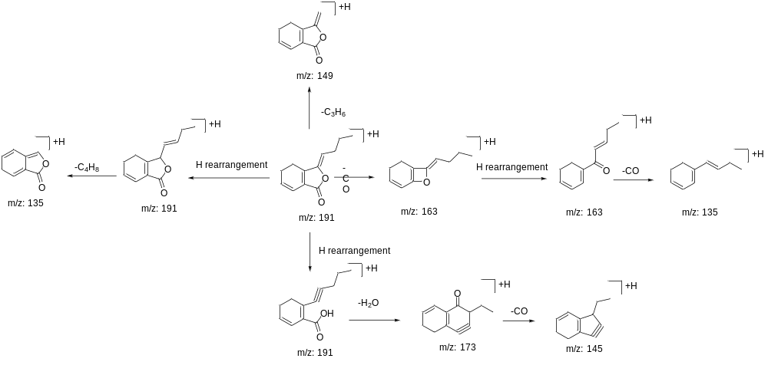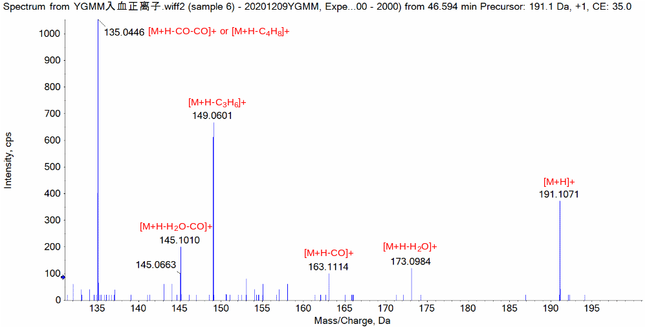
Fig.S5 The possible fragament pathway of Z-Ligustilide
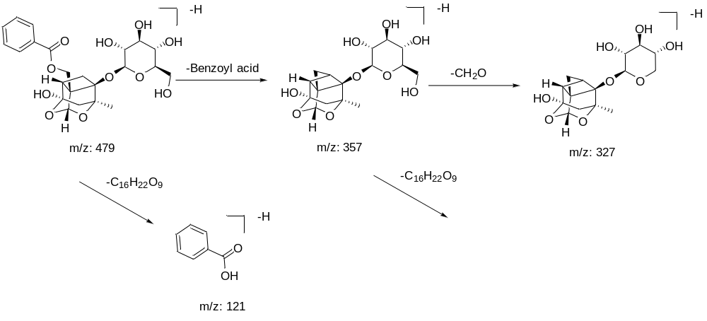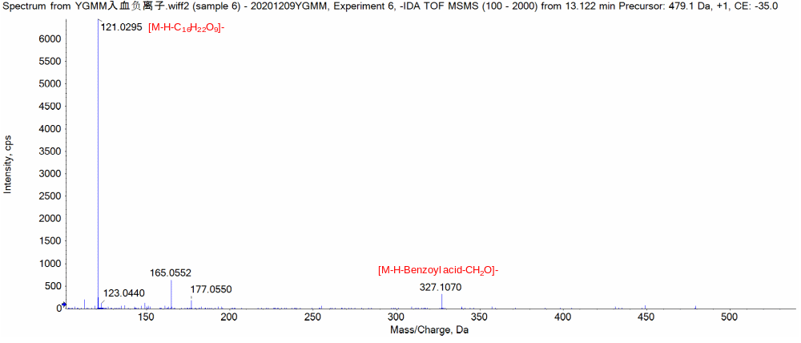
Fig.S6 The possible fragament pathway of paeoniflorin
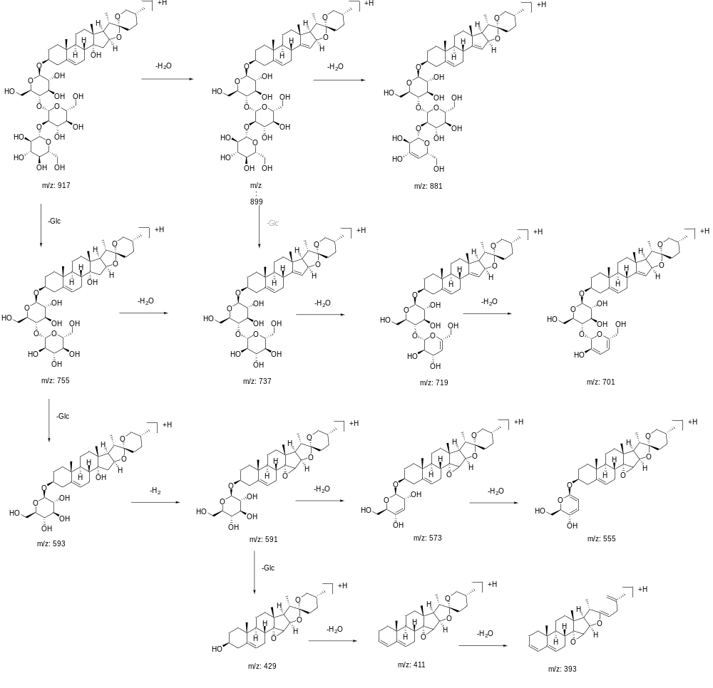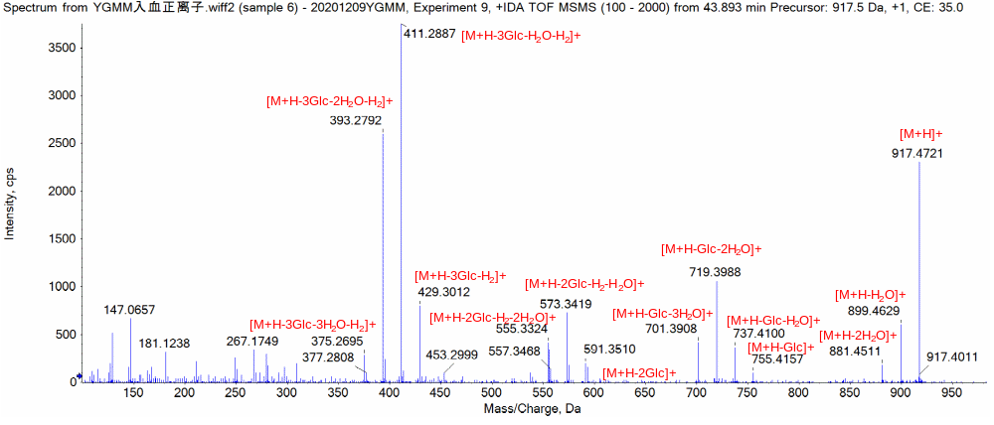 Fig.S7 The possible fragament pathway of polygoside A
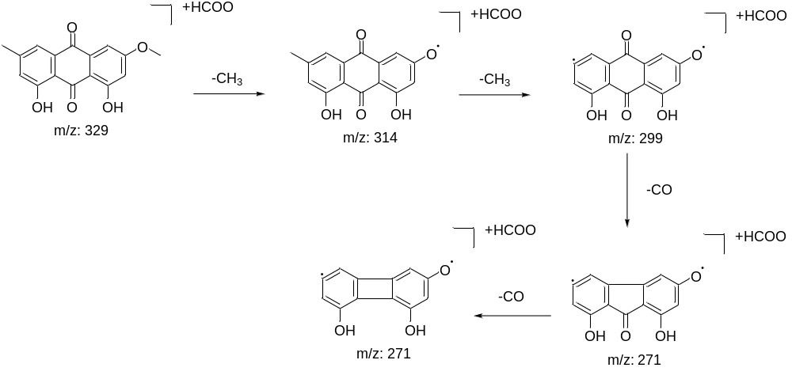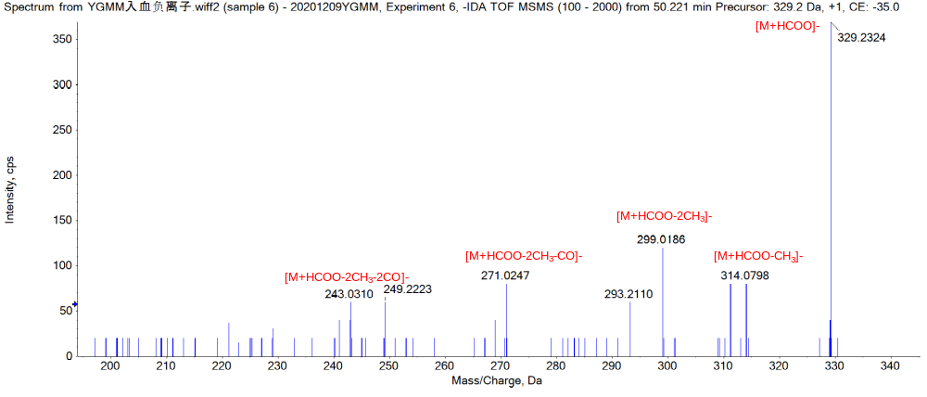
Fig.S8 The possible fragament pathway of emodin-3-methyl ether

