Supplementary Information: Mediterranean Diet and Associations with the Gut Microbiota and Pediatric-Onset Multiple Sclerosis: a Trivariate Analysis

Supplementary Methods.

Supplementary Fig. 1. Flow-chart showing the selection of the pediatric-onset MS cases and controls for the Diet cohort and Diet-Microbiota subcohort
Supplementary Fig. 2. The Diet-cohort: The Mediterranean diet score distribution for pediatric-onset MS cases and controls
Supplementary Fig. 3. The Diet-cohort: Correlations between the alternative Mediterranean diet score, their dietary components and specific nutrients
Supplementary Fig. 4. The Diet-microbiota subcohort: The trivariate relationships between diet, the overall microbiota (at the ASV-level) and disease status (MS vs controls)

Supplementary Table 1. The dietary components and scoring criteria for the alternative Mediterranean diet score.
Supplementary Table 2. Description and categorization of cohort characteristics used for the Diet-cohort and the Diet-microbiota subcohort analyses.
Supplementary Table 3. The association of each component of the Mediterranean diet (g/day and specific score) with odds of MS
Supplementary Table 4. Association of Mediterranean diet score and nutrient intakes with odds of MS in the Diet cohort and Diet-microbiota subcohort with additional adjustments for race and overweight status

This supplementary material has been provided by the authors to give readers additional information about their work.

eMethods.

Bioinformatics: assigning taxonomy

Amplicon sequence variants (ASVs) were assigned taxonomy using QIIME2’s Naive Bayes classifier trained on SILVA taxonomy database (v. 132).¹ SILVA appends a distinct integer to the genera nomenclature to distinguish clusters that have a 94.5% sequence similarity.² We then removed these integer identifiers before aggregating ASVs at the genus-level, but kept them when assigning taxonomy to the ASVs. This was performed to prevent sub-genus groupings when calculating the relative abundance of each genera.

Diet-microbiota subcohort: multivariate methods

To minimize the undue influence of potential outlying taxa in all multivariate analyses, the filtered clr-transformed taxa were winsorized to the 0.05 and 0.95 quantiles. The multivariate multiple regression analyses performed were: PERMANOVA via the R function adonis with 10,000 permutations, non-metric multidimensional scaling (NMDS) via metaMDS, and partial constrained redundancy analysis via the rda function, all performed using the R package vegan (v. 2.5-7).³ NMDS is a type of ordination similar to principal component analysis (PCA) but non-parametric and NMDS attempts to condense all variation in the data into a prespecified number of axes , in our case, two axes. PERMANOVA models were adjusted for race (White vs non-White), sequence depth, overweight/obese status, Bristol stool scale group, age at stool sample procurement and sex and additionally adjusted for total energy intake when a dietary measure was modeled. Redundancy analysis (RDA) performs a multivariate multiple linear regression followed by principal component analysis (PCA) of the matrix of fitted values. Like PCA, RDA computes canonical axes that are linear combinations of the outcome data (e.g. ASV-sample table) but must also be linear combinations of the independent variables (e.g. aMED score) that best explain the variation of the outcome data.⁴ Specifically, using RDA, the variation exclusively explained by the aMED scores from the overall microbiota composition were extracted and summarized into a single principle component (PC-aMED) after removing variation explained by sequence depth, race (White, non-White), overweight/obese status, Bristol stool scale group, age at stool sample procurement, sex and total energy intake. The PC-aMED was scaled as weighted sums of species. All multivariate analyses including the ordination were based on the Aitcheson distance (the Euclidean distance between samples after clr-transformation).⁵ The aMED and other nutrients (whole-grains, fiber and iron) were included in the ordination, redundancy analysis and the mediation analysis (see the section below) if they were found significantly associated with odds of MS in the Diet-microbiota subcohort.

Complementary mediation analyses

Individual gut microbiota taxa abundances and principle components were tested individually as candidate mediators if they were found significantly associated (P<0.05) with both a dietary measure and with odds of MS in the Diet-microbiota subcohort.⁶ Only those dietary patterns and nutrients that were found significantly associated with MS odds were included in the analyses. Candidate taxa were standardized to Z-scores when modeled as an independent variable. The direct association (known as ‘natural direct effect’) and the indirect (mediated) association (known as the ‘natural indirect effect’) of the dietary measures with the MS odds were measured in terms of odds ratio and their 95% confidence intervals using the Quasi-Bayesian approximation (the default method) with 10,000 Monte Carlo draws. Mediation is hypothesized when the indirect association is significant (P<0.05). Complementary mediation is hypothesized when both the indirect and the direct associations are significant and point at the same direction. Competitive mediation is hypothesized when the direct and indirect association are both significant but point in the opposite direction, so that their associations offset each other.⁶
Supplementary Fig. 1: Flow-chart showing the selection of the pediatric-onset MS cases and controls for the Diet-cohort and Diet-Microbiota subcohort
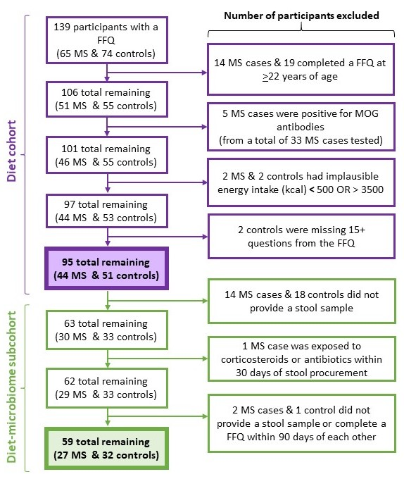

Abbreviations: MOG = Myelin oligodendrocyte glycoprotein; FFQ = food frequency questionnaire
MOG antibody-related details (including the assays used) are described elsewhere.⁷

Supplementary Fig. 2. The Diet-cohort: The Mediterranean diet score distributions for the pediatric-onset MS cases and controls

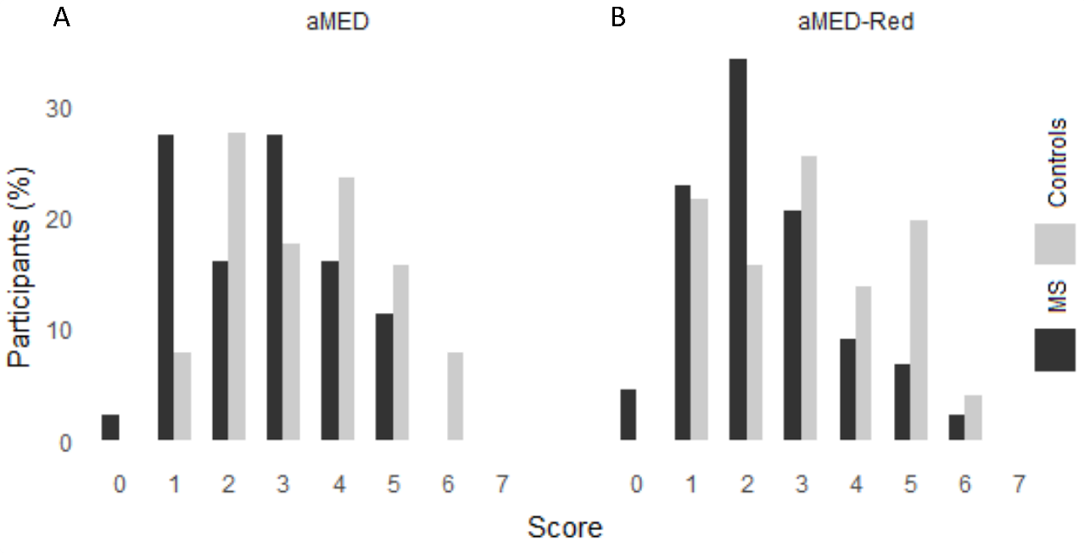
Abbreviations: aMED = alternative Mediterranean diet score; aMED-Red = alternate Mediterranean diet score with unprocessed red meat.
Bars represent the percent of MS cases or controls scoring 0 through 7 (indicating the lowest to highest resemblance to the Mediterranean diet) for (A) aMED and (B) aMED-Red. Percentage were calculated with the denominator reflecting the total number of individuals in the respective groups (44 MS cases or 51 controls).

Supplementary Fig. 3. The Diet-cohort: Correlations between the alternative Mediterranean diet score, their dietary components and specific nutrients

A |  | B

Abbreviations: aMED = alternative Mediterranean diet score; aMED.Red = alternate Mediterranean diet score with unprocessed red meat; MUFA.SFA = ratio of monosaturated fatty acids to saturated fatty acids; R.P meat = red and processed meat; UP.red.meat = unprocessed red meat
Pairwise spearman correlations are shown. (A) The dietary components are in units of daily intake (grams). Nutrient intakes of fiber (g/day), whole-grains (g/day) and iron (mg/day) were also included. (B) The dietary components were dichotomized into 0 and 1 (see Supplementary Table 1 for scoring criteria). Importantly, the findings indicate that the aMED/aMED-Red scores were not strongly correlated by any one component.

Supplementary Fig. 4. The Diet-microbiota subcohort: The trivariate relationships between diet, the overall microbiota (at the ASV-level) and disease status (MS vs controls)
Abbreviations: aMED = alternate Mediterranean diet score; aMED-Red = alternate Mediterranean diet score with unprocessed red meat; P&R meat = processed and red meat; UP meat = Unprocessed red meat; MUFA:SFA = ratio of monounsaturated to saturated fat; NMDS = non-metric multidimensional scaling; OR_{adj} = adjusted odds ratio; PC-aMED = principal component of the gut microbiota composition constrained by the aMED; PC-Fiber = principal component of the gut microbiota composition constrained by fiber intake
All methods are based on microbiota abundances at the amplicon sequence variant (ASV)-level. (A–D) Ordination plot visualizing beta-diversity using non-metric multidimensional scaling. Each circle represents a microbiota composition dissimilarity measure and are colored based on either the aMED score, fiber intake, or disease status (MS vs control). (D) Variation explained (R²) from the overall gut microbiota using permutational multivariate analysis of variance (PERMANOVA). (E and F) The scatter plot on the left side displays the correlation of the aMED score and fiber intake with PC-aMED and PC-Fiber scores, respectively. The right side is a box plot summarizing the PC scores by MS (blue) and controls (red). The association of the respective PC scores with disease status is displayed. Similar to the PERMANOVA results, PC-aMED and PC-fiber explained 3.1% and 3.6% of the gut microbiota variation, respectively, when
Supplementary Table 2. Description and categorization of cohort characteristics used for the Diet cohort and the Diet-microbiota subcohort analyses

Variable name | Variable description | Additional information (related to the analyses or further categorization of the variable, if applicable)
Sex | Male; Female (binomial).  Biological sex. | -
Age | Age at time of food frequency questionnaire (FFQ) completion and age at stool sample collection in years. | The median and interquartile range of the two ages were the same. Thus, the age at time of FFQ completion was used in all analysis except for the multivariate analyses of the microbiota, where age at time of stool procured was used instead.
Disease status | Multiple Sclerosis; Healthy Control (binomial) | -
Race | Black; Caucasian; White, Caucasian; Mexican; Hispanic & Black; Indian; Caucasian/black; South Asian; Non-White, Caucasian; Asian/Caucasian; Oriental; Pakistani; Tamil; NA (categorical)  Race was self-identified | Grouped into 3 categories (White, non-White, and unknown):  White = "Caucasian", "White, Caucasian", or "Caucasian."
Overweight/obese status | Participant’s weight (kg) and height (m) nearest to the time of FFQ completion | Grouped into 3 categories (overweight or obese, other, and unknown:  Overweight or obese = Body mass index ≥85th percentiles.  Other = Body mass index <85th percentiles  Age- and sex-specific body mass index (BMI) percentiles were calculated from the weight and height based on the US Centers for Disease Control and Prevention growth reference curves.
Bristol Stool Scale Group | 7-point ordinal scale. | Grouped into 3 categories (hard; medium; loose):  Hard = Types 1-2  Medium = Types 3-5  Loose = Types 6-7
Abbreviations: NA = Not available
Supplementary Table 3. The Diet-cohort: The association of each component of the alternative Mediterranean diet (g/day and specific scoreª ) with odds of MS
(A) | aMED & aMED-Red components intake (g/day) | Median (Q1, Q3)
(A) | aMED & aMED-Red components intake (g/day) | MS cases, n=44 | Controls, n=51 | OR_{crude} (95% CI) | P |  | OR_{adj} (95% CI) | P
 | Fruits | 83 (31-190) | 130 (66-230) | 0.80 (0.52-1.2) | 0.30 |  | 0.73 (0.46-1.1) | 0.17
 | Vegetables | 52 (27-120) | 63 (42-120) | 0.98 (0.65-1.5) | 0.91 |  | 0.87 (0.56-1.3) | 0.54
 | Legumes | 0.0 (0.0-8.8) | 0.0 (0.0-15) | 0.49 (0.21-0.91) | 0.058 |  | 0.45 (0.18-0.85) | 0.041
 | Whole-grain foods | 7.3 (0.0-22) | 17 (1.8-49) | 0.77 (0.45-1.2) | 0.28 |  | 0.76 (0.45-1.2) | 0.26
 | Fish | 0.0 (0.0-14) | 0.0 (0.0-11) | 1.2 (0.79-1.8) | 0.41 |  | 1.2 (0.77-1.8) | 0.47
 | Red and processed meat | 52 (23-87) | 43 (17-68) | 1.1 (0.73-1.7) | 0.65 |  | 1.2 (0.75-2.1) | 0.41
 | Unprocessed red meat | 0.0 (0.0-11) | 9.5 (0.0-25) | 0.77 (0.48-1.2) | 0.24 |  | 0.77 (0.47-1.2) | 0.26
 | MUFA:SFA | 0.99 (0.9-1.1) | 1.0 (0.92-1.1) | 0.84 (0.55-1.3) | 0.42 |  | 0.85 (0.54-1.3) | 0.41
(B) | aMED & aMED-Red components score (0 or 1ª) | Participants scoring 1 (%)
(B) | aMED & aMED-Red components score (0 or 1ª) | MS=Black; Control=Gray |  | OR_{crude} (95% CI) | P |  | OR_{adj} (95% CI) | P
 | Fruits | 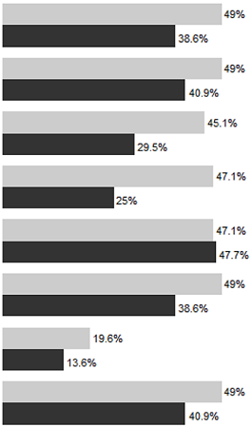 |  | 0.64 (0.27-1.5) | 0.30 |  | 0.60 (0.24-1.4) | 0.25
 | Vegetables |  |  | 0.72 (0.31-1.6) | 0.43 |  | 0.57 (0.23-1.3) | 0.21
 | Legumes |  |  | 0.51 (0.21-1.2) | 0.12 |  | 0.47 (0.19-1.1) | 0.090
 | Whole-grain foods |  |  | 0.37 (0.15-0.88) | 0.028 |  | 0.40 (0.16-0.97) | 0.047
 | Fish |  |  | 1.0 (0.46-2.3) | 0.95 |  | 0.97 (0.42-2.2) | 0.94
 | Red and processed meat |  |  | 0.63 (0.27-1.5) | 0.29 |  | 0.66 (0.28-1.6) | 0.35
 | Unprocessed red meat |  |  | 0.64 (0.19-21.9) | 0.43 |  | 0.57 (0.17-1.8) | 0.34
 | MUFA:SFA |  |  | 0.72 (0.31-1.6) | 0.43 |  | 0.78 (0.33-1.8) | 0.56

Abbreviations: aMED = alternate Mediterranean diet score; aMED-Red = alternate Mediterranean diet score with unprocessed red meat; MUFA:SFA = ratio of monosaturated fatty acids to saturated fatty acids; Q1 = 1st quartile; Q3 = 3rd quartile
ª A score of 1 indicates a healthy amount while 0 indicates an unhealthy amount (see Supplementary Table 1 for the scoring criteria).
Results are represented as odds ratio adjusted for total energy intake, age at FFQ completion and sex, their 95% confidence intervals and P values. Findings where P < 0.05 are in bold. (A) The table displays the summary statistics by disease status (MS and controls) and the association of a 1-standard deviation increase in the intakes of each dietary components of the aMED and aMED-Red and odds of MS. Intakes of each dietary components were standardized into Z-scores. All Q-values were >0.32 (B) Bars represent the percent of MS cases or controls scoring 1 for each of the seven dietary components of the aMED and aMED-red. Percentages were calculated with the denominator reflecting the total number of individuals in the respective groups (44 MS cases or 51 controls). All Q-values were >0.36. Similar findings were observed within the smaller Diet-microbiota cohort (results not shown).

Supplementary Table 4. Association of Mediterranean diet score and nutrient intakes with odds of MS in the Diet cohort and Diet-microbiota subcohort with additional adjustments for race and overweight status
A The Diet-cohort
 | Logistic regression models: OR_{adj} (95% CI)
Dietary measure | Adjusted for total energy intake, age and sex. | Additionally adjusted for overweight/obese status and race
aMED score | 0.66 (0.47–0.90), P=0.011 | 0.61 (0.43–0.84), P=0.0040
aMED-Red score | 0.67 (0.48–0.91), P=0.013 | 0.62 (0.43–0.85), P=0.0047
Fiber (g/d) | 0.87 (0.78–0.96), P=0.011 | 0.86 (0.76–0.95), P=0.0054
Whole-grains (oz equiv./d) | 0.45 (0.17–1.0), P=0.079 | 0.40 (0.14–0.94), P=0.058
Iron (mg/d) | 0.80 (0.63–0.96), P=0.030 | 0.78 (0.61–0.95), P=0.023

B The Diet-microbiota subcohort
 | Logistic regression models: OR_{adj} (95% CI)
Dietary measure | Standard non-robust model | Additionally adjusted for overweight/obese status and race
aMED score | 0.62 (0.40–0.91), P=0.022 | 0.56 (0.34–0.85), P=0.011
aMED-Red score | 0.65 (0.43–0.94), P=0.030 | 0.59 (0.37–0.87), P=0.012
Fiber (g/d) | 0.86 (0.74–0.97), P=0.028 | 0.84 (0.71–0.96), P=0.020
Whole-grains (oz equiv./d) | 0.58 (0.21–1.3), P=0.23 | 0.58 (0.20–1.4), P=0.27
Iron (mg/d) | 0.86 (0.68–1.1), P=0.17 | 0.86 (0.68–1.1), P=0.20

Abbreviations: aMED = alternate Mediterranean diet score; aMED-Red = alternate Mediterranean diet score with unprocessed red meat. OR_{adj} = adjusted odds ratio
Results are represented as the association of a 1-unit increase in the respective dietary measure and odds of MS. Race was categorized as White, non-White, or unknown and overweight/obese status was categorized as overweight or obese, other, or unknown. (A) The number of individuals with unknown race and overweight/obese status were 39 and 34 for the Diet-cohort, respectively, (B) and 7 and 2 for the Diet-microbiota subcohort, respectively. Significant associations (P<0.05) are in bold.

References
1. Quast C, Pruesse E, Yilmaz P, et al. The SILVA ribosomal RNA gene database project: improved data processing and web-based tools. Nucleic Acids Res. 2013;41(Database issue):D590-596.
2. Henderson G, Yilmaz P, Kumar S, et al. Improved taxonomic assignment of rumen bacterial 16S rRNA sequences using a revised SILVA taxonomic framework. PeerJ. 2019;7:e6496.
3. Borcard D, Gillet F, Legendre P. Numerical ecology with R. Vol 2: Springer; 2011.
4. Legendre P, Legendre L. Numerical ecology. Elsevier; 2012.
5. Aitchison J, Barceló-Vidal C, Martín-Fernández JA, Pawlowsky-Glahn V. Logratio analysis and compositional distance. Mathematical geology. 2000;32(3):271-275.
6. Zhao X, Lynch J, xa, et al. Reconsidering Baron and Kenny: Myths and Truths about Mediation Analysis. Journal of Consumer Research. 2010;37(2):197-206.
7. Waters P, Fadda G, Woodhall M, et al. Serial Anti-Myelin Oligodendrocyte Glycoprotein Antibody Analyses and Outcomes in Children With Demyelinating Syndromes. JAMA Neurol. 2020;77(1):82-93.
8. Black LJ, Baker K, Ponsonby AL, et al. A Higher Mediterranean Diet Score, Including Unprocessed Red Meat, Is Associated with Reduced Risk of Central Nervous System Demyelination in a Case-Control Study of Australian Adults. J Nutr. 2019;149(8):1385-1392.
9. Health Canada. Canada’s Food Guide. 2019. https://food-guide.canada.ca/en/. Accessed January 5th, 2022.

