Supplemental Information
Figure S1. Effects of different doses of SAL on non-small cell lung cancer. Different doses of SAL (1.0 mg/kg·d、3.0 mg/kg·d、6.0 mg/kg·d) on the tumor size of non-small cell lung cancer (A) and the survival rate of tumor-bearing mice (B). PTX (2.0 mg/kg·d) treatment as positive control, PBS as negative control.
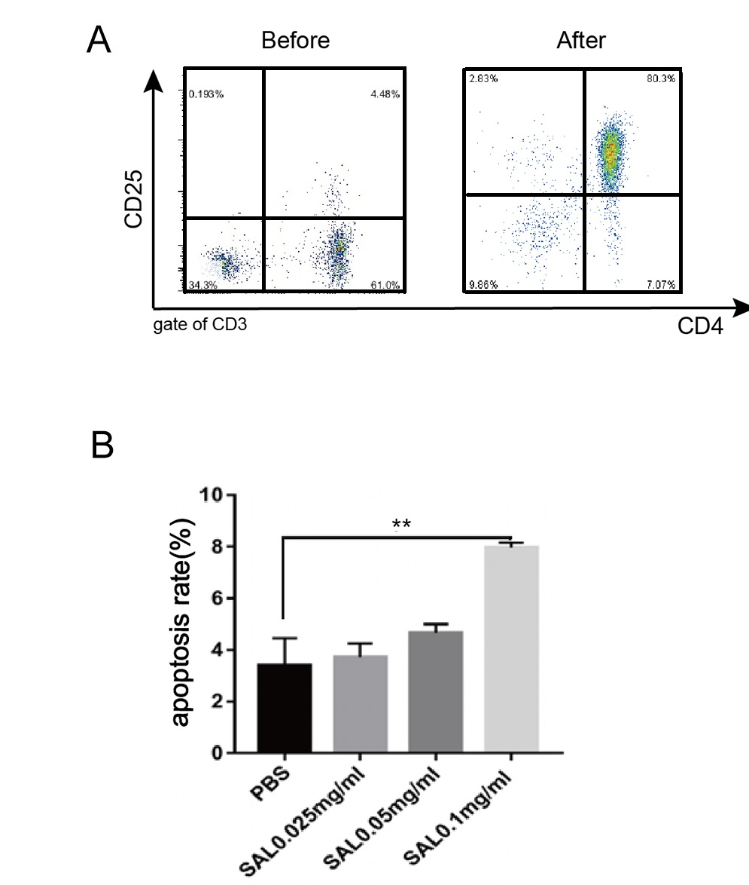
Figure S2. Isolated Treg and the effect of SAL on Treg. (A) Purity of mouse spleen CD4⁺CD25⁺T cells sorted by magnetic beads. (B) The apoptosis rate of Treg stimulated by different concentrations of SAL was detected by flow cytometry.

