Supplementary Information

Fig. S 1: Wind speed differences in WRF 18h forecasts (“w” and “w/o” Aeolus assimilation in IFS initial state) against the corresponding IFS analyses.
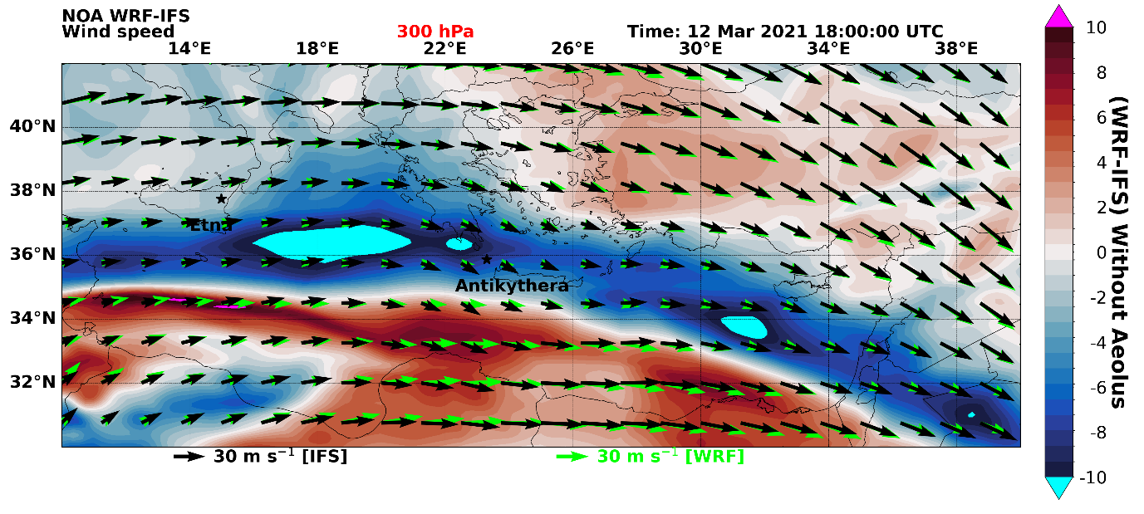
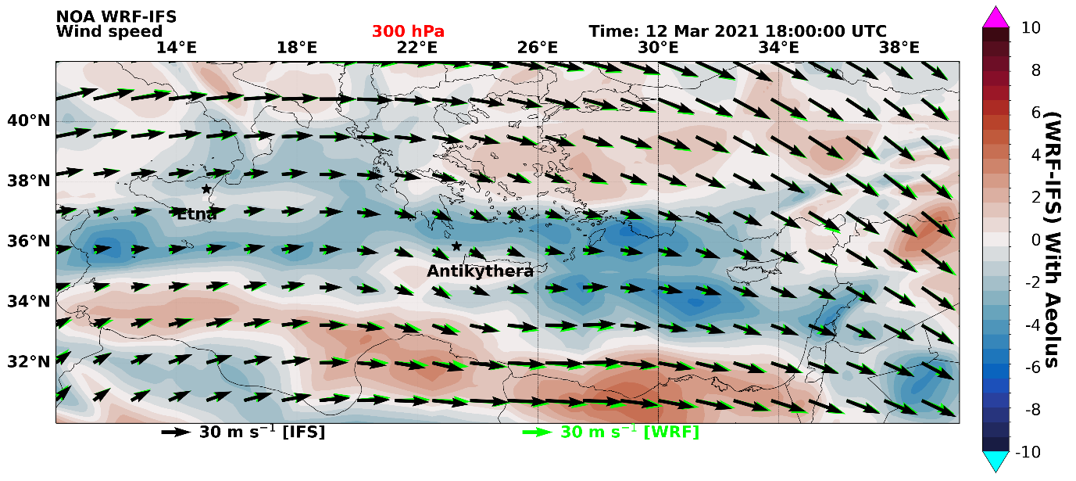
Upper panel: horizontal Windspeed differences at 300 hPa (~9.6 km) WRF-IFS control run. Lower panel: horizontal Windspeed differences at 300 hPa (~9.6 km) WRF-IFS with assimilated Aeolus wind fields.

