Supplementary Information

Insight into interactions of N-ethylpentylone synthetic drug with water and biomacromolecules

Sanja Belić¹, Marija Petrin Miličević¹, Milan Vraneš¹, Aleksandar Tot¹, Nenad Janković²
Nataša Radosavljević Stevanović³, Jovana Nikolov¹, Nikolett Cakó Bagány¹ and Slobodan Gadžurić¹*

¹University of Novi Sad, Faculty of Science, Trg D. Obradovića 3, 21000 Novi Sad, Serbia
²University of Kragujevac, Institute for Information Technologies, Department of Science, Jovana Cvijića bb, 34000 Kragujevac, Serbia
³Ministry of Interior of Republic of Serbia, National Forensic Center,
Department for Physical-Chemical and Toxicological Expertises, 11000, Belgrade, Serbia

Table S1 Molality (m, given in mol of NEP-HCl per kg of water), density (d), apparent molar volume (V_{ϕ}) and partial molar volume of NEP-HCl in aqueous solution (V₁) and solvent (V₂) in the temperature range from T = (293.15 to 313.15) K at p = 1·10⁵ Pa.
m / | d / | V₁ / | V₂/ | V_{ϕ}/
(mol·kg⁻¹) | (g·cm⁻³) | (cm³·mol⁻¹) | (cm³·mol⁻¹) | (cm³·mol⁻¹)
 |  | T = 293.15 K
0.00000¹ | 0.99821
0.05898 | 1.00175 | 239.623 | 18.032 | 225.25
0.06919 | 1.00223 | 242.626 | 18.028 | 227.06
0.07929 | 1.00265 | 245.733 | 18.023 | 229.07
0.08889 | 1.00301 | 248.626 | 18.019 | 230.98
0.09733 | 1.00323 | 251.813 | 18.015 | 233.35
 |  | T = 298.15 K
0.00000¹
0.05898 | 1.00044 | 240.298 | 18.055 | 228.02
0.06919 | 1.00089 | 243.197 | 18.052 | 229.90
0.07929 | 1.00132 | 245.685 | 18.048 | 231.45
0.08889 | 1.00169 | 248.092 | 18.044 | 233.02
0.09733 | 1.00193 | 250.798 | 18.041 | 235.03
 |  | T = 303.15 K
0.00000¹ | 0.99565
0.05898 | 0.99884 | 241.695 | 18.083 | 231.72
0.06919 | 0.99931 | 243.609 | 18.080 | 232.80
0.07929 | 0.99973 | 245.721 | 18.077 | 234.15
0.08889 | 1.00007 | 248.062 | 18.074 | 235.81
0.09733 | 1.00035 | 250.005 | 18.071 | 237.19
 |  | T = 308.15 K
0.00000¹ | 0.99404
0.05898 | 0.99701 | 243.456 | 18.115 | 235.82
0.06919 | 0.99745 | 245.068 | 18.113 | 236.79
0.07929 | 0.99787 | 246.541 | 18.110 | 237.68
0.08889 | 0.99824 | 248.036 | 18.108 | 238.66
0.09733 | 0.99848 | 250.057 | 18.106 | 240.24
 |  | T = 313.15 K
0.00000¹ | 0.99222
0.05898 | 0.99490 | 245.937 | 18.151 | 241.20
0.06919 | 0.99533 | 246.723 | 18.150 | 241.60
0.07929 | 0.99575 | 247.416 | 18.148 | 241.93
0.08889 | 0.99610 | 248.534 | 18.147 | 242.72
0.09733 | 0.99634 | 250.080 | 18.146 | 244.00
Standard uncertainties are: u(d) = 7.6·10⁻⁴ g cm⁻³; u(m)_{NEP-HCl} = 8.410^{–4} mol ·kg⁻¹; u(T) = 0.015 K; u(V_{ϕ}) = 9.8·10⁻³ cm³·mol⁻¹; u (V₂) = 9.8·10⁻³ cm³·mol⁻¹. Relative standard uncertainty: u_{r}(p) = 0.015.
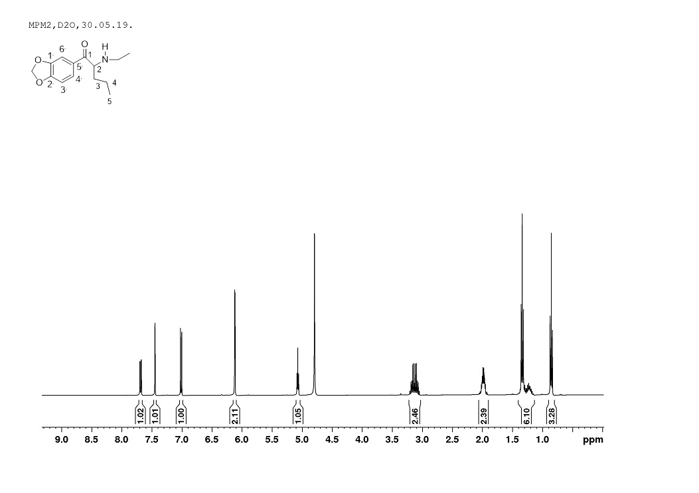
Figure S1 ¹H NMR Spectra of NEP
¹H NMR (D₂O): 0.85, t, 3 H, J_{CH2,CH3} = 7.3 Hz, CH₃-5, 1.13-1.38, m, 2 H, CH₂-4, 1.33, t, 3H, J_{CH2,CH3} = 7.3 Hz, NHCH₂CH₃, 1.98, m, 2 H, CH₂-3, 3.13, m, 2 H, NHCH₂CH₃, 5.07, t, 1 H, J_{2,3} = 5.7 Hz, H-2, 6.12, d, 2 H, OCH₂O, 7.01, d, 1 H, J_{3′,4′} = 8.3 Hz, H-3′,7.45, d, 1 H, J_{4′,6′} = 1.8 Hz, H-6′, 6.86, dd, 1 H, J_{4′,6′} = 1.8 Hz, J_{3′,4′} = 8.3 Hz, H-4′.

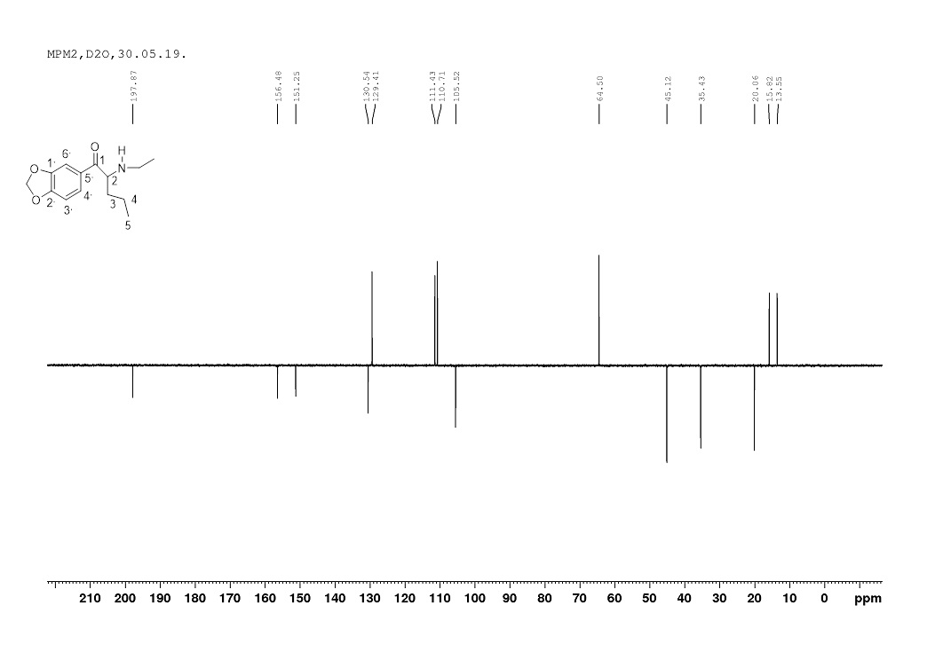
Figure S2 ¹³C NMR Spectra of NEP
¹³C NMR (D₂O): 13.55 (NHCH₂CH₃), 15.82 (CH₃-5), 20.06 (CH₂-4), 35.43 (CH₂-3), 45.12 (NHCH₂CH₃), 64.50 (C-2), 105.52 (OCH₂O), 110.71 (C-6′), 111.43 (C-3′), 129.41 (C-4′), 130.54 (C-5′), 151.25 (C-1′), 156.48 (C-2′), 197.87 (C=O).

Figure S3 Variation of density in aqueous solution versus molality of NEP-HCl at different temperatures: T = (■) 293.15; (●) 298.15; (▲)303.15; (▼) 308.15; () 313.15 K

Figure S4 Variation of apparent molar volume with NEP-HCl concentration in water at different temperatures: T= (■) 293.15; (●) 298.15; (▲) 303.15; (▼) 308.15; () 313.15 K
Figure S5 Variation of partial molar volume of NEP-HCl in water at different temperatures:
T= (■) 293.15; (●) 298.15; (▲) 303.15; (▼) 308.15; () 313.15 K
Figure S6 Variation of partial molar volume of water at different temperatures:
T = (■) 293.15; (●) 298.15; (▲) 303.15; (▼) 308.15; () 313.15 K

References

In Table S1:
- D. M. Bhattacharya, D. V. Kawadkar, C. P. Pandhurnekar, A. V. Wankhade, U. R. Pratap, S. P. Zodape, J. Chem. Eng. Data, 2017, 62, 4083-4092.

* Corresponding author: E-mail: slobodan.gadzuric@dh.uns.ac.rs; Tel: +381 21 485 2744; Fax: +381 21 454 065

