Video-rate switching of high-reflectivity hybrid cavities spanning all primary colors
Kunli Xiong*^{1,2}, Oliver Olsson², Stefano Rossi³, Magnus P. Jonsson³, Andreas Dahlin², and Jeremy J. Baumberg¹

¹ Nanophotonics Centre, Department of Physics, Cavendish Laboratory, University of Cambridge, Cambridge, CB3 0HE, England, UK
² Department of Chemistry and Chemical Engineering, Chalmers University of Technology, Gothenburg 41296, Sweden
³ Department of Science and Technology, Linköping University, Norrköping 60174, Sweden.

Supporting information

Schematic diagram of the Au-SiO₂-Pt (ASP) nanocave fabrication

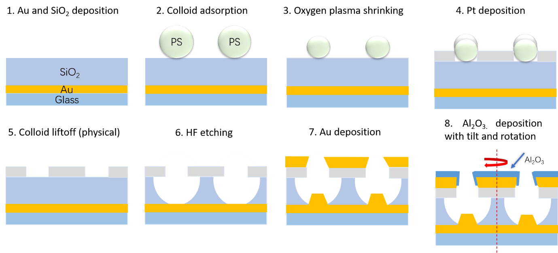
Fig. S1 shows the fabrication process for ASP nanocaves. More details are described in the methods section (Nanofabrication).
Fig. S1. Fabrication of the ASP nanocaves. Au and SiO₂ are deposited by physical vapor deposition, followed by binding of polystyrene colloids (PS) and oxygen plasma shrinking their diameter. After depositing Pt and removing the colloids, nanocaves are generated by immersing in HF (hydrogen fluoride). Nanocylinders are formed by Au deposition, and protective Al₂O₃ is deposited with tilt and rotation.

Numerical simulations of optical properties of ASP nanocaves

Numerical simulations are performed in Ansys Lumerical 2021 FDTD. The model uses periodic boundary conditions in $x, y$, and perfectly matched layers in $z$, with periodicity 525 nm. A plane wave source is used with injection along $z$ and of Bloch/periodic type. The reflectivity is calculated using a reflectance monitor. Literature data is used for permittivities of Pt and Au (see references in main text). The dielectrics are modeled as non-dispersive with refractive index 1.73 for Al₂O₃ and 1.43 for SiO₂, while 1.52 is used for glass.

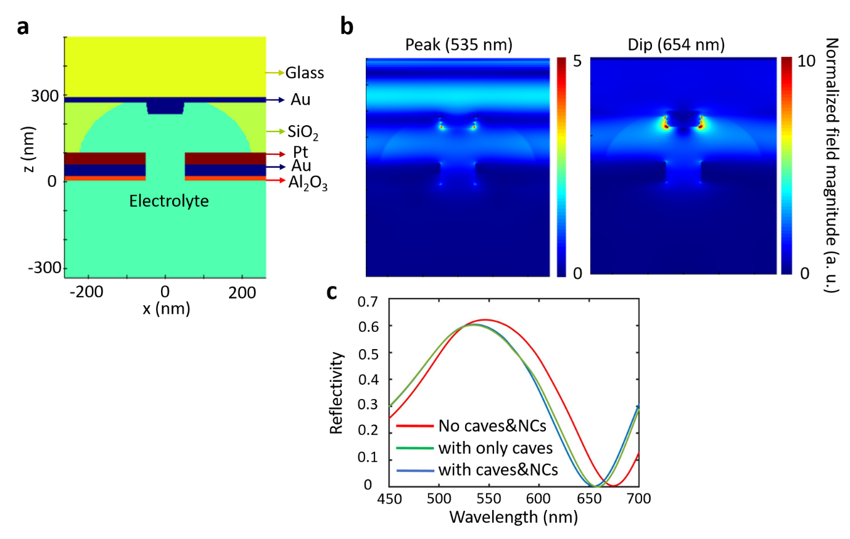
Fig. S2 shows the near field plots and simulated spectra. The near fields show that a plane wave is reflected at the maximum and minimum reflectivity wavelengths. There is no significant field enhancement in the nanocaves. From the simulated spectra, the influence of nanocaves and nanocylinders is negligible.
Fig. S2. a, Design of numerical simulations. b, Near field plots at the maximum and minimum reflectivity wavelengths. c, Comparing simulated spectra with different nanostructures. NC: nanocylinders.

Confirming volume ratio of air to SiO₂ and sample over-etching

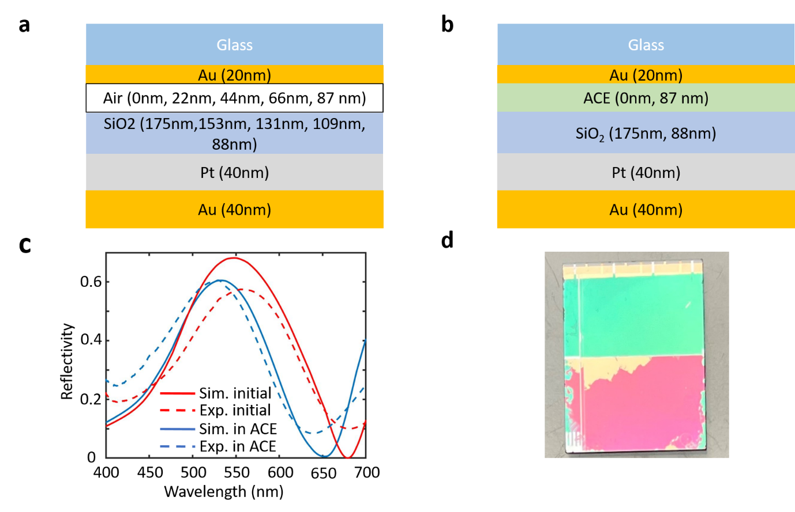
Fig. S3 shows the schematic diagrams of multi-thin film system simulations and compares the simulated and experimental reflectivity before and after HF etching. After HF etching, the reflectivity is measured when the sample is immersed in acetonitrile. This confirms the volume ratio of air to SiO₂ is ~ 1. Fig. S3b shows an over-etched sample. Part of the middle area is broken because the Pt layer collapses.
Fig. S3. a, Schematic diagrams of the multi-thin film system simulation in Fig. 1d. b, Schematic diagrams of the simulation before and after HF etching. c, Red lines are simulated and experimental reflectivity before HF etching. Blue lines are simulated and experimental reflectivity of a sample immersed in acetonitrile after HF etching. d, Photo of an over-etched sample (same sample as Fig. 1c in the main text).

Optical properties of PProDOTMe₂

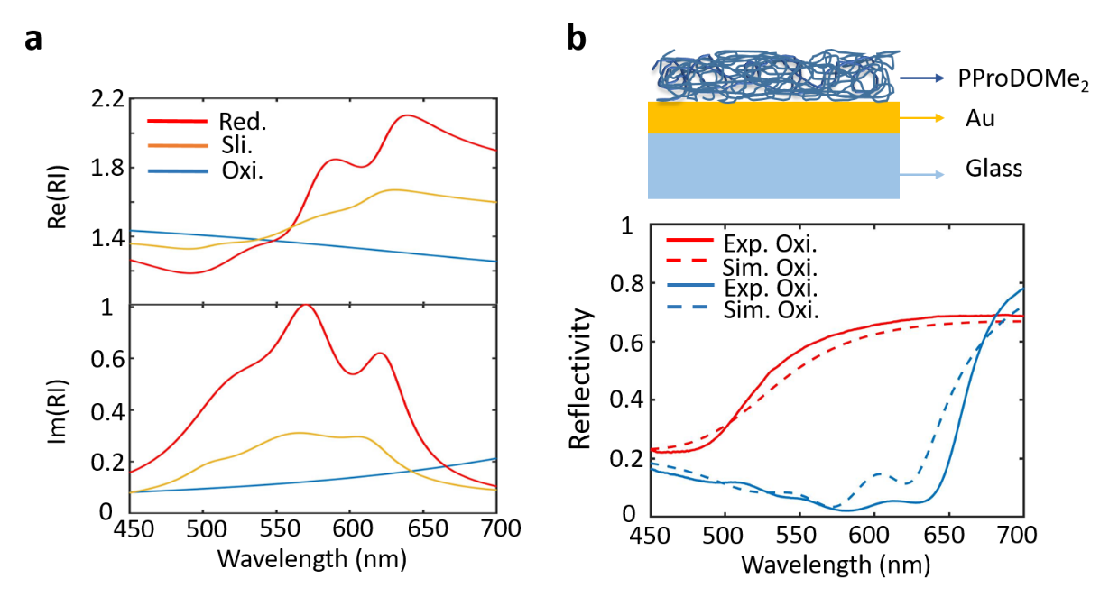
Fig. S4a shows the real and imaginary refractive index (RI) of PProDOTMe₂ in different redox states, which is taken from reference 27. Fig. S4b compares the simulated and experimental results of a thin PProDOTMe₂ layer deposited on a Au mirror, confirming the RI.
Fig. S4. a, Calculated real and imaginary refractive index (RI) of PProDOTMe₂ in different redox states (reduced, slightly oxidized, fully oxidized). b, Top: schematic diagram of the numerical simulation. Bottom: Comparing reflective spectra of simulated and experimental results.

Colors of printed paper

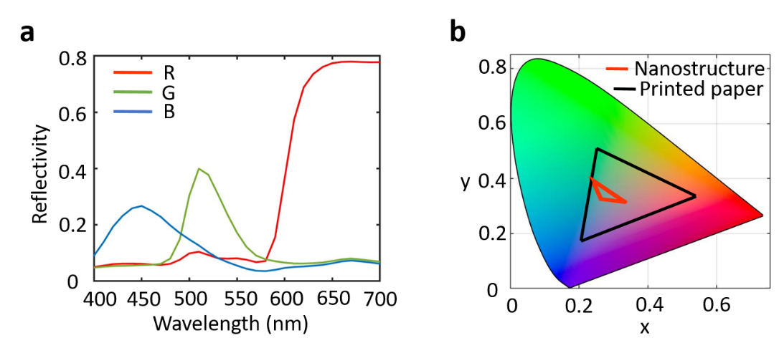
Fig. S5 shows printed paper reflectivity and gamut coverage, used for the Printing comparison in the main text. As described in the main text, printed paper has a high reflectivity in the red and a larger gamut coverage than our hybrid nanomaterial.
Fig. S5. a, Reflectivity of printed paper in red, green, and blue. b, Comparing gamut coverage of the nanostructure and printed paper.

Color control in reduction reactions

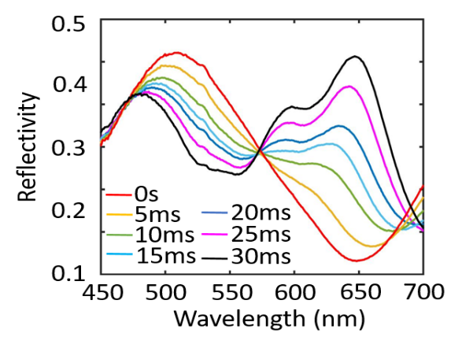
Fig. S6 shows reflectivity variations in reduction reactions with different pulse durations. Here > 90% of the full contrast is achieved with a 30 ms duration pulse, which is ~ 5% less than from oxidation reactions.
Fig. S6. Reflection spectra for different pulse durations at -0.6 V.

First order reaction kinetics

The doping current $I$ can be written as:

$I=I_{0}\exp{(-t/τ)} (1)$

here $I_{0}$ is the maximum doping current of the polymer film, and $τ$ is the characteristic time for the reaction. Equation (1) can be transformed to:

$\ln\left(I\right)=\ln\left(I_{0}\right)-t/τ (2)$

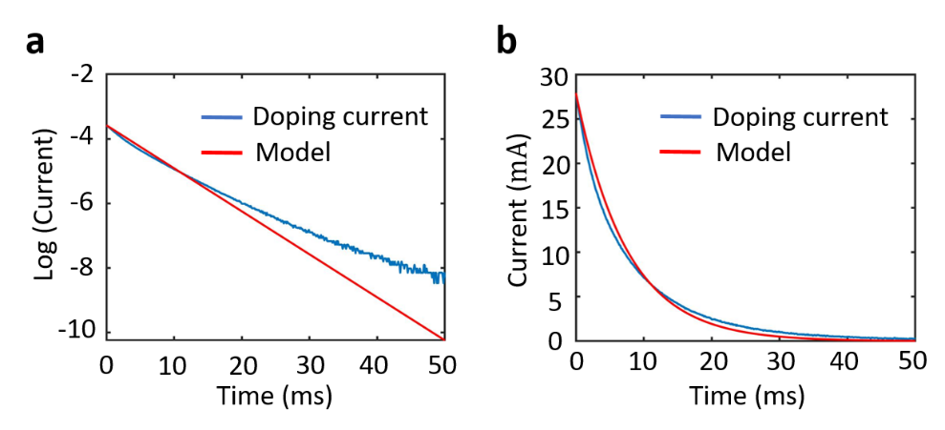
With $I_{0}=27.9 mA$ in Equation (2), this gives characteristic time $τ=7.5 ms$. Fig. S7 compares the model of doping current and experimental data.
Fig. S7. Comparing numerical models and experimental data. a, Logarithm of doping current vs time. b, Doping current vs time.

Optical properties of structures without SiO₂ nanocaves

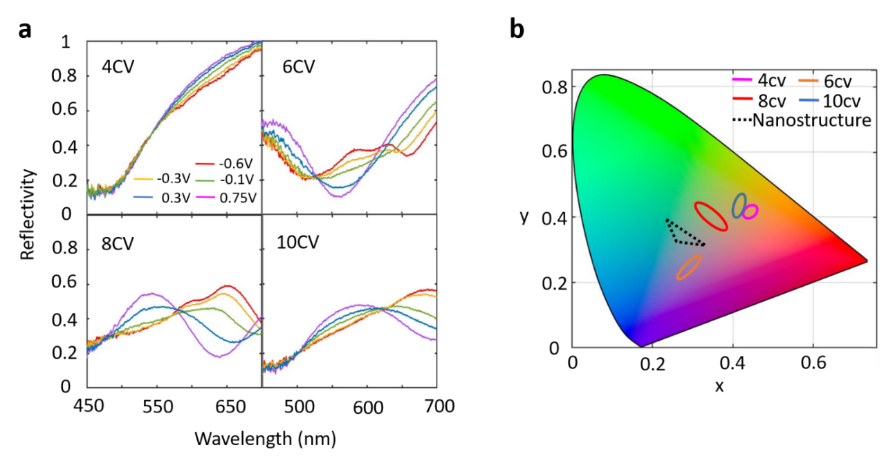
It is challenging to modulate colors covering RGB using PProDOTMe₂ in a simple planar intracavity layer. Fig. S8 shows several samples with different thicknesses of PProDOTMe₂ as intracavity layers, which change the Fabry–Pérot interference and gamut coverage. In addition, it is hard to solve color uniformity problems. In the main text Fig. 4C, the sample with 8 cyclic voltammetry depositions is chosen to compare with ASP nanocave samples since it is closest to the CIE white point.
Fig. S8. a, Reflectance spectra at five voltages for samples without ASP nanocaves. Thicknesses of PProDOTMe₂ intracavity layers increase with CV deposition cycles. b, Gamut coverage of these samples with different numbers of CV deposition cycles.

