Supplementary table 1- Effect of medium compositions on VOCs production by endophytic fungi TML9 with qualitative olfactory observations obtained from independent ratings of 0-5, 5 being the maximum
Medium composition | Independent olfactory score (0-5)
PDA | 2
CDA | 1.5
Oatmeal | 1
Modified PDA with instantly smashed potato + dextrose agar (M-PDA) | 2.5
M-PDA + Tryptone | 3
MPDA + Peptone | 3.5
MPDA + Yeast extract (MPDA-YE) | 4
MPDA + Beef extract | 3.5
MPDA-YE + Cellulose | 4
MPDA-YE + Dextrose | 4.5
MPDA-YE + Malt extract | 5
MPDA-YE + Sucrose | 4.5
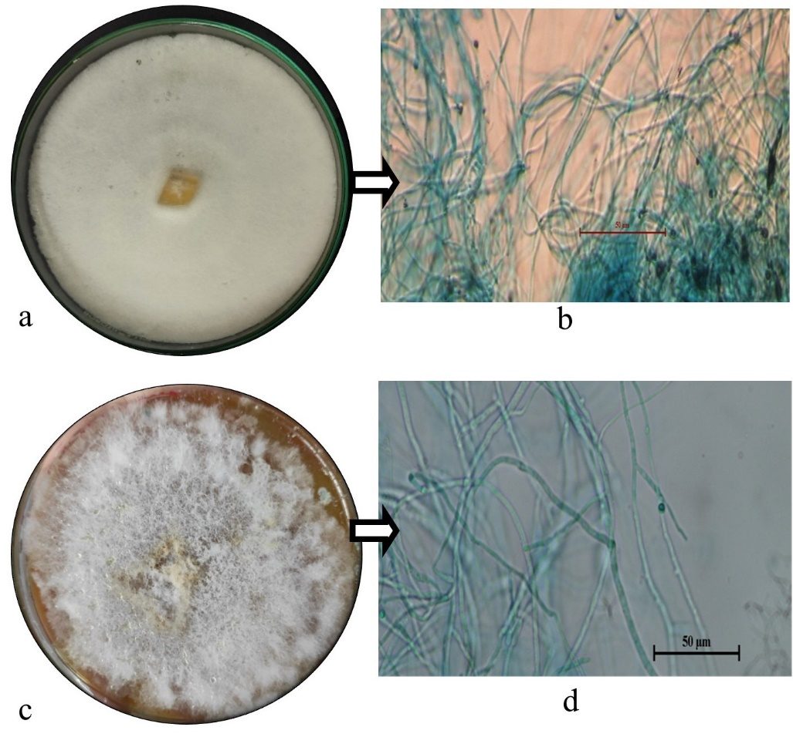

Supplementary Figure 1- Macroscopic plate morphology (Top view) of the sterile endophytic fungal isolate a- TML3 and c- TML9. Light microscopic view of the sterile hyphae of the isolates b-TML3 and d- TML9
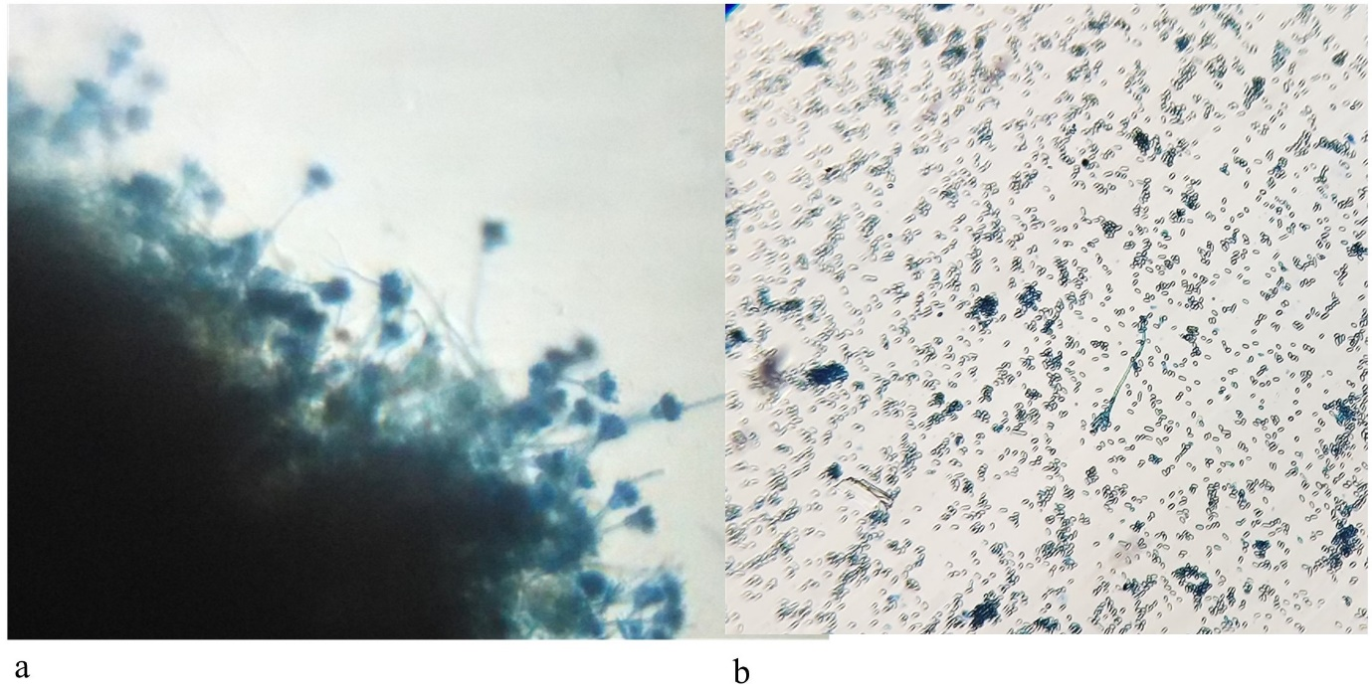

Supplementary Figure 2- a- Penicillus structure of the germinated conidia in the non- VOC treated oranges, b- Less occurrence of conidial germination in TML9- VOC treated orange fruits.
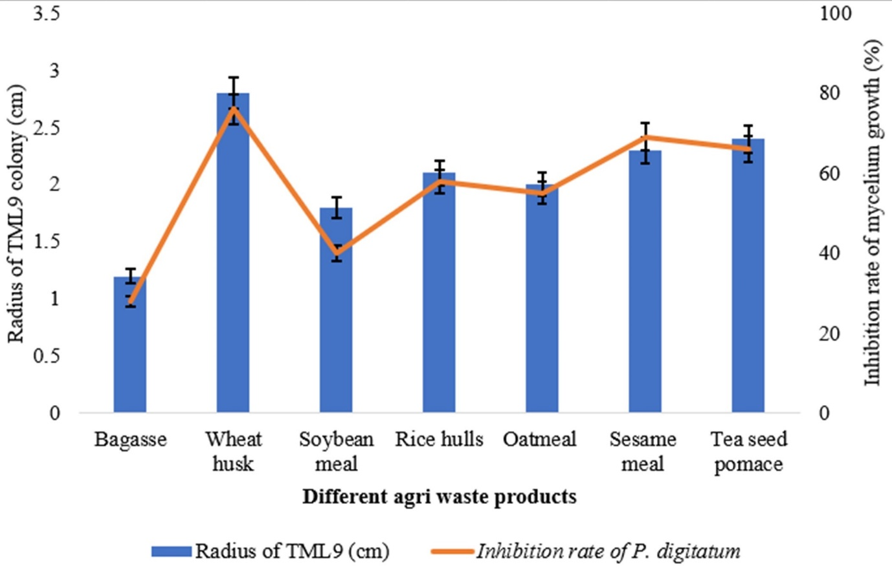

Supplementary Figure 3- Effect of different media composition on the a- growth of endophytic fungi TML9, and b- inhibition of mycelial growth of the fungal pathogen P. digitatum

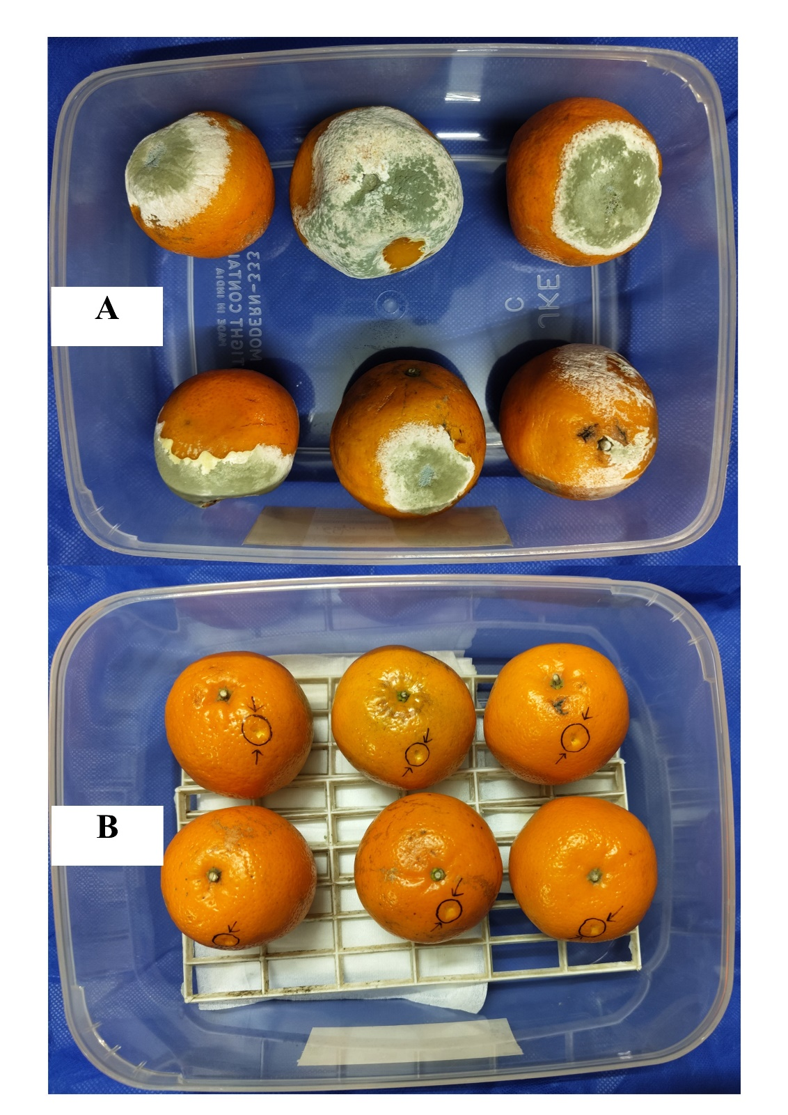

Supplementary Figure 4- Effect of T-WH on the control of green mold (P. digitatum) of orange. A. Inoculated by Penicillium digitatum without any bio-fumigation by T-WH, B. Inoculated P. digitatum and bio-fumigated by T-WH.

