1,3,4-Oxadiazole derivatives as potential antifungal agents: Synthesis, characterization, Ct-DNA binding, molecular docking, and TD-DFT studies

Rabiya Mehandiª, Razia Sultanaª, Saiema Ahmedi^{c}, Aysha Fatima^{d}, Khursheed ul Islam^{f}, Manish Ranaª, Nikhat Manzoor^{c}, Saleem Javed^{b}, Mohammad Mahfuzul Haque^{e} Jawed Iqbal^{f}, Rahisuddinª*, Nahid Nishat^{b}*

ª Molecular and Biophysical Laboratory, Department of Chemistry, Jamia Millia Islamia, New Delhi 110025, India
^{b} Department of Chemistry, Jamia Millia Islamia, New Delhi 110025, India
^{c} Department of Biosciences, Jamia Millia Islamia, New Delhi 110025, India
^{d} S. O. S. in Chemistry, Jiwaji University, Gwalior, M. P. 474011, India
^{e} Department of Biotechnology, Jamia Millia Islamia, New Delhi 110025, India
^{f} Multidisciplinary Center for Advanced Research and Studies, Jamia Millia Islamia, New Delhi 110025, India

∗ Corresponding authors:
*rahisuddin@.jmi.ac.in (Rahisuddin)
*nnishat@jmi.ac.in (N. Nishat)

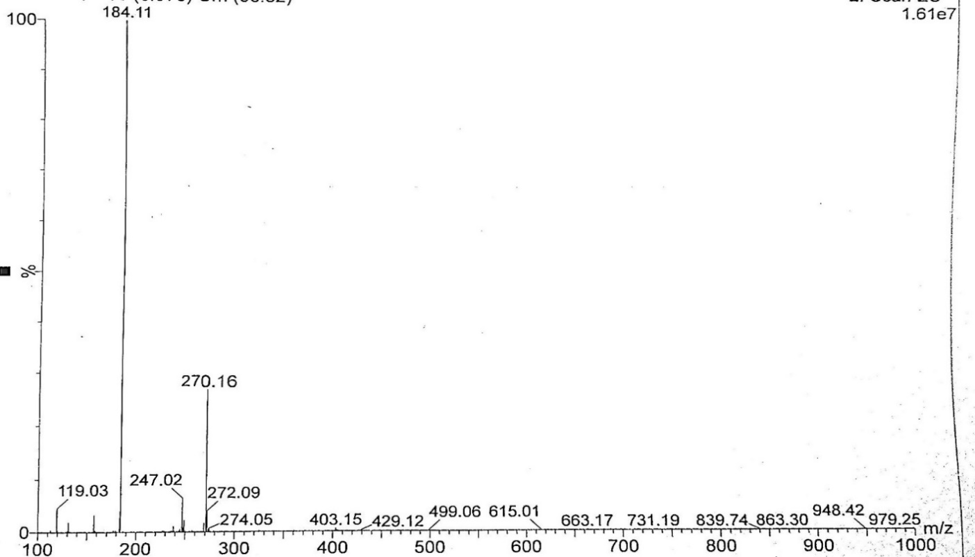
3a
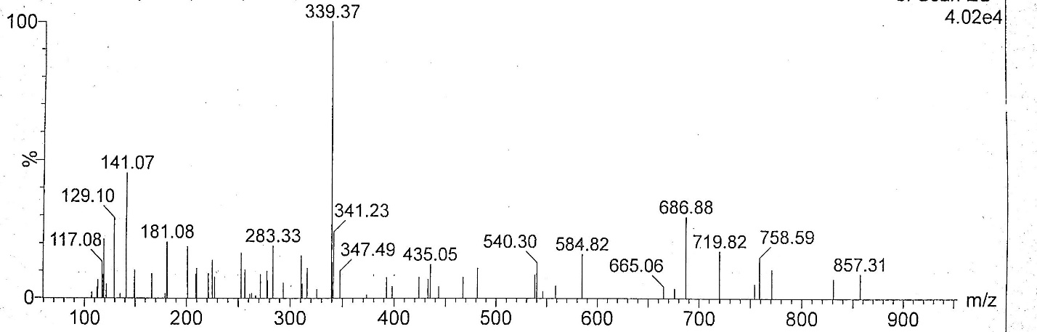
3b
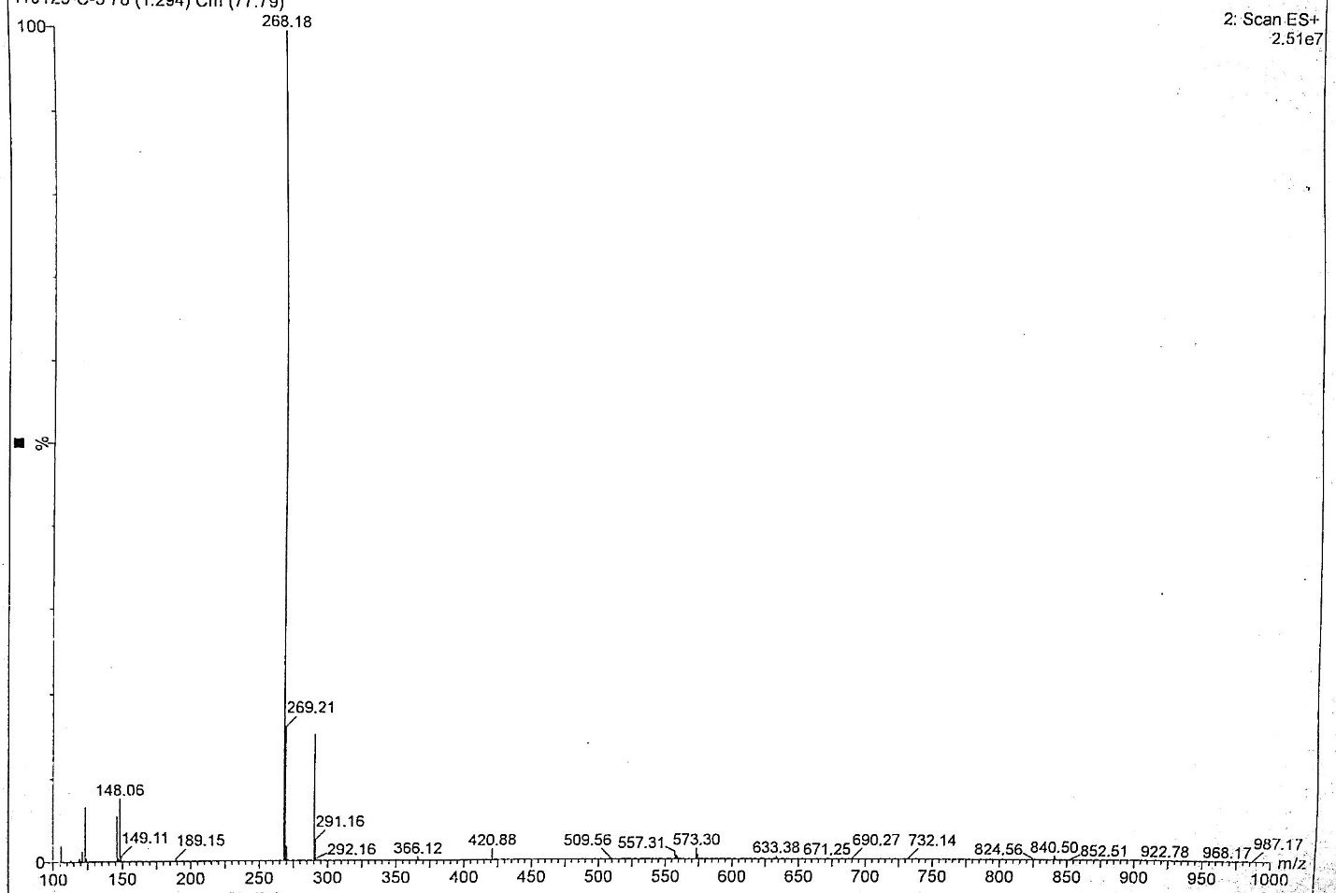
3c
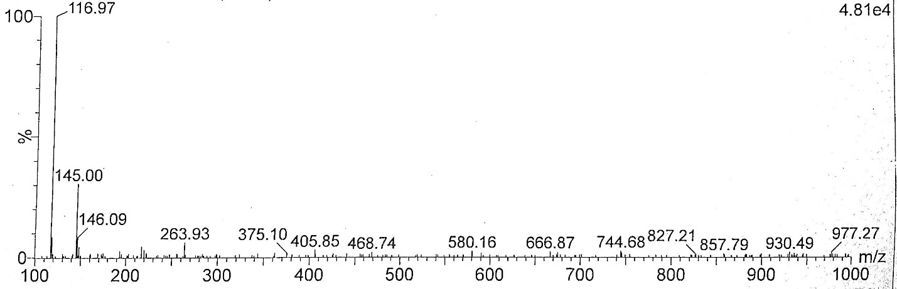
3d
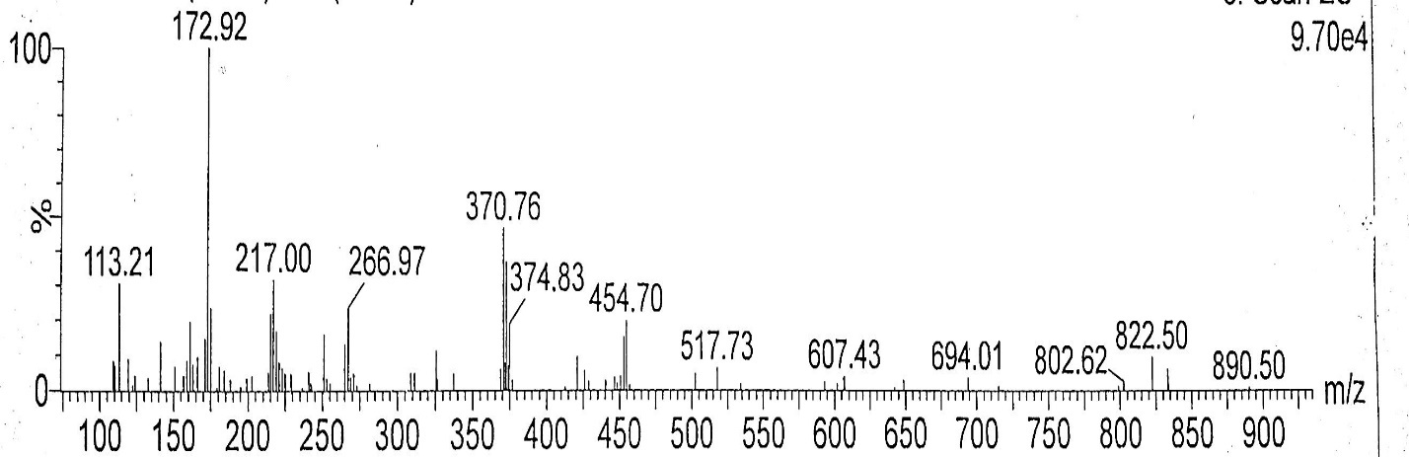
3e
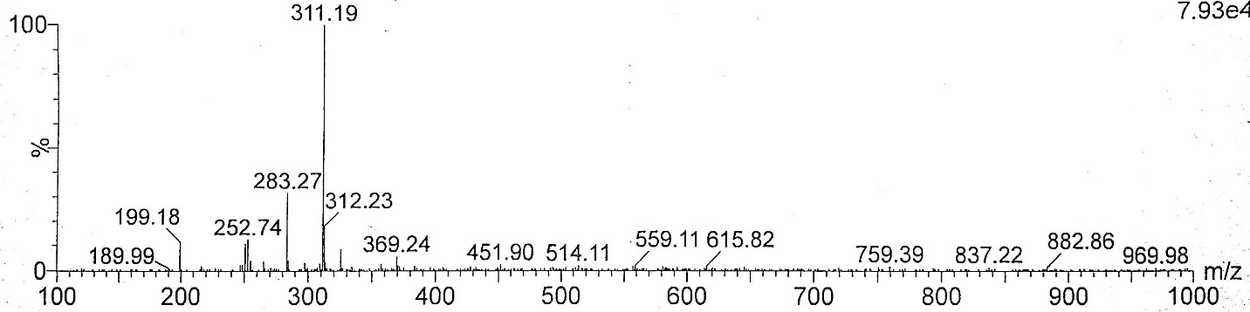
3f
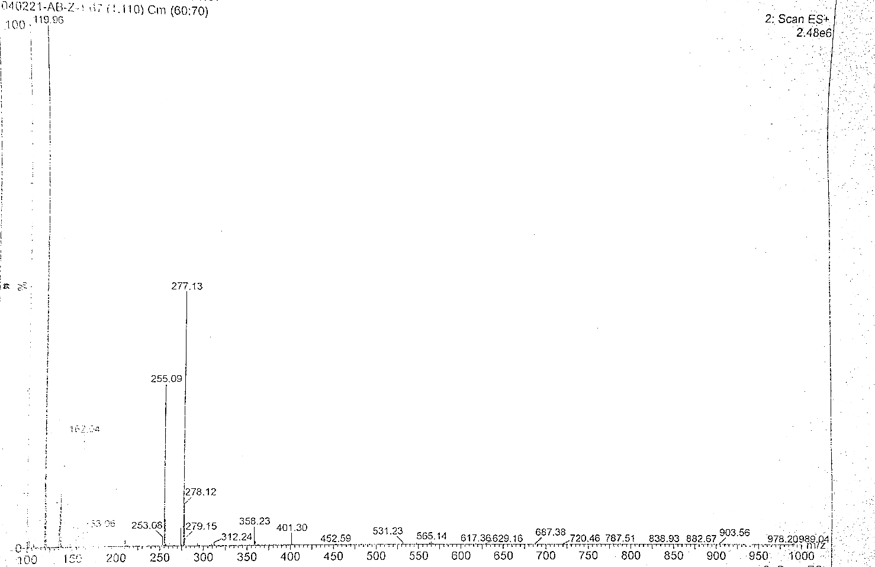
3g
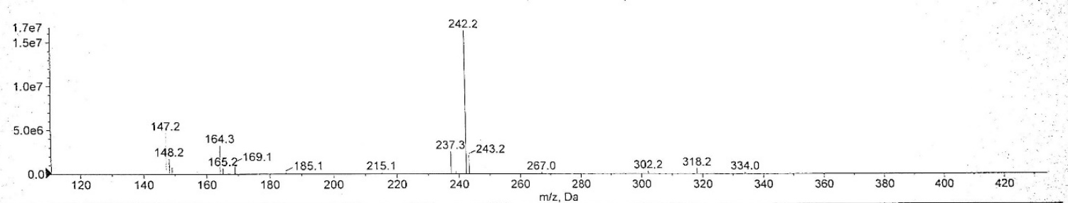
3h
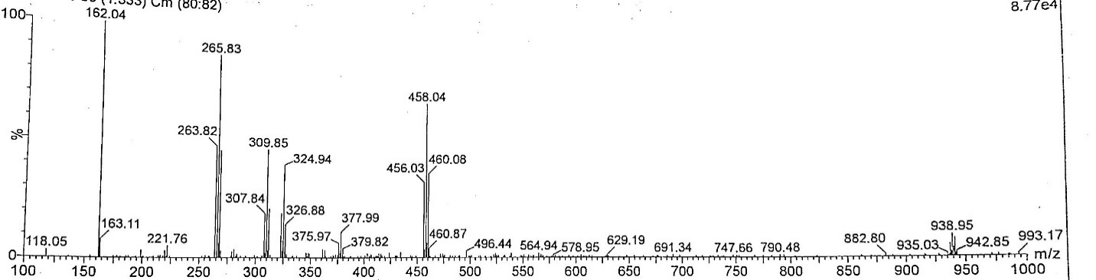

3i
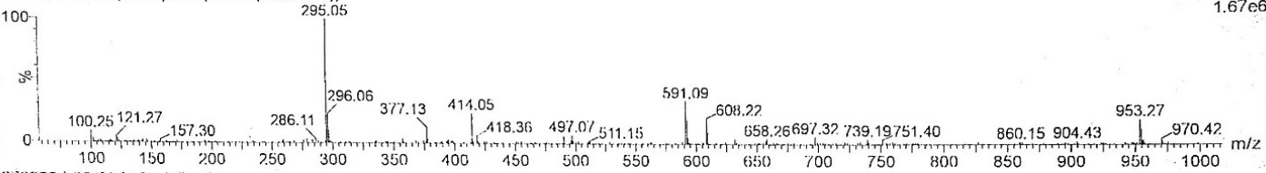
3j
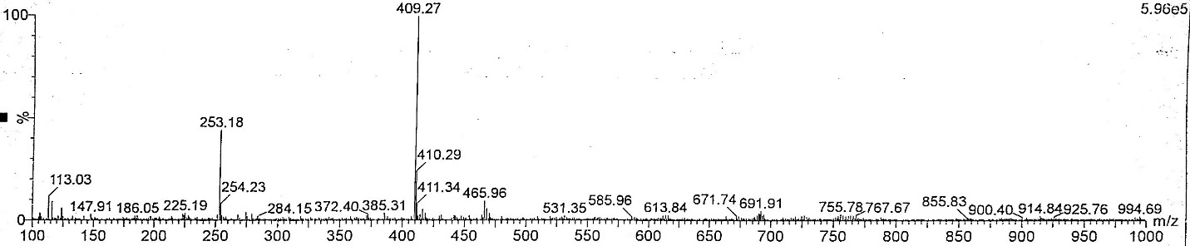
3k
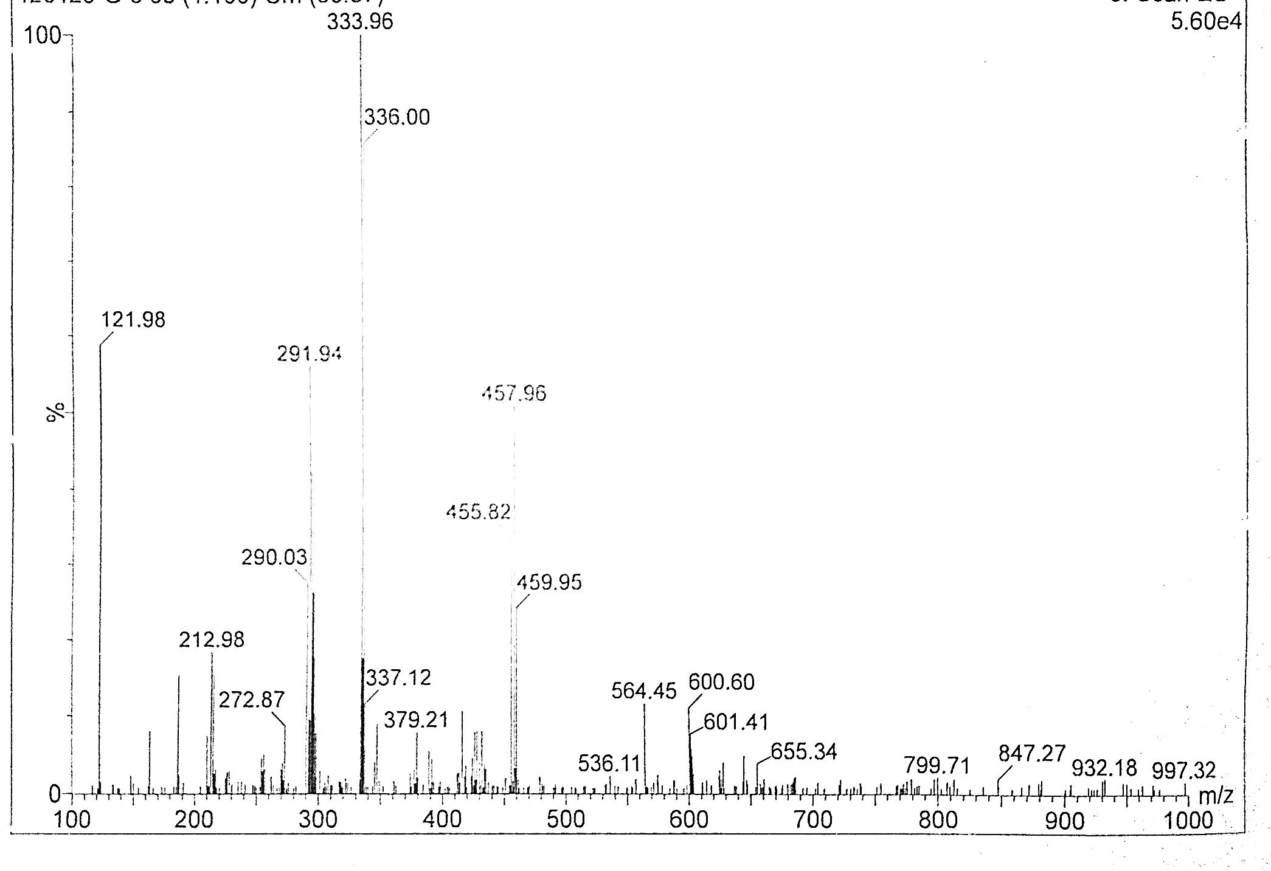
3l
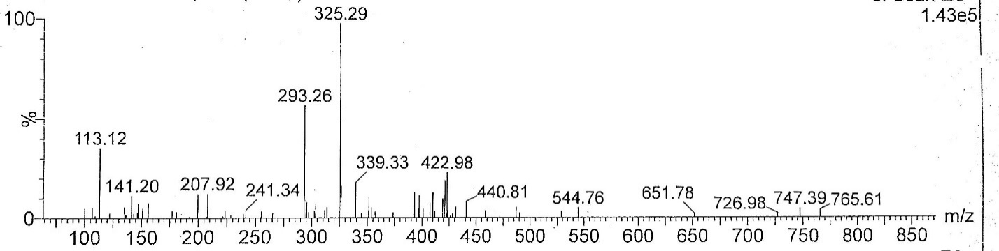
3m
Figure S1. LC-MS Spectral analysis of compounds 3a-3m

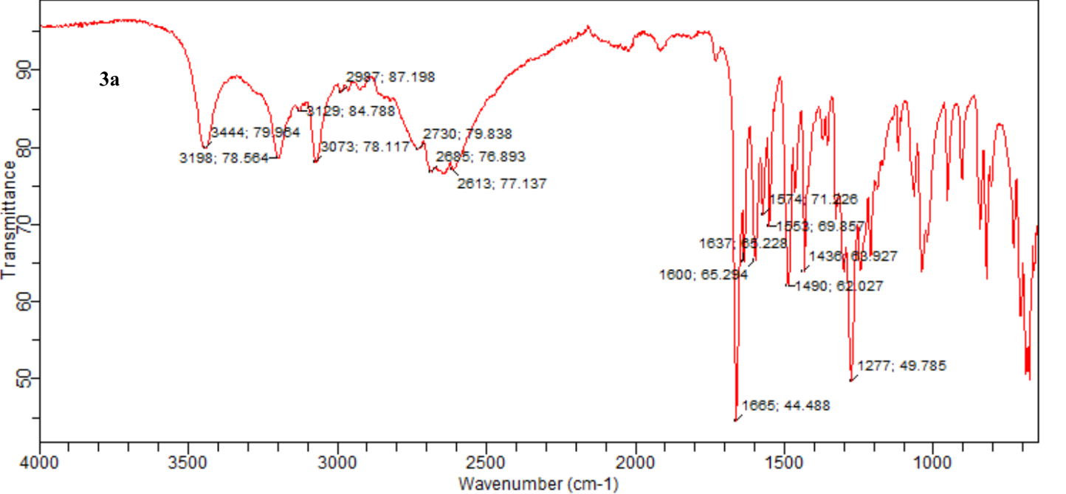
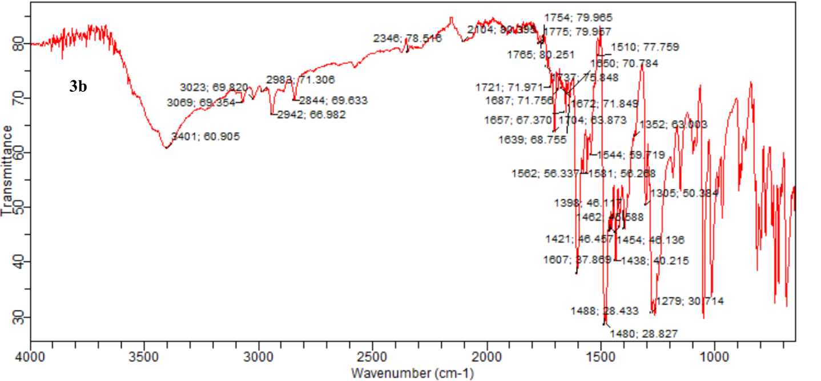
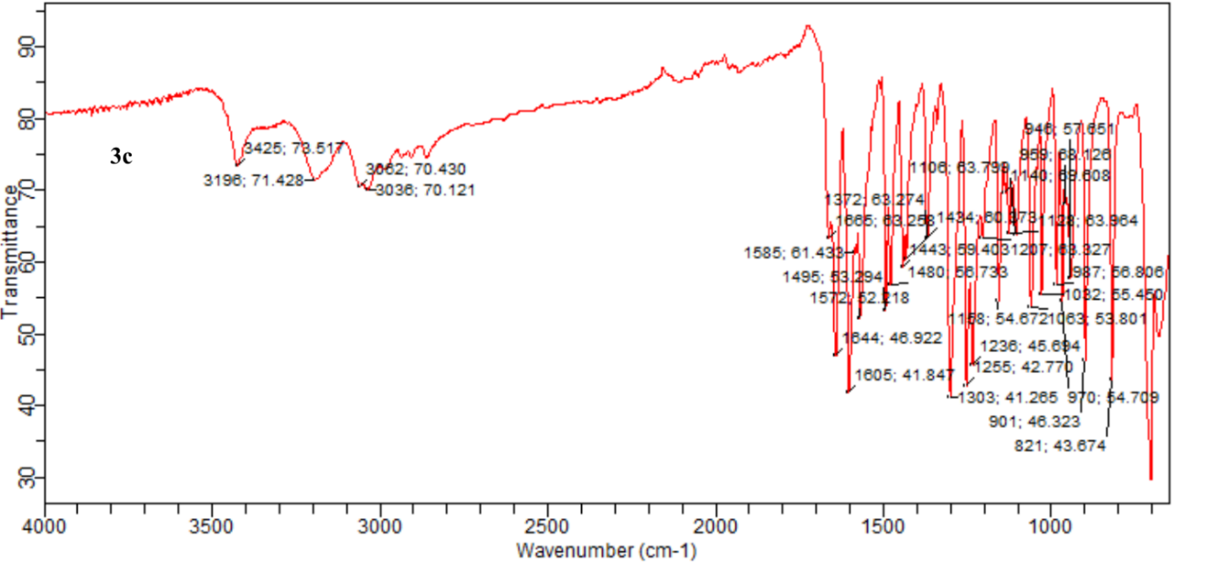

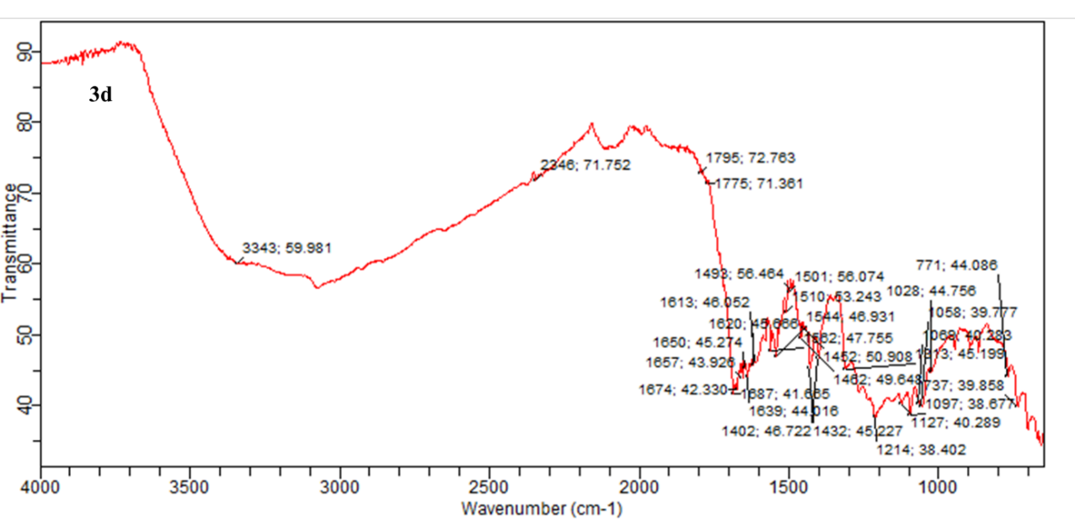
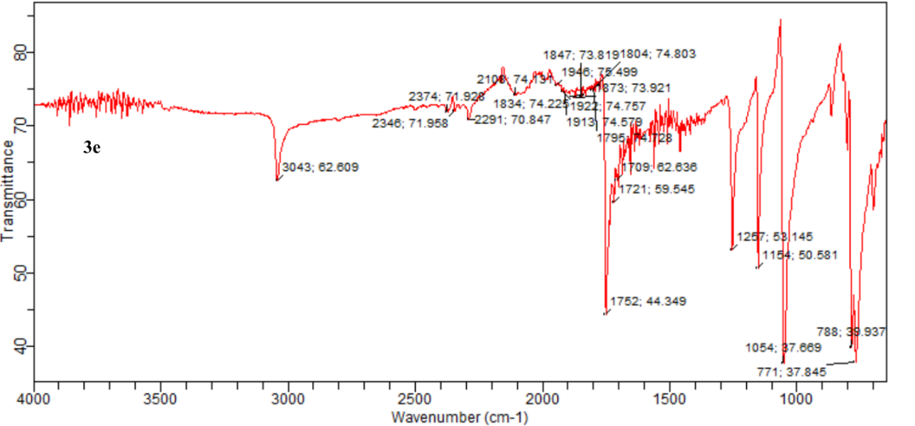
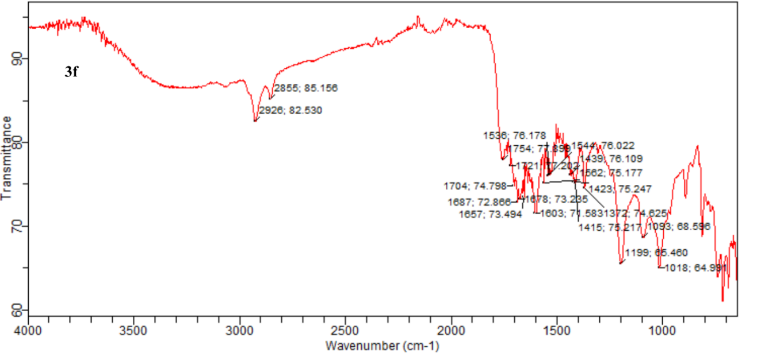
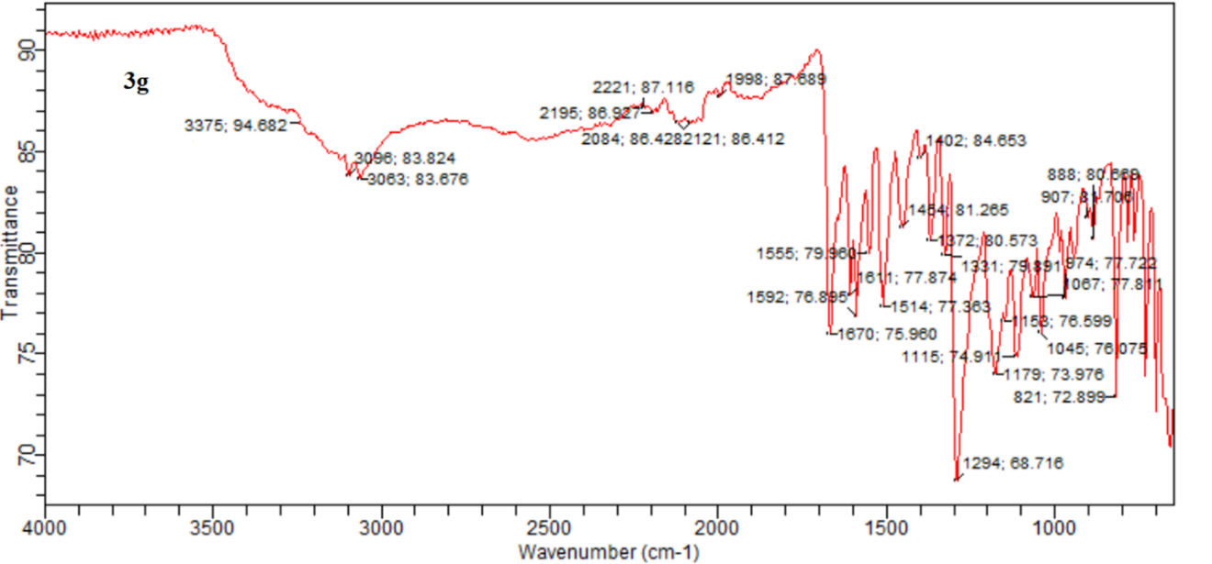
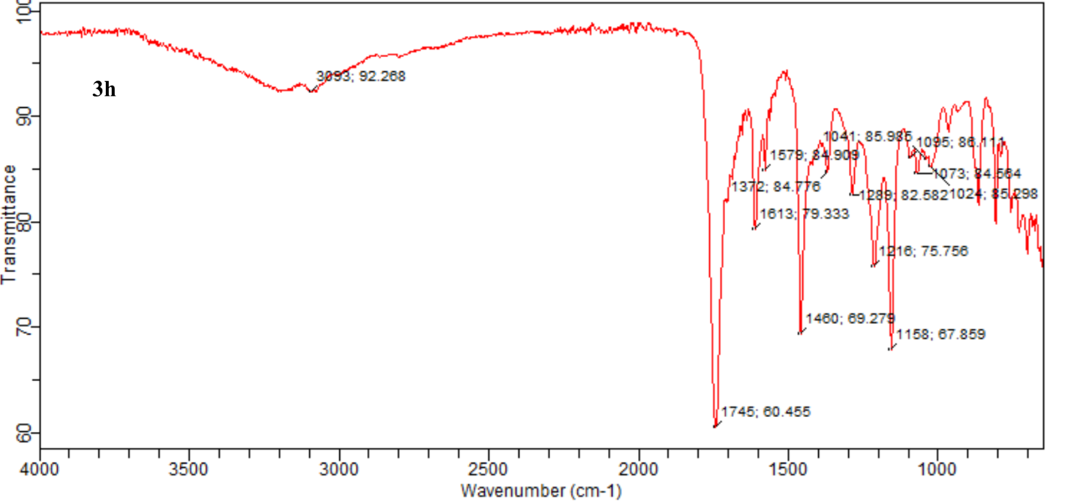
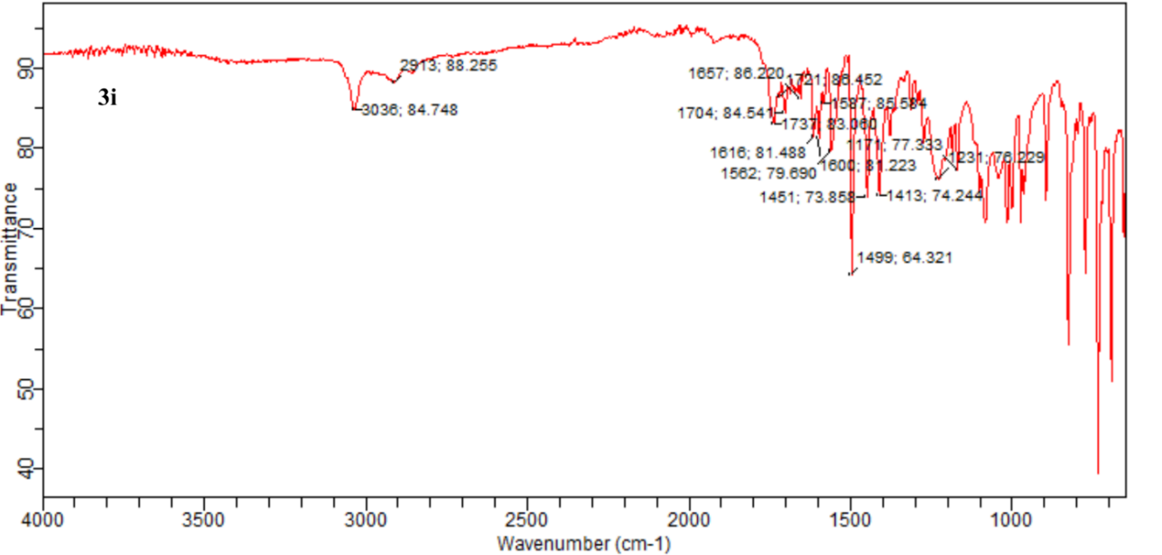
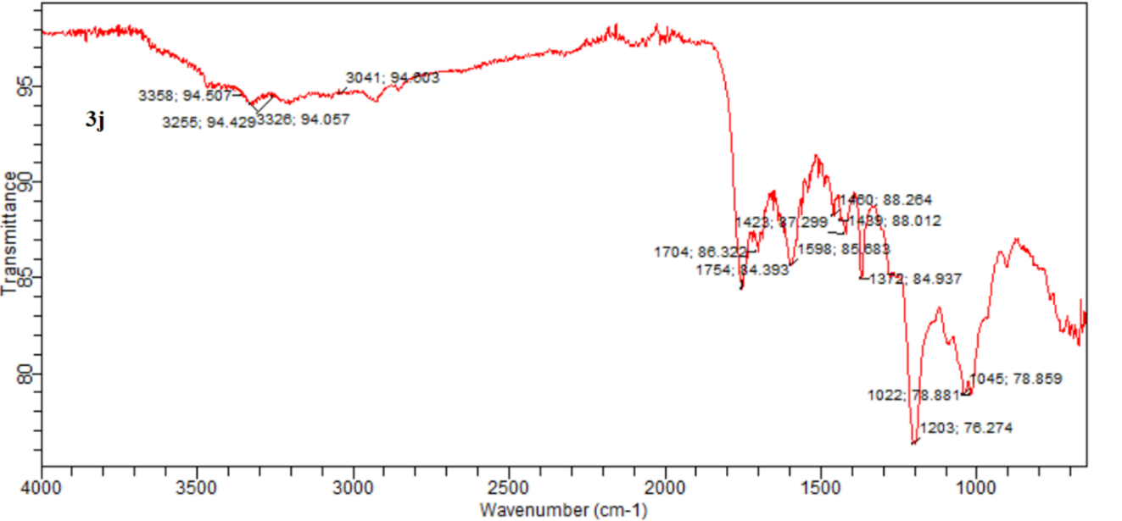
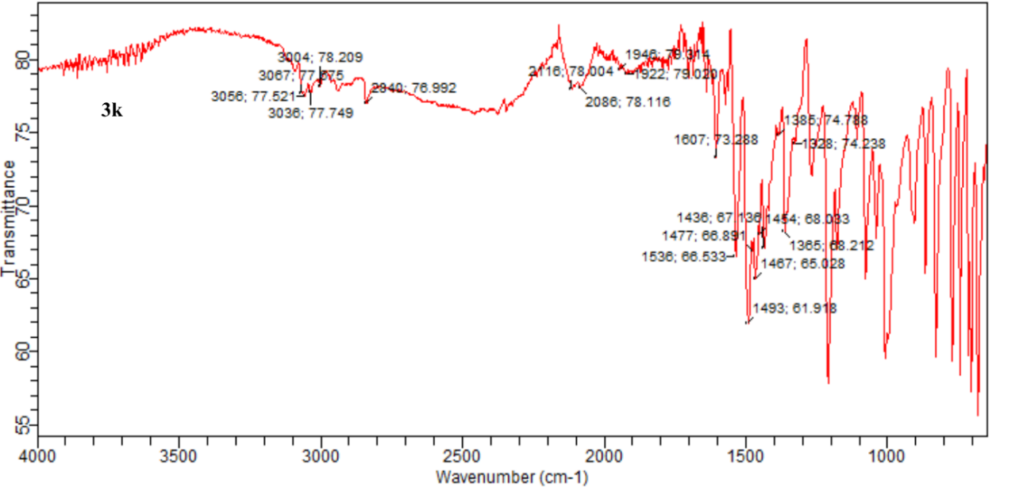
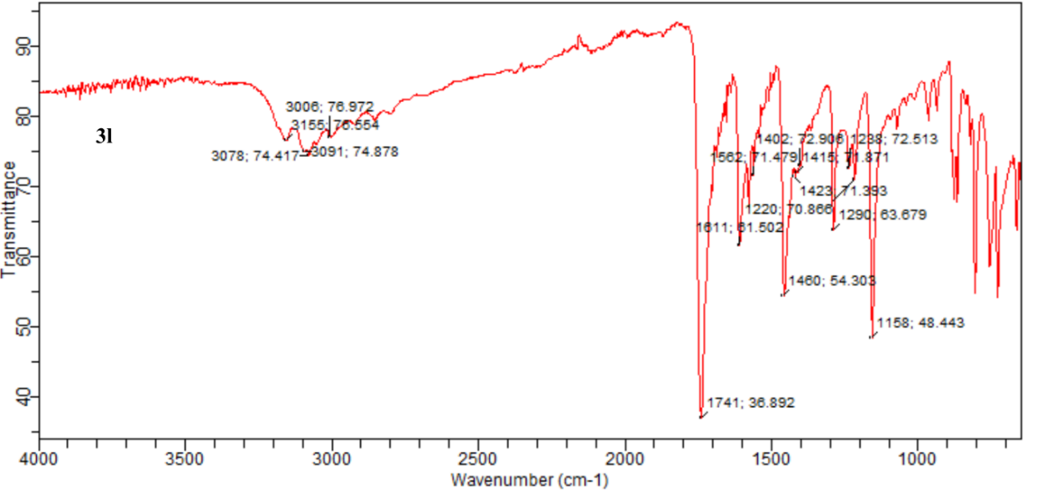
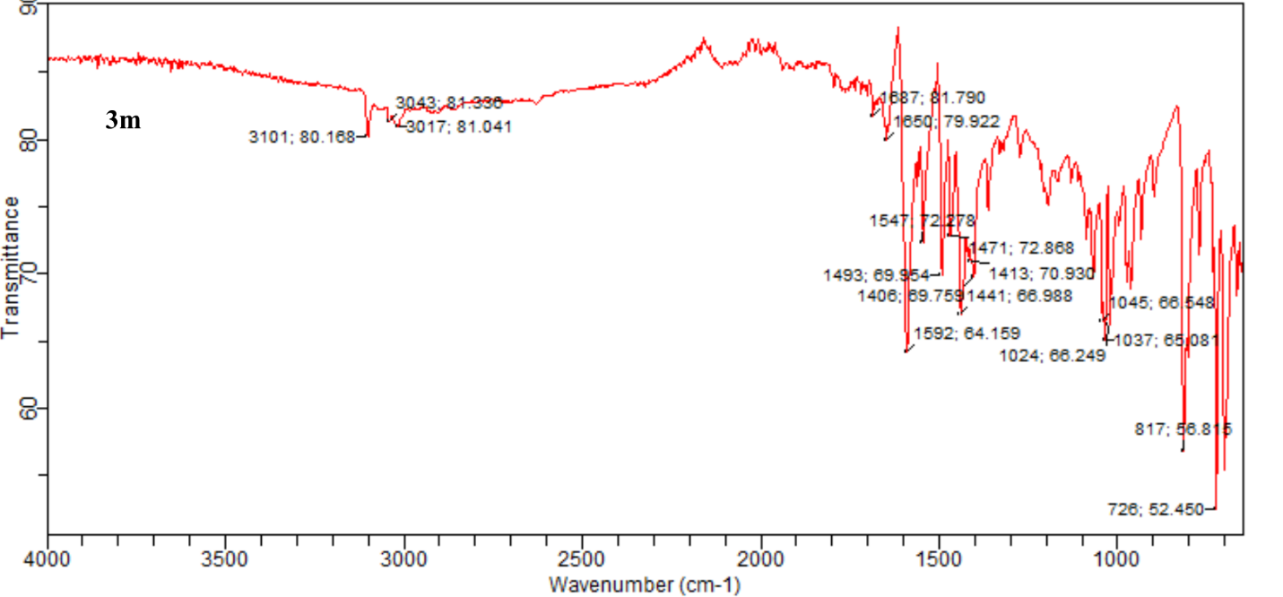
Figure S2. FT-IR spectra of compounds 3a-3m.
Figure S3. ¹H and 13C-NMR spectra of 3a-3f, 3h, 3j-3l.

Table S1. Optimized geometrical parameters of 3g: Bond length (Å), Bond angles (°)

Parameter  Bond length (Å) | B3LYP/6-311++G(d-p) | Experimental | Parameter  Bond angle (º) | B3LYP/6-311++G(d,p) | Experimental
O1-C2 | 1.3755 | 1.36 | C2-O1-H20 | 110.7421 | -
O1-H20 | 0.9626 | - | O1-C2-C3 | 114.8343 | -
C2-C3 | 1.4061 | - | O1-C2-C19 | 124.5085 | -
C2-C19 | 1.3815 | - | C3-C2-C19 | 120.6571 | -
C3-O4 | 1.3576 | - | C2-C3-O4 | 120.5694 | 117.8
C3-C5 | 1.3905 | - | C2-C3-C5 | 119.4475 | -
O4-H21 | 0.9667 | - | O3-C3-C5 | 119.9831 | -
C5-C6 | 1.391 | - | C3-O3-H21 | 108.6297 | -
C5-H22 | 1.083 | - | C3-C5-C6 | 120.2807 | -
C6-C7 | 1.3993 | - | C3-C5-H22 | 118.609 | -
C6-H23 | 1.0822 | - | C6-C5-H22 | 121.1103 | -
C7-C8 | 1.4525 | - | C5-C6-C7 | 120.2014 | -
C7-C19 | 1.4052 | - | C5-C6-H23 | 119.9401 | -
C8-N9 | 1.3026 | 1.29 | C7-C6-H23 | 119.8585 | -
C8-O18 | 1.3613 | 1.37 | C6-C7-C8 | 121.5397 | -
N9-N10 | 1.3839 | 1.41 | C6-C7-C19 | 119.6516 | -
N10-C11 | 1.2982 | 1.29 | C8-C7-C19 | 118.8087 | -
C11-C12 | 1.4643 | - | C7-C8-N9 | 128.4854 | 128.3
C11-O18 | 1.3598 | 1.36 | C7-C8-O18 | 119.6762 | 119.2
C12-C13 | 1.4014 | - | N9-C8-O18 | 111.8384 | 113.5
C12-N17 | 1.3391 | - | C8-N9-N10 | 106.5375 | 106.3
C13-C14 | 1.3879 | - | N9-N10-C11 | 106.7222 | 105.5
C13-H24 | 1.0822 | - | N10-C11-C12 | 127.6115 | -
C14-C15 | 1.3936 | - | N10-C11-O18 | 111.9976 | 113.4
C14-H25 | 1.084 | - | C12-C11-O18 | 120.391 | 117.6
C15-C16 | 1.3937 | - | C11-C12-C13 | 119.2573 | -
C15-H26 | 1.0833 | - | C11-C12-N17 | 117.3644 | -
C16-N17 | 1.3339 | - | C13-C12-N17 | 123.3783 | -
C16-H27 | 1.0862 | - | C12-C13-C14 | 118.1797 | -
C19-H28 | 1.0846 | - | C12-C13-H24 | 119.7557 | -
 |  |  | C14-C13-H24 | 122.0646 | -
 |  |  | C13-C14-C15 | 118.9607 | -
 |  |  | C13-C14-H25 | 120.3003 | -
 |  |  | C15-C14-H25 | 120.739 | -
 |  |  | C14-C15-C16 | 118.3384 | -
 |  |  | C14-C15-H26 | 121.3585 | -
 |  |  | C16-C15-H26 | 120.303 | -
 |  |  | C15-C16-N17 | 123.5872 | -
 |  |  | C15-C16-H27 | 120.5025 | -
 |  |  | N17-C16-H27 | 115.9103 | -

Table S2. Optimized geometrical parameters of 3i: Bond length (Å), Bond angles (°)
Parameter  Bond length (Å) | B3LYP/6-311++G(d-p) | Experimental | Parameter  Bond angle (º) | B3LYP/6-311++G(d,p) | Experimental
Br1-C2 | 1.8858 | - | Br1-C2-C3 | 126.6283 | -
C2-C3 | 1.3679 | - | Br1-C2-S17 | 120.3115 | -
C2-S17 | 1.7365 | - | C3-C2-S17 | 113.0601 | -
C3-C4 | 1.4192 | - | C2-C3-C4 | 111.8226 | -
C3-H18 | 1.0806 | - | C2-C3-H18 | 123.5907 | -
C4-C5 | 1.3747 | - | C4-C3-H18 | 124.5867 | -
C4-H19 | 1.0814 | - | C3-C4-C5 | 113.2503 | -
C5-C6 | 1.4381 | - | C3-C4-H19 | 123.868 | -
C5-S17 | 1.748 | - | C5-C4-H19 | 122.8818 | -
C6-N7 | 1.2998 | 1.29 | C4-C5-C6 | 128.3884 | -
C6-O16 | 1.3619 | 1.37 | C4-C5-S17 | 111.5717 | -
N7-N8 | 1.3845 | 1.41 | C6-C5-S17 | 120.0399 | -
N8-C9 | 1.2955 | 1.29 | C5-C6-N7 | 128.366 | 128.3
C9-C10 | 1.4661 | - | C5-C6-O16 | 119.5731 | 119.2
C9-O16 | 1.3731 | 1.36 | N7-C6-O16 | 112.0609 | 113.8
C10-C11 | 1.4007 | - | C6-N7-N8 | 106.7577 | 106.3
C10-N15 | 1.34 | - | N7-N8-C9 | 106.7752 | 105.5
C11-C12 | 1.3906 | - | N8-C9-O10 | 129.9089 | -
C11-H20 | 1.082 | - | N8-C9-O16 | 111.8968 | 113.4
C12-C13 | 1.3906 | - | O10-C9-O16 | 118.1943 | 117.6
C12-H21 | 1.0839 | - | C9-O10-C11 | 120.568 | -
C13-C14 | 1.3964 | - | C9-O10-N15 | 116.3409 | -
C13-H22 | 1.0833 | - | C11-O10-N15 | 123.0911 | -
C14-N15 | 1.3303 | - | O10-C11-C12 | 118.3526 | -
C14-H23 | 1.0863 | - | O10-C11-H20 | 120.4995 | -
 |  |  | C12-C11-H20 | 121.148 | -
 |  |  | C11-C12-C13 | 118.9142 | -
 |  |  | C11-C12-H21 | 120.2733 | -
 |  |  | C13-C12-H21 | 120.8126 | -
 |  |  | C12-C13-C14 | 118.2382 | -
 |  |  | C12-C13-H22 | 121.4111 | -
 |  |  | C14-C13-H22 | 120.3507 | -
 |  |  | C13-C14-N15 | 123.6734 | -
 |  |  | C13-C14-H23 | 120.4439 | -
 |  |  | N15-C14-H23 | 115.8827 | -
 |  |  | O10-N15-C14 | 117.7306 | -
 |  |  | C6-O16-C9 | 102.5094 | -
 |  |  | C2-S17-C5 | 90.2954 | -

Table S3. Optimized geometrical parameters of 3m: Bond length (Å), Bond angles (°)
Parameter  Bond length (Å | B3LYP/6-311++G(d-p | Experimental | Parameter  Bond angle (º) | B3LYP/6-311++G(d,p) | Experimental
C1-O2 | 1.4198 | - | O2- C1-H23 | 105.8228 | -
C1 -H23 | 1.0887 | - | O2- C1-H24 | 111.4494 | -
C1 -H24 | 1.0959 | - | O2-C1-H25 | 111.452 | -
C1 -H25 | 1.0959 | - | H23-C1-H24 | 109.223 | -
O2 -C3 | 1.3663 | 1.36 | H23-C1-H25 | 109.2233 | -
C3 -C4 | 1.4017 | - | H24-C1-H25 | 109.5697 | -
C3 -C6 | 1.403 | - | C1-O2-C3 | 118.782 | 117.8
C4 -C5 | 1.3999 | - | O2-C3-C4 | 115.3622 | -
C4 -H26 | 1.0831 | - | O2-C3-C6 | 123.9657 | -
C5 -C8 | 1.3826 | - | C8-C7-C11 | 104.5158 | -
C5 -H27 | 1.0833 | - | C5-C8-C7 | 120.5198 | -
C6 -C7 | 1.3995 | - | C5-C8-N9 | 127.8128 | 128.3
C6 -28 | 1.0803 | - | C7-C8-N9 | 111.6673 | -
C7 -C8 | 1.4159 | - | C8-N9-C10 | 106.1295 | -
C7 -C11 | 1.4395 | - | N9-C10-C11 | 112.6454 | -
C8 -N9 | 1.4148 | - | N9-C10-H29 | 122.626 | -
N9 -C10 | 1.3031 | 1.29 | C11-C10-H29 | 124.7286 | -
C10 -C11 | 1.4593 | - | C7-C11-C10 | 105.0419 | -
C10 -H29 | 1.082 | - | C7-C11-C12 | 130.4921 | -
C11 -C12 | 1.4086 | - | C10-C11-C12 | 124.466 | -
C12 -N13 | 1.3207 | - | C11-C12-N13 | 127.6637 | -
C12 -O22 | 1.3712 | 1.37 | C11-C12-O22 | 121.5087 | 119.2
N13 -N14 | 1.3652 | 1.41 | N13-C12-O22 | 110.8276 | 113.5
N4 -C15 | 1.3056 | 1.29 | C12-N13-N14 | 107.2357 | 106.3
C15 -C16 | 1.4629 | - | N13-N14-C15 | 107.0656 | 105.5
C15 -O22 | 1.3642 | 1.36 | N14-C15-C16 | 129.2572
C16 -C17 | 1.4012 | - | N14-C15-O22 | 111.9437 | 113.4
C16 -N21 | 1.3408 | - | C16-C15-O22 | 118.7991 | 117.6
C17 -C18 | 1.3903 | - | C15-C16-C17 | 120.6011 | -
C17 -H30 | 1.0818 | - | C15-C16-N21 | 116.2668 | -
C18 -C19 | 1.3908 | - | C17-C16-N21 | 123.1322 | -
C18 -H31 | 1.0839 | - | C16-C17-C18 | 118.3478 | -
C19 -C20 | 1.3972 | - | C16-C17-H30 | 120.4674 | -
C19 -C20 | 1.3972 | - | C18-C17-H30 | 121.1849 | -
C19 -H32 | 1.0832 | - | C19-C20-N21 | 123.6461 | -
C20 -N21 | 1.3296 | - | C19-C20-H33 | 120.4502 | -
C20 -H33 | 1.0862 | - | N21-C20-H33 | 115.9037 | -
 |  |  | C16-N21-C20 | 117.6967 | -
 |  |  | C12-O22-C15 | 102.9275 | -

Figure S4 (a) theoretical FT-IR spectra of 3g.
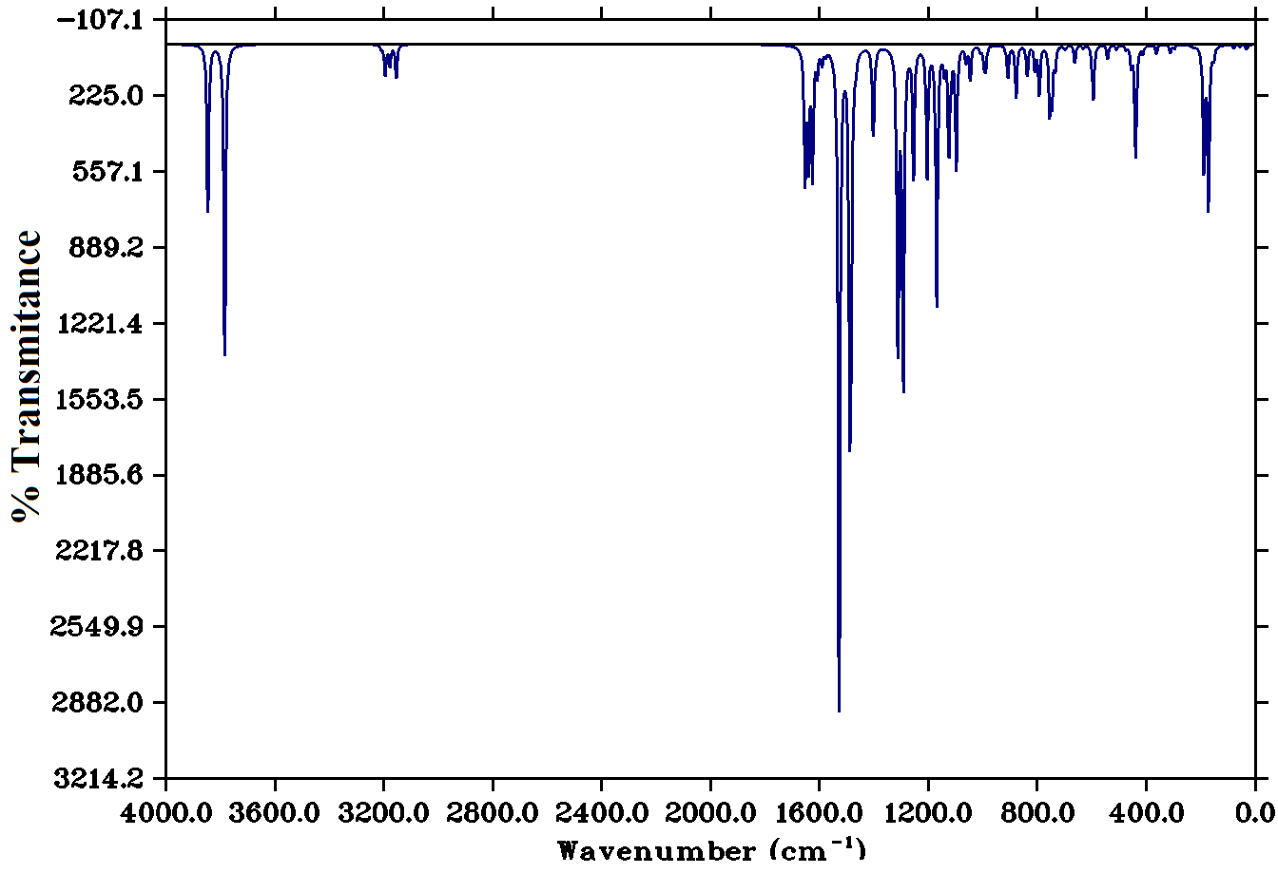

Figure S4 (b) Experimental FT-IR spectra of 3g.
Figure S5 (a) theoretical FT-IR spectra of 3i.
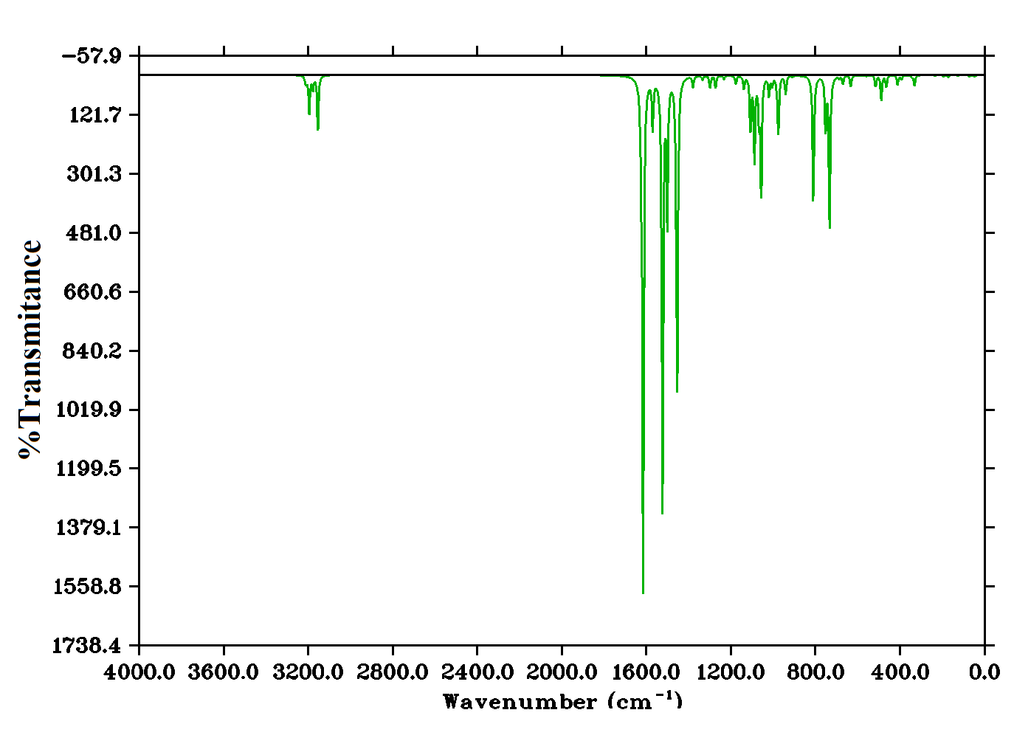

Figure S5 (b) Experimental FT-IR spectra of 3i.

Figure S6 (a) theoretical FT-IR spectra of 3m.
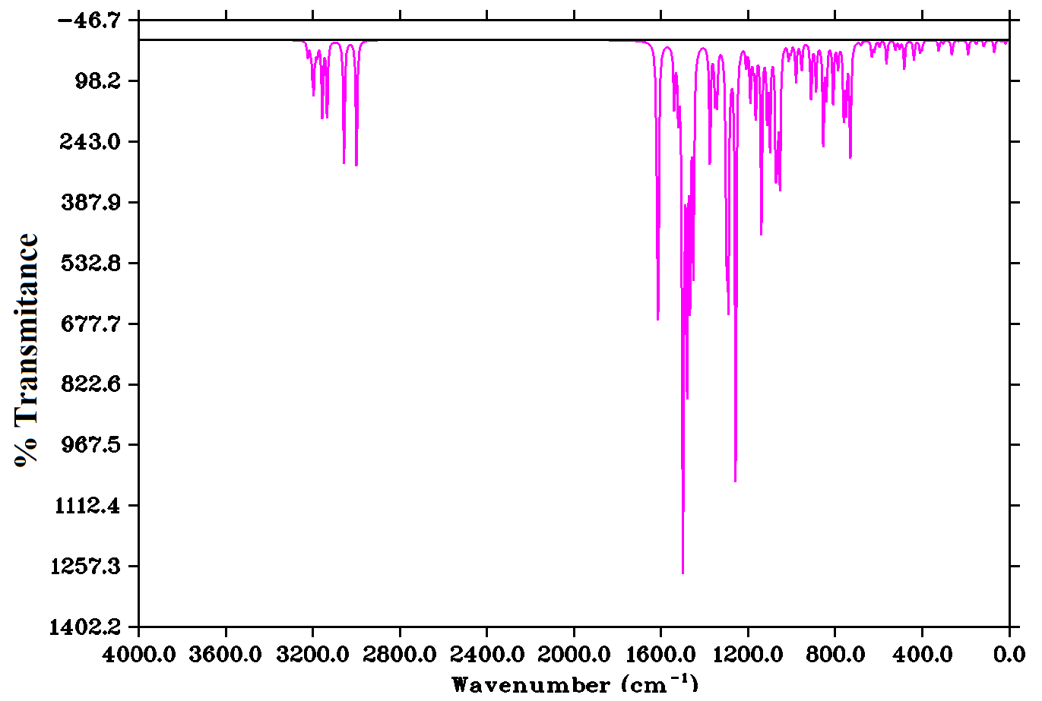

Figure S6 (b) Experimental FT-IR spectra of 3m.

Table S4. Calculated vibrational frequencies (cm⁻¹) assignments of 3g based on B3LYP/6–311++G(d,p) basis set.0
Mode No | Experimental wave number (cm ⁻¹) | Theoretical wave number (cm ⁻¹) |  | I _{IR} | Assignments (PED)
Mode No | FT-IR | Unscaled | Scaled | I _{IR} | Assignments (PED)
78 | 3096 | 3846 | 3734.466 | 92.8331 | γOH(61)
77 | 3063 | 3784 | 3674.264 | 171.8713 | γOH(51)
76 | - | 3209 | 3115.939 | 1.2350 | γCH(78)
75 | - | 3208 | 3114.968 | 0.9902 | γCH(29)
74 | - | 3195 | 3102.345 | 13.8691 | γCH(28)
73 | - | 3193 | 3100.403 | 3.6843 | γCH(64)
72 | - | 3178 | 3085.838 | 4.0315 | γCH(57)
71 | - | 3177 | 3084.867 | 7.9589 | γCH(57)
70 | - | 3154 | 3062.534 | 18.4484 | γCH(30)
69 | 1670 | 1653 | 1605.063 | 71.9789 | γCC(30)+ βHCC(61)+ βHCO(16)+ βCCC(11)
68 | 1611 | 1641 | 1593.411 | 60.8015 | γCN(42)+ γCC(30)+ βHCC(61)+ βHCO(16)+ βCCC(11)
67 | 1592 | 1626 | 1578.846 | 70.0333 | γCN(42)+ γCC(30)+ βHCC(61)+ βCCC(11)
66 | 1555 | 1608 | 1561.368 | 13.4537 | γCN(42)+ γCC(30)+ βHCC(61)+ βCCC(11)
65 | 1514 | 1591 | 1544.861 | 8.6862 | γCN(26)+ γCC(30)+ βHCO(16)+ βHCC(61)+ βCCC(11)
64 | - | 1578 | 1532.238 | 3.3321 | γCN(52)+ γCC(30)+ βHCO(16)+ βHCC(61)+ βCCC(11)
63 | 1454 | 1528 | 1483.688 | 370.6107 | γCN(26)+ βHCO(16)+ βHCC(61)+ βCCC(11)
62 | - | 1489 | 1445.819 | 169.2365 | γCN(26)+ γCC(30)+ βHCC(61)+ βCCC(11)
61 | - | 1484 | 1440.964 | 126.3702 | βHCO(16)+ βHCC(12)+ βCCC(11)+ βHCN(16)+ βNCC(16)
60 | 1372 | 1467 | 1424.457 | 6.7958 | βHCC(12)+ βCCC(11)+ βHCN(16)
59 | 1331 | 1403 | 1362.313 | 48.4733 | γCC(30)+ βHCC(61)+ βCCC(11)+ βHCO(16)
58 |  | 1394 | 1353.574 | 3.7687 | γCC(51)+ γCO(15)+ βHCO(16)+ βHCC(12)+ βCCC(11)+ βNCC(16)
57 | - | 1342 | 1303.082 | 0.0829 | γCC(32)+ γCO(15)+ βHCO(16)+ βHCC(12)+ βCCC(11)+ βNCC(16)
56 | - | 1315 | 1276.865 | 8.8282 | γCN(61)+ βCCC(11)+ βHCC(16)
55 | - | 1312 | 1273.952 | 157.3895 | γCN(45)+ γCC(11)+ γCO(15)+ βHCC(16)+ βCCC(11)+ βNCC(16)
54 | - | 1298 | 1260.358 | 27.8249 | γCN(45)+ γCC(19)+ βHCC(12)+ βCCC(11)+ βNCC(16))
53 | - | 1292 | 1254.532 | 174.5775 | γCC(51)+ γCO(15)+ βHCO(16)+ βHCC(12)+ βCCC(11)+ βNCC(16)
52 | - | 1255 | 1218.605 | 71.0324 | γCC(51)+ βHCO(16)+ βHCC(12)+ βNCC(16)
51 | - | 1205 | 1170.055 | 72.3651 | γCC(51)+ βHCO(16)+ βHCC(12)
50 | 1179 | 1174 | 1139.954 | 1.9084 | βHCC(12)+ βCCC(16)
49 | 1153 | 1170 | 1136.07 | 141.4721 | γCC(32)+ βHCO(16)+ βHCC(12)+ βCCC(11)
48 | - | 1142 | 1108.882 | 11.8100 | γNN(32)+ γCC(15)+ γCO(15)+ βHCO(16)+ βHCC(12)+ βCCC(11)+ βNCC(16)+βNNC(12)
47 | - | 1125 | 1092.375 | 58.3505 | γCO(42)+ γNN(32)+ γCC(15)+ βHCO(16)+ βHCC(12)+ βCCC(11)+ βNCC(16)+βNNC(12)
46 | 1087 | 1117 | 1084.607 | 9.3505 | βHCC(12)+ βCCC(16)
45 | 1045 | 1098 | 1066.158 | 67.8550 | γNN(32)+ γCC(15)+ γCO(15)+ βHCO(16)+ βHCC(12)+ βCCC(11)+ βNCC(16)+βNNC(12)

Table S5. Calculated vibrational frequencies (cm⁻¹) assignments of 3i based on B3LYP/6–311++G(d,p) basis set.
Mode No | Experimental wave number (cm ⁻¹) | Theoretical wave number (cm ⁻¹) |  | I _{IR} | Assignments (PED)
Mode No | FT-IR | Unscaled | Scaled | I _{IR} | Assignments (PED)
63 | 3036 | 3228 | 3134.388 | 0.1052 | γCH(61)
62 | - | 3213 | 3119.823 | 2.1222 | γCH(51)
61 | - | 3208 | 3114.968 | 1.8406 | γCH(78)
60 | - | 3195 | 3102.345 | 14.7595 | γCH(29)
59 | - | 3178 | 3085.838 | 5.1058 | γCH(28)
58 | 2913 | 3154 | 3062.534 | 20.9684 | γCH(64)
57 | 1657 | 1625 | 1577.875 | 20.1741 | γCC(57)+ γCN(57)+ HCC(61)+ βCOC(16)+ βCCC(11)
56 | 1562 | 1621 | 1573.991 | 0.7846 | γCC(57)+ γCN(57)+ HCC(61)+ βCOC(16)+ βCCC(11)
55 | - | 1615 | 1568.165 | 195.3817 | γCC(57)+ γCN(57)+ HCC(61)+ βCOC(16)+ βCCC(11)+ βCNN(11)
54 | - | 1570 | 1524.47 | 19.0316 | γCC(30)+ γCN(57)+ βHCC(61)+ βCCC(11)+ HCC(61)+ βCOC(16)+ βCCN(11)+ βCNN(16)
53 | 1499 | 1524 | 1479.804 | 166.5876 | γCN(42)+ γCC(30)+ βHCC(61)+ βCCN(16)+ βCCC(11)
52 | - | 1501 | 1457.471 | 54.0326 | γCN(42)+ γCC(30)+ βHCC(61)+ βCCC(11)
51 | - | 1458 | 1415.718 | 31.6210 | γCN(42)+ γCC(30)+ βHCC(61)+ βCCC(11)
50 | 1413 | 1454 | 1411.834 | 104.6322 | γCN(26)+ γCC(30)+ βCCN(16)+ βHCC(61)+ βCCC(11)
49 | - | 1380 | 1339.98 | 4.1612 | γCC(30)+ βCOC(16)+ βHCC(61)+ βCNN(11)+ βCCC(11)
48 | - | 1335 | 1296.285 | 1.5317 | γCN(26)+ βHCC(16)+ βCCN(61)
47 | - | 1324 | 1285.604 | 0.0914 | γCN(26)+ βHCC(61)+ βCCC(11)
46 | - | 1299 | 1261.329 | 4.7349 | γCC(26)+ γCN(26)+ βHCC(12)+ βCCC(11)+ βHCN(16)
45 | 1231 | 1273 | 1236.083 | 4.6340 | βHCC(12)+ βCCC(11)+ βCCN(16)+ βCCN(16)
44 | - | 1233 | 1197.243 | 1.3559 | βHCC(61)+ βCCC(11)
43 | - | 1177 | 1142.867 | 3.1496 | βHCC(12)+ βCCC(11)
42 | - | 1139 | 1105.969 | 4.8377 | γCC(32)+ γCO(15)+ βCCO(16)+ βCNN(12)+ βCCC(11)+ βNCC(16)
41 | - | 1108 | 1075.868 | 20.2828 | γNN(31)+ γCC(32)+ γCO(15)+ βCNN(12)+ βCCC(11)+ βCNN(16)
40 | - | 1089 | 1057.419 | 32.4840 | γNN(12)+ γCO(15)+ βHCC(12)+ βCCC(11)+ βCOC(16)+ βCNN(16)
39 | - | 1068 | 1037.028 | 14.8594 | γCC(32)+ γCO(15)+ βCNN(12)+ βHCC(11)+ βCCC(16)
38 | 1002 | 1057 | 1026.347 | 45.3356 | γNN(31)+ γCC(32)+ γCO(15)+ βCNN(12)+ βHCC(11)+ βCCC(16)
37 |  | 1020 | 990.42 | 7.3130 | γNN(31)+ γCO(32)+ γCC(15)+ βCNN(12)+ βHCC(11)+ βCCC(16)
36 | 975 | 1015 | 985.565 | 0.042 | γCC(51)+ βHCO(16)+ βHCC(12)
35 | - | 1005 | 975.855 | 3.6464 | βHCC(12)+ βCCC(16)
34 | - | 986 | 957.406 | 0.4079 | γCC(32)+ βHCO(16)+ βHCC(12)+ βCCC(11)
33 | - | 980 | 951.58 | 4.7057 | γNN(32)+ γCC(15)+ γCO(15)+ βHCO(16)+ βHCC(12)+ βCCC(11)+ βNCC(16)+βNNC(12)
32 | - | 976 | 947.696 | 20.2037 | γCO(42)+ γNN(32)+ γCC(15)+ βHCO(16)+ βHCC(12)+ βCCC(11)+ βNCC(16)+βNNC(12)
31 | - | 941 | 913.711 | 6.9667 | βHCC(12)+ βCCC(16)

Table S6. Calculated vibrational frequencies (cm⁻¹) assignments of 3m based on B3LYP/6–311++G(d,p) basis set.
Mode No | Experimental wave number (cm ⁻¹) | Theoretical wave number (cm ⁻¹) |  | I _{IR} | Assignments (PED)
Mode No | FT-IR | Unscaled | Scaled | I _{IR} | Assignments (PED)
93 | 3101 | 3223 | 3129.533 | 4.6672 | γCH(27)
92 | - | 3215 | 3121.765 | 0.2512 | γCH(26)
91 | - | 3210 | 3116.91 | 1.6572 | γCH(49)
90 | - | 3202 | 3109.142 | 6.5014 | γCH(50)
89 | - | 3196 | 3103.316 | 13.856 | γCH(45)
88 | 3043 | 3189 | 3096.519 | 2.4932 | γCH(52)
87 | - | 3179 | 3086.809 | 3.6392 | γCH(38)
86 | 3017 | 3156 | 3064.476 | 22.9961 | γCH(57)
85 | - | 3057 | 2968.347 | 22.5328 | γCH(46)
84 | - | 3034 | 2943.114 | 37.4174 | γCH(42)
83 | - | 2999 | 2912.029 | 38.4881 | γCH(91)
82 | 1592 | 1619 | 1572.049 | 27.6927 | γCC(26)+ γCN(26)+ βHCC(12)+ βCCC(11)+ βHCN(16)+ βCCO(10)
81 | - | 1618 | 1571.078 | 2.1267 | γCC(26)+ γCN(26)+ βHCC(12)+ βCCC(11)+ βCNC(16)+ βCCO(10)
80 | - | 1615 | 1568.165 | 24.2165 | γCC(26)+ γCN(26)+ βHCC(12)+ βCCC(11)+ βCNC(16)+ βCCO(10)
79 | 1547 | 1613 | 1566.223 | 51.9448 | γCC(26)+ γCN(26)+ βHCC(12)+ βCCC(11)+ βCNC(16)+ βCCO(10)
78 | 1493 | 1540 | 1495.34 | 17.9993 | γCN(20)+ γCC(25)+ βHCC(12)+ βCCC(11)+ βCNC(16)
77 | 1471 | 1521 | 1476.891 | 17.6977 | γCN(20)+ γCC(25)+ βHCH(58)+ βCOC(15)+ βHCC(12)+
76 | - | 1504 | 1460.384 | 3.6649 | βHCH(58)+βCCC(10)
75 | - | 1501 | 1457.471 | 135.5178 | γCN(20)+ γCC(25)+ βCCC(11)+ βCNC(16)+ βCCO(10)+ βHCH(15)+ βHCC(20)
74 | - | 1496 | 1452.616 | 33.1337 | γCN(18)+βHCC(16)+ βHCN(26)
73 | 1441 | 1492 | 1448.732 | 9.7618 | βHCH(58)+βCCC(10)
72 | - | 1481 | 1438.051 | 92.9750 | γCN(22)+ γCC(11)+ βCCC(11)+ βCNC(16)+ βCCO(10)+ βHCH(15)+ βHCC(20)
71 | 1413 | 1467 | 1424.457 | 68.4096 | γCC(26)+ γCN(26)+ βHCC(12)+ βCCC(11)+ βCNC(16)
70 | 1406 | 1452 | 1409.892 | 65.2378 | βHCC(61)
69 | - | 1444 | 1402.124 | 1.1145 | γCN(22)+ γCC(41)+ βHCC(10)+ βCCC(11)+ βCOC(16)+ βCNN(16)
68 | - | 1376 | 1336.096 | 36.1181 | γCN(26)+ γCC(49)+ βHCC(10)+ βCCC(11)+ βCNN(16)
67 | - | 1353 | 1313.763 | 15.5251 | γCC(53)+ βHCC(13)+ βCCC(11)+ βCNC(16)
66 | - | 1343 | 1304.053 | 16.4321 | γCN(13)+ γCC(53)+ βHCC(13)+ βCCC(11)+ βCNC(16)
65 | - | 1304 | 1266.184 | 9.1516 | γCN(19)+ γCC(11)+ βHCC(13)+ βCCC(11)+ βCNC(16)+ βCNN(27)
64 | - | 1299 | 1261.329 | 52.8886 | γCN(40)+ γCC(53)+ βHCC(13)+ βCCC(11)+ βCNC(16)
63 | - | 1291 | 1253.561 | 67.966 | γCC(17)+ γCN(10)+ βHCC(20)+ βCCC(11)+ βCNC(16)
62 | - | 1277 | 1239.967 | 2.7316 | γCC(17)+ γCN(10)+ βHCC(20)+ βCCC(11)+ βCNC(16)+ βCOC(16)+ βCNN(16)
61 | - | 1258 | 1221.518 | 130.4667 | γCO(13)+ γCC(17)+ γCN(10)+ βHCC(20)+ βCCC(11)+ βCNC(16)+ βCOC(16)+ βCNN(16)
60 | - | 1209 | 1173.939 | 6.3129 | γCC(17)+ γNN(10)+ βHCC(20)+ βCHC(20)+ βCCC(11)+ βCNC(16)+ βCOC(16)+ βCNN(16)

Table S7. Mulliken charge distribution, Fukui function and local softness corresponding to (0,1), (−1,2) and (1,2) charge and multiplicity of 3g.
Atom | Mulliken atomic charges |  |  | Fukui Functions |  |  |  | Local softness
Atom | N (0, 1) | N-1 (+1, 2) | N+1 (-1, 2) | fr₊ | fr₋ | Δf | fr₀ | sr₊fr₊ | sr₋fr₋ | sr₀ fr₀
1O | -0.304262 | 0.061319 | -0.059417 | 0.244845 | -0.24485 | 0.48969 | -0.06037 | 0.11977 | -0.11977 | -0.02953
2C | -0.497912 | -0.464668 | -0.51468 | -0.01677 | 0.016768 | -0.03354 | -0.02501 | -0.0082 | 0.008202 | -0.01223
3C | -0.080259 | -0.063224 | -0.08636 | -0.0061 | 0.006101 | -0.0122 | -0.01157 | -0.00298 | 0.002984 | -0.00566
4O | -0.244627 | 0.17132 | -0.01594 | 0.228687 | -0.22869 | 0.457374 | -0.09363 | 0.111866 | -0.11187 | -0.0458
5C | -0.189868 | 0.08219 | -0.03928 | 0.150588 | -0.15059 | 0.301176 | -0.06074 | 0.073662 | -0.07366 | -0.02971
6C | -0.517167 | -0.257875 | -0.38065 | 0.136517 | -0.13652 | 0.273034 | -0.06139 | 0.066779 | -0.06678 | -0.03003
7C | 0.928914 | 0.996806 | 0.931174 | 0.00226 | -0.00226 | 0.00452 | -0.03282 | 0.001106 | -0.00111 | -0.01605
8C | 0.064937 | 0.053559 | 0.046679 | -0.01826 | 0.018258 | -0.03652 | -0.00344 | -0.00893 | 0.008931 | -0.00168
9N | 0.031641 | 0.11837 | -0.01643 | -0.04807 | 0.048071 | -0.09614 | -0.0674 | -0.02351 | 0.023515 | -0.03297
10N | -0.072855 | -0.022921 | -0.13508 | -0.06223 | 0.062225 | -0.12445 | -0.05608 | -0.03044 | 0.030438 | -0.02743
11C | -0.424822 | -0.40093 | -0.43991 | -0.01509 | 0.015088 | -0.03018 | -0.01949 | -0.00738 | 0.007381 | -0.00953
12C | -0.114066 | -0.122583 | -0.11622 | -0.00215 | 0.002154 | -0.00431 | 0.003182 | -0.00105 | 0.001054 | 0.001556
13C | 0.436123 | 0.768815 | 0.597391 | 0.161268 | -0.16127 | 0.322536 | -0.08571 | 0.078887 | -0.07889 | -0.04193
14C | -0.711729 | -0.483821 | -0.62017 | 0.091559 | -0.09156 | 0.183118 | -0.06817 | 0.044787 | -0.04479 | -0.03335
15C | 0.073946 | 0.353934 | 0.099413 | 0.025467 | -0.02547 | 0.050934 | -0.12726 | 0.012458 | -0.01246 | -0.06225
16C | -0.175426 | 0.061423 | -0.04227 | 0.133156 | -0.13316 | 0.266312 | -0.05185 | 0.065135 | -0.06514 | -0.02536
17N | -0.055898 | -0.032984 | -0.12347 | -0.06757 | 0.067572 | -0.13514 | -0.04524 | -0.03305 | 0.033054 | -0.02213
18O | 0.038269 | 0.070602 | -0.00777 | -0.04604 | 0.046039 | -0.09208 | -0.03919 | -0.02252 | 0.022521 | -0.01917
19C | -0.152826 | 0.110668 | -0.07695 | 0.075876 | -0.07588 | 0.151752 | -0.09381 | 0.037116 | -0.03712 | -0.04589

Table S8. Mulliken charge distribution, Fukui function and local softness corresponding to (0,1), (−1,2) and (1,2) charge and multiplicity of 3i.
Atom | Mulliken atomic charges |  |  | Fukui Functions |  |  |  | Local softness
Atom | N (0, 1) | N-1 (+1, 2) | N+1 (-1, 2) | fr₊ | fr₋ | Δf | fr₀ | sr₊fr₊ | sr₋fr₋ | sr₀ fr₀
1Br | -0.02493 | 0.161108 | -0.155876 | -0.13095 | 0.130946 | -0.26189 | -0.15849 | -0.06416 | 0.064162 | -0.07766
2C | 0.12335 | 0.178672 | 0.113302 | -0.01005 | 0.010048 | -0.0201 | -0.03269 | -0.00492 | 0.004923 | -0.01602
3C | -0.407735 | -0.126611 | -0.245412 | 0.162323 | -0.16232 | 0.324646 | -0.0594 | 0.079537 | -0.07954 | -0.02911
4C | 0.38098 | 0.646599 | 0.392428 | 0.011448 | -0.01145 | 0.022896 | -0.12709 | 0.005609 | -0.00561 | -0.06227
5C | -0.142399 | -0.100834 | -0.110212 | 0.032187 | -0.03219 | 0.064374 | -0.00469 | 0.015771 | -0.01577 | -0.0023
6C | 0.03359 | 0.033897 | -0.012656 | -0.04625 | 0.046246 | -0.09249 | -0.02328 | -0.02266 | 0.02266 | -0.01141
7N | 0.016075 | 0.090307 | -0.027587 | -0.04366 | 0.043662 | -0.08732 | -0.05895 | -0.02139 | 0.021394 | -0.02888
8N | -0.134221 | -0.068715 | -0.192011 | -0.05779 | 0.05779 | -0.11558 | -0.06165 | -0.02832 | 0.028317 | -0.03021
9C | 0.141041 | 0.185452 | 0.10185 | -0.03919 | 0.039191 | -0.07838 | -0.0418 | -0.0192 | 0.019203 | -0.02048
10C | -0.299407 | -0.320716 | -0.277751 | 0.021656 | -0.02166 | 0.043312 | 0.021483 | 0.010611 | -0.01061 | 0.010526
11C | -0.049635 | 0.204887 | 0.077965 | 0.1276 | -0.1276 | 0.2552 | -0.06346 | 0.062523 | -0.06252 | -0.0311
12C | -0.386973 | -0.14929 | -0.257753 | 0.12922 | -0.12922 | 0.25844 | -0.05423 | 0.063317 | -0.06332 | -0.02657
13C | -0.144202 | 0.132816 | -0.08912 | 0.055082 | -0.05508 | 0.110164 | -0.11097 | 0.02699 | -0.02699 | -0.05437
14C | -0.0135 | 0.243898 | 0.133366 | 0.146866 | -0.14687 | 0.293732 | -0.05527 | 0.071963 | -0.07196 | -0.02708
15N | 0.096839 | 0.13132 | 0.044141 | -0.0527 | 0.052698 | -0.1054 | -0.04359 | -0.02582 | 0.025822 | -0.02136
16O | -0.030032 | 0.005382 | -0.072556 | -0.04252 | 0.042524 | -0.08505 | -0.03897 | -0.02084 | 0.020836 | -0.01909
17S | -0.310771 | -0.248174 | -0.422119 | -0.11135 | 0.111348 | -0.2227 | -0.08697 | -0.05456 | 0.05456 | -0.04262

Table S9. Mulliken charge distribution, Fukui function and local softness corresponding to (0,1), (−1,2) and (1,2) charge and multiplicity of 3m.
Atom | Mulliken atomic charges |  |  | Fukui Functions |  |  |  | Local softness
Atom | N (0, 1) | N-1 (+1, 2) | N+1 (-1, 2) | fr₊ | fr₋ | Δf | fr₀ | sr₊fr₊ | sr₋fr₋ | sr₀ fr₀
1C | -0.35477 | 0.19664 | 0.111808 | 0.466578 | -0.55141 | 1.017988 | 0.013488 | 0.519124 | -0.61351 | 0.015007
2O | -0.14598 | -0.1180 | -0.16951 | -0.02353 | -0.02798 | 0.00445 | -0.11051 | -0.02618 | -0.03113 | -0.12296
3C | -0.93387 | -0.9021 | -0.96107 | -0.0272 | -0.03177 | 0.00457 | -0.51002 | -0.03026 | -0.03535 | -0.56746
4C | -0.04663 | 0.24324 | 0.08008 | 0.12671 | -0.28987 | 0.41658 | -0.04154 | 0.14098 | -0.32251 | -0.04622
5C | -0.50224 | -0.2462 | -0.33504 | 0.1672 | -0.25604 | 0.42324 | -0.21194 | 0.18603 | -0.28487 | -0.23581
6C | -0.02361 | 0.15432 | -0.0031 | 0.02051 | -0.17793 | 0.19844 | -0.08026 | 0.02282 | -0.19797 | -0.0893
7C | 1.07411 | 1.10597 | 1.0203 | -0.05381 | -0.03186 | -0.02195 | 0.467315 | -0.05987 | -0.03545 | 0.519944
8C | -1.43198 | -1.4671 | -1.37530 | 0.05668 | 0.03512 | 0.02156 | -0.64175 | 0.063063 | 0.039075 | -0.71402
9N | 0.01212 | 0.10773 | -0.0984 | -0.11052 | -0.09561 | -0.01491 | -0.15227 | -0.12297 | -0.10638 | -0.16941
10C | 0.40643 | 0.69287 | 0.541962 | 0.135532 | -0.28644 | 0.421972 | 0.195527 | 0.150795 | -0.3187 | 0.217547
11C | 0.45852 | 0.55085 | 0.319338 | -0.13918 | -0.09233 | -0.04685 | 0.043913 | -0.15486 | -0.10273 | 0.048858
12C | 0.15135 | 0.15423 | 0.149349 | -0.002 | -0.00288 | 0.000879 | 0.072234 | -0.00223 | -0.0032 | 0.080369
13N | 0.05682 | 0.15043 | -0.04284 | -0.09966 | -0.09361 | -0.00605 | -0.11806 | -0.11088 | -0.10415 | -0.13135
14N | -0.0901 | -0.0357 | -0.10814 | -0.01804 | -0.0544 | 0.03636 | -0.09029 | -0.02007 | -0.06053 | -0.10046
15C | 0.12650 | 0.15314 | 0.074123 | -0.05238 | -0.02664 | -0.02574 | -0.00245 | -0.05828 | -0.02964 | -0.00272
16C | -0.7429 | -0.7706 | -0.7100 | 0.0329 | 0.0277 | 0.0052 | -0.3247 | 0.036605 | 0.03082 | -0.36127
17C | 0.49622 | 0.6949 | 0.61222 | 0.116 | -0.19868 | 0.31468 | 0.26477 | 0.129064 | -0.22106 | 0.294588
18C | -0.6449 | -0.417 | -0.4991 | 0.1458 | -0.2279 | 0.3737 | -0.2906 | 0.16222 | -0.25357 | -0.32333
19C | 0.06143 | 0.3424 | 0.17510 | 0.11367 | -0.28097 | 0.39464 | 0.0039 | 0.126471 | -0.31261 | 0.004339
20C | -0.0122 | 0.2390 | 0.16292 | 0.17512 | -0.2512 | 0.42632 | 0.04342 | 0.194842 | -0.27949 | 0.04831
21N | 0.12632 | 0.1559 | 0.10024 | -0.02608 | -0.02958 | 0.0035 | 0.02229 | -0.02902 | -0.03291 | 0.0248
22O | -0.0151 | 0.0158 | -0.04482 | -0.02972 | -0.0309 | 0.00118 | -0.05272 | -0.03307 | -0.03438 | -0.05866

Figure S7. Graph showing Mulliken atomic charges of 3g.

Figure S8. Graph showing Mulliken atomic charges of 3i.

Figure S9. Graph showing Mulliken atomic charges of 3m.

Table S10 Comparison of the electronic properties of 3g attained experimentally and calculated by TD-DFT/B3LYP method.
 | Experimental |  | TD-B3LYP/6-311++G(d,p)
 | λ_{max}(nm) | Band gap(eV) | λ_{cal} (nm) | Band Gap (eV) | Oscillatory Strength | Assignments
Gas |  |  | 334.81 | 3.70 | 0.5275 | HL
 |  |  | 283.00 | 4.31 | 0.0012 | H-3L
 |  |  | 282.02 | 4.39 | 0.0208 | H-2L
Methanol | 278 | 4.46 | 341.11 | 3.63 | 0.5805 | HL
 |  |  | 287.47 | 4.31 | 0.1063 | H-1L
 |  |  | 278.63 | 4.44 | 0.0015 | H-3L

Table S11. Comparison of the electronic properties of 3i attained experimentally and calculated by TD-DFT/B3LYP method.
 | Experimental |  | TD-B3LYP/6-311++G(d,p)
 | λ_{max}(nm) | Band gap(eV) | λ_{cal} (nm) | Band Gap (eV) | Oscillatory Strength | Assignments
Gas |  |  | 334.84 | 3.70 | 0.7808 | HL
 |  |  | 300.49 | 4.12 | 0.0005 | H-1L
 |  |  | 284.19 | 4.36 | 0.0362 | HL+1
Methanol | 294 | 4.22 | 341.31 | 3.63 | 0.8531 | HL
 |  |  | 288.29 | 4.30 | 0.0009 | H-3L
 |  |  | 285.58 | 4.34 | 0.0562 | HL+1

Table S12. Comparison of the electronic properties of 3m attained experimentally and calculated by TD-DFT/B3LYP method.
 | Experimental |  | TD-B3LYP/6-311++G(d,p)
 | λ_{max}(nm) | Band gap(eV) | λ_{cal} (nm) | Band Gap (eV) | Oscillatory Strength | Assignments
Gas |  |  | 1572.89 | 0.7863 | 0.0003 | HL
 |  |  | 632.30 | 1.9608 | 0.0003 | H-2L
 |  |  | 554.53 | 2.2358 | 0.1348 | H-1L
Methanol | 310 | 4.00 | 1662.55 | 0.7457 | 0.0008 | HL
 |  |  | 585.97 | 2.1159 | 0.1991 | H-1L
 |  |  | 562.79 | 2.2030 | 0.0004 | H-3L
Table S13. Calculated energy values of 3g, 3i, and 3m by B3LYP/6– 311++G(d,p) method.
Parameter | Values (3g) | Values (3i) | Values (3m)
E_{Homo}(eV) | -6.1832 | -6.511 | -6.1909
E_{Lumo}(eV) | -2.0946 | -2.4293 | -4.3933
Ionization potential | -6.1832 | -6.511 | -6.1909
Electron affinity | -2.0946 | -2.4293 | -4.39334
Energy gap(eV) | 4.0886 | 4.0817 | 1.79756
Electronegativity | -4.1389 | -4.47015 | -5.29212
Chemical potential | -4.1389 | -4.47015 | -5.29212
Chemical hardness | 2.0443 | 2.04085 | 0.89878
Chemical softness | 0.489165 | 0.489992 | 1.112619
Electrophilicity index | 4.1898 | 4.895 | 15.580

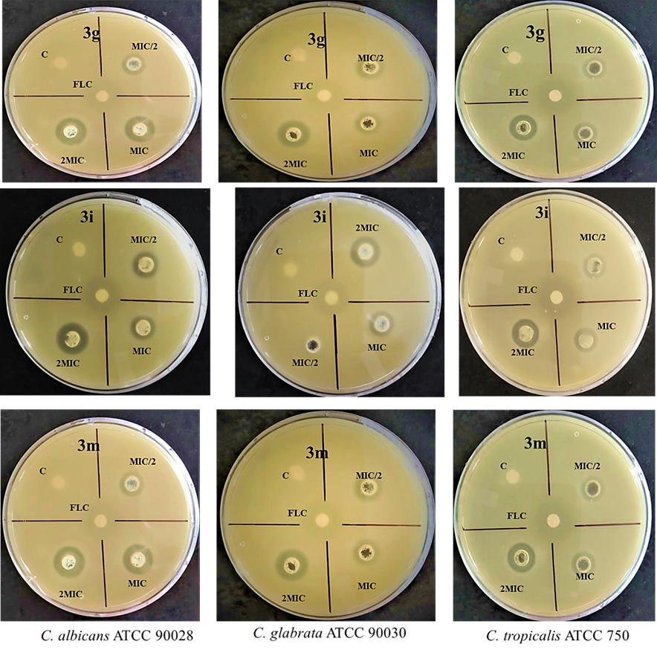
Figure S13. In vitro susceptibility of test compounds against Candida albicans ATCC 90028, Candida glabrata ATCC 90030 and Candida tropicalis ATCC 750. Fluconazole was taken as a positive control. The MIC of FLC (positive control) was 10 µg/ml and gave ZOI of 21 mm.
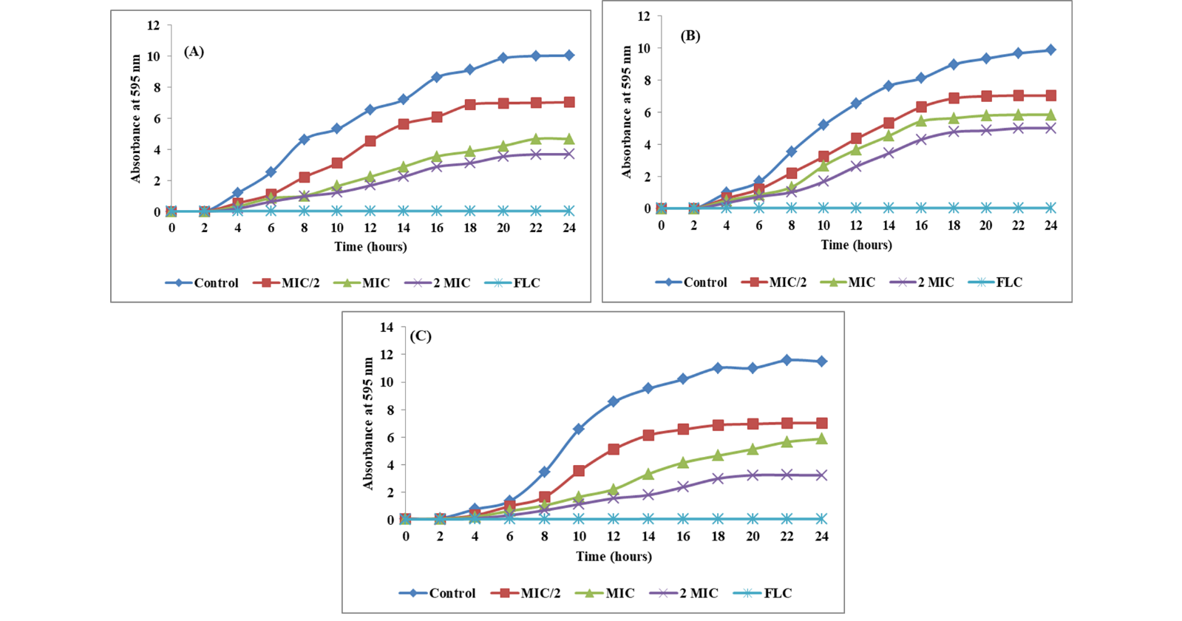
Figure S14. Growth pattern of C. albicans ATCC 90028 (A), C. glabrata ATCC 90030 (B) and C. tropicalis ATCC 750 (C) in absence and presence of 3g at varying concentrations. Fluconazole was taken as positive control at its MIC value (10 μg/ml).

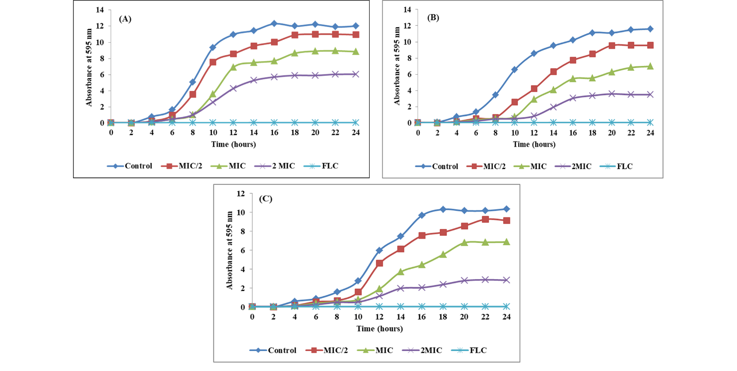
Figure S14. Growth pattern of C. albicans ATCC 90028 (A), C. glabrata ATCC 90030 (B) and C. tropicalis ATCC 750 (C) in absence and presence of 3i at varying concentrations. Fluconazole was taken as positive control at its MIC value (10 μg/ml).

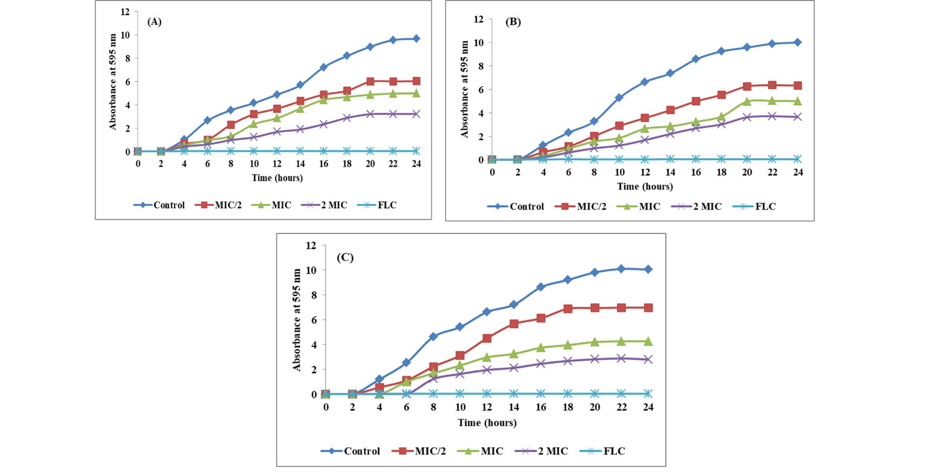
Figure S14. Growth pattern of C. albicans ATCC 90028 (A), C. glabrata ATCC 90030 (B) and C. tropicalis ATCC 750 (C) in absence and presence of 3m at varying concentrations. Fluconazole was taken as positive control at its MIC value (10 μg/ml).

