Raw imaging of Western blot gel

Figure 1
Figure 1A LDHA

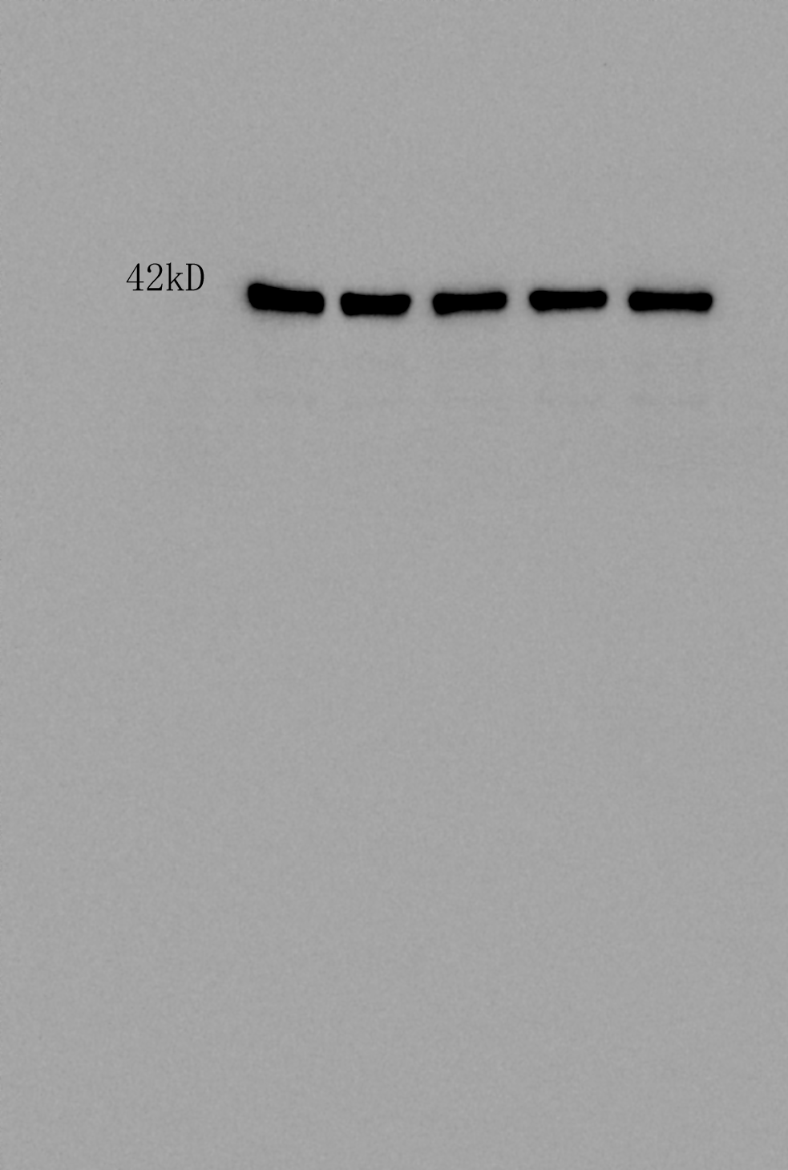
Figure 1A Actin

Figure 5
Figure 5A LDHA (1)
Figure 5A LDHA (2)

Figure 5A Actin(1)
Figure 5A Actin(2)

