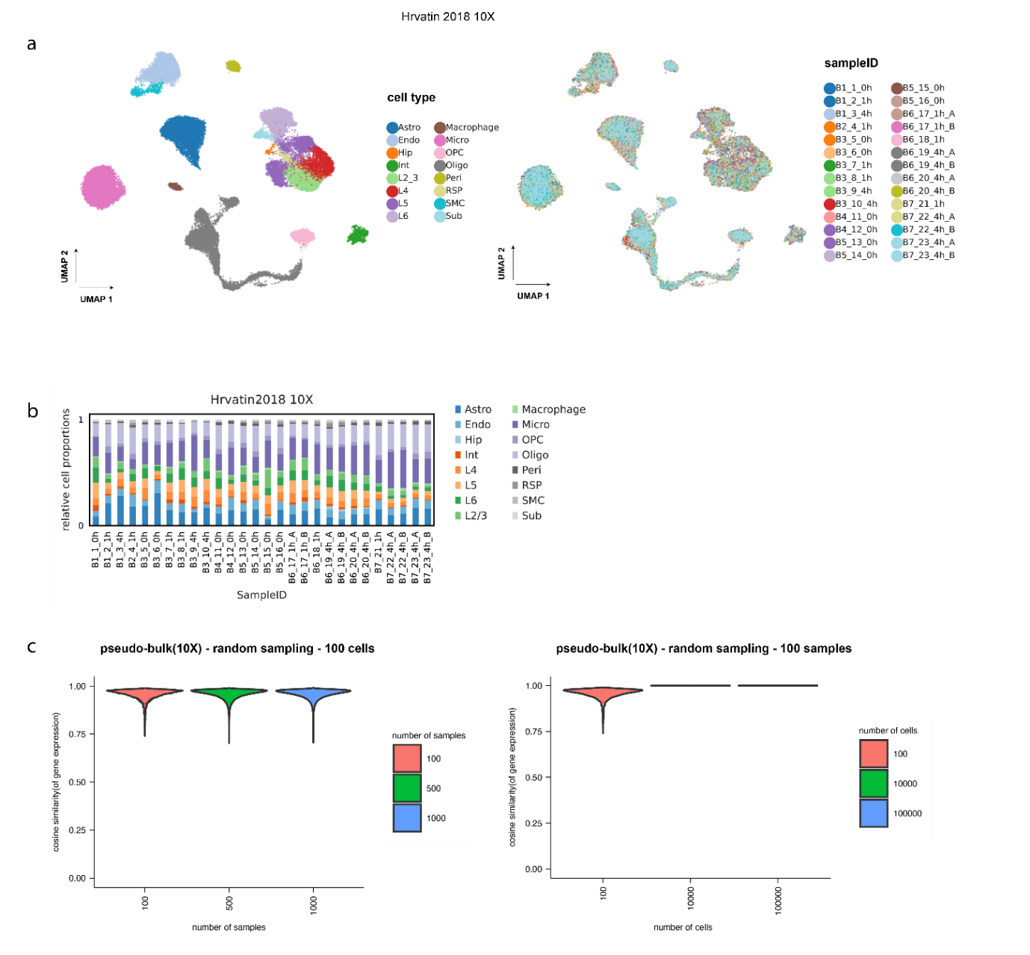

Supplementary Figure 1. Multi-Parametric simulation for pseudo-bulk RNA-seq data deriving from single-cell RNA-Seq data

a.UMAP plot of 10x mouse brain single-cell dataset after filtering and reanalysis. The dataset contains 16 cell-types as shown with different colours (left) and 28 samples. b. bar plot of cell-type proportions for each sample based on the single-cell dataset. c. violin plot of the cosine similarity of gene expression in randomly sampled pseudo-bulks with 100,500 and 1000 samples (left) as well as across different numbers of sampled cells 100, 10K and 100K (right).

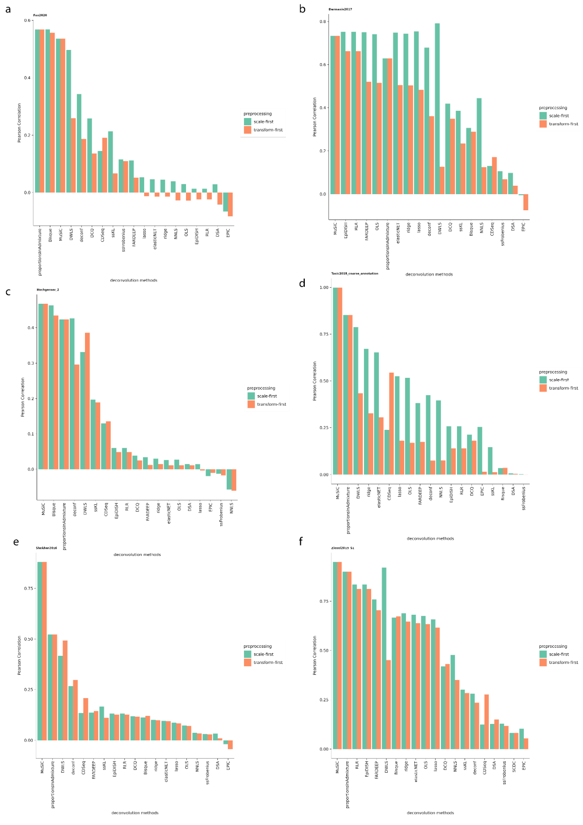

Supplementary Figure 2: Preprocessing of simulated data from 6 brain tissue datasets.
a-e. Barplots showing Pearson Correlation values of 6 self-reference deconvolution tasks in which the effect of scaling or transforming first the input matrices is tested.
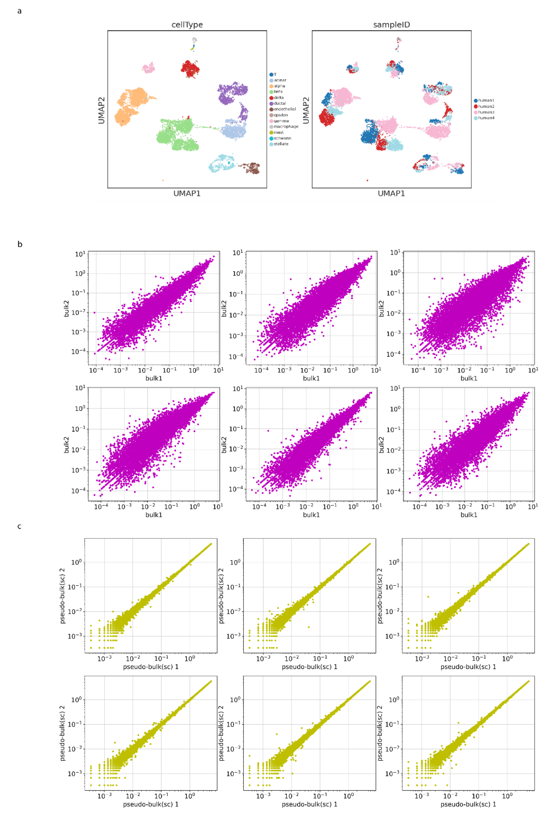
Supplementary Figure 3. Comparison of gene expression in pseudo-bulk (sc) and real bulk data.

a.UMAP plot of a single-cell dataset (BaronHuman2018) from 4 pancreatic islets after re-analysis, different colours indicate different cell-types based on author’s annotations (left) or the different samples (right). b. Scatter plot demonstrating gene expression between 12 different bulk samples from Fadista2015 pancreatic RNA-seq dataset. c. scatter plot of gene expression deriving from 12 pseudo-bulk profiles generated from the pancreatic single-cell dataset

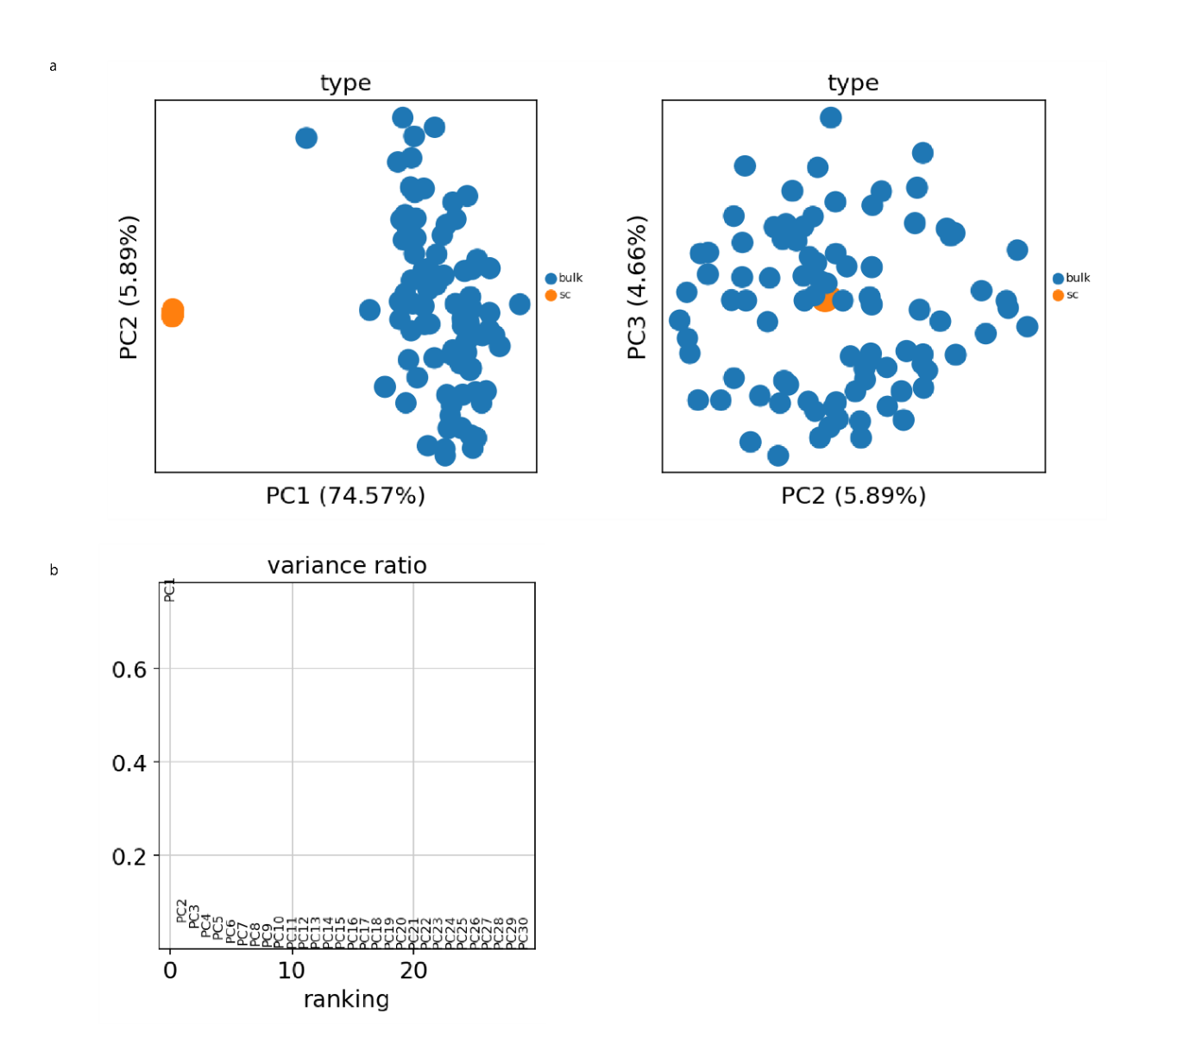

Supplementary Figure 4 : Combined Principal Component Analysis of real bulk and pseudo-bulk samples.

a.PCA results from 78 real bulk samples (Fadista 2014) and 78 pseudo-bulk samples (BaronHuman2018). PC1 and PC2 can explain 80.46% of the variance (left) , PC2 and PC3 shown on the right scatter plot. b. Variance ratio plot, "Explained" variance ratio as a function of the number of principal components. The inclusion of 30 PCs accounts for 98.08% of the variance.

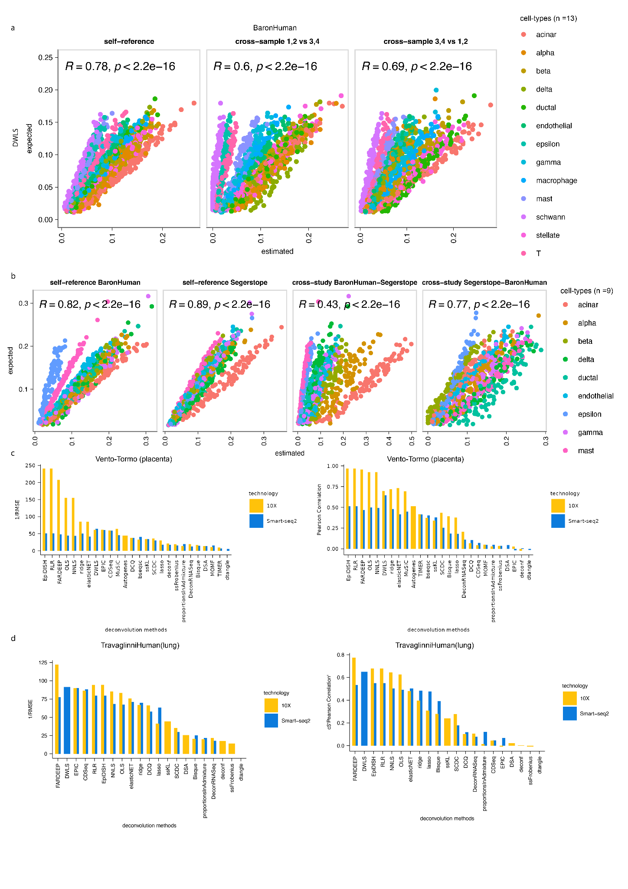

Supplementary Figure 5: Cross-reference deconvolution of pseudo-bulk samples across different tissues.

a.scatter plots showing results from self-reference and 2 examples of cross-sample deconvolution from the method DWLS utilising a single-cell from human pancreas(13 cell-types). Pearson correlation(R) and p-value are reported for each task. b.scatter plots showing the results from two self-reference tasks from two pancreatic studies(9 cell-types) as well as two cross-study deconvolution tasks. c. Bar plots showing 1/RMSE and Pearson correlation values from the 26 feasible deconvolution runs from two placenta tissue datasets that come from the same study but different technologies (10X and Smart-seq2). d. Bar plots showing 1/RMSE and Pearson correlation values from the 26 feasible deconvolution runs from two lung tissue datasets that come from the same study but different technologies (10X and Smart-seq2)

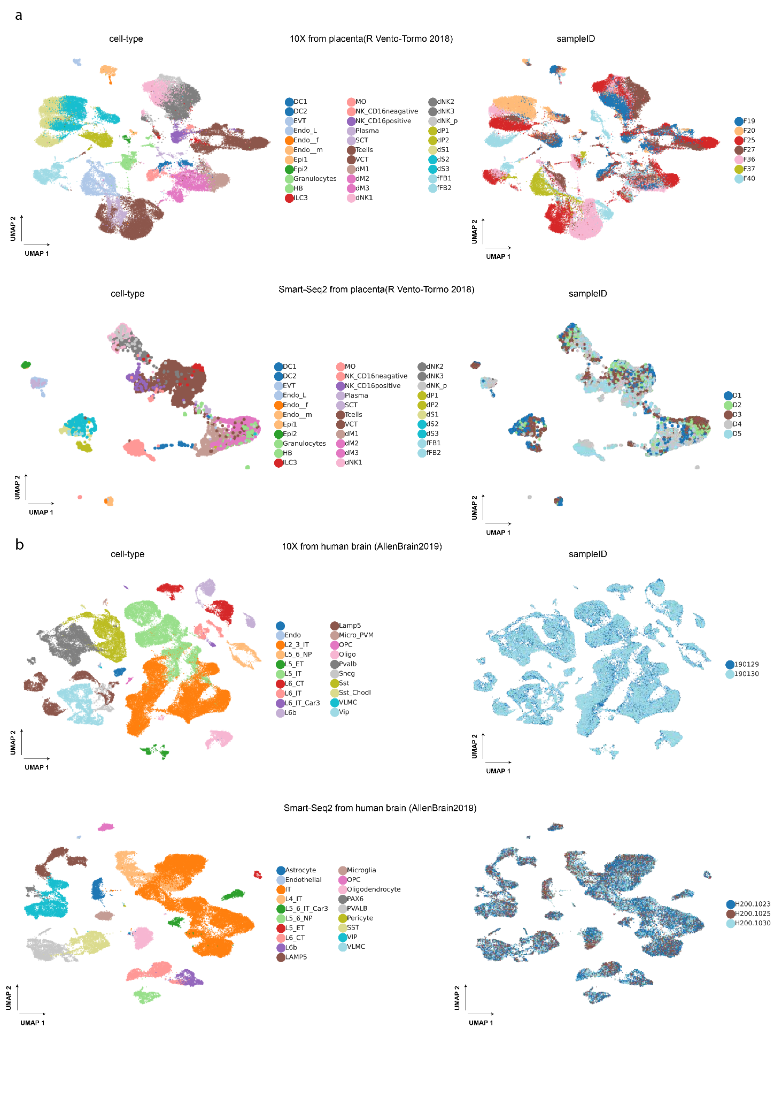

Supplementary Figure 6 : Single-cell references from human placenta and brain for cross-technology deconvolution

a.UMAP plots of two single-cell dataset(10X and Smart-Seq2) from human placenta after re-analysis, different colours indicate different cell-types based on author’s annotations (left) or the different samples (right). b. UMAP plots of two single-cell dataset(10X and Smart-Seq2) from human brain after re-analysis, different colours indicate different cell-types based on author’s annotations (left) or the different samples (right).

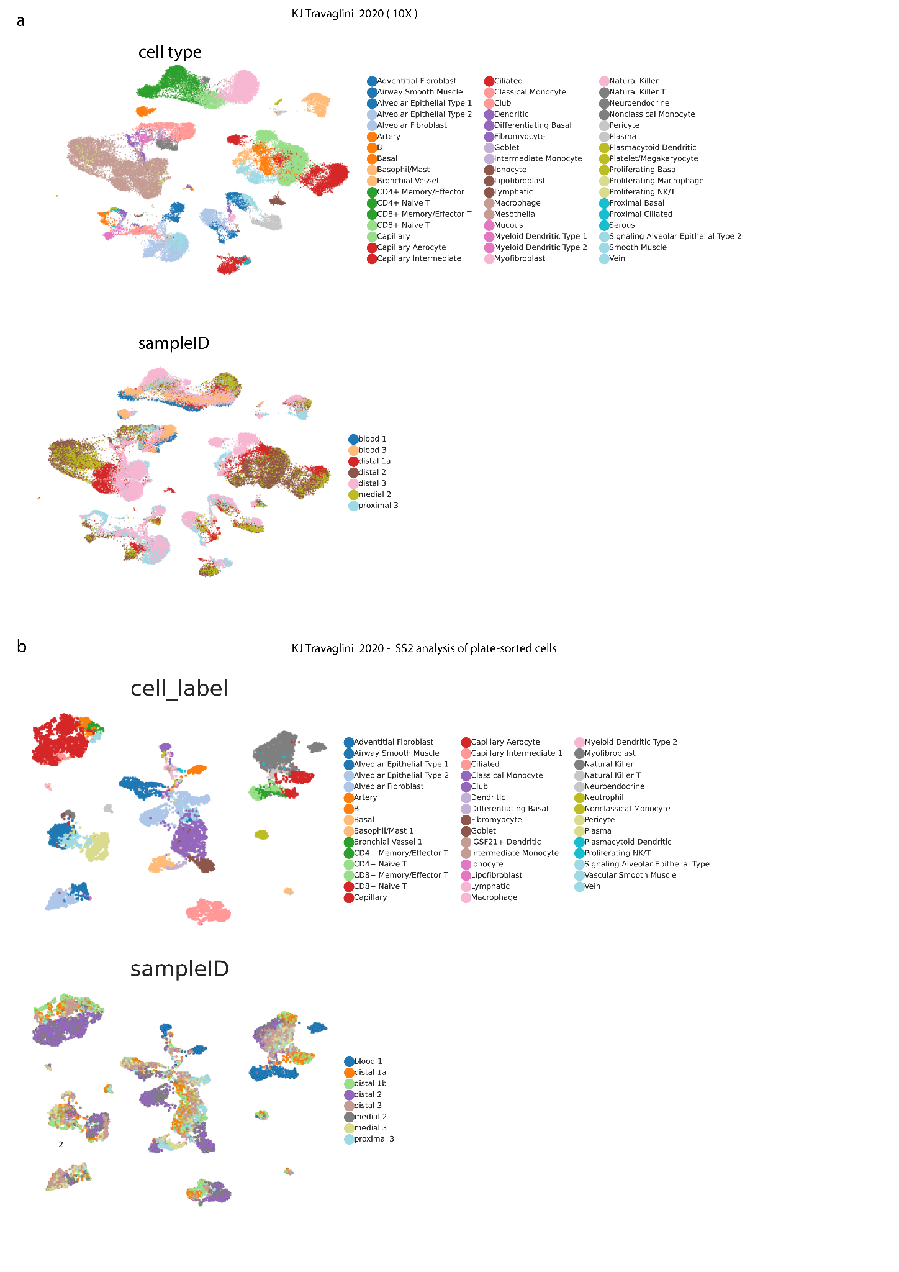

Supplementary Figure 7 : Single-cell references from human lung tissue.
a.UMAP plots of a single-cell 10X dataset from human lung after re-analysis, different colours indicate different cell-types based on author’s annotations (top) or the different samples (bottom). b. UMAP plots of a single-cell Smart-seq2 dataset from human lung after re-analysis, different colours indicate different cell-types based on author’s annotations (top) or the different samples (bottom).

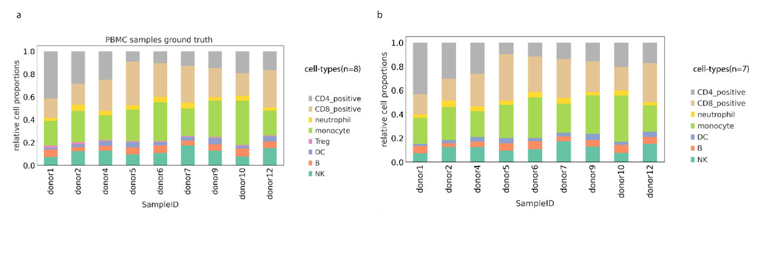

Supplementary Figure 8. Ground truth proportions of PBMC data
a. Bar plot showing initial ground truth proportions of 9 PMBC samples measured by flow cytometry. b. Bar plot with ground truth proportions after summing up cell-type proportions of CD4+ T cells and T-regs
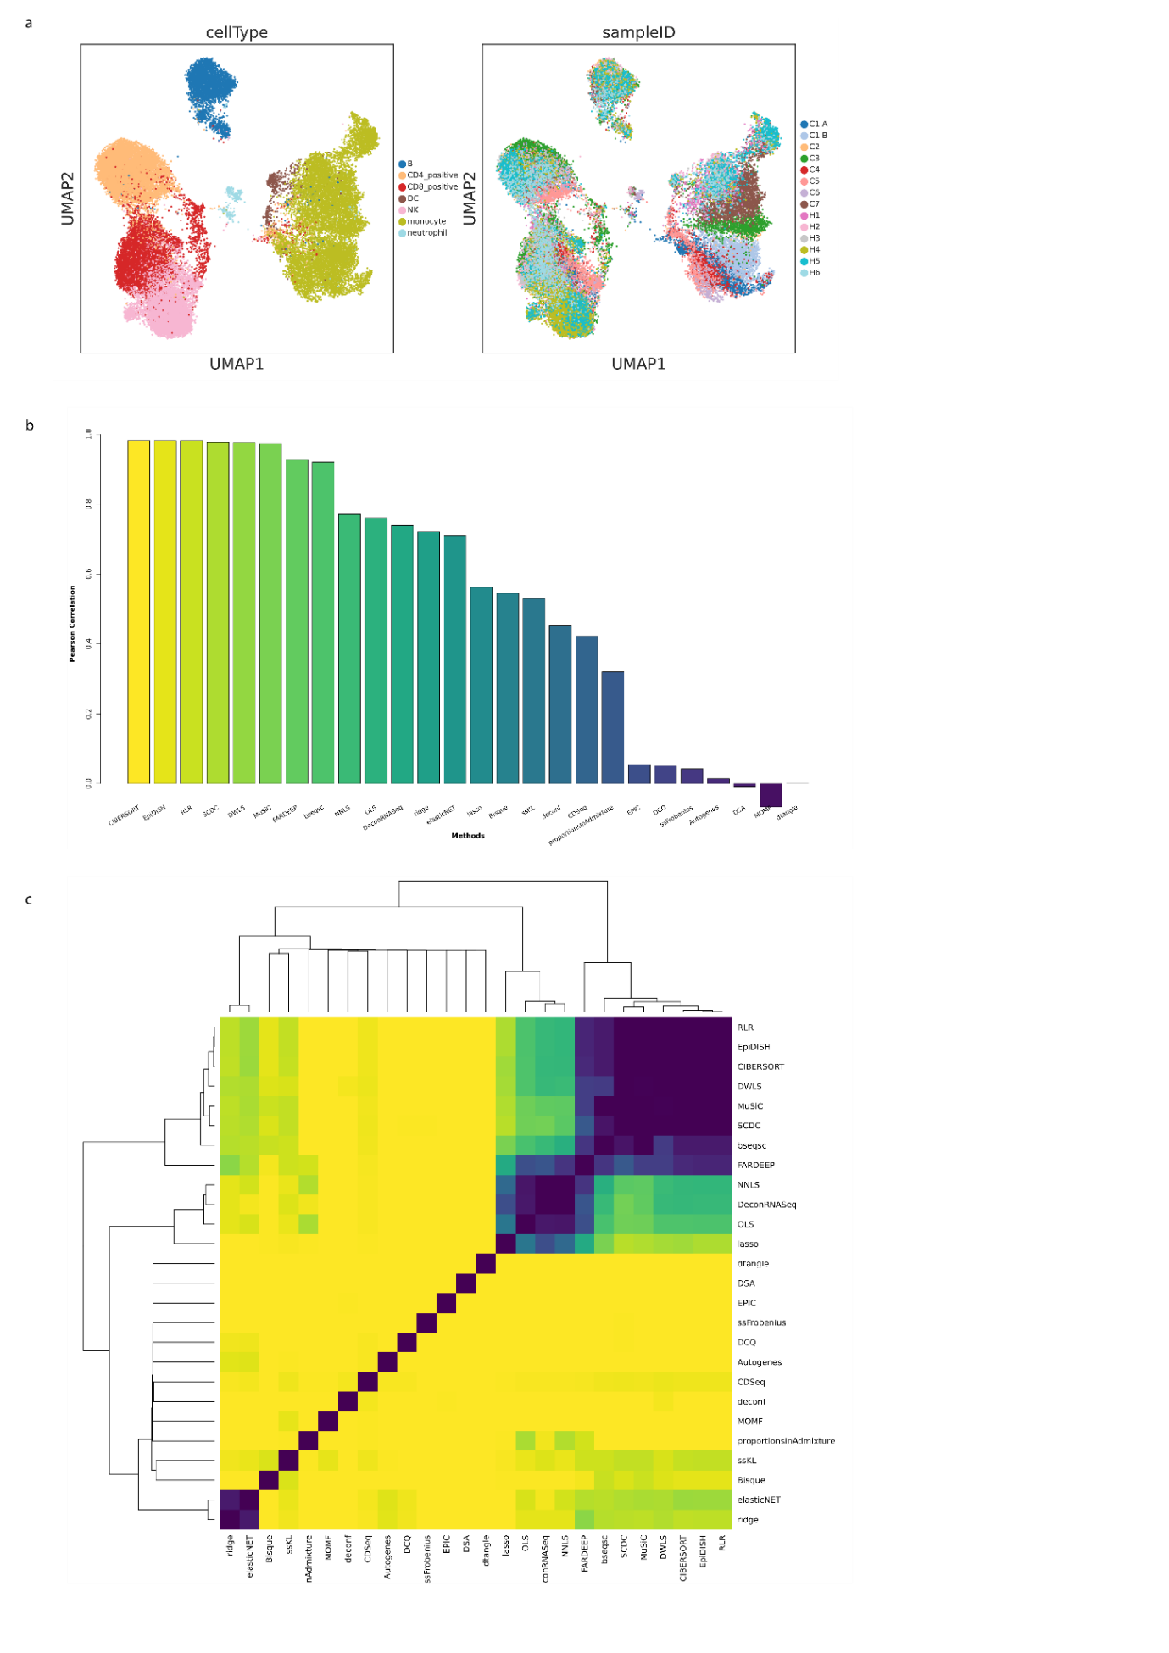
Supplementary Figure 9. Self-reference deconvolution utilising a PBMC single-cell reference.

a. Umap plots of a single-cell PBMC dataset from Wilk2020 after re-analysis. Cell-type and sampleIDs are shown in the two UMAPs respectively. b. Results from self-reference deconvolution task using Wilk2020 single-cell RNA-Seq dataset. c. Pairwise correlation approach to compare results across methods.

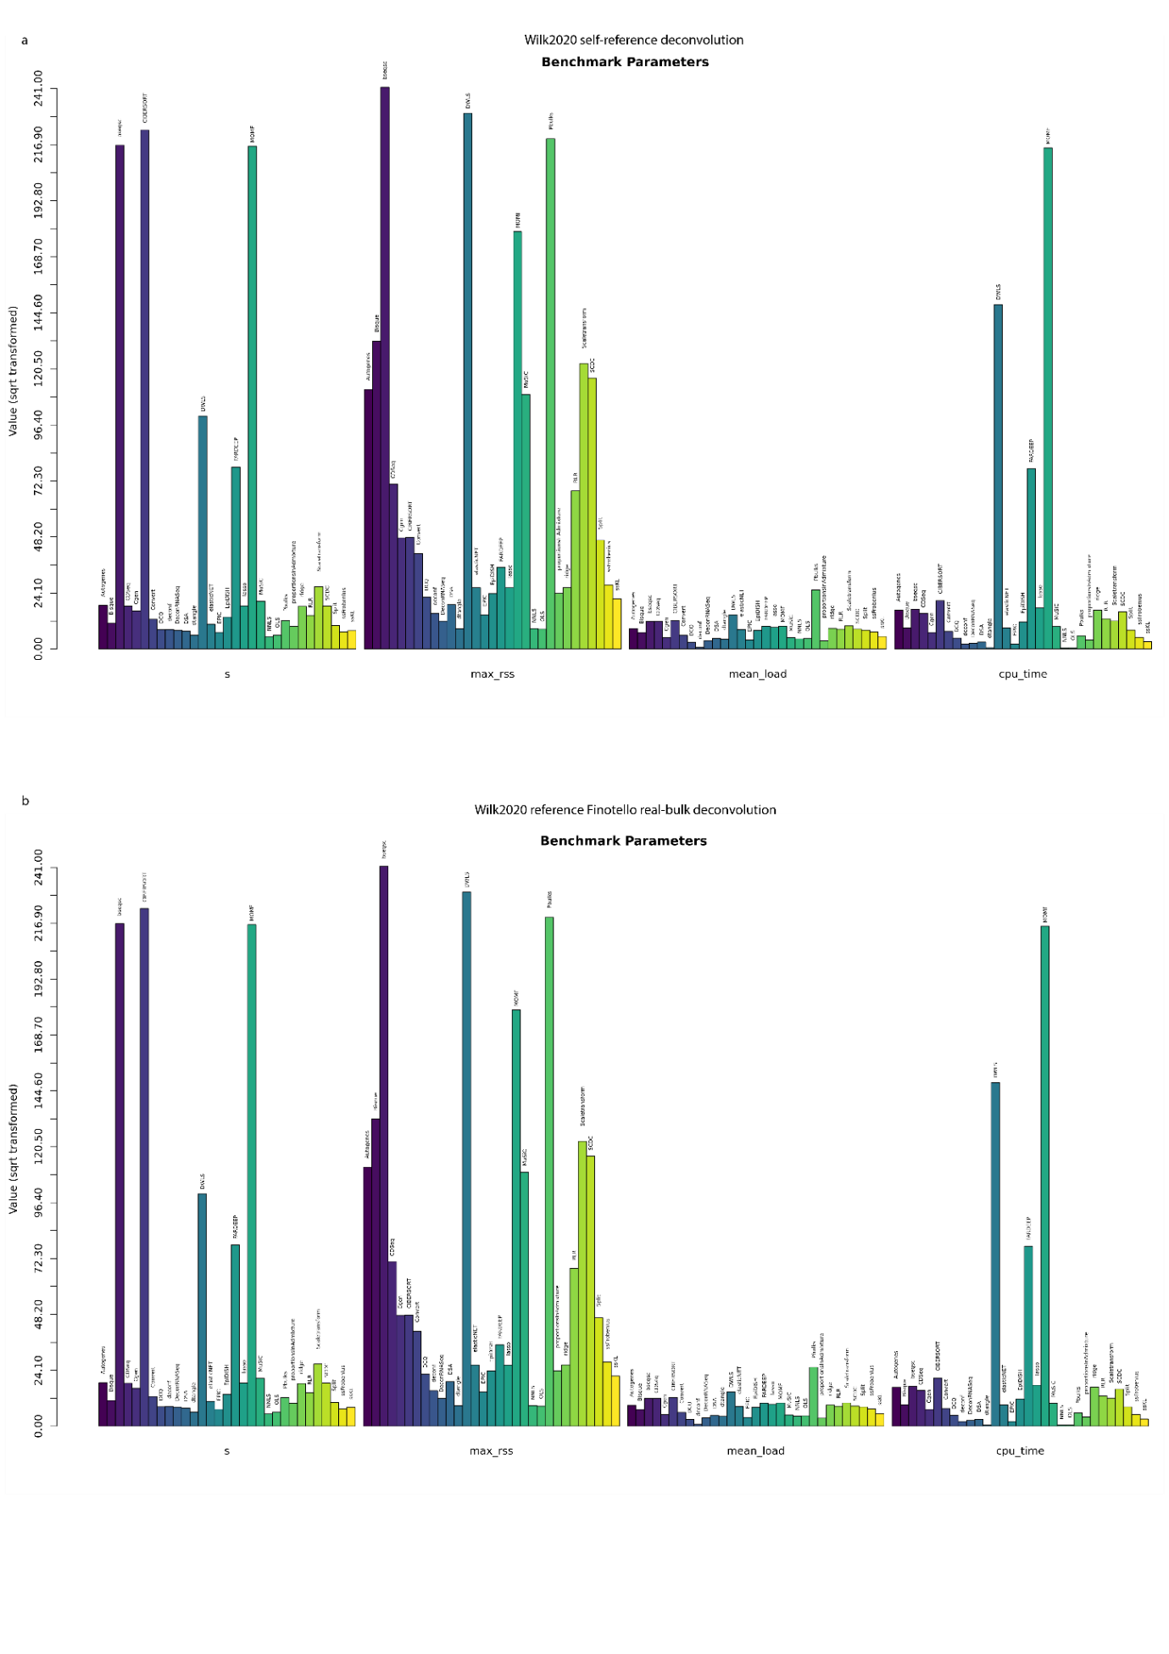

Supplementary Figure 10. Evaluation of scalability on simulated and real PBMC data.
a-b. for scalability assessment purposes, time (s), memory (maximum resident set size), mean load (CPU usage divided by total time) and CPU time are visualised in barplot for Wilk2020-self-reference task as well as for the deconvolution of Finotello PBMC real bulk samples.

