Supplementary tables

Table S1: List of accessions chosen to constitute the Senegalese pearl millet core collection
Entry | Sample | Morphotype | Phenotypic traits subgroup
1 | PgSL1 | Sanio | Subgroup_1
4 | PgSL4 | Sanio | Subgroup_1
9 | PgSL9 | Sanio | Subgroup_1
21 | PgSL21 | Sanio | Subgroup_1
23 | PgSL23 | Sanio | Subgroup_1
24 | PgSL24 | Sanio | Subgroup_1
25 | PgSL25 | Sanio | Subgroup_1
26 | PgSL26 | Sanio | Subgroup_1
27 | PgSL27 | Sanio | Subgroup_1
29 | PgSL29 | Sanio | Subgroup_1
31 | PgSL31 | Sanio | Subgroup_1
2 | PgSL2 | Sanio | Subgroup_2
3 | PgSL3 | Sanio | Subgroup_2
7 | PgSL7 | Sanio | Subgroup_2
11 | PgSL11 | Sanio | Subgroup_2
12 | PgSL12 | Sanio | Subgroup_2
15 | PgSL15 | Sanio | Subgroup_2
16 | PgSL16 | Sanio | Subgroup_2
20 | PgSL20 | Sanio | Subgroup_2
22 | PgSL22 | Sanio | Subgroup_2
28 | PgSL28 | Sanio | Subgroup_2
30 | PgSL30 | Sanio | Subgroup_2
5 | PgSL5 | Sanio | Subgroup_3
6 | PgSL6 | Sanio | Subgroup_3
8 | PgSL8 | Sanio | Subgroup_3
10 | PgSL10 | Sanio | Subgroup_3
13 | PgSL13 | Sanio | Subgroup_3
14 | PgSL14 | Sanio | Subgroup_3
17 | PgSL17 | Sanio | Subgroup_3
18 | PgSL18 | Sanio | Subgroup_3
19 | PgSL19 | Sanio | Subgroup_3
69 | PgSL69 | Souna | Subgroup_1
71 | PgSL71 | Souna | Subgroup_1
72 | PgSL72 | Souna | Subgroup_1
73 | PgSL73 | Souna | Subgroup_1
77 | PgSL77 | Souna | Subgroup_1
35 | PgSL35 | Souna | Subgroup_1
38 | PgSL38 | Souna | Subgroup_1
39 | PgSL39 | Souna | Subgroup_1
44 | PgSL44 | Souna | Subgroup_1
48 | PgSL48 | Souna | Subgroup_1
53 | PgSL53 | Souna | Subgroup_1
55 | PgSL55 | Souna | Subgroup_1
59 | PgSL59 | Souna | Subgroup_1
63 | PgSL63 | Souna | Subgroup_1
65 | PgSL65 | Souna | Subgroup_2
66 | PgSL66 | Souna | Subgroup_2
67 | PgSL67 | Souna | Subgroup_2
68 | PgSL68 | Souna | Subgroup_2
82 | PgSL82 | Souna | Subgroup_2
83 | PgSL83 | Souna | Subgroup_2
85 | PgSL85 | Souna | Subgroup_2
87 | PgSL87 | Souna | Subgroup_2
88 | PgSL88 | Souna | Subgroup_2
90 | PgSL90 | Souna | Subgroup_2
91 | PgSL91 | Souna | Subgroup_2
70 | PgSL70 | Souna | Subgroup_2
79 | PgSL79 | Souna | Subgroup_2
81 | PgSL81 | Souna | Subgroup_2
32 | PgSL32 | Souna | Subgroup_2
33 | PgSL33 | Souna | Subgroup_2
34 | PgSL34 | Souna | Subgroup_2
36 | PgSL36 | Souna | Subgroup_2
42 | PgSL42 | Souna | Subgroup_2
45 | PgSL45 | Souna | Subgroup_2
46 | PgSL46 | Souna | Subgroup_2
49 | PgSL49 | Souna | Subgroup_2
50 | PgSL50 | Souna | Subgroup_2
51 | PgSL51 | Souna | Subgroup_2
52 | PgSL52 | Souna | Subgroup_2
54 | PgSL54 | Souna | Subgroup_2
56 | PgSL56 | Souna | Subgroup_2
57 | PgSL57 | Souna | Subgroup_2
58 | PgSL58 | Souna | Subgroup_2
61 | PgSL61 | Souna | Subgroup_2
62 | PgSL62 | Souna | Subgroup_2
64 | PgSL64 | Souna | Subgroup_2
84 | PgSL84 | Souna | Subgroup_3
86 | PgSL86 | Souna | Subgroup_3
89 | PgSL89 | Souna | Subgroup_3
74 | PgSL74 | Souna | Subgroup_3
75 | PgSL75 | Souna | Subgroup_3
76 | PgSL76 | Souna | Subgroup_3
78 | PgSL78 | Souna | Subgroup_3
80 | PgSL80 | Souna | Subgroup_3
37 | PgSL37 | Souna | Subgroup_3
40 | PgSL40 | Souna | Subgroup_3
41 | PgSL41 | Souna | Subgroup_3
43 | PgSL43 | Souna | Subgroup_3
47 | PgSL47 | Souna | Subgroup_3
60 | PgSL60 | Souna | Subgroup_3

Table S2: Representativeness statistics of early (Souna) and late (Sanio) flowerings landraces core collection. %MD= Percentage of mean difference, %VD= Percentage of variance difference, % CR= Coincidence rate, and %VR= Variable rate

 | %CR |  | %VR |  | %VD |  | %MD
Souna | 96.97 |  | 131.8 |  | 40.49 |  | 1.7
Sanio | 92.54 |  | 104.58 |  | 14.47 |  | 0.99

Table S3: Means, P-values and correlation with axis from the Discriminant Analysis of early- and late- flowerings

Trait | Souna | Sanio | p-value | Correlation
DM | 0.043 (± 0.039) | 0.004 (± 0.008) | < 0.0001 | -0.5167
HT | 48.378 (± 3.094) | 71.796 (± 5.634) | < 0.0001 | 0.9588
FLO | 52.317 (± 2.897) | 76.801 (± 5.823) | < 0.0001 | 0.9639
NPT | 5.534 (± 0.933) | 7.928 (± 1.012) | < 0.0001 | 0.7835
NTN | 8.207 (± 0.433) | 11.479 (± 1) | < 0.0001 | 0.9375
IL | 20.622 (± 1.046) | 22.025 (± 0.975) | < 0.0001 | 0.5612
FLL | 44.93 (± 3.472) | 48.354 (± 3.229) | < 0.0001 | 0.4448
FLW | 4.641 (± 0.405) | 4.491 (± 0.358) | 0.0858 | -0.185
MSD | 4.232 (± 0.319) | 4.131 (± 0.289) | 0.1413 | -0.1588
PH | 220.266 (± 18.434) | 282.191 (± 18.293) | < 0.0001 | 0.8684
SL | 51.559 (± 7.02) | 43.754 (± 5.702) | < 0.0001 | -0.5034
ST | 8.13 (± 0.714) | 8.993 (± 0.905) | < 0.0001 | 0.4768
PE | 3.956 (± 1.734) | 1.583 (± 1.191) | < 0.0001 | -0.5988
SW | 5.863 (± 0.555) | 5.762 (± 0.478) | 0.3915 | -0.0929
Biomass | 1156.411 (± 318.566) | 2228.964 (± 376.957) | < 0.0001 | 0.8525
GY | 1341.09 (± 418.2) | 2195.8 (± 743.151) | < 0.0001 | 0.6105

Table S4: Descriptive statistics of 12 traits in the germplasm and the core collection of early flowerings. SD= Standard deviation, VC= Variation coefficients, DM= Downy mildew incidence, FLO= 50% Flowering time, NTN= Nodal tiller number, PH= Plant height, NPT= Number of productive tillers, FLL= Flag leaf length, FLW= Flag leaf width, SL= Spike length, ST= Spike thickness, SW= 1000 seed weight, GY= Grain yield, PY= Panicle Yield
 |  | All Early flowering |  |  |  |  |  |  |  | Early Core set
Characters |  | Min - Max |  | Mean |  | SD |  | VC |  | Min - Max |  | Mean |  | SD |  | VC
DM |  | 2,08 - 42,67 |  | 15,08 |  | 5,53 |  | 0,37 |  | 2,08 - 42,67 |  | 15 |  | 7,39 |  | 0,49
FLO |  | 52,83 - 65,92 |  | 57,09 |  | 2,23 |  | 0,04 |  | 52,83 - 65,92 |  | 57,77 |  | 2,93 |  | 0,05
NPT |  | 2,59 - 6,42 |  | 4,46 |  | 0,5 |  | 0,11 |  | 2,59 - 6,42 |  | 4,51 |  | 0,64 |  | 0,14
PH |  | 193,24 - 270,47 |  | 235,84 |  | 10,83 |  | 0,05 |  | 193,24 - 267,64 |  | 234,41 |  | 14,99 |  | 0,06
NTN |  | 7,11 - 9,06 |  | 7,98 |  | 0,35 |  | 0,04 |  | 7,22 - 9,06 |  | 8,04 |  | 0,44 |  | 0,05
FLL |  | 40,09 - 57,74 |  | 47,41 |  | 2,57 |  | 0,05 |  | 40,09 - 57,74 |  | 47,57 |  | 3,27 |  | 0,07
FLW |  | 3,82 - 5,59 |  | 4,71 |  | 0,26 |  | 0,06 |  | 04 - 5,42 |  | 4,68 |  | 0,32 |  | 0,07
SL |  | 34,91 - 70,9 |  | 53,06 |  | 4,59 |  | 0,09 |  | 34,91 - 70,9 |  | 51,73 |  | 5,77 |  | 0,11
ST |  | 6,61 - 10,64 |  | 8,44 |  | 0,44 |  | 0,05 |  | 6,61 - 10,64 |  | 8,45 |  | 0,65 |  | 0,08
SW |  | 5,63 - 8,34 |  | 6,95 |  | 0,37 |  | 0,05 |  | 5,78 - 8,34 |  | 6,92 |  | 0,42 |  | 0,06
GY |  | 440,72 - 2195,73 |  | 1537,51 |  | 227,4 |  | 0,15 |  | 440,72 - 2161,27 |  | 1427,39 |  | 300,2 |  | 0,21
PY |  | 1174,56 - 3499,66 |  | 2557,74 |  | 319,79 |  | 0,13 |  | 1174,56 - 3499,66 |  | 2453,56 |  | 430,69 |  | 0,18

Table S5: Descriptive statistics of 12 traits in the germplasm and the core collection of late flowerings. SD= Standard deviation, VC= Variation coefficients, DM= Downy mildew incidence, FLO= 50% Flowering time, NTN= Nodal tiller number, PH= Plant height, NPT= Number of productive tillers, FLL= Flag leaf length, FLW= Flag leaf width, SL= Spike length, ST= Spike thickness, SW= 1000 seed weight, GY= Grain yield, PY= Panicle Yield

 |  | All Late flowering |  |  |  |  |  |  |  | Late Core set
Characters |  | Min - Max |  | Mean |  | SD |  | VC |  | Min - Max |  | Mean |  | SD |  | VC
DM |  | 12,61 - 35,98 |  | 24,17 |  | 4,27 |  | 0,18 |  | 12,61 - 35,98 |  | 24,33 |  | 4,65 |  | 0,19
FLO |  | 80,08 - 91,75 |  | 86,23 |  | 3,36 |  | 0,04 |  | 80,5 - 91,25 |  | 86,23 |  | 3,44 |  | 0,04
NPT |  | 08 - 12 |  | 9,81 |  | 0,79 |  | 0,08 |  | 08 - 11,58 |  | 9,94 |  | 0,87 |  | 0,09
PH |  | 309,58 - 361,42 |  | 335,63 |  | 10,76 |  | 0,03 |  | 309,58 - 361,42 |  | 335,22 |  | 11,16 |  | 0,03
NTN |  | 12,48 - 14,45 |  | 13,48 |  | 0,46 |  | 0,03 |  | 12,6 - 14,45 |  | 13,56 |  | 0,48 |  | 0,04
FLL |  | 48,7 - 58,12 |  | 52,33 |  | 1,81 |  | 0,03 |  | 49,57 - 58,12 |  | 52,42 |  | 2 |  | 0,04
FLW |  | 3,56 - 4,2 |  | 3,89 |  | 0,14 |  | 0,04 |  | 3,56 - 4,2 |  | 3,87 |  | 0,16 |  | 0,04
SL |  | 34,82 - 48,25 |  | 40,13 |  | 2,88 |  | 0,07 |  | 35,53 - 46,52 |  | 40,54 |  | 2,68 |  | 0,07
ST |  | 1,38 - 1,72 |  | 1,55 |  | 0,07 |  | 0,04 |  | 1,38 - 1,68 |  | 1,54 |  | 0,06 |  | 0,04
SW |  | 5,35 - 7,08 |  | 6,2 |  | 0,37 |  | 0,06 |  | 5,52 - 6,87 |  | 6,15 |  | 0,33 |  | 0,05
GY |  | 511,37 - 1104,86 |  | 853,57 |  | 128,57 |  | 0,15 |  | 511,37 - 1102,32 |  | 809,02 |  | 136,69 |  | 0,17
PY |  | 1443,45 - 3550,03 |  | 2248,88 |  | 375,65 |  | 0,17 |  | 1443,45 - 3550,03 |  | 2197,09 |  | 456,56 |  | 0,21

Supplementary figures

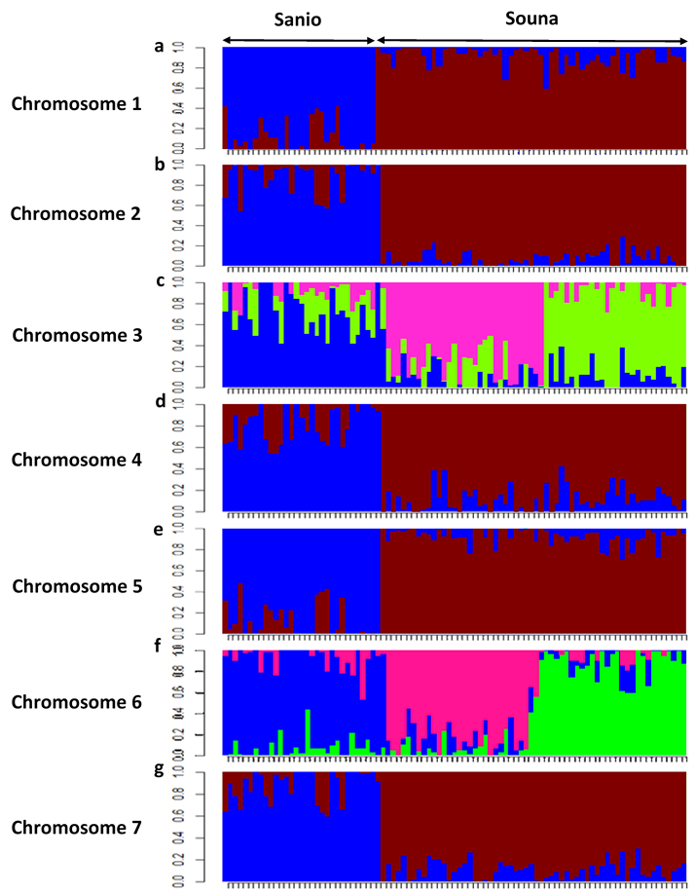

Figure S1: Genetic Structure of Senegalese pearl millet landraces core collection at chromosome level (a-g) from chromosome 1 to chromosome 7, respectively
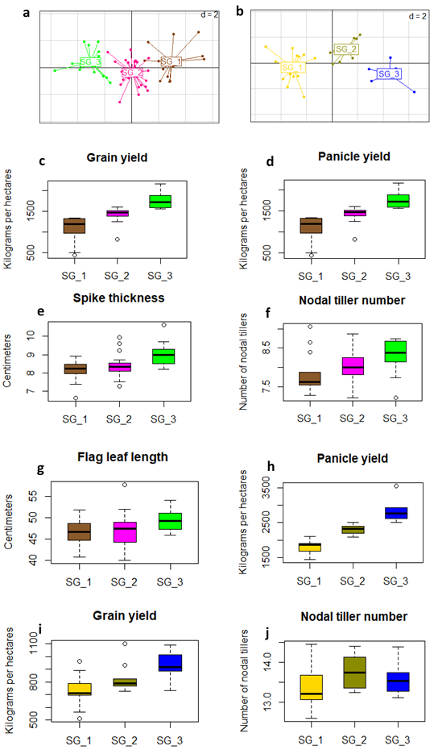

Figure S2: Discriminant analysis of (a) early flowering (Axis1= 98.49, Axis2= 1.51) and (b) late flowering landraces (Axis1=95.59, Axis2=4.41), from phenotypic traits of accessions of the core collection. Boxplots of (c) grain yield, (d) panicle yield, (e) Spike thickness, (f) Nodal tiller number and (g) Flag leaf length according to different subgroups of early flowering landraces. Boxplots of (h) panicle yield, (i) grain yield and (j) Nodal tiller number according to different subgroups of late flowering landraces of the core collection.

