Supporting Information

Stacking Faults Defect-Rich MoNi Alloy for Ultrahigh-Performance Hydrogen Evolution

Yuan Wang,^{a,b,*} Hamidreza Arandiyan,^{c,d,*} Sajjad S. Mofarah,^{e} Xiangjian Shen,^{f} Stuart A. Bartlett,^{g} Pramod Koshy,^{f} Charles C. Sorrell,^{f} Hongyu Sun,^{h} Cristina Pozo-Gonzalo,^{b} Kamran Dastafkan,ª Sylvia Britto,^{g} Suresh K. Bhargava,^{d} Chuan Zhao^{a,*}

Dr. Yuan Wang, Dr. Kamran Dastafkan, Prof. Chuan Zhao
ª School of Chemistry, The University of New South Wales, Sydney, NSW 2052, Australia

Dr. Yuan Wang, Dr. Cristina Pozo-Gonzalo
^{b} Institute for Frontier Materials, Deakin University, Melbourne, Vic 3125, Australia

Dr. Hamidreza Arandiyan
^{c} Laboratory of Advanced Catalysis for Sustainability, School of Chemistry, University of Sydney, Sydney, NSW 2006, Australia

Dr. Hamidreza Arandiyan, Prof. Suresh K. Bhargava
^{d} Centre for Applied Materials and Industrial Chemistry (CAMIC), School of Science, RMIT University, Melbourne, Vic 3001, Australia

Dr. Sajjad S. Mofarah, Dr. Pramond Koshy, Prof. Charles C. Sorrell
^{e} School of Materials Science and Engineering, UNSW Sydney, Sydney, NSW 2052, Australia

Prof. Xiangjian Shen
^{f} Engineering Research Centre of Advanced Functional Material Manufacturing of Ministry of Education, Zhengzhou University, Zhengzhou, 450001 PR China

Dr. Stuart A. Bartlett, Dr. Sylvia Britto
^{g} Diamond Light Source, Harwell Science and Innovation Campus, Didcot OX11 0DE, UK

Prof. Hongyu Sun
^{h} School of Resources and Materials, Northeastern University at Qinhuangdao, Qinhuangdao 066004, PR China

*Corresponding authors: helena.wang@deakin.edu.au (Y. Wang), hamid.arandiyan@sydney.edu.au (H. Arandiyan), chuan.zhao@unsw.edu.au (C. Zhao)

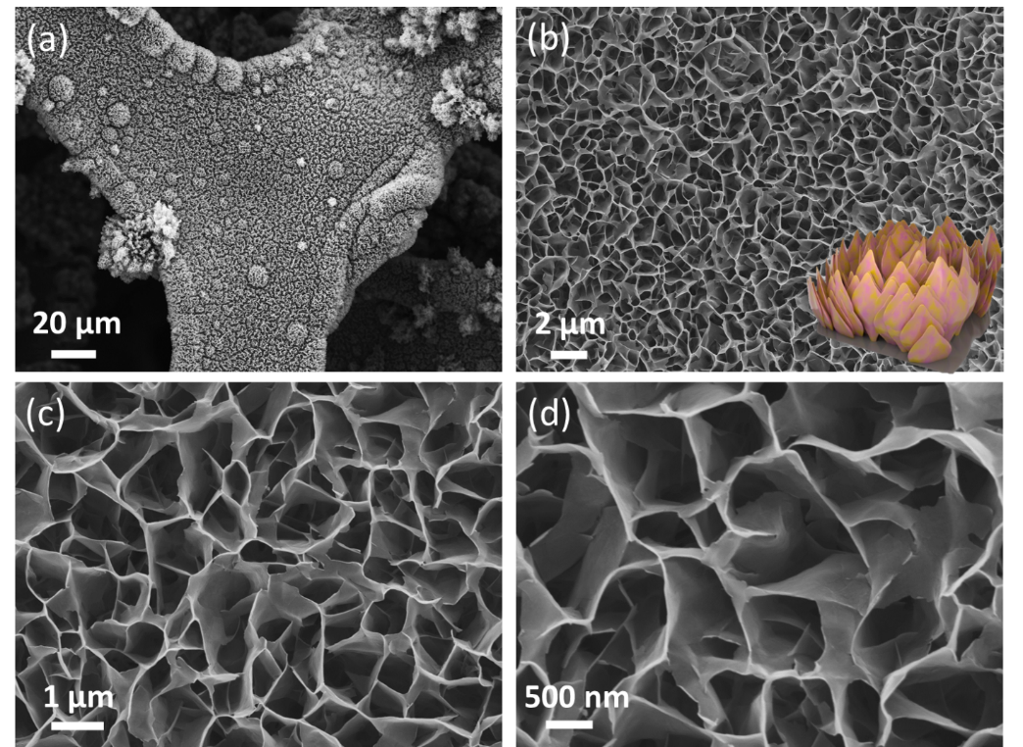
Fig. S1. (a-d) SEM images of the hydrothermal products MoNiO_{x} before reduction treatments.

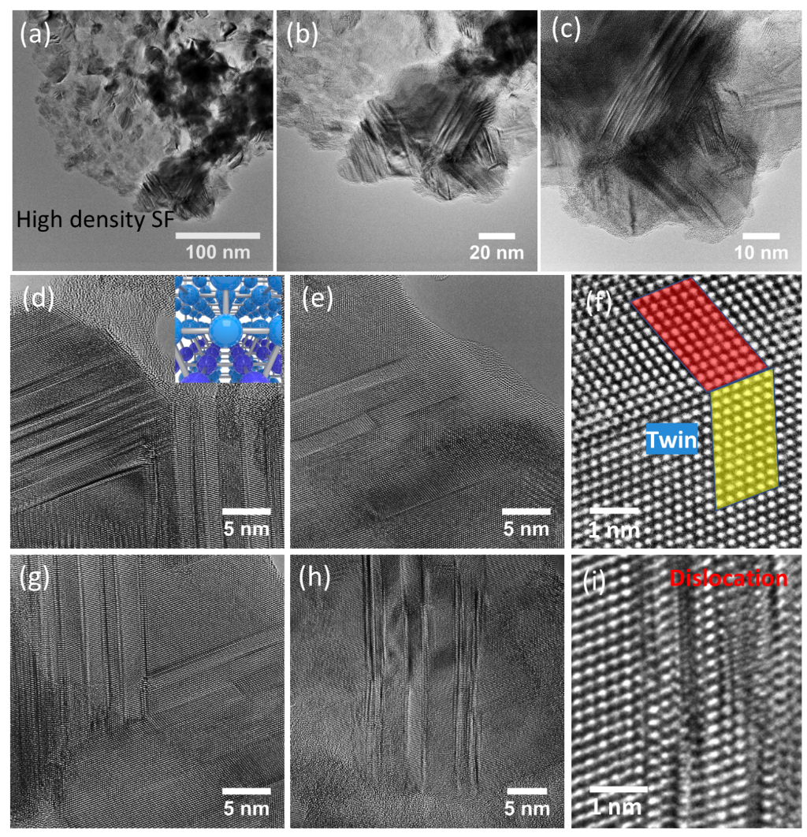
Fig. S2. (a-i) HR-TEM images of d-MoNi with high density of stacking fault (SF) defects.

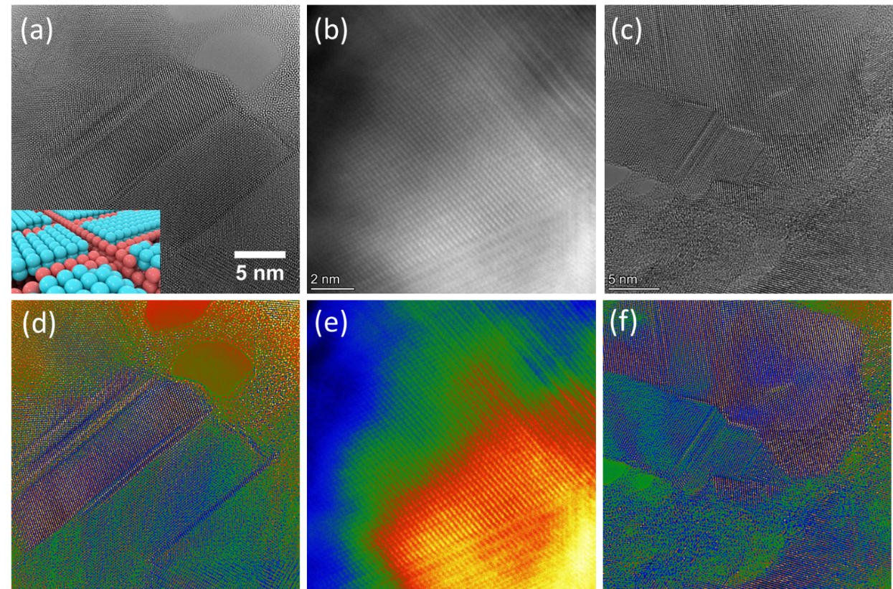
Fig. S3. (a-f) HR-TEM images of d-MoNi with high density of stacking fault (SF) defects, where false colour is applied for (d-f).

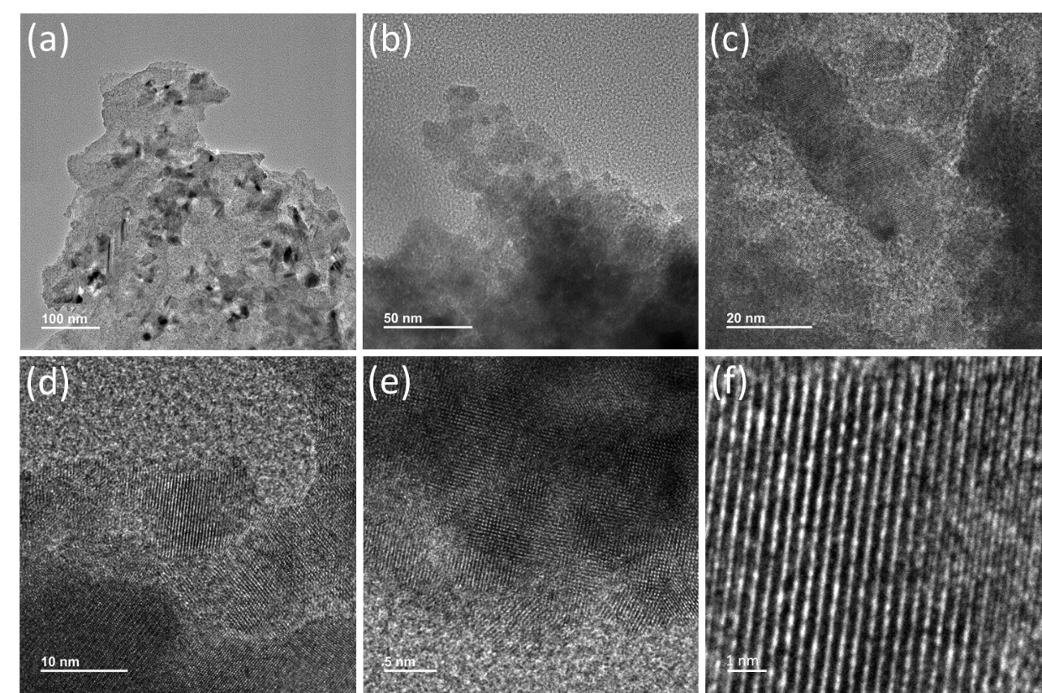
Fig. S4. HR-TEM images of MoNi.

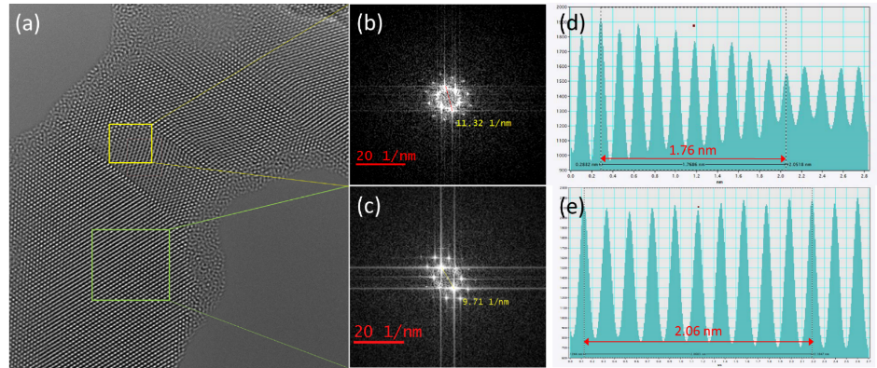
Fig. S5. (a) HR-TEM of d-MoNi, FFT of (b) yellow area of close-packed MoNi₄ (2$\overline{1}$1) plane and (c) green area of MoNi₄ (310) plane of (a), line profiles of (d) yellow area and (e) green area of (a).

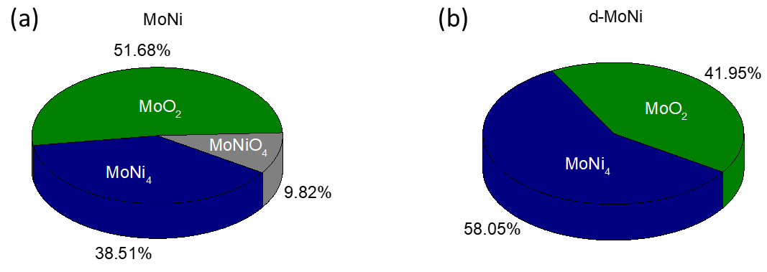
Fig. S6. (a, b) Phases quantification based on reference intensity ratios (RIR values) using X'pert Highscore software.

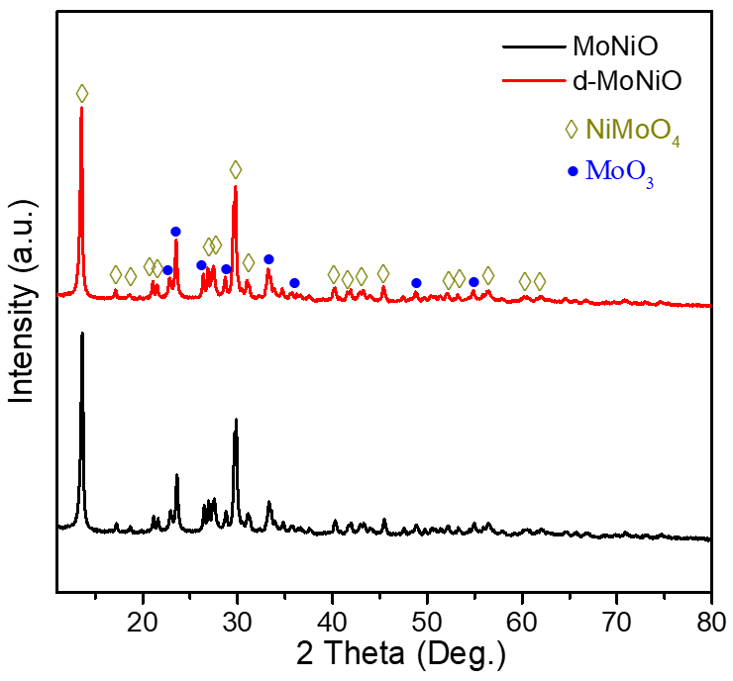
Fig. S7. XRD profiles of MoNi precursors during the synthesis, of which MoNiO is precursor after hydrothermal treatment, d-MoNiO is precursor of MoNiO after NaBH₄ treatment.

Table S1. Lattice constant, strain rate and grain size of d-MoNi and MoNi.
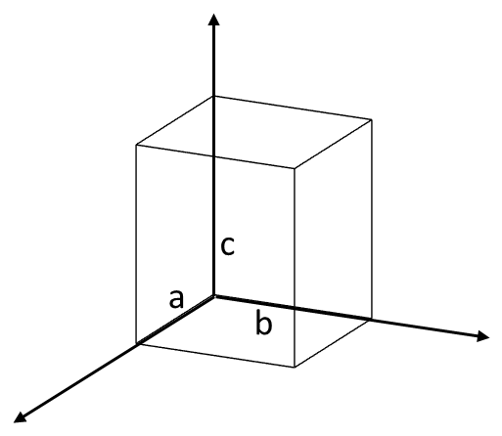 | Lattice constantª  (Å) |  |  | Strainª  (%) | Grain size^{b}  (nm)
 | a | b | c | Strainª  (%) | MoNi₄ | MoO₂
d-MoNi | 5.507 | 5.507 | 3.722 | 4.1 | 8.58 | 8.80
MoNi | 5.710 | 5.710 | 3.558 | 0.2 | 8.66 | 7.88
Standard lattice constant | 5.720 | 5.720 | 3.564 | - | - | -
ª Calculation of Strain by equation:
$$\frac{1}{d_{hkl}^{2}}=\frac{h^{2}}{a^{2}}+\frac{k^{2}}{b^{2}}+\frac{l^{2}}{c^{2}} (1)$$
$$2d\sin{θ=nλ⇒}d_{hkl}=\frac{λ}{2\sin{θ}} (2)$$
Where $d_{hkl}$ is the interplanar spacing in Å, (hkl) is Miller indices, a, b, and c are lattice constant in Å, n is the diffraction order, for first-order n=1, $λ$ is the X-ray wavelength, $θ$ is the Bragg’s angle in degrees. Strain (%) is calculated based on the calculated lattice constant and standard lattice constant.
^{b} Calculation of grain size by Scherrer equation:
$$D=\frac{Kλ}{β\cos{θ}} (3)$$
Where D is average crystallite size, K is Scherrer constant, $λ$ is the X-ray wavelength, $β$ is the line broadening at FWHM in radians, $θ$ is the Bragg’s angle in degrees.

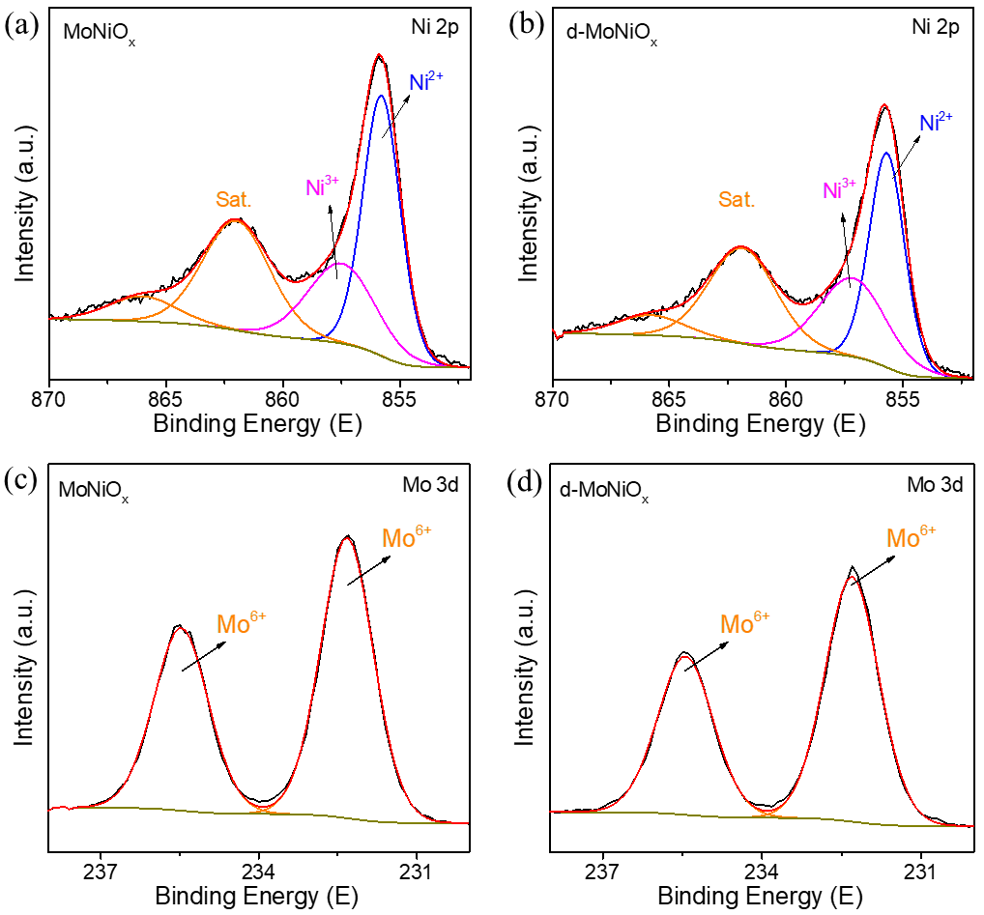
Fig. S8. XPS profiles of Ni 2p of (a) MoNiO_{x} and (b) d- MoNiO_{x}, Mo 3d spectra of (c) Ni 2p and (d) MoNiO_{x}. MoNiO_{x} is precursor after hydrothermal treatment, d-MoNiO_{x} is precursor of MoNiO_{x} after NaBH₄ treatment. The MoNiO_{x} is hydrothermal product before reduction treatment, which is composed with mixture of MoNiO₄ and MoO₃. There is no obvious phase change in d-MoNiO_{x} sample after NaBH₄ treatment.

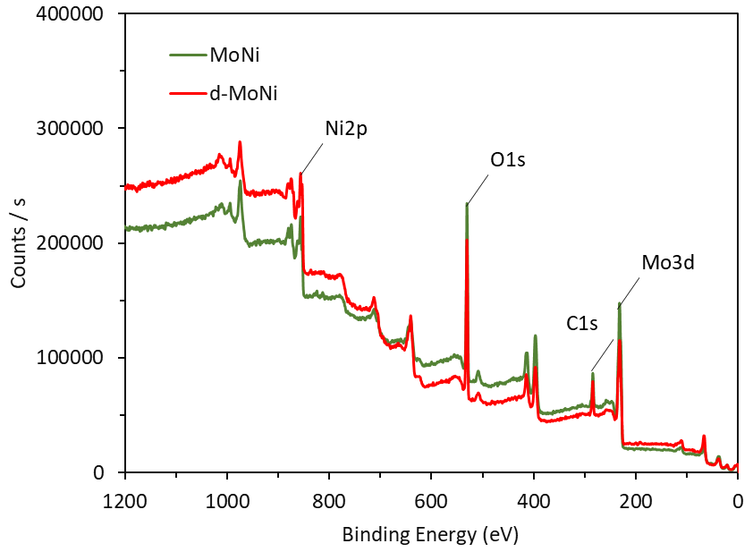
Fig. S9. XPS survey profiles of MoNi and d-MoNi.

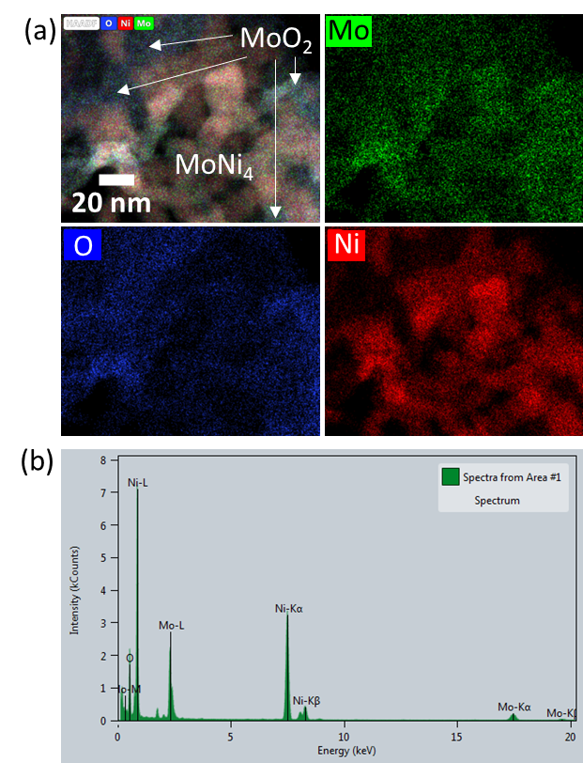
Fig. S10. (a) HAADF-STEM-EDS mappings of d-MoNi, where red represents Ni, green refers to Mo, and blue refers to O, (b) EDS spectra of d-MoNi.

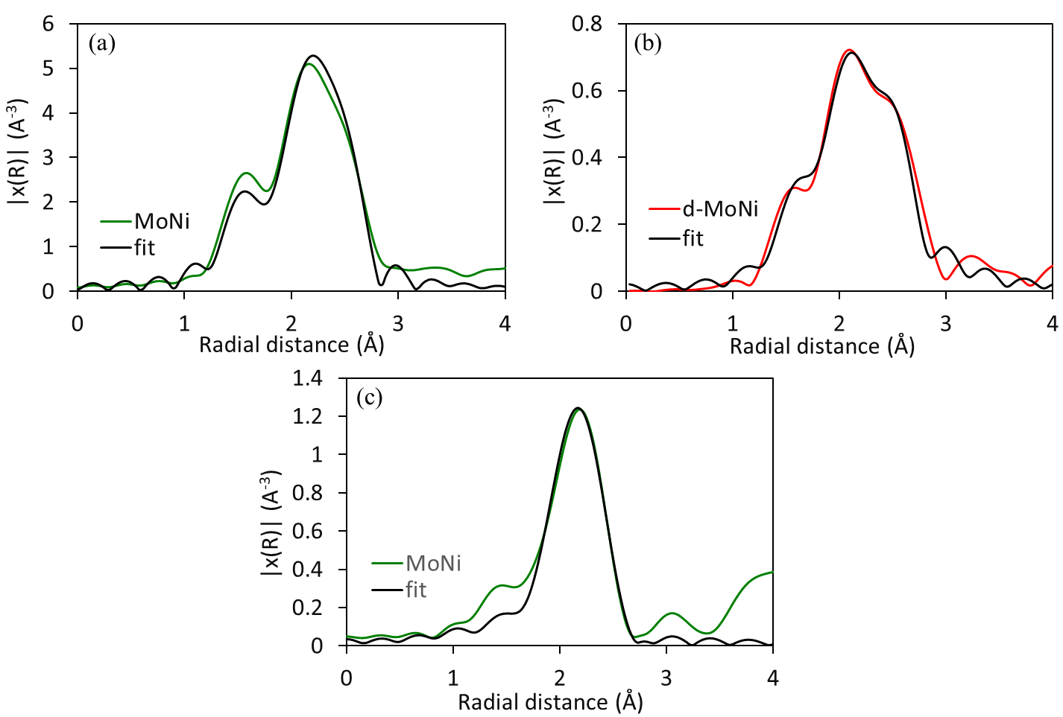
Fig. S11. The Mo K-edge EXAFS data (Green/Red) and fit (Black) for (a) MoNi and (b) d-MoNi, (c) Ni K-edge EXAFS data (Green) and fit (Black) for MoNi.

Table S2. Displaying the fitted parameters for the different samples comparing changes of fitted distance and coordination number for each path (for both fits; S0₂ = 1, E₀ = 4(3), σ²_{Mo-O} = 0.003, σ²_{Mo-Ni} = 0.009, σ²_{Mo-Mo} = 0.009, k-range = 3 -12, R-range = 1.35 – 3.6, R-factor_{d-MoNi}= 0.04, R-factor_{MoNi}= 0.02).
Sample | Path | CN | Distance
d-MoNi | Mo-O | 0.43(3) | 1.99(5)
d-MoNi | Mo-Ni | 2.09(4) | 2.53(2)
d-MoNi | Mo-Mo | 2.48(5) | 2.70(2)
MoNi | Mo-O | 0.79(2) | 2.03(2)
MoNi | Mo-Ni | 1.99(2) | 2.54(2)
MoNi | Mo-Mo | 1.79(3) | 2.74(2)

Table S3. The fitted parameters for the Ni K-edge EXAFS for MoNi and d-MoNi sample displaying fitted distance and coordination number (fit details: S0₂ = 1, E₀ = -3(4), k-range = 2.5 - 9, R-range = 1.35 – 3.7, R-factor= 0.03).
Sample | Path | CN | Distance | σ²
d-MoNi | Ni-Ni | 4 | 2.60(2) | 0.007(1)
d-MoNi | Ni-Mo | 2 | 3.39(9) | 0.012(8)
MoNi | Ni-Ni | 4 | 2.59(1) | 0.008(1)
MoNi | Ni-Mo | 2 | 3.33(7) | 0.016(8)

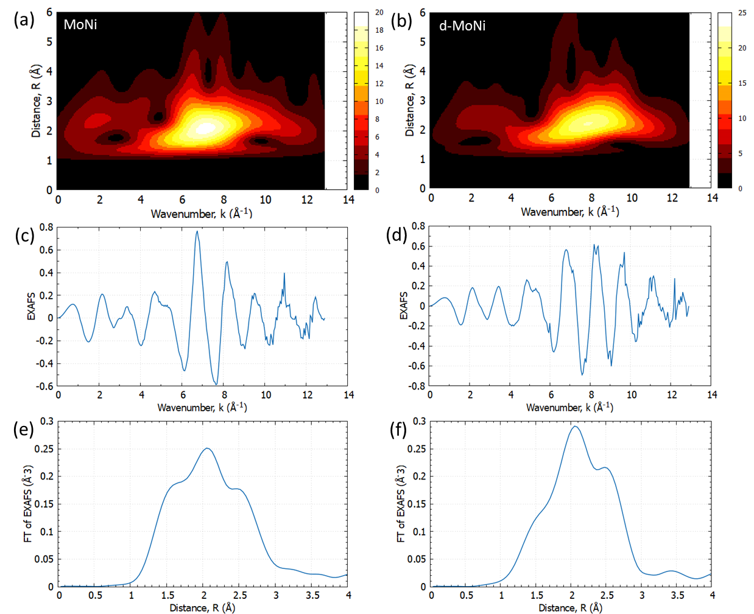
Fig. S12. Mo K-edge EXAFS wavelet transform of (a) MoNi and (b) d-MoNi, EXAFS of (c) NiMo and (d) d-NiMo, and k²-weighted FT of EXAFS of (e) NiMo, and (f) d-NiMo.

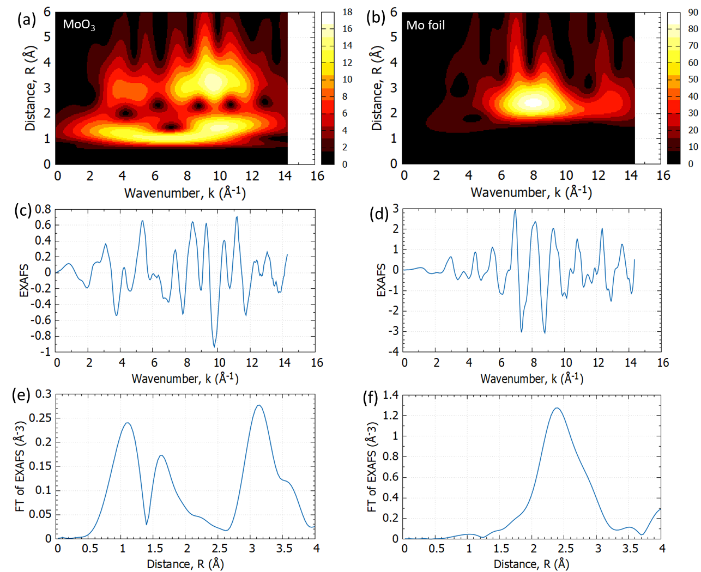
Fig. S13. Mo k edge EXAFS wavelet transform of (a) MoO₃ and (b) Mo foil, EXAFS of (c) MoO₃ and (d) Mo foil, and k²-weighted FT of EXAFS of (e) MoO₃, and (f) Mo foil.

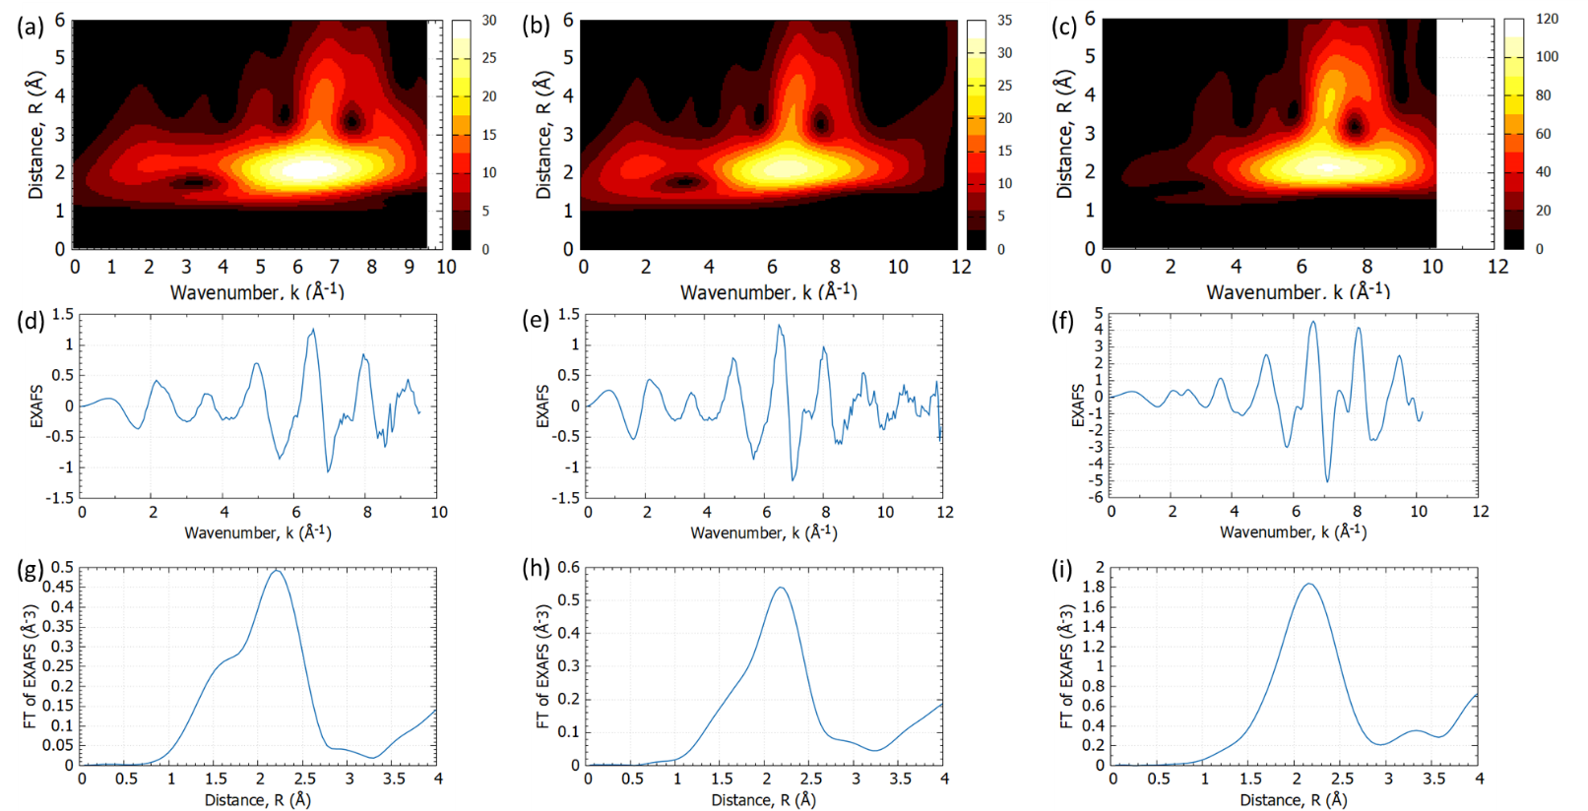
Fig. S14. Ni k edge EXAFS wavelet transform of (a) MoNi, (b) d-MoNi, and (c) Ni foil, EXAFS of (d) MoNi, (e) d-MoNi, and (f) Ni foil, and k²-weighted FT of EXAFS of (g) MoNi, (h) d-MoNi, and (i) Ni foil.

Table S4. The simulated results were compared with experimental results of pristine MoNi₄, MoNi₄, and d-MoNi₄.
Sample | SAED (Camera Length) | d-space  (nm) | Plane | 2$θ$ (TEM) | 2$θ$ (XRD) | Peak Intensity Ratio  $$\frac{(2\overline{1}1)}{\left(310\right)} \frac{\text{(}310)}{(2\overline{1}1)}$$
Simulated Pristine MoNi₄ | 4.82 1/nm | 0.207 | ($2\overline{1}1$) | 43.59 | 43.59 | 2.27 | 0.44
Simulated PristineMoNi₄ | 5.57 1/nm | 0.179 | ($310$) | 50.76 | 50.76 | 2.27 | 0.44
Experimental MoNi₄ |  |  | ($2\overline{1}1$) |  | 43.67 | 4.14 | 0.24
Experimental MoNi₄ |  |  | ($310$) |  | 50.85 | 4.14 | 0.24
Simulated MoNi₄ | 4.83 1/nm | 0.207 | ($2\overline{1}1$) | 43.67 | 43.67 | 4.14 | 0.24
Simulated MoNi₄ | 5.58 1/nm | 0.179 | ($310$) | 50.85 | 50.85 | 4.14 | 0.24
Experimental d-MoNi₄ | 4.85 1/nm | 0.206 | ($2\overline{1}1$) | 43.85 | 43.90 | 3.73 | 0.27
Experimental d-MoNi₄ | 5.66 1/nm | 0.176 | ($310$) | 51.67 | 51.28 | 3.73 | 0.27
Simulated d-MoNi₄ | 4.86 1/nm | 0.206 | ($2\overline{1}1$) | 43.96 | 43.96 | 3.73 | 0.27
Simulated d-MoNi₄ | 5.62 1/nm | 0.177 | ($310$) | 51.20 | 51.20 | 3.73 | 0.27

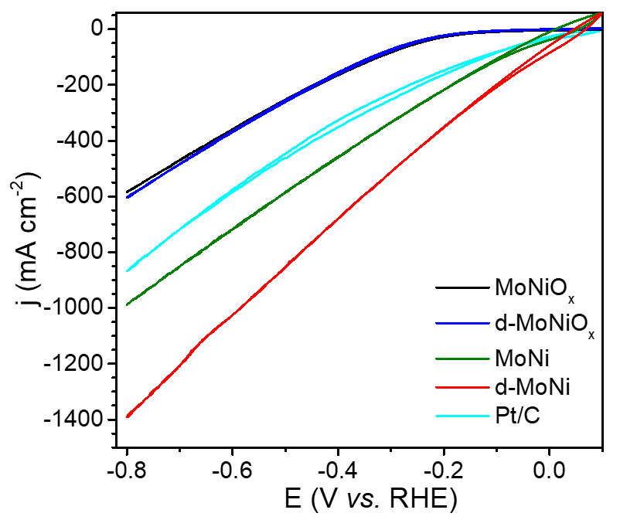
Fig. S15. CV curves of MoNiO_{x}, d-MoNiO_{x}, MoNi, d-MoNi, and Pt/C without iR compensation, 5 mV s⁻¹ in 1M KOH.

Table S5. HER catalytic performance of MoNi and d-MoNi, including potentials at different current densities and turnover frequency (TOF).
Catalysts | Potential (V vs. RHE) at current density |  | TOF (s⁻¹) at potential
Catalysts | -500 mA cm⁻² | -1000 mA cm⁻² | -0.05 V vs. RHE | -0.1 V vs. RHE
MoNi | -0.20 | -0.34 | 1.1 | 2.6
d-MoNi | -0.06 | -0.12 | 4.8 | 9.6
20%Pt/C | -0.32 | - | 1.8 | 2.5

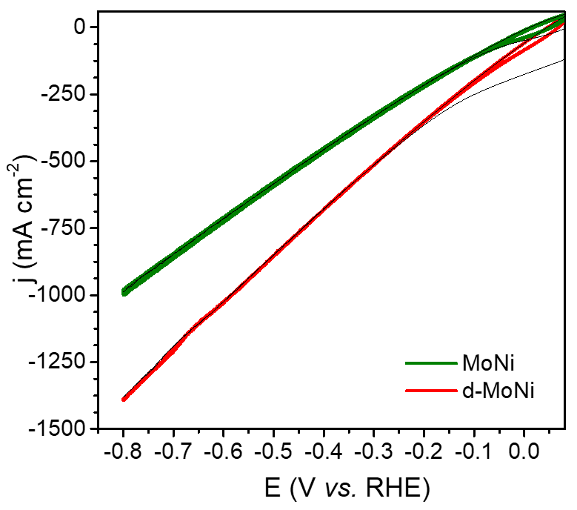
Fig. S16. CV activation curves of MoNi and d-MoNi without iR compensation before the HER performance test, 10 mV s⁻¹ for 100 cycles in 1M KOH.

Table S6. Faraday efficiency measurements of HER for d-MoNi by TCD-GC method.
E/V vs. Ag/AgCl | I/mA | Ar flow rate / mL min⁻¹ | H₂ peak | FE_{HER}
-1.131 | -35.5 | 20 | 4426394 | 1.023
-1.131 | -35.6 | 20 | 4295403 | 0.990
-1.131 | -35.7 | 20 | 4416293 | 1.015
FE_{HER:} 100.9 ± 1.7 %; STDEV: 1.7%

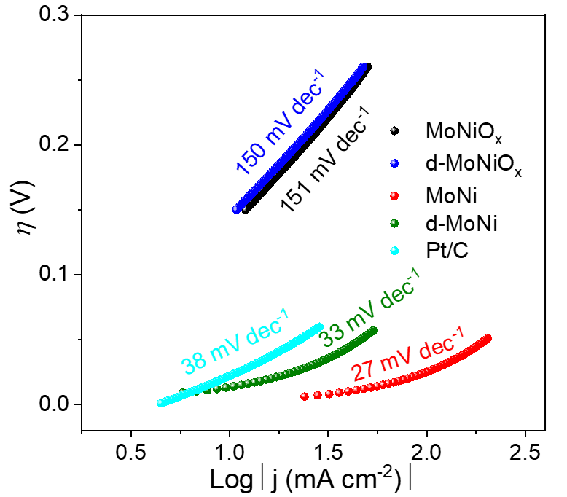
Fig. S17. Tafel plots of MoNiO_{x}, d-MoNiO_{x}, MoNi, d-MoNi, and Pt/C derived from CV results in Fig. 5a.

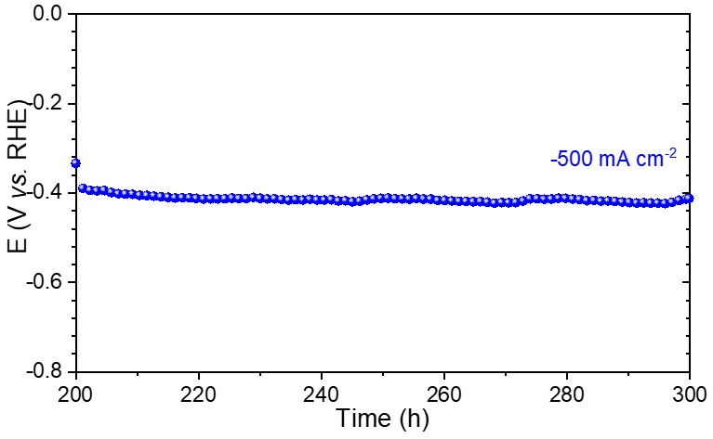
Fig. S18. Chronopotentiometry of d-MoNi at -500 mA cm⁻² in 1M KOH, no iR compensation.

Table S7. HER catalytic stability of d-MoNi compared to previous reported HER catalysts.
Catalysts | Current density  (mA cm⁻²) | Stability duration  (h) | Electrolyte | Reference
d-MoNi | 1000 | 100 | 1 M KOH | Current work
d-MoNi | 500 | 300 | 1 M KOH | Current work
Ni₆Mo₆C/NiMoO_{x}-400 | 50 | 60 | 1 M KOH | ¹
Co-doped CeO₂ | 50 | 14 | 1 M KOH | ²
MoNi₄ | 3 | 20 | 1 M KOH | ³
MoS₂ | 500 | 24 | 0.5M H₂SO₄ | ⁴
MoNi₄/Mo | 100 | 100 | 1 M KOH | ⁵
MoNi₄/MoO₂ | 200 | 30 | 1 M KOH | ⁶
o-CoSe₂|P | 100 | 20 | 1 M KOH | ⁷
MoS₂ | 20 | 200 | 0.5M H₂SO₄ | ⁸
NiO@1T-MoS₂ | 100 | 30 | 1 M KOH | ⁹

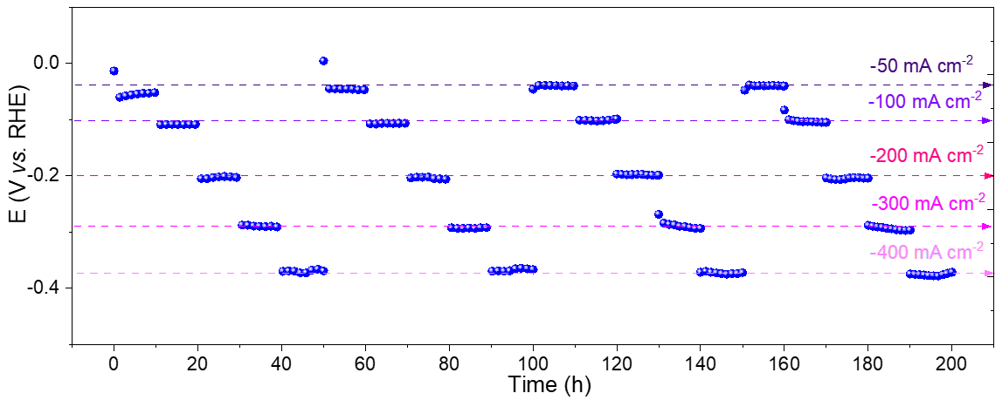
Fig. S19. Chronopotentiometry of d-MoNi at multi-current densities of -50, -100, -200, -300, and -400 mA cm⁻² in 1M KOH, each holds for 10h for 4 cycles with no iR compensation.

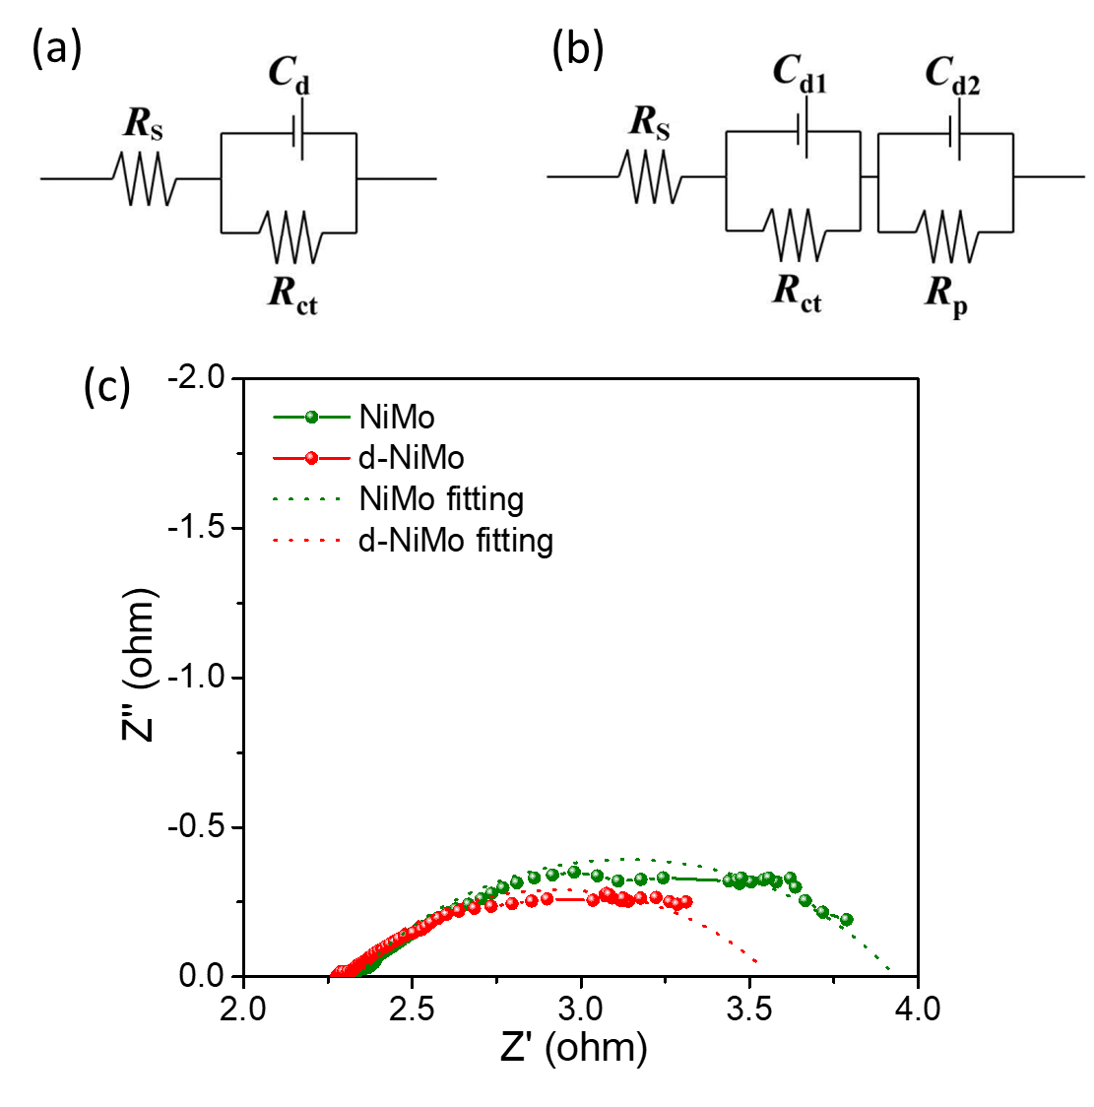
Fig. S20. Electrical Equivalent circuit models for fitting the EIS response of hydrogen evolution reaction on (a) MoNi one-time constant model and (b) d-MoNi two-time constant model, where R_{s} is the series resistance, R_{ct} denotes the charge transfer resistance, R_{d} related to is the defects the electrode surface, and the double layer capacitance is represented by the elements C_{d}, C_{d1} and C_{d2}, (c) Nyquist plots of the MoNi and d-MoNi at η = 100 mV in 1 M KOH.

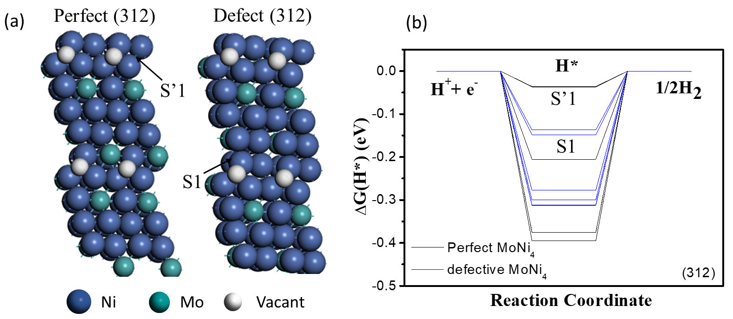
Fig. S21. (a) Atomic structural models of MoNi₄ (121) surface and (b) MoNi₄ (310) surface, (c) calculated adsorption free energy diagram for the Tafel step of perfect and defective MoNi₄ on (121) surface and (d) on (310) surface, (e) atomic structural models of MoNi₄ (312) surface and (f) calculated adsorption free energy diagram for the Tafel step of perfect and defective MoNi₄ on (312) surface.

Table S8. Gibbs free energy (ΔG_{H}, eV) of the Heyrovsky step on multi-adsorption sites of (211), (310), and (312) facets of perfect and defective MoNi₄.
Defect MoNi₄ |  |  |  |  |  | Perfect MoNi₄
(211) |  | (310) |  | (312) |  | (211) |  | (310) |  | (312)
Site | ΔG_{H}  (eV) | Site | ΔG_{H}  (eV) | Site | ΔG_{H}  (eV) | Site | ΔG_{H}  (eV) | Site | ΔG_{H}  (eV) | Site | ΔG_{H}  (eV)
S1 | -0.02188 | S1 | -0.12317 | S1 | -0.13707 | S’1 | -0.28963 | S’1 | -0.29901 | S’1 | -0.03594
S2 | -0.03681 | S2 | -0.27655 | S2 | -0.14864 | S’2 | -0.29132 | S’2 | -0.36258 | S’2 | -0.03678
S3 | -0.09623 | S3 | -0.27673 | S3 | -0.27729 | S’3 | -0.31345 | S’3 | -0.36631 | S’3 | -0.20537
S4 | -0.23596 | S4 | -0.31623 | S4 | -0.2999 | S’4 | -0.31556 | S’4 | -0.42812 | S’4 | -0.37503
S5 | -0.23842 | S5 | -0.36095 | S5 | -0.29998 | S’5 | -0.3478 |  |  | S’5 | -0.37542
S6 | -0.24881 |  |  | S6 | -0.31144 | S’6 | -0.35241 |  |  | S’6 | -0.3951
S7 | -0.26399 |  |  | S7 | -0.31235 | S’7 | -0.35364 |  |  | S’7 | -0.39533
S8 | -0.37191 |  |  |  |  | S’8 | -0.38644
S9 | -0.37213 |  |  |  |  | S’9 | -0.40505
S10 | -0.38307 |  |  |  |  | S’10 | -0.41437
S11 | -0.38363

References
1. Zheng, X.; Chen, Y.; Bao, X.; Mao, S.; Fan, R.; Wang, Y., In Situ Formed Bimetallic Carbide Ni6Mo6C Nanodots and NiMoOx Nanosheet Array Hybrids Anchored on Carbon Cloth: Efficient and Flexible Self-Supported Catalysts for Hydrogen Evolution. ACS Catal. 2020, 10 (19), 11634-11642.
2. Jiang, S.; Zhang, R.; Liu, H.; Rao, Y.; Yu, Y.; Chen, S.; Yue, Q.; Zhang, Y.; Kang, Y., Promoting Formation of Oxygen Vacancies in Two-Dimensional Cobalt-Doped Ceria Nanosheets for Efficient Hydrogen Evolution. J. Am. Chem. Soc. 2020, 142 (14), 6461-6466.
3. Duan, Y.; Yu, Z.-Y.; Yang, L.; Zheng, L.-R.; Zhang, C.-T.; Yang, X.-T.; Gao, F.-Y.; Zhang, X.-L.; Yu, X.; Liu, R.; Ding, H.-H.; Gu, C.; Zheng, X.-S.; Shi, L.; Jiang, J.; Zhu, J.-F.; Gao, M.-R.; Yu, S.-H., Bimetallic nickel-molybdenum/tungsten nanoalloys for high-efficiency hydrogen oxidation catalysis in alkaline electrolytes. Nat. Commun. 2020, 11 (1), 4789.
4. Zhang, C.; Luo, Y.; Tan, J.; Yu, Q.; Yang, F.; Zhang, Z.; Yang, L.; Cheng, H.-M.; Liu, B., High-throughput production of cheap mineral-based two-dimensional electrocatalysts for high-current-density hydrogen evolution. Nat. Commun. 2020, 11 (1), 3724.
5. Wang, Y.; Sharma, A.; Duong, T.; Arandiyan, H.; Zhao, T.; Zhang, D.; Su, Z.; Garbrecht, M.; Beck, F. J.; Karuturi, S.; Zhao, C.; Catchpole, K., Direct Solar Hydrogen Generation at 20% Efficiency Using Low-Cost Materials. 2021, 11 (34), 2101053.
6. Zhang, J.; Wang, T.; Liu, P.; Liao, Z.; Liu, S.; Zhuang, X.; Chen, M.; Zschech, E.; Feng, X., Efficient hydrogen production on MoNi4 electrocatalysts with fast water dissociation kinetics. Nat. Commun. 2017, 8, 15437.
7. Zheng, Y.-R.; Wu, P.; Gao, M.-R.; Zhang, X.-L.; Gao, F.-Y.; Ju, H.-X.; Wu, R.; Gao, Q.; You, R.; Huang, W.-X.; Liu, S.-J.; Hu, S.-W.; Zhu, J.; Li, Z.; Yu, S.-H., Doping-induced structural phase transition in cobalt diselenide enables enhanced hydrogen evolution catalysis. Nat. Commun. 2018, 9 (1), 2533.
8. Zhu, J.; Wang, Z.-C.; Dai, H.; Wang, Q.; Yang, R.; Yu, H.; Liao, M.; Zhang, J.; Chen, W.; Wei, Z.; Li, N.; Du, L.; Shi, D.; Wang, W.; Zhang, L.; Jiang, Y.; Zhang, G., Boundary activated hydrogen evolution reaction on monolayer MoS2. Nat. Commun. 2019, 10 (1), 1348.
9. Huang, Y.; Sun, Y.; Zheng, X.; Aoki, T.; Pattengale, B.; Huang, J.; He, X.; Bian, W.; Younan, S.; Williams, N.; Hu, J.; Ge, J.; Pu, N.; Yan, X.; Pan, X.; Zhang, L.; Wei, Y.; Gu, J., Atomically engineering activation sites onto metallic 1T-MoS2 catalysts for enhanced electrochemical hydrogen evolution. Nat. Commun. 2019, 10 (1), 982.

